No. | Company Name / Logo / Wesite | Company description | Participants Name/ email/ contact | Lucky draw
1. | ICONIC HOTEL  www.iconichotel.com.my  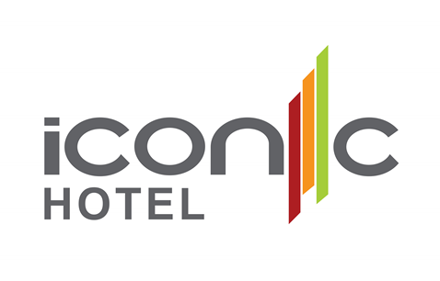 | Iconic Hotel with 195 rooms is designed to deliver an inspirational experience with it's three unique themes - Modern, Urban & Contemporary. | - Khor Bee Ai  - beeai@iconichotel.com.my  - +60164488605 | - 2D1N stay in Iconic Hotel - Superior Room
2. | PACIFIC WORLD DESTINATION EAST SDN BHD  www.destinationservices.com   | Pacific World Destination East Sdn Bhd is a travel operator licensed by the Ministry of Tourism Malaysia (license No. KPK/LN 1685). Established in 1989, it has been actively involved in destination management and handling travel related services. Through the years, it has gone through many changes and now belong to TUI Travel Group. At Destination Services, we are a global business of local experts, crafting exceptional experiences worldwide and setting leading product and service standards.  We create holidays with the right mix of activities and leisure that will give clients an exciting experience. From accommodation, transfers, tours, activities and tailored roundtrips to handling of leisure groups who seek a unique experience. | - Steffanie Tan  - stan@destinationservices.com  - Mobile: 6012 4720 885  - Vivien Cheng  - vcheng@destinationservices.com  - 6012 4810 885 | Ground/land services package for 2 persons, consist of  -Arrival & departure airport transfers on private basis  -Full Day Tour of Penang on private basis  -The prize will be valid for 6 months from the date of event.  You can combine this land package with the Penang hotel accommodation to make it a total Penang package.
3. | PARKROYAL PENANG RESORT  www.parkroyalhotels.com  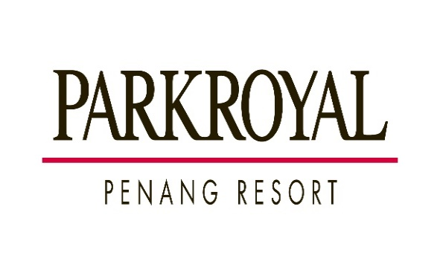 | Located at the stunning Batu Ferringhi beach, the five-star PARKROYAL Penang  Resort is a tropical oasis designed for all. The beach resort features 284 guestrooms  and 26 suites with private balconies overlooking the stunning sea and tropical  garden. Food and beverage offerings include the all-day dining Cinnamon Asian  Kitchen, showcasing renowned local, Asian and International cuisine. Savour  authentic Italian flavours at Gustoso and Gustoso By The Beach. Relax at the Sunset  Bar with stunning sunset views while indulging in creative cocktails or sway along  with live music at the contemporary yet stylish Javana Lounge. Enjoy unparalleled  leisure facilities, such as fitness and wellness center, two outdoor swimming pools, a  children’s pool with exciting waterslides, Amazonia, movie room, a kids’ club, water  sports centre and a plethora of on-site activities that aim to please kids of all ages.  To top the whole relaxation experience, rejuvenate in its award-wining St Gregory  Spa. Already one of the most well-known resorts located along Penang Island’s  famous Batu Ferringhi beach, PARKROYAL Penang Resort has upped the ante by  developing a range of exciting new experiences which are bound to delight  holidaymakers from arrival through to departure. | - Doris Hor  - Director of Sales & Marketing  - doris.hor@parkroyalhotels.com  - 019 570 8813 | 3D/2N stay in Premier Seaview Room inclusive of Buffet Breakfast for 2 persons
4. | TOUR & INCENTIVE TRAVEL  www.tour-incentive.travel   | We are among the leading Destination Management Companies and Tour Operators in Malaysia, with more than 2 decades of ground handling experience. We pride ourselves in delivering genuine Malaysian hospitality for free independent travellers, tour groups, special interests and MICE business travellers. With our network traversing Peninsular and East Malaysia, our operation and business policy is much entrenched on our core value of professionalism, creativity and competitiveness. | - Mr. Lawrence Koay  - Managing Director  - lkoay@tour-incentive.travel  - +6012-488 0532  - Mr. Joseph Lee  - Sales Manager  - joseph@tour-incentive.travel  - +6012-516 1084 | Tour & Incentive will be contributing 2 vouchers of “Penang Airport Return Transfer + 1 Half day city tour for 2 pax”
5. | PENANG HOP ON HOP OFF  www.myhoponhopoff.com/pg  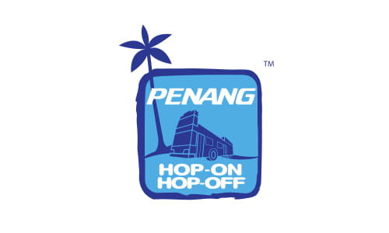 | Penang Hop On Hop Off City Tour  Tour Details:  1. 11 designated stops  2. Taking you over Penang most attractions and must visit places.  3. Close up beautiful scenery with 360 degree views at the open deck.  4. Every Friday, Saturday and Sunday, and during Malaysia Public & School holiday.  5. Live Commentary with English speaking & Open Top Double Deck Bus  Penang Hill & Kek Lok Si Shuttle  Hop onto Your Penang Hill + Kek Lok Si Shuttle to explore one of Malaysia’s must-see attractions. Enjoy the ride to the iconic tourist spot on the original double decker tour bus of the city, Penang Hop On Hop Off. Experience the steepest tunnel track in the world via Penang Hill Funicular Railway and the largest Buddhist temple in Malaysia!.  Panoramic Tour of Penang  Discover! Feel! Taste! Experience the panoramic tour of the city by hopping on our  Exclusive “Panoramic Tour of Penang” with our experienced tour assistant bringing you the best Penang sightseeing spots during the day!  Excursion Tours  Penang Hop On Hop Off Sightseeing Tours –  Morning | 10.00 AM / Afternoon | 02.00 PM *Monday to Thursday  Penang Hop On Hop Off Sunset Tours – Evening | 06.30 PM *Daily | - ANGELINE CHEN  - SALES & MARKETING MANAGER  - +6012 4233 558 | pleased to contribute 10 lucky draw vouchers for the roadshow
6. | HOMPTON BY THE BEACH PENANG  https://homptonhotel.com/  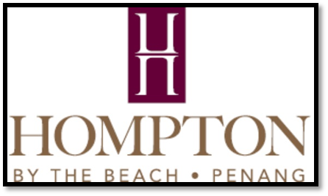 | 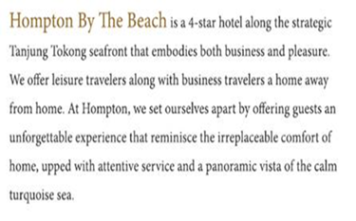 | - Dottie Azura  - dosm@homptonhotel.com  - +6019 497 1970  - Charmaine Seah  - sales.manager@homptonhotel.com  - +6012 494 9219 | 2D1N stay at Premium Suite inclusive 02 breakfast – valid for 06 months  2D1N stay at Deluxe room inclusive 02 breakfast – valid for 06 months
7. | THE NORTHAM ALL SUITE, PENANG  www.northamhotel-penang.com   | Located on Penang’s famed ‘Millionaire Row’, The Northam All Suite Penang in George Town, Penang, Malaysia offers guests the astute corporate and leisure traveller a spacious haven to unwind amongst the heart of the islands’ business and commercial district, and being less than 5 minutes from Gurney drive, the city’s famed seafront promenade. It is approximately 20km away from the Penang International Airport, approximately 20 minutes by road or 4 hours drive from Kuala Lumpur via the North-South Expressway. Our ideal location, meanwhile, brings you just minutes from many notable sites in George Town and even lets you revel in excellent city and sea views. | - Mr Adrian Cheah  - 6012 369 8169  - DOSM@northam-hotel.com.my | One Junior Suite Voucher with 02 Breakfast (3 Days 2 Nights)
8 | LONE PINE HOTEL  www.lonepinehotel.com  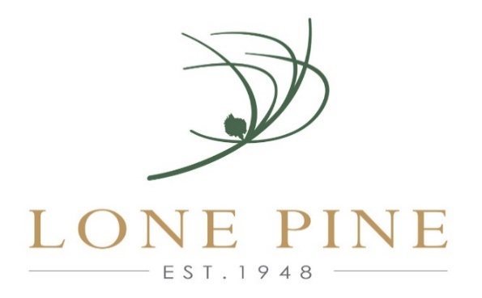 | Tucked idyllically along Penang's coastline, Lone Pine Hotel is the only Batu Ferringhi luxury boutique hotel. Contemporary beach hotel retains its uniqueness & charm with only 90 rooms, making it one of the top hotels in Penang Island offering cozy rooms to spacious suites, opening out onto seafront terraces, balconies or a private courtyard. It is a place where you can do everything or do nothing at all. Al fresco dining by the beach, “The Bungalow” serves traditional favourites ranging from colonial-style steaks to burgers, pasta to Penang wok-fried noodles and fun mouth-watering snacks to satisfy your poolside munchies. Swim laps in the pool or laze in hammocks at the garden. Indulge in pampering and rejuvenating SPA treatments in cabanas or an invigorating session at the gym.  Beautiful island sunset, cool sea breezes & the comforting shade of casuarinas, Lone Pine Hotel is the perfect place for a holiday to remember. | - Mr. Francois Sigrist  - gm@lonepinehotel.com  - 604 886 8686 / Mobile – 012 427 9433 | Two (02) vouchers x 2D/1N stay in Premier Garden Room inclusive breakfast for 02 persons
9. | LEXIS SUITES PENANG  http://www@lexissuitespenang.com   | Nestled along the idyllic and pristine beach of Teluk Kumbar and overlooking the straits of Malacca, LEXIS SUITES PENANG is about three-and-a-half-hour drive from Kuala Lumpur, 30 minutes to Gurney Drive, 20 minutes to Penang Second Bridge and mere 10 minutes’ drive to Penang International Airport. An embodiment of contemporary design coupled with luxurious fittings, Lexis Suites Penang is designed by a team of world class, award-wining architects. Spacious yet cosy, each of 222 Suites are tastefully decorated and showcases floor-to-ceiling glass door in guestrooms, allowing generous amount of natural light into the abode. This seaside property also stands out as the only resort in the island that boosts the luxury and convenience of a private dip pool and steam room in every Suite. | - Ms Serene Law  - serenelaw@frozenlimeasia.com  - 65 6661 0646  - Mr Leonard Chiang  - leonardchiang@frozenlimeasia.com  - 65 6661 0646 | voucher of 3 day 2 nights with 2 breakfast
10 | THE PRESTIGE HOTEL PENANG  http://theprestige.my/  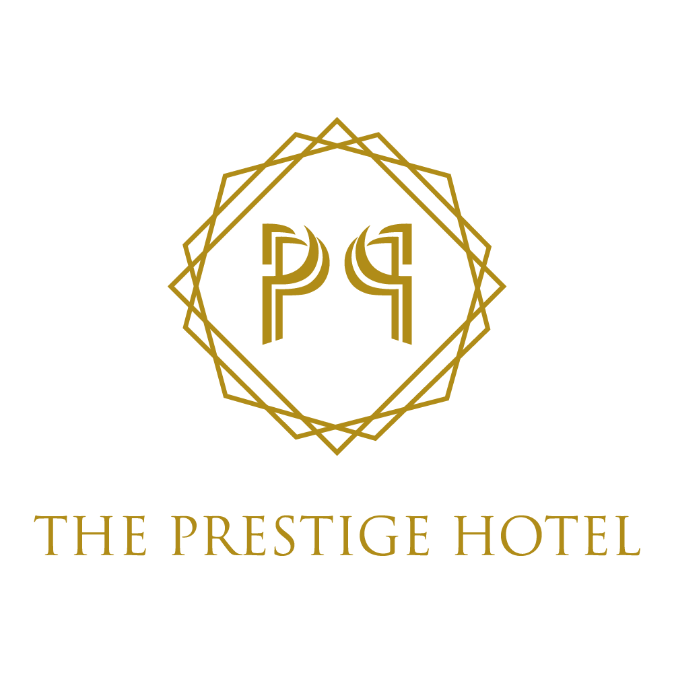 | The Prestige Hotel is a luxury homegrown hospitality label located in the heart of the Georgetown UNESCO world heritage site. Inspired by its colonial Victorian heritage, it welcomes the urbane traveller to a magical contemporized colonial scene, with 162 rooms, an all day dining outlet, an arcade with a mix of retail outlets, event spaces and a rooftop infinity pool.  25 minutes away from Penang International Airport, within walking distance to Penang’s cultural hotspots and popular gourmet finds, together with Prestige’ bespoke hospitality, The Prestige Hotel brings local inspiration to life for intrepid world travellers seeking to experience local charm at its best. It is the perfect designer living space for the busy business executive and the contemporary world traveller of today. | - Melvin Ooi (General Manager)  - melvin@theprestige.my  - 60 19-477 2892  - Feon Lee (Director of Sales)  - feon@theprestige.my  - 6012 4937068 | 2 vouchers x 2 Days 1 night stay at Deluxe room with 2 breakfast.
11 | HOLIDAY INN RESORT PENANG  https://penang.holidayinnresorts.com/  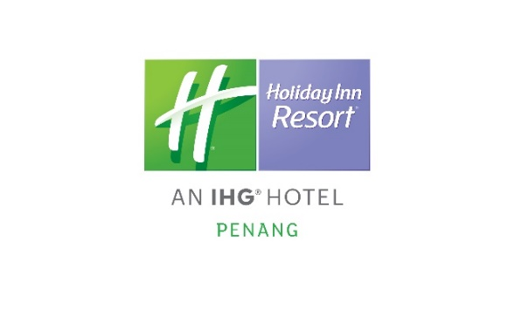 | Holiday Inn Resort Penang is strategically located in the heart of Batu Ferringhi. The resort is comprised of the 7-floor Beach Wing and 23-storey Ferringhi Tower with 347 guestrooms ranging from 35sqm to 68sqm. The Resort is just a doorstep away from the vibrant night market and 30-minutes drive to the UNESCO World Heritage Site in Georgetown | - Name: Kelvin Gan  - Email: kelvin.gan@ihg.com  - Contact: +6017 6847 304 | 3 Days 2 Nights accommodation at Holiday Inn Resort Penang (validity 1 October - 31 March 2019, T&C apply)
12 | SHANGRI-LA’S RASA SAYANG RESPRT & SPA PENANG  Shangri-La.com   | Surrounded by majestic soaring trees, ancient and lush, the foliage reaches for the ground like falling rain but remains suspended above the earth – This is the setting for the beautiful Shangri-La’s Rasa Sayang Resort & Spa. The resort is tucked away amidst century-old rain trees which accentuate the natural beauty that surrounds your clients during their stay here. Rasa Sayang Resort & Spa has a sense of history, place and tradition. Its distinctive Minangkabau architecture houses artefacts of Malaysian culture. Guests here can enjoy the artfully arranged traditional jewellery, batik-printing moulds, coral sculptures and signature items from the prolific Malaysian kitchen. As your customers spend time at the resort, it’s almost impossible not to make time for relaxation and there’s nowhere better than at CHI, The Spa. Eleven private villas, allows guests to have a hidden retreat away from the stresses of everyday life, letting them indulge in a traditional tropical treatment and emerge refreshed and rejuvenated, which is the overriding feeling you will get to enjoy at Shangri-La’s Rasa Sayang Resort & Spa. | - Choong Kit Siong  - Director of Sales  - Shangri-La’s Rasa Sayang Resort & Spa, Penang  - kitsiong.choong@shangri-la.com  - M. +60 17 541 7482 | 2 Nights stay in Deluxe Garden View Room with Buffet Breakfast for 2 person  Validity until 30 April 2020
13 | THE HABITAT PENANG HILL  www.thehabitat.my   | The Habitat Penang Hill offers the most authentic, diverse and educational rainforest experience in Malaysia. Our world class rainforest discovery centre sits on the fringes of a forest reserve protected since 1911 and consists of a 1.6km nature trail that was built by the British East India Company in the early 1800s.  Apart from the myriad of flora and fauna that are discoverable along our trail, guests to our park will enjoy breath-taking views of Penang and its surrounding areas atop Curtis Crest Tree Top Walk, the highest public viewing point on the island.  We are also home to the Langur Way Canopy Walk, the longest two-span stressed ribbon bridge in the world and the only one that sits within a pristine rainforest. The bridge unlocks a unique view of the canopy layer of the rainforest, where more than 50% of biodiversity in the rainforest is believed to reside.  Experience the rainforest at a whole new level with the Flight of the Colugo zipline experience; a 5 zipline, one abseil and one net bridge walk through the rainforest canopy, guided by our professionally certified aerial trail team.  By reconnecting our visitors to nature, we hope to inspire them to make choices for a sustainable future and to help cultivate a sense of appreciation and respect for the delicate and diverse ecosystem that we are striving to protect. | - Mr Andrew  - andrewoon@thehabitat.my  - +60 122107550  - Mr. Chip  - munchip@thehabitat.my  - +012 3283898 | 10 standard entrance tickets (Valued at RM55 per piece – valid for 6 months)
14 | ROYALE CHULAN PENANG  www.royalechulan.com   | Royale Chulan Penang is at the heart of UNESCO Heritage Site in George Town, Penang, Malaysia. This 4-star heritage property with 180 rooms offers a charming fusion of history through its colonial architecture and style, and modern luxuries through unique accommodations and gourmet dining options. Part of this hotel in Penang is a beautifully restored heritage building built in 1892 which provides a charming old-world sophistication unique to Royale Chulan Penang. | - Suzyana binti Sujod (Suzy)  - suzy.rckl@royalechulan.com  - 016-920 1241 | 3Day2Night Stay in Deluxe Room with breakfast for 2 persons  (with 3 months validity period)
15 | DISCOVERY OVERLAND HOLIDAYS  www.discoveryoverland.com   | Founded in year 2000, Discovery Overland Holidays is a well established travel expert specializing in providing seamless experiences to ulfil the wishes of our esteemed travel partners. We have branch offices strategically located in Malaysia, Singapore and Thailand, covering main tourist destinations such as Kuala Lumpur, Penang, Langkawi, Kuching, Kota Kinabalu, Singapore, Bangkok and Phuket. With a total staff strength of about 80 people and a fleet of over 15 vehicles, we are bold enough to declare that we are the experts of our destination. We have a wide selection of products and tailor-made programs that serve as a guide of what we can offer to our travel partners. We strongly believe in preserving the sustainability of our destination without compromising on the comfort and quality of our experiences. Allow us to take you on a journey that is designed in a more attentive way to help you unwind and rejuvenate | - Mr Jen Chan  - Director of Sales  - Tel: + (6) 03 9222 8113 Ext: 326  - H/P: + (6) 012 232 8580  - Fax: + (6) 03 9222 8248  - E-mail: Jen_Chan@discoveryoverland.com | We will sponsor 2D1N night stay inclusive of breakfast for 2 persons at Clans Kongsi Georgetown Hotel (validity: immediate till 31st March 2020)
16 | PENANG CONVENTION & EXHIBITION BUREAU  https://www.pceb.my/  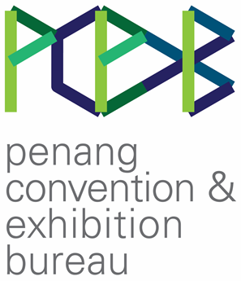 | Penang Convention & Exhibition Bureau (PCEB) is a state bureau established in 2016 to develop the Business Events and meetings, incentives, conventions and exhibitions (MICE) industry in Penang. PCEB aims to position Penang as the preferred location for Business Events activities in the region. With its rich UNESCO heritage, thriving multicultural society, state-of-the-art facilities and vibrant natural attractions, Penang offers a truly eclectic tropical experience. | - Tricia Loh  Head of Sales  tricia@pceb.my  - Bryan Khoo  Sales Executive  bryan@pceb.my  - Grace Ng | 5 Tickets to Be@penang
17 | MY PASSION TRAVEL SDN BHD  http://www.mypassiontravel.asia   | My Passion Travel (MPT) is a Taiwanese based company and we are the inbound agent which act as local DMC for all the local ground handling work for our series booking from Taiwan. Meantime, MPT just came out 2 new coaches in 2019. | - Mr. Edmund Foo  - edmund@mypassiontravel.asia  - +6012-416 3033 | 2@ Half day Tour Vouchers by Van (max 6 pax)

