

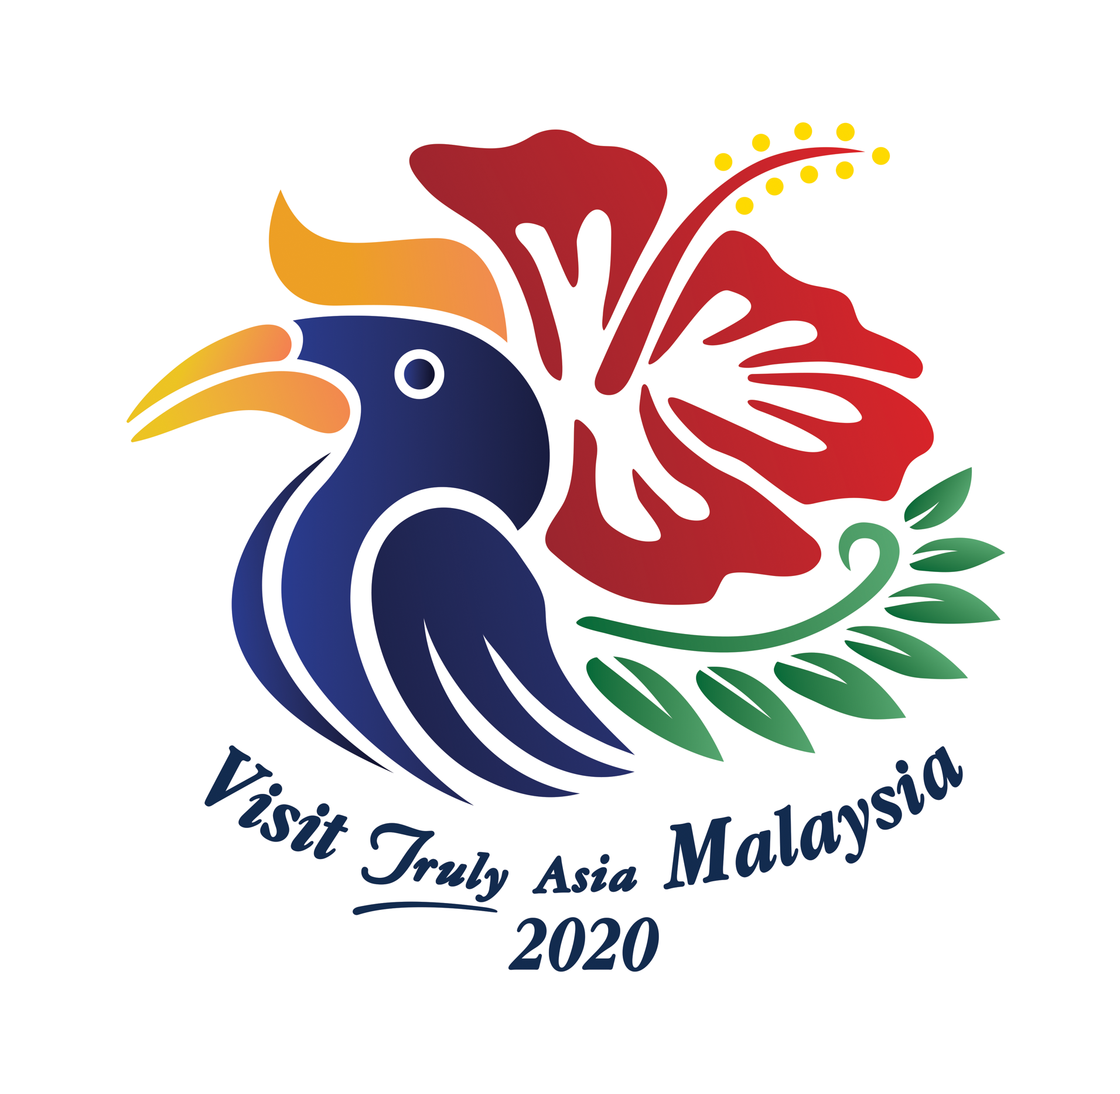


TENTATIVE PROGRAM FOR MR ANDERS PIHL PRESS TRIP 04-11 MAR 2020

Date/Time Destination/Program

04-05MAR LANGKAWI
Program at The Datai as per separate itinerary
Overnight: The Datai

06MAR LANGKAWI
Breakfast at the resort and check-out
0900hrs Depart The Datai for Cable Car and Oriental Village
Lunch
1400hrs Experience Zipline by Umgawa Legendary Adventures
1630hrs Check-in to resort
1800hrs Inspection followed by dinner at the resort
Overnight: Meritus Pelangi Beach Resort

07MAR LANGKAWI
0900hrs Depart for half day cruise/island hopping
1300hrs Lunch at resort
Afternoon free to discover Cenang Beach area and own activities
Overnight: Meritus Pelangi Beach

08MAR LANGKAWI / PENANG
0815hrs Transfer to Langkawi International Airport for flight to Penang
1030hrs Depart Langkawi for Penang
1110hrs Arrive Penang. Meet and transfer to Hotel.
1400hrs Tour of Khoo Kongsi followed by hotel inspection and afternoon Tea at The Clans
Overnight: The Clans

09MAR PENANG
0900hrs Walking tour covering Chow Rasta Morning market. UNESCO Heritage area joss stick making, temples, little India, wall art, Peranakan Mansion etc. Georgetown food trail.
1300hrs Lunch at Hainan Town Restaurant
Overnight: The Clans

10MAR PENANG
0830hrs Pick up for tour of Penang National Park
1100hrs Spice Garden
1300hrs Lunch at Hawker
1500hrs Check-in at E&O followed by English afternoon tea at Palm Court restaurant at the hotel. (if time permits)
1800hrs Inspection followed by dinner at Java Tree restaurant at the hotel.
Overnight: Eastern Oriental Hotel (Heritage Wing)

11MAR PENANG
0830hrs Depart for visit of Penang Hill
1000hrs The Habitat
1130hrs Kek Lok Si temple.
1300hrs Buffet lunch at Sarkies Restaurant at the hotel
1400hrs Check-out and transfer to airport for departure flight
1645hrs Flight departing to Bangkok.
End of services.

*Please note:
- Above is proposed tentative program and timing subject to change
- Only indicated meals are provided
- Fights and all expenses of personal nature are on own account such as alcoholic beverages during
meals, laundry, gratuities etc. unless otherwise informed by host.

Contact persons for ground arrangements

Langkawi
Ground handling and Guide: Mr. John Britto +60164666268
Co-ordinator Langkawi Development Authorities: Ms. Tini +60124477969
The Datai: Ms Celine Miguel +60192638509
Meritus Pelangi Beach: Ms. Hasniza Suid @ Sue +60124207233

Penang
Ground handling and Guide: TBA
Co-ordinator Penang Global Tourism: Ms. Pauline Yoon +60164735119
The Clans: Ms. Joyce Chin +60124762243
Eastern & Oriental Hotel: Ms. Eileen Chong +60164198238

Overall coordination: Tourism Malaysia Ms. Nasha Abdullah +46708606603 (Sweden)

