No. | Company Name / Address/Logo / Wesite | Company description | Participants Name/ email/ contact | Lucky draw
1. | ICONIC HOTEL  71, Jln Icon City, Bukit Tengah, 14000 Bukit Mertajam, Pulau Pinang  www.iconichotel.com.my  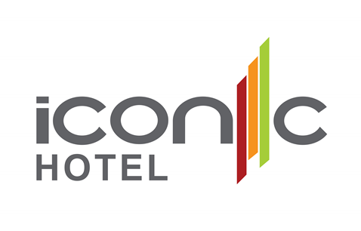 | Iconic Hotel located in the heart of Icon City - Bukit Mertajam, one of the hottest and lively areas at Mainland Penang. Accessible within 10 minutes from Penang Bridge. The 195 stylishly designed rooms are to deliver an “Impressive, Incomparable and Inspiring” experience with three unique themes - Modern, Urban and Contemporary. All rooms are equipped with a 40” LED TV, stylish workspace with high-speed internet access, in-room safe, complimentary minibar and coffee machine. Iconic Hotel also has 5 function rooms which can host up to 400 guests, 1 executive meeting room, business center, and 1 VIP dining room. The hotel provided a healthy lifestyle with leisure services such as swimming pool, 24 hours’ gym & sauna. | - Khor Bee Ai  - beeai@iconichotel.com.my  - +60164488605 | 2D1N Superior room with 2 breakfasts
2. | CLANS KONGSI  2 cannon square, 10200 penang, malaysia  www.clansgeorgetown.com  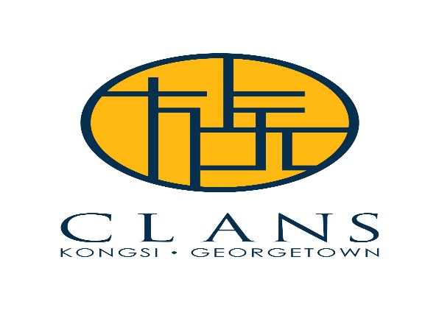 | CLANS KONGSI GEORGETOWN is situated within the enclave of the infamous UNESCO World Heritage Site - Leong San Tong Khoo Kongsi, in the heart of Georgetown World Heritage Site.  A 42-room accommodation in charming century-old clan houses built in the 1860s’ Southern Chinese Eclectic architecture which provides unique heritage living experience.  Additionally, local flavours in tastes & sights in the surroundings of historical sites, local shops, cafes and restaurants that are all within walking distance. | - Ms JOYCE CHIN  - joyce_chin@emerging-view.com  - (+6012) 476 2243 | 1 Stay Voucher for 3days/2nights stay for 2 persons incl of Breakfast and Tea
3. | TRAVELODGE GEORGETOWN, PENANG  101, Jalan Macalister, 10400 George Town, Penang, Malaysia  https://www.travelodgehotels.asia/hotel/travelodge-georgetown/   | Travelodge Georgetown is located on the well-known Macalister Road – a major thorough fare in the historic Georgetown in Penang renowned for being a food paradise.  Penang’s diversity in ethnicity, culture and religion has resulted in a mouth-watering variety of iconic street food; Georgetown in particular offers a dazzling array of hawker fare that pays  homage to the citys multi-cultural make-up. With a UNESCO World Heritage listing, charming architecture, whimsical street art and of course  the tantalising street food, Georgetown is well-positioned to capture both international and domestic tourists, and Travelodge Georgetown is the perfect place to stay. | - Tan Kai Jing  - kaijing.tan@travelodgehotels.asia  - 60 17 429 1527 | One-night stay in one Superior Room with Two breakfasts
4. | VANGOHH EMINENT HOTEL & SPA  Jalan Machang Bubok 2, Taman Machang Bubok, 14000 Bukit Mertajam Penang  www.vangohh.com  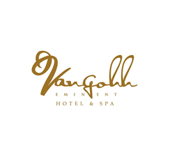 | VANGOHH EMINENT HOTEL & SPA, a luxury five star Hotel & Spa inspired by art, lifestyle and romance bringing its first to Bukit Mertajam Penang. A Paradise in Bukit Mertajam and a bold take on hospitality offers both locals and visitors an inspired place to stay while enjoying the tranquility and fantastic view of the BM Hill.  Vangohh Eminent Hotel & Spa deviates from the conventional hotel experience, and we are so thrilled and eager to extend our uniquely way of hospitality with personalized experiences. The Hotel aren’t just confined to a specific age group, but are joined by their appreciation of informal, flexible service and a buzzing social scene. ( Logo attached | - Ice Goh  - Rain Lim  - Joan Chai  - icegoh@vangohh,com  - 0124650105 | To be confirmed
5. | GRAND ORIENT HOTEL  No. 3079, Jalan Laguna 1, 13700, Perai, Penang  www.grandorienthotel.com  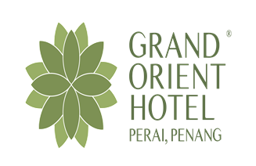 | Grand Orient Hotel and Laguna Waterpark situated in a superb position close to the 1st Penang Bridge. We were designed seamlessly to match the Amazon theming including the appearance and facade of the hotel building which we have cladded with aluminium louvre in wooden colour. The selected flooring with natural earthy tones will definitely ensure the feel of immersion is present in the Grand Orient Hotel when the visitor’s step into the hotel lobby. Adding more fun to nature, the Laguna Water Park was created to tailor for anyone and everyone, especially for family, leisure and adventure travellers. | - James Chang  - Ahmad Muizz  - james@ilcpg.com.my  - Contact Number: 017-562 6555 | 02 x 02 Days 01 Night stay @ Deluxe Room inclusive Breakfast & Waterpark Admission Ticket for 02
6. | EVERGREEN LAUREL HOTEL PENANG  53, Persiaran Gurney, 10250 Penang, Malaysia  www.evergreen-hotels.com  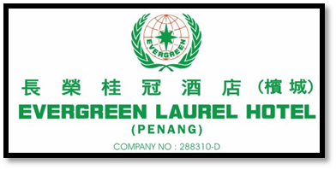 | Evergreen Laurel Hotel was a Penang  5-Star hotel which strategically located along the famed Gurney Drive overlooking the serene seaside,  within walking distance from the latest shopping complex and hawkers centers.  A deluxe Business cum Leisure hotel, providing 368 elegantly designed spacious guestrooms with uninterrupted view of the Sea or Georgetown and Penang Hill.  Savor the International and Chinese Cuisine in Cafe Laurel with a spectacular ocean view.  Lobby Lounge is the perfect place to meet for leisure or business to unwind with our live band performance.  The elegance Ballroom and Function Rooms are well prepared to accommodate for corporate conventions, Banquet Reception and Cocktail Parties.  The Health Club has complete facilities, including Poolside Bar, Indoor & Outdoor Gym, Tennis courts, Sauna, Jacuzzi and Kids Club.  Business Center is fully equipped with the latest communication tools and secretarial services. | - Mr. David Soo  - Mr. Rayden Low  - pendos@evergreen-hotels.com pensls1@evergreen-hotels.com  - +604-222 9988- (Evergreen Laurel Hotel General Line); 012-493 1685-(David); 012-488 5605- (Rayden) | Deluxe Room (Seaview Room) for 2 Days 1-night stay with breakfasts in total of 2 x vouchers
7. | DESIGN VILLAGE OUTLET MALL  5-1 Design Village Outlet Mall, 733 Jalan Cassia Barat 2, 14110 Bandar Cassia, Penang.  www.designvillage.today   | Design Village Penang’s Outlet Mall is the greenest mall in Malaysia and the only outlet mall in Northern Region owned and managed by PE Land (Penang) Sdn Bhd. With a lush 24-acres carefully curated award-winning tropical garden and 150 stores, wide sheltered walkways and captivating jewel boxes at every corner, it’s a whole new shopping experience. | - Suly Ooi  - ooisl@designvillage.today  - 012-5523893 | Coach Women Wallet (worth RM1500) X 1 unit  Bonia Handbag (worth RM1,899) X 1 unit
8 | HOTEL EQUATORIAL PENANG  1, Jalan Bukit Jambul, Bayan Lepas, 11900 Penang  www.equatorial.com   | Hotel Equatorial Penang is a 5-star hotel situated within minutes from the Penang International Airport, the Penang Free Industrial Zone, and the heritage city of George Town. Located on a high elevated ground, Hotel Equatorial Penang offers breath-taking views of the lush landscaped garden, greenery golf course, city, and Penang skyline – including two Penang bridges.  The hotel houses 662 well-appointed guestrooms and suites in 2 wings– the Main Wing & the North Wing; where both share a spacious lobby. All accommodations feature private balcony overlooking beautiful views. Club and suite guests enjoy exclusive access to the Equator Club Lounge. As a premier destination for business events, the hotel is a world class venue with exceptional facilities in its 2 ballrooms integrated with giant LED boards and supported with 21 function rooms. Indulge in refined culinary, recreational and wellness facilities as Hotel Equatorial Penang stays true in delivering sophisticated experience with high quality standards and gracious hospitality for business or leisure purpose. | - Ms. Ainun Ismail / Senior Sales Manager / Hotel Equatorial Penang  - Mr. Zeston Ooi / Sales Manager / Regional Sales Office Kuala Lumpur (Equatorial Group)  - Ms Jess Kaw / Group Director of Sales & Marketing / Regional Sales Office Kuala Lumpur (Equatorial Group)  - ainun@pen.equatorial.com  - +60 4 6327129 /+60 12 4088803 | One (1) complimentary voucher for 2D 1N stay with breakfast for two persons in Club Premier room
9. | TROPICAL SPICE GARDEN  Lot 595 Mukim 2, Jalan Teluk Bahang, 11050 Penang, Malaysia  www.tropicalspicegarden.com  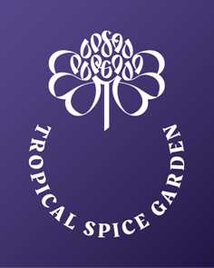 | Growing out of Penang’s rich past as a spice island, Tropical Spice Garden is a bio-diverse living museum of the spices  and other plants that have been our medicines as well as our foods since the dawn of time. The garden is home to over 500 species and showcases the real cultural heritage of Penang and establishes the island’s place in world history. Set in a shaded valley between rainforest and seashore, its peaceful spice terraces and green vistas offer a timeless window on to the cultures of the past. | - Evelyne Teh  - evelyne@tropicalspicegarden.com  - +6012 - 4718797 | 1 Cooking School complimentary voucher for 1 person  (worth RM 260.00)  4 Live guided tour complimentary vouchers in 2 sets ( RM48.00 x 4 = RM 192.00)
10 | ROYAL CHULAN PENANG  No 1 & 2, Pangkalan Weld, 10300 Georgetown, Penang  www.royalechulan.com  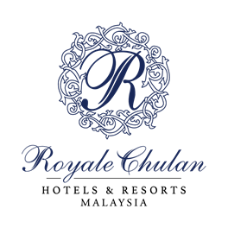 | Royale Chulan Penang is at the heart of UNESCO Heritage Site in George Town, Penang, Malaysia. This 4-star heritage property offers a charming fusion of history through its colonial architecture and style, and modern luxuries through unique accommodations and gourmet dining options. Part of this hotel in Penang is a beautifully restored heritage building built in 1892 which provides a charming old-world sophistication unique to Royale Chulan Penang. | - Eric Ng  - ericng.rcp@royalechulan.com  - +60123819997 / +60163303285 | 2D/1N stay in Superior Room inclusive of breakfast for 2 persons x 1 voucher.
11 | FLAMINGO HOTEL BY THE BEACH PENANG  Jalan Tanjung Bungah 11200 Penang Malaysia  www.flamingo.com.my  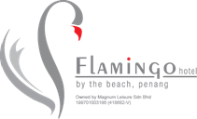 | Flamingo Hotel by the beach, Penang boasts 280 well-appointed rooms made up of 250 deluxe rooms, 28 suites and 2 presidential suites, and exudes all the charm and demeanor any guest would expect from a contemporary beachfront retreat. Its pristine white beachfront with completed facilities as well as direct access to beach sports provides the perfect escape to rest and relax. Every room is furnished with modern contemporary furniture and comes equipped with a LCD TV, hair dryer and a private balcony with panoramic views. Coffee or tea making facilities, a mini bar and safe box are standard in-room amenities. | - Ms Jenny  - Mr Ronnie  - jenny.wong@flamingo.com.my  - Ronnie@flamingo.com.my  - +6016 484 6820 | 2D1N deluxe room  with breakfast
12 | THE TOP PENANG  1, Jalan Penang, George Town, 10000 George Town, Pulau Pinang  www.thetop.com.my   | The Top Penang, Penang’s Highest Iconic Entertainment Tower Discover the largest and the best indoor theme park The Top Penang which offers you more than 18 themed attractions in one iconic destination. Have a never-ending fun on the highest tower in Penang. Eat, Play and Learn at the same time and same place. | - Bobby Yong (KL)  - Kenny (Penang)  - bobbyyong@owg.com.my  - kennywong@thetop.com.my  - +6012-3909142  - +6017-289 0755 | 6 tickets of The TOP  Penang – “Top Day Fun Pass”, 6 x RM 99 = RM 594  (Can be used by Non-Mykad Holder)
13 | THE GRAVITYZ  19-1, Jalan Metrowangsa, Section 2, Wangsa Maju, 53000 Kuala Lumpur  www.thegravityz.com   | The Gravityz offers an experience that is out of this world as it features activities involving one of the best high-altitude sports platforms in ASEAN; you will enjoy a breathtaking view comparable to an eagle eye’s view. To those out there who live for adrenaline pumped moments, The Gravityz is a platform for you to elevate yourself to new heights, literally. We encourage everyone to build their confidence and to take a leap out of their comfort zone, hence our tagline: Beyond Confidence. | - J.Hong Low  - jhong@agcsports.my  - 0163383348 | 6 ticket of TheGravityz ride
14 | THE HABITAT PENANG HILL  The Habitat Penang Hill Bukit Bendera 11300 Penang Malaysia  https://thehabitat.my/   | The Habitat Penang Hill offers the most complete and educational Malaysian rainforest experience and is located less than 10km from the UNESCO World Heritage Site of George Town in Penang. Explore their 1.6km Nature Trail which is steeped in history as it was first built in the early 1800s by the British East India Company on the edge of a forest reserve protected since 1911. Take in the sights and sounds of the rainforest from Langur Way Canopy Walk 40m off the forest floor. Revel in the 360-degree views of Penang Island and the mainland from Curtis Crest Treetop Walk that allows you to see just how important Penang’s forests are to the health and well-being of urban Penang both as a source of water as well as a green lung. Finally, experience the rainforest from the air with the Flight of the Colugo zip line course which allows visitors to see the rainforest canopy from the perspective of one of Malaysia's most iconic mammal species, the Sunda Colugo and the thousands of other forest species that live in the tree-tops. Visitors will find themselves immersed in the natural beauty of the rainforest, marveling at the beautiful flora and fauna that inhabit this natural sanctuary including species such as the Dusky Leaf Langur monkey, Racquet-tailed Drongo bird, the flying Draco lizard, numerous species of wild butterflies and other ancient rainforest giants such as the Damar Minyak (Agethis borneensis) and Rhu Bukit (Dacrydium elatum) conifer trees. In short, The Habitat Penang Hill is a nature experience not to be missed when visiting Penang.” | - Noorhasanah Abdul Rahman  - hasanah@thehabitat.my  - 012-4533 862 | 10 Standard Entry ticket
15 | ANGSANA TELUK BAHANG, PENANG  11, Jalan Teluk Bahang, 11050 Teluk Bahang, Pulau Pinang  https://www.angsana.com/en/malaysia/penang  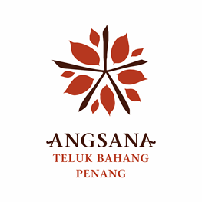 | Angsana Teluk Bahang, Penang, the first Angsana brand in Malaysia, is managed by Banyan Tree Hotels & Resorts. The vibrant resort located on the idyllic Teluk Bahang beach, is set to open in Q2 2020.  The resort offers 250 sea view rooms and suites with intimate designs of peranakan-theme décor complete with modern amenities.  Enjoy the resort’s 5 restaurants and bars, 4 meeting rooms, 2 swimming pools with a children’s pool, a kids’ club, a gallery and wellness centre with a spa and a gym. | - Lim Chin Ying  - chinying.lim@angsana.com  - 016-5557501 | Complimentary One Night Stay in Deluxe Room with breakfast for 2 persons
16 | JAZZ HOTEL PENANG  No.1, Jalan Seri Tanjung Pinang 1, 10470 Tanjung Tokong, Penang  www.jazzhotelpg.com  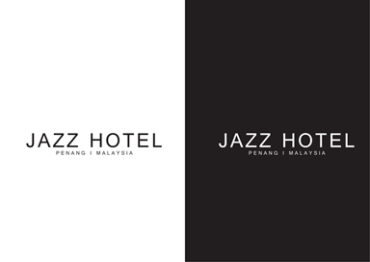 | Ideally located in Tanjung Tokong, Jazz Hotel Penang is a leisure stroll to Straits Quay and marina,  whilst family attractions, shopping, and dining at Gurney Drive’s famous street food are just minutes away.  Stay pampered, in one of the luxurious 255 rooms and suites in the 30 stories hotel;  optimized for the tech-savvy traveller with free secure high-speed internet connection and 24-hour security.  A perfect jump starts for the fitness-enthusiast, prioritize morning ‘me-time’ with gym and  a dip in the infinity pool against a backdrop sea view on the highest floor.  Where there is Jazz, there is Life. Jazz is Life! | - Low I Yin  - Angeline Chow  - dosm@jazzhotelpg.com  - angeline.chow@jazzhotelpg.com  - 012-428 8003 / 016-440 9725 | 2 Days 1 Night Room Stay Voucher
17 | PARKROYAL PENANG RESORT  Batu Ferringhi Beach 11100 Pulau Pinang  parkroyalhotels.com  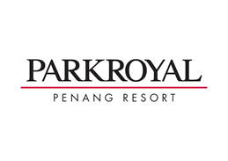 | The Habitat Penang Hill offers the most complete and educational Malaysian rainforest experience and is located less than 10km from the UNESCO World Heritage Site of George Town in Penang. Explore their 1.6km Nature Trail which is steeped in history as it was first built in the early 1800s by the British East India Company on the edge of a forest reserve protected since 1911. Take in the sights and sounds of the rainforest from Langur Way Canopy Walk 40m off the forest floor. Revel in the 360-degree views of Penang Island and the mainland from Curtis Crest Treetop Walk that allows you to see just how important Penang’s forests are to the health and well-being of urban Penang both as a source of water as well as a green lung. | - Ms Penny Chia  - Director of Sales  - penny.chia@parkroyalhotels.com  - 019 848 9229  - Ms Kathrin Kwek  - Senior Sales Manager  - 016 212 8307  - kathrin.kwek@parkroyalhotels.com | 1 voucher x 3D/2N stay in Premier Seaview Room inclusive of buffet breakfast for 2 persons
18 | PENANG WEDDING PROFESSIONALS ASSOCIATION (PWPA)  www.pwpa.org.my   | Penang Wedding Professional Association (PWPA) is a member-run association formed by a group of professionals from a multitude of wedding disciplines. With the aim of making a difference in the wedding industry in Penang and taking it across the globe, PWPA serves as a community-based networking hub to build a strong force for wedding professionals.  We strive to bring the world to Penang and make Penang a premiere wedding destination! | - Low Chin Siang, Ann Tan  - info@pwpa.org.my  - 0164101880 | n/a
19. | HOTEL PENAGA (METICBIZ SDN BHD)  No. 47, Jalan Dato Koyah, 10050 Georgetown Penang Malaysia  www.hotelpenaga.com   | Located in the heart of Georgetown, Penang, Malaysia, a UNESCO World Heritage Site converted from a cluster of 15 pre-war terraces and shop houses which spans along Hutton lane, Transfer Road & Clarke Street. | - Ms. Jessie Lau  - ssm@hotelpenaga.com  - 016 421 2056 | 2D1N Hutton Deluxe  inclusive of breakfast for 2 persons
20. | VOUK HOTEL SUITES PENANG  57-G-3, Mansion One, Jalan Sultan Ahmad Shah, Georgetown, Penang, 10050, Malaysia  http://www.voukhotelsuites.com.my/  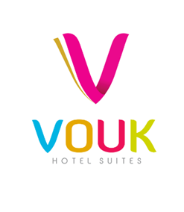 | "VOUK Hotel Suites can perfectly cater to the needs of both business and leisure travellers." | - BOO Kern Yih,  - se3@voukhotelsuites.com.my  - 012 565 7001 | 2D1N stay at Deluxe Room with breakfast for 2 person - voucher
21. | GHOST MUSEUM  193, Lebuh Victoria, 10030 Georgetown, Penang.  https://www.facebook.com/magicworldpg/   | Magic World, Malaysia first interactive museum of magic, will take you in to the secret World of Magic, a prominent attraction place. In the heart of Georgetown, near Victoria Street, where locals and tourist alike are drown to the historic building, great art and the cosmopolitan flair of the city, you'll find the entrance to the Magic World.  The Magic World will carry you into the secret world of magic; you will be enchanted by the tricks and illusion where their main purposed is to bewitches you and sends your imagination off on a journey through fun and thrill. Try out your own magical power by discovering your way through our Mirror Maze, lift up your partner by using your mind or might in our Flying Tower, buried yourself in our Well of Fortune without moving a single coin and amazed crowd with the oldest trick in the magic world body separation or so we call it Body Ripper!! | - Hazlami Rosli  - themereno.hazlami@gmail.com  - 0125656327 | 10 pcs of Penang Best Attractions Tickets
22.
23. | THE PRESTIGE HOTEL PENANG  8, Gat Lebuh Gereja, George Town, 10300 George Town, Pulau Pinang  http://theprestige.my/  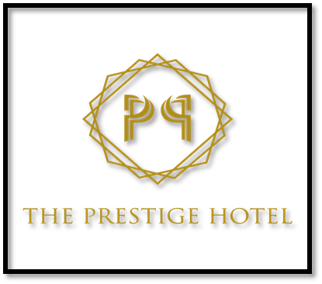 | The Prestige Hotel is a luxury homegrown hospitality label located in the heart of the Georgetown UNESCO world heritage site. Inspired by its colonial Victorian heritage, it welcomes the urbane traveller to a magical contemporized colonial scene, with 162 rooms, an all-day dining outlet, an arcade with a mix of retail outlets, event spaces and a rooftop infinity pool.  25 minutes away from Penang International Airport, within walking distance to Penang’s cultural hotspots and popular gourmet finds, together with Prestige’ bespoke hospitality, The Prestige Hotel brings local inspiration to life for intrepid world travellers seeking to experience local charm at its best. It is the perfect designer living space for the busy business executive and the contemporary world traveller of today. | - Feon Lee (Director of Sales)  - feon@theprestige.my  - 6012 4937068 | 2D1N at Deluxe Room with breakfast for 2 person - voucher
24. | HOTEL NEO+ PENANG BY ASTON  68 Jalan Gurdwara Pulau Pinang  penang.neohotels.com  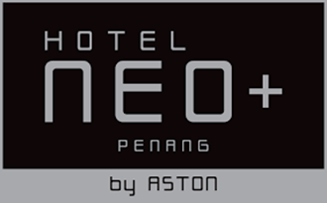 | Located in the heart of Penang, Hotel NEO+ Penang offers modern and stylish accommodation. Free WiFi access throughout the property, outdoor pool, 24-hour front desk and a multi-level carpark. Fitted with parquet flooring, the 196 air-conditioned rooms come with a desk, clothes rack, a personal safe, flat-screen TV and tea/coffee making facilities.  Convenience and comfort. The hotel is within walking distance to the 7th Street Market (Chit Tiau Lor Ban) and New Lane Hawker Centre,400m from shopping complex Komtar, Prangin Mall and First Avenue, while Penang International Airport is approximately 14 km away. | - Noor Azaini Binti Md Isa  - langkawism@safehotels.com  - 0194433693 | TBA
 | Lucky draw from Event company |  |  | 2 ipad  - 1 Huawei mobile

