Change of signatories

- CIMB Bank Berhad (Current Account)
Current authorised signatories :-
Group A Group B
Mr Ooi Chok Yan YB Yeoh Soon Hin
Dato Rosli bin Jaafar (Resigned on 1 March 2019)

Conditions of Signatures:
- For amount below RM100,000
To be signed JOINTLY by the signatory of Group A and any one of the signatories of Group B

- For amont of RM100,000 and above
To be signed JOINTLY by both signatories of Group B

- RHB Asset Management S/B (RHB Investment Account)

Current authorised signatories :-
YB Yeoh Soon Hin - Director
Dato’ Rosli bin Jaafar - Director
Mr Ooi Chok Yan - CEO

Authority Limits :
Mode of Transfer for RHB Investment Account | Limit | Authority Level
BUY, SELL, SWITCH & TRANSFER | Any amount above RM50,000 but not exceeding RM100,000 | JOINTLY by the CEO and ANY one Director
BUY, SELL, SWITCH & TRANSFER | Any amount above RM100,000 | JOINTLY by the CEO and ANY both Directors
Opening / Closing of Account | N/A | JOINTLY by the CEO and ANY both Directors
- Audited Financial Statement (Page 7 & page 33)

Page 7
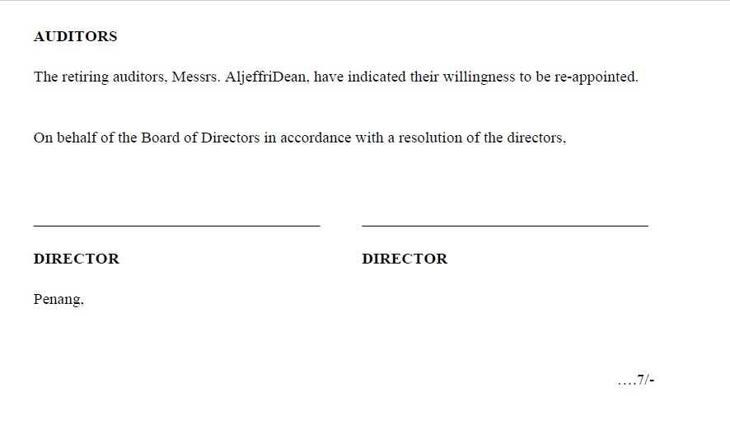
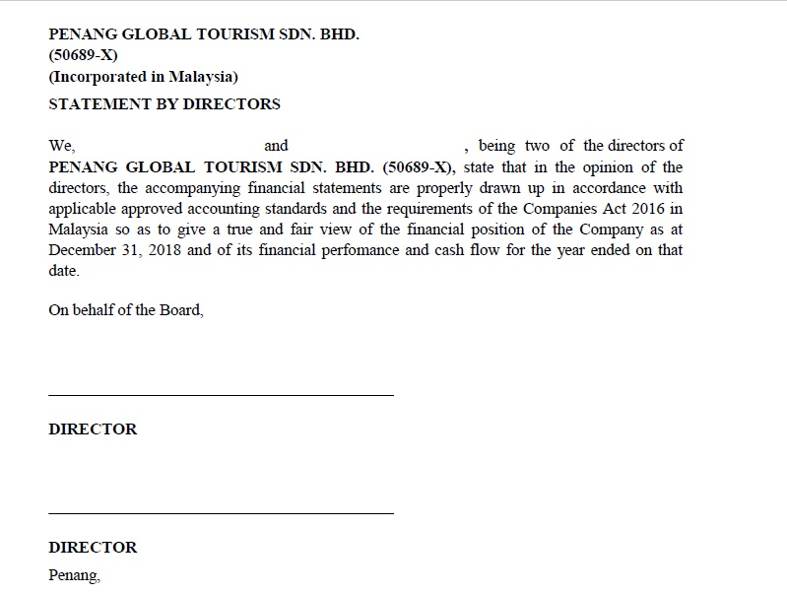
Page 33

- Letter of Representative
(Refer to attachment)

