Proposals for Additional RM1.5 Million

Communications Budget for 2014

The budget for Communications this year is RM1,900,050. The breakdown of this budget is allocated as follows.

No | Itemised budget allocation: | RM
1 | New Brochure | 40,000
2 | Print Advertising | 50,000
3 | TV Advertising | 660,000
4 | Outdoor Advertising | 224,550
5 | Radio Advertising (ASTRO) | 200,000
6 | Google AdSense (Indonesia, HK, Philippines & Singapore) | 200,000
7 | Singapore Media Campaign | 180,000
8 | Taiwan Media Campaign | 30,000
9 | Website | 68,000
10 | New Video | 62,500
11 | Photography & Video Archiving | 30,000
12 | Adhoc Copywriting | 20,000
13 | A&P of Events | 115,000
14 | Provisional | 20,000
Total |  | 1,900,050

Pie chart of the 2014 Communications budget:

Additional Budget for 2014 – Proposed Allocation for Specific Markets

An additional RM1.5 million has been granted to Penang Global Tourism for advertising and promotions by CM during the last BOD meeting held on 10 February 2014. As shown earlier the current budget for Communications covers very little of certain market segments and does not have any allocated at all for markets which we need to focus on, such as Hong Kong, Australia Indonesia, Thailand, Taiwan and even Europe. As such, with this additional RM1.5 million, we wish to propose advertising and media campaigns to reach out to these markets. We are also including in this submission, outdoor advertising at the North-South Expressway as we have not had the opportunity to make Penang visible enough locally due to budget constraints.

The following is an approximate breakdown of the RM1.5 million in these said markets.

No. | Projects | Budget (RM)
1 | Hong Kong Media Campaign | 550,000
2 | TripAdvisor (Australia, Indonesia, Thailand and Taiwan) | 100,000
3 | KLM In-Flight Magazine – Europe | 200,000
4 | Additional budget to extend SMRT – Orchard Station x 8 pillars | 150,000
5 | KLIA Billboard | 300,000
6 | North South Expressway Billboards | 200,000
Total |  | 1,500,000

Visit Penang 2015
We are also planning to incorporate the Visit Penang 2015 promotion in the mediums of the proposed advertising as stated above. The mediums we are looking at are KLM’s in-flight magazine, the KLIA billboard (that allows for a visual change at minimal cost), the North-South Expressway as well as TripAdvisor that drives traffic to the ‘my Penang’ website.

Pie chart of the budget allocation for RM1.5 million:

Hong Kong Media Campaign
We also received a clear directive from CM that we should undertake a media campaign in Hong Kong. We have gone through several proposals for outdoor advertising in Hong Kong and would like to propose a couple of options as follows:

- 12 x buses (Emperor Plus format) for 3 months
- 3 x trams (fully wrapped) for 3 months
- Combination of 8 x buses and 3 x trams for 3 months
As per Hong Kong’s local survey, bus-body ads are most widely seen compared to ads on bus shelters, MTR and taxis. The buses we are intending to wrap are with KMB, one of Hong Kong’s biggest share of bus fleet network. KMB penetrates everywhere in Hong Kong particularly Kowloon and the New Territories.

The Emperor Plus format as follows:
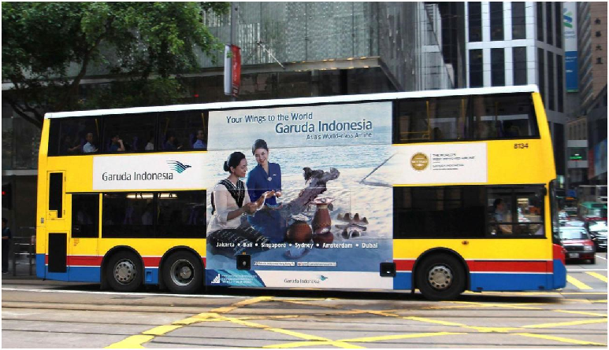

Picture of a wholly wrapped tram:
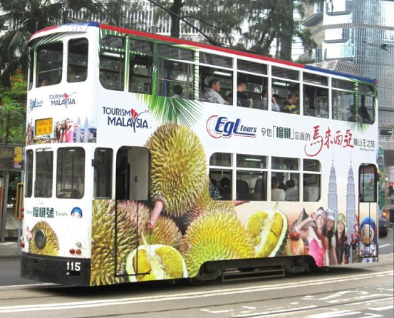

The following are the 3 options to consider with its respective costing. Option 1 and 2 are within a budget of RM350,000 however, Option 3 requires about RM550,000 budget. The third option requires a bigger budget as it is a combination of using 2 mediums, i.e. buses and trams. Basically advertising on trams alone will only focus within the island whereas the buses will reach the Cross Harbour Area. Hence, we strongly recommend Option 3 as it covers both areas.

OPTION 1: Use of 12 buses (1-sided emperor plus format) for 12 weeks (3 months)
- Per panel @ HK$20,240 per month x 12 buses for 3 months: HK$728,640 (RM306,028)
- Production cost @ HK$7,000 x 12 buses: HK$84,000 (RM35,280)
Total amount: HK$812,640 (RM341,308)
OPTION 2: Use of 3 trams (wholly wrapped) for 12 weeks (3 months)
- 3 trams @ HK$19,800 per week x 12 weeks: HK$712,800 (RM299,376)
- Production cost @ HK$20,400 x 3 trams: HK$61,200 (RM25,704)
Total amount: HK$774,000 (RM325,080)
OPTION 3: Use of 8 buses (1-sided emperor plus format) and 3 trams (wholly wrapped) for 12 weeks (3 months)
- Per panel @ HK$20,240 per month x 8 buses for 3 months: HK$485,760 (RM204,000)
- Production cost @ HK$7,000 x 8 buses: HK$56,000 (RM35,280)
Sub amount: HK$541,760 (RM227,539)
+
- 3 trams @ HK$19,800 per week x 12 weeks: HK$712,800 (RM299,376)
- Production cost @ HK$20,400 x 3 trams: HK$61,200 (RM25,704)
Sub amount: HK$774,000 (RM325,080)
Total amount: HK$1,315,760 (RM552,619)

If Option 3 is approved, we propose that RM200,000 is taken from the budget of North South Expressway Billboards. We have actually included in this report, two options for advertising in the North South Expressway, i.e. for RM400,000 and RM200,000.

Online advertising – TripAdvisor
In terms of online advertising aside from our already planned Google AdSense campaign (for Indonesia, HK, Philippines & Singapore markets) which is targeted to drive traffic to our ‘my Penang’ website, we also wish to propose digital advertising in TripAdvisor targeting markets in Australia, Indonesia, Thailand and Taiwan.

Details of the digital advertising as follows:
- Cost USD30,000 (RM96,000)
- 1 million targeted impressions (1 month)
- 10% bonus impressions added to the budget at no charge
- Penang tourism page sponsorship on TripAdvisor site of Australia, Indonesia, Thailand and Taiwan for 12 months
- Contextual targeting - arts & culture, i.e. users who are viewing these types of attractions and destinations
- Destination targeting, i.e., users who are viewing these destination pages, for example, Australian looking at Thailand

TripAdvisor is the world’s largest travel site. It has 260 million unique visitors a month, 37 domains in 21 languages and features over 139,000 destinations with 150 million reviews and opinions. It also has the most downloaded travel app in the world – 82 million downloads to date.
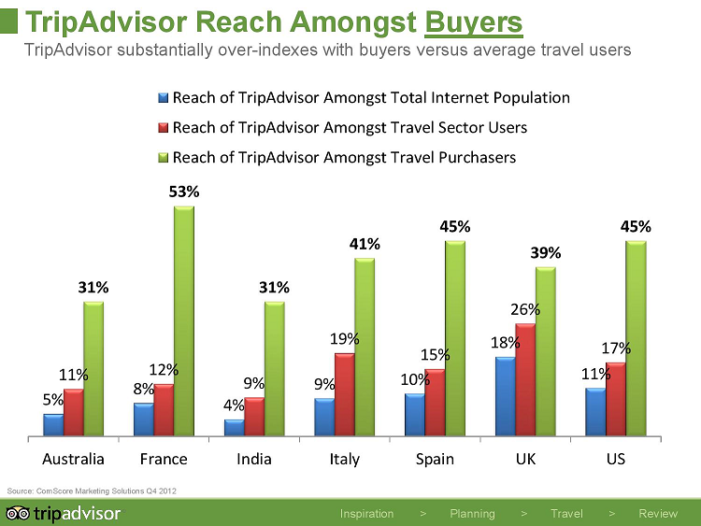

According to TripAdvisor’s Global Research Panel (May 2012), 76% of respondents use TripAdvisor to research multiple destinations per trip planning cycle, 75% have a general region determined and are using TripAdvisor to compare destinations and 40% say they recall booking a different destination than the one they originally started researching on.

Here are some additional facts to look at about TripAdvisor:
- In 2013, more than 24 million pages of Penang content by over 3 million individuals were viewed by prospective travellers on TripAdvisor worldwide
- An estimated 1 in every 16 people online in the world visited TripAdvisor in Aug 2013
- In 2013, 40% of all online travel purchases were influenced by TripAdvisor
- TripAdvisor users are 3 times more engaged when driven to a destination’s website compared to users from Facebook, Twitter and Pinterest

Print advertising – KLM’s Inflight Magazine, Holland Herald
In order to sustain our presence in the European market, for this year, we can start off by placing print ads in KLM’s inflight magazine, called Holland Herald. The magazine reaches to over 25 million frequent travellers every year. Every month, 2.1 million travellers fly KLM. KLM is one of Europe’s largest carriers with 720 flights a month.

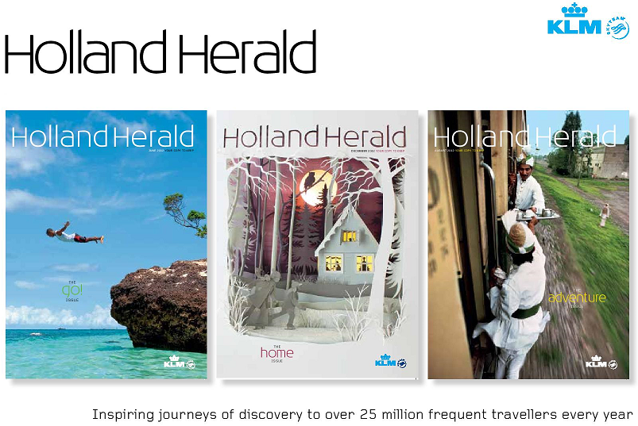

Further details about the magazine as follows:
- Monthly publication
- 2.1 million passengers a month; 25 million a year
- 155,000 printed copies
- Distribution on board of all KLM flights, KLM lounges at Amsterdam Airport

Holland Herald is also the biggest English-language magazine published in the Netherlands and it is also the oldest inflight magazine in the world since its launch in 1966. According to Holland Herald’s reader survey, 72% of passengers travelled to a featured destination after reading Holland Herald.

The rate we have been offered is EUR43,158 (RM194,211) for 3 insertions (full page). The published rate for a full page is EUR17,815 per insertion. We have been given a 15% discount.

Singapore – SMRT
In our initial budget we have included a Singapore Media Campaign to be undertaken at the SMRT’s Orchard station and it is for a 6-week campaign that costs RM168,000. We would like to however extend the campaign to another 6 weeks as it would be more effective and worthwhile as production cost is SGD12,000 regardless of duration.

SMRT’s passenger trips total up to 2.6 million daily. And with 2.6 million passenger rides daily, SMRT offers one of the largest outdoor advertising presence. It has 128 main line trains, 40 circle line trains and 101 stations. Its top most station, i.e., with highest traffic, is the Orchard station.

The following is the cost to advertise on the 8 pillars at the station’s concourse open area.
- 6-week campaign: SGD55,200, i.e. SGD9,200 a week
- Production cost: SGD12,000 for 8 pillars
Amount: SGD67,200 (RM168,000)

Therefore the additional budget to extend the campaign for another 6 weeks is as follows:
- +6 weeks: SGD55,200
- Production cost: -none-
Amount: SGD55,200 (RM138,000)
**Total amount for 12 weeks: SGD122,400 (RM306,000)
**Note, the initial Communications’ budget already has an allocation of RM180,00
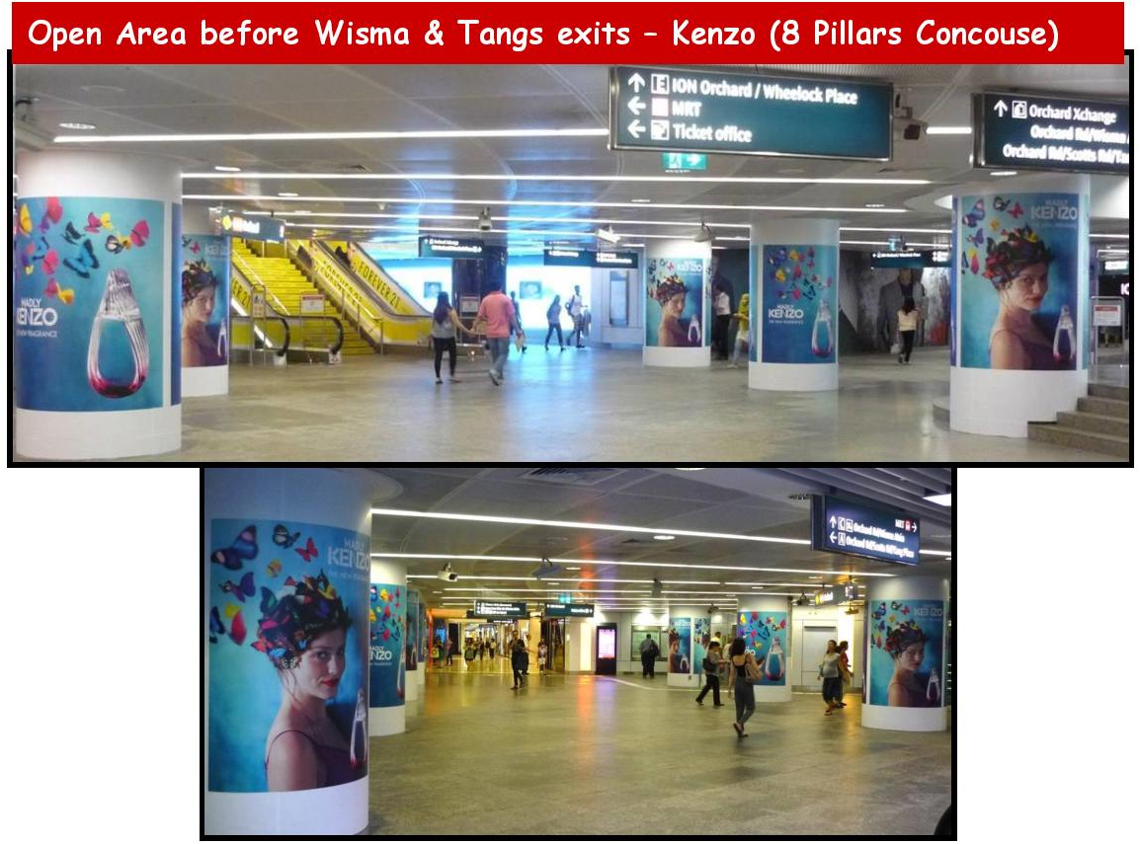

KLIA Billboard
Under CM’s directive, we actually already placed a wall mounted lightbox billboard at KLIA located on a beam / bulkhead of an escalator from Level 5 to Level 3 in the domestic departure. The cost of this billboard ad is RM318,800. The billboard measures 10’ (H) x 28’ (W) and will be up for a whole year till 31 March 2015. It was installed on 1 April 2014. This was not planned or included in the initial budget for Communications. Hence, this cost now comes under the additional RM1.5 million.

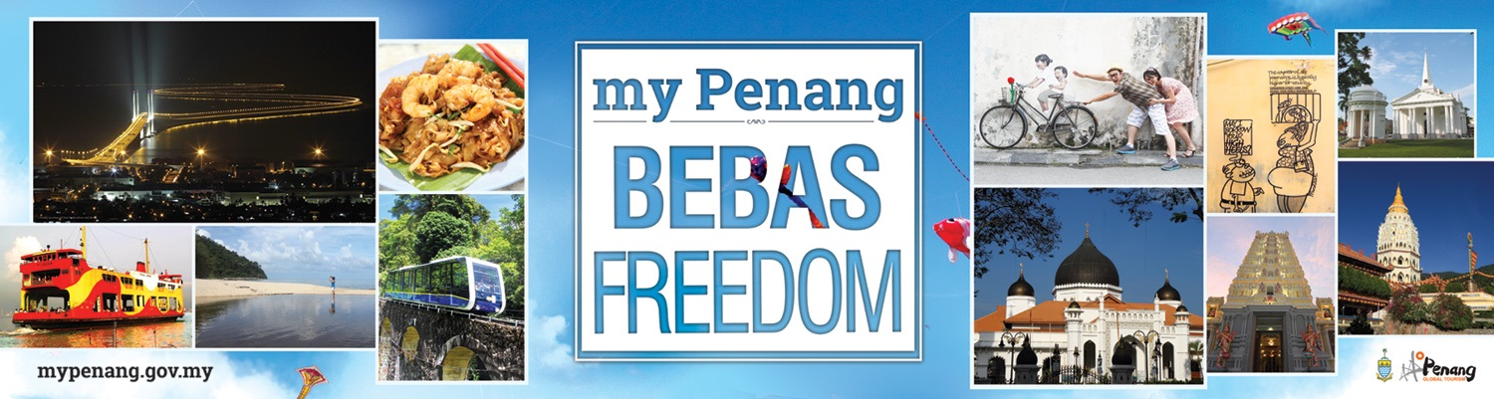
Visual of the billboard at KLIA:

North-South Expressway Billboards
Besides the billboard ads placed in the airports, we would like to propose some billboards ads at the North-South Expressway, north and south bound traffic between KL, Melaka and Singapore for 12 months. These billboards are targeted to capture the interests of drivers heading south to Melaka and Singapore and vice versa.

The following are two options of selected billboard spaces along the North-South Expressway. The two options will enable us to pick accordingly after the choice has been made on advertising at the SMRT Orchard station as advertising at the SMRT is priority.

Option 1:
No. | Location | Billboard Size | Cost (RM)
1 | KL → Melaka:  Bangi - Kajang | 10’ (H) x 40’ (W) | 33,680
2 | KL → Melaka:  Jasin - Tangkak | 10’ (H) x 40’ (W) | 33,680
3 | KL → Ipoh:  Bidor - Tapah | 20’ (H) x 60’ (W) | 99,768
6 | Melaka → Singapore:  Yong Peng - Ayer Hitam | 30’ (H) x 20’ (W) – 2 sides | 94,680
7 | Singapore → Melaka:  Simpang Renggam interchange | 20’ (H) x 60’ (W) | 99,768
8 | Singapore → Melaka:  Senai Utara interchange | 10’ (H) x 40’ (W) | 35,800
Total |  |  | 397,376

Option 2:
No. | Location | Billboard Size | Cost (RM)
1 | KL → Melaka:  Bangi - Kajang | 10’ (H) x 40’ (W) | 33,680
2 | KL → Ipoh:  Tanjong Malim - Slim River | 20’ (H) x 60’ (W) | 35,800
3 | Melaka → Singapore:  Yong Peng - Ayer Hitam | 30’ (H) x 20’ (W) – 2 sides | 94,680
4 | Singapore → Melaka:  Senai Utara interchange | 10’ (H) x 40’ (W) | 35,800
Total |  |  | 199,960

