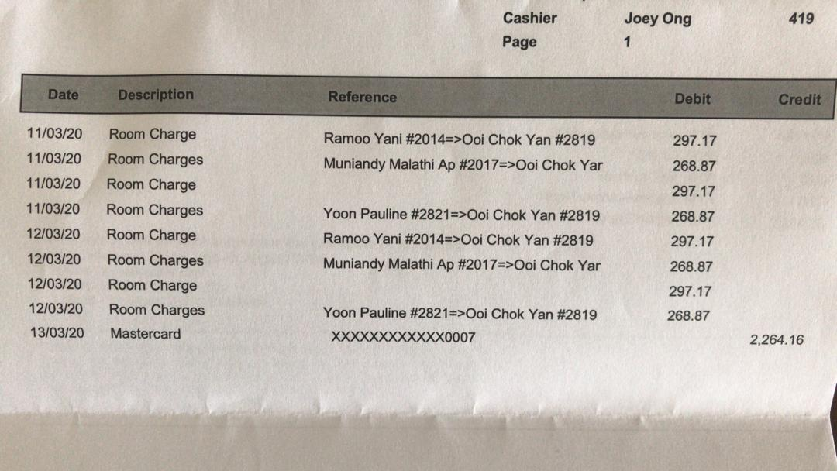
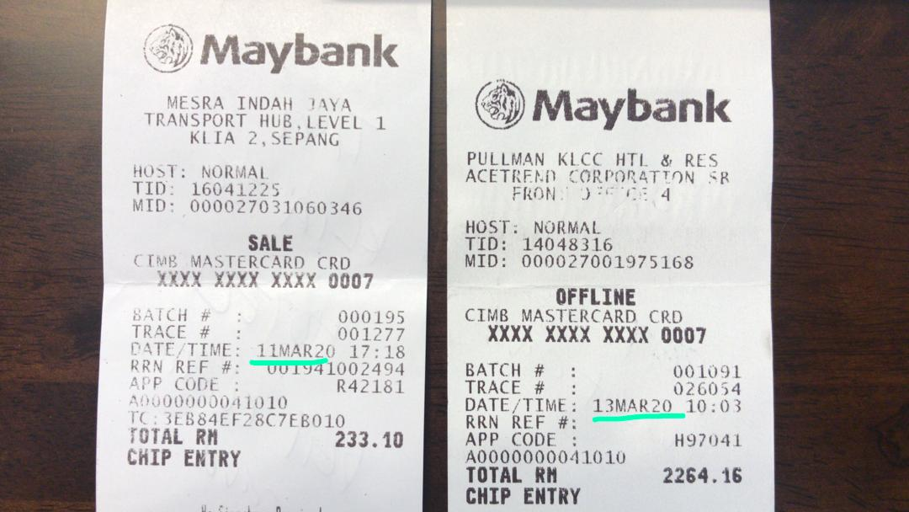
KL Roadshow – Transportation & Hotel Accommodation (OCY, YP, Yani & Malathi)

