Experience Penang Roadshow in Kuala Lumpur

Main Delegation : Penang Global Tourism
Date : 12 March 2020
Venue : Pullman Kuala Lumpur City Centre
Penang delegation : Iconic Hotel Penang, Clans Kongsi Georgetown, Travelodge Georgetown, Vangohh Eminent Hotel & Spa, Grand Orient Hotel, Evergreen Laurel Hotel, Design Village, Hotel Equatorial Penang, Tropical Spice Garden, Royale Chulan Penang, The Top Penang, The Habitat Penang Hill, The Gravityz, Angsana Teluk Bahang, Jazz Hotel Penang, PARKROYAL Penang Resort, Flamingo Hotel By The Beach, Penang Wedding Professionals Association, Hotel Penaga, Vouk Hotel Suites, Ghost Museum, Sunway Hotel Georgetown, The Prestige Hotel and Hotel NEO+ Penang.

Period/Months: | 12 March 2020
Budget: | RM180,000
Actual : | RM137,878.21

- Experience Penang 2020 roadshow in Kuala Lumpur was led by Mr Ooi Chok Yan, CEO of Penang Global Tourism. A total of 24 participants from Penang hotels, attractions and association has joined the roadshow.
- The roadshow were attended by 160 travel agents, online travel agents, airlines and bloggers. PGT also invited Tourism Malaysia and the major tourism associations such as Malaysian Association Of Tour And Travel Agents, Malaysia Chinese Tourism Association, Malaysia Inbound Chinese Association and Kuala Lumpur Tour Guide Association to join the event.
- During the roadshow, there were Penang destination presentation that showcasing participants on some of Penang Island and Seberang Perai's undiscovered and hidden holiday gems, showing there’s much more to Penang than just its well-known icons. Besides that, there were also launching of Experience Penang 2020, business networking session and dinner with lucky draw session.
- PGT also collaborated with Penang Wedding Professional Association on a photography contest that open to its members and run on social media. A total of 20 finalists with the highest votes displayed their work at the KL roadshow. The contest was undertaken from 25th Feb to 5th March.
- The roadshow aim to further strengthen Penang’s appeal as a preferred travel destination among the tourism players in Kuala Lumpur and Selangor. It was also good opportunity for the tourism players to meet and network with Penang hotels and attractions.
- 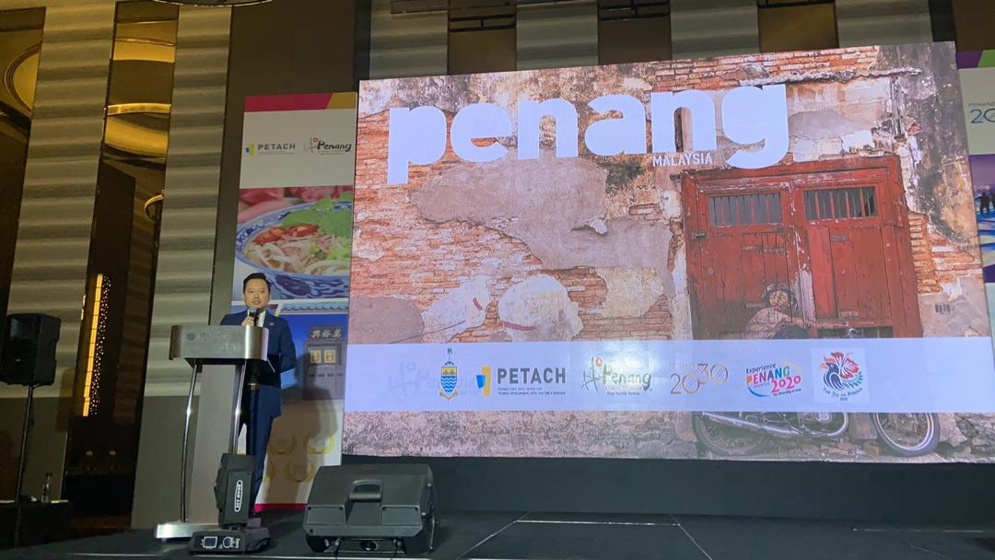
< Destination Presentation by Mr Ooi Chok Yan>
- 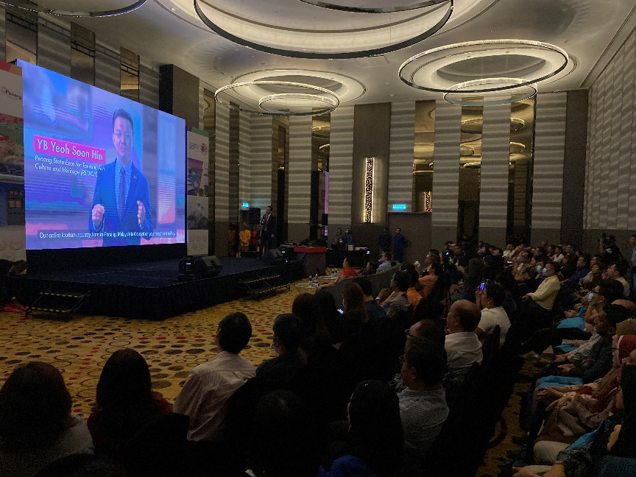
<Penang’s safety measure video>
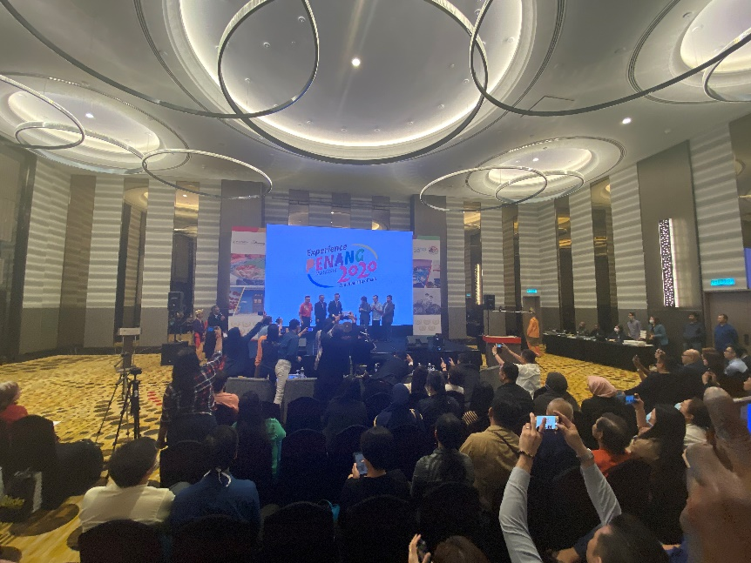
<Launching of Experience Penang 2020>
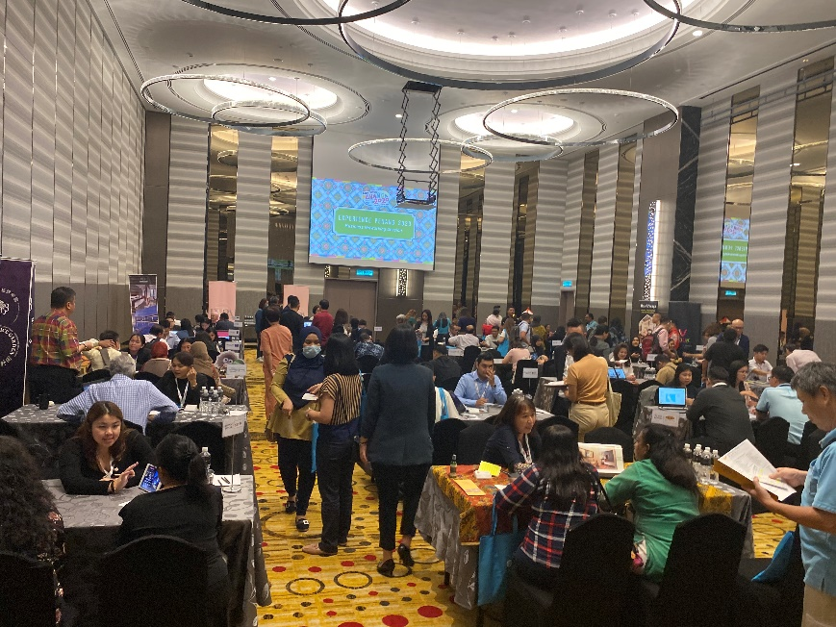
<B2B Session>
- 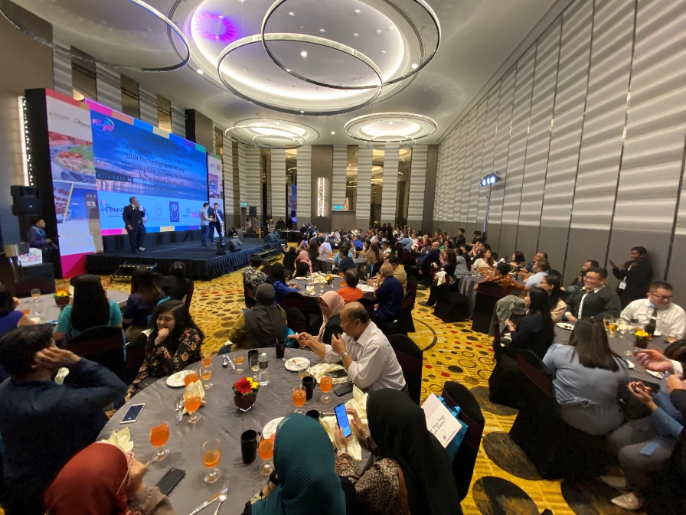
<Dinner>
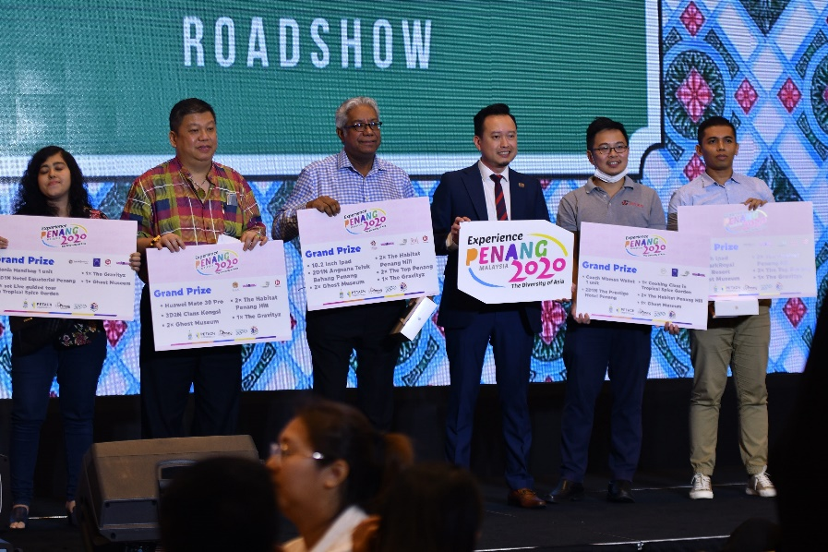
<Lucky Draw Winners>
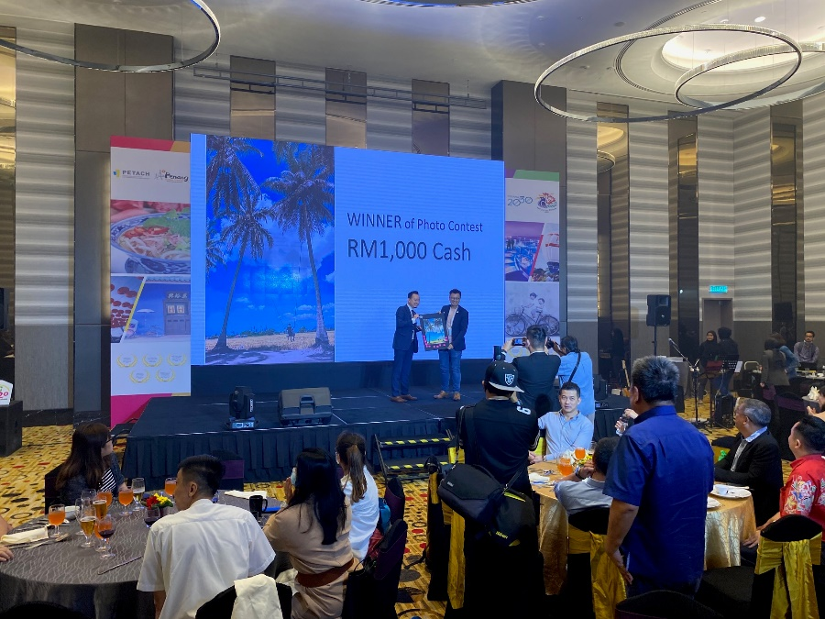
<PWPA Photography Contest Winner>

