Inflight Magazine – Gateway
PGT initially signed up for 12 issues in Gateway, the inflight magazine of China Southern Airlines, However, due to the Covid-19 pandemic, PGT revised the number of insertions to only 3 advertorials. So far, the published ads were in the issues of January 2020 and August 2020. The final one will be in December 2020.
Period/Months: | January, August and December 2020
Budget: | RM364,485.00
Actual: | RM 378,095.97

January 2020 issue – published ad on Experience Penang:
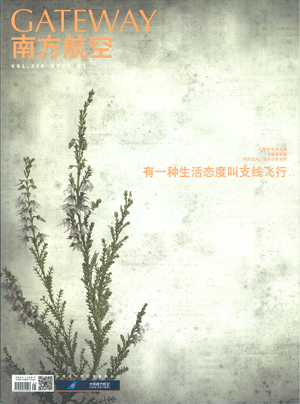
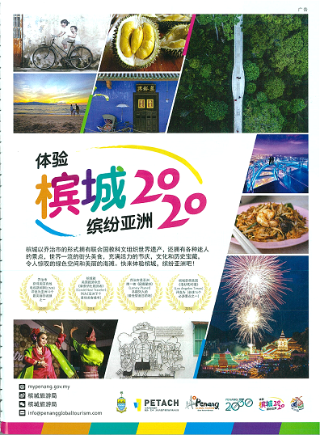

August 2020 issue – published ad on Responsible Tourism:
