Concept Wall & Travellator Panel in Singapore’s Dhoby Ghaut MRT Station
On 16th December 2019, PGT kick-started the advertising of EPY2020 in Singapore’s Dhoby Ghaut MRT Station on the travellator wallscape + glass panel for 8 weeks. The ad space entails the Concept Wall + Travellator Panel. The Concept Wall includes 4x Lightboxes where the length of the travellator is 54.4m and the concept wall is 45m. Dhoby Ghaut has the highest footfall, being a highly used transit station by commuters in Singapore where its footfall/traffic is approximately 11.5mil every month. The advertising not only reaches the local Singaporeans but also foreign expats and tourists who commute via the MRT.
Period/Months: | 16 December 2019 – 9 February 2020
Budget: | RM560,000.00
Actual : | RM 564,234.63

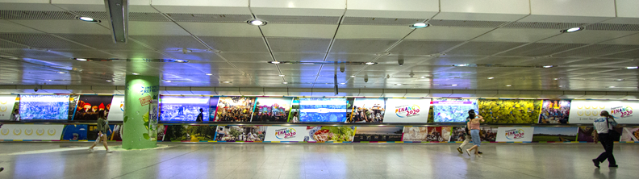
Photos of the completed travellator ad:

