OOH Advertising in Taiwan (10x Buses, Escalator Wall and Lightbox ad in Ximen MRT Station)
PGT also undertook another international advertising campaign that commenced in December 2019 – June 2020 which involved wrapping of 10 buses in Taipei for 7 months. Subsequently, for 3 months, from January 2020 – March 2020, EPY was also featured on the escalator wall of Taipei’s Ximen MRT Station. Ximen MRT station has the highest footfall, being a highly used transit station by commuters where its footfall/traffic is approximately 4.8 million people every month.

Note: The last ad that was included in this campaign, i.e. Lightbox ad in Ximen MRT station, was initially planned in April 2020 – June 2020. However, due to Covid-19 pandemic, PGT has postponed it to December 2020.

Period/Months: | -December 2019 – June 2019: 10x Buses  -January 2020 – March 2020: Escalator Wall  -December 2020 – February 2020: Lightbox
Budget: | RM450,000.00
Actual : | RM477,743.00

Photo of “U” Shaped Escalator Wall Ad at Ximen MRT Station:
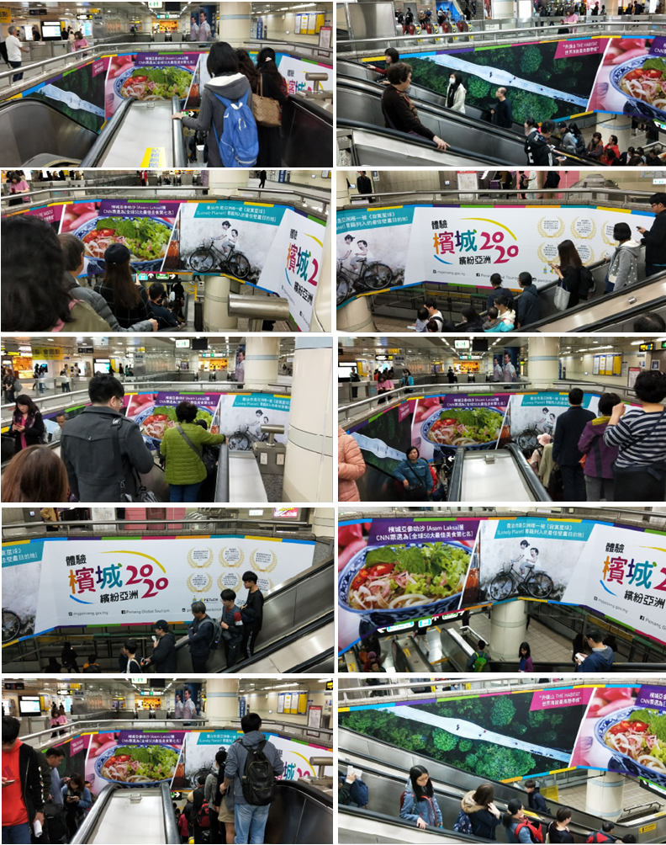

Photos of the two-sided wrapped buses with extended window stickers:
