Projects under COMMS – Tourism Tax

- Inflight Magazine – Gateway
PGT initially signed up for 12 issues in Gateway, the inflight magazine of China Southern Airlines, However, due to the Covid-19 pandemic, PGT revised the number of insertions to only 3 advertorials. So far, the published ads were in the issues of January 2020 and August 2020. The final one will be in December 2020.
Period/Months: | January, August and December 2020
Budget: | RM364,485

January 2020 issue – published ad on Experience Penang:



August 2020 issue – published ad on Responsible Tourism:

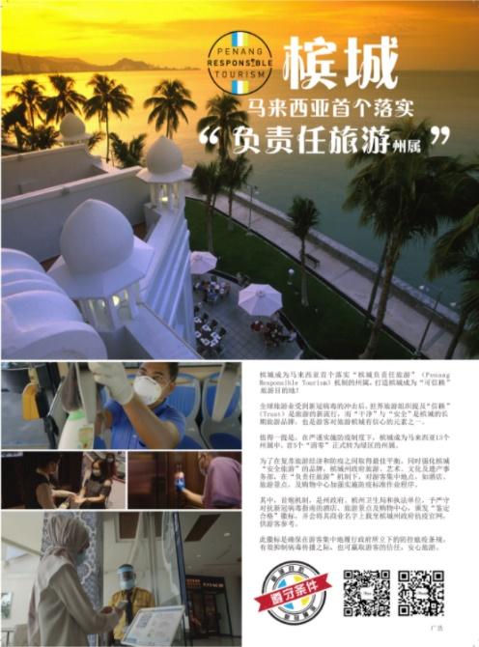

- Concept Wall & Travellator Panel in Singapore’s Dhoby Ghaut MRT Station
On 16th December 2019, PGT kick-started the advertising of EPY2020 in Singapore’s Dhoby Ghaut MRT Station on the travellator wallscape + glass panel for 8 weeks. The ad space entails the Concept Wall + Travellator Panel. The Concept Wall includes 4x Lightboxes where the length of the travellator is 54.4m and the concept wall is 45m. Dhoby Ghaut has the highest footfall, being a highly used transit station by commuters in Singapore where its footfall/traffic is approximately 11.5mil every month. The advertising not only reaches the local Singaporeans but also foreign expats and tourists who commute via the MRT.
Period/Months: | 16 December 2019 – 9 February 2020
Budget: | RM560,000

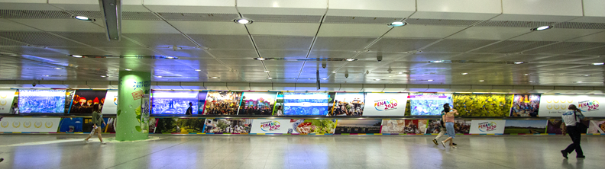
Photos of the completed travellator ad:

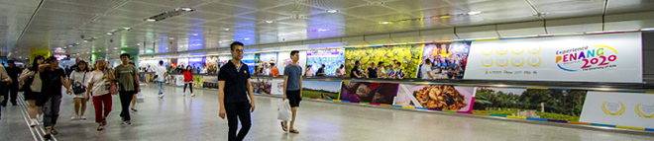

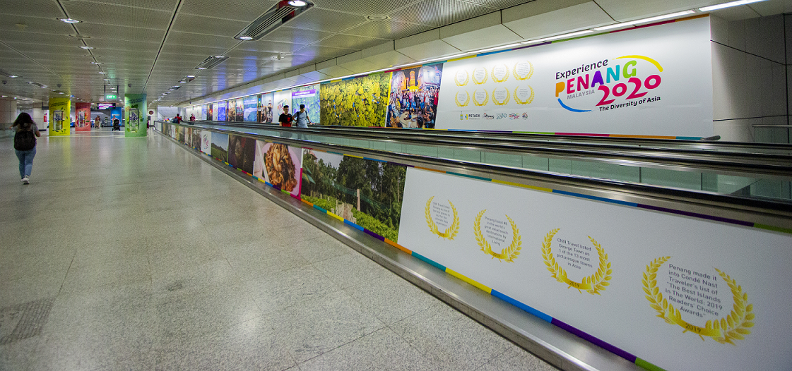

- OOH Advertising in Taiwan (10x Buses, Escalator Wall and Lightbox ad in Ximen MRT Station)
PGT also undertook another international advertising campaign that commenced in December 2019 – June 2020 which involved wrapping of 10 buses in Taipei for 7 months. Subsequently, for 3 months, from January 2020 – March 2020, EPY was also featured on the escalator wall of Taipei’s Ximen MRT Station. Ximen MRT station has the highest footfall, being a highly used transit station by commuters where its footfall/traffic is approximately 4.8 million people every month.

Note: The last ad that was included in this campaign, i.e. Lightbox ad in Ximen MRT station, was initially planned in April 2020 – June 2020. However, due to Covid-19 pandemic, PGT has postponed it to December 2020.

Period/Months: | -December 2019 – June 2019: 10x Buses  -January 2020 – March 2020: Escalator Wall  -December 2020 – February 2020: Lightbox
Budget: | RM450,000

Photo of “U” Shaped Escalator Wall Ad at Ximen MRT Station:
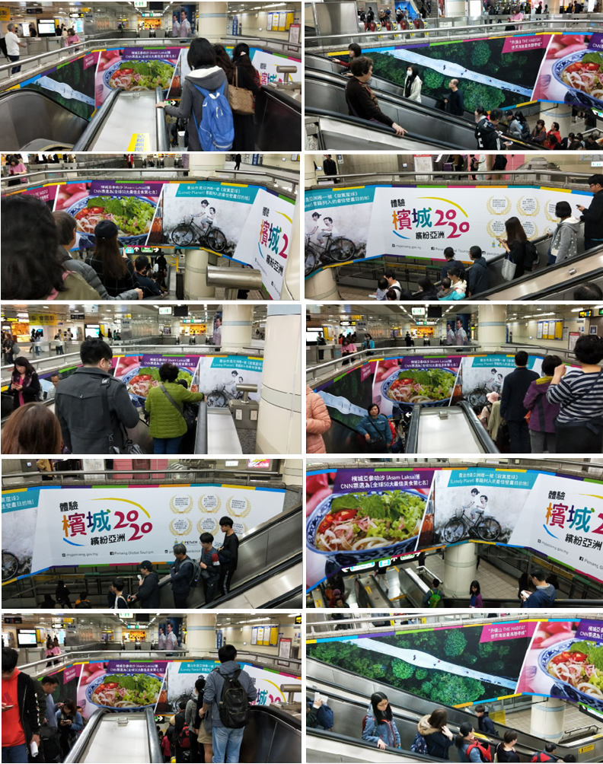

Photos of the two-sided wrapped buses with extended window stickers:
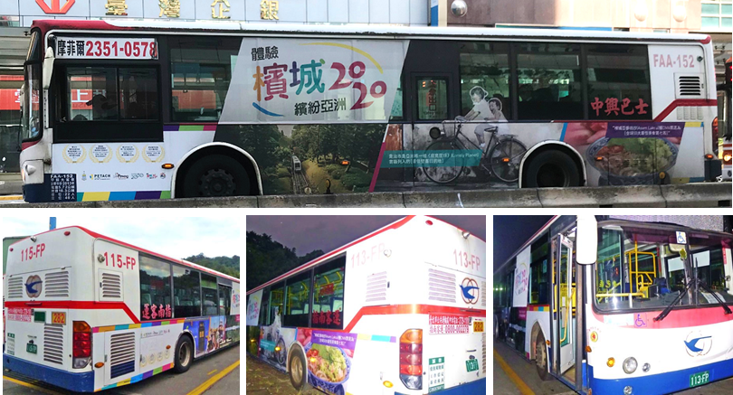

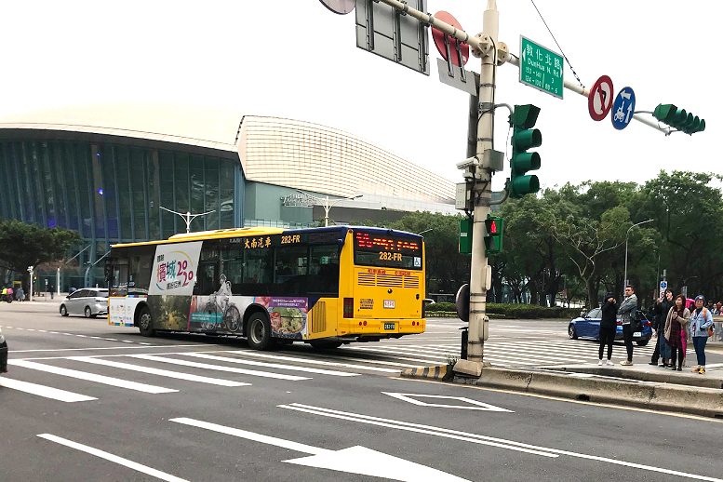

- Domestic Advertising in Kuala Lumpur (Covered Walkways)
The OOH advertising on Covered Walkways were completed end of Feb 2020. The ads will be up for 12 months, located in KL’s city centre at Jalan Sultan Ismail and Jalan Raja Chulan fronting Wisma Genting and Wisma Cosway respectively. The vehicle traffic at both these locations are approximately 3.6 mil and 2.5mil respectively on a monthly basis. An unveiling will be undertaken on 12 March, on the same day as our KL roadshow. Included in the ads were street art where people can take photos with and upcoming events which will be changed every quarter.

Note: The media owner of the Covered Walkways, has extended the campaign period till 30 April 2021 and offer us a 1-month complimentary ad/poster due to the Covid-19 pandemic as compensation.

Period/Months: | February 2020 – January 2021  Complimentary extension till 30 April 2020
Budget: | RM270,000

Photos of some of the completed Covered Walkway ads:
