3.2.5 Website Google Analytics (1 August 2018 – 28 February 2019 and 1 August – 29 February 2020)

Website traffic
The Google Analytics Report shows a spike on 21 October 2019 of 2,244 users in comparison to 21 October 2018 with 597 users. Besides that, there was also a spike on 31 December 2019 with 3,121 users in comparison to the previous year of 1,022 users and a spike on 8 February 2020 with 2,544 users to the site.
The significant increase of users to the website for October and December 2019 could be brought by visitors searching for information on Penang Hot Air Balloon Fiesta, Penang Stories and upcoming events for final quarter of 2019. The spike for February 2020 could be brought by a few festivals such as Thaipusam and Chap Goh Meh which took place the during the same period of time. Besides that, the spike could also be brought by adverts that ran on PGT’s Facebook page on Penang Hot Air Balloon Fiesta, Festivals and Chinese New Year Celebration events.
According to the analytics report, majority of users to our mypenang.gov.my website was acquired organically via Google. There were also users who were linked to our website through Facebook posts, some organically and some through adverts. There were quite a number of visitors that were linked to our website mypenang.gov.my through Penang Sentral’s official website, www.penangsentral.com.my, City Council of Seberang Perai official website, mpsp.gov.my, PGT Facebook Page and the culturetrip.com
Comparison between 1 August 2018 – 28 February 2019 and 1 August 2019 – 29 February 2020
The comparison report shows an increase of 23.27% in new users to the website. There’s also an increase in page views, sessions and bounce rate.

Top 5 countries visiting the site and most viewed pages
The top 5 countries visiting the site are the United States, United Kingdom, Singapore, Indonesia and Australia. Their most-viewed pages are mainly on eCoupon, Culture & Heritage, Events and Food & Lifestyle.
The following pages show the relevant charts and tables summarizing the Google analytics report as highlighted above.
Period: 1 August 2018 – 28 February 2019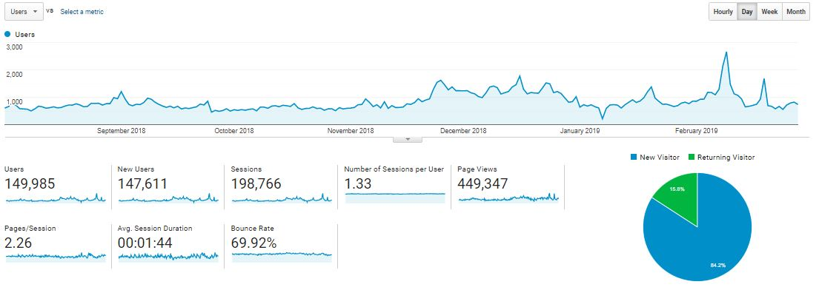
Period: 1 August 2019 – 29 February 2020
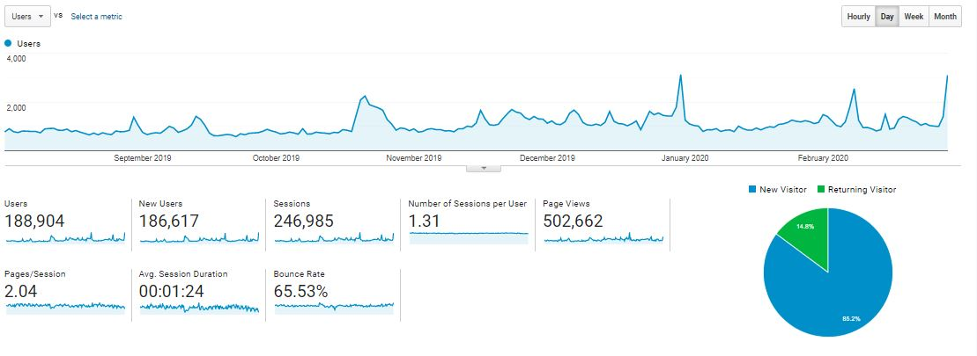

Comparison Period: 1 August 2018 – 28 February 2019 and 1 August 2019 – 29 February 2020
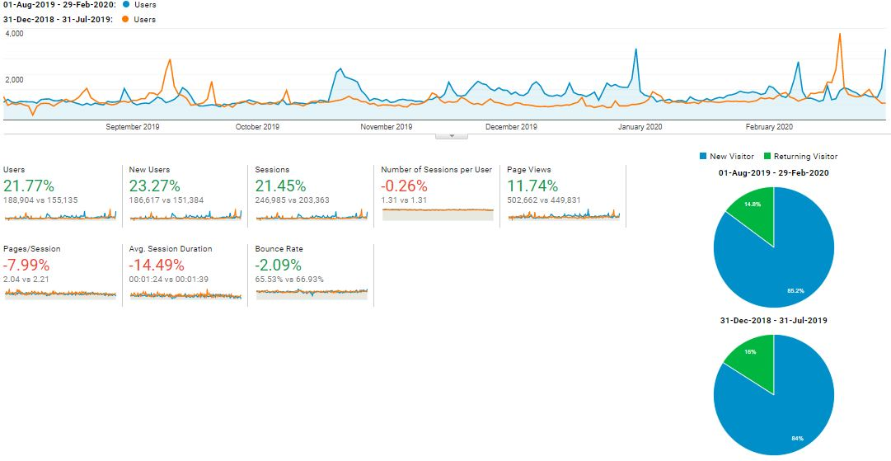

Top 10 user’s location and sources: 1 August 2018 – 28 February 2019
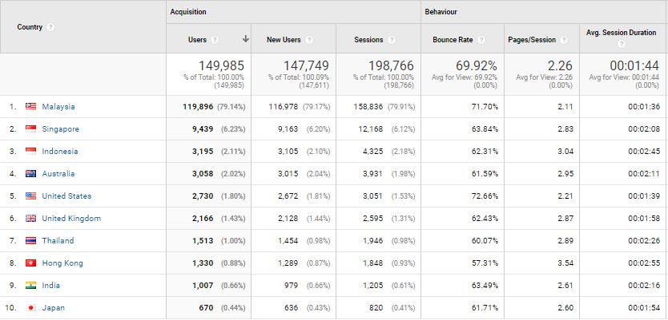

Top 10 user’s location and sources: 1 August 2019 – 29 February 2020
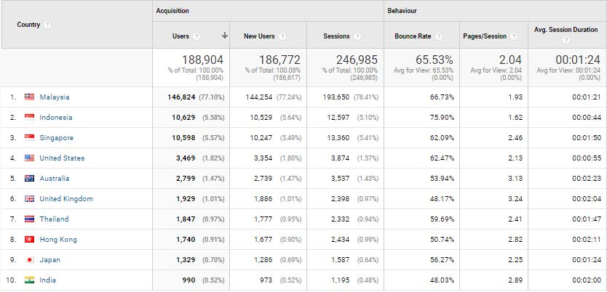

With reference to the above, visitors to the site, in comparison of the time periods:

Item | 1 August 2018 – 28 February 2019 | 1 August 2019 – 29 February 2020
Users | 149,985 | 188,904
Sessions | 198,766 | 246,985
Page Views | 449,347 | 502,662
Ave. Session Duration | 00:01:44 | 00:01:24
Bounce Rate | 69.92% | 65.53%

The top 5 countries visiting our website; in comparison of the time periods:

Country | No. of New Session |  | Increase / Decrease | Most-viewed Pages
Country | 1 August 2018 – 28 February 2019 | 1 August 2019 – 29 February 2020 | Increase / Decrease | Most-viewed Pages
Singapore | 12,168 | 13,360 | 1,192 | Culture & Heritage, Events, Free CAT Bus, Directory
Indonesia | 4,325 | 12,597 | 8,272 | Culture & Heritage, Events, Free CAT Bus
Australia | 3,931 | 3,537 | (394) | Events, Culture & Heritage, Free CAT Bus
United States | 3,051 | 3,874 | 823 | Events, Culture & Heritage, Free CAT Bus
United Kingdom | 2,595 | 2,398 | (197) | Culture & Heritage, Free CAT Bus, Stories, Events, Health Tourism, Food & Lifestyle

The following are the top 10-page views in the mypenang.gov.my website from 1 August 2018 – 28 February 2019:
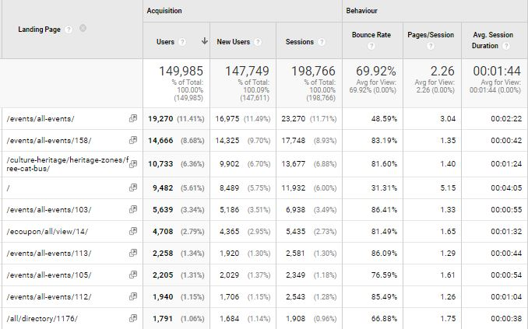

The following are the top 10-page views in the mypenang.gov.my website from 1 August 2019 – 29 February 2020:
