Website traffic
The Google Analytics Report shows a spike on 21 October 2019 of 2,244 users in comparison to 21 October 2018 with 597 users. Besides that, there was also a spike on 31 December 2019 with 3,121 users in comparison to the previous year of 1,022 users and a spike on 8 February 2020 with 2,544 users to the site.
The significant increase of users to the website for October and December 2019 could be brought by visitors searching for information on Penang Hot Air Balloon Fiesta, Penang Stories and upcoming events for final quarter of 2019. The spike for February 2020 could be brought by a few festivals such as Thaipusam and Chap Goh Meh which took place the during the same period of time. Besides that, the spike could also be brought by adverts that ran on PGT’s Facebook page on Penang Hot Air Balloon Fiesta, Festivals and Chinese New Year Celebration events.

21 October 2019 – 2,244 users
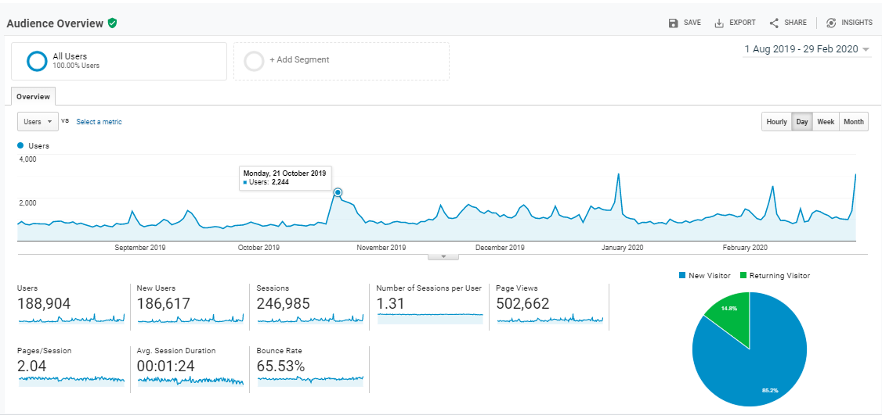
31 December 2019 – 3,121 users
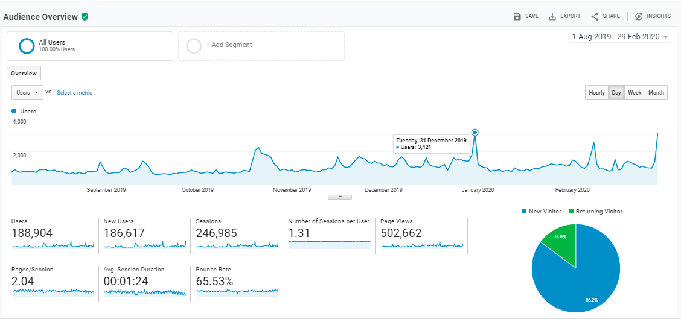

8 February 2020 – 2,544 users
