PGT’s Facebook Page Analytics
Period: 1 October 2019 to 29 February 2020
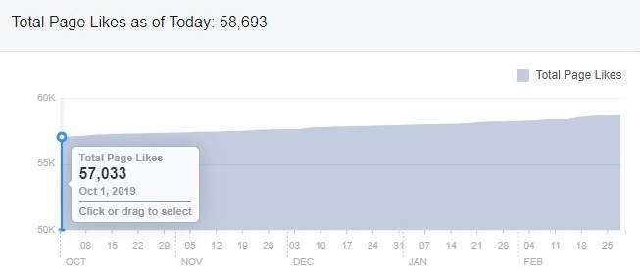
Period: 1 October 2019 to 28 February 2019
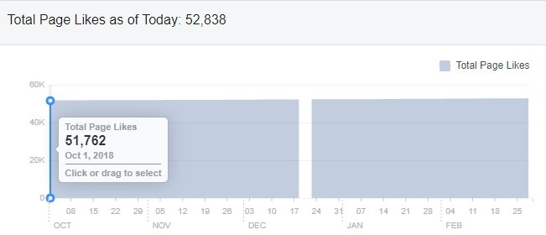
Top posts/ most viewed posts on PGT Facebook page
Month | Posts/ Videos | Total Reach
October 2019 | Penang Stories: Little India really turns the lights on this October | Organic: 1,946  Paid: 243,433
November 2019 | PSFF Promo Video | Organic: 3,250  Paid: 1,096,711 (1 mil)
December 2019 | The opening of Starbucks 4th Signing Store in the world in Penang | Organic: 13,190  Paid: 211,939
January 2019 | Chinese New Year Events in Penang | Organic: 30,157  Paid: 42,786
February 2019 | Penang Stories: Romantic places in Penang | Organic: 8,460  Paid: 174,375

Summary:
- Based on the insights of PGT’s Facebook Page, there’s been an increase in likes in comparison to last year, same period.
- The number of likes recorded for 1 October 2018 – 28 February 2019 = 1,076 and the number of likes recorded for 1 October 2019 – 29 February 2020 = 1,660
- This indicates that the number of likes on the page have been increasing in a relatively good pace.
Penang Foodie Video – Total Reach
Videos | Total Views | Total Reach
Video 1/20 - Must Try Penang Food |  | 7,000,000
Video 2/20 - Unique Experiences in Penang |  | 294,000
Video 3/20 - Things to Do in Seberang Perai |  | 395,000
Video 4/20 - Penang’s Best Street Treats |  | 1,400,000
Video 5/20 - Free Things to Do in Penang |  | 452,000
Video 6/20 - Best Kopitiams in Penang |  | 721,000
Video 7/20 - After Dark Places in Penang |  | 434,000
Video 8/20 - Penang’s Best Breakfast Spots |  | 68,775
Video 9/20 - Family-Friendly Activities in Penang |  | 8,070
Video 10/20 - Penang’s Long-Standing Food Vendors |  | 8,071
Video 11/20 - Penang’s Historical and Cultural Spots |  | 230,554
Video 12/20 - Seafood Places in Penang |  | 5,709
Video 13/20 - Must Have Local Products |  | 4,173
Video 14/20 - Lunch Spots in Penang |  | 8,942
Video 15/20 - Insta Spots in Penang |  | 7,777
Video 16/20 - Best Muslim-Friendly Food |  | 3,423
Video 17/20 - Beautiful Worship Places in Penang |  | 8,717
Video 18/20 - Best Vegetarian Food in Penang |  | 11,320
Video 19/20 - Best Nasi Kandar in Penang |  | 5,159
Video 20/20 - Best Food Options in Penang |  | 9,350
Total |  | 11,076,040

E-Newsletter: Jan 2020 Issue
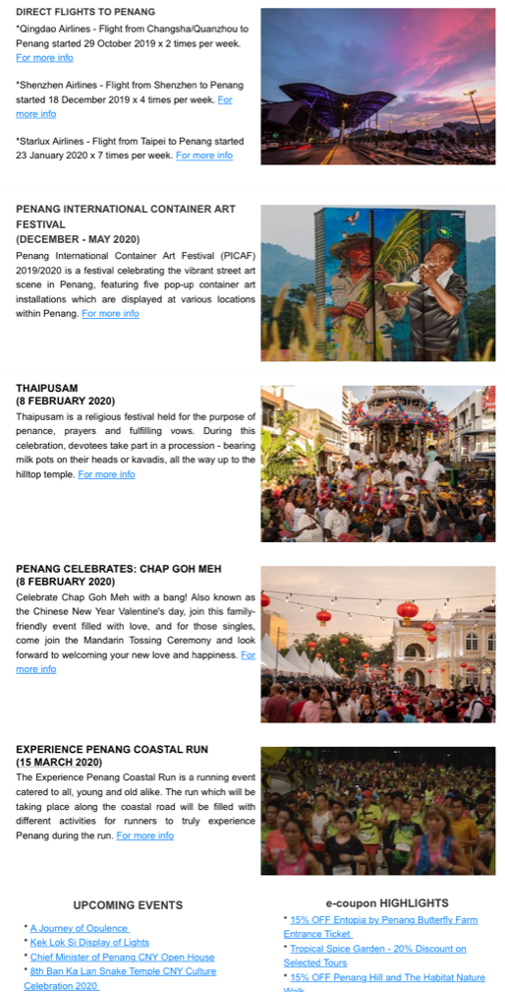
Mobile App

