3.2.4 Festivals in A Box (1 October 2019 - 29 February 2020)
The festival in a box videos are used on an ongoing basis to promote the year-round festivals happening in Penang. It is an effective way to promote the events as it’s more visually driven and gives a good preview of what the festivals are all about. The videos posted on Facebook also drive visitors to our mypenang website for more details.

Videos shared on PGT’s Facebook page from 1 October 2019 – 29 February 2020:
No. | Videos | Total Views as at 29 February 2020 | Date Published
1 | Festivals in a Box: Pesta Chingay Parade | 1.8k | 11 December 2019
2 | Festivals in a Box: Pongal Celebration | 537 | 13 January 2020
3 | Festivals in a Box: Chinese New Year | 2.6k | 23 January 2020
4 | Festivals in a Box: Pai Thee Kong | 1.1k | 29 January 2020
5 | Festivals in a Box: Thaipusam | 1.3k | 3 February 2020

Festivals in a Box: Pesta Chingay Parade
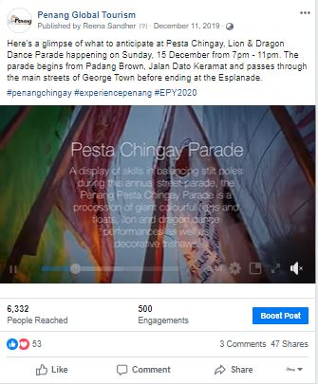

Festivals in a Box: Pongal Celebration
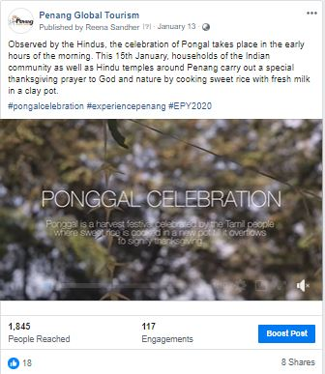

Festivals in a Box: Chinese New Year
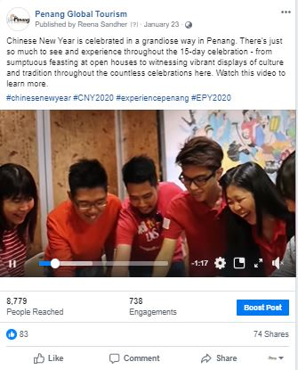

Festival in a Box: Pai Thee Kong/ Hokkien New Year
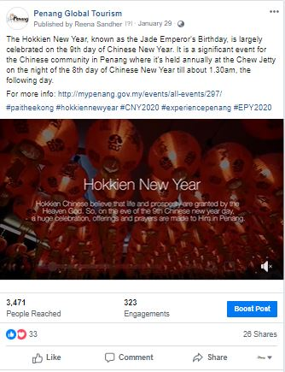

Festivals in a Box: Thaipusam
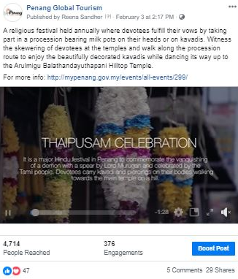

3.2.5 Penang Foodie x Experience Penang 2020 Videos (1 October 2019 – 26 December 2019)

The collaboration between Penang Foodie and Penang Global Tourism is to feature Penang via 20 listicle videos every week, for 20 weeks to promote and commemorate Experience Penang 2020 campaign.

Videos that were cross-posted on PGT’s Facebook page and Penang Foodie’s Page:
No. | Videos | Total Views | Total Reach | Date Published
1 | Video 8/20: 20 Penang’s Best Breakfast Spots | 2 Mil | 68,775 | 3 October 2019
2 | Video 9/20: 20 Family-Friendly Activities in Penang | 71k | 8,070 | 10 October 2019
3 | Video 10/20: 20 Penang’s Long-Standing Food Vendors | 387k | 8,071 | 17 October 2019
4 | Video 11/20: 20 Penang’s Historical and Cultural Spots | 40k | 230,554 | 24 October 2019
5 | Video 12/20: 20 Seafood Places in Penang | 211k | 5,709 | 31 October 2019
6 | Video 13/20: 20 Must Have Local Products | 121k | 4,173 | 7 November 2019
7 | Video 14/20: 20 Lunch Spots in Penang | 400k | 8,942 | 14 November 2019
8 | Video 15/20: 20 Insta Spots in Penang | 89k | 7,777 | 21 November 2019
9 | Video 16/20: 20 Best Muslim-Friendly Food | 335k | 3,423 | 28 November 2019
10 | Video 17/20: 20 Beautiful Worship Places in Penang | 43k | 8,717 | 5 December 2019
11 | Video 18/20: 20 Best Vegetarian Food in Penang | 141k | 11,320 | 12 December 2019
12 | Video 19/20: 20 Best Nasi Kandar in Penang | 251k | 5,159 | 19 December 2019
13 | Video 20/20: 20 Best Food Options in Penang | 220k | 9,350 | 26 December 2019

Video 8/20: 20 Penang’s Best Breakfast Video 9/20: 20 Family-Friendly Activities in
Spots Penang
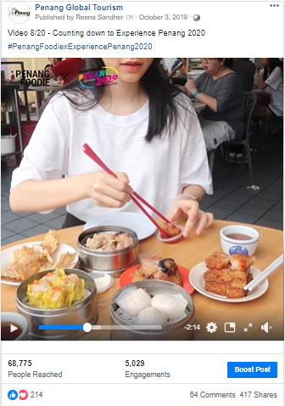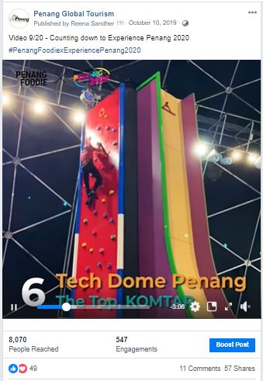

Video 10/20: 20 Penang’s Long-Standing Video 11/20: 20 Penang’s Historical and Cultural
Food Vendors Spots
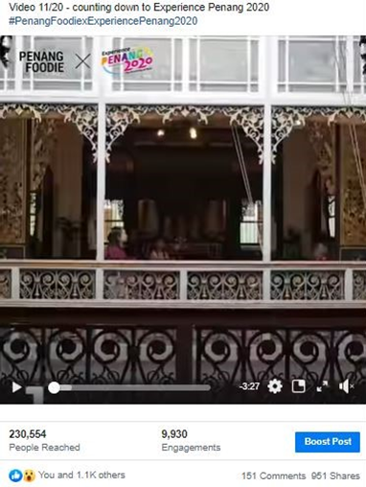

Video 12/20: Seafood Places in Penang Video 13/20: 20 Must Have Local Products
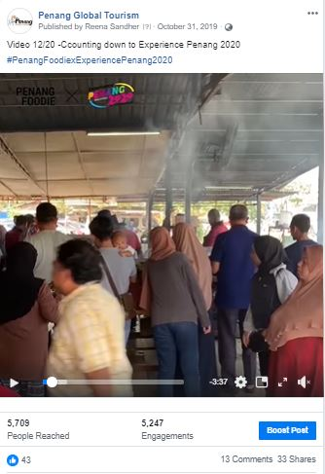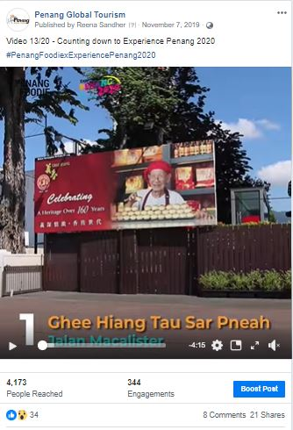

Video 14/20: 20 Lunch Spots in Penang Video 15/20: 20 Insta Spots in Penang
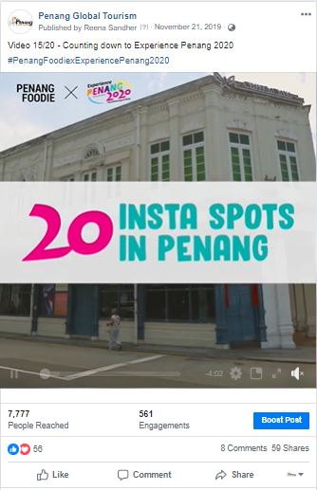

Video 16/20: 20 Best Muslim-Friendly Food Video 17/20: 20 Beautiful Worship Places in Penang
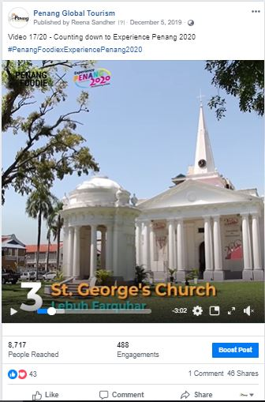

Video 18/20: 20 Best Vegetarian Food in Video 19/20: 20 Best Nasi Kandar in Penang
Penang


Video 20/20: 20 Best Food Options in Penang
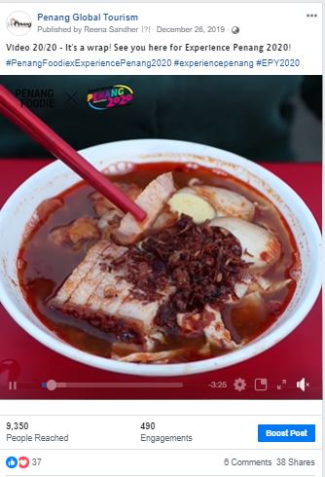

Other promotional videos:

Penang Here & Now 2019 Penang Street Food Festival 2019
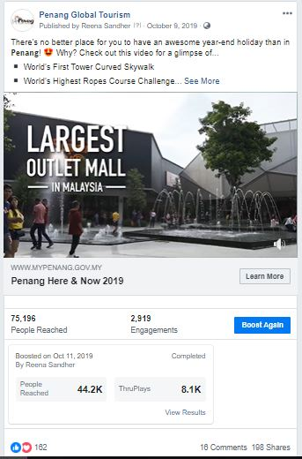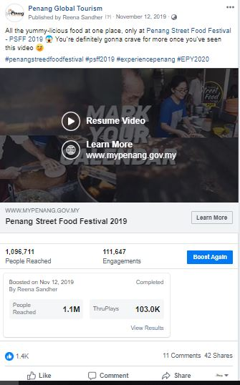

Boosted Posts on PGT, Experience Penang and Penang Hot Air Balloon Facebook Page from
1 October 2019 – 29 February 2020
PGT’s Facebook Page
Post/ Advert | Target Market | Budget (RM) | Duration | Reach | Results
Penang Here & Now 2019 | United Kingdom | 1,000 | 11 - 21 October | 44, 217 | 20.1k views  198 shares  162 reactions  16 comments
Penang Stories: Deepavali | Australia  Indonesia  Singapore  Thailand | 1,000 | 19 - 26 October | 257, 662 | 15 shares  549 reactions  15 comments  11,297 link clicks
Penang Street Food Festival | Australia  Indonesia  Singapore  Thailand | 1,000 | 8 - 13 November | 610, 049 | 35 shares  107k reactions  71 comment
Penang Street Food Festival Promo Video | Australia  Indonesia  Singapore  Thailand | 1,000 | 12 – 17 November | 1,122,562 | 299k views  42 shares  1.4k reactions  11 comments
George Town Literary Festival  *Audience chosen by PCEB | Johor  Alor Setar  Melaka  Seremban  Kuantan  Ipoh  Perlis  Kuala Lumpur  George Town | 800 | 13 – 18 November | 40, 736 | 17 shares  3.6k reactions  2 comments
George Town Literary Festival  *Audience chosen by PCEB | Johor  Alor Setar  Melaka  Seremban  Kuantan  Ipoh  Perlis  Kuala Lumpur  George Town | 800 | 14 - 19 November | 24,441 | 1 share  1000 reactions  1 comment
George Town Literary Festival  *Audience chosen by PCEB | Alor Setar  Kota Bharu  Kelantan  Ipoh  George Town | 800 | 19 - 24 November | 72,911 | 247 shares  1,000 reactions  145 comments
Penang Street Food Festival | Johor  Melaka  Negeri Sembilan  Perak  Kuala Lumpur  Singapore | 1,000 | 19 - 24 November | 47,999 | 55 shares  6.3k reactions  14 comments
Penang Stories: School Holidays | Australia  Hong Kong  Singapore  Bangkok  Malaysia | 1,000 | 20 – 30 November | 251,648 | 65 shares  148 reactions  0 comment  3,270 link clicks
Penang Bridge International Marathon 2019 – Race Day Info  *specific target audience | Johor  Melaka  Negeri Sembilan  Perak  Selangor  Kuala Lumpur  Singapore | 300 | 21 – 24 November | 61,664 | 38 shares  272 reactions  13 comments
This Weekend in Penang | Johor  Melaka  Negeri Sembilan  Ipoh  Selangor  Kuala Lumpur  Singapore | 300 | 21 - 24 August | 11,828 | 11 shares  160 reactions  4 comments
Penang International Dragon Boat Festival | Malaysia | 1,000 | 29 November – 6 December | 38,824 | 35 shares  21.k reactions  3 comments
Butterworth Fringe Festival (BFF) | Johor  Melaka  Negeri Sembilan  Perak  Selangor  Kuala Lumpur  Singapore | 1,000 | 30 November - 8 December | 32,040 | 9 shares  689 reactions  0 comment
Christmas Market | Negeri Sembilan  Perak  Penang  Selangor  Kuala Lumpur | 500 | 6 December – 8 December | 81,823 | 205 shares  884 reactions  71 comments
Penang Stories: Café & Bar Hopping | Australia  Hong Kong  Malaysia  Singapore  Bangkok | 1,000 | 20 December - 5 January | 101,760 | 36 shares  155 reactions  6 comments  2,043 Link Clicks
Starbucks: World’s 4th Signing Store | Malaysia | 500 | 23 December -5 January | 213, 631 | 183 shares  1.5k reactions  50 comments
Accolades: Six of the world’s most thrilling long-haul city breaks by Telegraph | United Kingdom | 1,000 | 7 January – 12 January | 33,560 | 24 shares  48 reactions  4 comments  1,156 link clicks
Chief Minister’s Chinese New Year Open House | Penang | 300 | 20 January – 25 January | 42,240 | 190 shares  3k reactions  72 comments
Chinese New Year Events in Penang | Penang | 300 | 21 January – 26 January | 43,728 | 324 shares  704 reactions  38 comments
Penang Celebrates: Chap Goh Meh | Penang | 500 | 4 February – 8 February | 73,873 | 5 shares  64 reactions  0 comments  303 link clicks
Penang Stories: Thaipusam | Australia  Hong Kong  Malaysia  Singapore  Thailand | 300 | 6 February – 9 February | 55, 200 | 96 shares  579 reactions  29 comments  1,484 link clicks
Penang Stories: Romantic places in Penang | Australia  Hong Kong  Malaysia  Singapore  Thailand | 1,000 | 18 February - 28 February | 171, 615 | 115 shares  321 reactions  36 comments  3,577 link clicks
Experience Penang Facebook Page
Post/ Advert | Target Market | Budget (RM) | Duration | Reach | Results
Penang Grand Parade | Penang | 500 | 31 December – 1 January | 57,008 | 253 shares  3k reactions  59 comments
Penang Grand Parade | Penang | 500 | 28 December – 1 January | 57,232 | 110 shares  2k reactions  28 comments
Penang Grand Parade | Johor, Alor Setar, Langkawi, Sungai Petani, Melaka, Seremban, Negeri Sembilan, Pahang, Ipoh, Perlis, Selangor, Kuala Lumpur, Putrajaya, Wilayah | 500 | 23 December – 1 January | 20, 752 | 14 shares  4,494 reactions  3 comments
Penang Celebrates: Chap Goh Meh | Penang | 300 | 11 January – 13 January | 23,760 | 144 shares  1,686 reactions  16 comments
Penang Celebrates: Chap Goh Meh | Kedah  Melaka  Negeri Sembilan  Perak  Perlis  Selangor  Kuala Lumpur | 200 | 11 January – 13 January | 14,664 | 26 shares  1,358 reactions  7 comments
Thaipusam - Video | Malaysia | 500 | 31 January – 4 February | 239, 936 | 591 shares  2.4k reactions  56 comments  104k views
Penang Celebrates: Chap Goh Meh | Penang | 300 | 5 February – 8 February | 28, 128 | 128 shares  562 reactions  28 comments
Penang Celebrates: Chap Goh Meh  *Setup photos | Penang | 150 | 7 February – 8 February | 41,768 | 120 shares  678 reactions  60 comments
Penang Hot Air Balloon Facebook Page
Post/ Advert | Target Market | Budget (RM) | Duration | Reach | Results
Promo Video | Kedah | 150 | 13 January – 17 January | 45,151 | 238 shares  474 reactions  108 comments
Promo Video | Perak | 150 | 13 January – 17 January | 44, 22 | 163 shares  352 reactions  74 comments
Promo Video | Kuala Lumpur | 200 | 13 January – 17 January | 56,831 | 95 shares  255 reactions  28 comments
Promo Video | China  Hong Kong  Indonesia  Jakarta  Qatar  Singapore  Taiwan  Vietnam | 1,000 | 13 January – 18 January | 665, 085 | 62 shares  1,830 reactions  12 comments
Promo Video | Australia  United Kingdom  Hong Kong  Indonesia  Singapore  Malaysia | 1,000 | 19 December – 26 December | 465,152 | 149 shares  1,604 reactions  18 comments
Path of HAB at Sia Boey  *Setup photos | Malaysia | 500 | 23 December – 28 December | 133,952 | 93 shares  15k reactions  38 comments
Path of HAB at Butterworth Art Walk | Johor  Alor Setar  Negeri Sembilan  Perak  Perlis  Kuala Lumpur | 500 | 28 December – 2 January | 48,400 | 153 shares  7,498 reactions  36 comments
Path of HAB at Sia Boey | Malaysia | 500 | 31 December – 5 January | 58,256 | 89 shares  11,406 reactions  28 comments
Images of HAB 2019 | Malaysia | 400 | 6 January – 10 January | 113,087 | 145 shares  954 reactions  105 comments
Random images of HAB | Malaysia | 2,000 | 20 January – 26 January | 457, 086 | 1.5k shares  10.4k reactions  1.9k comments
HAB Pop Up | Air Itam  Bayan Lepas | 130 | 29 January – 31 January | 41,719 | 180 shares  377 reactions  83 comments
Opening Ceremony | Penang | 400 | 30 January – 1 February | 50,865 | 264 shares  1.7k reactions  223 comments

3.2.5 Website Google Analytics (1 August – 15 November 2019 and 16 November – 29 February 2020)

Website traffic
The Google Analytics Report shows a spike on 20 July which could be brought by visitors searching for information on the George Town Festival and Penang Bon Odori Festival as r coincides with the date of the festival. Besides that, there was a spike on 17 July, which is brought by adverts that ran on PGT’s Facebook page on Penang Bon Odori Festival.
According to the analytics report, majority of users to our mypenang.gov.my website was acquired organically via Google. There were also users who were linked to our website through Facebook posts, some organically and some through adverts. There were quite a number of visitors that were linked to our website mypenang.gov.my through Penang Sentral’s official website, www.penangsentral.com.my and through Penang Foodie’s official website, penangfoodie.com
Comparison between 16 April – 31 July 2019 and 1 August – 15 November 2019
The comparison report shows an increase of 0.7% in new users to the website. However, the number of page views, sessions and bounce rate decreased a little.

Top 5 countries visiting the site and most viewed pages
The top 5 countries visiting the site are the United States, Great Britain, Singapore, China and Australia. Their most-viewed pages are mainly on eCoupon, Culture & Heritage, Events and Food & Lifestyle.
Comparison between 1 August – 15 November 2019 and 16 November – 29 February 2020
The comparison report shows an increase of 0.2% in new users to the website. However, the number of page views, sessions and bounce rate increased.

Top 5 countries visiting the site and most viewed pages
The top 5 countries visiting the site are the United States, Great Britain, India, Singapore and China. The most-viewed pages are mainly on Free CAT Bus, Culture & Heritage, Events, Food & Lifestyle and directory.
The following pages show the relevant charts and tables summarizing the Google analytics report as highlighted above.
Period: 16 April – 31 July 2019 (3.5 months)
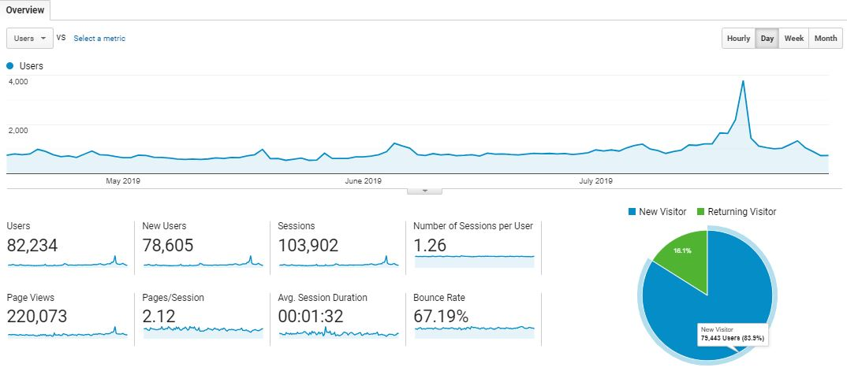
Period: 1 August – 15 November 2019 (3.5 months)
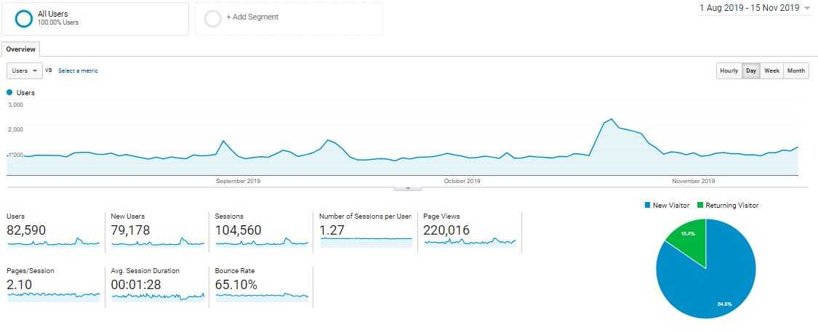

Comparison Period: 1 August – 15 November and 16 April – 31 July 2019
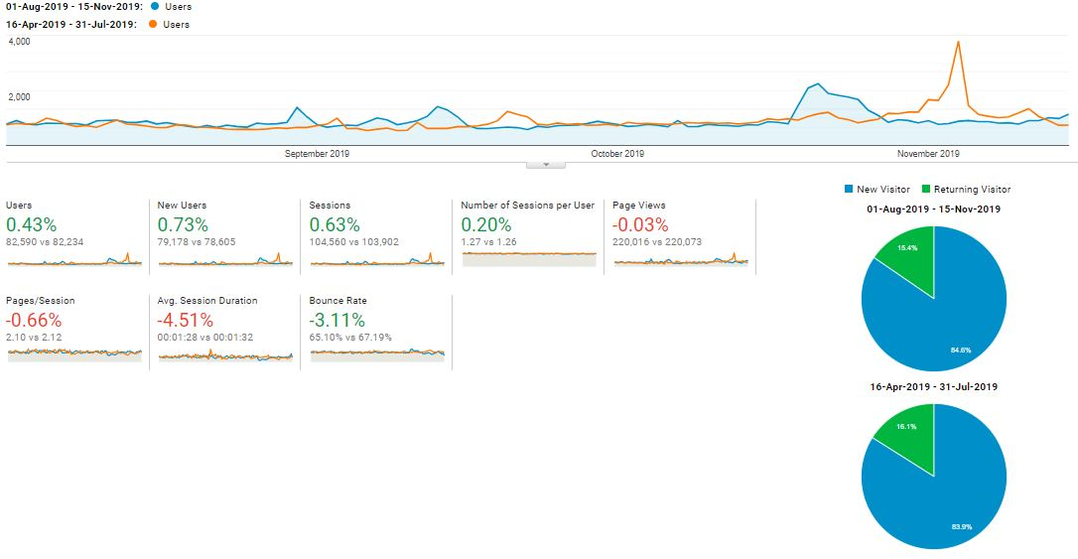

Comparison Period: 16 November 2019 – 29 February 2020 and 1 August – 15 November 2019
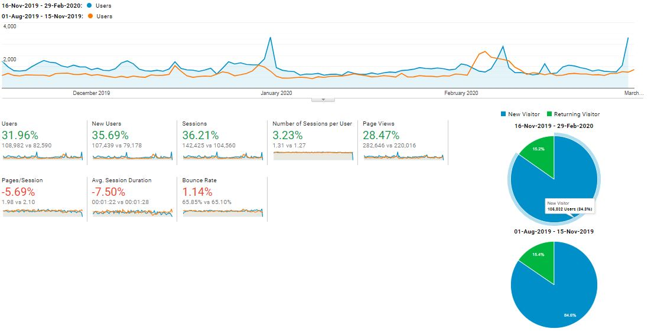

Top 10 user’s location and sources: 1 August – 15 November 2019
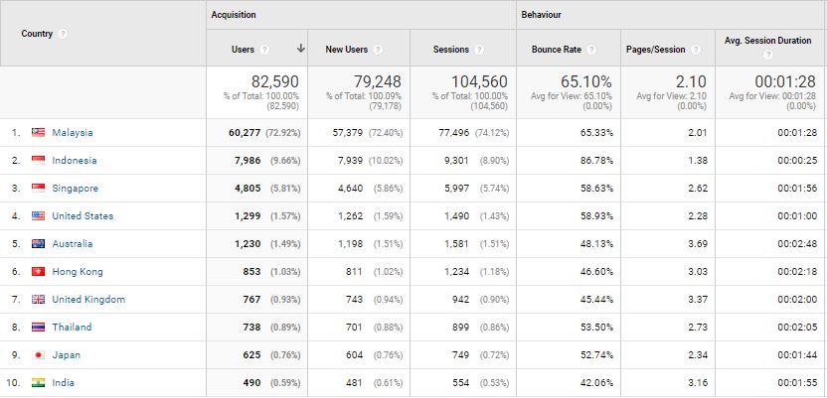

Top 10 user’s location and sources: 16 November 2019 – 29 February 2020
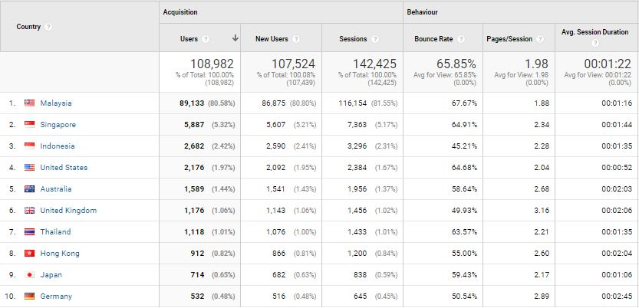

With reference to the above, visitors to the site, in comparison of the time periods:

Item | 1 August – 15 November 2019 | 16 April – 31 July 2019
Users | 82,590 | 82,234
Sessions | 104,560 | 103,902
Page Views | 220,016 | 220,073
Ave. Session Duration | 00:01:28 | 00:01:32
Bounce Rate | 65.10% | 67.19%

With reference to the above, visitors to the site, in comparison of the time periods:

Item | 16 November 2019 – 29 February 2020 | 1 August – 15 November 2019
Users | 108,982 | 82,590
Sessions | 142,425 | 104,560
Page Views | 282,646 | 220,016
Ave. Session Duration | 00:01:22 | 00:01:28
Bounce Rate | 65.85% | 65.10%

The top 5 countries visiting our website; in comparison of the time periods:

Country | No. of New Session |  | Increase / Decrease | Most-viewed Pages
Country | 16 April – 31 July 2019 | 1 August – 15 November 2019 | Increase / Decrease | Most-viewed Pages
Singapore | 5,817 | 4,805 | (1,015) | Culture & Heritage, Events, Free CAT Bus, Directory
Indonesia | 1,612 | 7,986 | 6,374 | Culture & Heritage, Events, Free CAT Bus
United States | 1,294 | 1,299 | 3,511 | Events, Culture & Heritage, Free CAT Bus
Australia | 1,274 | 1,230 | (44) | Events, Culture & Heritage, Free CAT Bus
Hong Kong | 929 | 853 | 76 | Culture & Heritage, Free CAT Bus, Stories, Events, Health Tourism, Food & Lifestyle

The top 5 countries visiting our website; in comparison of the time periods:

Country | No. of New Session |  | Increase / Decrease | Most-viewed Pages
Country | 1 August – 15 November 2019 | 16 November 2019 – 29 February 2020 | Increase / Decrease | Most-viewed Pages
Singapore | 4,805 | 5,887 | 1,082 | Culture & Heritage, Events, Free CAT Bus, Directory
Indonesia | 7,986 | 2,682 | (5,304) | Culture & Heritage, Events, Free CAT Bus
United States | 1,299 | 2,176 | 877 | Events, Culture & Heritage, Free CAT Bus
Australia | 1,230 | 1,589 | 359 | Events, Culture & Heritage, Free CAT Bus
Hong Kong | 853 | 912 | 59 | Culture & Heritage, Free CAT Bus, Stories, Events, Health Tourism, Food & Lifestyle

The following are the top 10-page views in the mypenang.gov.my website from 1 August – 15 November 2019:
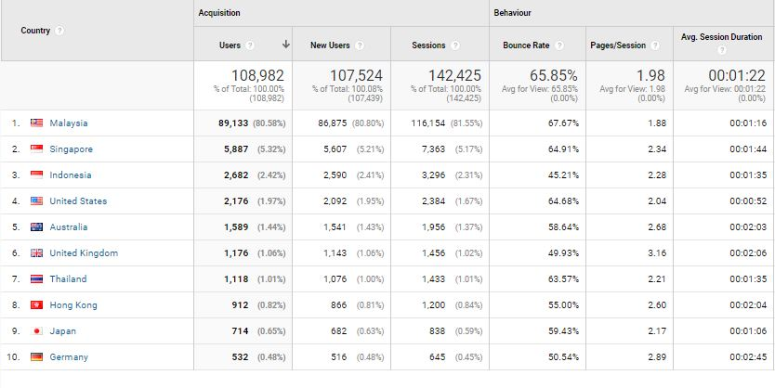

The following are the top 10-page views in the mypenang.gov.my website from 16 November 2019 – 29 February 2020:

3.2.6 Penang Global Tourism Mobile App
The following table shows the total number of downloads for 1 September to 29 February 2020 on iOS and Android:
Domestic/In’tial | iOS |  | Android
Malaysia | 123 | 25.52% | 271 | 50.56%
Overseas | 359 | 74.48% | 265 | 49.44%
Total downloads | 482 | - | 536 | -

The total number of downloads (Malaysia and overseas) in the five months is 1,018.
The top 5 international countries for number of downloads on our mobile app are as follows:

iOS:
1. Hong Kong - 45
2. Singapore - 35
3. China - 32
4. Germany - 24
5. Thailand - 19

Android:
1. Indonesia - 65
2. Singapore - 55
3. Hong Kong - 18
4. Thailand - 16
5. Great Britain - 12

To be consistent with PGT’s website, updates are being done on PGT’s mobile app. For easier management, the backend CMS for e-coupon has been updated to enable further editing and amendments after item has been listed.

Don’t Say Penang Bojio Issue #7 – August 2019
Overview Report:
Item | Figure
Recipients | 3,922
Successfully Sent | 3,922
Opened This Campaign | 310 (7.90%)
Clicked A Link | 95 (2.42%)
Unsubscribed | 12 (0.31%)

Number of link clicks and links viewed:
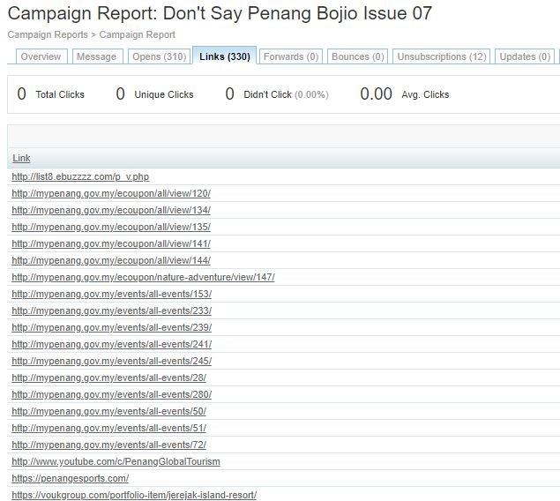

Don’t Say Penang Bojio Issue #1 – January 2020
Overview Report:
Item | Figure
Recipients | 4,426
Successfully Sent | 4,426
Opened This Campaign | 280 (6.33%)
Clicked A Link | 40 (0.90%)
Unsubscribed | 8 (0.18%)
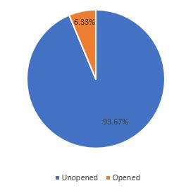
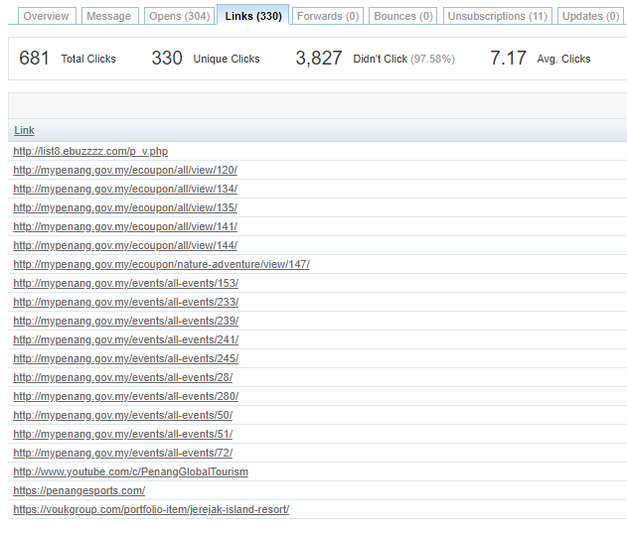

Summary:
- Percentage of recipients who opened the latest issue decreased by 1.67%
- Percentage of link clicks decreased slightly. Most link clicks are to Penang events and featured e-coupons, as well as PGT’s YouTube page, and featured new attractions in Penang.
- Percentage of recipients who unsubscribed in this issue is 0.18% lesser compared to the previous issue.

3.3 Recent Publicity (October 2019 – February 2020)

October 2019
Foreign
No | Name | Description | Type of Publication
1 | Asia One | - A write up on ‘Your next long weekend destination – Penang, Malaysia. An itinerary for 3 days on Penang. | Online
2 | Simple Flying | - Taiwan’s Starlux receives Its first airbus aircraft ahead of its launch. It’s launch network focuses on Southeast Asian destinations, commencing with flights to Da Nang, Macau, and Penang in Jan 2020.  - Starlux Airlines announces its first three destinations - Da Nang, Vietnam, Macau and Penang, Malaysia from its hub in Taipei. | Online

Local
No | Name | Description | Type of Publication
1 | Travel 360 | - The Habitat was listed under Spotlight section  - An article was written on George Town Treasures under Travel Log section | Print
2 | Senses of Malaysia | - A write up on Historic Mansions Reimagined as Hotels in Penang under Explore section | Print
3 | Penang Monthly | - A write up on George Town Literary Festival | Print
4 | The Expat | - A write up on Make the Most Out of 48 Hours in Penang under Short Trips & Weekend Getaway | Print
5 | The Star | - Featured Penang Coffee and Desserts Festival that took place at Gurney Paragon. In the article it was stated that the festival in its sixth year featured over 50 exhibitors offering a glimpse or urban coffee and desserts scene in Penang  - An article on MATTA Fair Penang. | Online
6 | Penang Foodie | - A write up on different events happening in Penang in the month of October | Online
7 | New Straits Times | - A write up the history and establishment of Penang Botanical Garden | Online
8 | Buletin Mutiara | - An article on Boba Festival which is also a part of Penang Coffee and Desserts Festival. There were 20 participating outlets, including food truck that took part in this festival at Gurney Plaza  - A local startup, Lokalocal launched ‘There’s more in Penang: 100 Experiences in Penang’ campaign to attract tourists.  - A write up on the closing ceremony of Penang Coffee and Desserts Festival which was held at Cheah Kongsi. The CM mentioned that this festival is a platform to enhance the coffee industry  - A write up on Miss Asia Global Malaysia. This pageant is entrusted with the task as a ‘tourism ambassadress’ to promote Penang and Malaysia in the international platform. | Online
9 | Kwong Wah Yit Poh | - St.Anne’s Church in Penang gets minor basilica status  - A write up and video coverage on Nine Emperor Gods Festival in Penang  - Penang recognised as the most loved state for tourism in the Going Places Readers’ Choice Awards 2018  - China Qingdao Airlines makes its first flight to Penang. | Online
10 | Guang Ming | - A write up on Nine Emperor Gods Festival in Penang | Online

November 2019
Foreign
No | Name | Description | Type of Publication
1 | Linkers | - A write up on Penang on Malam di Penang Festival dan Kuliner | Print
2 | Silkwinds | - A write up on Penang under Postcards section | Print
3 | NewsPressed | - Cycling in Penang is easy with LinkBike Bike share, pay and ride.  - Continental and fusion cuisine in Penang try Jalan Sultan Ahmad Shah | Online
4 | Business Insider Singapore | - Starbucks just opened its fourth signing store worldwide in Penang. | Online
5 | Business News Asia | - ESCAPE Gravityplay, World’s Longest Inner Tube Water Slide, Opens in Malaysia | Online
6 | The Japan Times | - From sight to taste, diverse wonders await discovery – a write up under special supplements. Penang National Park was highlighted in the article. | Online

Local
No | Name | Description | Type of Publication
1 | iNPenang | - A write up on Butterworth Fringe Festival 2019 under Festival section | Print
2 | The Star | - Penang government open to proposal for new airport. The massive 650ha project is estimated to cost RM10bil. The consortium has proposed an airport large enough to handle between 16 and 25 million passengers a year  - State using social media to promote tourism - Penang tourism, arts, culture and heritage committee (PETACH) had fostered a digital campaign with Penang Global Tourism (PGT) through a social media video app with monthly active users of 180 million, including 50 million in South-East Asia.  - Penang Bridge International Marathon attracts 25,000 runners from 65 different countries. This year special PBIM 2019 ambassador was Bernard Lagat, a five-time Olympian and thirteen-time medallist at World Championships and Olympics levels.  - Hundreds celebrate Loy Krathong. Candles on lotus-shaped floats lit up an artificial river at Love Lane as hundreds of people converged to celebrate Loy Krathong – the Thai festival of lights. | Online
3 | The Malaysian Insight | - Putrajaya to focus on Penang airport expansion. The federal government is focused on the expansion of the Penang international airport to increase passenger capacity to meet increasing demand, said Finance Minister Lim Guan Eng. | Online
4 | Malaysia Tatler | - 5 creative spaces in George Town, Penang for a memorable event. | Online
5 | Free Malaysia Today | - A write up on Penang Heritage trails.  - Botanic Gardens: The pride of Penang. A write up on the history and attractions within the gardens.  - A write up on The Colonial Penang Museum - a treasure trove of delights | Online
6 | New Straits Times | - Award-winning global cruise brand Royal Caribbean International is set to boost the number of tourists’ arrivals during Visit Malaysia Year 2020.  - GTLF kicks-off with a slew of activities and book launches. | Online
7 | Rojak Daily | - New Starbucks outlet in Penang is only the fourth of its kind in the world. | Online
8 | Hype | - Starbucks Malaysia launched 2nd signing store in Penang. | Online
9 | Guang Ming | - PSFF2019 Opening ceremony – the people of Penang are the ambassadors of Penang and should invite more tourists to Penang | Online
10 | Kwong Wah Yit Poh | - Penang Bridge International Marathon starts in good weather.  - More than 25,000 people participated in PBIM 2019. Mentioned by the CM the landmark of Penang Bridge is irreplaceable | Online

December 2019
Foreign
No | Name | Description | Type of Publication
1 | Linkers | - A write up on George Town, Penang – Dasawarsa “Unesco World Heritage Site” | Print
2 | Focus Taiwan | - Starlux Airlines to start selling tickets ahead of the start of flights to Macau, Penang. | Online
3 | Simple Flying | - Starlux Airlines schedules its first flights to its initial destinations, including Penang. | Online
4 | Taipei Times | - StarLux Airlines to start selling tickets before even the launching of its services. | Online
5 | Asia One | - Penang retains charm as top tourist destination in Malaysia | Online
6 | Xin Hua Net | - Direct flights links Shenzhen to Penang | Online
7 | Gold Coast Bulletin | - This new airline sold out its very first flight in just 11 minutes flat. | Online

Local
No | Name | Description | Type of Publication
1 | The Star | - A write up on Butterworth Fringe Festival - More than 100 local and international artists will take part in the upcoming two-day BFF at Padang Permuda Merdeka, starting Dec 7.  - Lots of exciting programmes at two-day Fringe Festival.  - Gurney Wharf public projects to begin early next year.  - A write up on the 40th Penang International Dragon Boat Festival 2019.  - Exploring nature’s beauty on two wheels – Seberang Perai Eco-Cycling 2019  - Penang gets into Malaysia Book of Records for tallest upcycled Christmas tree in the country.  - Penang retains charm as top tourist destination | Online
2 | Buletin Mutiara | - The Penang government is working on the latest initiative called The Penang New Core City to further bridge and unify the Penang island and mainland. | Online
3 | Kwong Wah Yit Poh | - Chairman of the Penang Tourism Development, Heritage, Culture and Art Committee, said that the state government intends to introduce two-wheeled balanced vehicles to Penang, aiming to create a new experience for tourists when exploring historic areas through two-wheeled balanced vehicles.  - Malaysia’s highest recycling tree lights up at Penang Christmas Bazaar in Penang Esplande.  - Direct flight launching from Shenzhen to Penang scheduled for December 18.  - Second Penang Bridge Toll to be reduced to RM 7 in January 2020. | Online
4 | The Sun Daily | - A write up on Nyonya Kebaya: A Peranakan Tale  - Penang Airport expansion works to begin in March next year. | Online
5 | New Straits Times | - Perak, Penang and Kedah record an increase in tourist arrivals. January to Dec 10, the state received 1,124,823 tourists compared with 1,063,619 during the same period last year. The number of visitors from January to Dec 10 — both domestic and international also increased from 1,571,044 to 1,708,945.
6 | The Malaysian Reserve | - Penang listed in ‘The last-minute holiday idea that won’t empty your wallet’ article. | Online
7 | China Press | - Penang International Container Art Festival will debut in Penang Street Art | Online
8 | Sin Chew | - Penang Chingay Parade goes on despite the rain and gather crowds.  - Penang International Container Art Festival lights up at five different locations  - 4 weekly direct flights from Shenzhen to Penang | Online
9 | Buletin Mutiara | - Shenzhen – Penang direct flights to promote business, tourism exchanges | Online
10 | Nan Yang | - Fresh look of Sia Boey will be open to the public soon. | Online

January 2020
Foreign
No | Name | Description | Type of Publication
1 | Sprudge | - The spurdge coffee guide to Penang | Online
2 | Asia One | - Cable car project in Penang set to start year-end | Online
3 | TTR Weekly | - AirAsia expands Penang hub by introducing Chengdu – Penang flights | Online
4 | Emirates | - Emirates to launch services to Penang via Singapore | Online
5 | Business Traveller | - Emirates secures Singapore-Penang fifth freedom rights | Online
6 | The National | - Emirates launches flights from Dubai to Penang | Online
7 | Travel Weekly Asia | - Emirates to launch daily service from Dubai to Penang in April | Online
8 | TTG Asia | - StarLux Airlines takes to the skies. After almost three years of preparation, Starlux Airlines launched three inaugural flights on January 23, 2020 to three destinations – Macau (thrice-daily), Danang (twice-daily) and Penang (daily). | Online

Local
No | Name | Description | Type of Publication
1 | Rojak Daily | - A write up on Penang International Container Art Festival | Online
2 | Sin Chew | - An article Penang International Container Art Festival  - Penang International Container Art Festival kicks-off at Balik Pulau | Online
3 | Kwong Wah | - 10 events to celebrate in the New Year in Penang  - Penang Hot Air Balloon Fiesta press conference was held Sia Boey and the dates for the Fiesta were announced for 1st and 2nd Feb 2020  - Penang Swettenham Pier expansion project to start early April  - Direct flights to Penang increase year by year  - 420 mini hot air balloons light up back lane and turns it into a romantic sea of lights  - Launching of PICAF 2020 at Kampung Terang, Balik Pulau | Online
4 | Buletin Mutiara | - Penang set to usher in the year of the Rat with a bang!  - The CM hopes that the Experience Penang Year 2020 campaign will promote more of the mainland  - Penang Hot Air Balloon Fiesta to take place on 1st and 2nd Feb 2020  - 10 Containers to be installed at 5 different locations for PICAF 2020  - AirAsia to begin direct flights connecting Penang and Chengdu  - Penang a hub for art scene PICAF 2020 is the first festival in Asia featuring urban art on container installations. It is aimed at promoting tourism through art and placemaking five neighbourhoods on island and mainland. | Online
5 | Guang Ming | - State representatives welcomes all parties to all the Chinese New Year events taking place in Penang  - 27.1% increase in tourists arriving in Penang via cruise  - 420 mini hot air balloons light up back lane and turns it into a romantic sea of lights  - An article on container installation at Kampung Terang, Balik Pulau | Online
6 | Malay Mail | - Penang to celebrate Chinese New Year with host of events | Online
7 | The Star | - Container murals a new towering sight  - Drawn towards a unique type of cargo – PICAF 2020 is the latest attraction highlighting the state’s vibrant art scene and the Experience Penang Year 2020  - The Chew Jetty Chinese New Year Celebration 2020 will be packed with colourful cultural acts to enthral the crowd.  - Maiden flight brings 188 from Taipei to Penang  - Happiness spilling over at Ponggal event | Online
8 | Free Malaysia Today | - Expansion of Penang cruise terminal to begin in April  - Penang’s container art in a padi field has become latest craze | Online
9 | The Sun Daily | - Penang Port to receive RM 150mil worth of investments | Online
10 | The Edge Markets | - Penang records 27.1% increase in cruise passengers  - Starlux Airlines’ makes maiden flight to Penang today | Online
11 | New Straits Times | - Emirates to begin Penang flights in April | Online
12 | The Malaysian Reserve | - Emirates to launch services to Penang via Singapore | Online

February 2020
Foreign
No | Name | Description | Type of Publication
1 | Inside Hook | - An article on Penang street food | Online

Local
No | Name | Description | Type of Publication
1 | Guang Ming | - Gurney Wharf to start construction in July and expected to be completed in the second half of next year  - Hot Air Balloon night show illumination during the opening ceremony of Penang Hot Air Balloon Fiesta  - Launching of PICAF installation at Karpal Singh Drive  - Launching of PICAF installation at Aspen Vision City | Online
2 | Kwong Wah Yit Poh | - The first phase of Gurney Wharf is expected to start in July  - After the upgrade works, Swettenham Pier is expected to become a tourist hotspot  - The grand opening ceremony of Penang Hot Air Balloon Fiesta 2020 by the Governor of Penang  - Penang Miaohui to see the century-old Nanyang scene experience  Highlights of the Penang Temple Fair to see the century-old Nanyang scene experience  - An article on PICAF installation at Karpal Singh Drive  - Launching of PICAF installation at Aspen Vision City  - In conjunction with the International Tour Guide Day, Penang Guide Association provides a free guided tour of George Town on Friday night. | Online
3 | The Star | - Gurney Wharf expected to be completed by August 2021  - Fiesta takes off to a picturesque start  - A proposal took place at Penang Hot Air Balloon Fiesta 2020  - Penang all set to double weekend celebration of Thaipusam and Chap Goh Meh  - Huge crowd expected for Thaipusam as it falls on a weekend.  - Hundreds of devotees enjoyed a night of festivities at the Hock Hin Keong (Ban Ka Lan Snake Temple) in Penang during the temple’s CNY Culture Celebration 2020.  - Balloon fans on cloud nine when 15 hot air balloons of various shapes took to the sky during the Penang Hot Air Balloon Fiesta 2020 at the Polo Ground.  - Thaipusam procession draws crowd in Penang despite the novel coronavirus scare, thousands of devotees took to the streets to pay homage to Lord Muruga on the eve of Thaipusam, which is one of the most colourful festivals in Malaysia.  - More than 10,000 people thronged the stretch of clan jetties along Weld Quay in George Town, Penang, to pay homage to the Jade Emperor at Chew Jetty.  - In conjunction with the International Tour Guide Day, Penang Guide Association provides a free guided tour of George Town on Friday night.  - Art scene scales new heights - perched high up on a vast padi field in Kampung Terang in Balik Pulau, Penang, are three vertical cargo containers, installed for the Penang International Container Art Festival (Picaf). | Online
4 | The Sun Daily | - Starbucks opens first Reserve store in Penang  - Penang CM launches rejuvenation of Penang waterfront | Online
5 | Malay Mail | - Swettenham Pier in Penang can accommodate 1.7 million passengers after the upgrade is done  - Penang Hill to soon be accessible to all, with greener building design. The Upper Station on Penang Hill is earmarked for an upgrade soon to make it accessible to all visitors, including those who are wheelchair-bound and senior citizens.  - Open Penang Studios 2020: Penang gets ready for an art explosion at the end of March  - In a bit to spur domestic tourism, Penangites get 50% discounts for ticketed attractions in the state | Online
6 | Buletin Mutiara | - Spectacular night of hot air balloon fiesta  - Latest PICAF installation at Batu Kawan – launching ceremony  - PICAF installation launching at Dataran Pemuda Merdeka  - The state government would do its part to help tourism products developed under the Penang Tourism Master Plan (PTMP) bring about benefits to the locals, says state Tourism Development, Arts, Culture, Heritage Committee chairman Yeoh Soon Hin. | Online
7 | New Straits Times | - A write up on Unique experiences for everyone in Penang during Valentines.  - Phase 2 of Penang Sentral to go full swing next year.  - Penang to beautify side, back lanes to attract visitors. | Online
8 | World of Buzz | - Voted ‘World’s Best Street Art’, Malaysians can admire these stunning container murals in Penang till May 2020 | Online
9 | Rojak Daily | - Rojak Daily listed Penang in their list of ‘8 Super Instagrammable Cafes Around Malaysia You Need to Check Out’. | Online
10 | Borneo Bulletin | - Penang upgrades lanes to attract visitors | Online

