3. Communications - Reported by D’Yani Ramoo

Report Overview
Events’ promotion:
The advertising and promotions of events undertaken for the past months of October 2019 to February 2020, were mainly for George Town Literary Festival, Penang Street Food Festival, Butterworth Fringe Festival, Penang Hot Air Balloon Fiesta and Penang Yosakoi Parade. PGT also supported other events during this period such as, Experience Christmas in Penang, Penang International Dragon Boat Festival, Miaohui Chinese New Year Celebration, Penang Grand Parade, Experience Penang Coastal Run, Penang Celebrates Chap Goh Meh and CM’s CNY Open House.

International campaigns:
For international markets, Comms continued to focus on advertising in inflight magazines featuring Experience Penang 2020 (EPY). The inflight magazines included SilverKris (SIA), Silkwinds (SilkAir), Oryx (Qatar Airways), Open Skies (Emirates), Sawasdee (Thai Airways), Qantas (Qantas Airlines), Linkers (Citilink) as well as Travel360 (AirAsia). It is to be noted that Qatar Airways ceased publication of its inflight magazine (Oryx) after December. Additionally, PGT also started to advertise in Gateway, the inflight magazine of China Southern Airlines, which we had signed up for 12 issues starting January. However, since February, the airlines had suspended all inflight materials due to the Covid-19 outbreak.

In December, we kick-started the advertising of EPY in Singapore’s Dhoby Ghaut MRT Station on the travellator wallscape + glass panel for 8 weeks. Also commencing in December was the wrapping of ten buses in Taipei for 7 months and from January for 3 months, EPY was also featured on the escalator wall in Ximen MRT Station.

Domestic campaign:
An outdoor advertising campaign on Covered Walkways were just completed end of Feb 2020. The ads will be up for 12 months - located in KL’s city centre at Jalan Sultan Ismail and Jalan Raja Chulan located in front of Wisma Genting and Wisma Cosway respectively.

3.1 Accomplished from October 2019 to February 2020

3.1.1 Print ads
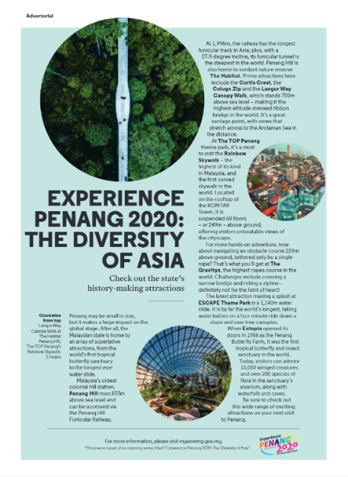
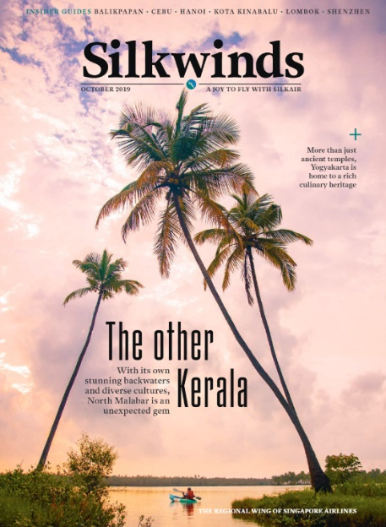
- SilkAir’s (Silkwinds) Oct 2019 issue – advertorial on Experience Penang (Attractions):

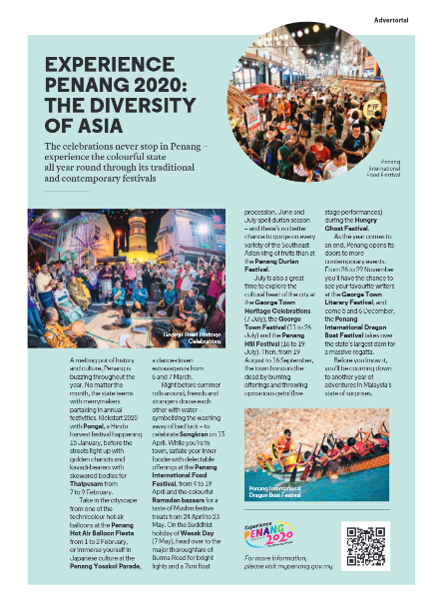
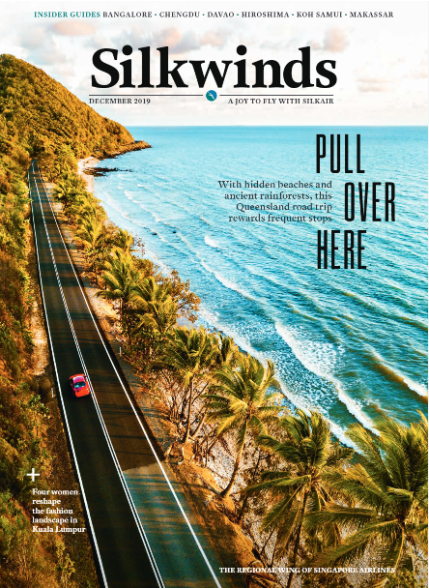
- SilkAir’s (Silkwinds) Dec 2019 issue – advertorial on Experience Penang (Festivals):

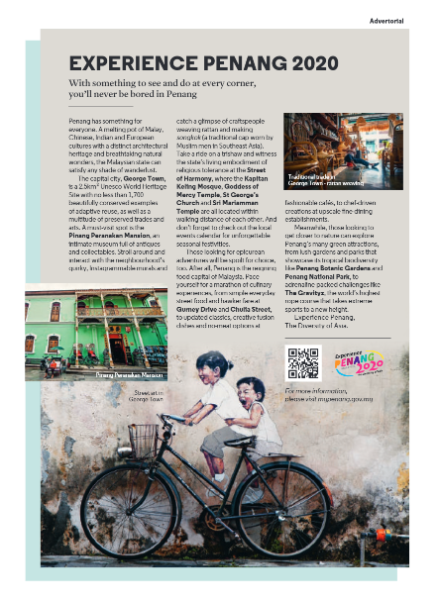
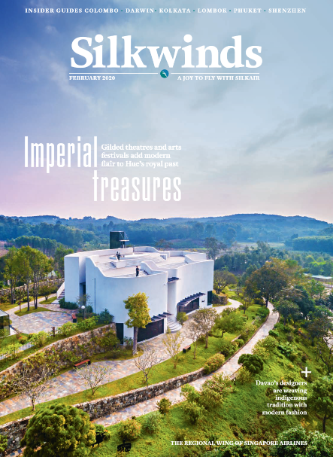
- SilkAir’s (Silkwinds) Feb 2020 issue – advertorial on Experience Penang (Heritage)

- SIA’s (SilverKris) Oct 2019 issue – advertorial on Experience Penang (Accolades):
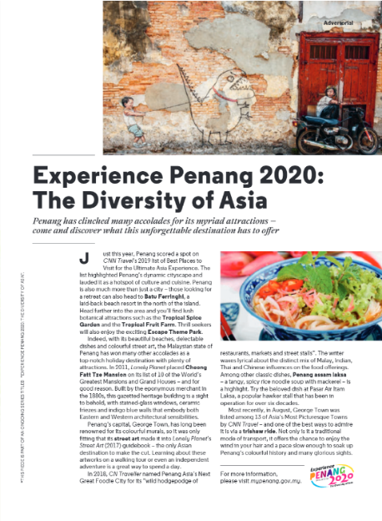
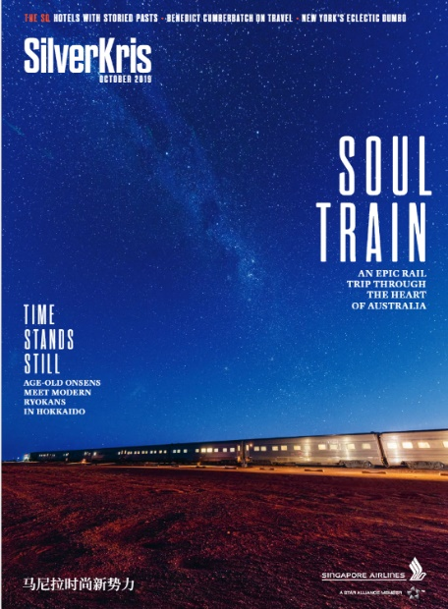

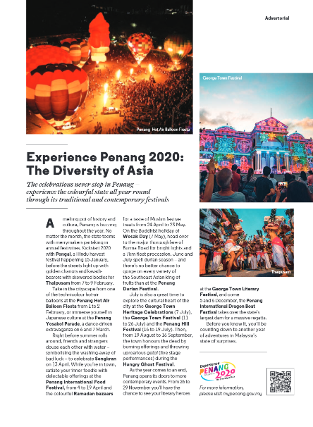
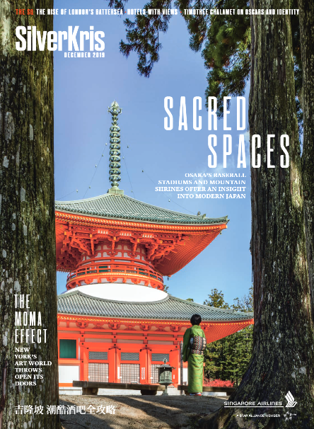
- SIA’s (SilverKris) Dec 2019 issue – advertorial on Experience Penang (Festivals):

- SIA’s (SilverKris) Feb 2020 issue – advertorial on Experience Penang (Overall):
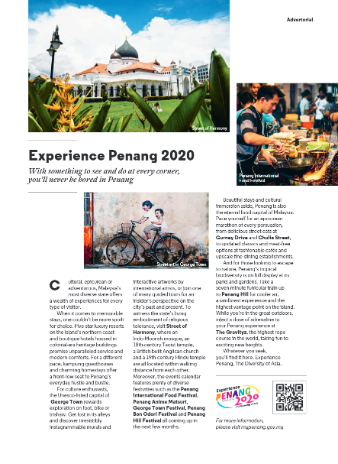
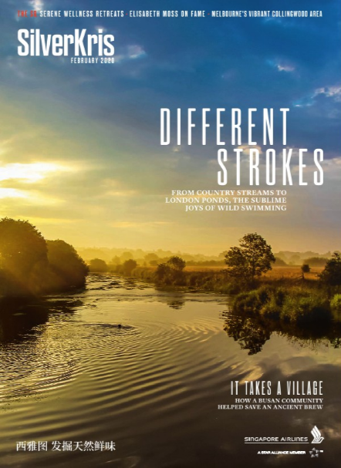

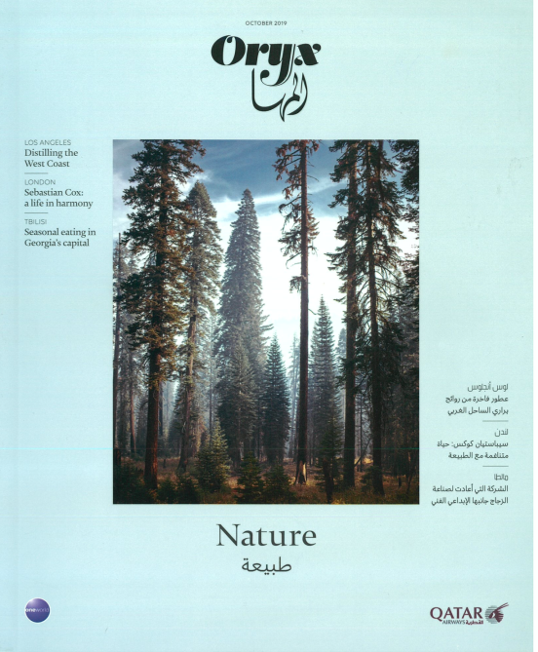
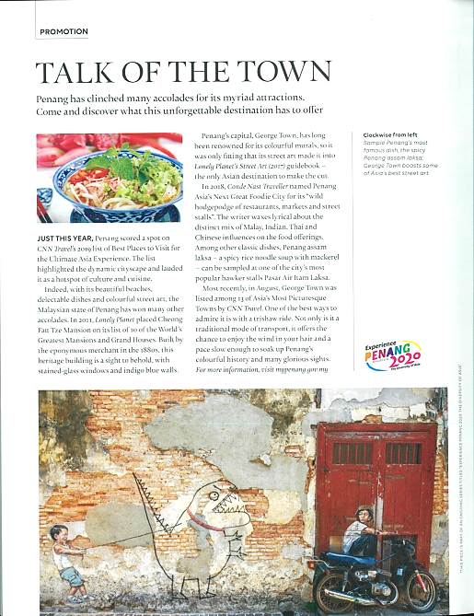
- Qatar’s (Oryx) Oct 2019 issue – advertorial on Experience Penang (Accolades):

- Qatar’s (Oryx) Dec 2019 issue – advertorial on Experience Penang (Festivals):
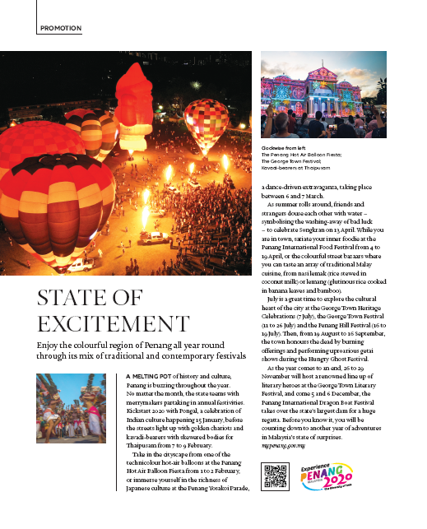
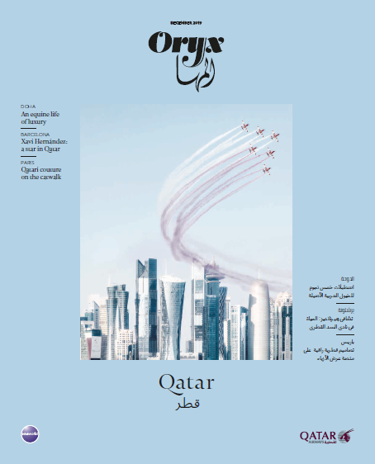

- AirAsia’s (Travel 360) Oct 2019 issue – advertorial on Experience Penang (Overall):
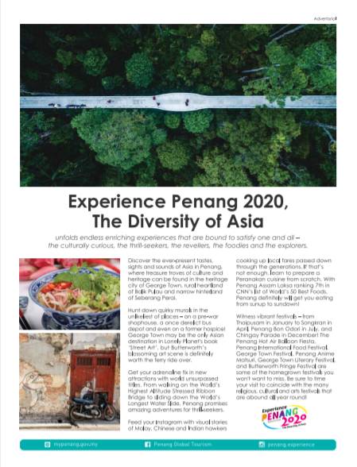
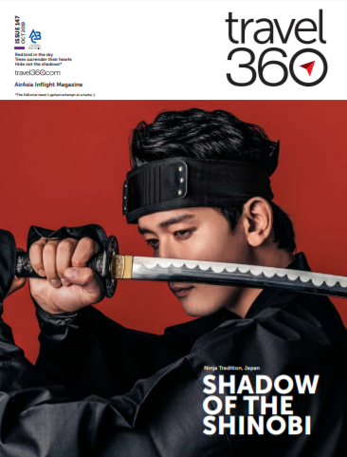

- AirAsia’s (Travel 360) Nov 2019 issue – ad on Butterworth Fringe Festival:
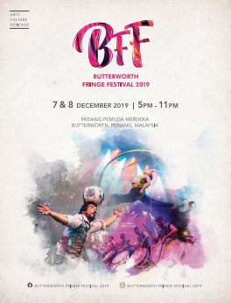
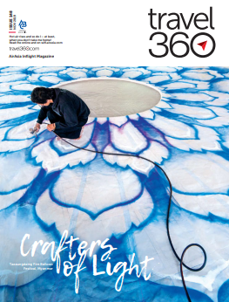

- AirAsia’s (Travel 360) Oct 2019 issue – advertorial on Experience Penang (Festivals):
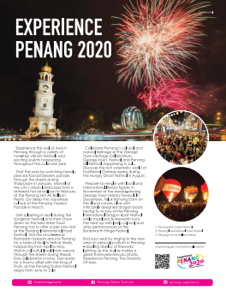
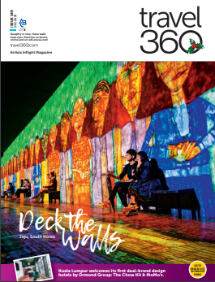

- Emirates’ (Open Skies) Nov 2019 issue – ad on Experience Penang:
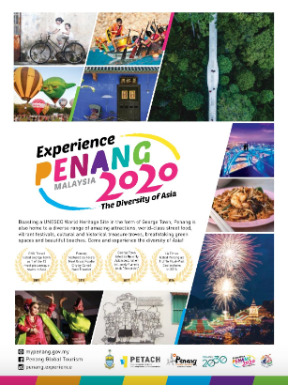
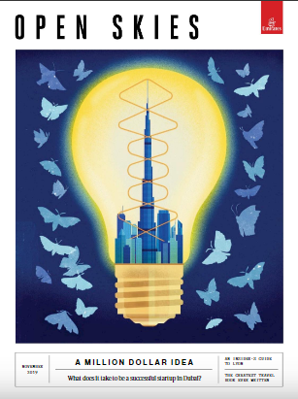

- Emirates’ (Open Skies) Dec 2019 issue – ad on Experience Penang:
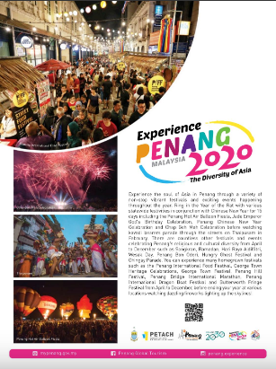
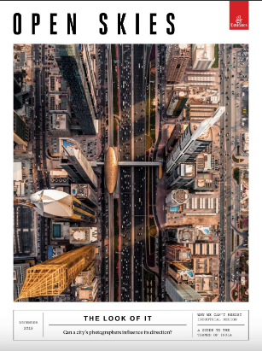

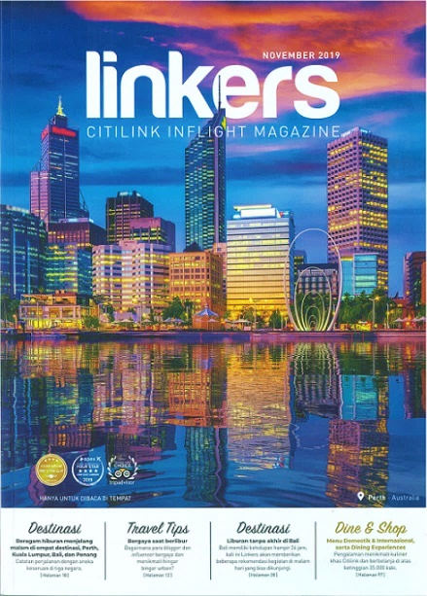
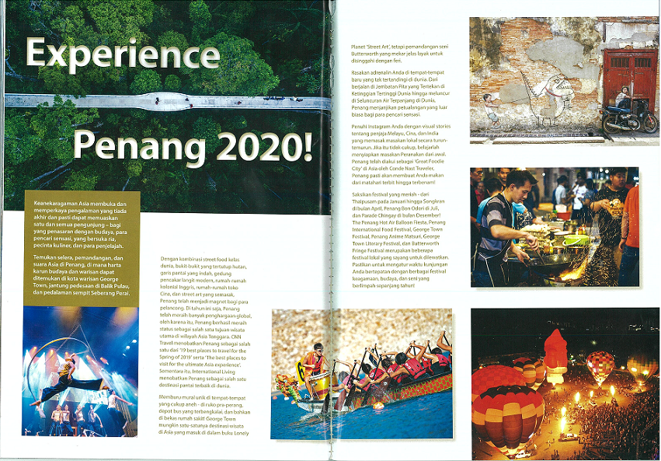
- Citilink’s (Linkers) Nov 2019 issue – double page advertorial on Experience Penang (Overall three pillars):

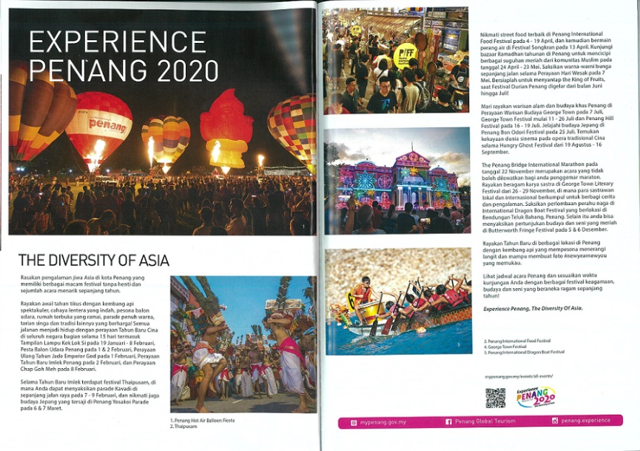
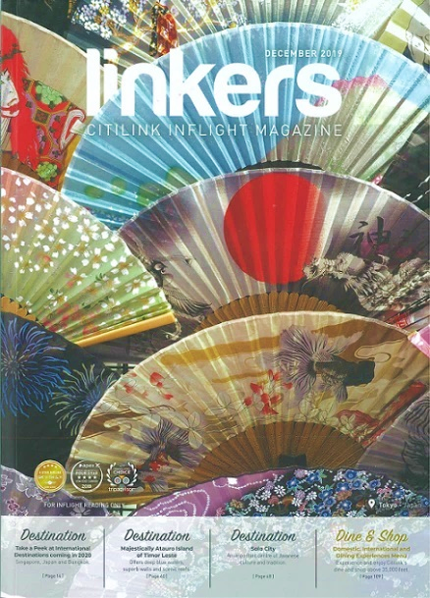
- Citilink’s (Linkers) Dec 2019 issue – double page advertorial on Experience Penang (Festivals):

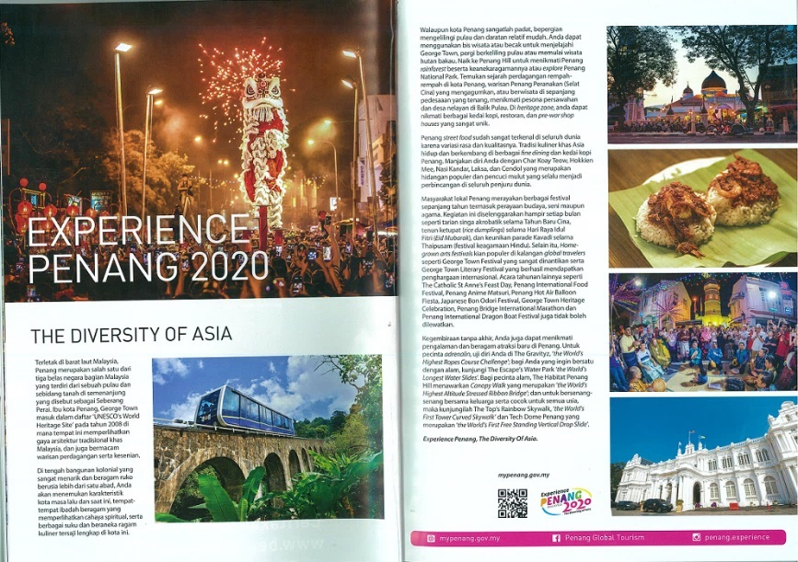
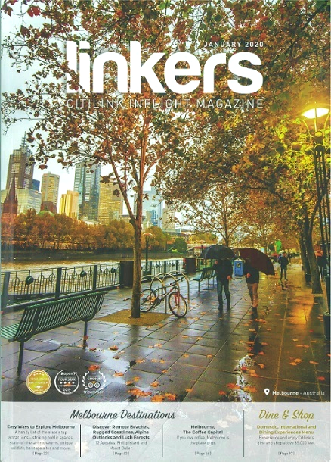
- Citilink’s (Linkers) Jan 2020 issue – double page advertorial on Experience Penang (Heritage & Culture):

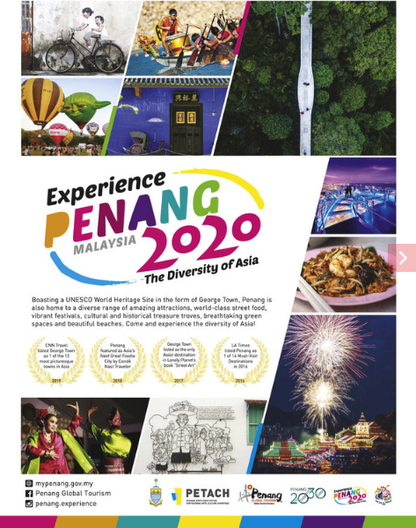
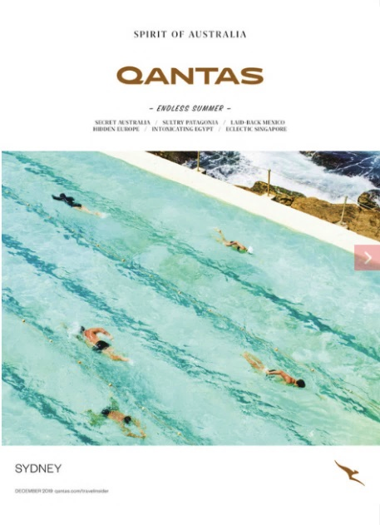
- Qantas Airline’s (Qantas) Dec 2019 issue – ad on Experience Penang:

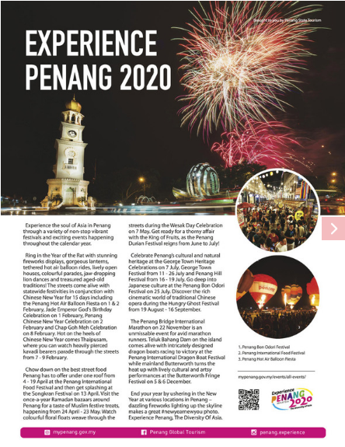
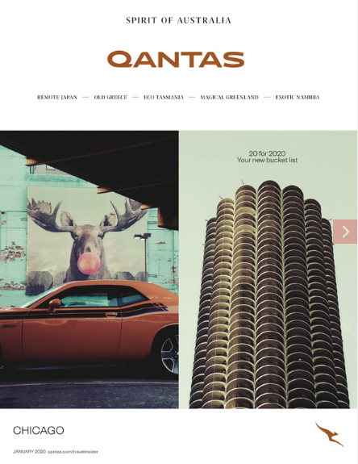
- Qantas Airline’s (Qantas) Jan 2020 – advertorial on Experience Penang (Festivals):

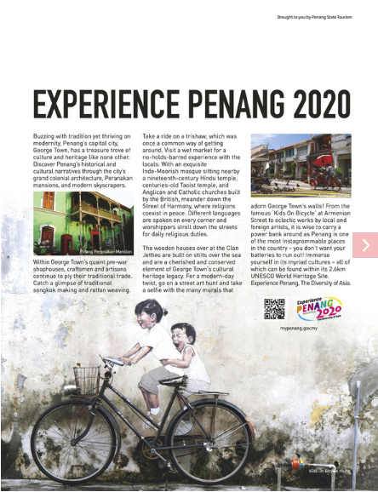
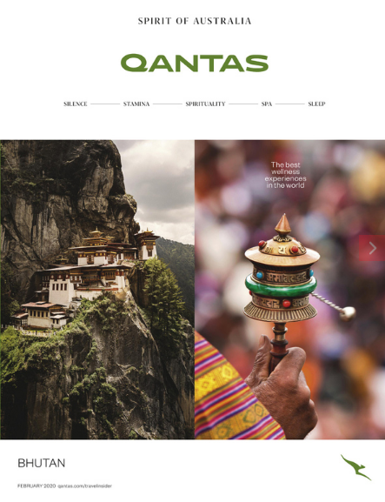
- Qantas Airline’s (Qantas) Feb 2020 – advertorial on Experience Penang (Heritage):

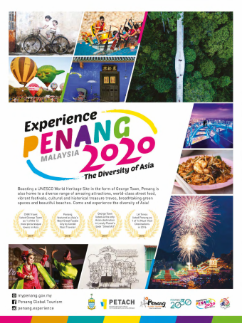
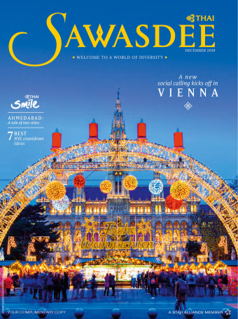
- Thai Airways’ (Sawasdee) Dec 2019 issue – ad on Experience Penang:

- Thai Airways’ (Sawasdee) Jan 2020 – advertorial on Experience Penang (Festivals):
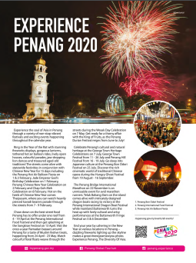
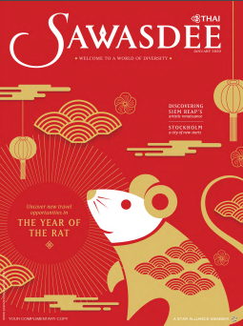

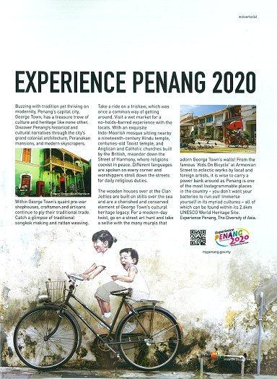
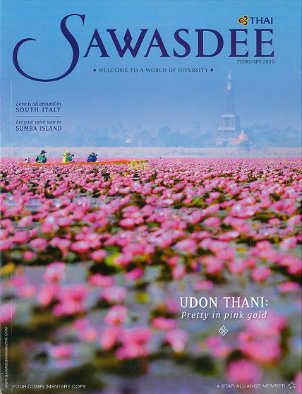
- Thai Airways’ (Sawasdee) Feb 2020 – advertorial on Experience Penang (Heritage):

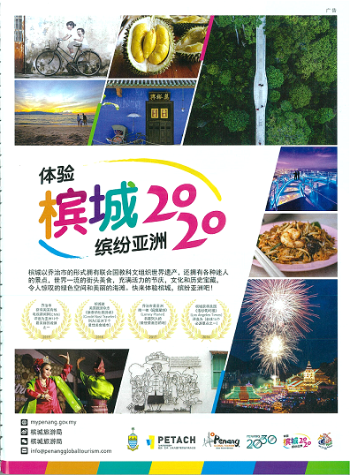
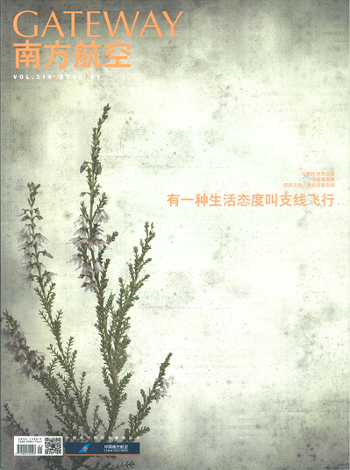
- China Southern Airlines’ (Gateway) Jan 2020 issue – ad on Experience Penang:

3.1.2 Events A&P
In the months of October 2019 to February 2020, PGT advertised and promoted various major events of Penang such as George Town Literary Festival, Penang Street Food Festival, Butterworth Fringe Festival, Penang Hot Air Balloon Fiesta and Penang Yosakoi Parade
where we had spent an estimated A&P cost as follows:

No. | Event | Event Date | Est. A&P Cost (RM)
1 | George Town Literary Festival | 21-24 Nov ‘19 | 40,000
2 | Penang Street Food Festival | 23 & 24 Nov ‘19 | 55,000
3 | Butterworth Fringe Festival | 7 & 8 Dec ‘19 | 80,000
4 | Penang Hot Air Balloon Fiesta | 1 & 2 Feb ‘20 | 75,000
5 | Penang Yosakoi Parade | 7 Mar ‘20 | 15,000

The estimated A&P cost above does not take into account the costing of LED advertising which we’ve signed up a whole year contract for LED screens in the island and mainland, namely at Anson Road, Queensbay, Raja Uda, AutoCity and Gurney Plaza.

PGT also promoted other events via LEDs, website, and social media. These events were on Experience Christmas in Penang, Miaohui Chinese New Year Celebration, Penang Grand Parade, Experience Penang Coastal Run, Penang Celebrates Chap Goh Meh and CM’s CNY Open House.

The following table shows the respective media spaces that were used in May to Sept:
No. | Media Spaces | Events*
1 | Billboards | GTLF, HAB
2 | Rapid Bus wraps | PSFF, BFF, HAB, CNY
3 | Armenian Street Poster | GTLF, PSFF, BFF, PIDBF, HAB, PY, CNY
4 | Airport & TIC Promo Cubes | GTLF, PSFF, BFF, PIDBF, HAB, PY, CNY
5 | LED screens | GTLF, PSFF, BFF, HAB, PY, ECiP, CNY, PGP, EPCR, CGH, CMOH
6 | Lamp post streamers | GTLF, PSFF, BFF, HAB, PY
7 | Print ads (Inflight mags, etc.) | GTLF, PSFF, BFF, PIDBF, HAB, PY
8 | Facebook advertising | GTLF, PSFF, BFF, PIDBF, HAB, PY, CNY, PGP, CGH, CMOH
9 | Website listing | GTLF, PSFF, BFF, PIDBF, HAB, PY, ECiP, CNY, PGP, EPCR, CGH, CMOH
*George Town Literary Festival – GTLF / *Penang Street Food Festival – PSFF /
*Butterworth Fringe Festival – BFF / *Penang Intl Dragon Boat Festival – PIDBF /
*Penang Hot Air Balloon Fiesta – HAB / *Penang Yosakoi – PY / *Exp. Christmas in Pg – ECiP /
*Miaohui CNY Celebration – CNY / *Penang Grand Parade – PGP /
*Exp. Penang Coastal Run – EPCR / *Penang Celebrates Chap Goh Meh – CGM /
*CM’s Open House – CMOH

3.1.3 Billboards
Ads were placed at IJM and Turf Club billboards to promote upcoming events. Note that we have remained the Experience Penang 2020 ad as a base, so that it can be displayed soon after the current event’s ad ends, whilst waiting for the next one to go up.

George Town Literary Festival:

- Penang Turf Club | 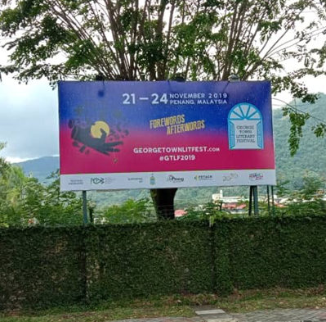
- IJM (Jelutong Expressway) | 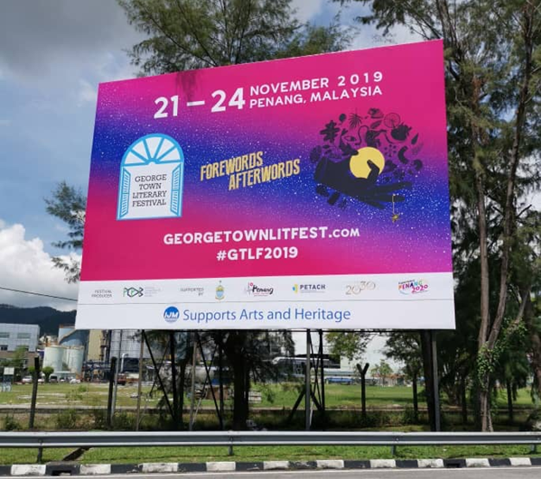

Penang Hot Air Balloon Fiesta:

- Penang Turf Club | 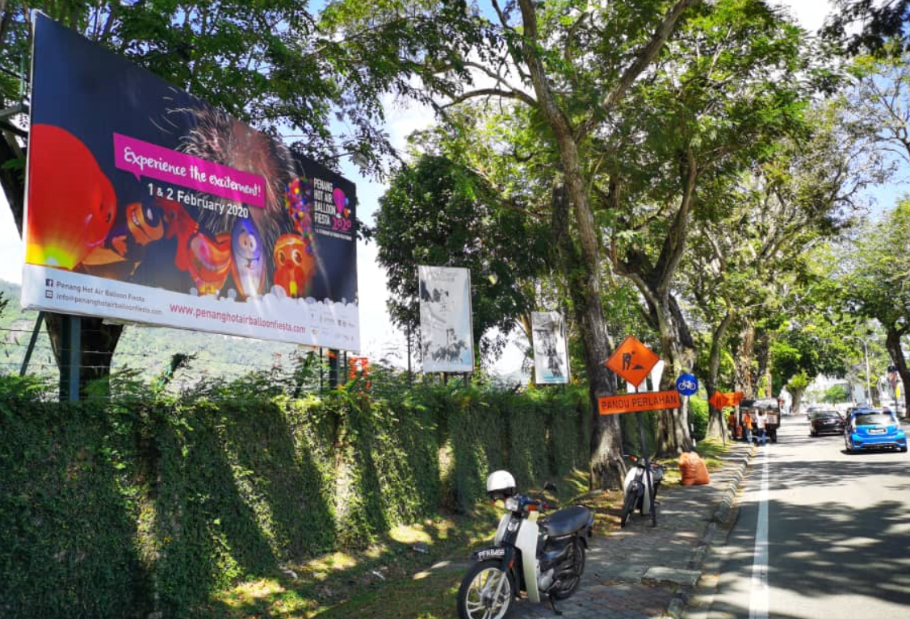
- IJM (Jelutong Expressway) | 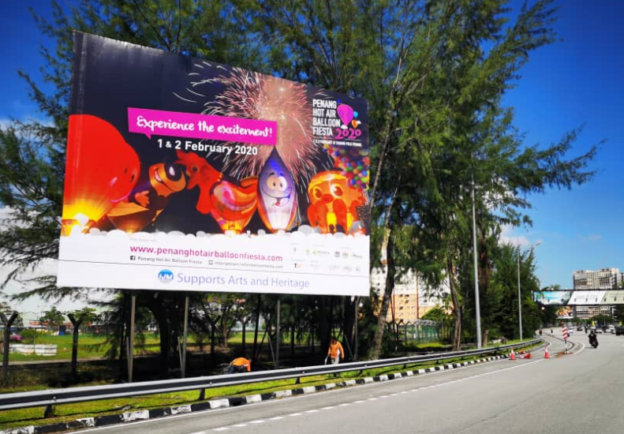

3.1.4 Rapid Bus Wraps

Penang Street Food Festival – the bus wrap included 1 x CAT bus, 2 x Sungai Nibong (304), 2 x Teluk Bahang (101) and 2 x Mak Mandin (701) route buses that started in Nov 2019, for a month.
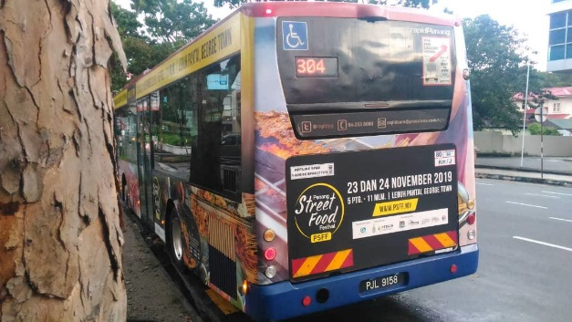
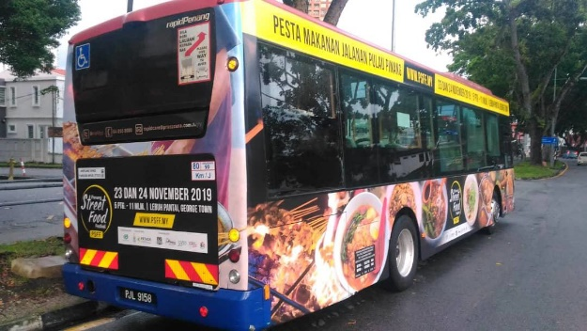

No. | Bus Route | Bus Plate No.
1. | CAT (Weld Quay) | PJG 965
2. | 304 (Sungai Nibong) | PJJ 7259
3. | 304 (Sungai Nibong) | PJJ 9158
4. | 101 (Teluk Bahang) | PLA 2891
5. | 101 (Teluk Bahang) | PLA 2920
6. | 701 (Mak Mandin) | PJG 4309
7. | 701 (Mak Mandin) | PJJ 4761

Butterworth Fringe Festival – the bus wrap included 1 x Airport (AT) and 1 x Teluk Bahang (101) buses that started in Oct 2019, for a month.
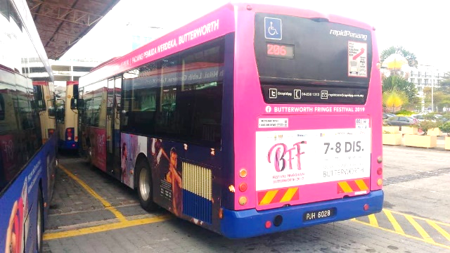
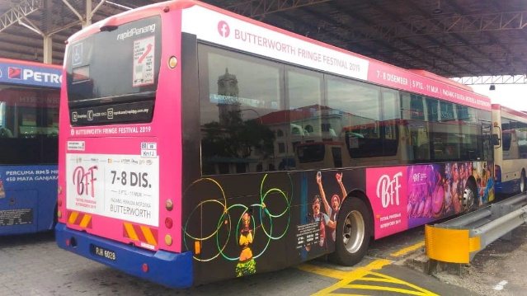

No. | Bus Route | Bus Plate No.
1. | CAT (Weld Quay) | PKY 1286
2. | AT (Airport) | PJH 6028

Chinese New Year Celebration (Miaohui) – the bus wrap included 1 x CAT bus that started in Dec 2019, for a month.
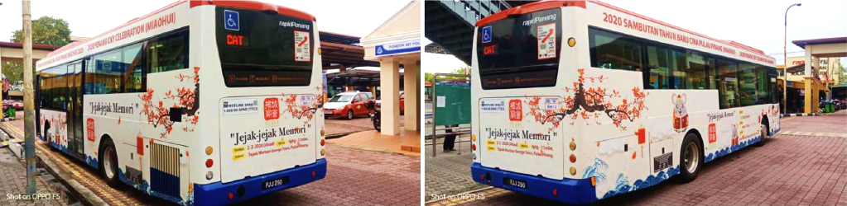

No. | Bus Route | Bus Plate No.
1. | CAT (Weld Quay) | PJJ 290

Penang Hot Air Balloon Fiesta – the bus wrap included 1 x CAT bus, 2 x Airport (AT), 1 x Sungai Nibong (304) 1 x Teluk Bahang (101) and 2 x Mak Mandin (701) route buses that started in Dec 2019, for a month.
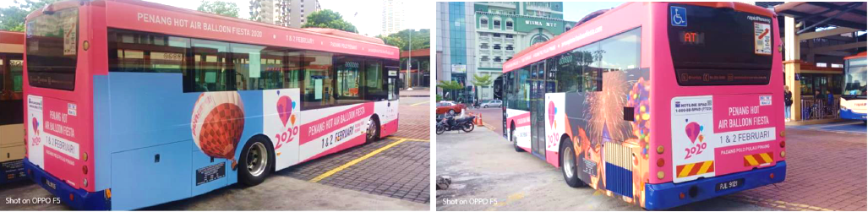

No. | Bus Route | Bus Plate No.
1. | CAT (Weld Quay) | PJH 197
2. | AT (Airport) | PJL 9121
3. | AT (Airport) | PJH 2920
4. | 304 (Sungai Nibong) | PJJ 5227
5. | 101 (Teluk Bahang) | PJL 9105
6. | 701 (Mak Mandin) | PJL 9087
7. | 701 (Mak Mandin) | PKX 3384

3.1.5 Promo CUBEs at Airport & TIC – the four sides of the CUBEs were changed to advertise Penang Hot Air Balloon Fiesta, Experience Penang Coastal Run, Penang Chinese New Year Celebration (Miaohui) and Penang Yosakoi Parade.
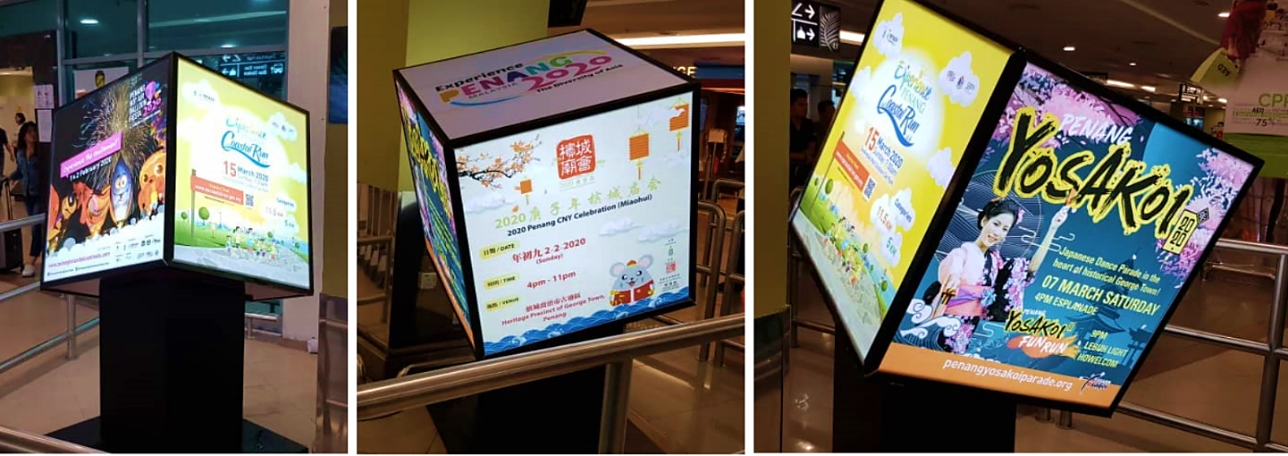

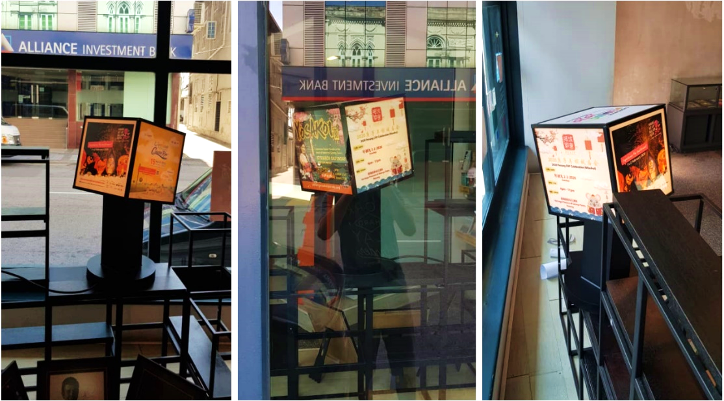

3.1.6 Armenian Street Posters – on Penang Street Food Festival, Penang Chinese New Year Celebration (Miaohui) and Penang Hot Air Balloon Fiesta:
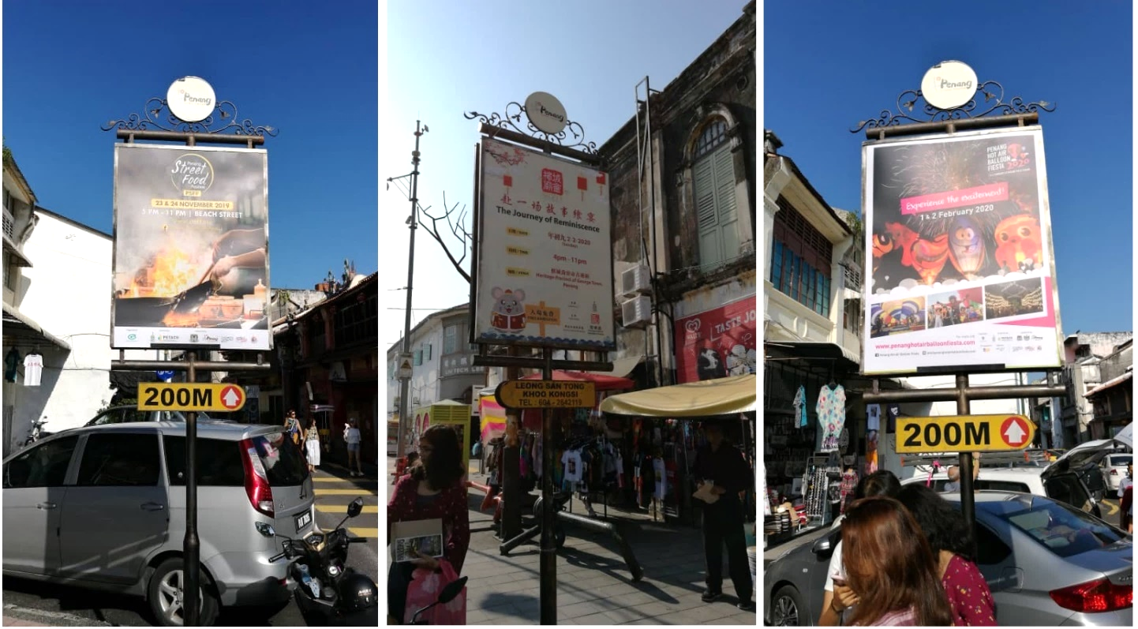

Armenian Street Posters – on George Town Literary Festival, Butterworth Fringe Festival and Penang International Dragon Boat Festival:
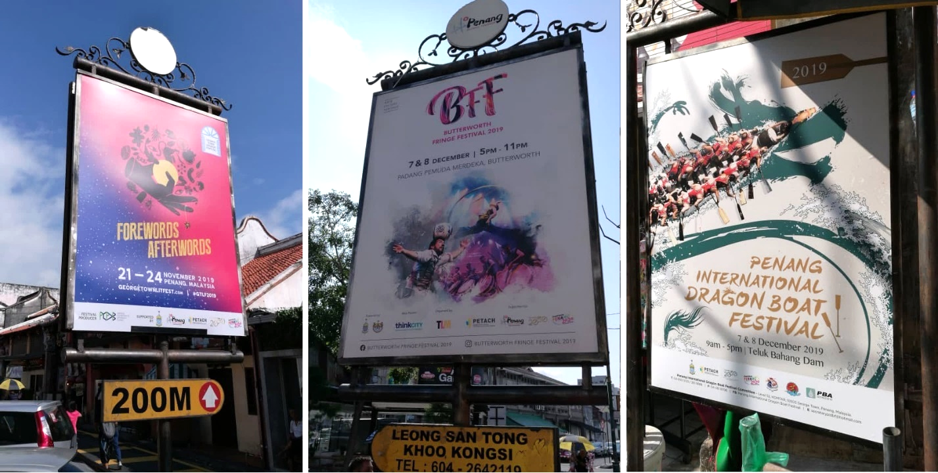

3.1.7 LED board – Anson Road (by Optimal Media)
George Town Literary Festival  13 Oct – 25 Nov | 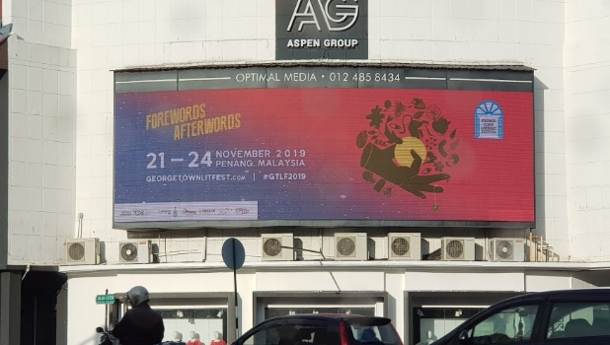
Penang Street Food Festival  25 Oct – 25 Nov | 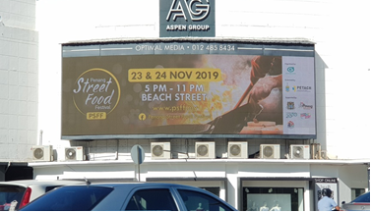
Butterworth Fringe Festival  25 Oct – 9 Dec | 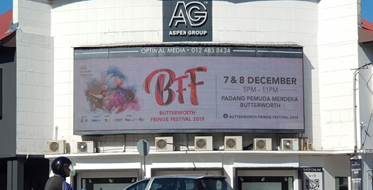
Experience Christmas in Penang  28 Nov – 9 Dec | 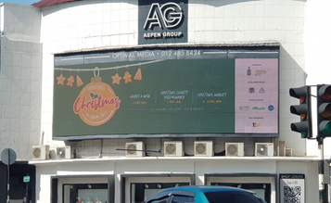
Penang Chinese New Year Celebration (Miaohui)  13 Dec – 3 Feb | 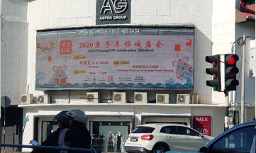
Penang Grand Parade  23 Dec – 2 Jan | 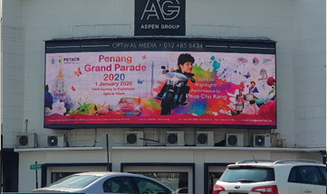
Penang Hot Air Balloon Fiesta  23 Dec – 3 Feb | 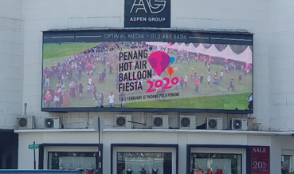
Experience Penang Coastal Run  6 Jan – 26 Feb | 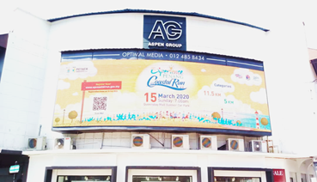
Chief Minister’s CNY Open House  17 Jan – 27 Feb | 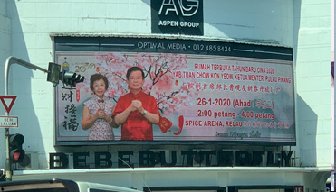
Penang Celebrates Chap Goh Meh  15 Jan – 9 Feb | 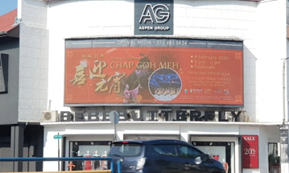
Penang Yosakoi Parade  11 Feb – Current | 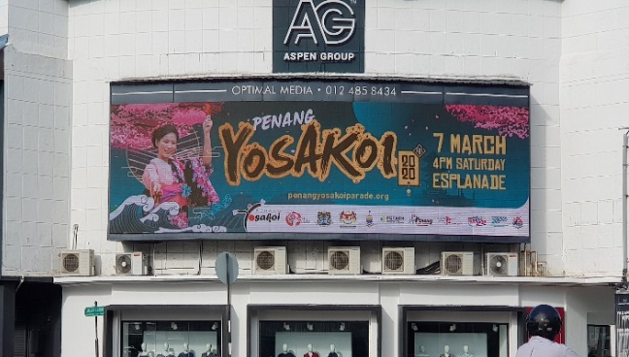

3.1.8 LED boards– AutoCity, Queensbay and Raja Uda (by Performance Plus)
AutoCity, Queensbay,  Raja Uda | George Town Literary Festival  13 Oct – 25 Nov | 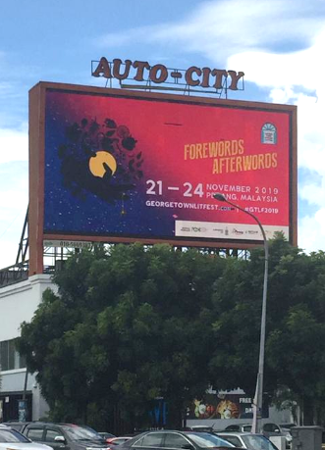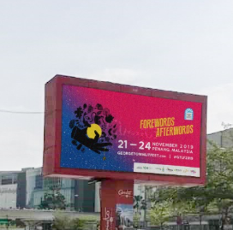
AutoCity, Queensbay,  Raja Uda | Penang Street Food Festival  25 Oct – 25 Nov | 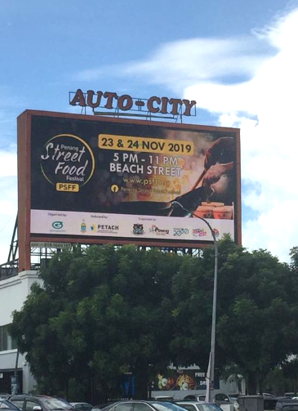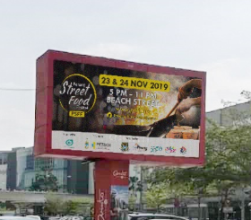
AutoCity, Queensbay,  Raja Uda | Butterworth Fringe Festival  25 Oct – 9 Dec | 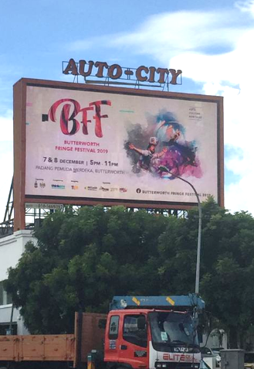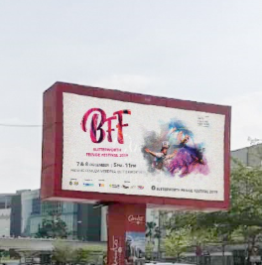
AutoCity, Queensbay, | Experience Christmas in Penang  28 Nov – 9 Dec | 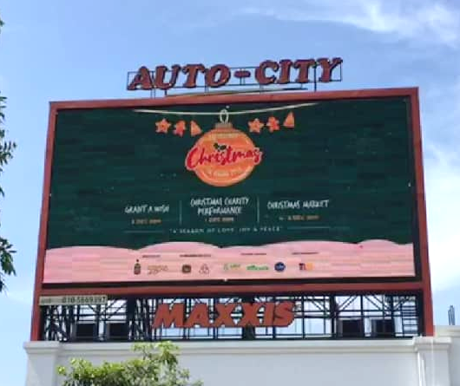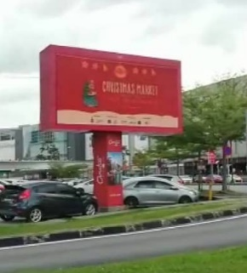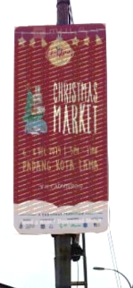
AutoCity, Queensbay,  Raja Uda | Penang Chinese New Year Celebration (Miaohui)  13 Dec – 3 Feb | 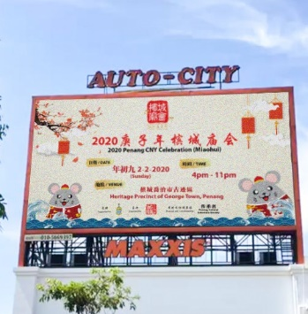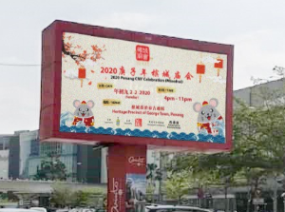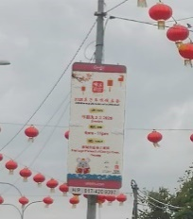
AutoCity, Queensbay,  Raja Uda | Penang Grand Parade  23 Dec – 2 Jan | 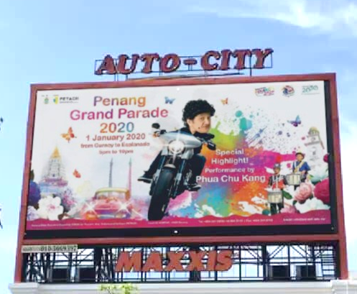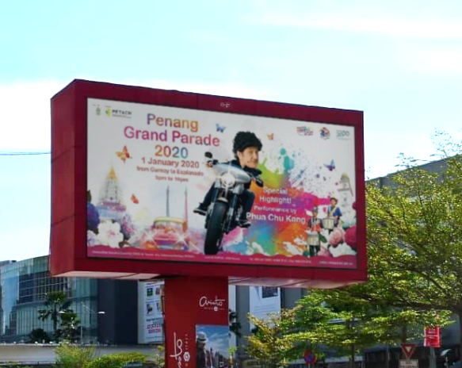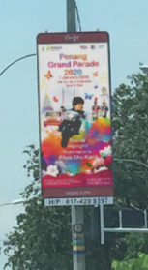
AutoCity, Queensbay,  Raja Uda | Penang Hot Air Balloon Fiesta  23 Dec – 3 Feb | 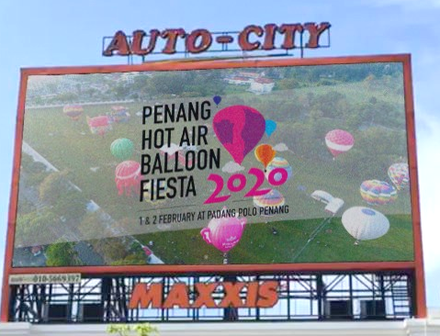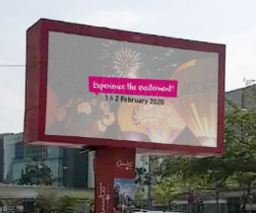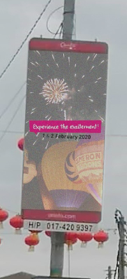
AutoCity, Queensbay,  Raja Uda | Experience Penang Coastal Run  6 Jan – 26 Feb | 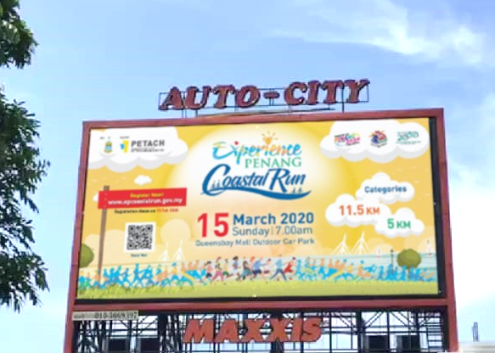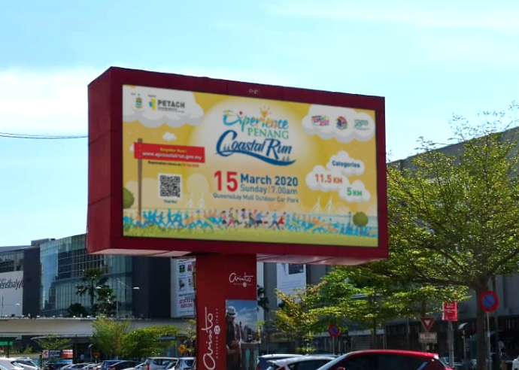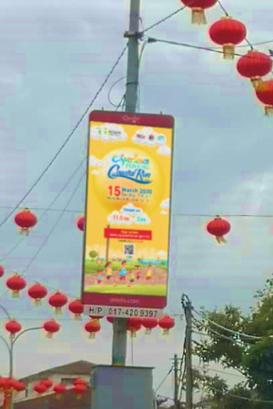
AutoCity, Queensbay,  Raja Uda | Chief Minister’s CNY Open House  17 Jan – 27 Feb | 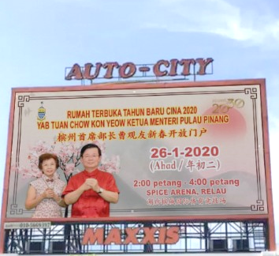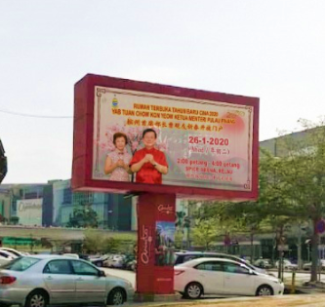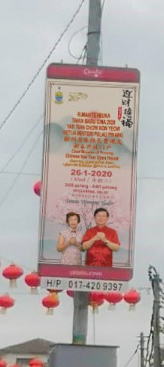
AutoCity, Queensbay,  Raja Uda | Penang Celebrates Chap Goh Meh  15 Jan – 9 Feb | 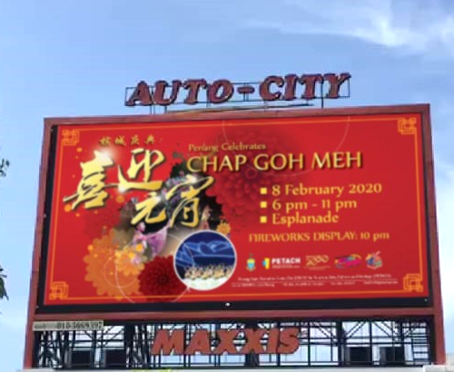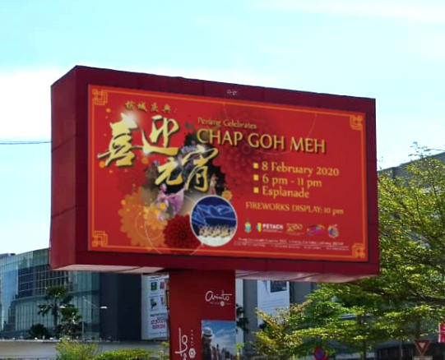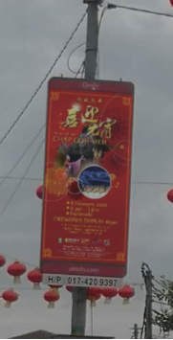
AutoCity, Queensbay,  Raja Uda | Penang Yosakoi Parade  11 Feb – Current | 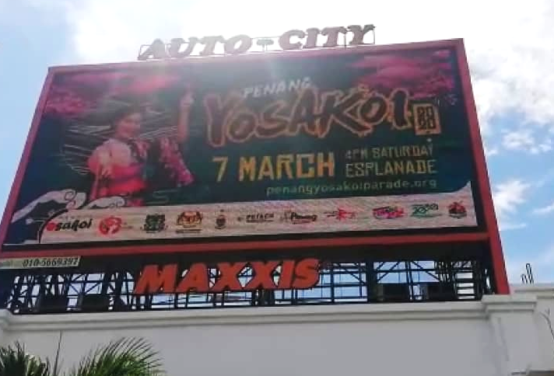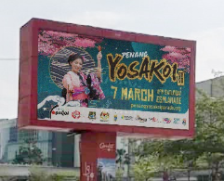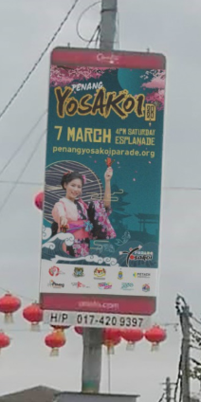

3.1.9 LED board – Gurney Plaza (by Performance Plus)
This LED board is located in the main atrium of the shopping complex. The advertising comprises 130 spots per day that loops every 8-10 minutes.

George Town Literary Festival  13 Oct – 25 Nov | 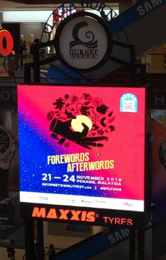
Penang Street Food Festival  25 Oct – 25 Nov | 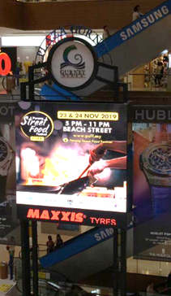
Butterworth Fringe Festival  25 Oct – 9 Dec | 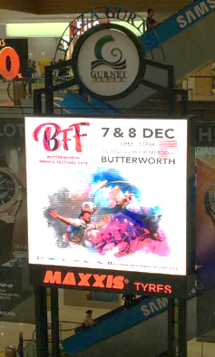
Penang Hot Air Balloon Fiesta  23 Dec – 3 Feb | 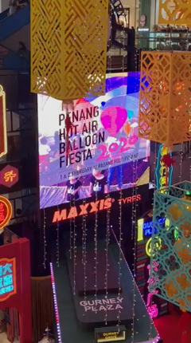

Experience Penang 2020  - Ongoing | 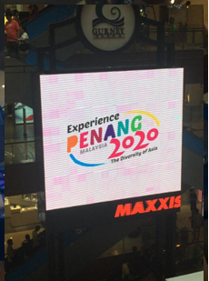

3.1.10 New Communication Materials (Updates & New)

The Other Side Of The Island - Teluk Bahang and Balik Pulau Brochures:
We have just completed the Teluk Bahang and Balik Pulau brochures that focuses on its places of interest and special features it respectively has. Both brochures underwent thorough checks to ensure the places and operators are current with updated information.

Balik Pulau Brochure – Cover | Balik Pulau Brochure – Inside
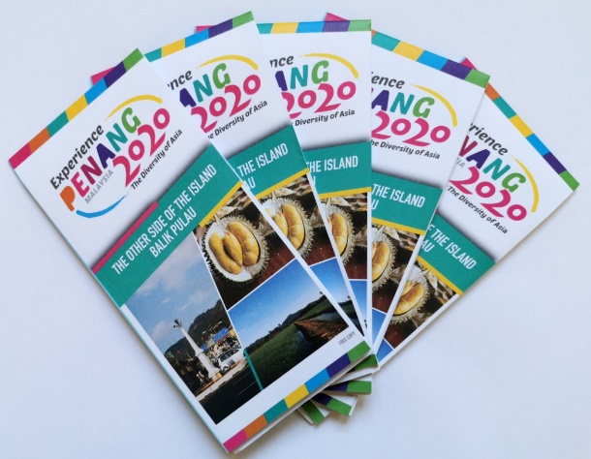 | 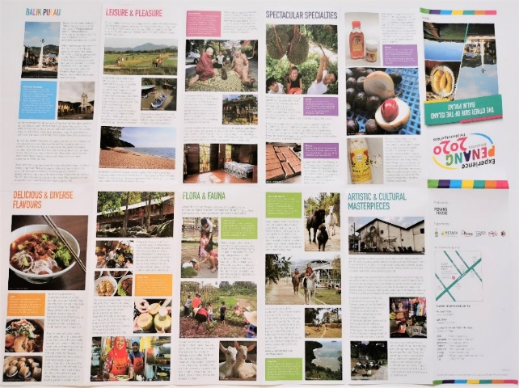

Balik Pulau Brochure – Map
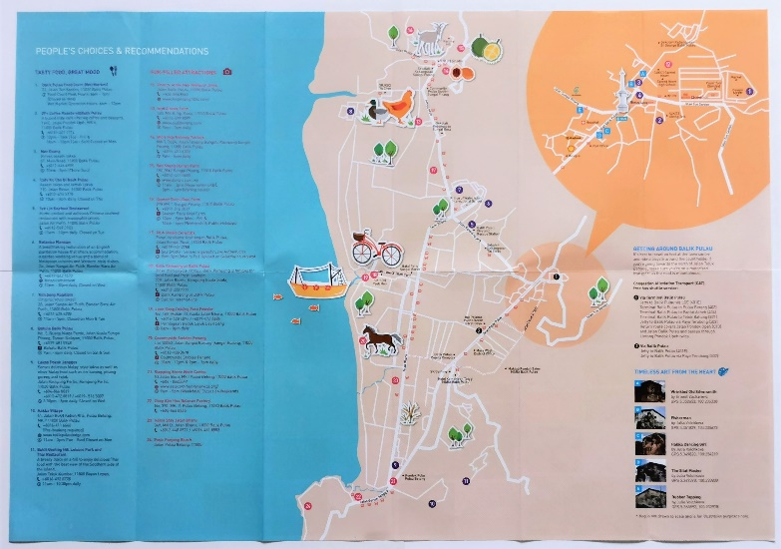

3.1.10 New Communication Materials (Updates & New)

The Other Side Of The Island - Teluk Bahang and Balik Pulau Brochures:
We have just completed the Teluk Bahang and Balik Pulau brochures that focuses on its places of interest and special features it respectively has. Both brochures underwent thorough checks to ensure the places and operators are current with updated information.

Teluk Bahang Brochure - Cover | Teluk Bahang Brochure – Inside
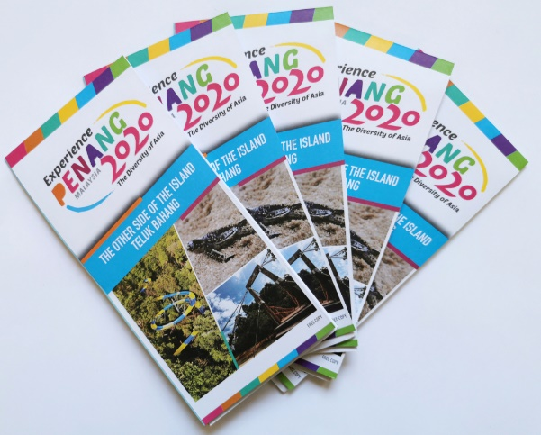 | 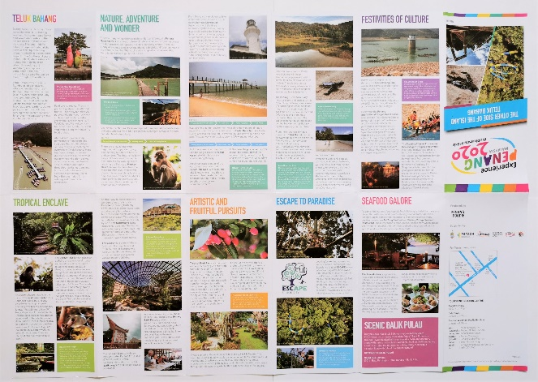

Teluk Bahang Brochure - Map
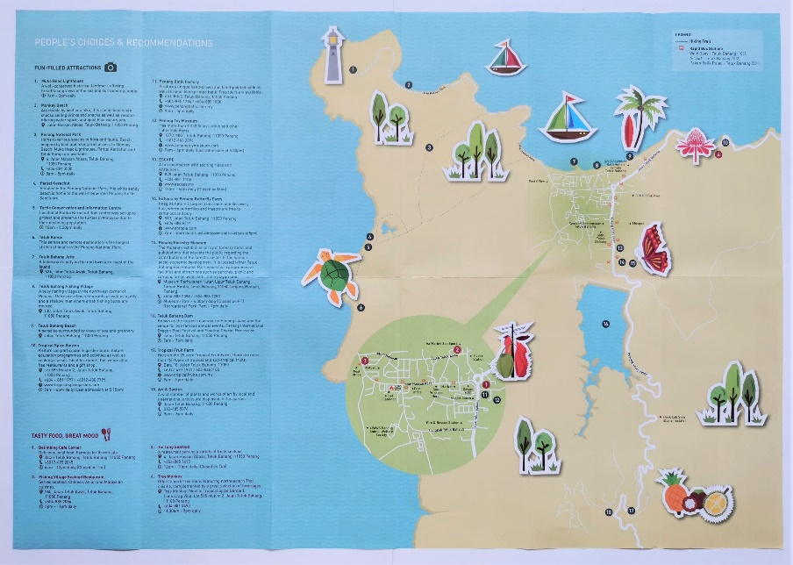

Seberang Perai Tourist Map and Street Food Brochures:
We have also just completed the Seberang Perai Brochures that focuses on places of interests as well as food. Both of these brochures underwent extensive checks and updates to ensure the places and operators are current. We also engaged the agency to take the latest photos of all that was included in both brochures.

Seberang Perai Tourist Map

Seberang Perai Street Food Brochure

Calendar of Events (COE) 2020 brochure:
We completed the COE2020 booklets - English and Simplified Chinese languages in January and February respectively. We also completed translating and producing the COE into a simplified foldable version, highlighting only the main events to seven other languages – Japanese, Korean, Thai, Vietnamese, Indonesian, Arabic and German.

The series of COE2020 – Booklets in English & Simplified Chinese:
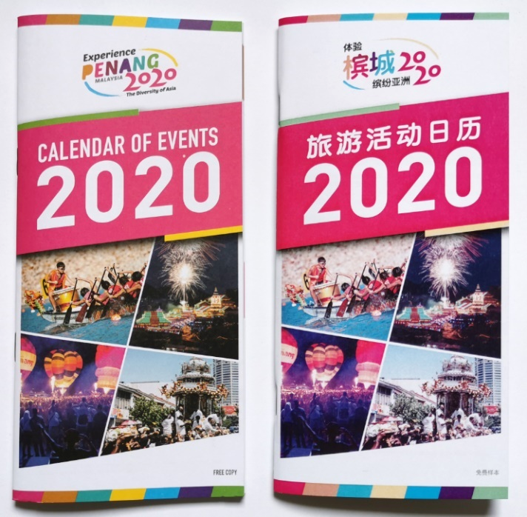

The series of COE2020 – Foldables in Japanese, Korean, Thai, Vietnamese, Indonesian, Arabic and German:
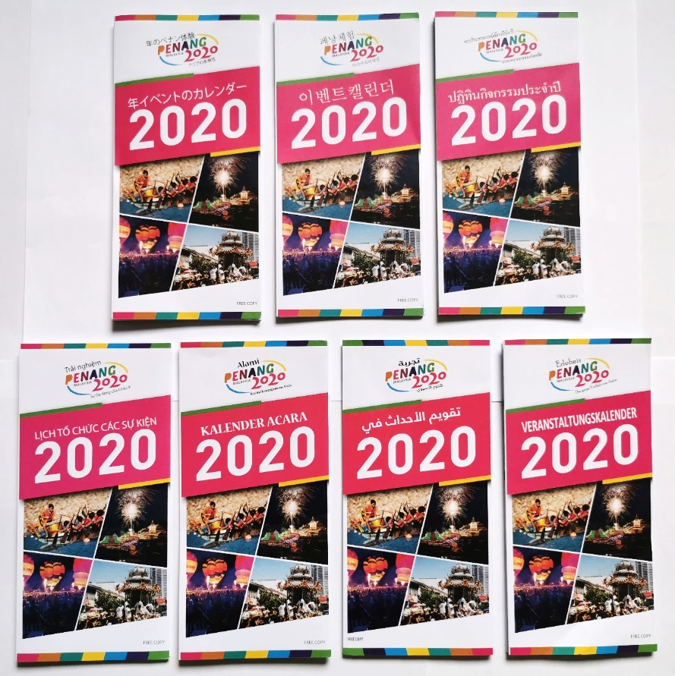

Calendar of Events (COE) 2020 brochure:
We completed the COE2020 booklets - English and Simplified Chinese languages in January and February respectively. We also completed translating and producing the COE into a simplified foldable version, highlighting only the main events to seven other languages – Japanese, Korean, Thai, Vietnamese, Indonesian, Arabic and German.

The series of COE2020 – Booklets in English & Simplified Chinese:
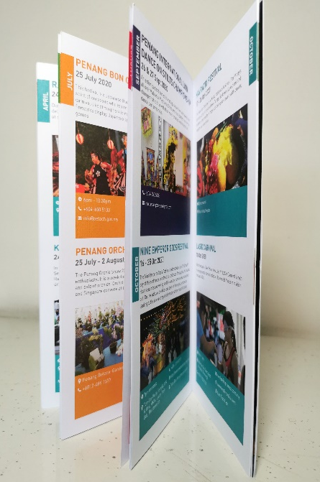

The series of COE2020 – Booklets in English & Simplified Chinese:
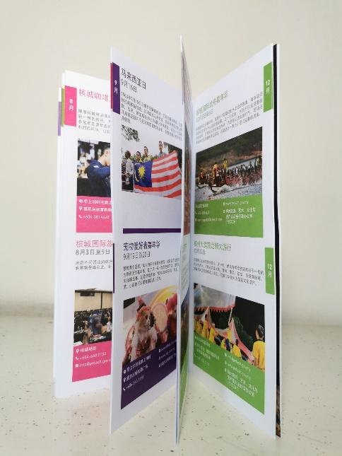

Last Friday, Saturday & Sunday (LFSS) brochure:
The LFSS brochure comprises a list of events happening in Penang during month ends. This brochure is updated and printed every quarter of the year. The following are visuals of the completed 2019’s 4th quarter (Oct-Dec) and 2020’s 1st quarter (Jan-Mar).

LFSS brochure (Q4) 2019:
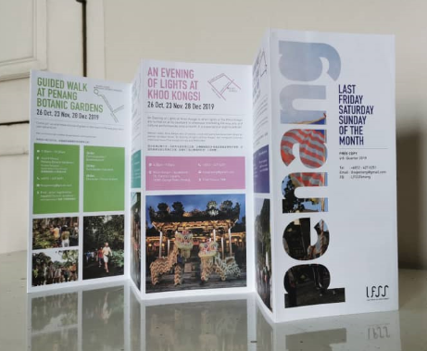

LFSS brochure (Q1) 2020:
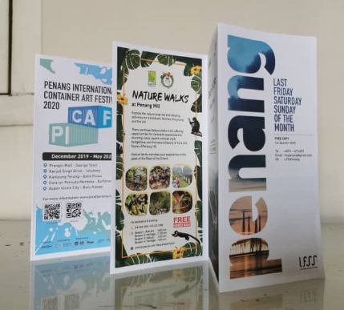

3.1.11 ASTRO Radio Advertising
PGT undertook a radio advertising campaign to promote Butterworth Fringe Festival that was aired via four of its radio stations, namely MIX, SINAR, MELODY and RAAGA from 11 to 17 Nov 2019. A Tamil station was also included to ensure inclusivity targeting all sects of the community. ASTRO Radio extended a buy one free one deal for this campaign where for every 35 spots per station, we were given an additional 35 spots complimentary. Breakdown as follows:
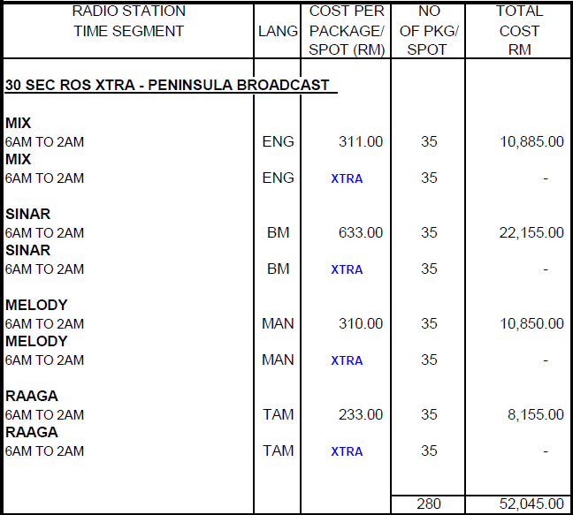

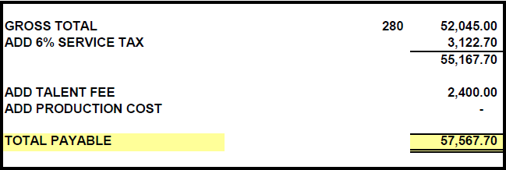

3.1.12 Domestic OOH Advertising – Covered Walkways
The OOH advertising on Covered Walkways were completed end of Feb 2020. The ads will be up for 12 months, located in KL’s city centre at Jalan Sultan Ismail and Jalan Raja Chulan fronting Wisma Genting and Wisma Cosway respectively. The vehicle traffic at both these locations are approximately 3.6 mil and 2.5mil respectively on a monthly basis. An unveiling will be undertaken on 12 March, on the same day as our KL roadshow. Included in the ads were street art where people can take photos with and upcoming events which will be changed every quarter. Photos of some of the completed Covered Walkway ads:
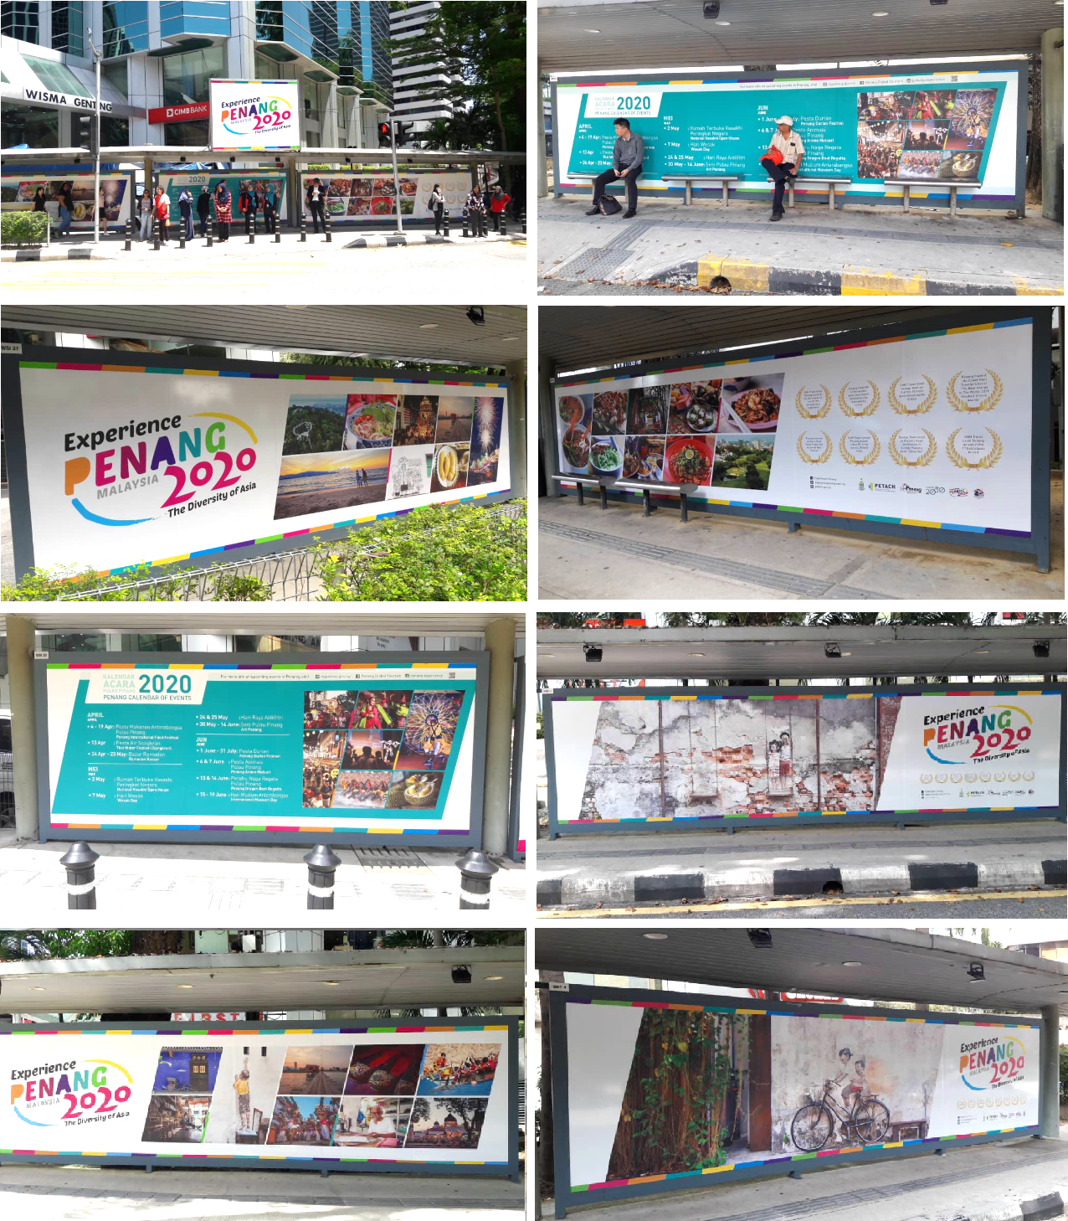

3.1.13 Concept Wall & Travellator Panel in Singapore’s Dhoby Ghaut MRT Station
The advertising campaign undertaken in Singapore kicked off on 16 Dec 2019 for 8 weeks to promote EPY2020 in the Dhoby Ghaut MRT Station. This A&P space entails the Concept Wall + Travellator Panel. The Concept Wall includes 4x Lightboxes where the length of the travellator is 54.4m and the concept wall is 45m. Dhoby Ghaut has the highest footfall, being a highly used transit station by commuters in Singapore where its footfall/traffic is approximately 11.5mil every month. The advertising not only reaches the local Singaporeans but also foreign expats and tourists who commute via the MRT. Photos of the completed travellator ad:
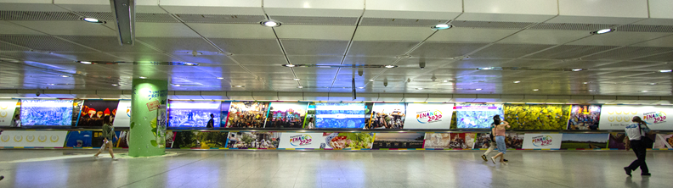

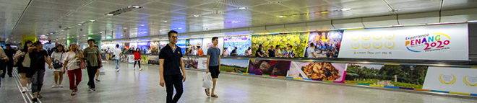

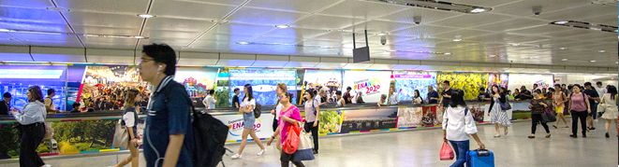

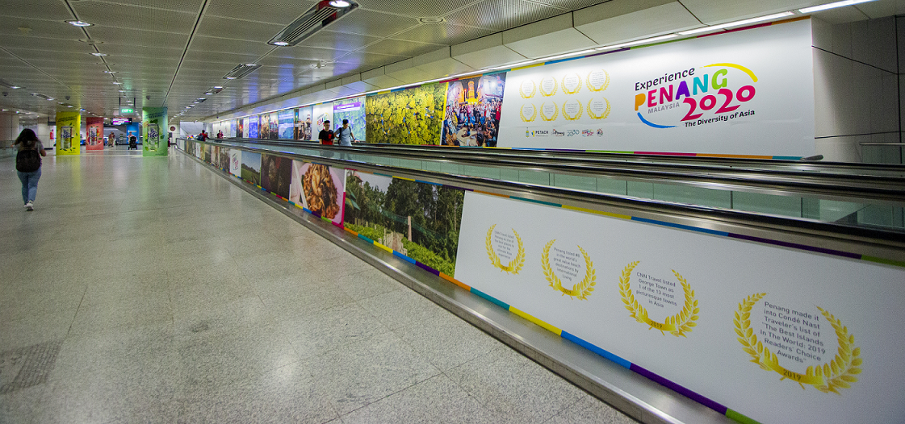

3.1.14 “U” Shaped Escalator Wall Ad at Taipei’s Ximen MRT Station
The advertising campaign in Taipei’s Ximen MRT station started just after the New Year of 2020 where the “U” Shaped Escalator Wall ad will be up until end of March. Ximen has the highest footfall, being a highly used transit station by commuters where its footfall/traffic is approximately 4.8 million people every month.

Photo of “U” Shaped Escalator Wall Ad at Ximen MRT Station:
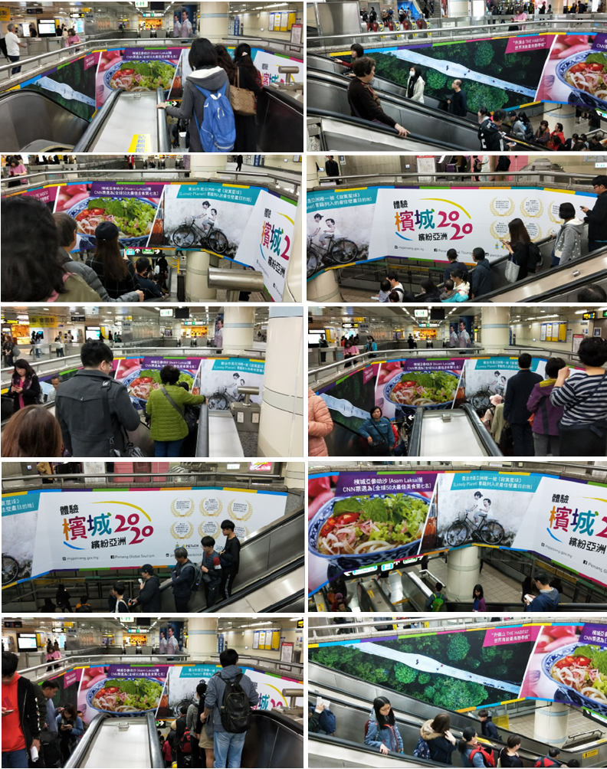

3.1.15 Bus wraps in Taipei
The Taipei advertising campaign also includes wrapping of 10 buses on both sides with extended window stickers. The buses were wrapped in December 2019 for over 7 months, ending in June 2020.

Photos of the two-sided wrapped buses with extended window stickers:
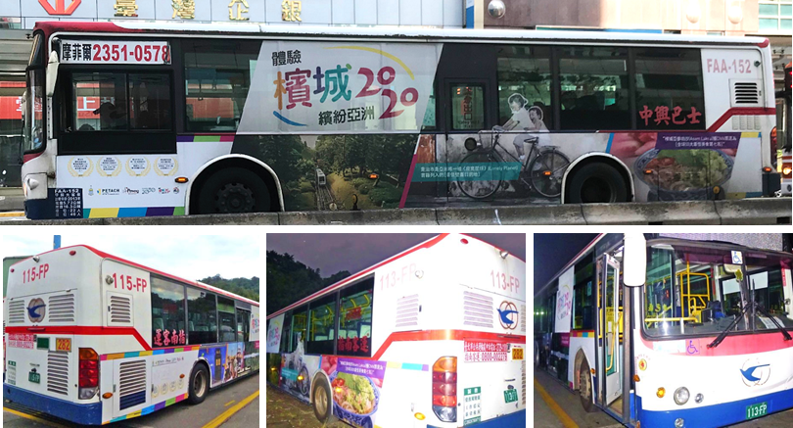

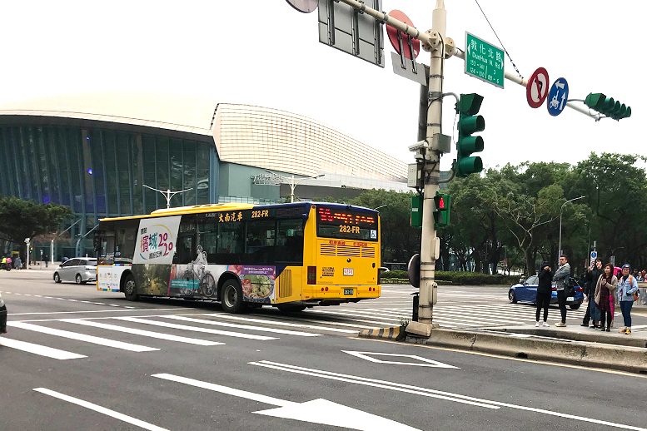

3.1.16 New Videos

HAB Promo Video
Footages of HAB2019 was edited and a video was produced to promote HAB2020 which was used via our social media platforms plus advertised on our LED screens and Airport TV. Footages also included The Path and Free Flying. Here are shots of the video:
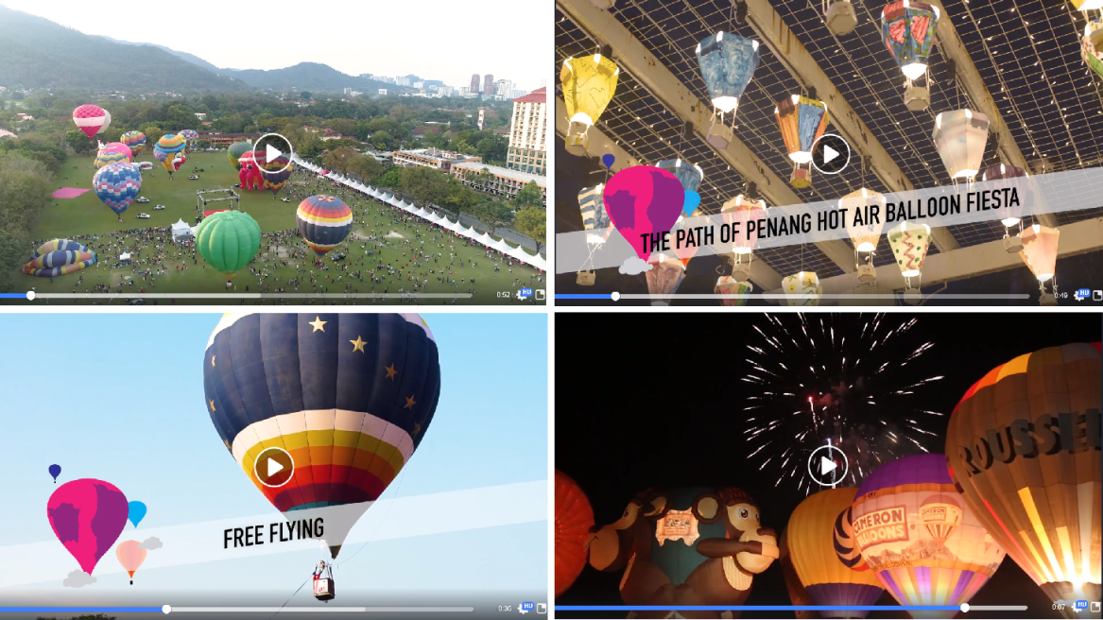

COE2020 Compilation Video
A video compilation of the annual events and festivals in Penang was produced to showcase the non-stop happenings we have here throughout the year. The footages were all taken from existing videos that were produced before such as those in “Festivals in a Box”. This fast-paced video will be especially used during our EPY roadshows this year. Here are shots of the video:
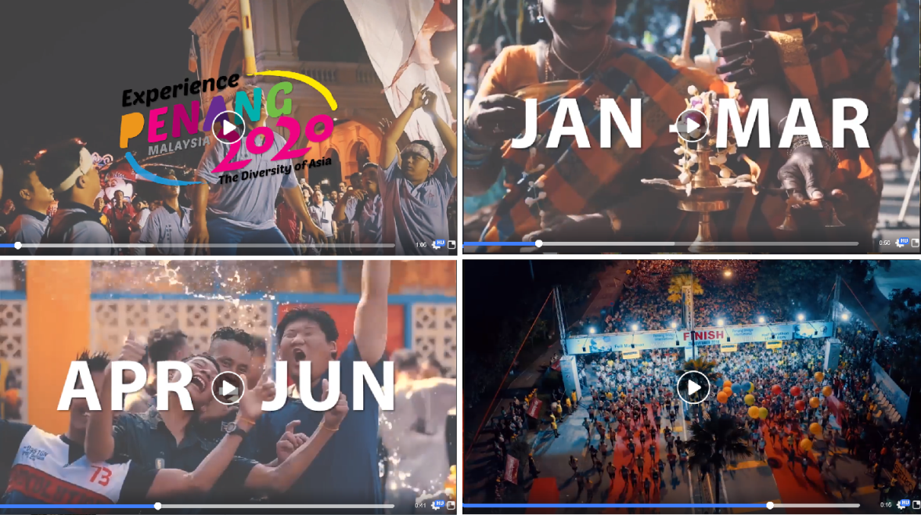

“Wuhan Jiayou” Video
In light of the rapidly evolving COVID-19 outbreak originating in Wuhan, at the initial stages when the virus started and many of the Chinese citizens were quarantined, we produced this video (“We Support Wuhan – Wuhan Jiayou”) to show our support towards those who were in their dire straits. Video clips of various industry players were compiled and put together for this video. It was shared via our social media platforms, especially Weibo, Wechat and Douyin. Here are shots of the video:
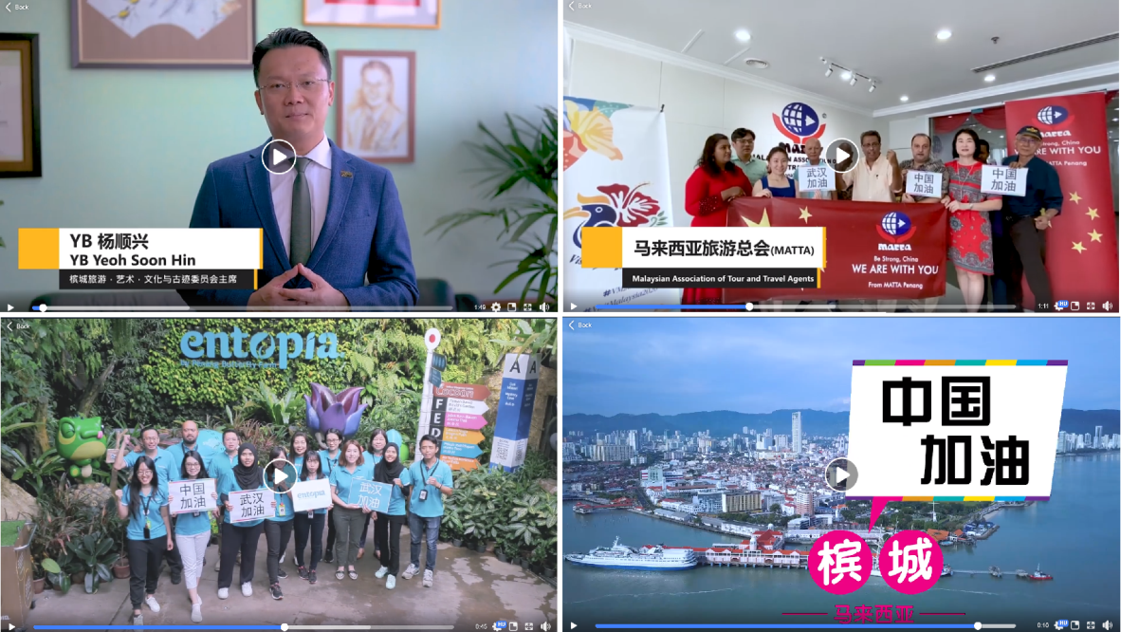

“Penang Welcomes You” Video
As part of the immediate recovery action plan, where a concerted effort is being put in place to recover the decline of businesses in the tourism sector, a video was produced to showcase that Penang is a safe place and visitors can travel here with peace of mind. This video involved various tourism industry players such as MAH, MCTA, MATTA, ATAP and Penang Port. It mainly highlights the various preventive measures such as cleaning and sanitising being undertaken at the respective areas involving the travel trade.
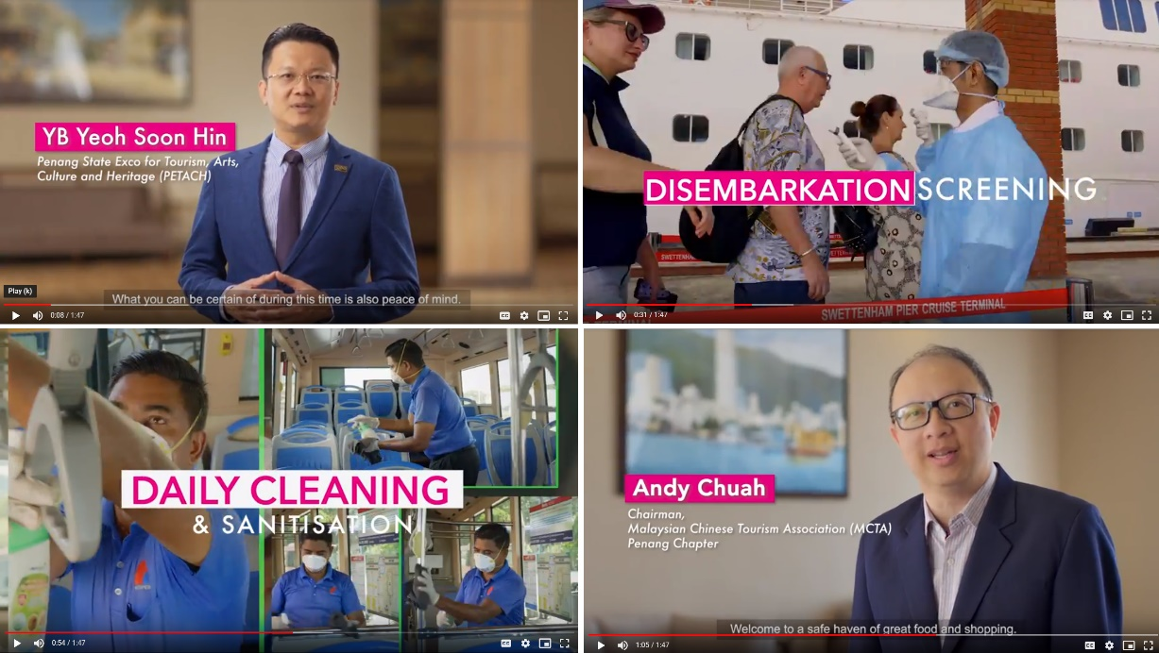

Penang Here & Now Video - Update
The Penang Here & Now video that mainly showcases the latest attractions in Penang and focuses its superlatives, was updated. Two new footages were added which were Escape’s world’s longest slide and Sia Boey – the first urban archaeological park in Malaysia. Here are shots of the video:
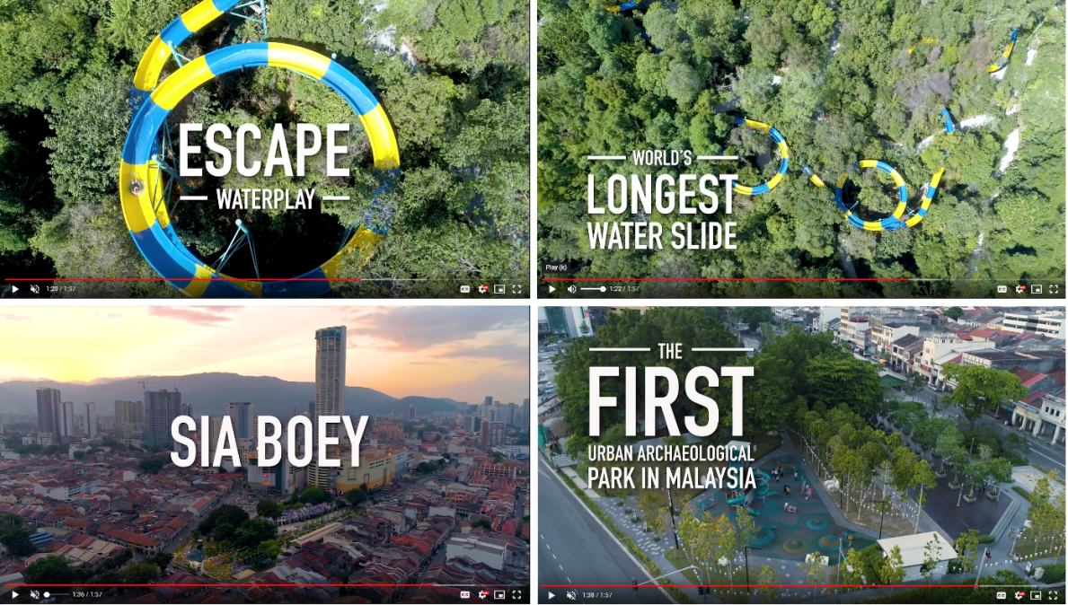

3.2 Updates

3.2.1 Accolades Video
We are currently producing a new accolades video where it will include the accolades received in the recent years from international media such as Conde Nast Traveler, Lonely Planet, The Telegraph, CNN Travel and International Living – where a total of 6 accolades are highlighted. The content/footages of the video will correlate with each of the featured accolade. However, it will also include and cover all other attributes of Penang.

3.2.2 Print Advertising – Inflight Magazine of SIA and SilkAir (SilverKris & Silkwinds)
As per 2019, we will be placing a series of advertorials in the inflight magazines of Singapore Airlines (Silverkris) and SilkAir (Silkwinds) in 6 issues of each publication for year 2020.

SilverKris
Inflight magazine of Singapore Airlines (SIA) – flies to 370 destinations in 86 countries worldwide via 3,400 flights with 1.6 million monthly passengers. The majority of SIA’s flights are long haul where it gives enough time to enjoy all of its on-board services.

Silkwinds
Inflight magazine of SilkAir, wholly owned subsidiary of SIA – flies to 52 cities in 16 countries via 3,320 flights, which includes 35 direct flights to Penang every week.

We will be advertising in 6 issues of each publication in the months of Feb, Mar, June, July, Oct and Dec. Ink Publishing will continue to provide free editorial services for all the advertorials.

3.2.3 Print Advertising – Inflight Magazine of AirAsia (Travel 360)
We will be placing a series of ads and advertorials in Travel 360 again this year for 6 issues from July to December. AirAsia has over 70mil passengers per year, with 4,983 weekly flights covering 232 destinations, with 22 hubs located in Malaysia, Thailand, Indonesia, India, Philippines and Japan. Also to note, there is a total of 110 weekly direct international flights and 218 weekly direct domestic flights via AirAsia to Penang.

3.2.4 Print Advertising – Inflight Magazine of Emirates (Open Skies)
This year too, we will be advertising in Open Skies the inflight magazine of Emirates Airlines for 3 issues – April, July and November 2020. 2020 promises to be an excellent year for Emirates as it will celebrate the EURO 2020 football, Tokyo Olympics, T20 Cricket World Cup in Australia as well as EXPO 2020 in Dubai. Emirates is the largest airline in the Middle East and has over 5 million passengers every month. Currently, Emirates Airlines connects travellers to 160 global destinations in 84 countries. Starting in April, Emirates will be operating daily flights to Penang via Singapore.

3.2.5 Festivals in A Box (1 October 2019 - 30 June 2020)
The festival in a box videos are used on an ongoing basis to promote the year-round festivals happening in Penang. It is an effective way to promote the events as it’s more visually driven and gives a good preview of what the festivals are all about. The videos posted on Facebook also drive visitors to our mypenang website for more details.

Festival in A Box videos shared on PGT’s Facebook page from 1 Oct 2019 - 30 June 2020:
No. | Videos | Total Views as at 30 June 2020 | Date Published
1 | Pesta Chingay Parade  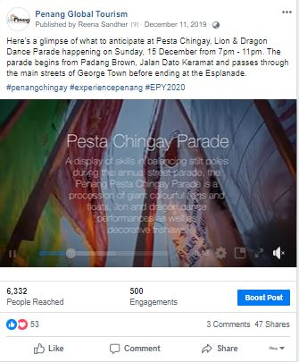 | 1.8k | 11 Dec 2019
2 | Pongal Celebration  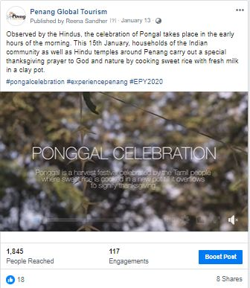 | 537 | 13 Jan 2020

No. | Videos | Total Views as at 30 June 2020 | Date Published
3 | Chinese New Year  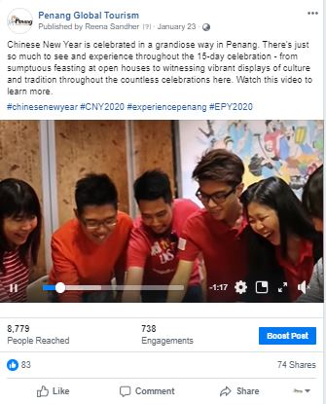 | 2.6k | 23 Jan 2020
4 | Pai Thee Kong  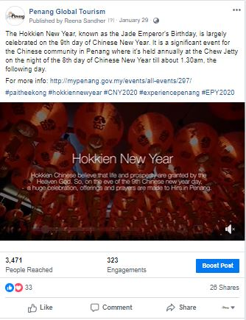 | 1.1k | 29 Jan 2020

No. | Videos | Total Views as at 30 June 2020 | Date Published
5 | Thaipusam  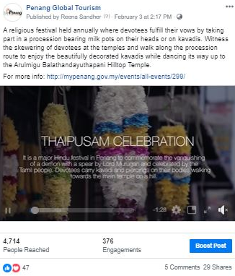 | 1.3k | 3 Feb 2020
6 | 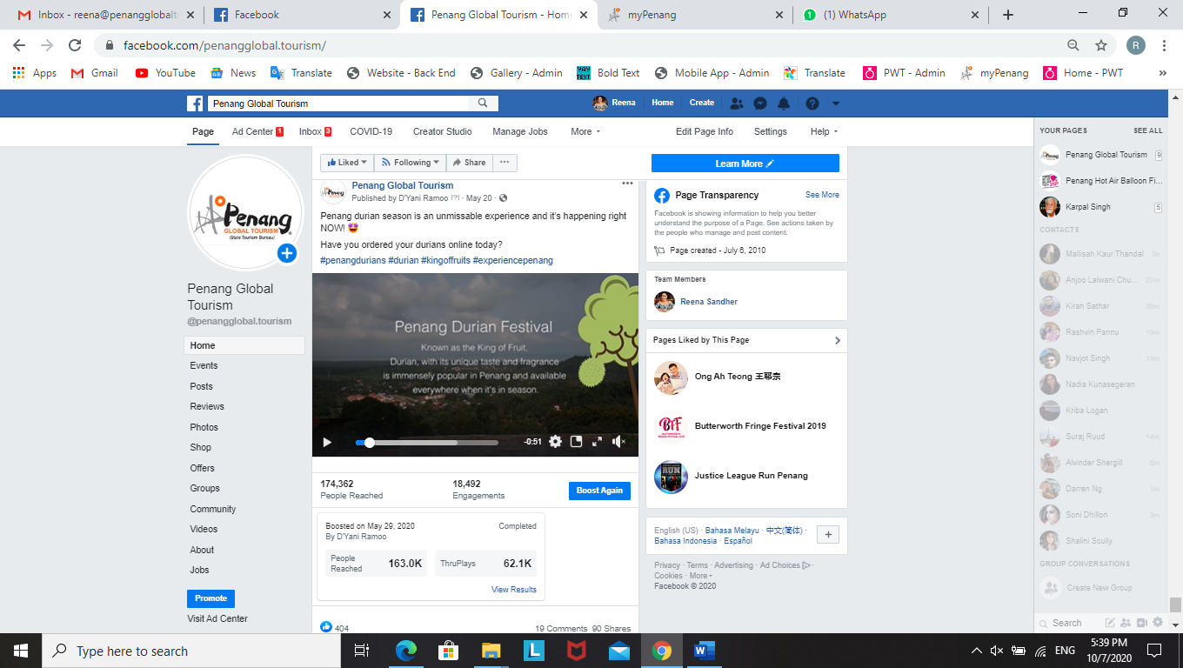 | 109k | 20 May 2020

3.2.6 Penang Foodie x Experience Penang 2020 Videos (1 October 2019 – 26 December 2019)
The collaboration between Penang Foodie and PGT was to feature Penang via 20 listicle videos every week, for 20 weeks to promote EPY2020 from Aug 2019. Here is the no. of views achieved from Oct to Dec 2019 – cross posted on PGT’s Facebook page and Penang Foodie’s Page:

Video #8: 20 Penang’s Best Breakfast Spots  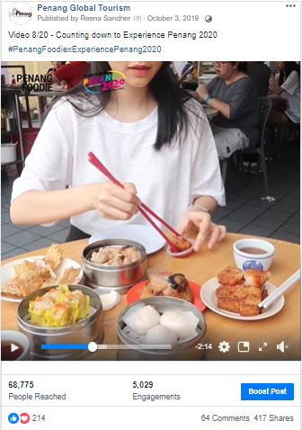 |  |  | Video #9: 20 Family-Friendly Activities in Penang  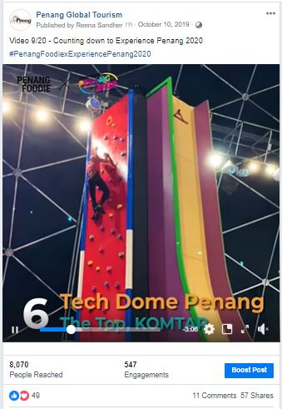
Total Views  2 mil | Total Reach  68,775 | Published  3 Oct 2019 | Total Views  71k | Total Reach  8,070 | Published  10 Oct 2019
Video #10: 20 Penang’s Long-Standing Food Vendors  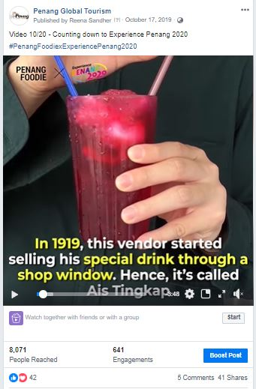 |  |  | Video #11: 20 Penang’s Historical and Cultural Spots  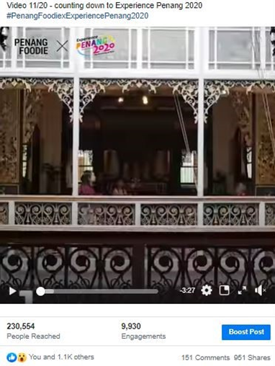
Total Views  387k | Total Reach  8,071 | Published  17 Oct 2019 | Total Views  40k | Total Reach  230,554 | Published  24 Oct 2019
Video #12: 20 Seafood Places in Penang  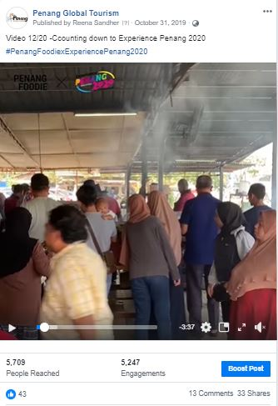 |  |  | Video #13: 20 Must Have Local Products  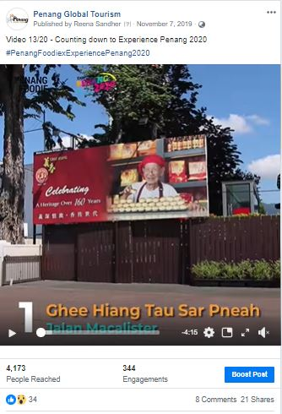
Total Views  211k | Total Reach  5,709 | Published  31 Oct 2019 | Total Views  121k | Total Reach  4,173 | Published  7 Nov 2019

Video #14: 20 Lunch Spots in Penang  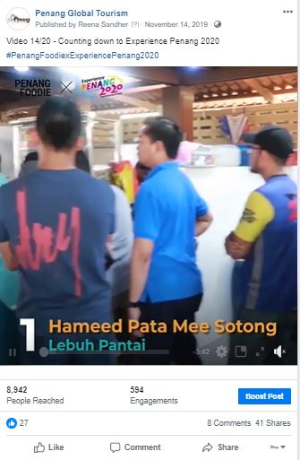 |  |  | Video #15: 20 Insta Spots in Penang  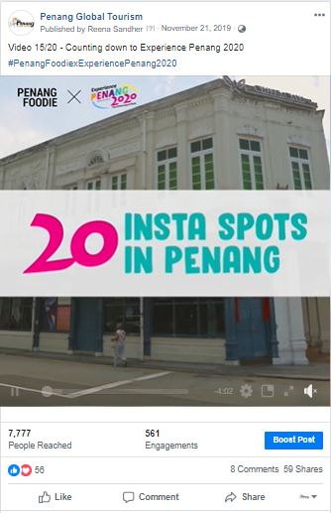
Total Views  400k | Total Reach  8,942 | Published  14 Nov 2019 | Total Views  89k | Total Reach  7,777 | Published  21 Nov 2019
Video #16: 20 Best Muslim-Friendly Food   |  |  | Video #17: 20 Beautiful Worship Places in Penang  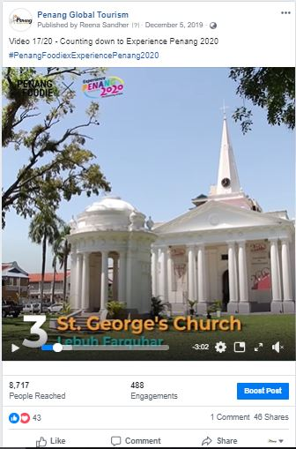
Total Views  335k | Total Reach  3,423 | Published  28 Nov 2019 | Total Views  43k | Total Reach  8,717 | Published  5 Dec 2019

Video #18: 20 Best Vegetarian Food in Penang  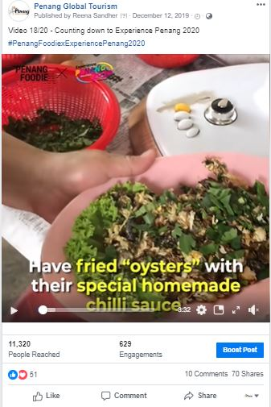 |  |  | Video #19: 20 Best Nasi Kandar in Penang  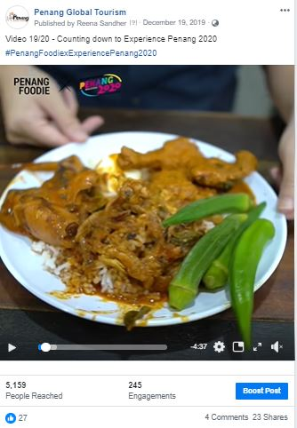
Total Views  141k | Total Reach  11,320 | Published  12 Dec 2019 | Total Views  251k |  | Total Reach  5,159 | Published  19 Dec 2019
Video #20: 20 Best Food Options in Penang
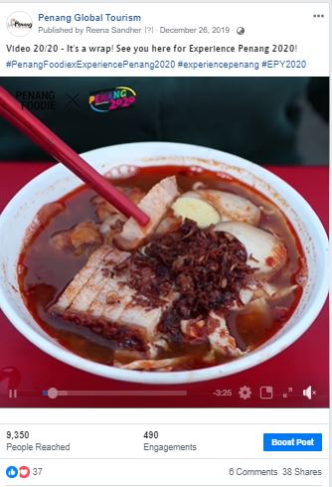
Total Views  220k | Total Reach  9,350 | Published  26 Dec 2019

THE TOTAL REACH & VIEWS FOR ALL 20 VIDEOS:
 | REACH | VIEWS
#1 Must Try Penang Food | 7,000,000 | 550,000
#2 Unique Experiences in Penang | 294,000 | 132,000
#3 Things to Do in Seberang Perai | 395,000 | 97,000
#4 Penang’s Best Street Treats | 1,400,000 | 585,000
#5 Free Things to Do in Penang | 452,000 | 97,000
#6 Best Kopitiams in Penang | 721,000 | 256,000
#7 After Dark Places in Penang | 434,000 | 134,000
#8 Penang’s Best Breakfast Spots | 68,775 | 2,000,000
#9 Family-Friendly Activities in Penang | 8,070 | 71,000
#10 Penang’s Long-Standing Food Vendors | 8,071 | 387,000
#11 Penang’s Historical and Cultural Spots | 230,554 | 40,000
#12 Seafood Places in Penang | 5,709 | 211,000
#13 Must Have Local Products | 4,173 | 121,000
#14 Lunch Spots in Penang | 8,942 | 400,000
#15 Insta Spots in Penang | 7,777 | 89,000
#16 Best Muslim-Friendly Food | 3,423 | 335,000
#17 Beautiful Worship Places in Penang | 8,717 | 43,000
#18 Best Vegetarian Food in Penang | 11,320 | 141,000
#19 Best Nasi Kandar in Penang | 5,159 | 251,000
#20 Best Food Options in Penang | 9,350 | 220,000
TOTAL | 11,076,040 | 6,160,000

3.2.7 Results of Paid Advertising via Social Media
Boosted Posts on PGT, Experience Penang and Penang Hot Air Balloon Facebook Page from 1 October 2019 – 30 June 2020:
PGT’s Facebook Page
Post/ Advert | Target Market | Budget (RM) | Duration | Reach | Results
Penang Here & Now 2019 Video | United Kingdom | 1,000 | 11 - 21 Oct | 44, 217 | 20.1k views  198 shares  162 reactions  16 comments
Penang Stories: Deepavali | Australia  Indonesia  Singapore  Thailand | 1,000 | 19 - 26 Oct | 257, 662 | 15 shares  549 reactions  15 comments  11,297 link clicks
Penang Street Food Festival | Australia  Indonesia  Singapore  Thailand | 1,000 | 8 - 13 Nov | 610, 049 | 35 shares  107k reactions  71 comment
Penang Street Food Festival Promo Video | Australia  Indonesia  Singapore  Thailand | 1,000 | 12 - 17 Nov | 1,122,562 | 299k views  42 shares  1.4k reactions  11 comments
George Town Literary Festival  *Audience chosen by PCEB | Johor  Alor Setar  Melaka  Seremban  Kuantan  Ipoh  Perlis  Kuala Lumpur  George Town | 800 | 13 - 18 Nov | 40, 736 | 17 shares  3.6k reactions  2 comments
George Town Literary Festival  *Audience chosen by PCEB | Johor  Alor Setar  Melaka  Seremban  Kuantan  Ipoh  Perlis  Kuala Lumpur  George Town | 800 | 14 - 19 November | 24,441 | 1 share  1000 reactions  1 comment
George Town Literary Festival  *Audience chosen by PCEB | Alor Setar  Kota Bharu  Kelantan  Ipoh  George Town | 800 | 19 - 24 November | 72,911 | 247 shares  1,000 reactions  145 comments
Penang Street Food Festival | Johor  Melaka  Negeri Sembilan  Perak  Kuala Lumpur  Singapore | 1,000 | 19 - 24 November | 47,999 | 55 shares  6.3k reactions  14 comments
Penang Stories: School Holidays | Australia  Hong Kong  Singapore  Bangkok  Malaysia | 1,000 | 20 – 30 November | 251,648 | 65 shares  148 reactions  0 comment  3,270 link clicks
PGT’s Facebook Page
Post/ Advert | Target Market | Budget (RM) | Duration | Reach | Results
Penang Bridge International Marathon 2019 – Race Day Info  *specific target audience | Johor  Melaka  Negeri Sembilan  Perak  Selangor  Kuala Lumpur  Singapore | 300 | 21 - 24 Nov | 61,664 | 38 shares  272 reactions  13 comments
This Weekend in Penang | Johor  Melaka  Negeri Sembilan  Ipoh  Selangor  Kuala Lumpur  Singapore | 300 | 21 - 24 Aug | 11,828 | 11 shares  160 reactions  4 comments
Penang International Dragon Boat Festival | Malaysia | 1,000 | 29 Nov - 6 Dec | 38,824 | 35 shares  21.k reactions  3 comments
Butterworth Fringe Festival (BFF) | Johor  Melaka  Negeri Sembilan  Perak  Selangor  Kuala Lumpur  Singapore | 1,000 | 30 Nov - 8 Dec | 32,040 | 9 shares  689 reactions  0 comment
Christmas Market | Negeri Sembilan  Perak  Penang  Selangor  Kuala Lumpur | 500 | 6 - 8 Dec | 81,823 | 205 shares  884 reactions  71 comments
Penang Stories: Café & Bar Hopping | Australia  Hong Kong  Malaysia  Singapore  Bangkok | 1,000 | 20 Dec - 5 Jan | 101,760 | 36 shares  155 reactions  6 comments  2,043 Link Clicks
Starbucks: World’s 4th Signing Store | Malaysia | 500 | 23 Dec -5 Jan | 213, 631 | 183 shares  1.5k reactions  50 comments
Accolades: Six of the world’s most thrilling long-haul city breaks by The Telegraph | United Kingdom | 1,000 | 7 - 12 Jan | 33,560 | 24 shares  48 reactions  4 comments  1,156 link clicks
Chief Minister’s Chinese New Year Open House | Penang | 300 | 20 - 25 Jan | 42,240 | 190 shares  3k reactions  72 comments
Chinese New Year Events in Penang | Penang | 300 | 21 - 26 Jan | 43,728 | 324 shares  704 reactions  38 comments
Penang Celebrates: Chap Goh Meh | Penang | 500 | 4 - 8 Feb | 73,873 | 5 shares  64 reactions  0 comments  303 link clicks

PGT’s Facebook Page
Post/ Advert | Target Market | Budget (RM) | Duration | Reach | Results
Penang Stories: Thaipusam | Australia  Hong Kong  Malaysia  Singapore  Thailand | 300 | 6 - 9 Feb | 55, 200 | 96 shares  579 reactions  29 comments  1,484 link clicks
Penang Stories: Romantic places in Penang | Australia  Hong Kong  Malaysia  Singapore  Thailand | 1,000 | 18 - 28 Feb | 171, 615 | 115 shares  321 reactions  36 comments  3,577 link clicks

Experience Penang’s Facebook Page
Post/ Advert | Target Market | Budget (RM) | Duration | Reach | Results
Penang Grand Parade | Penang | 500 | 31 Dec - 1 Jan | 57,008 | 253 shares  3k reactions  59 comments
Penang Grand Parade | Penang | 500 | 28 Dec - 1 Jan | 57,232 | 110 shares  2k reactions  28 comments
Penang Grand Parade | Johor, Alor Setar, Langkawi, Sungai Petani, Melaka, Seremban, Negeri Sembilan, Pahang, Ipoh, Perlis, Selangor, Kuala Lumpur, Putrajaya, Wilayah | 500 | 23 Dec - 1 Jan | 20, 752 | 14 shares  4,494 reactions  3 comments
Penang Celebrates: Chap Goh Meh | Penang | 300 | 11 - 13 Jan | 23,760 | 144 shares  1,686 reactions  16 comments
Penang Celebrates: Chap Goh Meh | Kedah  Melaka  Negeri Sembilan  Perak  Perlis  Selangor, KL | 200 | 11 - 13 Jan | 14,664 | 26 shares  1,358 reactions  7 comments
Thaipusam - Video | Malaysia | 500 | 31 Jan - 4 Feb | 239, 936 | 591 shares  2.4k reactions  56 comments  104k views
Penang Celebrates: Chap Goh Meh | Penang | 300 | 5 - 8 Feb | 28, 128 | 128 shares  562 reactions  28 comments
Penang Celebrates: Chap Goh Meh  *Setting up photos | Penang | 150 | 7 - 8 February | 41,768 | 120 shares  678 reactions  60 comments
Penang Hot Air Balloon’s Facebook Page
Post/ Advert | Target Market | Budget (RM) | Duration | Reach | Results
Promo Video | Kedah | 150 | 13 - 17 Jan | 45,151 | 238 shares  474 reactions  108 comments
Promo Video | Perak | 150 | 13 - 17 Jan | 44, 22 | 163 shares  352 reactions  74 comments
Promo Video | Kuala Lumpur | 200 | 13 - 17 Jan | 56,831 | 95 shares  255 reactions  28 comments
Promo Video | China  Hong Kong  Indonesia  Jakarta  Qatar  Singapore  Taiwan  Vietnam | 1,000 | 13 - 18 Jan | 665, 085 | 62 shares  1,830 reactions  12 comments
Promo Video | Australia  United Kingdom  Hong Kong  Indonesia  Singapore  Malaysia | 1,000 | 19 - 26 Dec | 465,152 | 149 shares  1,604 reactions  18 comments
Path of HAB at Sia Boey  *Setting up photos | Malaysia | 500 | 23 - 28 Dec | 133,952 | 93 shares  15k reactions  38 comments
Path of HAB at Butterworth Art Walk | Johor  Alor Setar  Negeri Sembilan  Perak  Perlis  Kuala Lumpur | 500 | 28 Dec - 2 Jan | 48,400 | 153 shares  7,498 reactions  36 comments
Path of HAB at Sia Boey | Malaysia | 500 | 31 Dec - 5 Jan | 58,256 | 89 shares  11,406 reactions  28 comments
Images of HAB 2019 | Malaysia | 400 | 6 - 10 Jan | 113,087 | 145 shares  954 reactions  105 comments
Random images of HAB | Malaysia | 2,000 | 20 - 26 Jan | 457, 086 | 1.5k shares  10.4k reactions  1.9k comments
HAB Pop Up | Air Itam  Bayan Lepas | 130 | 29 - 31 Jan | 41,719 | 180 shares  377 reactions  83 comments
Opening Ceremony | Penang | 400 | 30 Jan - 1 Feb | 50,865 | 264 shares  1.7k reactions  223 comments

Note: The total amounts spent on each Facebook page during this period are as follows:
Penang Global Tourism = RM16,400
Experience Penang = RM2,950
Penang Hot Air Balloon Fiesta = RM6,930

3.2.8 PGT’s Facebook Page Analytics
Based on the insights of PGT’s Facebook Page, there has been an increase in likes in comparison to the same period last year. The number of likes recorded for 1 Oct 2019 to 30 June 2020 is 57,033 and the number of likes recorded for 1 Oct 2018 to 30 June 2019 is 54,811. Thus, indicating that the number of likes on the page has been increasing in a relatively good pace.

Total Page Likes as of 30 June 2020:
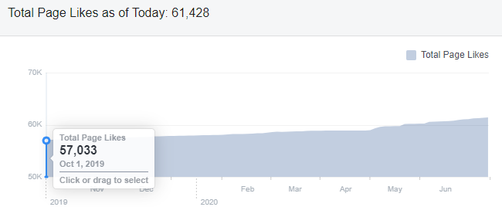

Total Page Likes as of 30 June 2019:
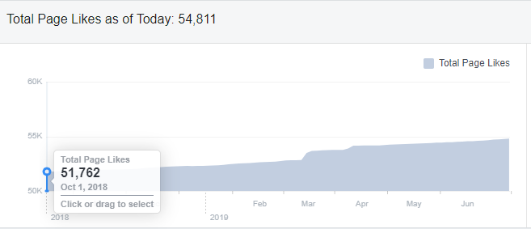

Top posts / most viewed posts on PGT’s Facebook page:
Month | Posts/ Videos | Total Reach
Oct 2019 | Penang Stories: Little India really turns the lights on this Oct | Organic: 1,946  Paid: 243,433
Nov 2019 | PSFF Promo Video | Organic: 3,250  Paid: 1,096,711 (1 mil)
Dec 2019 | Opening of Starbucks’ 4th Signing Store in the world in Penang | Organic: 13,190  Paid: 211,939
Jan 2020 | Chinese New Year Events in Penang | Organic: 30,157  Paid: 42,786
Feb 2020 | Penang Stories: Romantic places in Penang | Organic: 8,460  Paid: 174,375
March 2020 | Penang Here & Now 2020 Video | Organic: 42,501  Paid: 293,810
April 2020 | It’s all in Penang…the unseen… | Organic: 509,013  Paid: -
May 2020 | Penang Declared Zero Case in 14 Days | Organic: 215,778  Paid: -
June 2020 | Jom! Experience Penang! Traveldeals.com campaign | Organic: 1,562  Paid: 161,845

3.2.9 Website Google Analytics
The analytics report shows a year-on-year (YOY) comparison between two time periods –
1 October 2019 - 30 June 2020 and 1 October 2018 - 30 June 2019.

Website traffic
The Google Analytics Report shows a spike on 21 October 2019 with 2,244 users whereas in comparison to 21 October 2018, it had 597 users. There was also a spike on 31 December 2019 with 3,121 users and comparatively to the previous year on the same date, there were 1,022 users. Additionally, there was also a spike on 8 February 2020 with 2,544 users to the site.
The significant increase of users to the website for October and December 2019 could be brought by visitors searching for information on Penang Hot Air Balloon Fiesta and Penang Stories and upcoming events for final quarter of 2019. The spike for February 2020 may have been a result of few large festivals that were happening at the same time, such as Thaipusam and Chap Goh Meh. These spikes may also be brought by adverts that ran on PGT’s Facebook page on Penang Hot Air Balloon Fiesta and the many CNY events that were happening throughout that period.
According to the analytics report, majority of users to our mypenang.gov.my website was acquired organically via Google. There were also users who were linked to our website through Facebook posts, some organically and some through adverts.

Comparison between 1 October 2019 – 30 June 2020 and 1 October 2018 - 30 June 2019
The comparison report shows an increase of 4.90% in new users to the website with an increase of page views. However, the number of sessions per user and bounce rate recorded a decrease of 0.16% and 5% respectively.

Top 5 countries visiting the site and most viewed pages
The top 5 countries visiting the site are the Indonesia, Singapore, United States, United Kingdom and Australia. Their most-viewed pages are mainly on Penang Stories, Events, Culture & Heritage, Events, Food & Lifestyle and Free CAT Bus.
The following pages show the relevant charts and tables summarizing the Google analytics report as highlighted above.

Period: 1 October 2018 - 30 June 2019
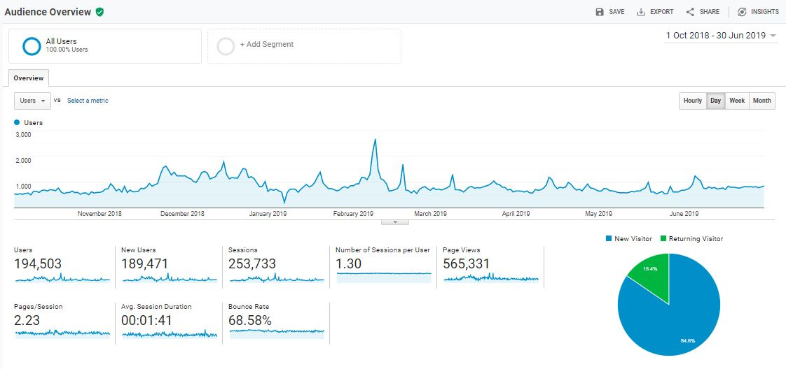

Period: 1 October 2019 – 30 June 2020
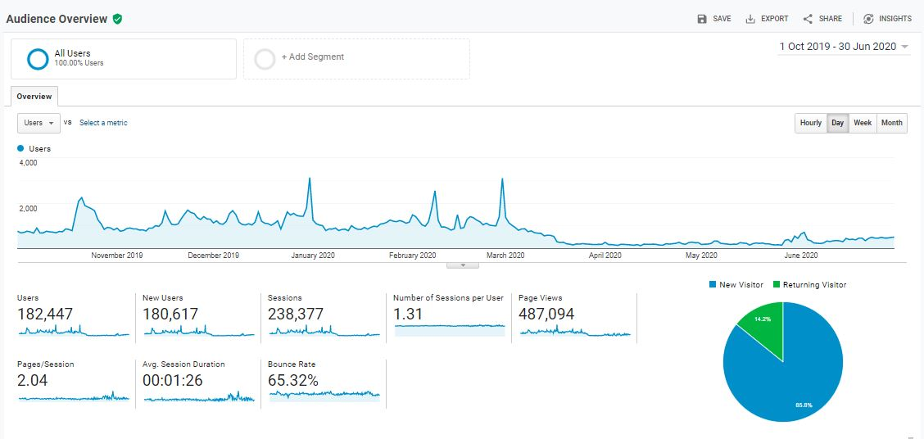

Comparison Period: 1 October 2018 – 30 June 2019 and 1 October 2019 – 30 June 2020
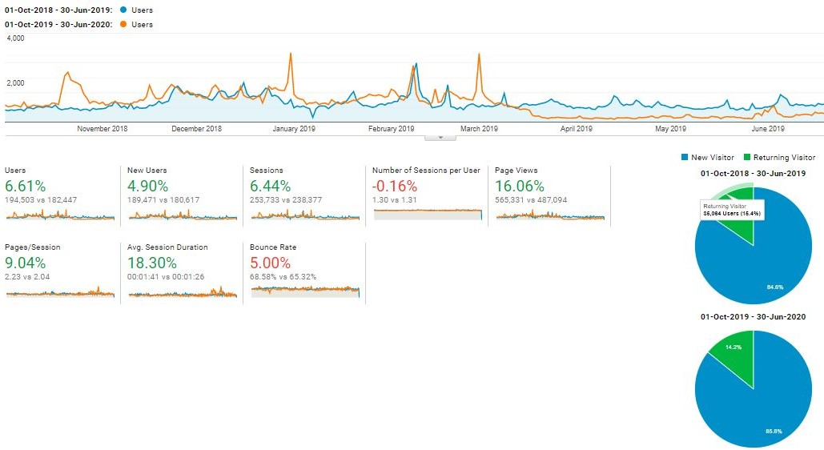

With reference to the above, visitors to the site, in comparison of the time periods:

Item | 1 October 2018 – 30 June 2019 | 1 October 2019 – 30 June 2020
Users | 194, 503 | 182, 447
Sessions | 253, 733 | 238, 377
Page Views | 565, 331 | 487, 094
Ave. Session Duration | 00:01:41 | 00:01:26
Bounce Rate | 68.58% | 65.32%

Top 10 user’s location and sources: 1 October 2019 – 30 June 2020:
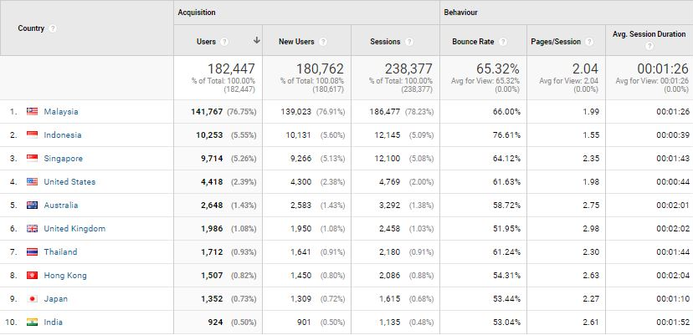

Top 10 user’s location and sources: 1 October 2018 – 30 June 2019:
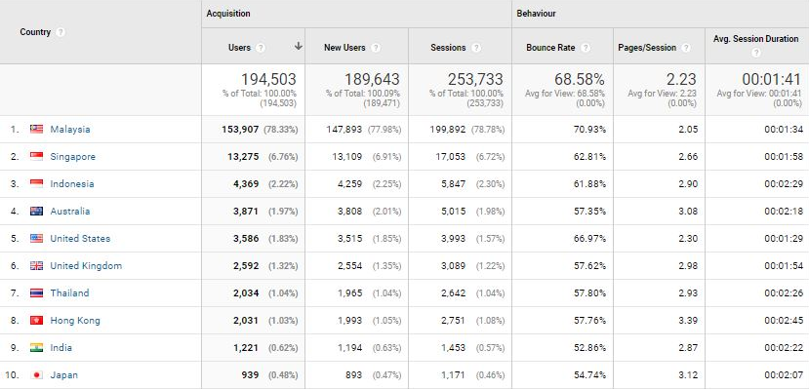

The top 5 countries visiting our website; in comparison of the said time periods:

Country | No. of New Session |  | Increase / Decrease | Most-viewed Pages
Country | 1 October 2018 – 30 June 2019 | 1 October 2019 – 30 June 2020 | Increase / Decrease | Most-viewed Pages
Indonesia | 1,274 | 7,082 | 5,808 | Penang stories
Singapore | 2,472 | 1,922 | (550) | Culture & Heritage, Events, Free CAT Bus/ Events
United States | 937 | 966 | 29 | Events, Culture & Heritage, Free CAT Bus
United Kingdom | 823 | 684 | (139) | Events, Culture & Heritage, Free CAT Bus
Australia | 602 | 600 | (2) | Culture & Heritage, Free CAT Bus, Stories, Events, Food & Lifestyle

The top 10-page views in the mypenang.gov.my website from 1 October 2019 – 30 June 2020:
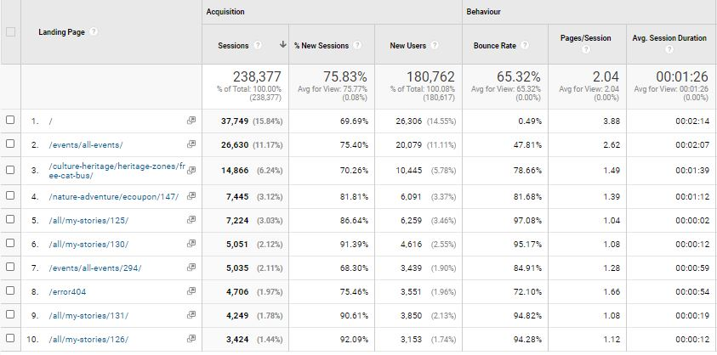

The top 10-page views in the mypenang.gov.my website from 1 October 2018 – 30 June 2019:
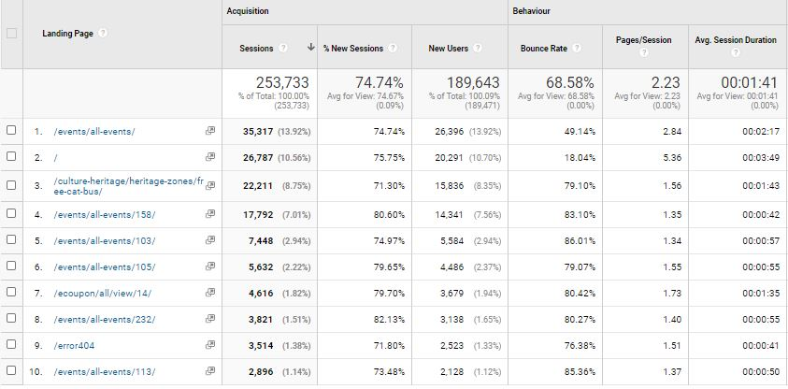

3.2.10 Penang Global Tourism Mobile App
The following table shows the total number of downloads for 1 Sept 2019 to 29 Feb 2020 on iOS and Android:
Domestic/In’tial | iOS |  | Android
Malaysia | 149 | 27.79% | 315 | 52.58%
Overseas | 390 | 72.76% | 284 | 47.41%
Total downloads | 536 | - | 599 | -

The total number of downloads (Malaysia and overseas) in the five months is 1,018.
The top 5 international countries for number of downloads on our mobile app are as follows:

iOS:
1. Hong Kong - 45
2. Singapore - 35
3. China - 32
4. Germany - 24
5. Thailand - 19

Android:
1. Indonesia - 65
2. Singapore - 55
3. Hong Kong - 18
4. Thailand - 16
5. Great Britain - 12

To be consistent with PGT’s website, updates are being done on PGT’s mobile app. For easier management, the backend CMS for e-coupon has been updated to enable further editing and amendments after item has been listed.

In view of our EPY2020 campaign, we had changed the mobile app’s homepage images to incorporate the Experience Penang branding. A total of 9 images were used highlighting various places of interests, as follows:
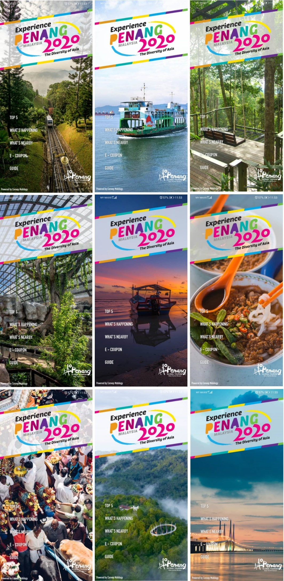

3.2.11 PGT’s E-Newsletter – Don’t Say Penang Bojio
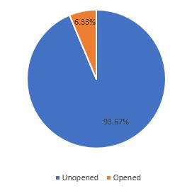
PGT’s e-newsletter, Don’t Say Penang Bojio highlights major events and upcoming events happening in the state, announces latest news and/or new openings on Penang’s tourism products, latest updates on direct flights to Penang, as well as latest special deals on PGT’s e-coupon.

Don’t Say Penang Bojio Issue #1 – January 2020
Overview Report:
Item | Figure
Recipients | 4,426
Successfully Sent | 4,426
Opened This Campaign | 280 (6.33%)
Clicked A Link | 40 (0.90%)
Unsubscribed | 8 (0.18%)

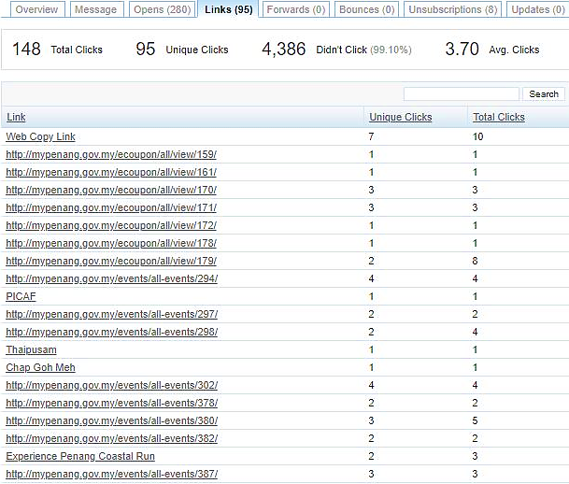
Number of link clicks and links viewed:

Summary:
- Percentage of recipients who opened the latest issue decreased by 1.67%
- Percentage of link clicks decreased slightly where most link clicks are to Penang events, featured e-coupons, PGT’s YouTube page, and featured attractions in Penang
- Percentage of recipients who unsubscribed in this issue is 0.18% - lesser compared to the previous issue
The following is a screenshot of Don’t Say Penang Bojio Issue #1 – January 2020:
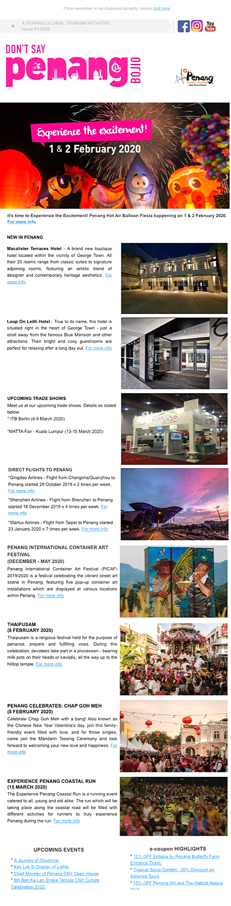

3.3 Recent Publicity (Oct 2019 – June 2020)

October 2019
Local
No | Name | Description | Type of Publication
1 | Travel 360 | The Habitat was listed under Spotlight section; article on George Town Treasures under the Travelogue section | Print
2 | Senses of Malaysia | Write up on Historic Mansions Reimagined as Hotels in Penang under Explore section | Print
3 | Penang Monthly | Write up on George Town Literary Festival | Print
4 | The Expat | Write up on Make the Most Out of 48 Hours in Penang under Short Trips & Weekend Getaway | Print
5 | The Star | Featured Penang Coffee and Desserts Festival that took place at Gurney Paragon | Online
6 | Penang Foodie | Write up on different events happening in Penang in the month of October | Online
7 | New Straits Times | Write up on the history and establishment of Penang Botanic Gardens | Online
8 | Buletin Mutiara | Featured Boba Festival which is also a part of Penang Coffee and Desserts Festival; write up on closing ceremony of Penang Coffee and Desserts Festival which was held at Cheah Kongsi; write up on Miss Asia Global Malaysia | Online
9 | Kwong Wah Yit Poh | Penang recognised as the most loved state for tourism in the Going Places Readers’ Choice Awards 2018; China Qingdao Airlines makes its first flight to Penang | Online

October 2019
Foreign
No | Name | Description | Type of Publication
1 | Asia One | Write up on ‘Your next long weekend destination – Penang, Malaysia. | Online
2 | Simple Flying | Write up on Taiwan’s Starlux included Penang mentioning that starts its flights to Da Nang, Macau, and Penang in Jan 2020. | Online
3 | CommuniNation | FAM trip by Elisabet Garcia Dahlback and Binge Eliasson of CommuniNation from Sweden to Penang. The articles published in their newspaper and magazine is mainly for Scadinavian readers. | Print

November 2019
Local
No | Name | Description | Type of Publication
1 | iNPenang | Write up on Butterworth Fringe Festival 2019 under Festival section | Print
2 | The Star | Featured on PETACH fostering a digital campaign with PGT social media video app – TikTok with monthly active users of 180 mil, including 50 mil in SEA | Online
3 | Malaysia Tatler | 5 creative spaces in George Town, Penang for a memorable event | Online
4 | New Straits Times | GTLF kicks-off with a slew of activities and book launches | Online
5 | Rojak Daily | New Starbucks outlet in Penang is only the fourth of its kind in the world. | Online
6 | Hype | Starbucks Malaysia launched 2nd signing store in Penang. | Online
7 | Guang Ming | Featured PSFF2019’s Opening ceremony | Online
8 | Kwong Wah Yit Poh | Featured on Penang Bridge International Marathon | Online
9 | Malaysiaairlines.com | Malaysia Airlines organized a familiarization our for the chefs from United Kingdom to Penang. The group was in Penang from 8 November – 12 November 2019. | Online

November 2019
Foreign
No | Name | Description | Type of Publication
1 | Linkers | Write up on Penang on Malam di Penang Festival dan Kuliner | Print
2 | Silkwinds | Write up on Penang under Postcards section | Print
3 | News Pressed | Cycling in Penang is easy with LinkBike, pay and ride; continental and fusion cuisine in Penang | Online
4 | Business Insider Singapore | Starbucks’ world’s fourth signing store opens in Penang | Online
5 | Business News Asia | Featured the opening of ESCAPE’s world’s longest water slide | Online
6 | The Japan Times | Write up under special supplement on Penang National Park | Online
7 | AirAsia and Kiwi.com | AirAsia and Kiwi.com organised a media FAM trip for Europe and Australia. Articles on the FAM trip were published in AisAsia aviation magazine. | Print
8 | Culturetrip.com | A FAM trip was organised for a journalist from culturetrip.com to write on traditional traders in Penang. The articles were then published on the website. | Online

December 2019
Local
No | Name | Description | Type of Publication
1 | The Star | Featured Butterworth Fringe Festival; on 40th Penang International Dragon Boat Festival 2019 | Online
2 | Kwong Wah Yit Poh | Direct flight launching from Shenzhen to Penang scheduled that’s scheduled to start on 18 Dec | Online
3 | New Straits Times | Perak, Penang and Kedah recorded an increase in tourist arrivals - Jan to Dec 10, 2019 | Online
4 | The Malaysian Reserve | Penang listed in ‘The last-minute holiday idea that won’t empty your wallet’ | Online
5 | China Press | Featured Penang International Container Art Festival | Online
6 | Sin Chew | Featured Penang International Container Art Festival; 4 weekly direct flights from Shenzhen to Penang | Online

No | Name | Description | Type of Publication
7 | Buletin Mutiara | Shenzhen – Penang direct flights to promote business, tourism exchanges | Online
8 | Nan Yang Siang Pau | Fresh look of Sia Boey will be open to the public soon | Online

December 2019
Foreign
No | Name | Description | Type of Publication
1 | Linkers | Write up on George Town, Penang – Dasawarsa “Unesco World Heritage Site” | Print
2 | Focus Taiwan | On Starlux Airlines, to start selling tickets ahead of its commencement of flights to Penang | Online
3 | Simple Flying | On Starlux Airlines, to schedule its first flights to the initial destinations, including Penang. | Online
4 | Taipei Times | On Starlux Airlines, to start selling tickets ahead of its commencement of flights to Penang | Online
5 | Asia One | Highlighted that Penang retains its charm as a top tourist destination in Malaysia | Online
6 | Xin Hua Net | About the direct flights between Shenzhen and Penang | Online

January 2020
Local
No | Name | Description | Type of Publication
1 | Rojak Daily | Write up on Penang International Container Art Festival | Online
2 | Sin Chew | Article on Penang International Container Art Festival | Online
3 | Kwong Wah | Featured Penang Hot Air Balloon Fiesta’s PC held at Sia Boey; launching of PICAF 2020 at Kampung Terang, Balik Pulau | Online
4 | Buletin Mutiara | Featured Penang Hot Air Balloon Fiesta to take place on 1st and 2nd Feb 2020; on PICAF -10 Containers to be installed at 5 different locations;  AirAsia to begin direct flights connecting Penang and Chengdu. | Online
5 | Guang Ming | Featured The Path of HAB - 420 mini hot air balloons light up back lane to a romantic sea of lights; article on container installation at Kampung Terang, Balik Pulau | Online
6 | Malay Mail | Penang to celebrates Chinese New Year with host of events | Online
7 | The Star | Featured PICAF -container murals a new towering sight; on Starlux’s maiden flight from Taipei to Penang | Online
8 | Free Malaysia Today | PICAF- Penang’s container art in a paddy field has become latest craze | Online
9 | The Edge Markets | Penang records 27.1% increase in cruise passengers; Starlux’s maiden flight to Penang from Taipei | Online
10 | New Straits Times | Highlighted on Emirates to operate flights to Penang in April | Online
11 | The Malaysian Reserve | Emirates to launch services to Penang via Singapore | Online

January 2020
Foreign
No | Name | Description | Type of Publication
1 | Sprudge | The Sprudge Coffee Guide to Penang | Online
2 | Asia One | Cable car project in Penang set to start year-end | Online
3 | TTR Weekly | AirAsia expands Penang hub by introducing Chengdu - Penang flights | Online
4 | Emirates | Emirates to launch services to Penang via Singapore | Online
5 | Business Traveller | Emirates secures Singapore-Penang fifth freedom rights | Online
6 | The National | Emirates launches flights from Dubai to Penang | Online
7 | Travel Weekly Asia | Emirates to launch daily service from Dubai to Penang in April | Online
8 | TTG Asia | Featured on Starlux’s launch of three inaugural flights - including Penang (daily) | Online

February 2020
Local
No | Name | Description | Type of Publication
1 | Guang Ming | Featured Penang Hot Air Balloon’s opening ceremony at Padang Polo;  launching of PICAF’s installation at Karpal Singh Drive; launching of PICAF’s installation in Batu Kawan | Online
2 | Kwong Wah Yit Poh | Featured Penang Hot Air Balloon’s opening ceremony at Padang Polo;  Penang Miaohui to see the century-old Nanyang scene experience; article on PICAF’s installation at Karpal Singh Drive; launching of PICAF’s installation in Batu Kawan | Online
3 | The Star | Featured Penang Hot Air Balloon’s opening ceremony at Padang Polo; featured PICAF’s installation in Balik Pulau | Online
4 | The Sun Daily | Starbucks opens first Reserve store in Penang | Online
5 | Malay Mail | Feature on “Penang Lang 50% Off” - in a bit to spur domestic tourism, Penangites get 50% discounts for ticketed attractions | Online
6 | Buletin Mutiara | Featured Penang Hot Air Balloon’s opening ceremony at Padang Polo;  PICAF’s installation at Batu Kawan; PICAF’s installation launching at Dataran Pemuda Merdeka | Online
7 | World of Buzz | Highlighted PICAF – ‘Voted as the ‘World’s Best Street Art’, Malaysians admire stunning container murals in Penang till May 2020 | Online
8 | Rojak Daily | Rojak Daily listed Penang in its list of ‘8 Super Instagrammable Cafes Around Malaysia You Need to Check Out’. | Online
9 | Borneo Bulletin | Featured Penang upgrades lanes to attract visitors | Online

February 2020
Foreign
No | Name | Description | Type of Publication
1 | Inside Hook | Included article on Penang street food. | Online

The following are the number of local and foreign news coverage based on what we have managed to monitor - mainly online, via Google Alerts and physical publications/magazines received through free subscriptions:

Month (2020) | Local News Coverage | Foreign News Coverage
October | 9 | 3
November | 9 | 8
December | 8 | 6
January | 11 | 8
February | 9 | 1
Total | 46 | 26

