3.2.5 Festivals in A Box (1 October 2019 - 30 June 2020)
The festival in a box videos are used on an ongoing basis to promote the year-round festivals happening in Penang. It is an effective way to promote the events as it’s more visually driven and gives a good preview of what the festivals are all about. The videos posted on Facebook also drive visitors to our mypenang website for more details.

Festival in A Box videos shared on PGT’s Facebook page from 1 Oct 2019 - 30 June 2020:
No. | Videos | Total Views as at 30 June 2020 | Date Published
1 | Pesta Chingay Parade  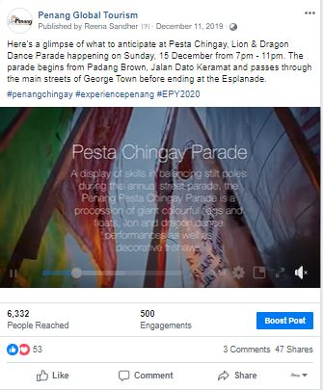 | 1.8k | 11 Dec 2019
2 | Pongal Celebration  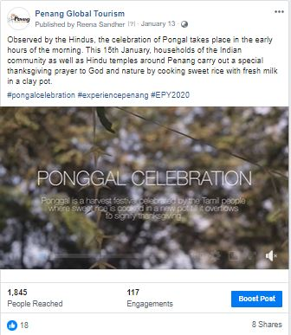 | 537 | 13 Jan 2020

No. | Videos | Total Views as at 30 June 2020 | Date Published
3 | Chinese New Year  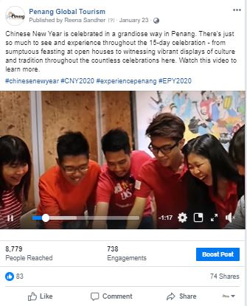 | 2.6k | 23 Jan 2020
4 | Pai Thee Kong  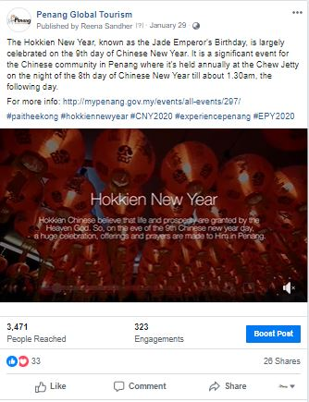 | 1.1k | 29 Jan 2020

No. | Videos | Total Views as at 30 June 2020 | Date Published
5 | Thaipusam  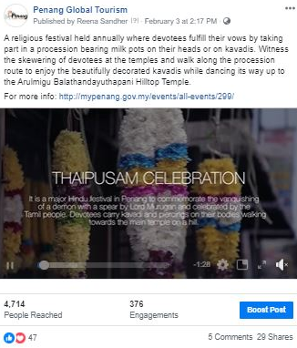 | 1.3k | 3 Feb 2020
6 | 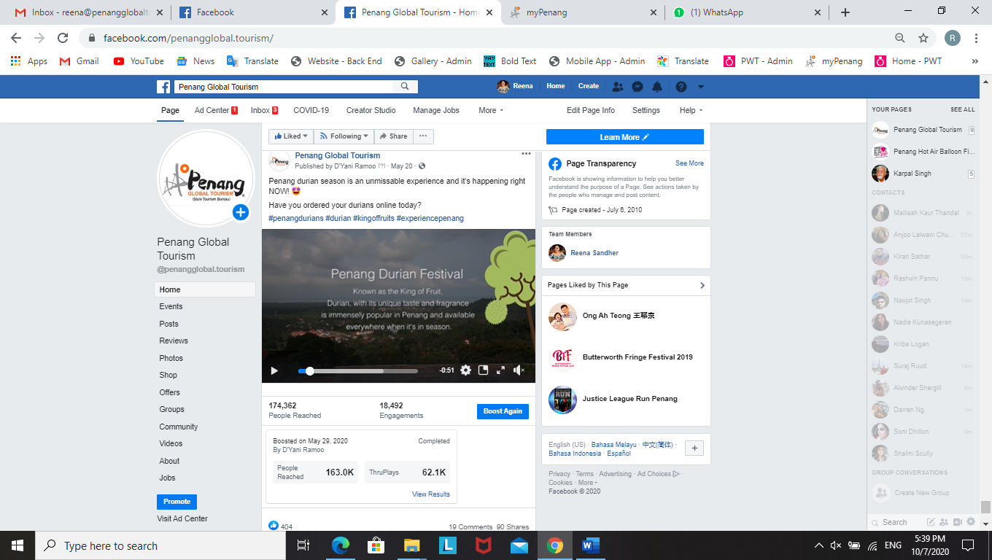 | 109k | 20 May 2020

3.2.6 Penang Foodie x Experience Penang 2020 Videos (1 October 2019 – 26 December 2019)
The collaboration between Penang Foodie and PGT was to feature Penang via 20 listicle videos every week, for 20 weeks to promote EPY2020 from Aug 2019. Here is the no. of views achieved from Oct to Dec 2019 – cross posted on PGT’s Facebook page and Penang Foodie’s Page:

Video #8: 20 Penang’s Best Breakfast Spots  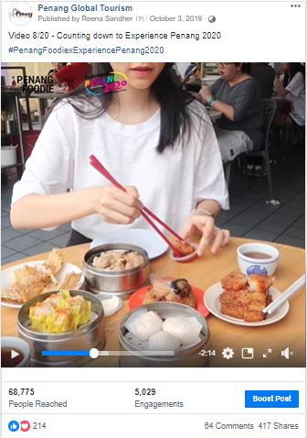 |  |  | Video #9: 20 Family-Friendly Activities in Penang  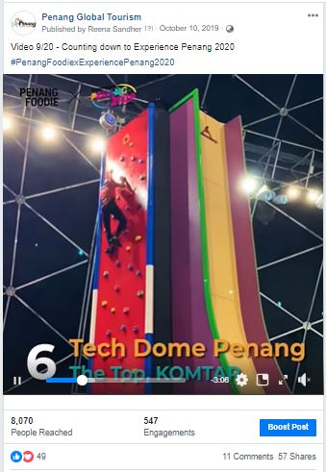
Total Views  2 mil | Total Reach  68,775 | Published  3 Oct 2019 | Total Views  71k | Total Reach  8,070 | Published  10 Oct 2019
Video #10: 20 Penang’s Long-Standing Food Vendors  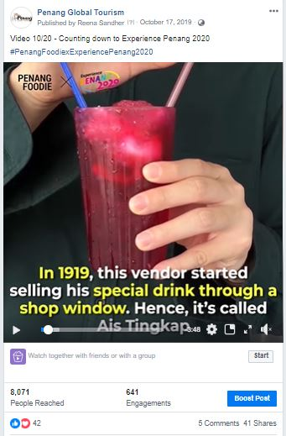 |  |  | Video #11: 20 Penang’s Historical and Cultural Spots  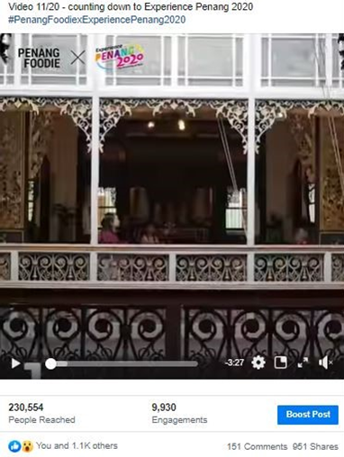
Total Views  387k | Total Reach  8,071 | Published  17 Oct 2019 | Total Views  40k | Total Reach  230,554 | Published  24 Oct 2019
Video #12: 20 Seafood Places in Penang  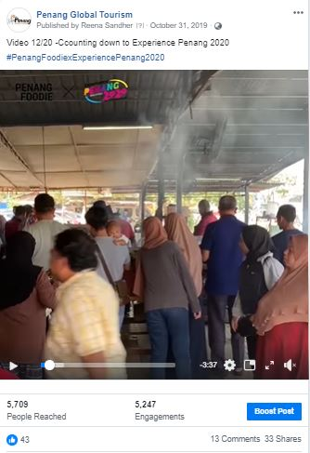 |  |  | Video #13: 20 Must Have Local Products  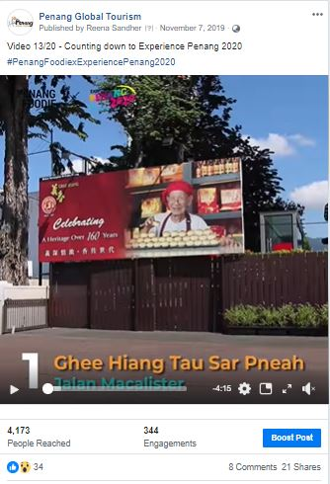
Total Views  211k | Total Reach  5,709 | Published  31 Oct 2019 | Total Views  121k | Total Reach  4,173 | Published  7 Nov 2019

Video #14: 20 Lunch Spots in Penang  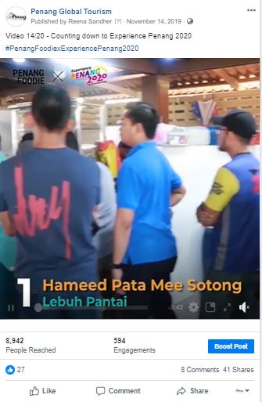 |  |  | Video #15: 20 Insta Spots in Penang  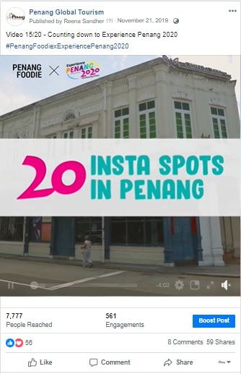
Total Views  400k | Total Reach  8,942 | Published  14 Nov 2019 | Total Views  89k | Total Reach  7,777 | Published  21 Nov 2019
Video #16: 20 Best Muslim-Friendly Food   |  |  | Video #17: 20 Beautiful Worship Places in Penang  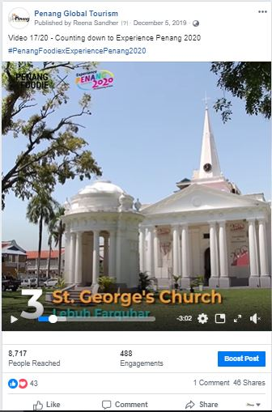
Total Views  335k | Total Reach  3,423 | Published  28 Nov 2019 | Total Views  43k | Total Reach  8,717 | Published  5 Dec 2019

Video #18: 20 Best Vegetarian Food in Penang  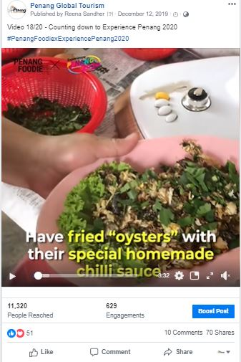 |  |  | Video #19: 20 Best Nasi Kandar in Penang  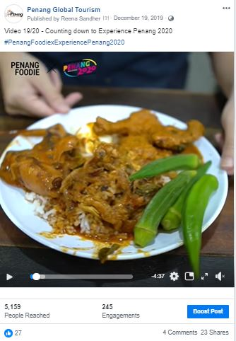
Total Views  141k | Total Reach  11,320 | Published  12 Dec 2019 | Total Views  251k |  | Total Reach  5,159 | Published  19 Dec 2019
Video #20: 20 Best Food Options in Penang
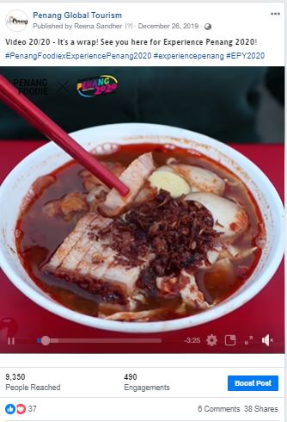
Total Views  220k | Total Reach  9,350 | Published  26 Dec 2019

THE TOTAL REACH & VIEWS FOR ALL 20 VIDEOS:
 | REACH | VIEWS
#1 Must Try Penang Food | 7,000,000 | 550,000
#2 Unique Experiences in Penang | 294,000 | 132,000
#3 Things to Do in Seberang Perai | 395,000 | 97,000
#4 Penang’s Best Street Treats | 1,400,000 | 585,000
#5 Free Things to Do in Penang | 452,000 | 97,000
#6 Best Kopitiams in Penang | 721,000 | 256,000
#7 After Dark Places in Penang | 434,000 | 134,000
#8 Penang’s Best Breakfast Spots | 68,775 | 2,000,000
#9 Family-Friendly Activities in Penang | 8,070 | 71,000
#10 Penang’s Long-Standing Food Vendors | 8,071 | 387,000
#11 Penang’s Historical and Cultural Spots | 230,554 | 40,000
#12 Seafood Places in Penang | 5,709 | 211,000
#13 Must Have Local Products | 4,173 | 121,000
#14 Lunch Spots in Penang | 8,942 | 400,000
#15 Insta Spots in Penang | 7,777 | 89,000
#16 Best Muslim-Friendly Food | 3,423 | 335,000
#17 Beautiful Worship Places in Penang | 8,717 | 43,000
#18 Best Vegetarian Food in Penang | 11,320 | 141,000
#19 Best Nasi Kandar in Penang | 5,159 | 251,000
#20 Best Food Options in Penang | 9,350 | 220,000
TOTAL | 11,076,040 | 6,160,000

3.2.8 PGT’s Facebook Page Analytics
Based on the insights of PGT’s Facebook Page, there has been an increase in likes in comparison to the same period last year. The number of likes recorded for 1 Oct 2019 to 30 June 2020 is 61,428 and the number of likes recorded for 1 Oct 2018 to 30 June 2019 is 54,811. Thus, indicating that the number of likes on the page has been increasing in a relatively good pace.

Total Page Likes as of 30 June 2020:
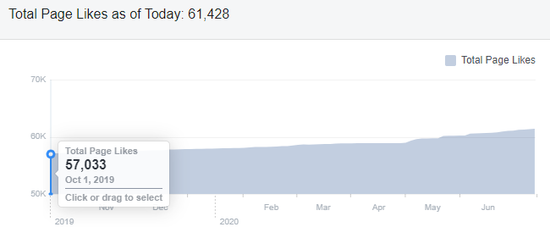

Total Page Likes as of 30 June 2019:
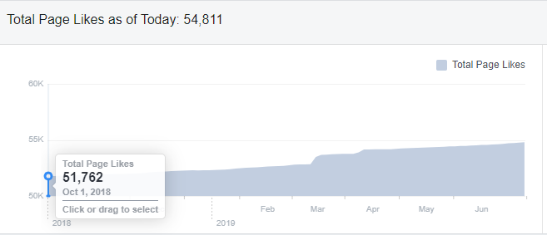

Top posts / most viewed posts on PGT’s Facebook page:
Month | Posts/ Videos | Total Reach
Oct 2019 | Penang Stories: Little India really turns the lights on this Oct | Organic: 1,946  Paid: 243,433
Nov 2019 | PSFF Promo Video | Organic: 3,250  Paid: 1,096,711 (1 mil)
Dec 2019 | Opening of Starbucks’ 4th Signing Store in the world in Penang | Organic: 13,190  Paid: 211,939
Jan 2020 | Chinese New Year Events in Penang | Organic: 30,157  Paid: 42,786
Feb 2020 | Penang Stories: Romantic places in Penang | Organic: 8,460  Paid: 174,375
March 2020 | Penang Here & Now 2020 Video | Organic: 42,501  Paid: 293,810
April 2020 | It’s all in Penang…the unseen… | Organic: 509,013  Paid: -
May 2020 | Penang Declared Zero Case in 14 Days | Organic: 215,778  Paid: -
June 2020 | Jom! Experience Penang! Traveldeals.com campaign | Organic: 1,562  Paid: 161,845

