3.2.4 Festivals in A Box (16 April - 30 September 2019)
The festival in a box videos are used on an ongoing basis to promote the year-round festivals happening in Penang. It is an effective way to promote the events as it’s more visually driven and gives a good preview of what the festivals are all about. The videos posted on Facebook also drive visitors to our mypenang website for more details.

Videos shared on PGT’s Facebook page from 16 April – 30 September 2019:
No. | Videos | Total Views as at 30 September 2019 | Date Published
1 | Festivals in a Box: Wesak Day Celebration | 25,103 | 3 May 2019
2 | Festivals in a Box: Ramadhan Bazaar | 75,782 | 6 May 2019
3 | Festivals in a Box: Penang Durian Festival | 66,322 | 21 June 2019
4 | Festivals in a Box: George Town Heritage Celebrations | 58,248 | 25 June 2019
5 | Festivals in a Box: St. Anne’s Festival | 685 | 17 July 2019
6 | Festivals in a Box: Penang Hungry Ghost Festival | 371 | 1 August 2019
7 | Festivals in a Box: Mid-Autumn Festival | 402 | 13 September 2019
8 | Festivals in a Box: Nine Emperor Gods Festival | 709 | 26 September 2019

Festivals in a Box: Wesak Day Celebration
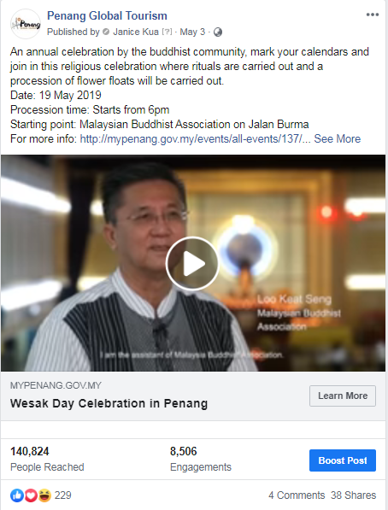

Festivals in a Box: Ramadhan in Penang
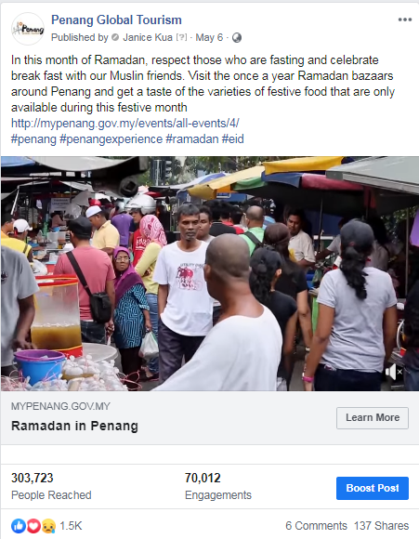

Festivals in a Box: Penang Durian Festival
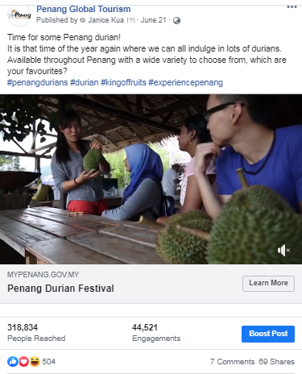

Festival in a Box: George Town Heritage Celebrations
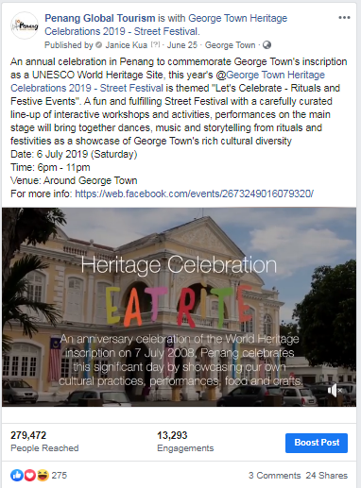

Festivals in a Box: St. Anne’s Festival
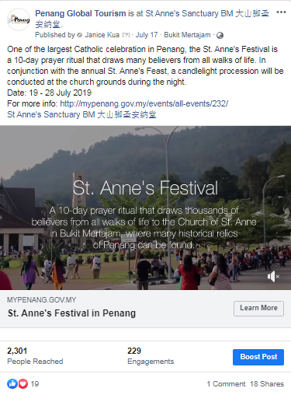

Festival in a Box: Penang Hungry Ghost Festival
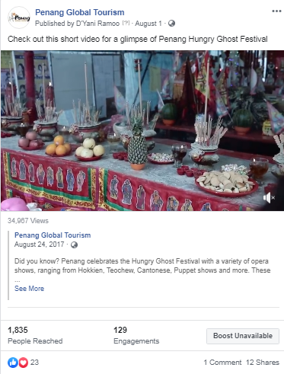

Festival in a Box: Mid-Autumn Festival
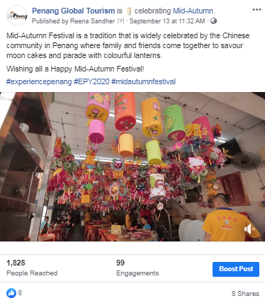

Festivals in a Box: Nine Emperor Gods Festival
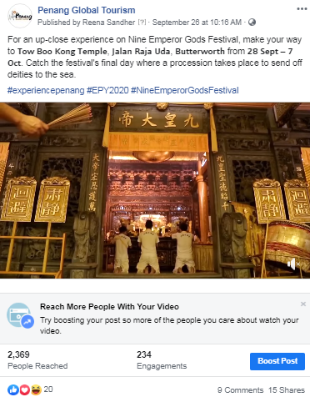

3.2.5 Penang Foodie x Experience Penang 2020 Videos (15 August – 30 September 2019)

The collaboration between Penang Foodie and Penang Global Tourism is to feature Penang via 20 listicle videos every week, for 20 weeks to promote and commemorate Experience Penang 2020 campaign.

Videos that were cross-posted on PGT’s Facebook page and Penang Foodie’s Page:
No. | Videos | Total Views | Total Reach | Date Published
1 | Video 1/20: 20 Must Try Penang Food | 550k | 7 million | 15 August 2019
2 | Video 2/20: 20 Unique Experiences in Penang | 132k | 294k | 26 August 2019
3 | Video 3/20: 20 Things To Do in Seberang Perai | 97k | 395k | 29 August 2019
4 | Video 4/20: 20 Penang’s Best Street Treats | 585k | 1.4 million | 05 September 2019
5 | Video 5/20: 20 Free Things To Do in Penang | 97k | 452k | 12 September 2019
6 | Video 6/20: 20 Best Kopitiams in Penang | 256k | 721k | 19 September 2019
7 | Video 7/20: 20 After Dark Places in Penang | 134k | 434k | 26 September 2019

Video 1/20: 20 Must Try Penang Food
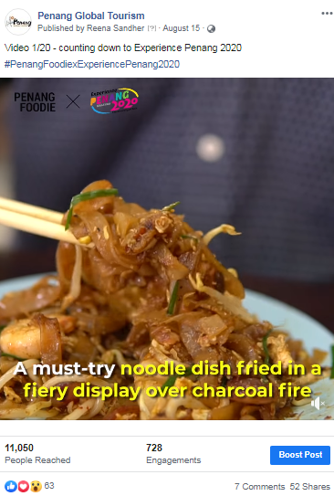

Video 2/20: 20 Unique Experiences in Penang
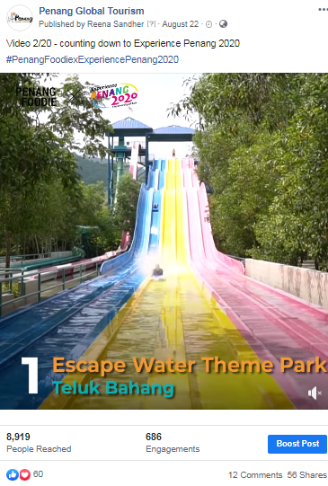

Video 3/20: 20 Things To Do in Seberang Perai
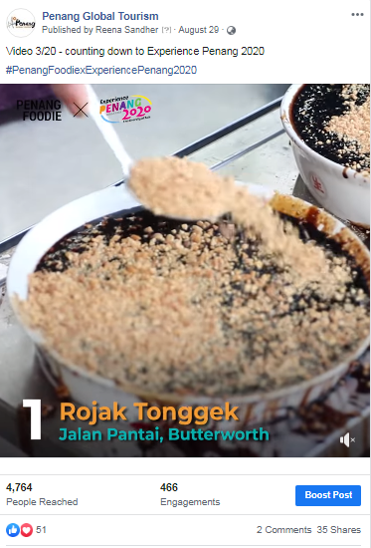

Video 4/20: 20 Penang’s Best Street Treats
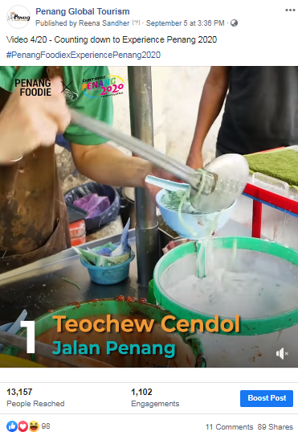

Video 5/20: 20 Free Things To Do in Penang
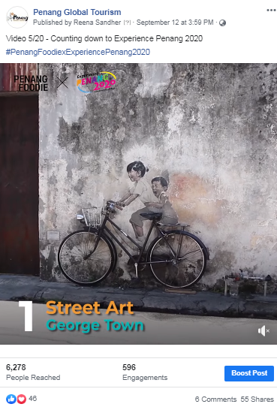

Video 6/20: 20 Best Kopitiams in Penang
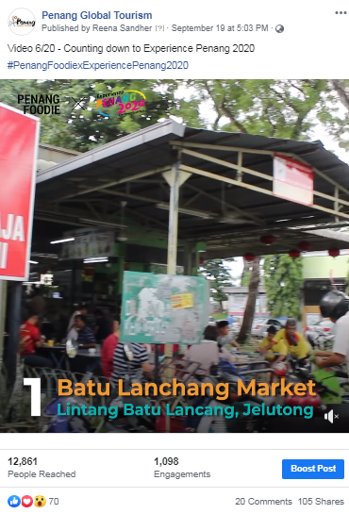

Video 7/20: 20 After Dark Places in Penang
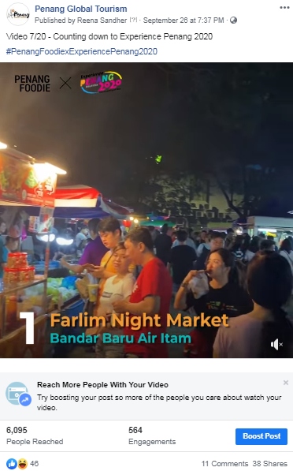

Other promotional videos:

Penang Asian Food & Culture Festival
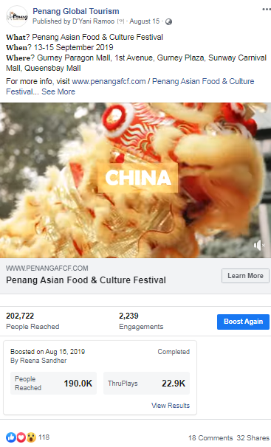

Penang Celebrates Mid-Autumn Festival 2019
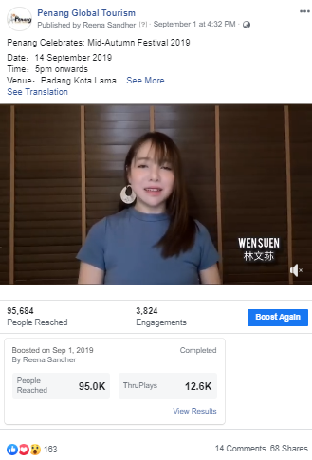

Boosted Posts on PGT & Experience Penang Facebook Page from 16 April – 30 September 2019
PGT’s Facebook Page
Post/ Advert | Target Market | Budget (RM) | Duration | Reach | Results
Festival in a Box: Wesak Day Celebration | Kedah  Perak  Penang  Selangor  Kuala Lumpur | 300 | 3 - 8 May | 5,450 | 32.2k views  38 shares  229 reactions  4 comments
Festival in a Box: Ramadan in Penang | Malaysia  Singapore | 300 | 6 May -  2 June | 303,723 | 97.7k views  137 shares  1,572 reactions  6 comments
Penang Stories: The Jalan Hutton Old-Time Chinese Barber | Hong Kong  Singapore  Malaysia | 200 | 31 May - 14 June | 139,131 | 14 shares  173 reactions  1 comment  1,471 link clicks
Festival in a Box:  Penang Durian Festival | Malaysia  Hong Kong  Singapore | 300  200  200 | 21 June -21 July | 318,834 | 79.3k views  69 shares  504 reactions  7 comments
Festival in a Box: George Town Heritage Celebrations | Northern | 500 | 25 June -  5 July | 279,472 | 74.2k views  24 shares  275 reactions  3 comments
George Town Festival: Macam Macam Berapit | Penang | 300 | 6 - 7 July | 24,111 | 9 shares  247 reactions  1 comment  0 link clicks
Penang Bon Odori Festival | Northern | 400 | 11 - 20 July | 138,080 | 18 shares  48 reactions  8 comments  0 link clicks
Penang Hill Festival 2019 | Northern | 300 | 16 - 20 July | 95,187 | 2 shares  15 reactions  0 comments  11 link clicks
Penang Bon Odori Festival | Penang | 300 | 17 - 20 July | 445,716 | 9 shares  85 reactions  8 comments  169 link clicks
Penang Bon Odori Festival: Night View | Northern | 500 | 17 - 20 July | 342, 141 | 27 shares  157 reactions  5 comments  1 link clicks
Penang Esports Festival | Indonesia  Malaysia  Thailand | 500 | 6 - 13 August | 32,860 | 24 shares  2,657 reactions  6 comments  1 link clicks
Penang Asian Food & Culture Festival: Promo Video | Johor, Kedah, Malacca, Perak, Penang, Selangor, Kuala Lumpur, Singapore | 1,000 | 16 - 26 August | 189,727 | 97.9 k views  50 shares  393 reactions  14 comments  616 link clicks
Penang Esports Festival | Penang; Target Audience – Gamers | 1,000 | 26 August - 5 September | 100,736 | 270 shares  917 reactions  241 comments  726 link clicks
13 of Asia’s Most Picturesque Towns | United Kingdom | 1,000 | 24 September - 1 October | 41,289 | 47 shares  136 reactions  18 comments  2,386 link clicks
Mid-Autumn Festival: Video | Langkawi, Kedah, Perak, Penang | 1,000 | 1 September - 11 September | 94,958 | 44.8k views  66 shares  185 reactions  6 comments
Penang Asian Food & Culture Festival: Promo Video | Langkawi, Kedah, Perak, Penang | 500 | 2 September - 7 September | 94,513 | 37.9k views  45 shares  117 reactions  27 comments  160 link clicks
Penang Asian Food & Culture Festival | Alor Setar, Langkawi, Sungai Petani, Kedah, Ipoh, Penang, Kuala Lumpur | 500 | 6 September - 14 September | 79,814 | 303 shares  650 reactions  218 comments  0 link clicks
Penang Coffee Festival | Kedah, Malacca, Ipoh, Penang, Selangor | 50 | 5 September - 10 September | 4,891 | 7 shares  547 reactions  2 comments  0 link clicks
Penang Esports Festival | Penang | 150 | 6 September -7 September | 10,748 | 7 shares  643 reactions  2 comments  0 link clicks
Penang Asian Food & Culture Festival | Penang | 500 | 9 September - 10 September | 37,040 | 32 shares  1221 reactions  9 comments  86 link clicks
Penang Asian Food & Culture Festival | Penang | 300 | 12 September - 15 September | 62,310 | 388 shares  373 reactions  182 comments  0 link clicks
Penang Coffee & Desserts Festival | Penang | 300 | 18 September - 22 September | 23,129 | 9 shares  327 reactions  0 comments  43 link clicks
Experience Penang Facebook Page
Post/ Advert | Target Market | Budget (RM) | Duration | Reach | Results
Mid-Autumn Festival: Promo Video | Kedah, Ipoh, Perlis, Penang, Selangor | 240.80 | 4 September - 13 September | 31,862 | 51 shares  113 reactions  5 comments  0 link clicks
Mid-Autumn Festival: Buletin Mutiara | Alor Setar, Langkawi, Sungai Petani, Ipoh, Perlis, Penang | 300 | 5 September - 10 September | 26,073 | 43 shares  155 reactions  10 comments  1002 link clicks
Mid-Autumn Festival: Promo Video | Alor Setar, Langkawi, Sungai Petani, Ipoh, Penang | 200 | 6 September - 13 September | 40,686 | 86 shares  331 reactions  17 comments  0 link clicks
Mid-Autumn Festival: Prep Photos | Alor Setar, Langkawi, Sungai Petani, Ipoh, Penang | 300 | 12 September - 14 September | 120,027 | 548 shares  1465 reactions  305 comments  0 link clicks

3.2.5 Website Google Analytics (16 April – 31 July 2019)

Website traffic
The Google Analytics Report shows a spike on 20 July which could be brought by visitors searching for information on the George Town Festival and Penang Bon Odori Festival as r coincides with the date of the festival. Besides that, there was a spike on 17 July, which is brought by adverts that ran on PGT’s Facebook page on Penang Bon Odori Festival.
According to the analytics report, majority of users to our mypenang.gov.my website was acquired organically via Google. There were also users who were linked to our website through Facebook posts, some organically and some through adverts. There were quite a number of visitors that were linked to our website mypenang.gov.my through Penang Sentral’s official website, www.penangsentral.com.my and through Penang Foodie’s official website, penangfoodie.com
Comparison between 1 January–15 April 2019 and 16 April – 31 July 2019
The comparison report shows an increase of 9.27% in new users to the website. However, the number of page views, sessions and bounce rate decreased a little.

Top 5 countries visiting the site and most viewed pages
The top 5 countries visiting the site are Singapore, Indonesia, United States, Australia and Hong Kong. Their most-viewed pages are mainly on Free CAT Bus, Culture & Heritage, Events, Health Tourism, Stories and Food & Lifestyle.
The following pages show the relevant charts and tables summarizing the Google analytics report as highlighted above.
Period: 16 April – 31 July 2019
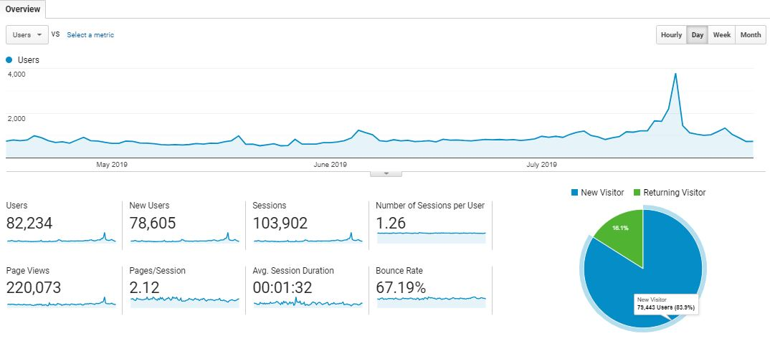

Top 10 user’s location and sources: 16 April – 31 July 2019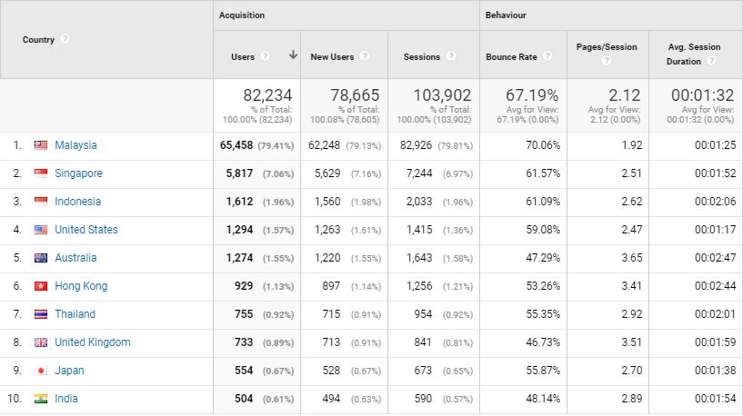
Top 10 user’s location and sources: 1 August – 30 September 2019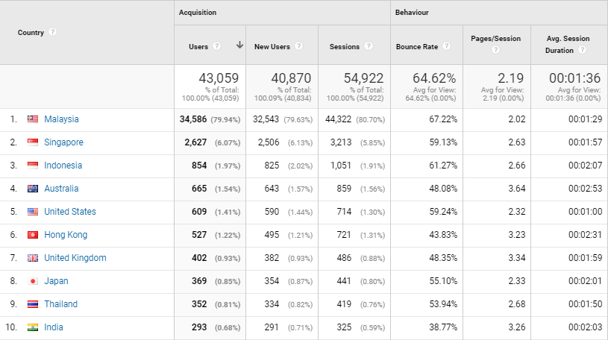
Comparison between 1 January – 15 April 2019 to 16 April – 31 July 2019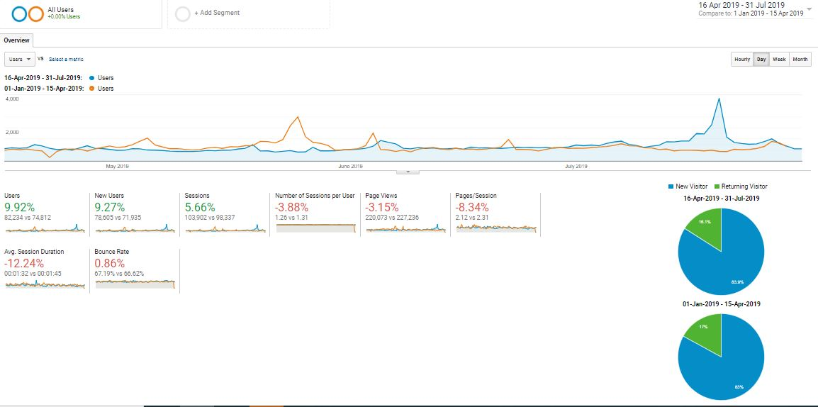

With reference to the above, visitors to the site, in comparison of the time periods:

Item | 16 April – 31 July 2019 | 1 Jan – 15 April 2019
Users | 82,234 | 74,812
Sessions | 103,902 | 98,337
Page Views | 220,073 | 227,236
Ave. Session Duration | 00:01:32 | 00:01:45
Bounce Rate | 67.19% | 66.62%

The top 5 countries visiting our website; in comparison of the time periods:

Country | No. of New Session |  | Increase / Decrease | Most-viewed Pages
Country | 1 Jan – 15 April 2019 | 16 April – 31 July 2019 | Increase / Decrease | Most-viewed Pages
Singapore | 4,807 | 5,817 | 1,010 | Culture & Heritage, Events, Free CAT Bus, Directory
Indonesia | 1,930 | 1,612 | -318 | Culture & Heritage, Events, Free CAT Bus
United States | 1,505 | 1,294 | -211 | Events, Culture & Heritage, Free CAT Bus
Australia | 1,540 | 1,274 | -266 | Events, Culture & Heritage, Free CAT Bus
Hong Kong | 885 | 929 | 44 | Culture & Heritage, Free CAT Bus, Stories, Events, Health Tourism, Food & Lifestyle

The following are the top 10-page views in the mypenang.gov.my website from 16 April – 31 July 2019:
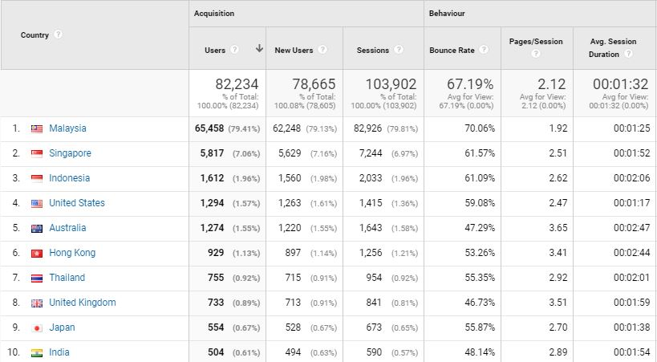

3.2.6 Penang Global Tourism Mobile App
The following table shows the total number of downloads for 1 April to 31 August 2019 on iOS and Android:
Domestic/In’tial | iOS |  | Android
Malaysia | 120 | 21.99% | 133 | 46.94%
Overseas | 420 | 78.01% | 151 | 53.06%
Total downloads | 540 | - | 284 | -

The total number of downloads (Malaysia and overseas) in the four months is 824.
The top 5 international countries for number of downloads on our mobile app are as follows:

iOS:
1. Singapore - 65
2. Hong Kong & Great Britain - 43
3. Indonesia - 40
4. Thailand - 24
5. Australia - 23

Android:
1. Indonesia -
2. Singapore -
3. Hong Kong -
4. Korea -
5. Thailand -

To be consistent with PGT’s website, updates are being done on PGT’s mobile app. For easier management, the backend CMS for e-coupon has been updated to enable further editing and amendments after item has been listed.

3.2.7 PGT’s E-Newsletter – Don’t Say Penang Bojio

The rebranded version Don’t Say Penang Bojio highlights major events and upcoming events happening in the state, announces latest news and/or new openings on Penang’s tourism products, latest updates on direct flights to Penang, as well as latest special deals on PGT’s e-coupon.

Don’t Say Penang Bojio Issue #6 – Apr 2019
Overview Report:
Item | Figure
Recipients | 4,117
Successfully Sent | 4,117
Opened This Campaign | 427 (10.37%)
Clicked A Link | 103 (2.50%)
Unsubscribed | 16 (0.39%)
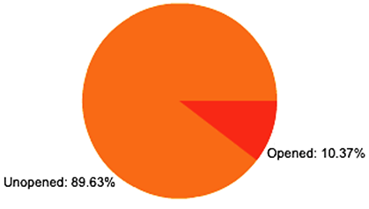

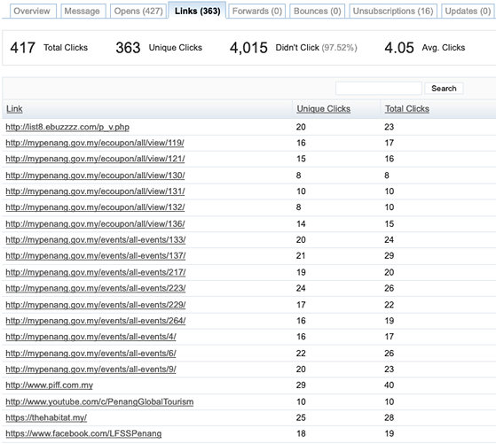
Number of link clicks and links viewed:

Don’t Say Penang Bojio Issue #7 – August 2019
Overview Report:
Item | Figure
Recipients | 3,922
Successfully Sent | 3,922
Opened This Campaign | 304 (7.75%)
Clicked A Link | 95 (2.42%)
Unsubscribed | 11 (0.28%)

Number of link clicks and links viewed:
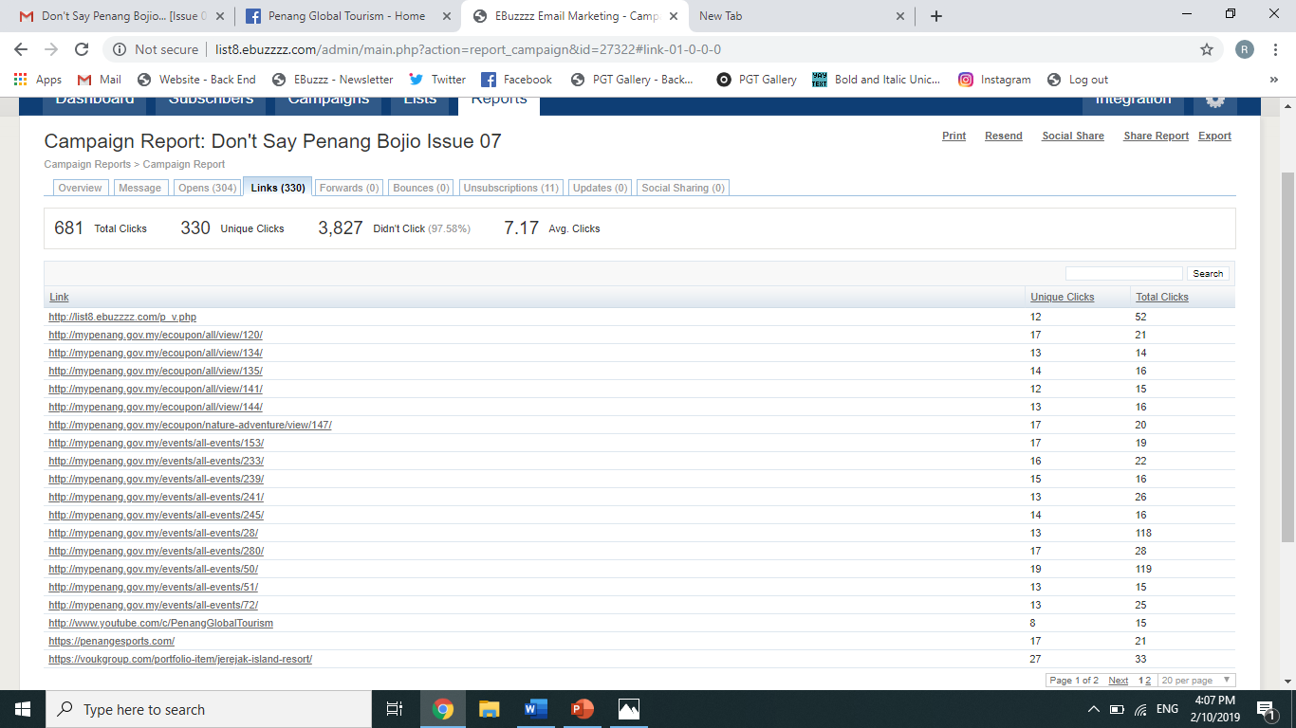

Summary:
- Percentage of recipients who opened the latest issue increased to above 10%
- Percentage of link clicks increased slightly. Most link clicks are to Penang events and featured e-coupons, as well as events, and featured new attractions in Penang.
- Percentage of recipients who unsubscribed in this issue is 0.28% lesser compared to the previous issue

3.3 Recent Publicity (May - September 2019)

May 2019
Local
No | Name | Description | Type of Publication
1 | The Star | Featured the Penang International Food Festival (PIFF 2019) drew to a close successfully and the visitors are enjoyed with the foods on 2 May 2019. | Online
2 | Malay Mail | Featured the Penang International Airport arrivals at record high as direct flights climb and the year-on-year airport arrival figure presented by Mr. Ooi Chok Yan on 6 May 2019. | Online
3 | Guang Ming Daily | Featured the Penang International Airport arrivals at record high as direct flights climb and the year-on-year airport arrival figure presented by Mr. Ooi Chok Yan on 6 May 2019. | Online
4 | Sinchew Daily | Featured the Penang International Airport arrivals at record high as direct flights climb and the year-on-year airport arrival figure presented by Mr. Ooi Chok Yan on 6 May 2019. | Online
5 | Malay Mail | Featured the George Town Heritage Celebrations 2019 themed “Let’s Celebrate – Rituals and Festive Events” and listed some of the activities that are going to be carried out during the celebration on 7 May 2019. | Online
6 | Kwong Wah Yit Poh | Featured the George Town Heritage Celebration 2019 themed “Let’s Celebrate – Rituals and Festive Events” starting from 6th of July and listed several cultural activities that are going to be carried out during the celebration on 7 May 2019. | Online
7 | The Star | Featured the well-prepared George Town Heritage Celebration 2019 themed “Let’s Celebrate – Rituals and Festive Events” and listed several cultural activities that are going to be carried out during the celebration on 15 May 2019. | Online
8 | The Star | Featured the well-prepared George Town Heritage Celebration 2019 themed “Let’s Celebrate – Rituals and Festive Events” and listed several cultural activities that are going to be carried out during the celebration on 18 May 2019. | Online
9 | FireFlyz | Featured the George Town Heritage Celebrations under the Upcoming Events part and listed Penang Free School, the Educational Institution as one of the 10 things & facts about amazing Malaysia in its May 2019 issue. | Magazine

Foreign
No | Name | Description | Type of Publication
1 | ELEVEN MEDIA GROUP Co.,Ltd | Listed George Town, Malaysia as “one of Southeast Asia’s most livable destination” on 29 May 2019. | Online
2 | Lion Air | Featured the landing of flight from Batik Air in Penang and was warmly welcomed on 30 May 2019. | Online
3 | Travel Daily News | Featured the landing of flight from Batik Air in Penang on 31 May 2019. | Online

June 2019
Local
No | Name | Description | Type of Publication
1 | Bernama | Featured the launching of Experience Penang Year 2020 with tagline The Diversity of Asia, and hashtag #EPY2020 as to stimulate the demand for experiential travel on 2 June 2019. | Online
2 | Guang Ming Daily | Featured the launching of Experience Penang Year 2020 and hope to satisfy the demand for travel experience on 3 June 2019. | Online
3 | The Sun Daily | Featured the government of Penang is expecting half a million attendance at the 10th edition of George Town Festival (GTF) that fall on 13-28 July 2019 with the theme “A festival for Everyone” on 3 June 2019. | Online
4 | Malay Mail | Featured the annual George Town Festival (GTF), themed “A Festival for Everyone” has been cut to 16 days from 13 – 28 July 2019 instead of a month long for this year due to the cut of budget on 3 June 2019. | Online
5 | The Star | Featured the annual George Town Festival (GTF), themed “A Festival for Everyone” has been cut to 16 days from 13 – 28 July 2019 instead of a month long for this year due to the cut of budget on 3 June 2019. | Online
6 | Guang Ming Daily | Featured the annual George Town Festival (GTF), themed “A Festival for Everyone” will be held on 13 – 28 July 2019 instead of a month long for this year due to the cut of budget and TLM Event Sdn Bhd will be the organizer for the first time on 3 June 2019. | Online
7 | Kwong Wah Yit Poh | Featured the annual George Town Festival (GTF), themed “A Festival for Everyone” will be held on 13 – 28 July 2019 instead of a month long for this year due to the cut of budget and TLM Event Sdn Bhd will be the organizer for the first time on 3 June 2019. | Online
8 | New Straits Times | Featured Penang was listed in CNN Travel as one of the 17 Asia’s best destinations to consider for the next adventure and also as a mecca for food and architecture lovers on 4 June 2019. | Online
9 | The Star | Featured Penang was listed in CNN Travel as one of the 17 best destinations to visit for the ultimate Asia experience and was a mecca for food and architecture lovers on 4 June 2019. | Online
10 | The Star | Featured the launching of Experience Penang Year 2020 with tagline ‘The Diversity of Asia’ to usher in the excitement of Visit Malaysia Year 2020 on 8 June 2019. | Online
11 | The Star | Featured Penang collaborates with popular Hindi TV channel to pull in Indian tourists on 8 June 2019. | Online
12 | Guang Ming Daily | Featured the interesting classical music night that will be carried out during 24 & 25 of July in Macallum Street during the George Town Festival (GTF) on 10 June 2019. | Online
13 | Kwong Wah Yit Poh | Featured the “Macam Macam Macallum” activities on 24 & 25 of July during the George Town Festival (GTF) on 11 June 2019. | Online
14 | Kwong Wah Yit Poh | Featured the E-Sport Carnival 2019 will be held on 7-8 of September at Penang SETIA SPICE on 12 June 2019. | Online
15 | New Straits Times | Featured the Cathay Pacific Airways Ltd increased the number of flights from Penang to Hong Kong on 17 June 2019. | Online
16 | The Star | Featured the launching of the #ExperiencePenang campaign on TikTok that is in partnership with Penang Global Tourism (PGT) on 20 June 2019. | Online
17 | The Star | Featured the launching of the #ExperiencePenang campaign on TikTok that is in partnership with Penang Global Tourism (PGT) on 22 June 2019. | Online
18 | Malay Mail | Featured YZD appointed to develop Penang Tourism Master Plan (PTMP) and YB Yeoh represented PGT to sign the official agreement with the witnessed by YAB Chow on 24 June 2019. | Online
19 | Guang Ming Daily | Featured YZD appointed to develop Penang Tourism Master Plan (PTMP) and YB Yeoh represented PGT to sign the official agreement with the witnessed by YAB Chow on 25 June 2019. | Online
20 | Kwong Wah Yit Poh | Featured YZD appointed to develop Penang Tourism Master Plan (PTMP) and YB Yeoh represented PGT to sign the official agreement with the witnessed by YAB Chow on 25 June 2019. | Online
21 | Sin Chew Daily | Featured YZD appointed to develop Penang Tourism Master Plan (PTMP) and YB Yeoh represented PGT to sign the official agreement with the witnessed by YAB Chow on 26 June 2019. | Online
22 | FireFlyz | Listed Vibrant Art in George Town, Penang as one of the 10 things & facts about amazing Malaysia in its June 2019 issue. | Magazine
23 | The Expat | Listed the events in Penang during June 2019, the Café in Penang that is serving with Matcha dessert, and featured the beachside at Batu Feringghi in its June 2019 issue. | Magazine
24 | Going Places | Listed the annual arts festival in Penang - George Town Festival under the Events + Happenings section in its June 2019 issue. | Magazine

Foreign
No | Name | Description | Type of Publication
1 | My Joy | Featured the best places to visit for the ultimate Asia experience and Penang was listed as one of the 17 of Asia’s best destinations on 14 June 2019. | Online
2 | Marketing Interactive | Featured the launching of TikTok’s online challenge, #Experience Penang, and named TikTok as co-branding partner of Penang Global Tourism to promote Penang as a key travel destination within Southeast Asia on 17 June 2019. | Online
3 | Silkwinds | Featured a cyclist travel for 400km on his bicycle from Kuala Lumpur and set Penang as his last destination, and mentioned the cycling lanes, routes, and bike-sharing system in Penang in its June 2019 issue. | Magazine

July 2019
Local
No | Name | Description | Type of Publication
1 | Kwong Wah Yit Poh | Featured AirAsia set flight for first direct flight from Penang to Malacca on 1 July 2019. | Online
2 | Sin Chew Daily | Featured the set flight of Air Asia direct flight from Penang to Malacca on 2 July 2019. | Online
3 | Sin Chew Daily | Featured Penang-Malacca round trip flight will depart from Penang to Malacca at 1320 and back to Penang at 1450 every afternoon on 2 July 2019. | Online
4 | The Malaysian Reserve | Featured the Penang – Malacca route launched by AirAsia on 2 July 2019. | Online
5 | Guang Ming Daily | Featured the Launching of Outdoor Advertising for Bus Shelter, Link Bikes, and Rapid Bus with the theme of EPY2020-The Diversity of Asia on 2 July 2019. | Online
6 | Kwong Wah Yit Poh | Featured the EPY2020 Outdoor Advertising Launch for Bus Shelter, Link Bikes, and Rapid Bus on 3 July 2019. | Online
7 | The Star | Featured AirAsia will operate its daily flight from Penang to Melaka every day at 1.20pm on 4 July 2019. | Online
8 | The Star | Featured the George Town Festival (GTF) from July 18 to 21 that connects Penang and Taiwan with cultural performances on 5 July 2019. | Online
9 | Kwong Wah Yit Poh | Featured the Strategic Partnership MOU Signing Ceremony between CTrip Group & PGT that focusing on accommodation, travel, and attractions expansion to enhance Penang’s global brand awareness on 10 July 2019. | Online
10 | The Star | Featured the 3 specially curated exhibitions for George Town Festival (GTF) 2019 which are “A Real Fake Forest”, “Superstition II”, and GERMIS: A Collaborative Orang Asli Art Exhibition” on 16 July 2019. | Online
11 | Kwong Wah Yit Poh | Featured one of the key programme for George Town Festival (GTF) 2019 – “Art In The City” and the road closure during the event. Besides, it featured the “When Night Fall” attracted 130,000 people – YB Yeoh on 17 July 2019. | Online
12 | Guang Ming Daily | Featured the activities that will be carried out during the “Art In The City” on 20 & 21 of July and YB Yeoh mentioned that 130,000 people was attracted to “When Night Fall” on 17 July 2019. | Online
13 | The Star | Featured the activities on George Town Festival (GTF) 2019 such as dance performance, projecting mapping, and ballet performance on 19 July 2019. | Online
14 | The Star | Featured the programmes for George Town Festival (GTF) 2019 – “When Night Fall” on the opening night such as Le Ballerine of Teatro Pavana, Lighted Drummers, Luminous Horses, and Dazzling Projection Mapping on 19 July 2019. | Online
15 | Kwong Wah Yit Poh | Featured the opening ceremony and the activities for George Town Festival (GTF) 2019 – Isle to Isle on 19 July 2019. | Online
16 | Guang Ming Daily | Featured the highlighted programme – The Extravaganza for the closing ceremony of George Town Festival (GTF) 2019 on 22 July 2019. | Online
17 | The Star | Featured the activities for the highlighted programme of George Town Festival (GTF) 2019 – The Extravaganza on 24 July 2019. | Online
18 | Kwong Wah Yit Poh | Featured the activities for the “Macam-Macam Macallum” during George Town Festival (GTF) 2019 on 25 July 2019. | Online
19 | Kwong Wah Yit Poh | Featured the closing ceremony for George Town Festival (GTF) 2019 ended successfully with the celebration themed – “The Extravaganza” and announced George Town Festival 2020 will be on 11-26 July next year on 29 July 2019. | Online
20 | Guang Ming Daily | Featured the 16 days event, George Town Festival (GTF) 2019 ended successfully with the celebration themed – “The Extravaganza” and announced George Town Festival 2020 will be on 11-26 July next year on 29 July 2019. | Online
21 | The Star | Featured the George Town Festival (GTF) 2019 ended successfully with the celebration themed – “The Extravaganza” and announced that GTF 2020 will be held for 16 days from July 11 to July 26 next year on 31 July 2019. | Online
22 | Fire Flyz | Featured George Town Festival on 13-28 July under the upcoming events section, featured Double Tree Resort by Hilton in Penang under the Comfort Zone: Where To Stay section, covered 3 pages for the Authentic Indian Food in Penang’s Little India, and Rich Heritage – George Town World Heritage Day under the 10 things & facts about amazing Malaysia in its July 2019 issue. | Magazine
23 | Travel 360 | Featured Penang under the Spotlight – Heritage Hive and mentioned George Town Heritage Celebrations (GTHC), George Town Festival (GTF), and Penang Hill Festival (PHF) that is happening in July in its July 2019 issue. | Magazine
24 | The Expat | - Featured the refurbished building, culture, wall art & iron caricatures, food, bar, coffee shop, accommodation and transportation under the expat excursions: penang by David Bowden in its July 2019 issue.  - Featured the coming up events (The Annual George Town Literary Festival) under the see you next month section in its July 2019 issue. | Magazine
25 | Senses of Malaysia | Featured the Wanderlust Thrives in Historic George Town such as the UNESCO heritage zone building, art and graffiti, cuisine, accommodation, and café under the destination focus: cities of the peninsula by David Bowden in its July/August/September 2019 issue. | Magazine

Foreign
No | Name | Description | Type of Publication
1 | Silkwinds | Featured Penang Iron Rod Artworks and listed Halab Restaurant, Soundmaker Studio, Flight of the Colugo Zipline, and Hikayat under the postcard section in its July 2019 issue. | Magazine
2 | Mix Magazine | Featured GeorgeTown Heritage, Habitat Penang Hill, Gravityz, Food Tour Penang, and Penang Peranakan Mansion under the Penang Pastimes section in its July 2019 issue. | Magazine

August
Local
No | Name | Description | Type of Publication
1 | Travel 360 | Stated the AirAsia’s new route between Melaka and Penang, which launched on July 1 in its August 2019 issue. | Magazine
2 | The Expat | Listed the upcoming events in August under Penang events, featured the Tower Spa at The Top Penang, and the Historic Mansions now serving as Hotels in Penang such as Cheong Fatt Tze-The Blue Mansion, East Indies Mansion, Macalister Mansion, Botanica Mansion, The Edison George Town, and Jawi Peranakan Mansion under Penang Promenade section. | Magazine
3 | Travel + Leisure | Featured an article on ‘A Penang Feast’ – A sleep one-stop-shop for literature, creativity and Penang’s latest, more artsy accommodation. | Magazine
4 | EZ Malaysia – Faces of Penang | Featured the major events happening in Penang by month, all year round. | Magazine
5 | The Star | Featured the closing of George Town Festival 2019 | Online
6 | The Star | The Economic Affairs Minister made a working visit to Penang Hill and The Habitat. It is stated that the ministry will look into allocation from the Federal Government to help improve existing infrastructure on Penang Hill. | Online
7 | The Star | It is reported that Swettenham Pier Cruise Terminal will be undergoing expansion. The completion of the extension work will be next year. | Online
8 | The Sun Daily | An article on getting the best mee goreng and mee rebus in Penang. | Online
9 | Rojak Daily | An article on getting unique burgers in Penang – 14 Lip-smacking (and unique) burgers to check out in Penang | Online
10 | Kwong Wah Yit Poh | Penang Wadda Gurdwara Sahib heritage building (Sikh Temple) will be undergoing restoration work | Online
11 | Kwong Wah Yit Poh | Sia Boey project is expected to be completed on September 3 | Online
12 | New Straits Times | Penang Botanical Garden will be undergoing major upgrade soon | Online
13 | The Edge Prop | It is featured in the article that Penang State is hopeful to get the distinction of having the fourth botanical garden to be listed under the UNESCO World Heritage Site. | Online
14 | The Star | Successful cleanliness programmes along the Batu Ferringhi tourist belt have largely contributed towards Penang’s listing as one of the top 10 great value beach destinations in the world | Online
15 | Unreserved Travel | Penang listed as one of the best hiking destinations in Asia Pacific | Magazine/ Online
16 | The Star | The 111-year-old Lebuh Pantai Fire and Rescue Station has been rebranded as Central Fire Station 1908 | Online
17 | The Star | Orchid show to boost local tourism and put the state on international map | Online
18 | Kwong Wah Yit Poh | Featured Penang Orchid Show 2019 | Online
19 | The Star Online | New weekly videos on Penang attractions soon – Penang Foodie will be uploading 20 videos and each video will comprise a list of 20 items that have been compiled using different categories | Online
20 | Guang Ming Daily | Penang artist, Mohd Azmi created a painting of 101 meters long and was awarded longest coffee painting award by Malaysia Book of Records. | Online
21 | Kwong Wah Yit Poh | The longest coffee painting in 101 meters, Penang artist Mohd Azmi receives Malaysia Book of Records award for longest coffee painting | Online

August 2019
Foreign
No | Name | Description | Type of Publication
1 | Travel Leisure | Featured the Hikayat bookstore located in Penang Beach Street, George Town under the discovery section in its August 2019 issue. | Magazine
2 | Silkwinds | Featured the Teochew Puppet Opera that survives in Malaysia only in Penang under The Professional section in its August 2019 issue. | Magazine
3 | Channel News Asia | Affordability and Island vacation drive Penang’s medical tourism sector – Within Malaysia, Penang is the top medical tourism destination, generating about 40 to 50 per cent of the country’s medical tourism income. | Online

September 2019
Local
No | Name | Description | Type of Publication
1 | The Star | Lanterns light up Mid-Autumn Fest in Penang - Several parks and roads here have been spruced up with bright and colourful lanterns in preparation for the Mid-Autumn Festival on Sept 13. | Online
2 | Guang Ming Daily | Penang Celebrates Mid-Autumn Festival – A celebration with many activities is lined up for the Mid-Autumn Festival organised by PETACH. | Online
3 | Buletin Mutiara | Penang to become hub of esports - PENANG is aiming to become one of the popular eSports hubs in Southeast Asia in the near future. | Online
4 | Kwong Wah Yit Poh | Penang esports festival opening at Setia SPICE Arena | Online
5 | Sin Chew Daily | The Penang E-sports Carnival is on the scene today. Preferred place for young people – Penang Esports launching at Setia SPICE Arena | Online
6 | Guang Ming Daily | Create an esports platform in Penang, Chief Minister of Penang says – Penang Esports launching at Setia SPICE Arena | Online
7 | Guang Ming Daily | Penang Asian Food & Culture Festival – The opening ceremony at Hin Bus Depot | Online
8 | Kwong Wah Yit Poh | Penang Asian Food & Culture Festival – The opening ceremony at Hin Bus Depot | Online
9 | Buletin Mutiara | A notable start to food and culture festival – The opening ceremony of Penang Asian Food & Culture Festival at Hin Bus Depot. It was officiated by Chief Minister of Penang. | Online
10 | Buletin Mutiara | Penang Coffee Festival – A press conference was held to announce on Penang Coffee Festival. | Online
11 | Buletin Mutiara | Mid-Autumn Festival, a time to celebrate with family – an announcement on ‘Penang Celebrates – Mid Autumn Festival 2019’ event | Online
12 | Guang Ming Daily | Penang Experience Pass – PETACH launched an experience pass for tourist to purchase while in Penang to experience 20 different attractions | Online
13 | Kwong Wah Yit Poh | Experience Penang Travel Card – Tur 20 different attractions for only RM 149. | Online
14 | Bernama | World’s longest water slide in Penang to open next month | Online

Foreign
No | Name | Description | Type of Publication
1 | CNN Travel | Penang listed as one of Asia’s 13 picturesque towns. | Online
2 | Channel News Asia | World’s longest tube water slide in Penang enters record books - The newest attraction at Escape theme park in Malaysia takes four minutes to ride – and is 1.1km long | Online

