LED Boards | Event and  ad display dates | Visual of displayed ad
 | Mau Hui  9 Jan – 10 Jan | 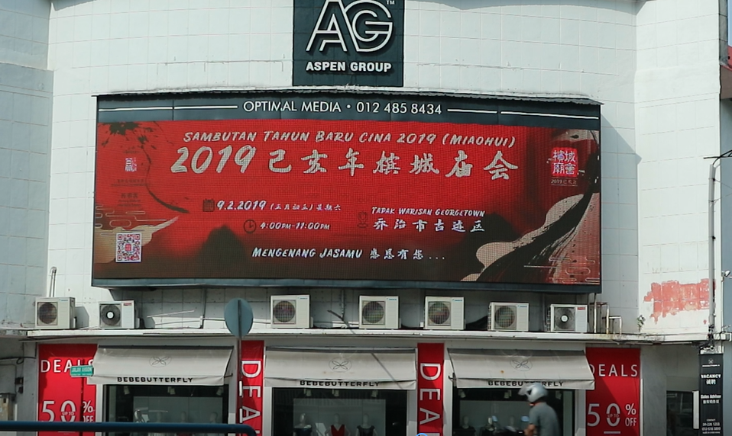
 | Yosakoi  12 Jan – 2 Mar | 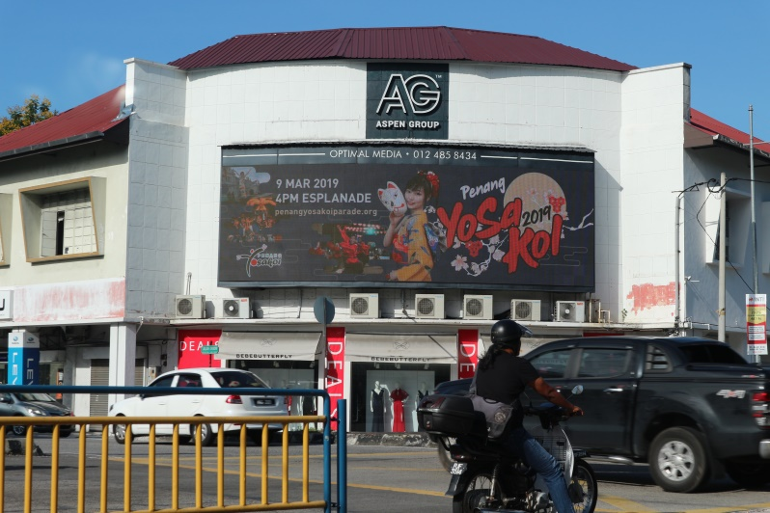
 | YB Lim Guan Eng Open House  24 Jan – 6 Feb 2019 | 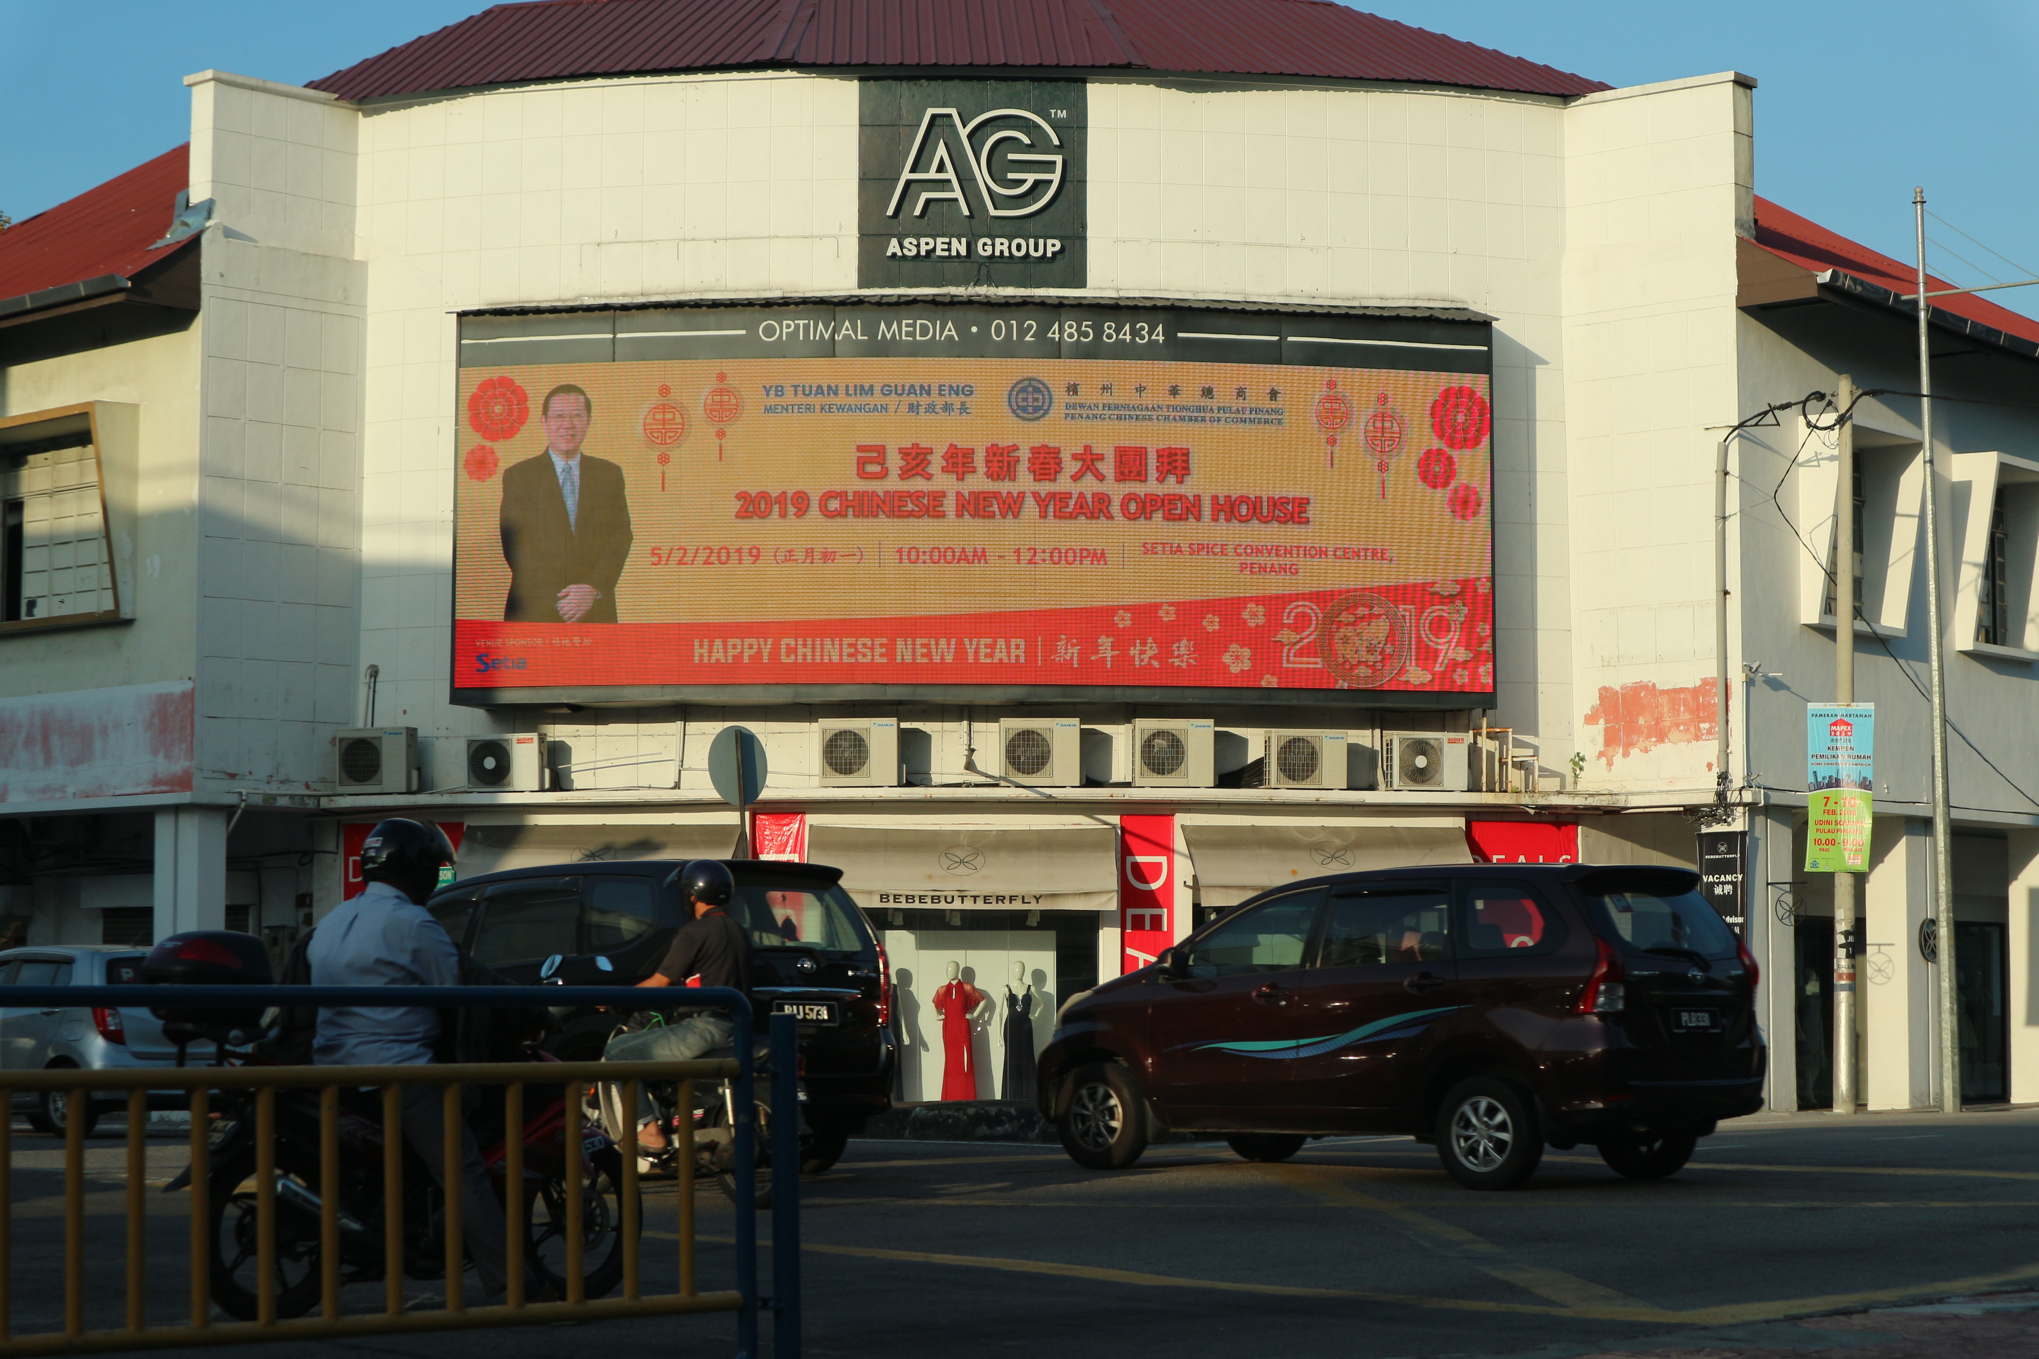
 | Joker Xue Concert  4 Feb – 15 Feb | 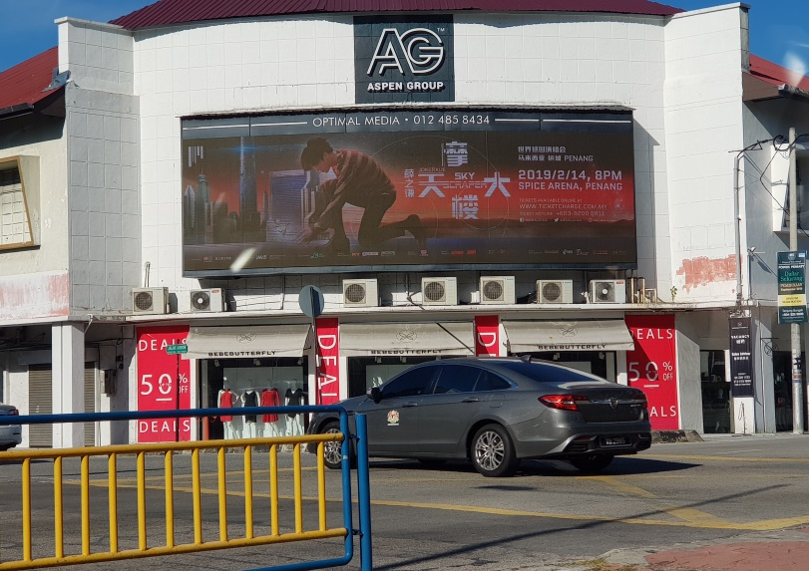
 | MZ Concert  20 Feb – 18 Mar | 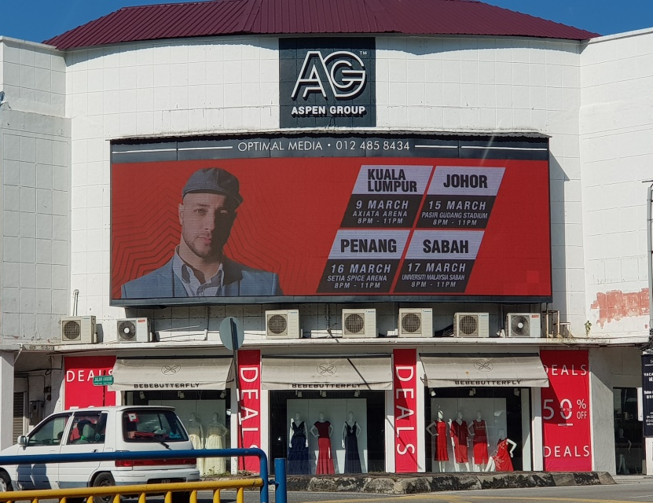
 | Halal Expo  21 Feb – 4 Mar | 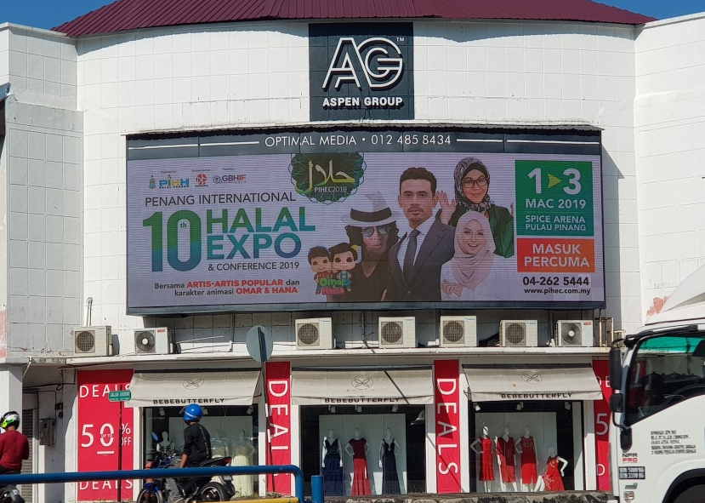
 | Matta Fair  21 Feb – 8 Apr | 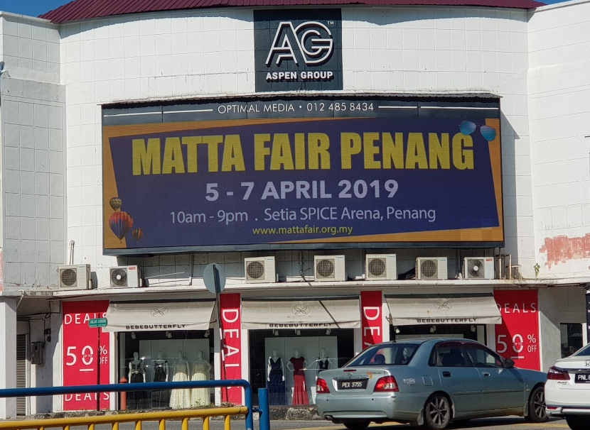
 | Penang Art Week  6 Mar – 1 Apr | 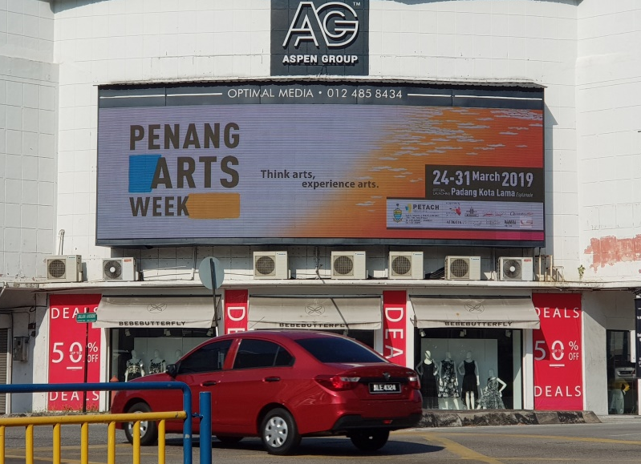
 | Penang International Food Festival  Mar 14 - | 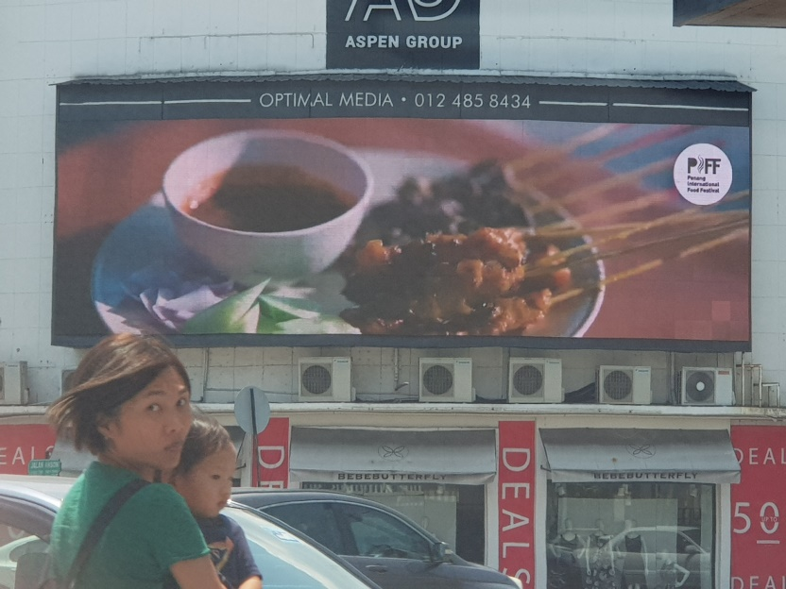
 | Penang Olympic Carnival  4 Apr - | 