LED Boards | Event and  ad display dates | Visual of displayed ad
AutoCity | CNY Celebration (Miao Hui) (date:  8/1/19) | 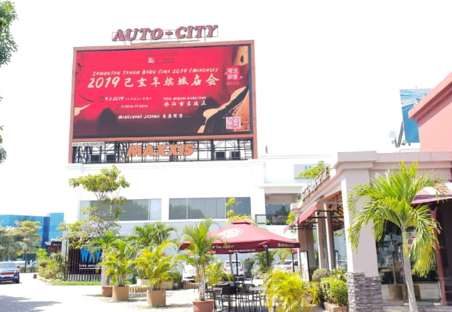
Queensbay | CNY Celebration (Miao Hui) (date:  8/1/19) | 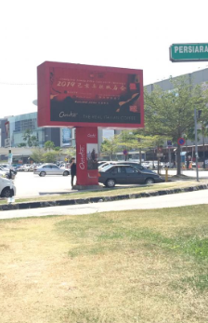
Sunway Carnival | CNY Celebration (Miao Hui) (date:  8/1/19) | 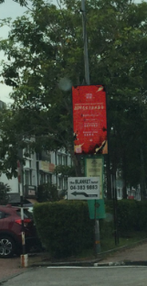
Raja Uda | CNY Celebration (Miao Hui) (date:  8/1/19) | 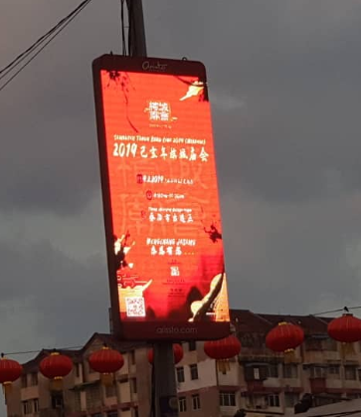
AutoCity | Penang Yosakoi 2019 (date:  13/1/19) | 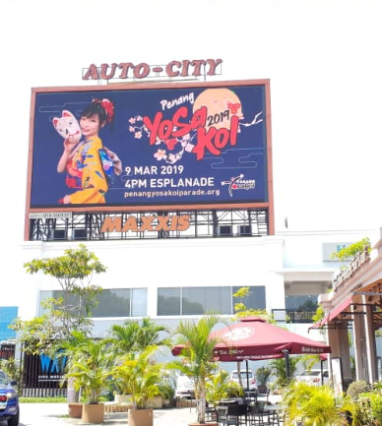
Queensbay | Penang Yosakoi 2019 (date:  13/1/19) | 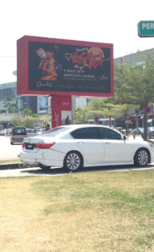
Sunway Carnival | Penang Yosakoi 2019 (date:  13/1/19) | 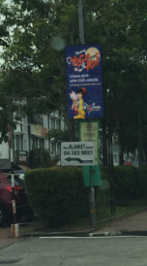
Raja Uda | Penang Yosakoi 2019 (date:  13/1/19) | 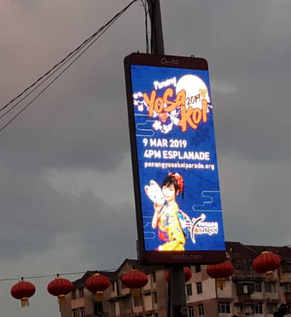
Auto-City | CNY Open House by Finance Minister - YB Lim Guan Eng (date:  23/1/19) | 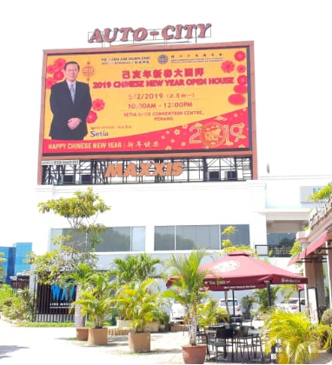
Queensbay | CNY Open House by Finance Minister - YB Lim Guan Eng (date:  23/1/19) | 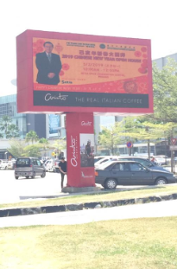
Sunway Carnival | CNY Open House by Finance Minister - YB Lim Guan Eng (date:  23/1/19) | 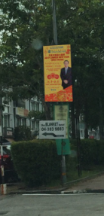
Raja Uda | CNY Open House by Finance Minister - YB Lim Guan Eng (date:  23/1/19) | 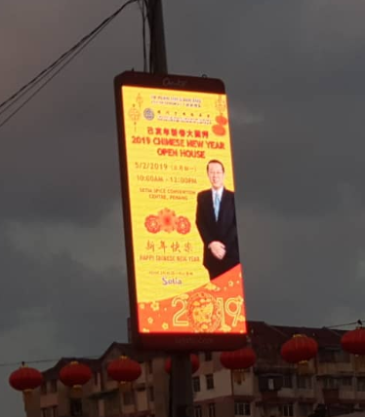
AutoCity | Maher Zain (date:  20/2/19) | 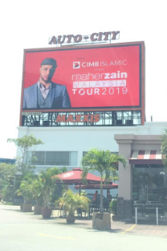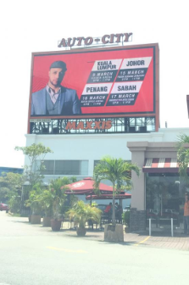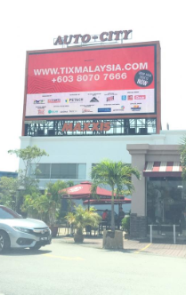
Queensbay | Maher Zain (date:  20/2/19) | 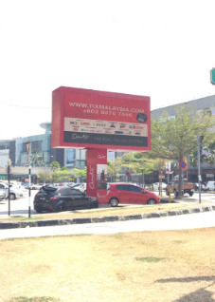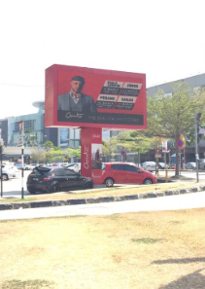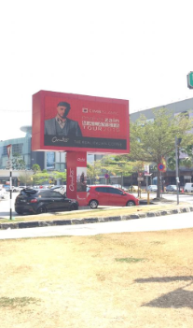
Sunway Carnival | Maher Zain (date:  20/2/19) | 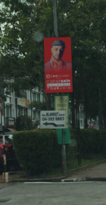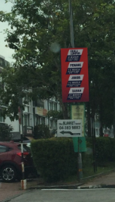  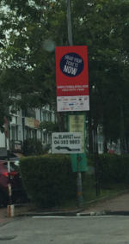
Raja Uda | Maher Zain (date:  20/2/19) | 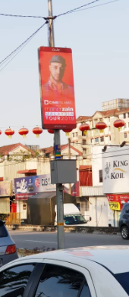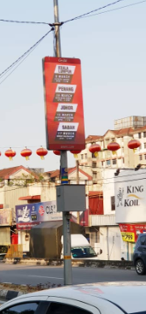  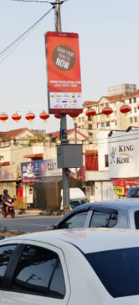
AutoCity | Matta Fair (date:  26/2/19) | 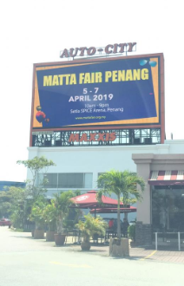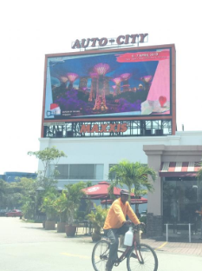  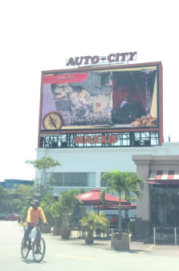
Queensbay | Matta Fair (date:  26/2/19) | 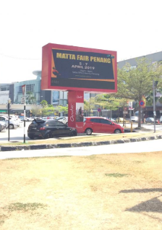  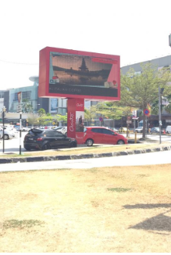  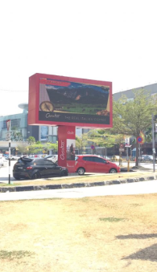
Sunway Carnival | Matta Fair (date:  26/2/19) | 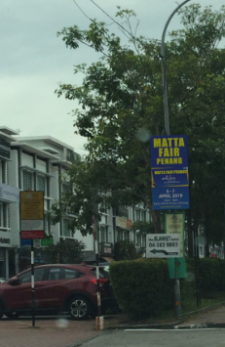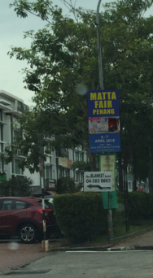  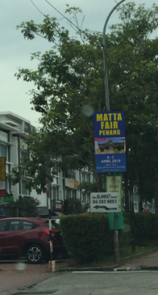
Raja Uda | Matta Fair (date:  26/2/19) | 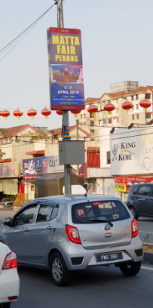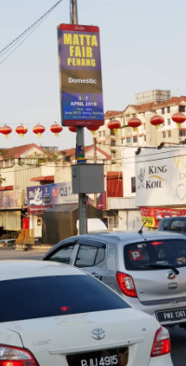  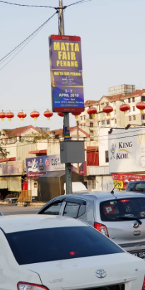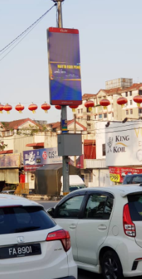
Auto City | Halal Expo (date:  26/2/19) | 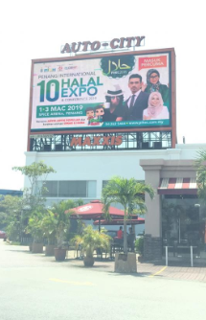
Queensbay | Halal Expo (date:  26/2/19) | 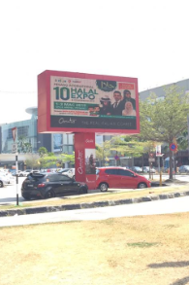
Sunway Carnival | Halal Expo (date:  26/2/19) | 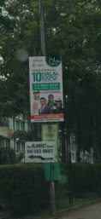
Raja Uda | Halal Expo (date:  26/2/19) | 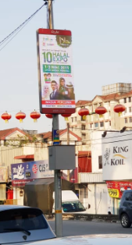
AutoCity | Penang Art Week (date:  7/3/19) | 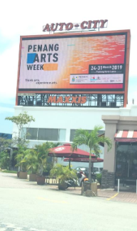
Queensbay | Penang Art Week (date:  7/3/19) | 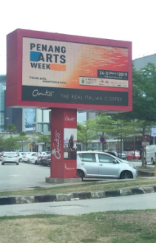
Raja Uda | Penang Art Week (date:  7/3/19) | 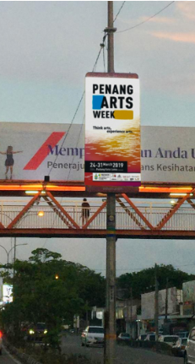
Autocity | Penang International Food Festival (PIFF) (date:  14/3/19) | 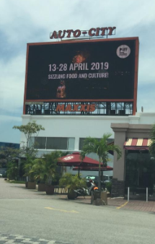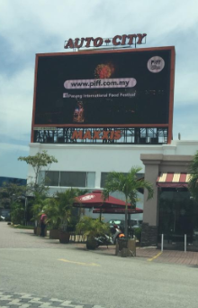  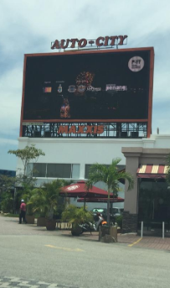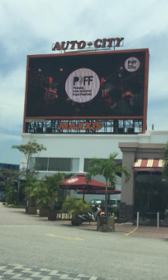
Queensbay | Penang International Food Festival (PIFF) (date:  14/3/19) | 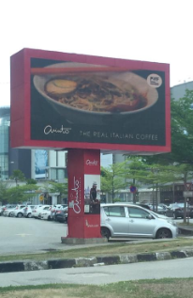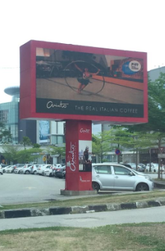  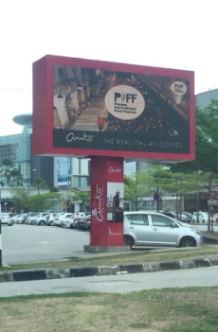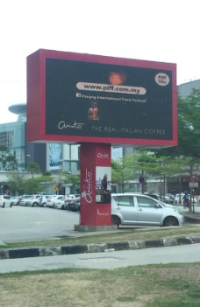
Raja Uda | Penang International Food Festival (PIFF) (date:  14/3/19) | 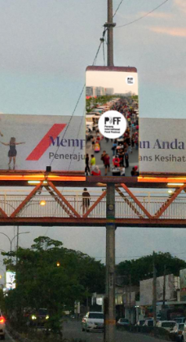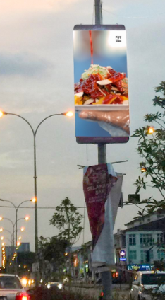  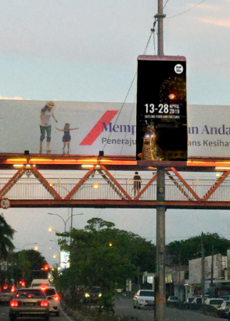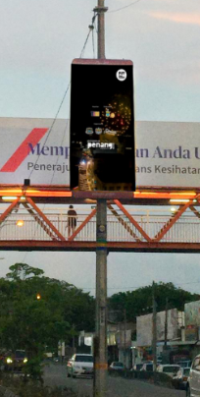
Gurney Plaza | Penang International Food Festival (PIFF) (date:  14/3/19) | 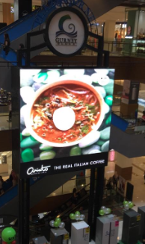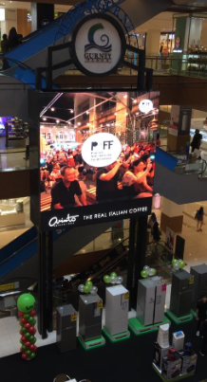  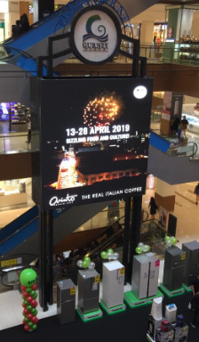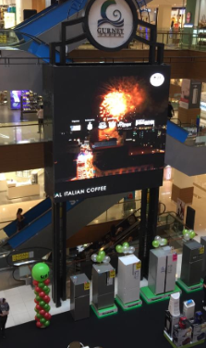
Raja Uda | Olympic Carnival Penang (date:  4/4/19) | 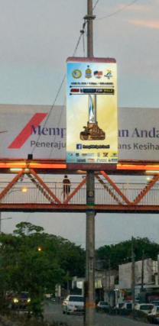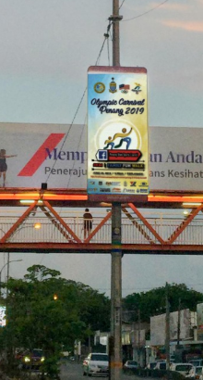
Queensbay | Olympic Carnival Penang (date:  4/4/19) | 