3. Communications - Reported by D’Yani Ramoo

Report Overview
Events’ promotion:
The advertising and promotions of events undertaken for the past three months, October to December were for Butterworth Fringe Festival, Dragon Boat Festival, Penang Celebrates Christmas with Jazz and Penang Hot Air Balloon Fiesta, that’s is coming up in February. Yosakoi Parade that’s happening in March was also advertised starting December via Airport Cube, Armenian Street Poster plus advertised in Escape magazine.

International campaigns:
For international markets, Comms focused on advertising in inflight magazines, i.e. Etihad Airways, Qatar Airways, Singapore Airlines, Citilink, Thai Smile and Qantas Airways, especially in the November and December issues to take advantage of the year-end high travel period.

For 2019, the A&P plan undertaken by Comms will focus on international markets of the top 10 consistent tourist arrivals and especially those with direct flights. We will reach out to these markets via online advertising with OTAs such as Expedia and TripAdvisor as well as via Google advertising where we’ll be able to better track and measure our advertising reach. We will still be placing advertorials in inflight magazines as our additional medium of advertising. As for outdoor advertising, we have planned to kick-off advertising on the Hong Kong trams in April and in Singapore, we are looking into advertising on double decker buses and bus shelters as well. Outdoor advertising locally in Penang will take place as usual via billboards, buses, LED screens and lamp post streamers. For nationwide coverage on the other had we will be regularly advertising via the ASTRO radio channels especially on the main events held.

3.1 Accomplished from October to December 2018

3.1.1 Print ads
- Etihad’s (Atlas) Oct 2018 issue – ad on Culture & Heritage:

- AirAsia’s (Travel 3Sixty)’s October 2018 issue – ad on George Town Literary Festival:

- SCOOT’s October 2018 issue – advertorial on George Town Literary Festival:

- SilkAir’s (Silkwinds) Oct 2018 issue – ad on George Town Literary Festival:

- Qatar’s (Oryx) Oct issue – advertorial on George Town Literary Festival:

- Qatar’s (Oryx) Nov issue – advertorial on Gorgeous Penang campaign:

- Qatar’s (Oryx) Dec issue – advertorial on Gorgeous Penang campaign:

- Citilink’s (Linkers) Nov issue – advertorial on Gorgeous Penang campaign:

- Citilink’s (Linkers) Dec issue – advertorial on Penang Hot Air Balloon Fiesta:

- SIA’s (SilverKris) Nov issue – advertorial on Gorgeous Penang campaign:

- SIA’s (SilverKris) Dec issue – advertorial on Gorgeous Penang campaign:

- Thai Smile’s (WeSmile) Nov issue – advertorial on Gorgeous Penang campaign:

- Thai Smile’s (WeSmile) Dec issue – advertorial on Gorgeous Penang campaign:

- Qantas’ Dec issue – advertorial on Gorgeous Penang campaign:

- Essenze Australia’s Vol.14 issue – ad and write-up on George Town Literary Festival:

- Essenze Australia’s Vol.15 issue – ad and write-up on Penang Hot Air Balloon Fiesta:

- Escape’s Dec 2018-Jan 2019 issue on Penang Hot Air Balloon Fiesta and Penang Yosakoi Parade:

- Penang Monthly’s Oct 2018 issue on George Town Literary Festival ad:

- Penang Monthly’s Nov 2018 issue on Butterworth Fringe Festival ad:

3.1.2 Events A&P
In the months of October to December, PGT advertised and promoted George Town Literary Festival, i.e. that had been budgeted for are as follows:
No. | Event | Event Date | Est. A&P Cost (RM)
1 | George Town Literary Festival | 22 – 25 Nov 2018 | 135,000
2 | Butterworth Fringe Festival | 1 & 2 Dec 2018 | 80,000
3 | Penang Celebrates Christmas with Jazz | 15 Dec 2018 | 25,000
4 | Penang Hot Air Balloon Fiesta | 9 & 10 Feb 2019 | 200,000
5 | Penang Yosakoi Parade | 9 Mar 2019 | 30,000

The estimated A&P cost above takes into account the costing of LED advertising which we’ve signed up a whole year contract on LED screen in the island and mainland; and series of print ads in magazines (including inflight); as well as radio advertising which all have separate budgets apart from its respective event budgets.

The following table shows the respective media spaces that were used in Oct to Dec:
No. | Media Spaces | Events*
1 | Billboards | GTLF, CJ, HAB, YP
2 | Rapid Bus wraps | GTLF, BFF, HAB, YP
3 | LED boards | GTLF, BFF, CJ, HAB, YP
4 | Airport & TIC Promo Cubes | GTLF, BFF, HAB, YP
5 | Armenian Street Poster | GTLF, BFF, HAB, YP
6 | Lamp post streamers | GTLF, CJ, HAB
7 | Print ads (Inflight mags, etc.) | GTLF, BFF, HAB, YP
8 | ASTRO Radio | GTLF, BFF, HAB
9 | Facebook advertising | GTLF, CJ
*George Town Literary Festival – GTLF / *Butterworth Fringe Festival – BFF /
*Penang Celebrates Christmas with Jazz – CJ / *Penang Hot Air Balloon Fiesta - HAB /
*Penang Yosakoi Parade – YP

3.1.3 Radio Advertising
To reach out to the locals nationwide, we advertised George Town Festival and Penang Street Food Festival via radio advertising, a more cost effective medium compared to print or outdoor advertising.

Radio Network Used:

ASTRO Radio
ASTRO Radio is the No. 1 radio network in Malaysia (No. 1 choice for all languages – Malay, Chinese, English and Tamil) with 15.4 million listeners every week, reaching 78% of listeners in Peninsula Malaysia. ASTRO Radio is also the No. 1 radio network in Sabah and Sarawak, reaching 85.4% or 1.13 million listeners, where the main cities of coverage are Kuching, Miri, Kota Kinabalu and Sandakan.

BFM89.9
BFM 89.9 is the No. 1 Business radio station in Malaysia with over 350,000 listeners and growing, reaching listeners in Kuala Lumpur, Selangor, Negeri Sembilan and Melaka. BFM's independent commentaries, high profile interviews, and business news have achieved a cult following among PMEB’s and the intellectual elite where its core listeners are 25 to 55 years old.

Radio Campaign – George Town Literary Festival
- Aired on: 22 Oct-16 Nov 2018 (on weekdays)
- Station: BFM89.9 (English)
- Note, this campaign also included 2 x interviews, call-in contest and live reads plus placement of a banner ad on BFM’s website.
Radio Campaign – Butterworth Fringe Festival
- Aired on: 12-18 Nov 2018 (whole week)
- Stations: ASTRO Radio’s Mix, Sinar, Melody & Raaga)
- Note, for this particular radio campaign, we advertised the festival in four different local languages, i.e. English, Chinese, Malay and Tamil.

3.1.4 Rapid Bus Wraps
Butterworth Fringe Festival – the bus wrap included 1 x CAT bus, 2 x Airport (AT) and 2 x Seberang Jaya (703) route buses that started on 1st Nov 2018.

No. | Bus Route | Bus Plate No.
1. | CAT | PJH 197
2. | AT (Airport) | PJH 6773
3. | AT (Airport) | PJH 4739
6. | 703 (Seberang Jaya) | PJG 4300
7. | 703 (Seberang Jaya) | PJL 9763

3.1.5 Billboards

Billboard at Waterfall Road
- on Penang Celebrates Christmas with Jazz

IJM Billboard at Udini Road
- on Penang Celebrates Christmas with Jazz

IJM Billboard at Scotland Road
- on Penang Celebrates Christmas with Jazz

3.1.6 Armenian Street Posters – on Butterworth Fringe Festival and Dragon Boat Festival that were installed in October 2018:

Armenian Street Posters – on Kek Lok Si Display of Lights, Penang Hot Air Balloon Fiesta and Penang Yosakoi Parade that were installed in December 2018:

3.1.7 Promo CUBEs at Airport & TIC – the four sides of the CUBEs were changed to advertise Kek Lok Si Display of Lights, Thaipusam Celebration, Penang Hot Air Balloon Fiesta and Penang Yosakoi Parade.

3.1.8 LED board – Anson Road (by Optimal Media)
Anson Road | George Town Literary Festival  25 Sept – 26 Nov
Anson Road | Butterworth Fringe Festival  23 Oct – 3 Dec
Anson Road | Penang Celebrates Christmas with Jazz  4 – 17 Dec
Anson Road | Penang Hot Air Balloon Fiesta  21 Dec – current

3.1.9 LED boards – AutoCity, Queensbay, Sunway Carnival and Raja Uda (by Performance Plus)
AutoCity | George Town Literary Festival  25 Sept – 26 Nov
Queensbay | George Town Literary Festival  25 Sept – 26 Nov
Sunway  Carnival | George Town Literary Festival  25 Sept – 26 Nov
Raja Uda | George Town Literary Festival  25 Sept – 26 Nov
AutoCity | Butterworth Fringe Festival  23 Oct – 3 Dec
Queensbay | Butterworth Fringe Festival  23 Oct – 3 Dec
Sunway  Carnival | Butterworth Fringe Festival  23 Oct – 3 Dec
Raja Uda | Butterworth Fringe Festival  23 Oct – 3 Dec
AutoCity | Penang Celebrates Christmas with Jazz  4 – 17 Dec
Queensbay | Penang Celebrates Christmas with Jazz  4 – 17 Dec
Sunway  Carnival | Penang Celebrates Christmas with Jazz  4 – 17 Dec
Raja Uda | Penang Celebrates Christmas with Jazz  4 – 17 Dec
AutoCity | Penang Hot Air Balloon Fiesta  21 Dec – current
Queensbay | Penang Hot Air Balloon Fiesta  21 Dec – current
Sunway  Carnival | Penang Hot Air Balloon Fiesta  21 Dec – current
Raja Uda | Penang Hot Air Balloon Fiesta  21 Dec – current

3.1.10 New Communication Materials
Calendar of Events
PGT designed and produced the Calendar of Events 2019 comprising events and festivals that happen throughout the year. The first batch of this brochure amounting 15,000 copies was printed on 11 December. A second update is now being undertaken and will be reprinted in time for ITB Berlin in March 2019. A Chinese version (in Traditional and Simplified) is also in progress to be produced. Next, a summarised (foldable) version of the main events listed in the brochure will be designed as well. Once done, it will be translated and produced in Korean, Japanese, Thai, Vietnamese and Arabic languages.

Other new brochures that are currently being designed and produced are the Penang Tourist Map and Penang Street Food, which are being updated by the design agencies (PenAds and Karisma Creative), where they are following the look and feel of PGT’s brochures, so as to standardise them.

3.2 Updates

3.2.1 Festivals in A Box (October - December 2018)
The festival in a box videos are used on an ongoing basis to promote the year-round festivals happening in Penang. It is an effective way to promote the events as it’s more visually driven and gives a good preview of what the festivals are all about. The videos posted on Facebook also drive visitors to our mypenang website for more details.

Videos shared on PGT’s Facebook page from 1 Oct - 31 December 2018:
No. | Videos | Total Views As At 11 Jan 2019 | Date Published
1 | Video on Mosques | 3.8K | 4 Oct 2018
2 | Festivals in a Box: Penang International Dragon Boat Festival | 93K | 25 Nov 2018
3 | Festivals in a Box: Penang Chingay Parade | 26K | 7 Dec 2018
4 | Penang Hot Air Balloon Fiesta 2019 | 75K | 19 Dec 2018

Video on Mosques
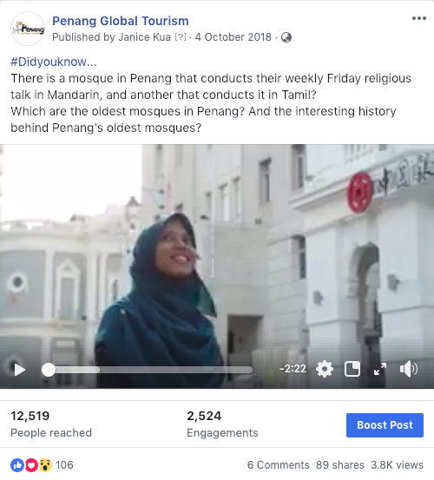

Festivals in a Box: Penang International Dragon Boat Festival
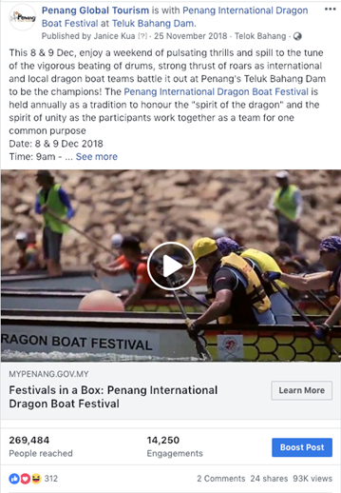

Festivals in a Box: Penang Chingay Parade
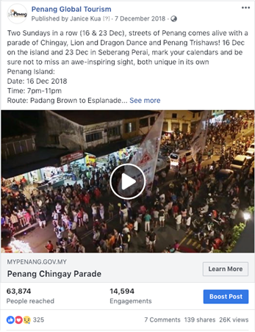

Penang Hot Air Balloon Fiesta 2019
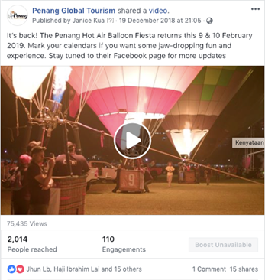

3.2.2 Website Google Analytics (October – December 2018)

Website traffic
The Google Analytics Report shows a spike starting 22 to 25 November as there were two adverts running on PGT’s Facebook leading to PGT’s website, one being a story on Penang War Museum and the other on Penang International Dragon Boat Festival. The gradual spike starting from 8 December to 16 December is caused by the promotions of Penang Chingay Parade which started on 7 December, and Penang Celebrates: Christmas with Jazz. A Penang Story on Penang Rice Dishes was also shared on PGT’s Facebook where all the above are linked to the website. The spike on 23 December could possibly be brought in by users searching for events and deals over the Christmas weekend period.
According to the analytics report, majority of users to our mypenang.gov.my website were acquired organically via Google or PGT’s Facebook Page. Adverts on Facebook and Instagram were also done throughout October to December 2018 which led traffic to the website’s event listing, e-coupon as well as My Stories.
Comparison between 1 July-30 September 2018 and 1 October-31 December 2018 The comparison report shows a 37.61% increase in users to the website, and an increase of 36.88% new users and 34.84% sessions launched. There is a vast increase of users from Singapore, United States and United Kingdom, following targeted adverts done on PGT’s social media platforms.

Top 5 countries visiting the site and most viewed pages
The top 5 countries visiting the site are Singapore, Australia, Indonesia, US and UK. Their most-viewed pages are mainly on Events, Free CAT bus, Culture & Heritage, Food & Lifestyle as well as My Stories.
The following pages show the relevant charts and tables summarizing the Google analytics report as highlighted above.
Ads published on PGT’s Facebook and Instagram page that links to mypenang.gov.my:

Advert | Target Market | Budget (RM) | Advert Duration | People Reached | Results
Penang Stories: Penang War Museum | Malaysia  Singapore  Australia  UK | 400  400  400  400 | 23 – 30 Nov | 132,389 | 96 Shares,  548 Reactions,  39 Comments
Festivals in a Box: Penang International Dragon Boat Festival | Malaysia (Northern Region)  Singapore  Thailand  Hong Kong | 400  200  200  200 | 25 Nov – 9 Dec  25 Nov – 2 Dec | 269,484 | 93K Views,  24 Shares,  312 Reactions,  2 Comments
e-coupon: G Hotel & G Kelawai Hotel | Malaysia  Singapore  Hong Kong | 100  200  200 | 27 Nov – 10 Dec | 280,656 | 30 Reactions
e-coupon: Wonderfood Museum Penang | Malaysia  Singapore | 100  100 | 27 Nov – 30 Dec | 18,334 | 8 Shares,  1 Comment,  28 Reactions
Festivals in a Box: Penang Chingay Parade | Malaysia | 300  300 | 5 – 17 Dec | 63,874 | 26k views,  140 Shares,  7 Comments,  325 Reactions
e-coupon: Jonathan Yun Jewellery | Malaysia | 100 | 7 – 24 Dec | 129,548 | 6 Reactions
Penang Stories: Penang Rice Dishes | Malaysia  Singapore  Australia  UK | 400  200  200  200 | 13 – 31 Dec | 510,081 | 1 Shares,  1 Comment,  56 Reactions
Penang Celebrates: Christmas with Jazz | Penang | 800 | 13 – 15 Dec | 1,554 | 1 Share,  2 Comments,  6 Reactions

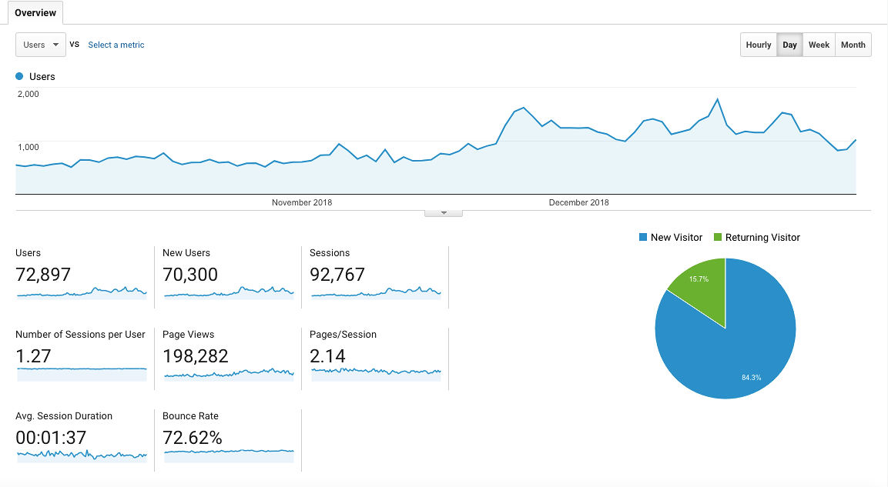
Period: 1 October - 31 December 2018

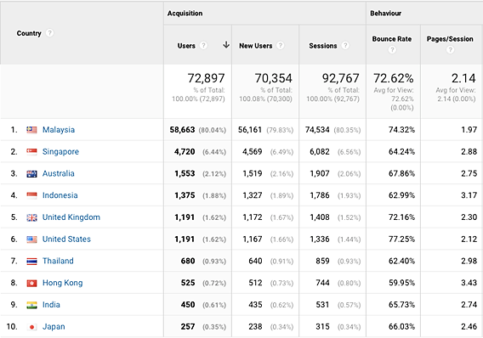
Top 10 users’ locations and sources:

Comparison between 1 July – 30 September 2018 and 1 October – 31 December 2018:
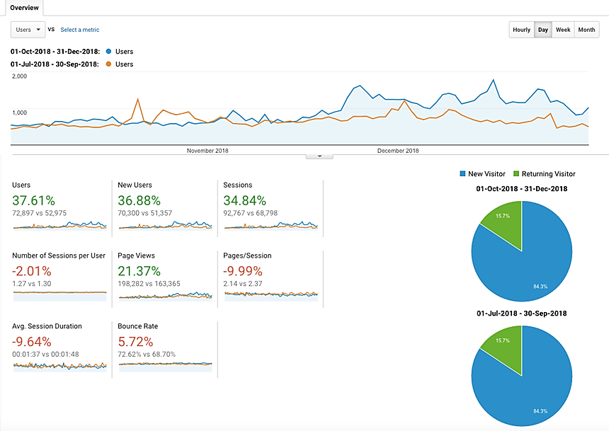

With reference to the above, visitors to the site, in comparison of the time periods:

Item | 1 Jul – 30 Sept 2018 | 1 Oct – 31 Dec 2018
Users | 52,975 | 72,897
Sessions | 68,798 | 92,767
Page Views | 163,365 | 198,282
Ave. Session Duration | 00:01:48 | 00:01:37
Bounce Rate | 68.70% | 72.62%

The top 5 countries visiting our website; in comparison of the time periods:

Country | No. of New Session |  | Increase / Decrease | Most-viewed Pages
Country | 1 Jul – 30 Sept 2018 | 1 Oct – 31 Dec 2018 | Increase / Decrease | Most-viewed Pages
Singapore | 3,766 | 4,720 | 954 | Free CAT Bus, Events, e-coupon, Culture & Heritage, Food & Lifestyle
Australia | 897 | 1,553 | 656 | Events, My Stories, Free CAT Bus
Indonesia | 864 | 1,375 | 511 | Events, Free CAT Bus, Culture & Heritage, Food & Lifestyle, Getting Around
United States | 898 | 1,191 | 293 | Events, Free CAT Bus
United Kingdom | 505 | 1,191 | 686 | Events, Culture & Heritage, Free CAT Bus, e-coupon, My Stories, Getting Around, Food & Lifestyle, Nature & Adventure

The following are the top 10 page views in the mypenang.gov.my website from
1 October – 31 December 2018:
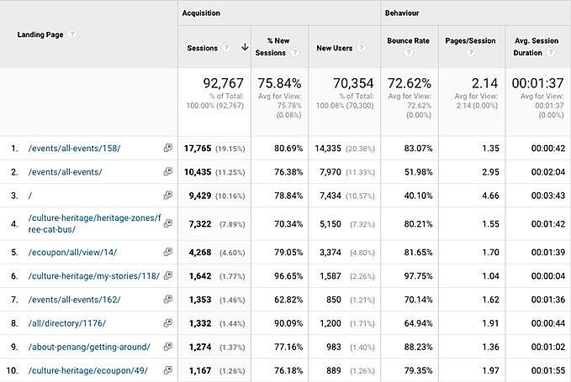

3.2.3 Penang Global Tourism Mobile App
The following table shows the total number of downloads for 1 October to 31 December 2018 on iOS and Android:
Domestic/In’tial | iOS |  | Android
Malaysia | 96 | 26.37% | 70 | 48.61%
Overseas | 268 | 73.63% | 74 | 51.39%
Total downloads | 364 | - | 144 | -

The total number of downloads (Malaysia and overseas) in the three months is 508.
The top 5 international countries for number of downloads on our mobile app are as follows:

iOS:
1. Singapore - 60
2. Thailand - 25
3. Indonesia - 25
4. Hong Kong - 23
5. Great Britain - 20

Android:
1. Indonesia - 24
2. Singapore - 16
3. Hong Kong - 10
4. Great Britain - 4
5. Taiwan - 3

To be consistent with PGT’s website, updates are being done on PGT’s mobile app. For easier management, the backend CMS for e-coupon has been updated to enable further editing and amendments after item has been listed.

3.2.4 PGT’s E-Newsletter – Don’t Say Penang Bojio
PGT has rebranded the e-newsletter as well as consolidated the previous two versions into one. This is due to the poor response received on the previous versions Hello Penang! (directed to industry players) and Don’t Say We Bojio (directed to the mass).

The rebranded version Don’t Say Penang Bojio highlights major events and upcoming events happening in the state, announces latest news and/or new openings on Penang’s tourism products, latest updates on direct flights to Penang, as well as latest special deals on PGT’s e-coupon.
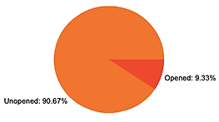
Don’t Say Penang Bojio Issue #4 – Nov 2018
Overview Report:
Item | Figure
Recipients | 3,879
Successfully Sent | 3,879
Opened This Campaign | 362 (9.33%)
Clicked A Link | 81 (2.09%)
Unsubscribed | 19 (0.49%)

Number of link clicks and links viewed:
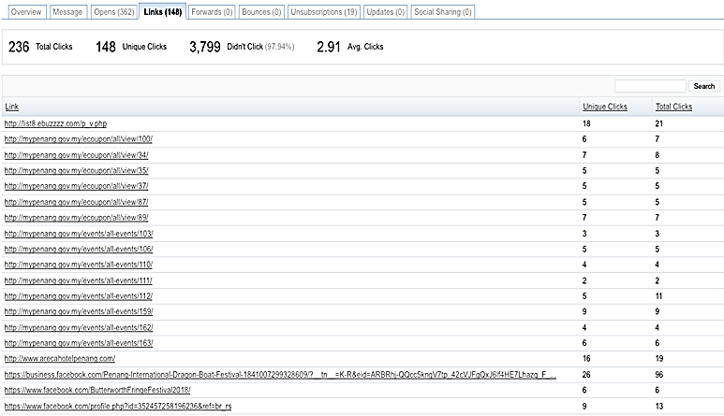

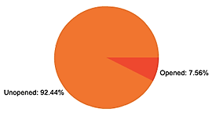
Don’t Say Penang Bojio Issue #5 – Jan 2019
Overview Report:
Item | Figure
Recipients | 3,968
Successfully Sent | 3,968
Opened This Campaign | 300 (7.56%)
Clicked A Link | 82 (2.07%)
Unsubscribed | 13 (0.33%)

Number of link clicks and links viewed:
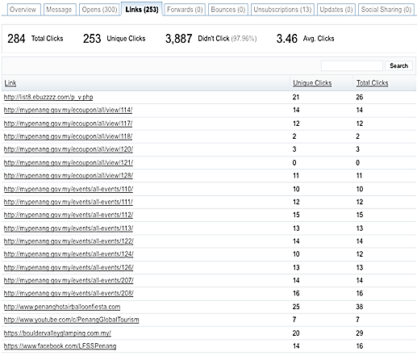

Summary:
- Number of recipients of this e-newsletter is rapidly increasing
- Percentage of recipients who opened the e-newsletter fluctuates and is low at an average of less than 10%.
- Percentage of link clicks is low at less than 3%. Most link clicks are to Penang events and featured e-coupons.
- Percentage of recipients who unsubscribed fluctuates and is at 0.33% - converted into 13 out of 3968 recipients in the latest issue.

3.3 Recent Publicity (Oct - Dec 2018)

October 2018
Local
No | Name | Description | Type of Publication
1 | Senses of Malaysia | Featured Penang in an article titled “North to Penang” in its October 2018 issue. | Magazine
2 | Essenze Malaysia | Featured Penang in its Vol. 52 – 18 issue. | Magazine
3 | The Expat | Featured Penang in its October 2018 issue. | Magazine

Foreign
No | Name | Description | Type of Publication
1 | www.worldofbuzz.com | Featured George Town as the only Asian city chosen for UNESCO’s New Heritage Projects on 1 October 2018. | Online
2 | The National | Featured Penang fine dining restaurants on 7 October 2018. | Online

November 2018
Local
No | Name | Description | Type of Publication
1 | The Star | Featured Penang’s Goddess of Mercy Temple on 12 November 2018. | Daily

Foreign
No | Name | Description | Type of Publication
1 | Essenze Australia | Featured the Penang International Luxury Collections Week 2018 in its issue of Vol. 14 - 18. | Magazine
2 | Conde Nast Traveller | Featured Penang as Asia’s Next Great Foodie City on 15 November 2018 | Online

December 2018
Local
No | Name | Description | Type of Publication
1 | The Star | Featured Penang Global Tourism in article titled “China pressmen experience diversity of Penang” on 10 December 2018. | Daily
2 | Travel 360 | Featured DoubleTree Resort by Hilton Hotel Penang in its December 2018 issue. | Magazine

Foreign
No | Name | Description | Type of Publication
1 | China Social Organisation | Featured Penang on its front cover in its 7th issue of 2018. | Magazine

