Facebook Posts Summary From 1 December 2020 - 31 March 2021
Total Posts & Total Reach of Facebook Posts – Boosted vs Non-Boosted:
 | Total Posts | % Total Posts | Total Reach
Boosted Posts | 9 | 3.35 | 678,280
Non-Boosted Posts | 260 | 96.65 | 1,670,724
Total | 269 | 100 | 2,349,004

Total Posts & Total Reach of Facebook Posts – Island vs Mainland:
 | Total Posts | % Total Posts | Total Reach
Island | 230 | 85.50 | 1,693,018
Mainland | 39 | 14.50 | 655,986
Total | 269 | 100 | 2,349,004

Google Analytics
mypenang website:

Period: 1 December 2020 – 31 March 2021
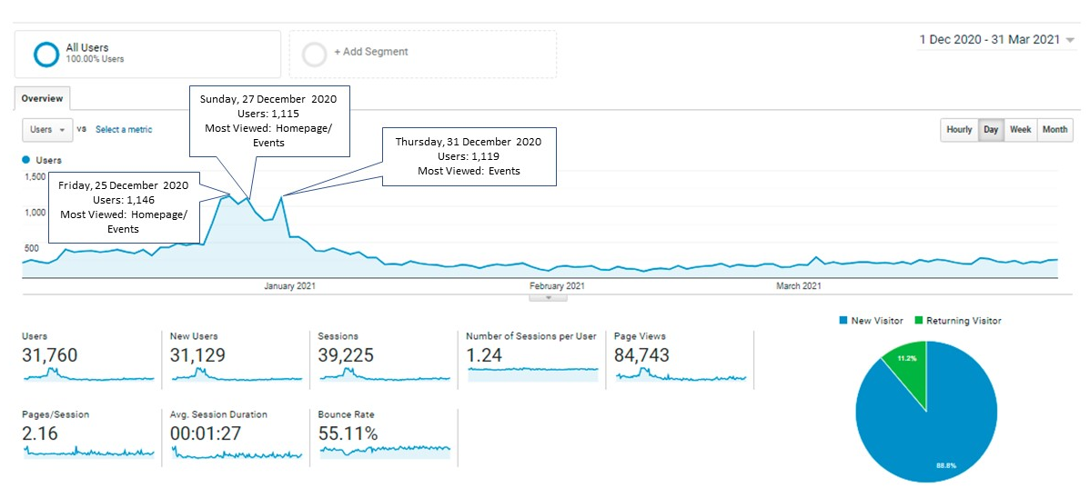 Period: 1 December 2019 – 31 March 2020
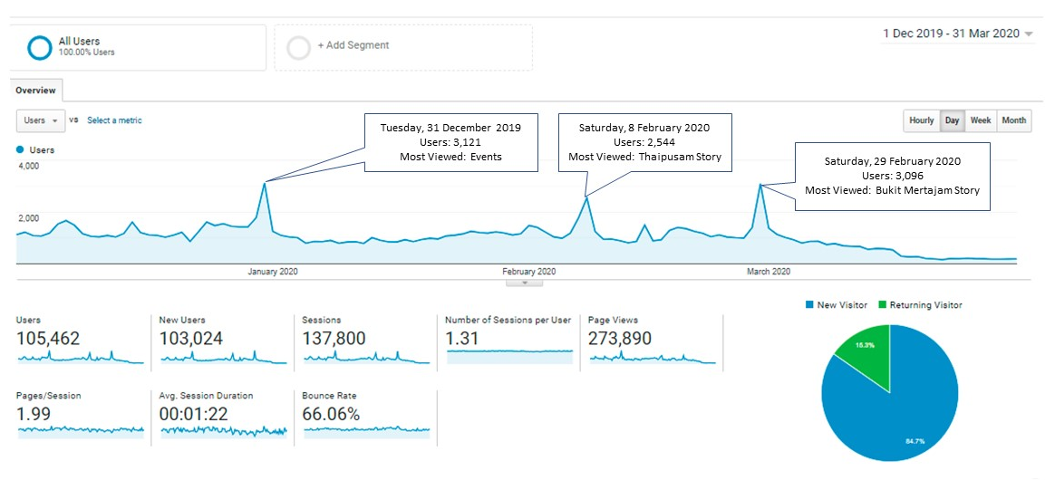

Penang Travel Deals website:
