3.2.4 Promotional Videos on Facebook (1 December 2020 – 31 March 2021)

No. | Videos | Total Views as at 31 March 2021 | Date Published
1 | Penang Hidden Gems – Jawi House Café Gallery   | 2.7k | 5 December 2020
2 | Kaki Travel – Magic World Penang  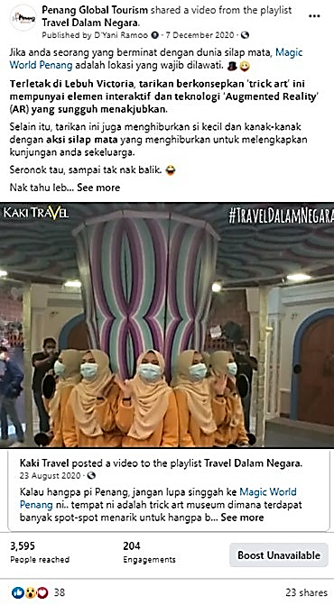 | 354k | 7 December 2020
No. | Videos | Total Views as at 31 March 2021 | Date Published
3 | Penang Foodie x Experience Penang  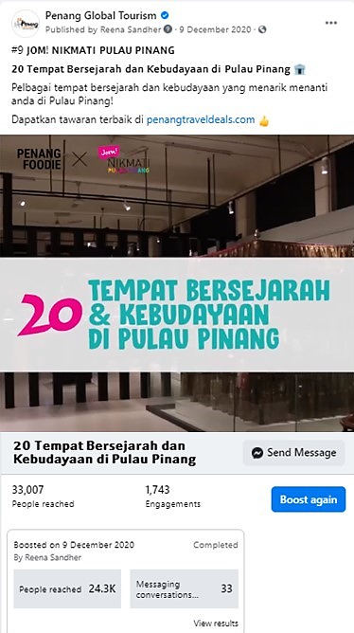 | 8.2k | 9 December 2020
4 | George Town – Night View  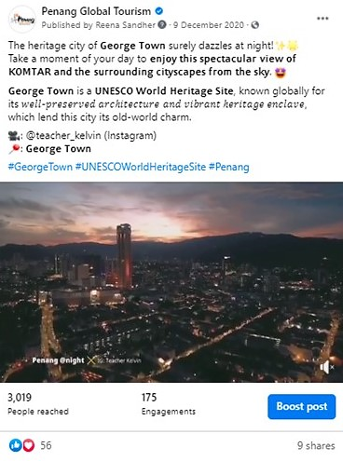 | 738 | 9 December 2020

No. | Videos | Total Views as at 31 March 2021 | Date Published
5 | Penang Today – Sia Boey Urban Archaeological Park  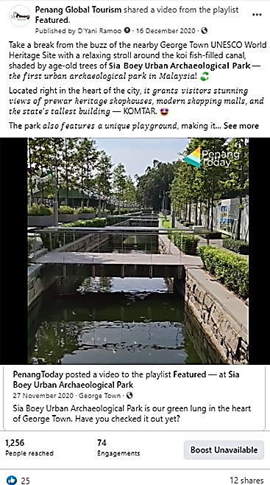 | 1.6k | 16 December 2020
6 | Pulau Aman  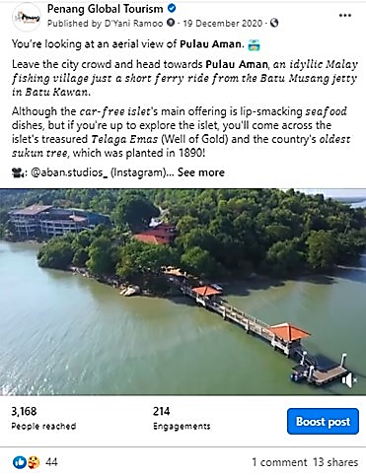 | 1.1k | 19 December 2020

No. | Videos | Total Views as at 31 March 2021 | Date Published
7 | Comparison Video – Experience it all in Penang  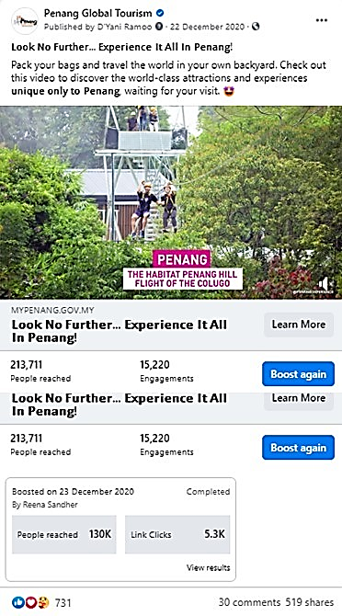 | 34.2k | 22 December 2020
8 | MBSP – Minor Basilica of St. Anne Penang  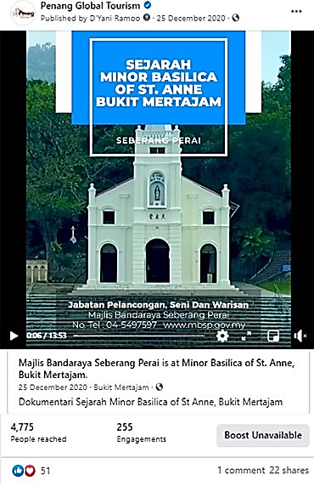 | 99.4k | 25 December 2020
No. | Videos | Total Views as at 31 March 2021 | Date Published
9 | FMT – Wall Mural by Azmi Hussin   | 6.2k | 26 December 2020
10 | Land of Char Koay Teow by Kenji Chai  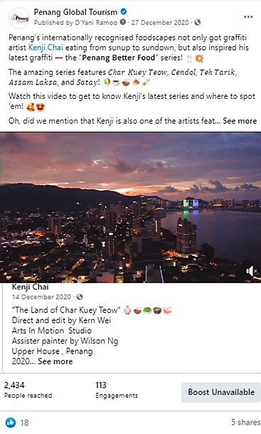 | 7k | 27 December 2020

No. | Videos | Total Views as at 31 March 2021 | Date Published
11 | Penang Today – The BRGR Restaurant  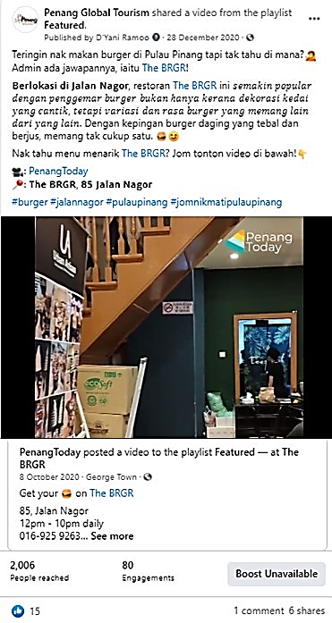 | 3.1k | 28 December 2020
12 | Destinasi TV – Laksa Janggus  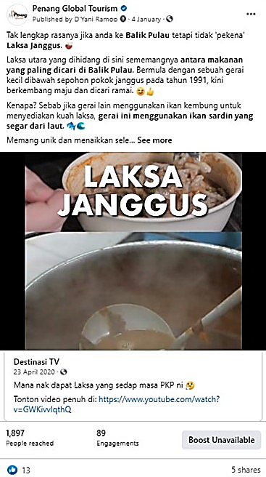 | 369k | 4 January 2021

No | Videos | Total Views as at 31 March 2021 | Date Published
13 | Cycling at Gertak Sanggul  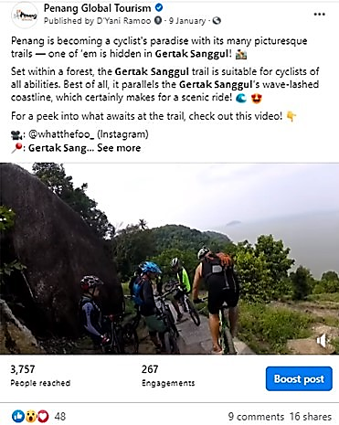 | 1.3k | 9 January 2021
14 | Yakpur Production – Nasi Dalca at Tasek Gelugor   | 10.7k | 25 January 2021

No. | Videos | Total Views as at 31 March 2021 | Date Published
15 | Tourism Malaysia x Hong Kong Celebrities  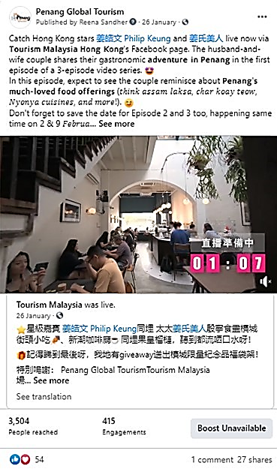 | 38.3k8 | 26 January 2021
16 | Raaga - Thaipusam  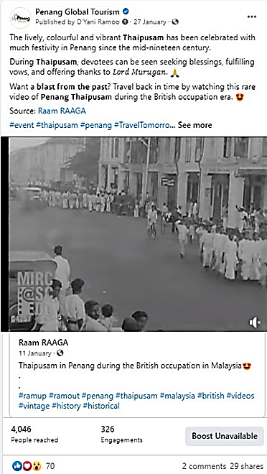 | 83.9k | 27 January 2021

No. | Videos | Total Views as at 31 March 2021 | Date Published
17 | Tourism Malaysia x Hong Kong Celebrities  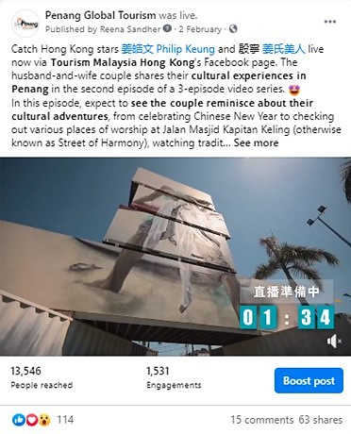 | 25k | 2 February 2021
18 | Teluk Kumbar  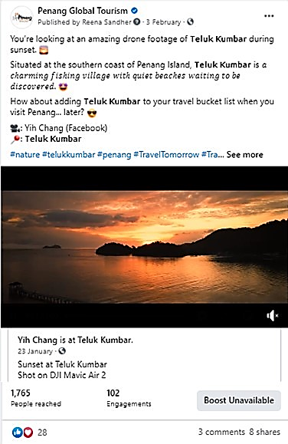 | 2.3k | 3 February 2021

No. | Videos | Total Views as at  31 March 2021 | Date Published
19 | Display of Lights – Kek Lok Si Temple  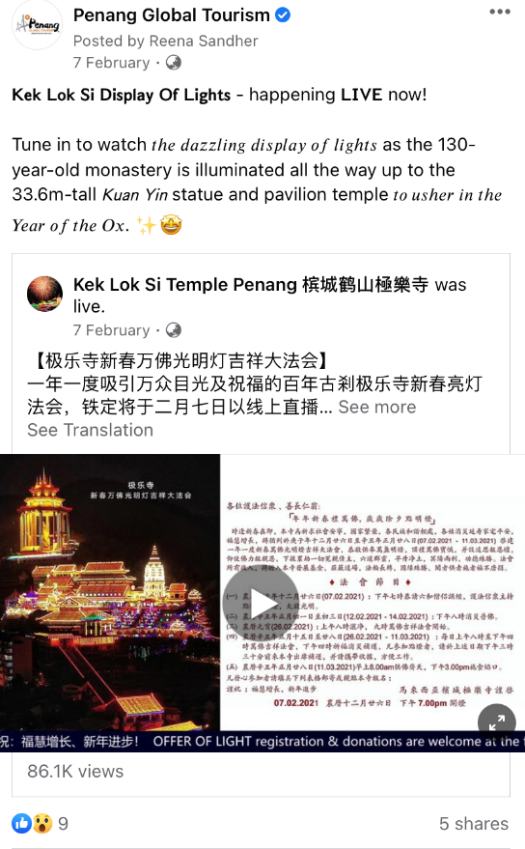 | 86.1k | 7 February 2021
20 | Kapitan Keling Mosque  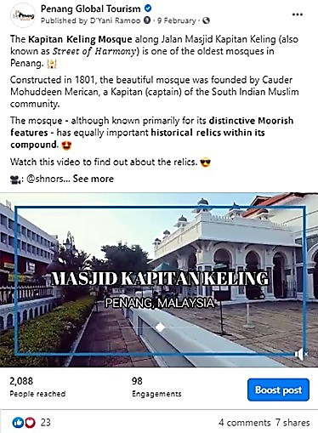 | 610 | 9 February 2021

No. | Videos | Total Views as at  31 March 2021 | Date Published
21 | Tourism Malaysia x Hong Kong Celebrities  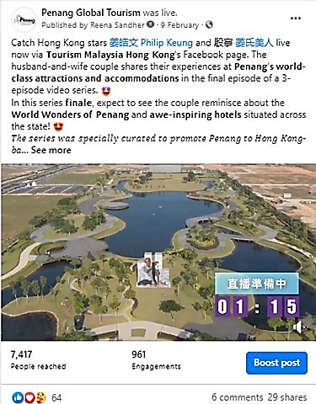 | 21.6k | 9 February 2021
22 | Miao Hui   | 11.7k | 15 February 2021

No. | Videos | Total Views as at  31 March 2021 | Date Published
23 | Laparpo – TwinCafe Simpang Empat  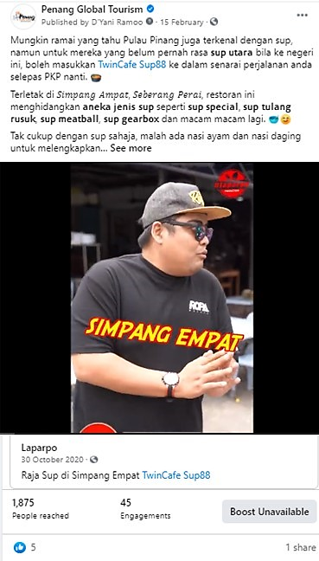 | 207k | 15 February 2021
24 | Penang by an Instagramer  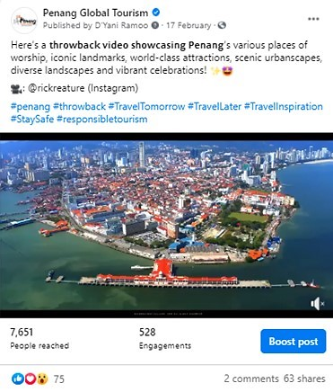 | 1.7k | 17 February 2021

No. | Videos | Total Views as at  31 March 2021 | Date Published
25 | Clan Jetties  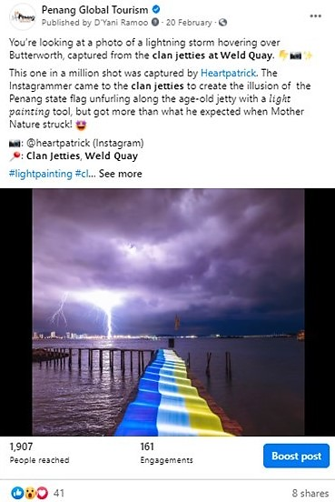 | 740 | 20 February 2021
26 | The Habitat Penang Hill  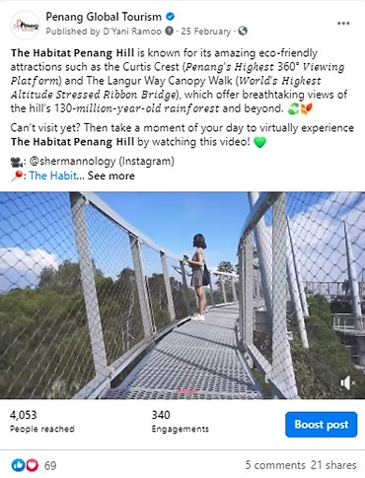 | 1.1k | 25 February 2021

No. | Videos | Total Views as at  31 March 2021 | Date Published
27 | Escape Theme Park   | 195k | 5 March 2021
28 | Penang by Jay Lim  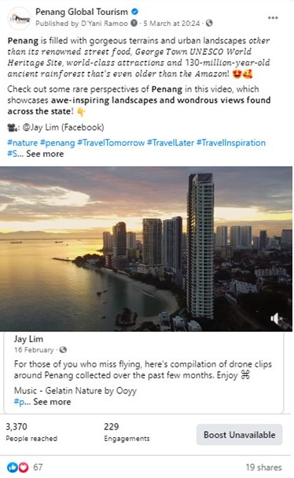 | 2.2k | 5 March 2021

No. | Videos | Total Views as at  31 March 2021 | Date Published
27 | HHWT Eats – Mee Udang Sri Tambang  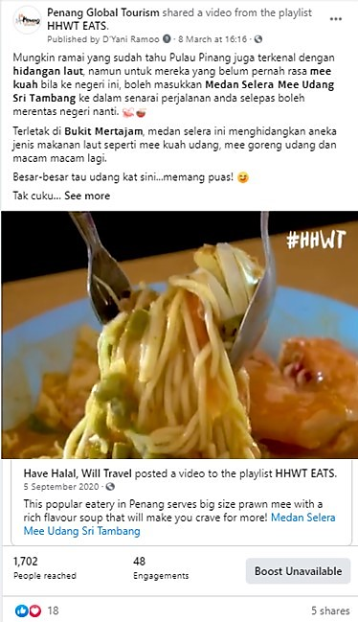 | 2.6k | 8 March 2021
28 | Escape Theme Park   | 528 | 10 March 2021

No. | Videos | Total Views as at  31 March 2021 | Date Published
29 | Penang City Hall  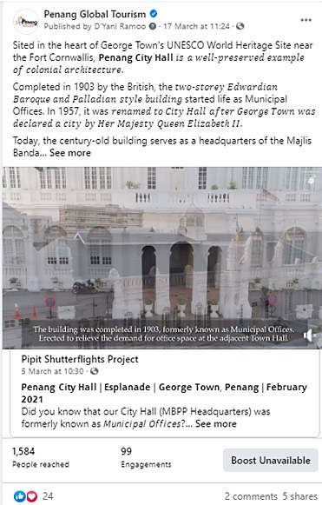 | 1.5k | 17 March 2021
30 | Entopia by Penang Butterfly Farm  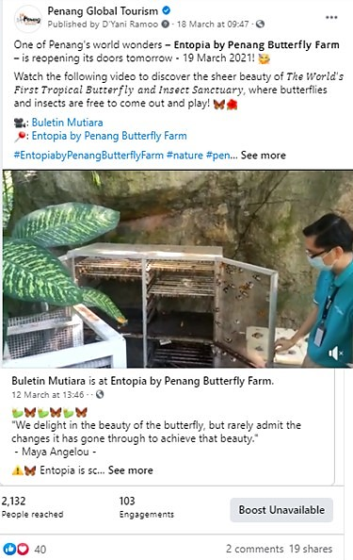 | 1.2k | 18 March 2021

No. | Videos | Total Views as at  31 March 2021 | Date Published
31 | Iwan Shifudo & Hot Pot Bertam   | 411 | 22 March 2021
32 | Penang Arts Council - Penang  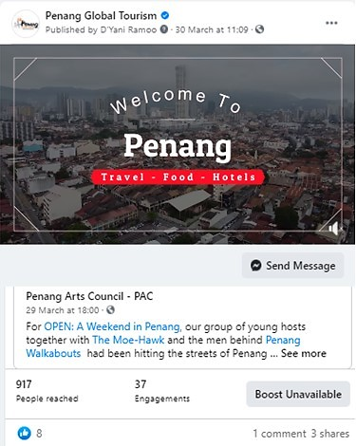 | 6.8k | 30 March 2021

3.2.5 Results of Paid Advertising via Social Media
Boosted Posts on PGT Facebook Page from 1 December 2020 – 31 March 2021:
PGT’s Facebook Page
Post/ Advert | Target Market | Budget (RM) | Duration | Reach | Results
Buletin Mutiara – Waterfall at Sg Rusa, Balik Pulau | Johor Bahru  Alor Setar  Kota Bharu  Melaka  Seremban  Kuantan  Ipoh  Perlis  Kuching  Miri  Selangor  Terengganu  Kuala Lumpur  Labuan  Kota Kinabalu  Putrajaya | 800 | 1 – 5 December 2020 | 134, 749 | 349 link clicks  300 shares  1.3k reactions  143 comments
Penang Stories –  8 Eco-Friendly Gems In Penang You Need To Know About | Johor Bahru  Alor Setar  Kota Bharu  Melaka  Seremban  Kuantan  Ipoh  Perlis  Kuching  Miri  Selangor  Terengganu  Kuala Lumpur  Labuan  Kota Kinabalu  Putrajaya | 800 | 5 – 9 December 2020 | 98, 752 | 463 link clicks  25 shares  1.3k reactions  2 comments
20 Tempat Bersejarah & Kebudayaan di Pulau Pinang | Johor Bahru  Alor Setar  Kota Bharu  Melaka  Seremban  Kuantan  Ipoh  Perlis  Kuching  Miri  Selangor  Terengganu  Kuala Lumpur  Labuan  Kota Kinabalu  Putrajaya | 800 | 9 – 13 December 2020 | 23, 092 | 8.2k views  392 link clicks  171 shares  401 reactions  36 comments
The Journey of Art | Johor Bahru  Alor Setar  Kota Bharu  Melaka  Seremban  Kuantan  Ipoh  Perlis  Kuching  Miri  Selangor  Terengganu  Kuala Lumpur  Labuan  Kota Kinabalu  Putrajaya | 200 | 11 – 13 December 2020 | 10, 660 | 13 shares  132 reactions  0 comments
Video - Look No Further.. Experience It All In Penang! | Johor Bahru  Alor Setar  Kota Bharu  Melaka  Seremban  Kuantan  Ipoh  Perlis  Kuching  Miri  Selangor  Terengganu  Kuala Lumpur  Labuan  Kota Kinabalu  Putrajaya | 800 | 23 – 28 December 2020 | 130, 432 | 519 shares  731 reactions  20 comments  5.3k link clicks  12k views
Kisah Pulau Pinang – 8 Permata Mesra Alam di Pulau Pinang Yang Perlu Anda Tahu | Johor Bahru  Alor Setar  Kota Bharu  Melaka  Seremban  Kuantan  Ipoh  Perlis  Kuching  Miri  Selangor  Terengganu  Kuala Lumpur  Labuan  Kota Kinabalu  Putrajaya | 800 | 23 – 28 December 2020 | 107, 320 | 29 shares  309 reactions  14 comments  5, 495 link clicks
Penang Travel Deals – Best CNY & V Day Deals | Penang | 300 | 6 – 10 February 2021 | 33, 424 | 4 shares  65 reactions  0 comment  911 link clicks
Penang Travel Deals – Best CNY & V Day Deals | Penang | 300 | 8 – 12 February 2021 | 33, 319 | 7 shares  63 reactions  0 comments  735 link clicks

The total amounts spent on PGT Facebook page from 1 December 2020 – 31 March 2021 is as follows:
Penang Global Tourism | RM 4,800

3.2.6 Facebook Posts from 1 December 2020 – 31 March 2021

December 2020 Facebook Posts
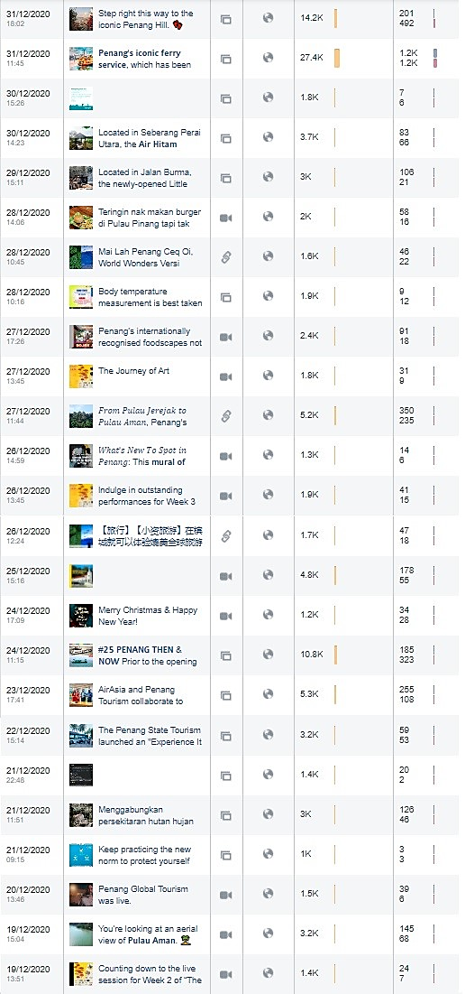

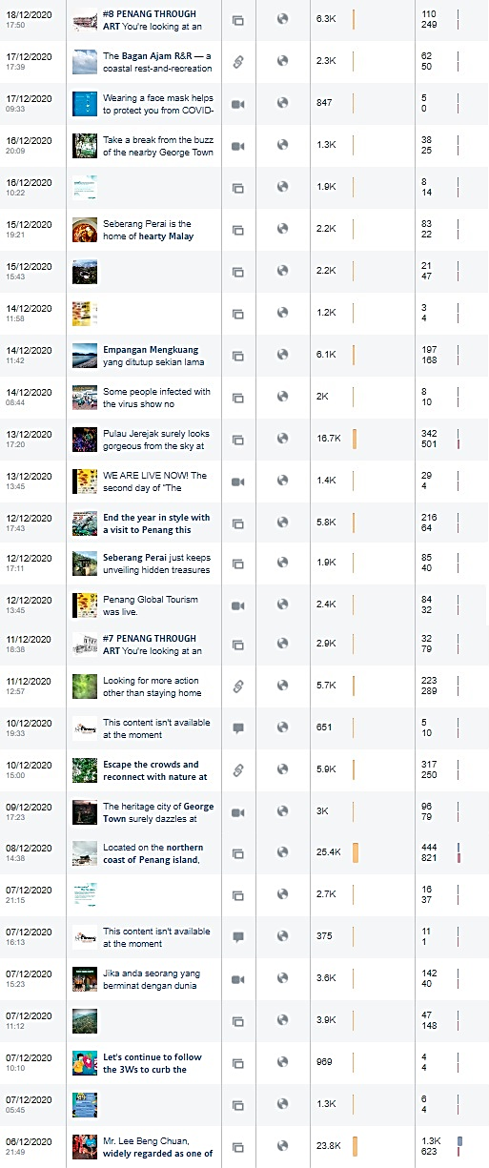

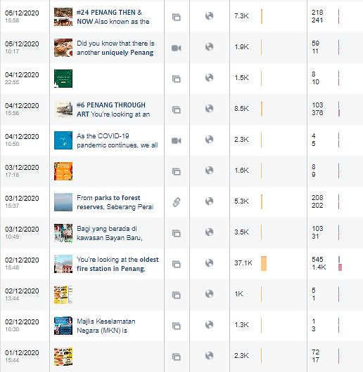
Total Post | Total Reach | Total Post Clicks | Total Reaction, Comments & Shares
68 | 315,042 | 8,589 | 8,756

January 2021 Facebook Posts
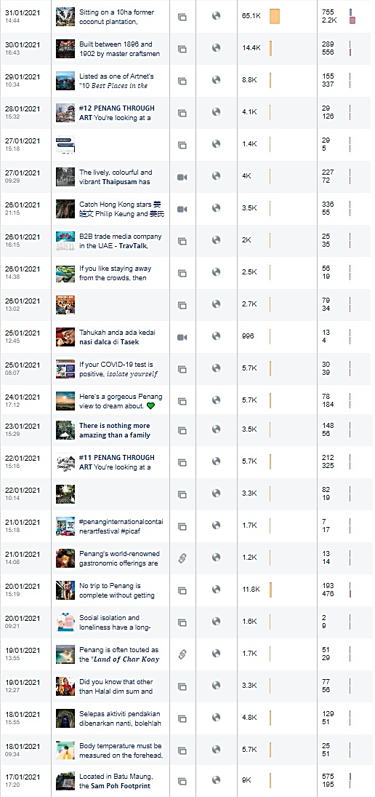
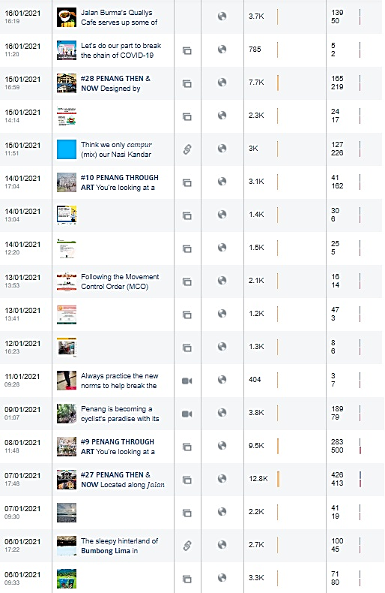

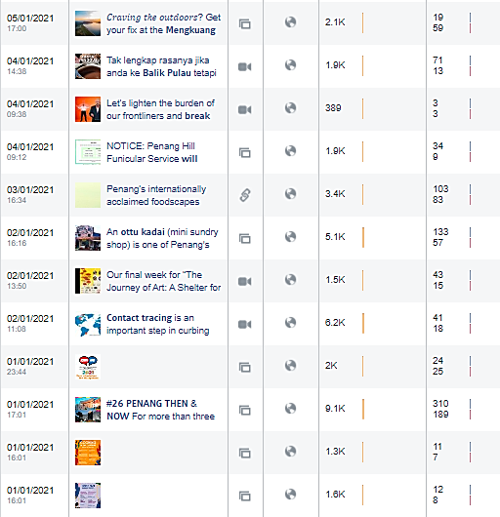
Total Post | Total Reach | Total Post Clicks | Total Reaction, Comments & Shares
55 | 273,474 | 6,159 | 7,303

February 2021 Facebook Posts
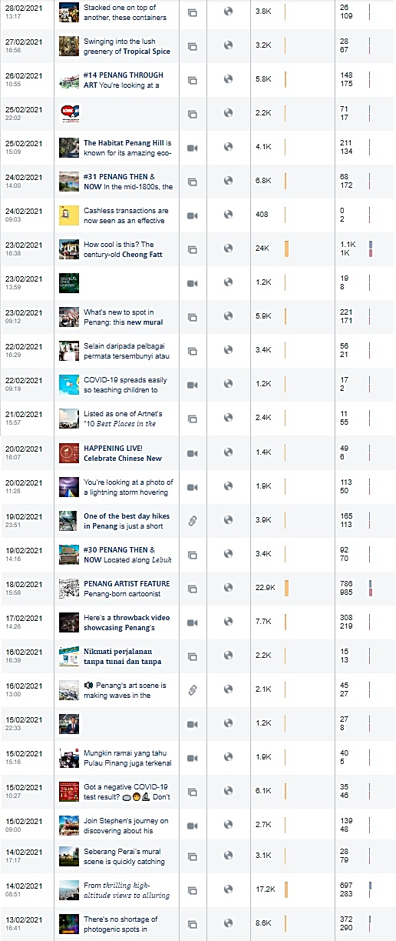

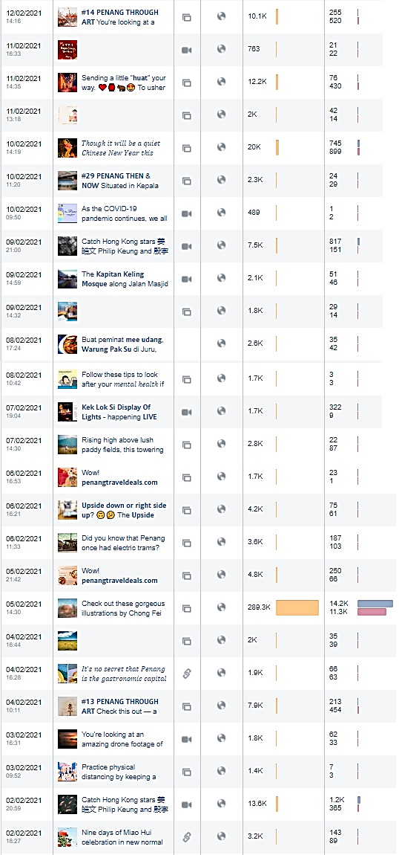


Total Post | Total Reach | Total Post Clicks | Total Reaction, Comments & Shares
60 | 571,760 | 24,376 | 19,714

March 2021 Facebook Posts
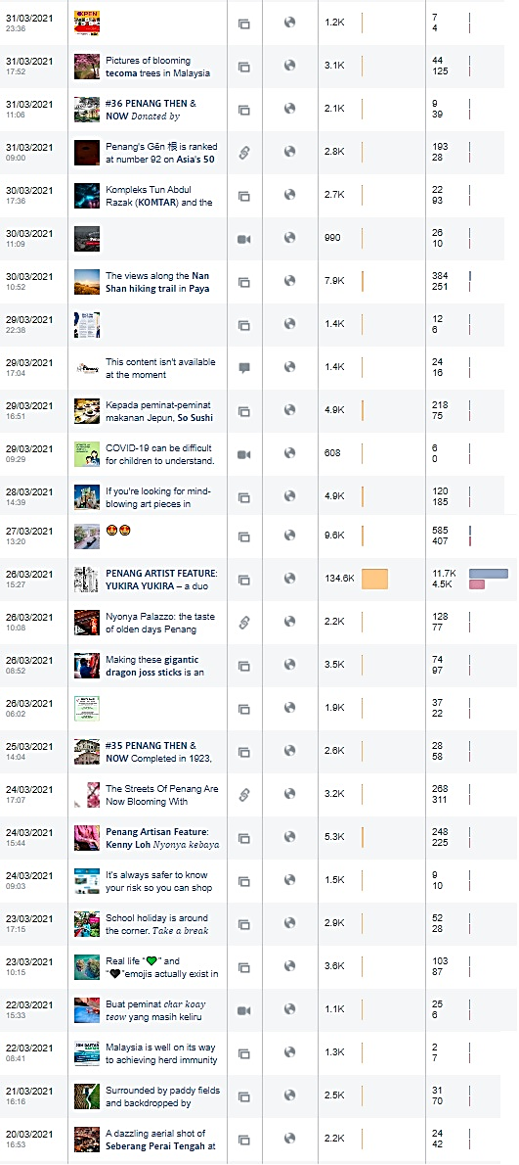

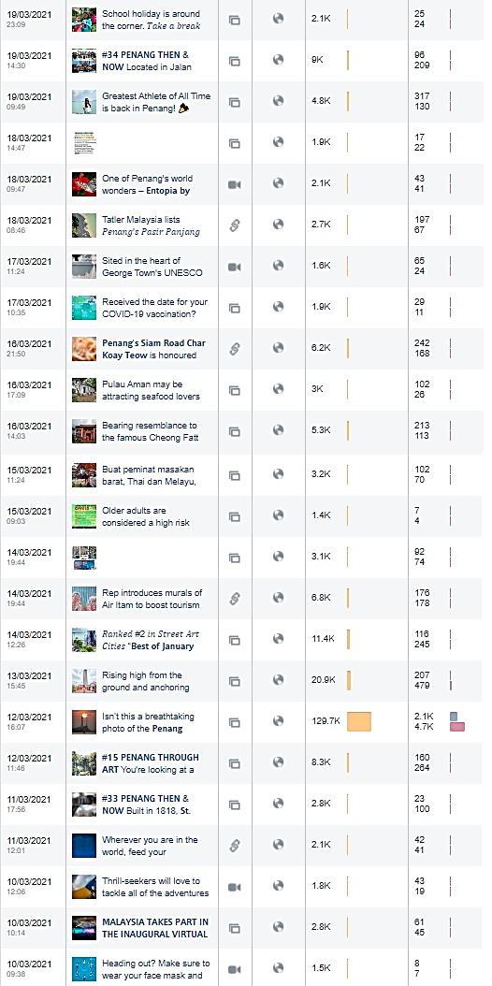

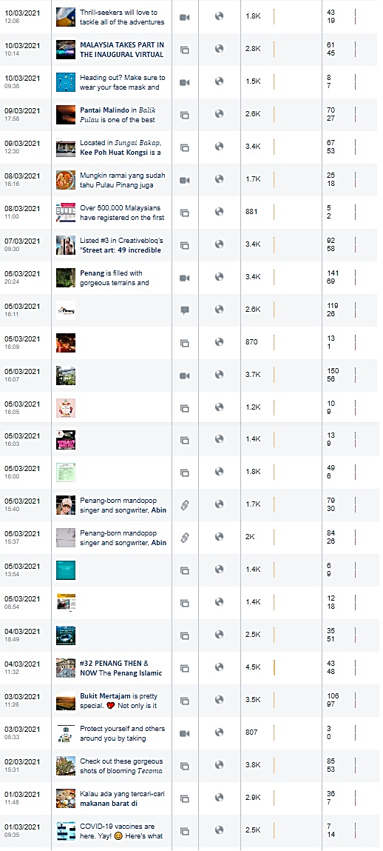
Total Post | Total Reach | Total Post Clicks | Total Reaction, Comments & Share
77 | 510,448 | 20,139 | 14,598

3.2.7 Total post and reach for PGT’s Facebook Page from 1 December 2020 – 31 March 2021 are as follows:
Month/ Year | Posts | Reach | Post Clicks | Reactions, Comments & Shares
December 2020 | 68 | 315,042 | 8,589 | 8,756
January 2021 | 55 | 273,474 | 6,159 | 7,303
February 2021 | 60 | 571,760 | 24,376 | 19,714
March 2021 | 77 | 510,448 | 20,139 | 14,598
Total | 260 | 1,670,724 | 59,263 | 50,371

3.2.8 Facebook Posts on Seberang Perai (Mainland) from December 2020 to March 2021 are as follows:

December 2020
No. | Posts | Total Reach | Total Engagement | Date Published
1 | Hiking in Penang Mainland | 5,254 | 410 | 3 December 2020
2 | 8 Eco-Friendly Gems in Penang You Need To Know | 102,304 | 2,080 | 5 December 2020
3 | 20 Tempat Bersejarah dan Kebudayaan di Pulau Pinang | 33,092 | 1,744 | 9 December 2020
4 | 8 Secret green spaces in and around Penang you need to know about | 5,895 | 567 | 10 December 2020
5 | Bukit Seraya Trek, Machang Bubuk | 1,895 | 125 | 12 December 2020
6 | Mengkuang Dam | 6,064 | 365 | 14 December 2020
7 | Mee Kuah & Laksa, Permatang Pauh | 2,187 | 105 | 15 December 2020
8 | Bagan Ajam R&R | 2,328 | 112 | 17 December 2020
9 | Pulau Aman | 3,173 | 214 | 19 December 2020
10 | Experience it all in Penang Video | 214,155 | 15,220 | 22 December 2020
11 | 8 Permata Mesra Alam di Pulau Pinang yang perlu anda tahu | 107,320 | 7,140 | 23 December 2020
12 | Minor Basilica of St. Anne’s documentary | 4,775 | 255 | 25 December 2020
13 | Air Hitam Dalam Educational Forest | 3,708 | 149 | 30 December 2020
January 2021
No. | Posts | Total Reach | Total Engagement | Date Published
1 | Mengkuang Dam | 2,066 | 78 | 5 January 2021
2 | Military Pillbox of Bumbong Lima | 2,719 | 145 | 6 January 2021
3 | Buletin Mutiara – Mengkuang Dam | 2,210 | 60 | 7 January 2021
4 | Empangan Seraya | 4,775 | 180 | 18 January 2021
5 | Food Trail in Bukit Mertajam | 1,218 | 27 | 21 January 2021
6 | Nasi Dalca Tasek Gelugor | 996 | 19 | 25 January 2021
7 | Frog Hill | 2,518 | 75 | 26 January 2021
8 | Kampung Agong | 65,381 | 2,973 | 31 January 2021
February 2021
No. | Posts | Total Reach | Total Engagement | Date Published
1 | Mee Udang, Warung Pak Su | 2,587 | 77 | 8 February 2021
2 | Then & Now – Jambatan Merdeka | 2,294 | 53 | 10 February 2021
3 | CNY Deco | 20,010 | 1,644 | 10 February 2021
4 | PICAF – Batu Kawan | 3,140 | 107 | 14 February 2021
5 | TwinCafe, Simpang Empat | 1,877 | 45 | 15 February 2021
6 | Throwback video of Penang | 7,668 | 529 | 17 February 2021
7 | Rojak Tonggek & Popia Yusof | 3,391 | 77 | 22 February 2021
8 | PICAF – Dataran Merdeka | 3,802 | 135 | 28 February 2021
March 2021
No. | Posts | Total Reach | Total Engagement | Date Published
1 | Brader’s Café, Jawi | 2,929 | 43 | 1 March 2021
2 | Buletin Mutiara – Tecoma Trees | 3,827 | 138 | 2 March 2021
3 | Bukit Mertajam Paddy Fields | 3,510 | 203 | 3 March 2021
4 | Medan Selera Mee Udang | 1,714 | 49 | 8 March 2021
5 | Kee Poh Huat Kongsi | 3,355 | 120 | 9 March 2021
6 | De Pauh Garden Restaurant | 3,274 | 174 | 15 March 2021
7 | Pulau Gedung | 2,963 | 128 | 16 March 2021
8 | Iwan Shifudo Grill & Hot Pot | 1,126 | 32 | 22 March 2021
9 | Tecome Tress, Bukit Mertajam | 9,606 | 992 | 27 March 2021
10 | Sushi Café, Bukit Mertajam | 4,880 | 293 | 29 March 2021

Seberang Perai Facebook Posts - Period: December 2020
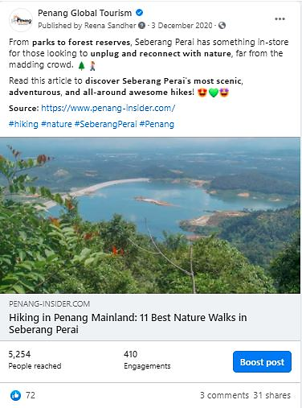 | 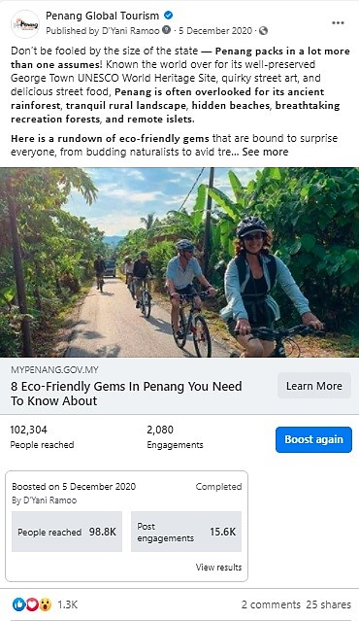
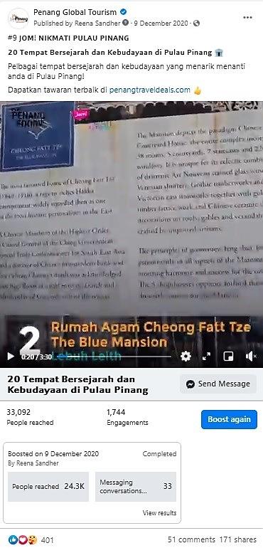 | 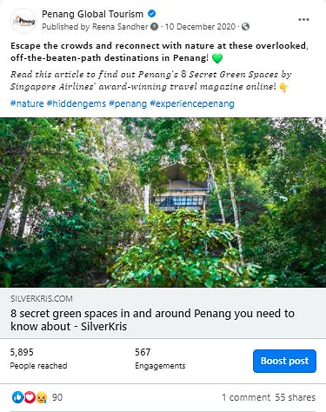

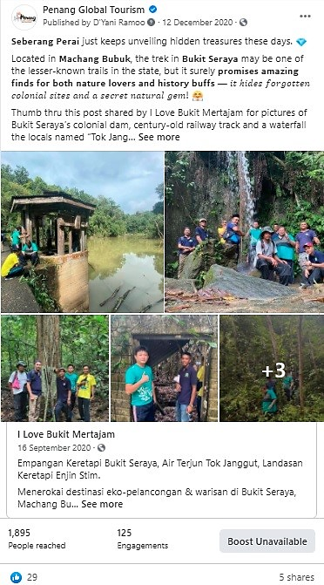 |  | 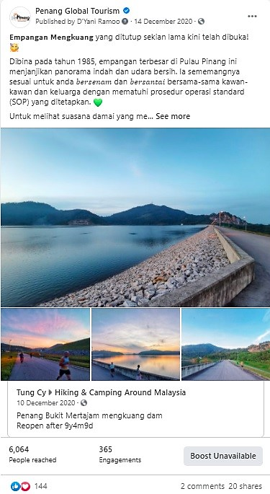
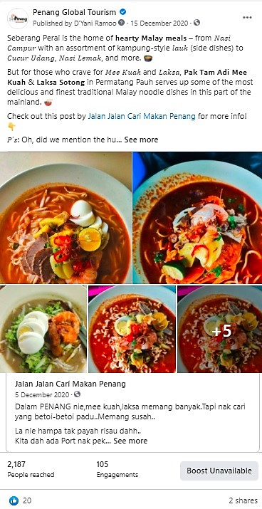 |  | 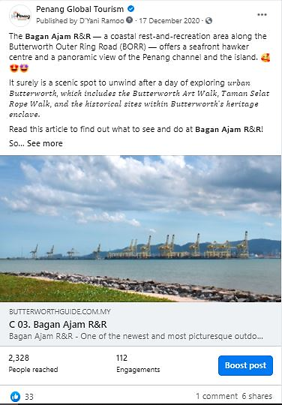
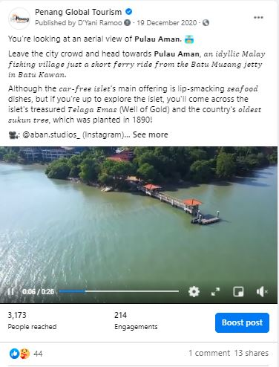 |  | 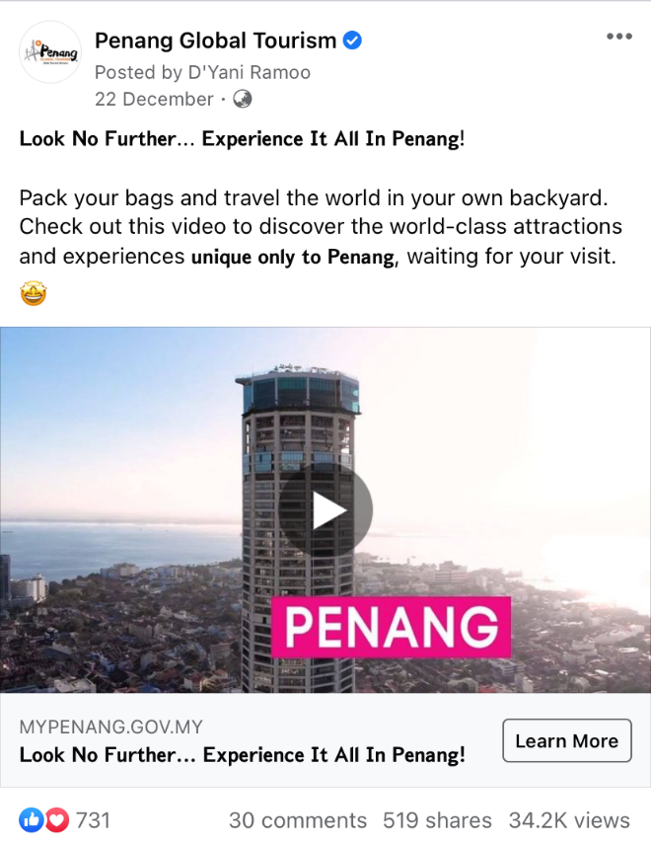
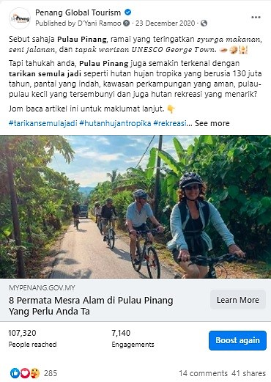 |  | 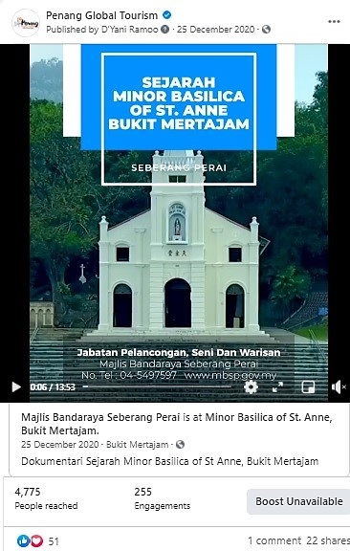
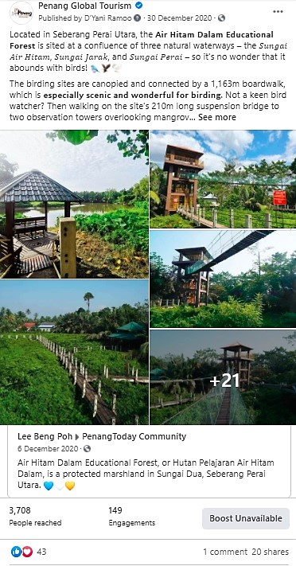

Total Post | Total Reach |  | Total Engagement
13 | 492,150 |  | 28,486

Seberang Perai Facebook Posts - Period: January 2021
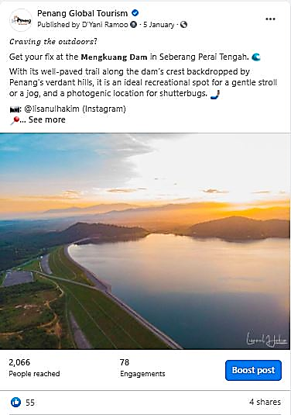 |  | 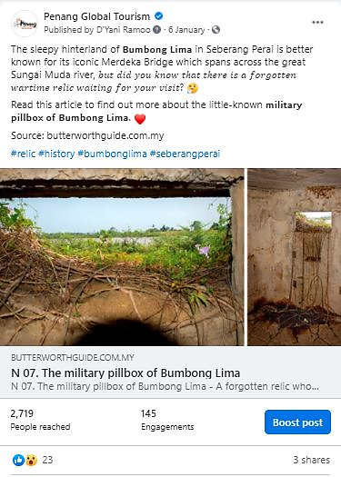
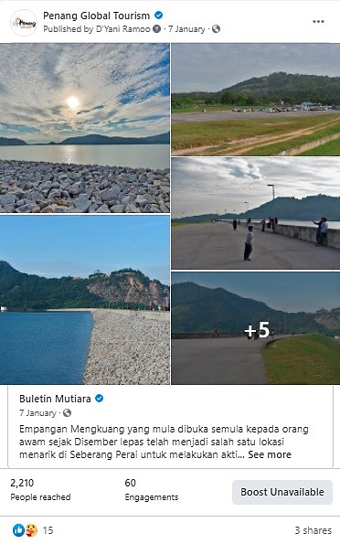 |  | 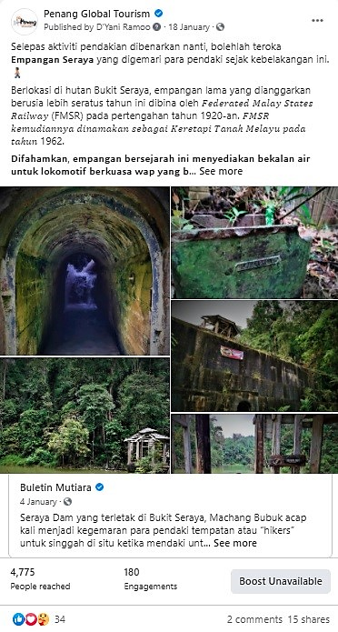
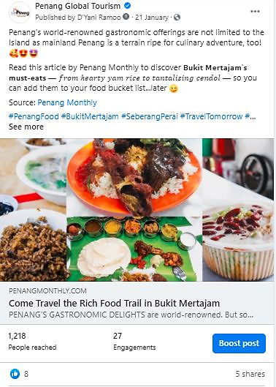 |  | 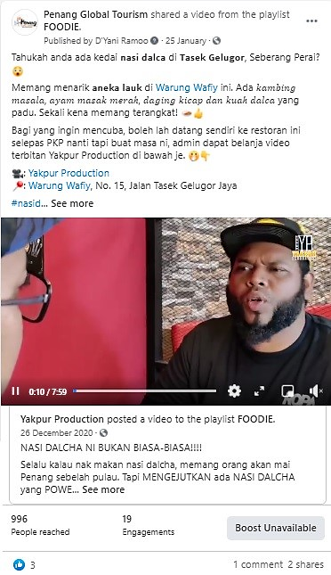
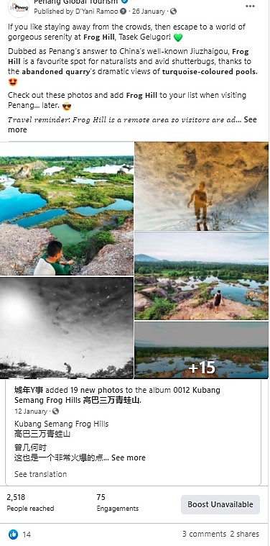 |  | 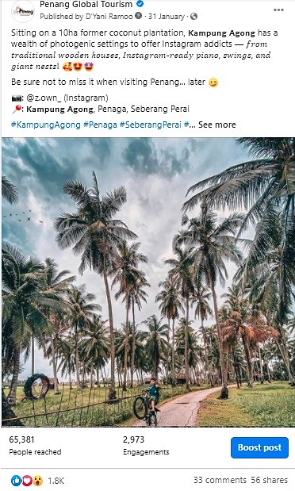
Total Post | Total Reach |  | Total Engagement
8 | 81,883 |  | 3,557

Seberang Perai Facebook Posts - Period: February 2021
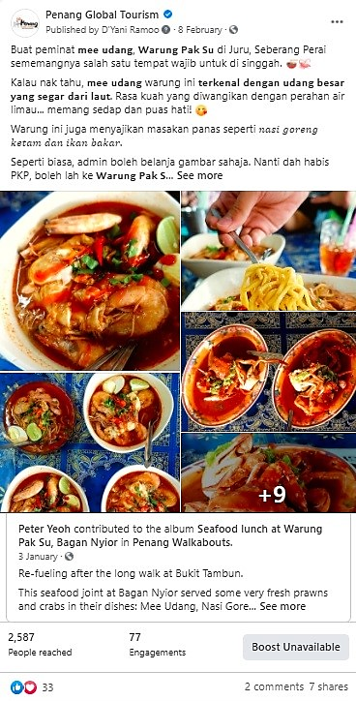 |  | 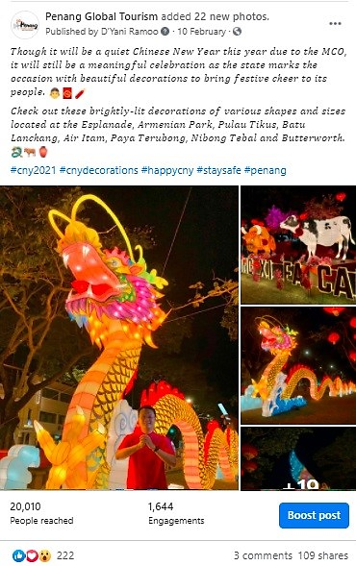
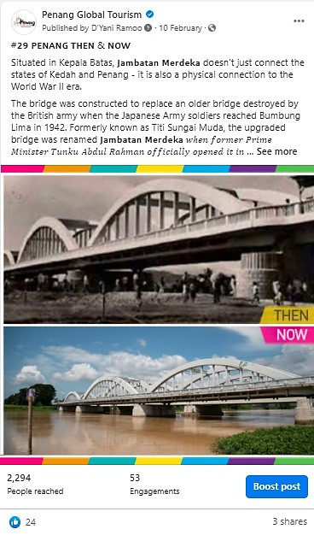 |  | 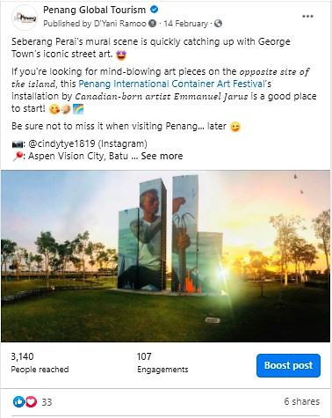
 |  | 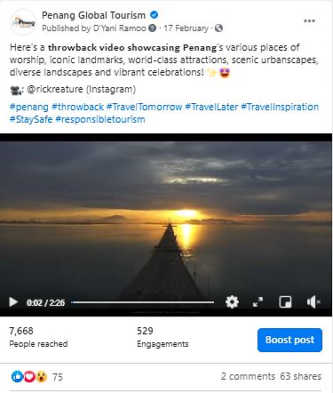
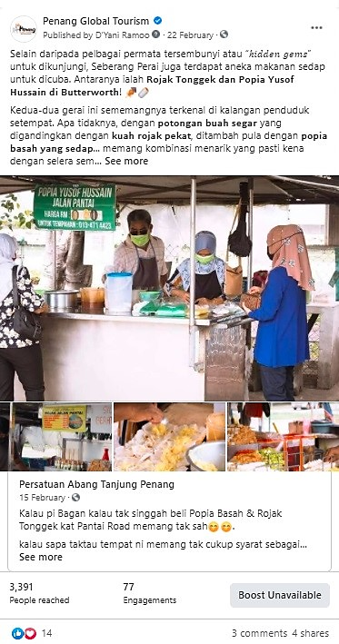 |  | 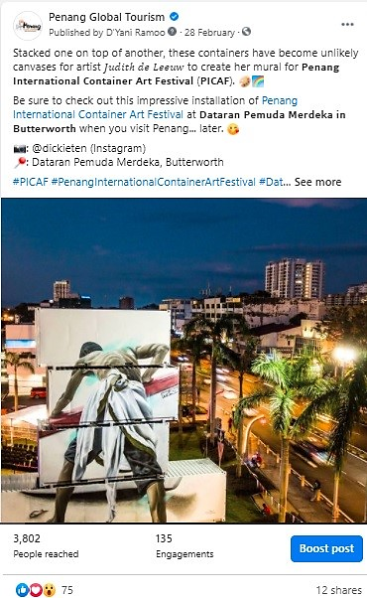
Total Post | Total Reach |  | Total Engagement
8 | 44,769 |  | 2,667

Seberang Perai Facebook Posts - Period: March 2021
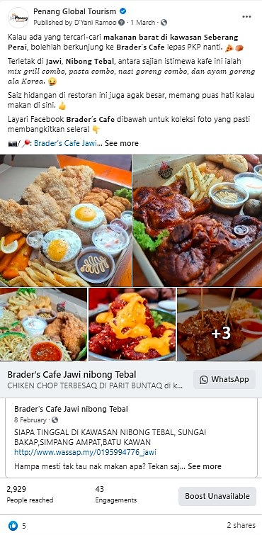 | 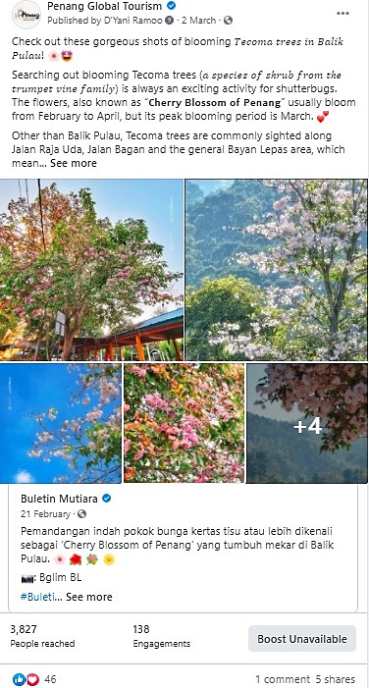
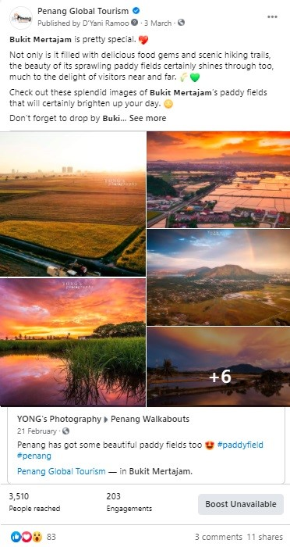 | 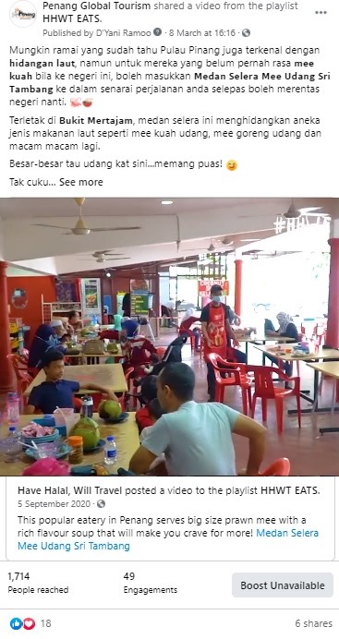

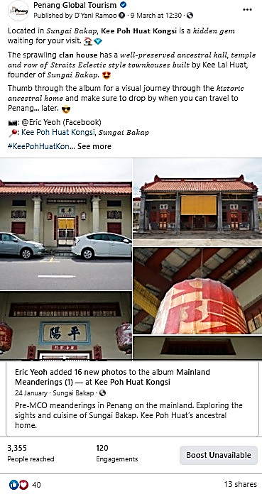 |  | 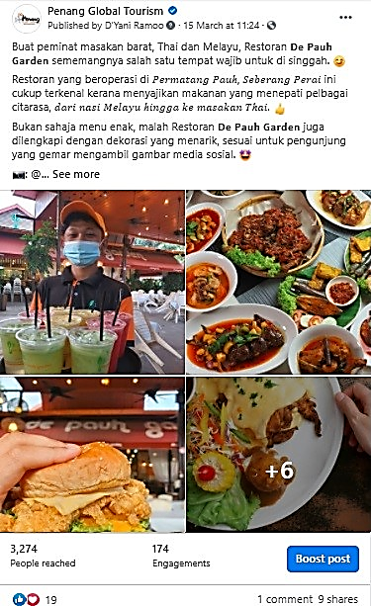
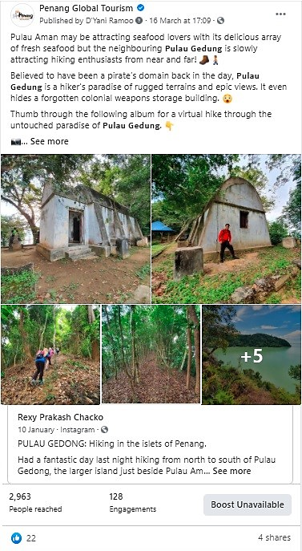 |  | 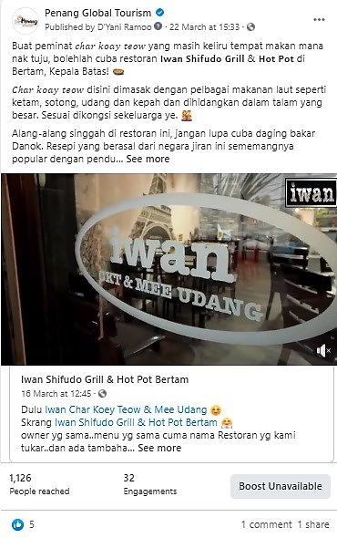
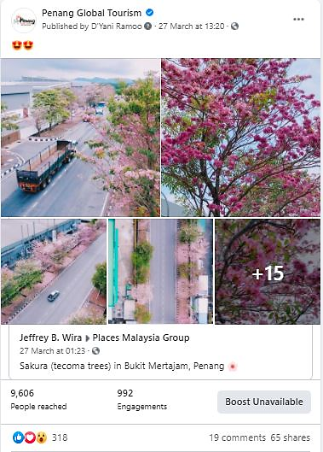 |  | 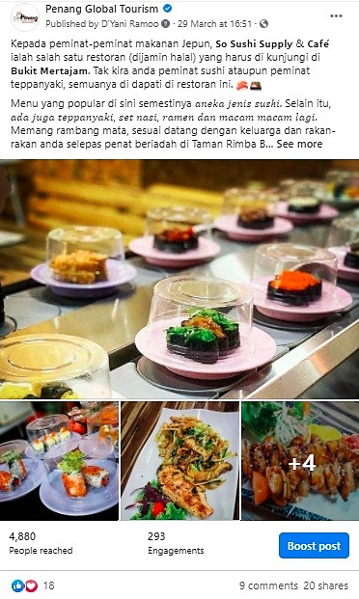
Total Post | Total Reach |  | Total Engagement
10 | 37,184 |  | 2,172

3.2.9 PGT’s Facebook Page Analytics
Based on the insights of PGT’s Facebook Page, there has been an increase in the number of Page Followers in comparison to the same period, a year before. The number of Page Followers recorded for current period of 1 December 2020 to 31 March 2021 was 69,617 and 71,096 whereas the number of Page Followers recorded on 1 December 2019 to 31 March 2020 was 58,644 and 60,063. Therefore, there’s a clear indication that there’s been an increase of Page Followers.

Comparison of Page Followers:
YOY Comparison | Page Followers |  | Increased by
1 December 2019 – 31 March 2020 | 58,644 | 60,063 | 1,419
1 December 2020 – 31 March 2021 | 69,617 | 71,096 | 1,479

Page Followers: 1 December 2019 to 31 March 2020
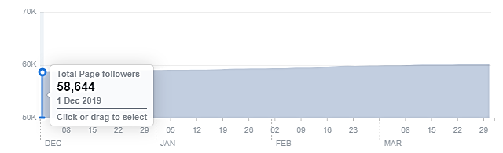

Page Followers: 1 December 2020 to 31 March 2021
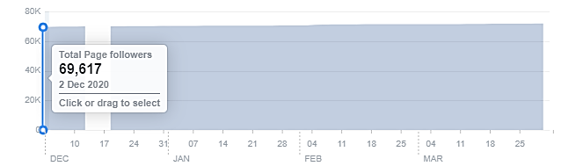

Each month from December 2020 to March 2021, the top posts on PGT’s FB Page, are as follows:
Month | Posts/Videos | Total Reach
December 2020 | Look No Further.. Experience It All In Penang (Comparison Video) | Organic: 88,600  Paid: 125,235
January 2021 | Instagram shot – Kampung Agong | Organic: 65,381  Paid: -
February 2021 | Illustrations by Chong Fei Giap | Organic: 289,265  Paid: -
March 2021 | Highlight of Penang cultural folktales by Mango Comics artists, Akira and Yuu. | Organic: 136,377  Paid: -

Facebook Posts Summary From 1 December 2020 - 31 March 2021

Total Posts & Total Reach of Facebook Posts – Boosted vs Non-Boosted:
 | Total Posts | % Total Posts | Total Reach
Boosted Posts | 9 | 3.35 | 678,280
Non-Boosted Posts | 260 | 96.65 | 1,670,724
Total | 269 | 100 | 2,349,004

Total Posts & Total Reach of Facebook Posts – Island vs Mainland:
 | Total Posts | % Total Posts | Total Reach
Island | 230 | 85.50 | 1,693,018
Mainland | 39 | 14.50 | 655,986
Total | 269 | 100 | 2,349,004

3.2.10 Website Google Analytics for mypenang.gov.my
The analytics report shows a year-on-year (YOY) comparison between two time periods –
1 December 2020 – 31 March 2021 and 1 December 2019 – 31 March 2020

Website traffic
The Google Analytics Report shows a downward trend when compared between year 2020 and year 2021. There was a spike on 31 December 2019 with 3,121 users. However, in comparison to 31 December 2020, there were only 1,119 users to the website. That’s a decrease of 64.15%. There’s also a difference in users on 8 February 2020 in comparison with 8 February 2021, recording 2,544 and 161 users respectively. The other major difference was recorded on 29 February 2020 and 1 March 2021 with a difference in users at 3096 and 190 respectively.
The significant decrease of users to the website for December 2020 to March 2021 could be due to the unforeseen circumstances of the Covid-19 pandemic. Based on previous reports, visitors head to the site mainly to know more on latest events and programmes. There were quite a number of visitors that were linked to our website, mypenang.gov.my directly and at the same time, via Facebook, Google, Penang state government’s website and yahoo.com.
The following is a list of the top 10 sites, mypenang.gov.my was accessed:
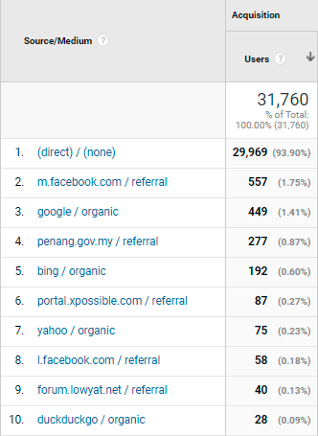

Comparison between 1 December 2020 – 31 March 2021 and 1 December 2019 – 31 March 2020
The comparison report shows a decrease of 69.78% in new users to the website. The number of sessions per user also recorded a slight decrease of 5.48%. However, there’s an increase on the Average Session Duration which is at 5.39%. Although with a lower number of users to the website, it shows that the time spent on the website as a whole has increased.

Top 5 countries visiting the site and most viewed pages
The top 5 countries visiting the site are Malaysia, United States, Singapore, China and Australia. Their most-viewed pages are mainly on Events, Culture & Heritage, Penang Stories, Directory and About Penang.
The following pages show the relevant charts and tables summarizing the Google analytics report as highlighted above.

Period: 1 December 2020 – 31 March 2021
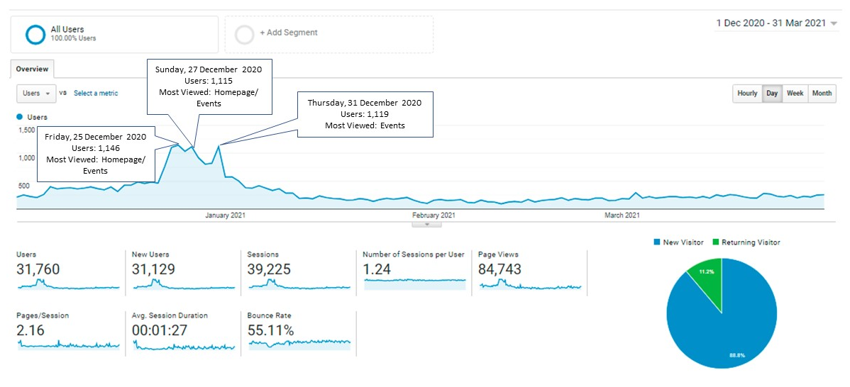
Period: 1 December 2029 - 31 March 2020
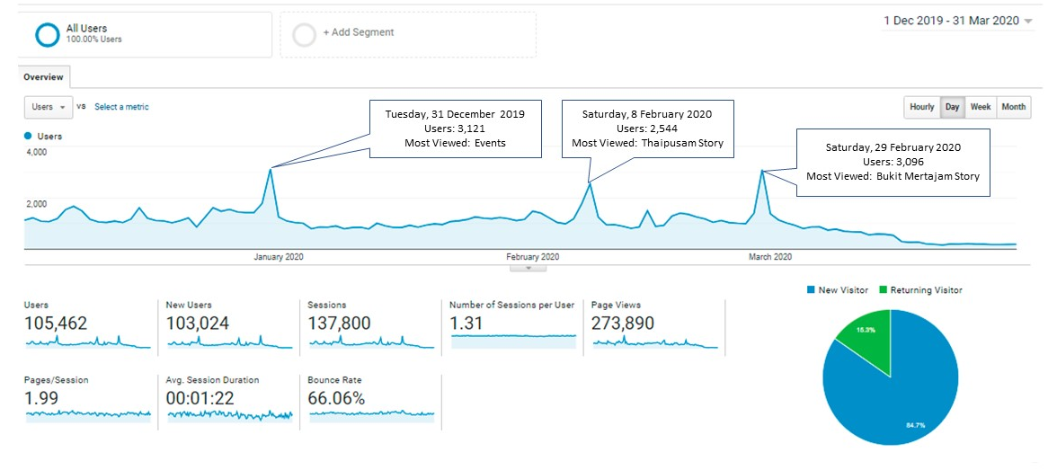

Comparison Chart of 1 December 2020 – 31 March 2021 and 1 December 2019 – 31 March 2020
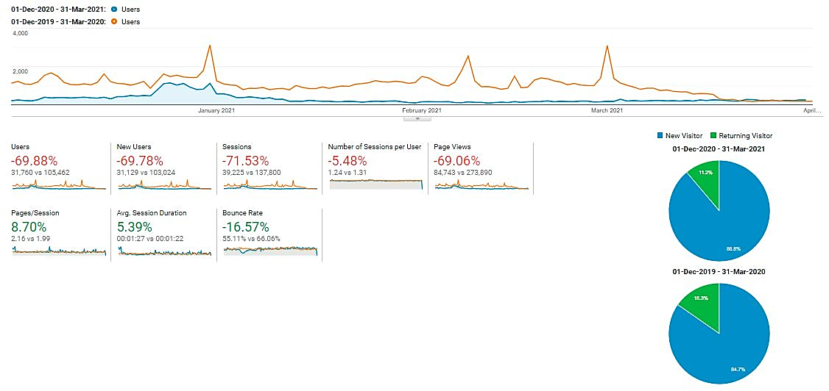
With reference to the above, visitors to the site, in comparison of the time periods:
Item | 1 December 2020 – 31 March 2021 | 1 December 2019 – 31 March 2020
Users | 31, 760 | 105, 462
Sessions | 39, 225 | 137, 800
Page Views | 84, 743 | 273, 890
Ave. Session Duration | 00:01:27 | 00:01:22
Bounce Rate | 55.11% | 66.06%

Current period’s Top 10 users by Country from 1 December 2020 – 31 March 2021:
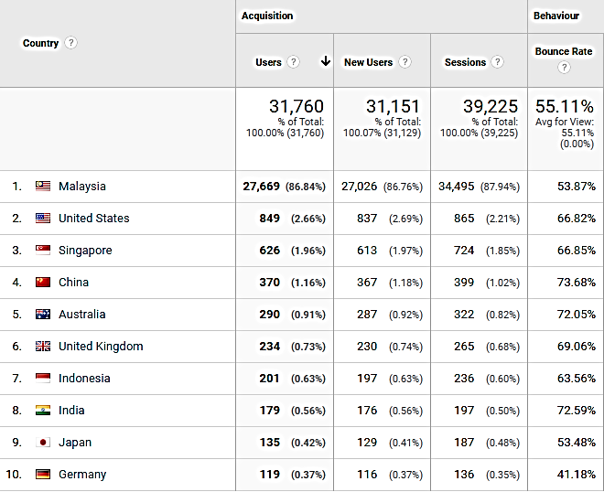

Comparison of the Top 10 users by Country:
(1 December 2020 – 31 March 2021 and 1 December 2019 – 31 March 2020)
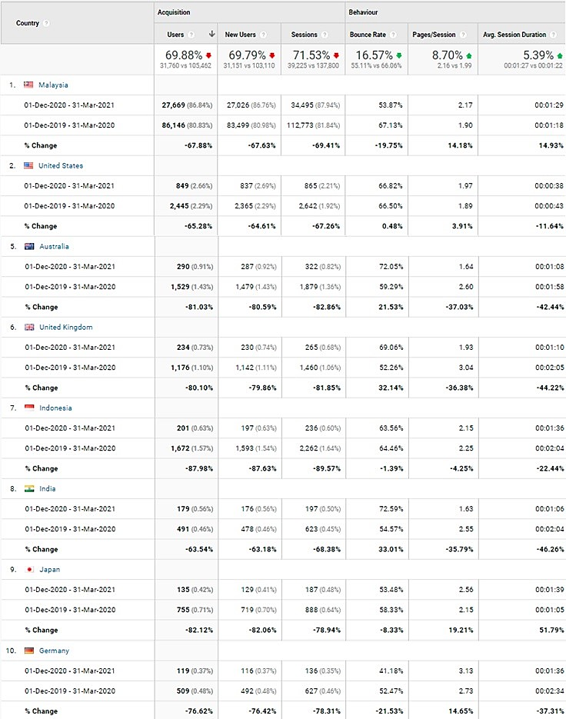

Most viewed pages by the Top 5 Countries visiting our website:
Country | Most viewed Pages
Malaysia | Events, Penang Stories, Culture and Heritage and Directory
United States | Penang Stories, Home page, Events
Singapore | Penang Stories, Culture and Heritage, Events
China | Penang Stories
Australia | Homepage, Penang Stories, Culture and Heritage

Top page views in the mypenang.gov.my website from 1 December 2020 – 31 March 2021:
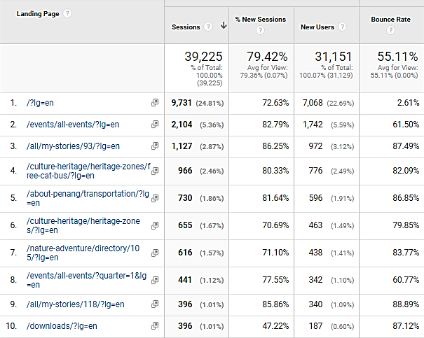

3.2.11 Website Google Analytics for Penang Travel Deals (penangtraveldeals.com)
The analytics report shows the time period of the website from 1 December 2020 – 31 March 2021. As the website was launched in June 2020, there will be no comparison report for this duration.

Website traffic
The Google Analytics Report shows a spike on 8 December 2020 with 639 users. There was also a spike on 24 December 2020 with 342 users and on 9 February 2021 with 234 users.
There’s be an upward trend of users to the website in December 2020 and it could have been brought by visitors searching for travel deals as interstate traveling was allowed at that point of time. Besides that, it could be a driven crowd from Facebook posts (organically and through adverts). There were quite a number of visitors that were linked to our penangtraveldeals.com website via Facebook and there were also users that searched for the website directly. Besides that, the other source that directed users to the website are via organic google search, Facebook, YouTube and news portal, such as Kwong Wah Yit Poh and Oh Media.
The following is a list of the top 10 sites, penangtraveldeals.com was accessed:
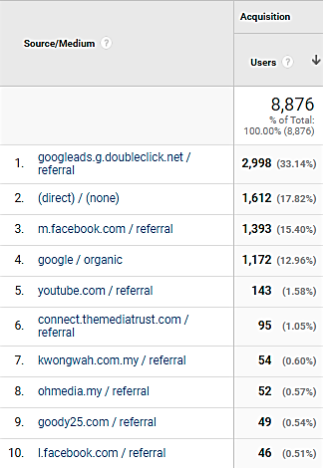

Top 5 countries visiting the site and most viewed pages
The top 5 countries visiting the site are Malaysia, United States, China, Singapore and Philippines. Their most-viewed pages are mainly on Frontliner Deals, Best Hotel Deals, Best Year End Deals and Best Attraction Deals.
The following pages show the relevant charts and tables summarizing the Google analytics report as highlighted above.

Period: 1 December 2020 – 31 March 2021
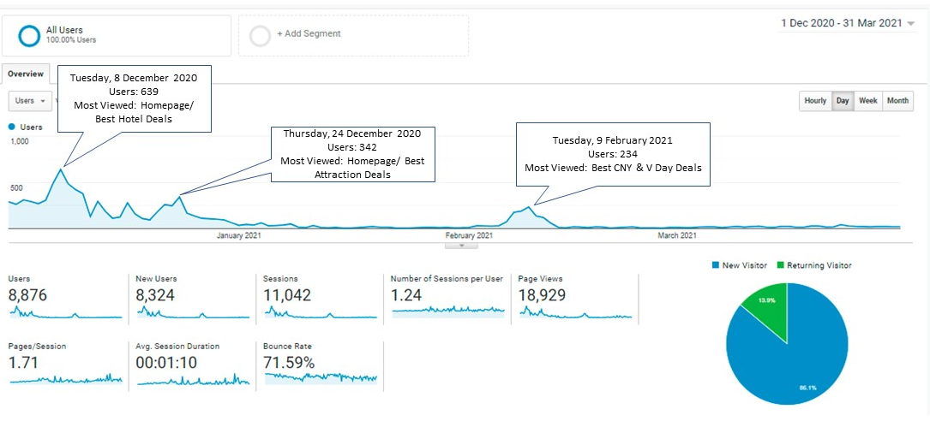

Current period’s Top 10 users by Country from 1 December 2020 – 31 March 2021:
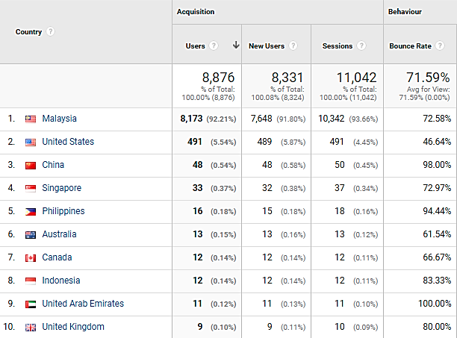

Most viewed pages by the Top 5 Countries visiting our website:
Country | Most viewed Pages
Malaysia | Best Frontliner Hotel Deals, Best Hotel Deals, Best Attraction Deals, Best Year End Deals
United States | Best Frontliner Hotel Deals, Best Attraction Deals, Best Food & Lifestyle Deals, Best Hotel Deals
China | Home Page, Best Frontliner Deals, Best Tour Packages
Singapore | Home Page, Best Attraction Deals, Best Tour Packages
Philippines | Best Frontliner Deals, Best Attraction Deals

Top page views in penangtraveldeals.com website from 1 December 2020 – 31 March 2021:
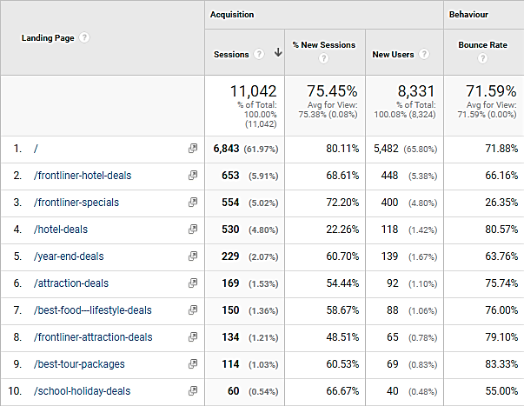

3.3 Recent Publicity (December 2020 – March 2021)
December 2020
Local
No | Name | Description | Type of Publication
1 | Bernama | - Penang launches Malaysia’s first Creative Economy E-Commerce live streaming event  - Public takes a ride on Ferry for one final time | Online
2 | Buletin Mutiara | - The Journey of Art launched in December by YB Yeoh Soon Hin  - Penang hotel industry plans to further boost its services come 2021 | Online
3 | Oriental Daily | - Penang State Government launches online platform for the art industry  - Hotel occupancy rates reaches 90% during Christmas holiday | Online
4 | The Star | - Traders prepare for domestic tourism  - Holidaymakers packing Penang heritage enclave  - Penang Hill launches “Experience Penang Hill” half-day excursions  - Restoring the iconic Balik Pulau roundabout  - Food outlets see roaring business after travel restrictions relaxed  - Miao Hui celebration with online twist | Online
5 | New Straits Times | - Penang State Government urged those traveling in to Penang to practise “Responsible Tourism”  - Last ride for thousands on Penang’s iconic car-carrying ferries | Online
6 | Guang Ming Daily | - Not many visitors at Kampung Agong after the re-opening of inter-state travel  - Getaway to Penang with AirAsia. A collaboration between PGT and AirAsia | Online
7 | Malaysiakini | - Penang’s iconic ferry services to cease on 31 Dec | Online
8 | Kwong Wah Yit Poh | - PETACE is committed in promoting creative arts | Print
9 | Malay Mail | - Penang pushes its “world” attractions in bid to draw domestic tourists | Online
10 | Where2lifestylemagazine | - AirAsia to start Penang to Kota Baru direct flights | Online

December 2020
Foreign
No | Name | Description | Type of Publication
1 | The People Online | - Penang joins forces with AirAsia to strengthen local tourism amid Covid-19 | Online

January 2021
Local
No | Name | Description | Type of Publication
1 | Guang Ming | - Penang continues to see a rise in domestic tourists  - Kek Lok Si Temple lights up on February 7th  - Penang state government launched “Creative Economy Entrepreneurship Fund” for the creative industry players | Online
2 | The Star | - Local tourists spend long weekend in Penang  - Jade Emperor celebration called off for the first time  - Penang hotels shift focus to F&B  - Hotel Equatorial Penang to shut down effective March 31 | Online
3 | The Malaysian Insight | - Penang focus on reviving domestic tourism industry in 2021 | Online
4 | Kwong Wah Yit Poh | - Penang focuses on domestic tourism in the first half of the year, focusing on nature, cultural and creative tourism  - Penang hotel may suspend business if MCO is extended to reduce operating costs | Online
5 | China Press | - Siam Road Char Koay Teow makes it to top 50 under BBC travel | Online
6 | Malay Mail | - Penang Port Commission gifts one ferry to state government | Online

January 2021
Foreign
No | Name | Description | Type of Publication
1 | Retail News Asia | - AirAsia and Penang Tourism collaborate to provide more value deals for domestic tourists | Online
2 | BBC Travel | - Siam Road Char Koay Teow listed as Malaysia’s humble ‘King of Noodles’ | Online

February 2021
Local
No | Name | Description | Type of Publication
1 | The Vibes | - Only half of all MAH hotels in Penang are open for business | Online
2 | The Star | - Annual lighting ceremony of Kek Lok Si temple goes live  - The ‘curry mee’ sisters immortalised in the form of a mural art at the Ayer Itam market | Online
3 | Malay Mail | - Penang CNY events will continue online, Chief Minister says as covid-19 restricts mass gathering | Online
4 | Kwong Wah Yit Poh | - Mural painted to honour the Curry Mee sisters in Air Itam  - Penang CNY decorations at Esplanade | Online
5 | Free Malaysia Today | - Hidden Penang café doubles as traditional Teochew Opera House | Online
6 | Oriental Daily | - George Town back alley beautified | Online
7 | New Straits Times | - The Top Penang keeps Chap Goh Meh tradition alive | Online

March 2021
Local
No | Name | Description | Type of Publication
1 | Free Malaysia Today | - Penang’s last trishaw maker to put the brakes on business  - Cartoonist, Azmi Hussin draws big success after repeated rejections  - ‘Susu Tarik” man of Air Itam becomes a work of art | Online
2 | The Star | - Traditional woodcarving artisan finds digital footing  - Tap into eco-tourism potential, said Penang CM | Online
3 | New Straits Times | - Penang artists and creative businesses gets a boost via Penang Arts Council  - Cruises set to resume in Penang beginning May 2021 | Online
4 | Tatler Malaysia | - Pasir Panjang Beach listed as one of stunning beaches in Malaysia to visit in 2021 | Online
5 | Nan Yang | - MATTA and MOTAC join forces to develop tourism in Penang | Online
6 | Kwong Wah Yit Poh | - Penang Ferry to be used as tourist attraction, mentioned YB Yeoh Soon Hin | Online

The following are the number of local and foreign news coverage based on what we have managed to monitor - mainly online, via Google Alerts and physical publications/magazines received through free subscriptions:

Month/Year (2020/2021) | Local News Coverage | Foreign News Coverage
December 2020 | 10 | 1
January 2021 | 6 | 2
February 2021 | 7 | 0
March 2021 | 6 | 0
Total | 29 | 3

