3.2.4 Other Promotional Videos (1 December 2020 – 31 March 2021)

No. | Videos | Total Views as at 31 March 2021 | Date Published
1 | 
2 | 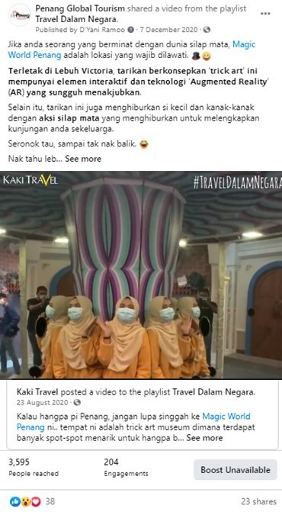

No. | Videos | Total Views as at 31 March 2021 | Date Published
3 | 
4 | 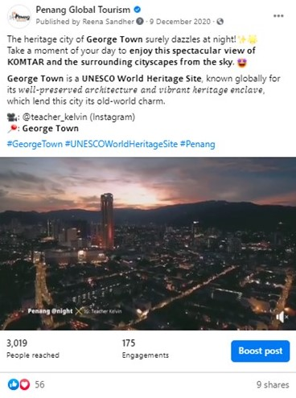

No. | Videos | Total Views as at 31 March 2021 | Date Published
5 | 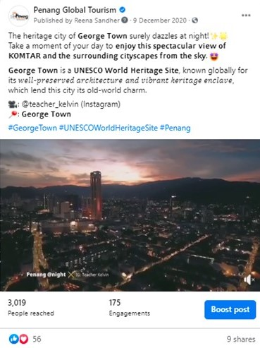
6 | 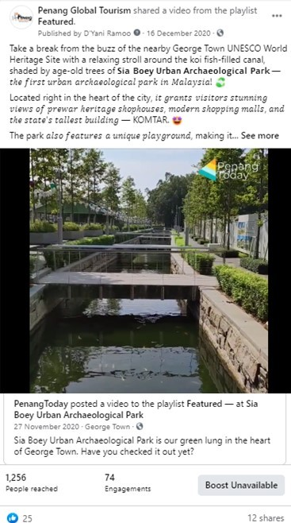

No. | Videos | Total Views as at 31 March 2021 | Date Published
7 | 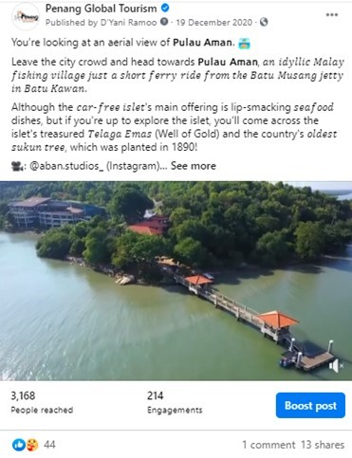
8 | 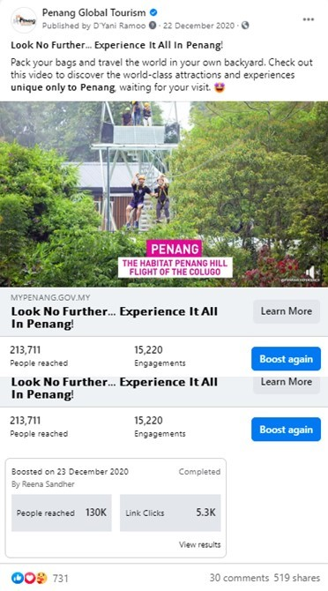
No. | Videos | Total Views as at 31 March 2021 | Date Published
9 | 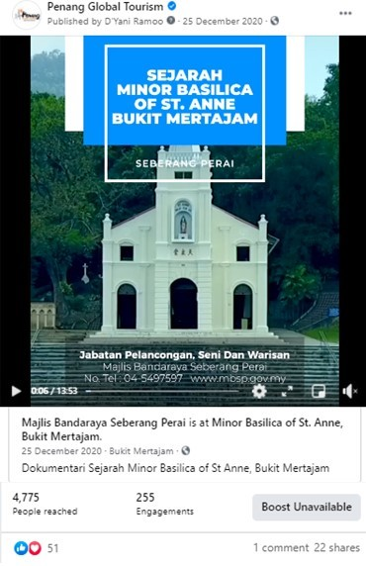
10 | 

No. | Videos | Total Views as at 31 March 2021 | Date Published
11 | 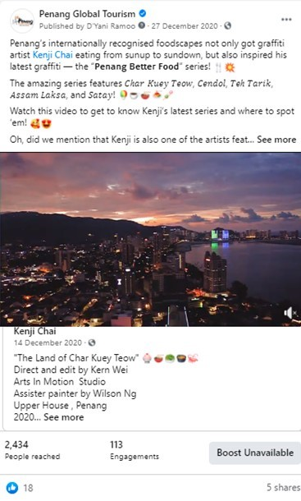
12 | 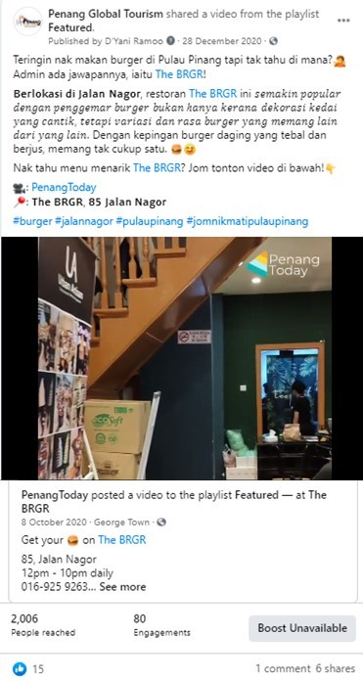

No. | Videos | Total Views as at 31 March 2021 | Date Published
13 | 
14 | 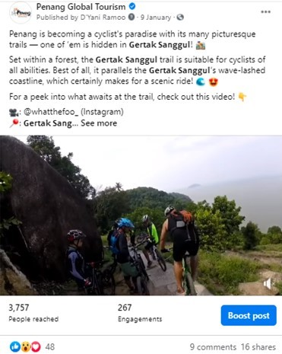

No. | Videos | Total Views as at 31 March 2021 | Date Published
15 | 
16 | 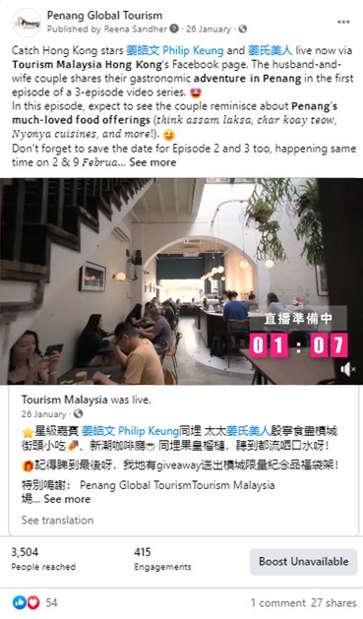

No. | Videos | Total Views as at 31 March 2021 | Date Published
17 | 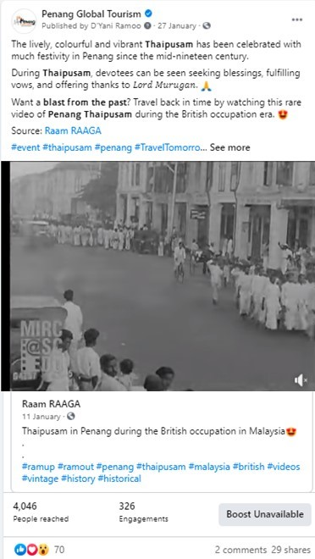
18 | 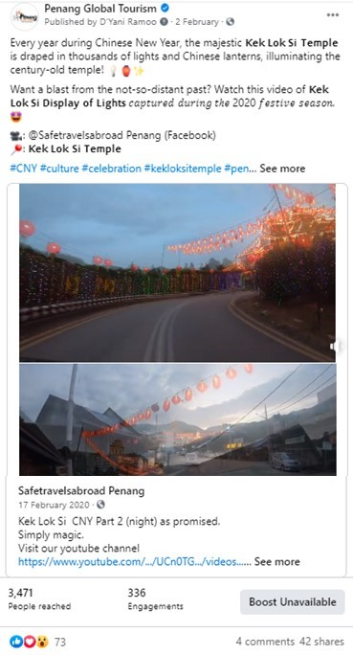

No. | Videos | Total Views as at  31 March 2021 | Date Published
19 | 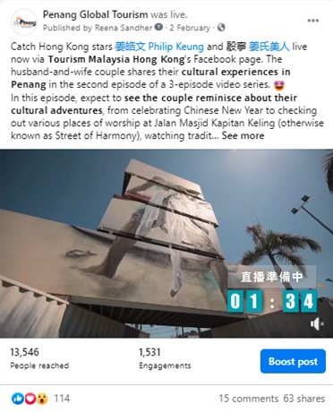
20 | 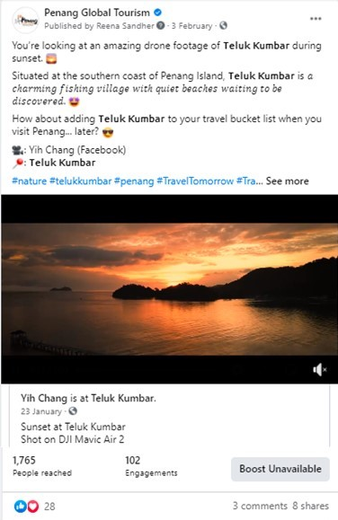

No. | Videos | Total Views as at  31 March 2021 | Date Published
21 | 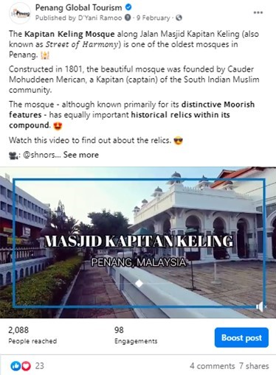
22 | 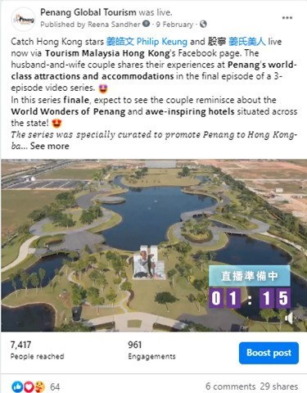

No. | Videos | Total Views as at  31 March 2021 | Date Published
23 | 
24 | 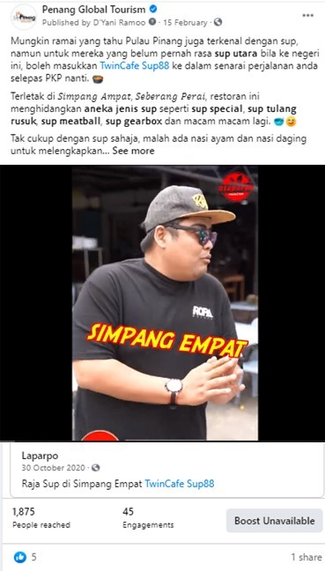

No. | Videos | Total Views as at  31 March 2021 | Date Published
25 | 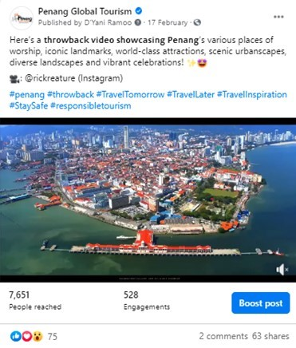
26 | 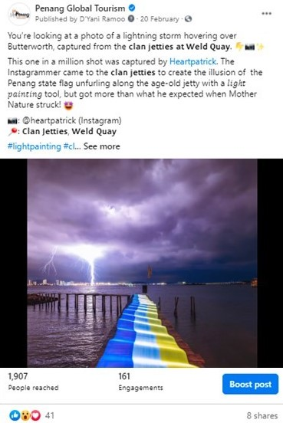

No. | Videos | Total Views as at  31 March 2021 | Date Published
27 | 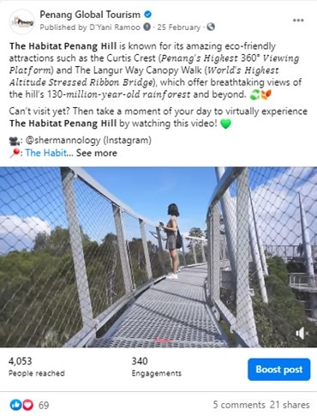
28 | 

No. | Videos | Total Views as at  31 March 2021 | Date Published
27
28

No. | Videos | Total Views as at  31 March 2021 | Date Published
29 | 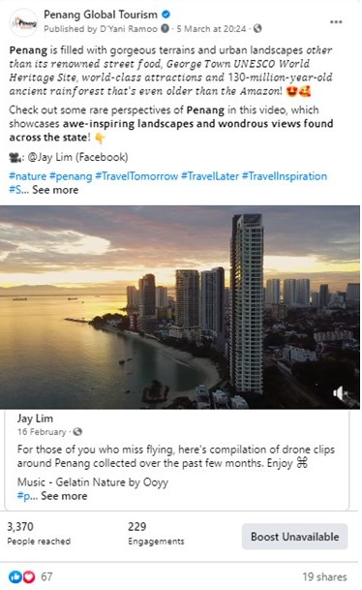
30 | 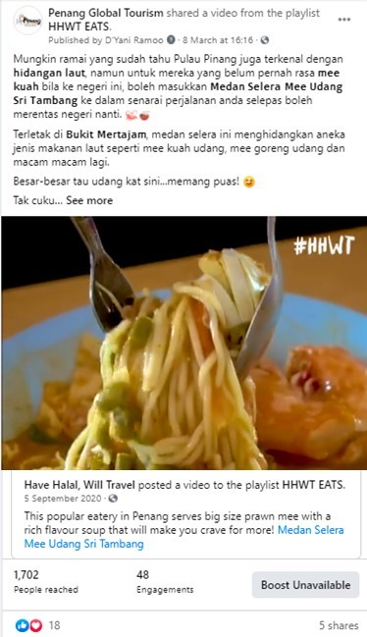

No. | Videos | Total Views as at  31 March 2021 | Date Published
31
32

3.2.5 Results of Paid Advertising via Social Media
Boosted Posts on PGT Facebook Page from 1 July 2020 – 30 November 2020:

PGT’s Facebook Page
Post/ Advert | Target Market | Budget (RM) | Duration | Reach | Results
Tarikan Terkini Pulau Pinang | Johor Bahru  Alor Setar  Kota Bharu  Melaka  Seremban  Kuantan  Ipoh  Perlis  Kuching  Miri  Selangor  Terengganu  Kuala Lumpur  Labuan  Kota Kinabalu  Putrajaya | 800 | 2 – 6 July 2020 | 114,368 | 141k views  1.3k shares  1k reactions  144 comments
Traditional Trades – George Town Unesco World Heritage Site | Johor Bahru  Alor Setar  Kota Bharu  Melaka  Seremban  Kuantan  Ipoh  Perlis  Kuching  Miri  Selangor  Terengganu  Kuala Lumpur  Labuan  Kota Kinabalu  Putrajaya | 600 | 6 – 10 July 2020 | 170,944 | 1k shares  5.9k reactions  50 comments
 | Penang | 400 | 5 - 9 July 2020 | 82,961 | -
20 Pengalaman Unik di Pulau Pinang | Johor Bahru  Alor Setar  Kota Bharu  Melaka  Seremban  Kuantan  Ipoh  Perlis  Kuching  Miri  Selangor  Terengganu  Kuala Lumpur  Labuan  Kota Kinabalu  Putrajaya | 800 | 9 – 13 July 2020 | 188,991 | 268k views  1.4k shares  1.7k reactions  161 comments
 | Johor Bahru  Alor Setar  Kota Bharu  Melaka  Seremban  Kuantan  Ipoh  Perlis  Kuching  Miri  Selangor  Terengganu  Kuala Lumpur  Labuan  Kota Kinabalu  Putrajaya | 800 | 26 – 30 October 2020 | 195,201
20 Aktiviti Percuma di Pulau Pinang | Johor Bahru  Alor Setar  Kota Bharu  Melaka  Seremban  Kuantan  Ipoh  Perlis  Kuching  Miri  Selangor  Terengganu  Kuala Lumpur  Labuan  Kota Kinabalu  Putrajaya | 800 | 16 – 20 July 2020 | 205,088 | 3.7k share  2.2k reactions  524 comments  142k views
20 Makanan Mesra Muslim Terbaik di Pulau Pinang | Johor Bahru  Alor Setar  Kota Bharu  Melaka  Seremban  Kuantan  Ipoh  Perlis  Kuching  Miri  Selangor  Terengganu  Kuala Lumpur  Labuan  Kota Kinabalu  Putrajaya | 800 | 23 – 27 July 2020 | 242,561 | 2.8k shares  2.1k reactions  410 comments  272k views
20 Lokasi Insta di Pulau Pinang | Johor Bahru  Alor Setar  Kota Bharu  Melaka  Seremban  Kuantan  Ipoh  Perlis  Kuching  Miri  Selangor  Terengganu  Kuala Lumpur  Labuan  Kota Kinabalu  Putrajaya | 800 | 30 July – 3 August 2020 | 339,456 | 3.4k shares  1.9k reactions  384 comments  229k views
Penang Travel Deals | Johor Bahru  Alor Setar  Kota Bharu  Melaka  Seremban  Kuantan  Ipoh  Perlis  Kuching  Miri  Selangor  Terengganu  Kuala Lumpur  Labuan  Kota Kinabalu  Putrajaya | 800 | 3 – 7 August 2020 | 40,448 | 10 shares  1.4k reactions  20 comment
20 Nasi Kandar Terbaik di Pulau Pinang | Johor Bahru  Alor Setar  Kota Bharu  Melaka  Seremban  Kuantan  Ipoh  Perlis  Kuching  Miri  Selangor  Terengganu  Kuala Lumpur  Labuan  Kota Kinabalu  Putrajaya | 800 | 4 – 9 September 2020 | 271,361 | 1k shares  1.3k reactions  205 comments  167k views
7 Keajaiban Dunia di Pulau Pinang | Johor Bahru  Alor Setar  Kota Bharu  Melaka  Seremban  Kuantan  Ipoh  Perlis  Kuching  Miri  Selangor  Terengganu  Kuala Lumpur  Labuan  Kota Kinabalu  Putrajaya | 800 | 9 – 13 September 2020 | 303,554 | 1.4k shares  1.9k reactions  383 comments
20 Aktiviti Mesra Keluarga di Pulau Pinang | Johor Bahru  Alor Setar  Kota Bharu  Melaka  Seremban  Kuantan  Ipoh  Perlis  Kuching  Miri  Selangor  Terengganu  Kuala Lumpur  Labuan  Kota Kinabalu  Putrajaya | 800 | 11 – 15 September 2020 | 209,918 | 1.1k shares  1k reactions  109 comments  138k views
Penang Stories - Best Rural Escapes: Exploring Kepala Batas, Penang | Johor Bahru  Alor Setar  Kota Bharu  Melaka  Seremban  Kuantan  Ipoh  Perlis  Kuching  Miri  Selangor  Terengganu  Kuala Lumpur  Labuan  Kota Kinabalu  Putrajaya | 800 | 25 – 29 September 2020 | 94,937 | 16 shares  1.2k reactions  8 comments  1,539 link clicks
Penang Stories – Menerokai Teluk Kumbar: Intan Yang Belum Diasah | Johor Bahru  Alor Setar  Kota Bharu  Melaka  Seremban  Kuantan  Ipoh  Perlis  Kuching  Miri  Selangor  Terengganu  Kuala Lumpur  Labuan  Kota Kinabalu  Putrajaya | 800 | 1 – 5 October 2020 | 189,926 | 54 shares  1.7k reactions  9 comments  965 link clicks
Techfest | Johor Bahru  Alor Setar  Kota Bharu  Melaka  Seremban  Kuantan  Ipoh  Perlis  Kuching  Miri  Selangor  Terengganu  Kuala Lumpur  Labuan  Kota Kinabalu  Putrajaya | 800 | 8 – 12 October 2020 | 6,504 | 3 shares  6.3k reactions  2 comments  491 link clicks
 | Singapore | 1,000 | 12 – 17 October 2020 | 87,600 | 23 reactions  830 link clicks  853 engagement
 | Japan | 500 | 14 – 19 October 2020 | 63,551 | 8 reactions  260 link clicks  270 engagement
 | South Korea | 500 | 15 – 20 October 2020 | 41,055 | 7 reactions  267 link clicks  275 engagement
 | Australia | 1,500 | 16 – 21 October 2020 | 58,849 | 17 reactions  621 link clicks  639 engagement
 | Taipei | 1,000 | 22 – 27 October 2020 | 61,328 | 18 reactions  742 link clicks  763 engagement
 | Indonesia | 500 | 23 – 28 October 2020 | 120.4k | 93 reactions  2,008 link clicks  2,104 engagement
 | Philippines | 500 | 25 – 30 October 2020 | 64,576 | 68 reactions  2,096 link clicks  2,167 engagement
 | United Kingdom | 1,500 | 26 – 31 October 2020 | 72,271 | 6 reactions  596 link clicks  605 engagement
 | Hong Kong | 1,000 | 26 – 31 October 2020 | 68,303 | 17 reactions  578 link clicks  596 engagement
 | Vietnam | 500 | 27 October – 1 November 2020 | 144.7k | 73 reactions  2,467 link clicks  2,545 engagement
 | Thailand | 1,000 | 27 October –  1 November 2020 | 169.2k | 66 reactions  2,606 link clicks  2,676 engagement
Penang Stories - Bukit Tambun | Johor Bahru  Alor Setar  Kota Bharu  Melaka  Seremban  Kuantan  Ipoh  Perlis  Kuching  Miri  Selangor  Terengganu  Kuala Lumpur  Labuan  Kota Kinabalu  Putrajaya | 800 | 3 – 7 November | 89,377 | 7.3k reactions  9 comments  650 link clicks  10,716 engagement
Penang Stories – Khazanah Tersembunyi Bukit Tambun | Johor Bahru  Alor Setar  Kota Bharu  Melaka  Seremban  Kuantan  Ipoh  Perlis  Kuching  Miri  Selangor  Terengganu  Kuala Lumpur  Labuan  Kota Kinabalu  Putrajaya | 800 | 17 – 21 November | 87,360 | 13,795 reactions  10 comments  783 link clicks  14,860 engagement
7 Keajaiban Dunia di Pulau Pinang | Johor Bahru  Alor Setar  Kota Bharu  Melaka  Seremban  Kuantan  Ipoh  Perlis  Kuching  Miri  Selangor  Terengganu  Kuala Lumpur  Labuan  Kota Kinabalu  Putrajaya | 800 | 17 – 21 November | 309.2k | 1,549 reactions  185 comments  195 link clicks  26,449 engagement
Pulau Aman by Buletin Mutiara | Johor Bahru  Alor Setar  Kota Bharu  Melaka  Seremban  Kuantan  Ipoh  Perlis  Kuching  Miri  Selangor  Terengganu  Kuala Lumpur  Labuan  Kota Kinabalu  Putrajaya | 800 | 22 – 26 November | 222.1k | 5,600 reactions  81 comments  107 link clicks  22,213 engagement
20 Aktiviti Percuma di Pulau Pinang | Johor Bahru  Alor Setar  Kota Bharu  Melaka  Seremban  Kuantan  Ipoh  Perlis  Kuching  Miri  Selangor  Terengganu  Kuala Lumpur  Labuan  Kota Kinabalu  Putrajaya | 800 | 26 – 30 November | 179.7k | 534 reactions  28 comments  1,397 link clicks  75,025 engagement

The total amounts spent on PGT Facebook page from 1 July – 30 November 2020 is as follows:
Penang Global Tourism | RM 24,900

3.2.6 Facebook Posts from 1 July – 30 November 2020

Period: July 2020
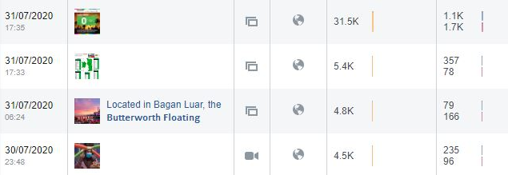
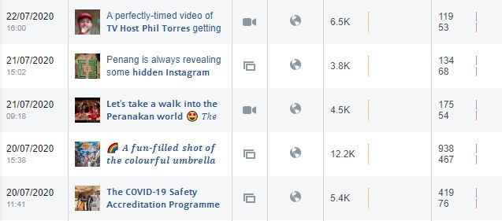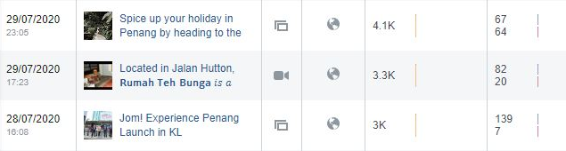
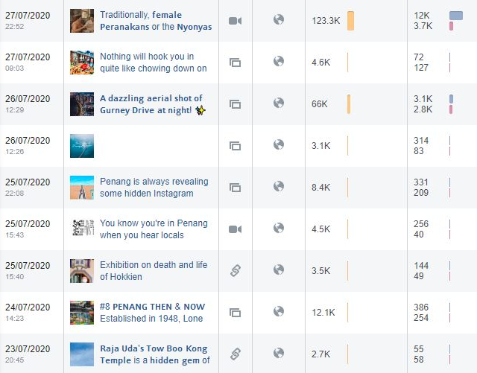

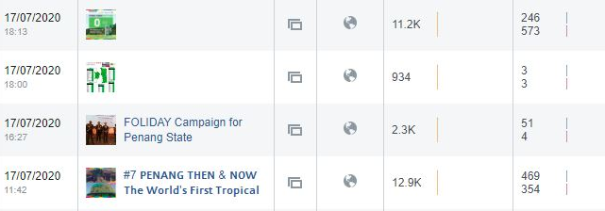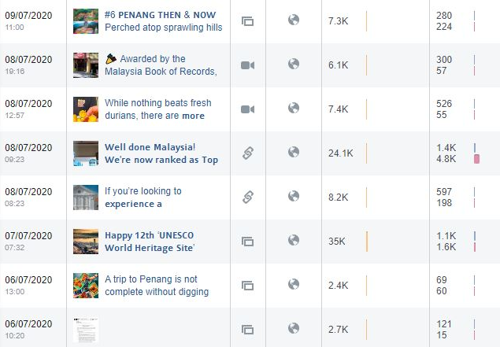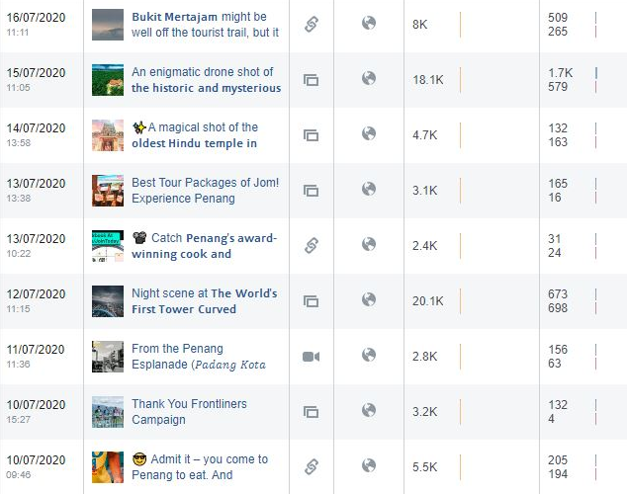

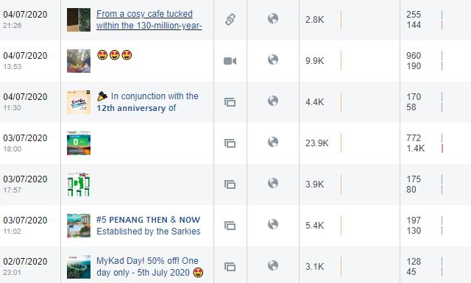
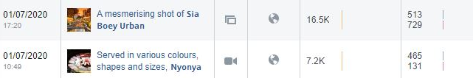
Total Post | Total Reach | Total Post Clicks | Total Reaction, Comments & Shares
51 | 582,734 | 33,002 | 22,965

Period: August 2020
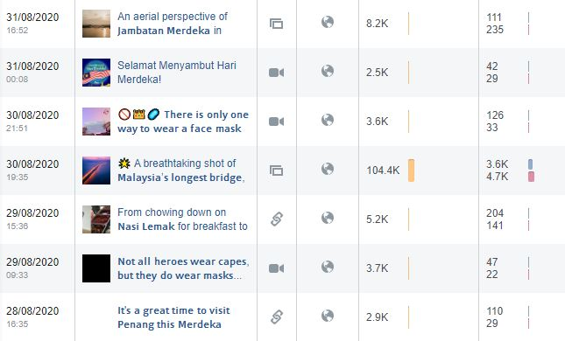

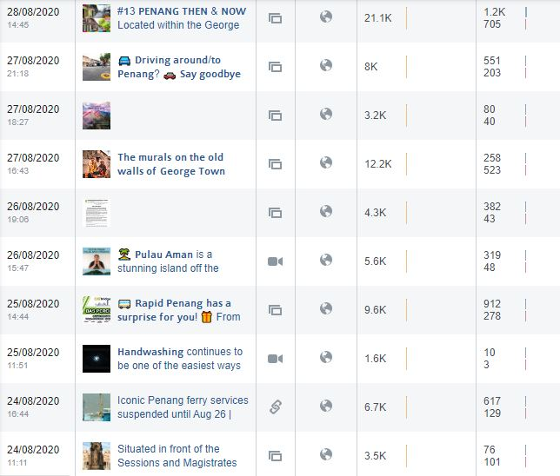
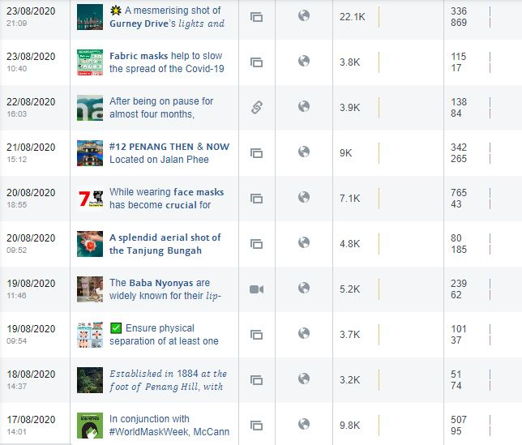

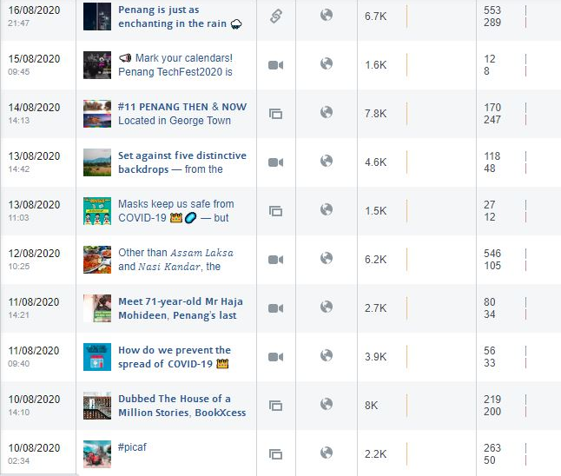
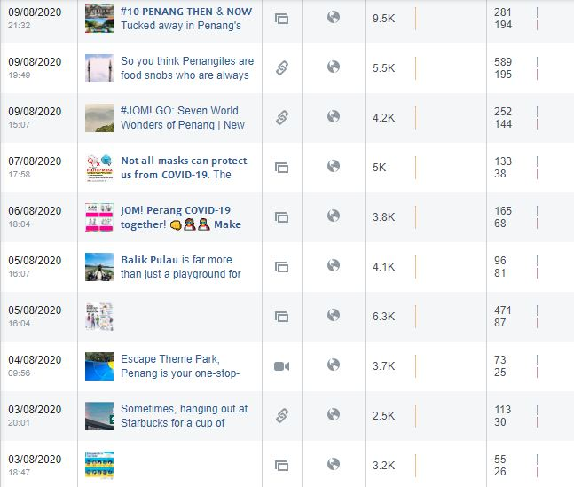

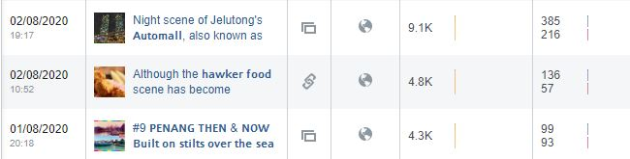
Total Post | Total Reach | Total Post Clicks | Total Reactions, Comments & Shares
50 | 390,100 | 16,211 | 11,273

Period: September 2020
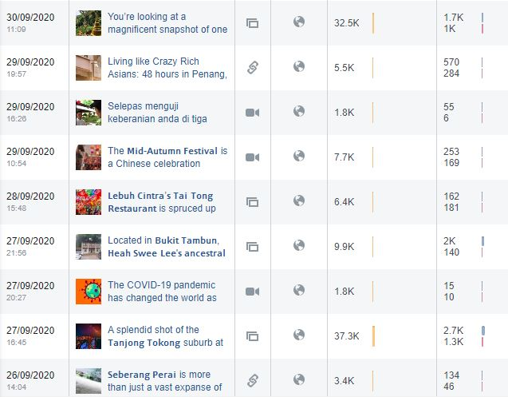
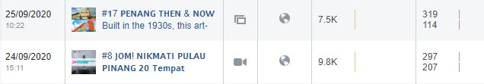

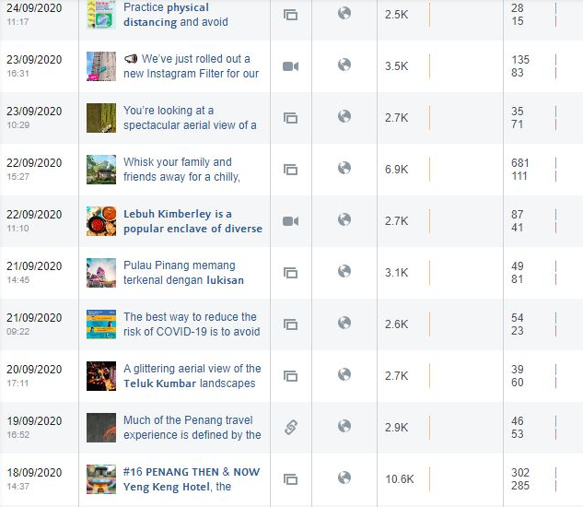
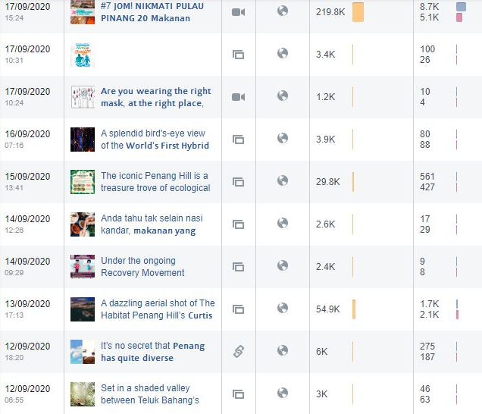
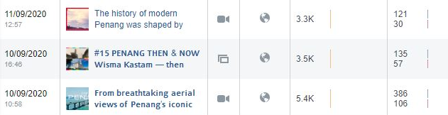
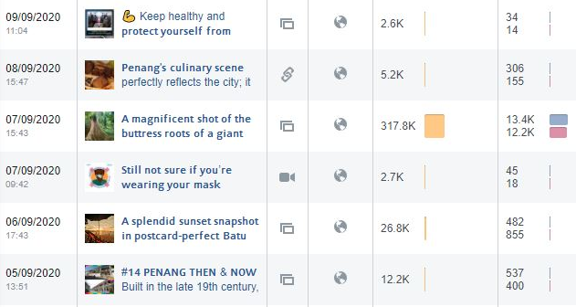
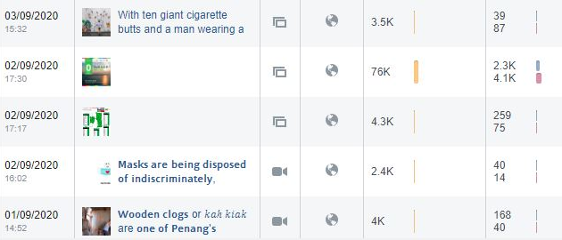
Total Post | Total Reach | Total Post Clicks | Total Reactions, Comments & Shares
45 | 960,500 | 39,411 | 30,463

Period: October 2020
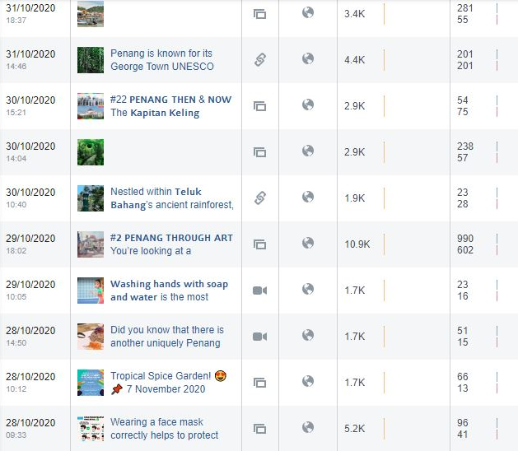

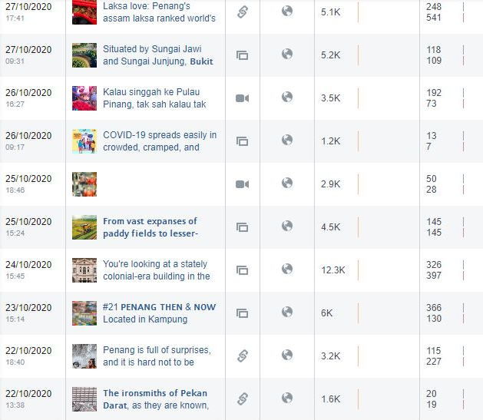
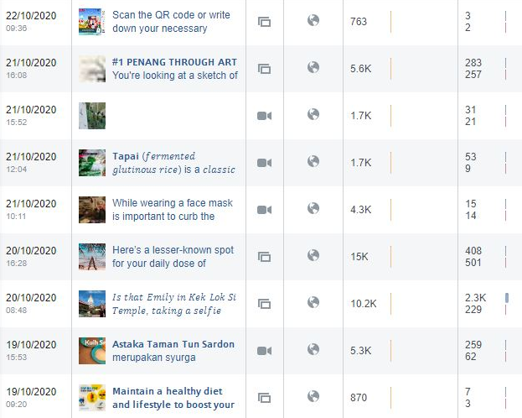

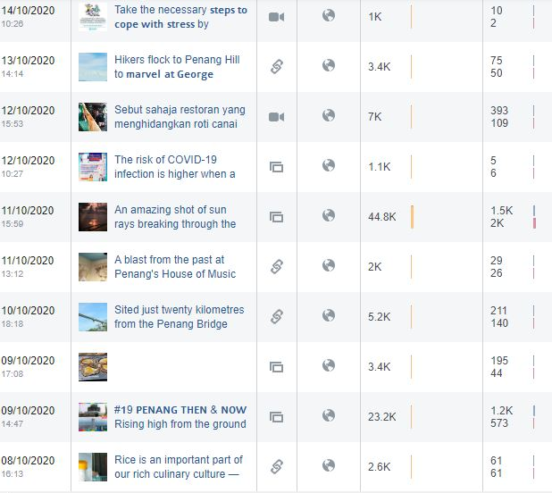
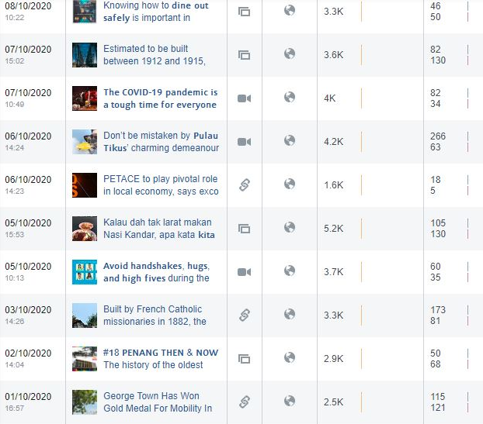

Total Post | Total Reach | Total Post Clicks | Total Reactions, Comments & Shares
61 | 315,733 | 13,668 | 9,494

Period: November 2020
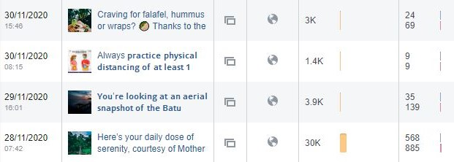
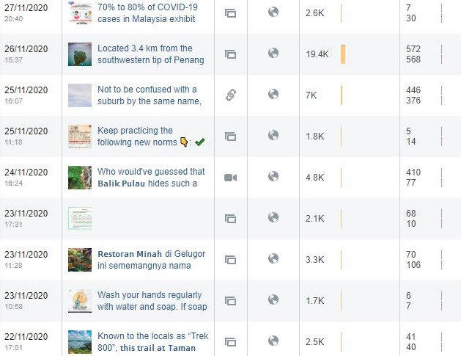
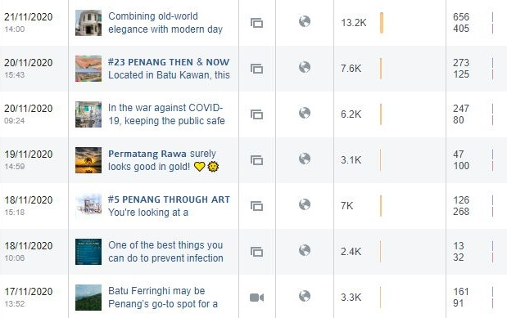
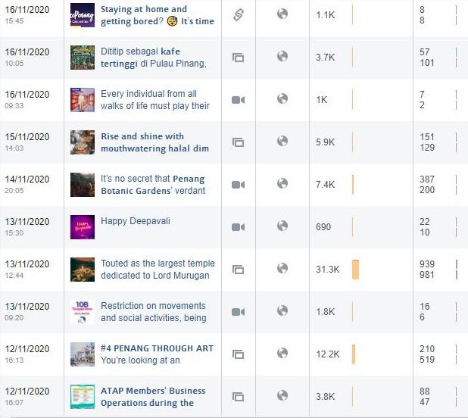
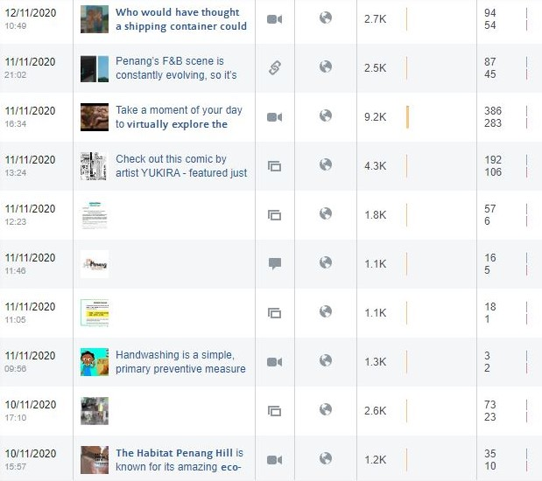

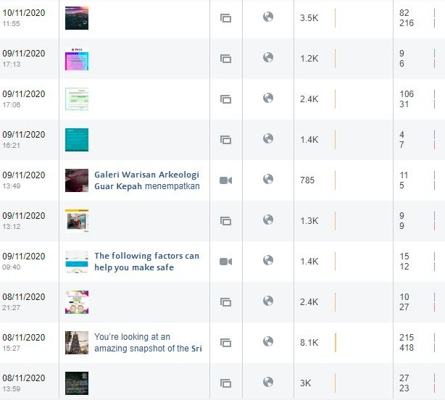
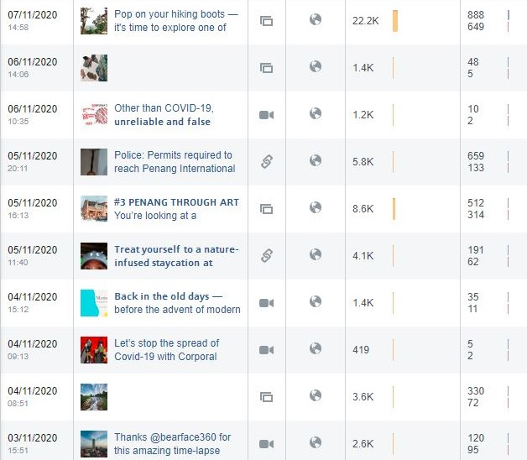

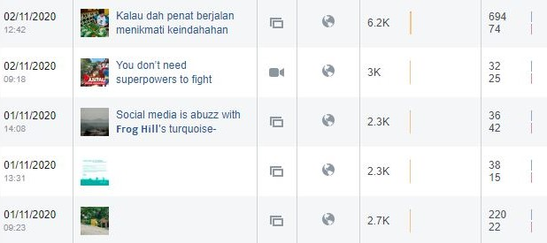
Total Post | Total Reach | Total Post Clicks | Total Reactions, Comments & Shares
66 | 317,195 | 10,989 | 8,274

Total post and reach for PGT’s Facebook Page from 1 July – 30 November 2020 are as follows:
Month | Posts | Reach | Post Clicks | Reactions, Comments & Shares
July | 51 | 582,734 | 33,002 | 22,965
August | 50 | 390,100 | 16,211 | 11,273
September | 45 | 960,500 | 39,411 | 30,463
October | 61 | 315,733 | 13,668 | 9,494
November | 66 | 317,195 | 10,989 | 8,274
Total | 273 | 2,566,262 | 113,281 | 82,469

3.2.7 Facebook Posts on Seberang Perai (Mainland) from July to November 2020 are as follows:

July 2020
No. | Posts | Total Reach | Total Engagement | Date Published
1 | The historic and mysterious 99-door mansion | 18,113 | 2,291 | 15 July 2020
2 | 19 Incredible things to do (and eat) in Bukit Mertajam by Penang Insider | 8,010 | 774 | 16 July 2020
3 | Tow Boo Kong Temple by Butterworth Guide | 2,745 | 113 | 23 July 2020
4 | Penang’s Hidden Food Gem – Pulau Aman | 4,560 | 199 | 27 July 2020
5 | Bagan Luar, Butterworth Floating Mosque | 4,764 | 245 | 31 July 2020
August 2020
No. | Posts | Total Reach | Total Engagement | Date Published
1 | Video on Pulau Aman by ML Studios | 5,572 | 390 | 26 August 2020
2 | Instagram shot on Penang Second Bridge | 104,351 | 8,338 | 30 August 2020
3 | Instagram shot on Jambatan Merdeka | 8,186 | 346 | 31 August 2020
September 2020
No. | Posts | Total Reach | Total Engagement | Date Published
1 | Instagram shot on big tree at Cherok Tokun | 317,811 | 25,620 | 7 Sept 2020
2 | Instagram shot – Seafood to try at Kepala Batas | 2,559 | 46 | 14 Sept 2020
3 | Instagram shot on PICAF at Dataran Merdeka | 3,103 | 130 | 21 Sept 2020
4 | Instagram shot on paddy field at Penaga | 2,738 | 106 | 23 Sept 2020
5 | Penang Stories: Exploring Kepala Batas | 99,383 | 3,282 | 25 Sept 2020
6 | The mysterious relic of Cherok Tokun by Butterworth Guide | 3,350 | 180 | 26 Sept 2020
7 | Heah Swee Lee’s ancestral mansion by Penang Hidden Gems | 9,941 | 2,097 | 27 Sept 2020
October 2020
No. | Posts | Total Reach | Total Engagement | Date Published
1 | The ‘Notre Dame’ of Pagar Tras | 3,314 | 254 | 3 Oct 2020
2 | Nasi Lemak Permatang Rawa | 5,189 | 235 | 5 Oct 2020
3 | Instagram shot of Jambatan Keretapi Pinang Tunggal | 3,607 | 212 | 7 Oct 2020
4 | Air Hitam Dalam Educational Forest, Tasek Gelugor | 5,170 | 351 | 10 Oct 2020
5 | Instagram shot of Penang Second Bridge | 44,858 | 3,479 | 11 Oct 2020
6 | The idyllic countryside district of Penanti by Butterworth Guide | 2,401 | 65 | 15 Oct 2020
7 | Instagram shot of paddy field at Sungai Dua | 6,863 | 402 | 18 Oct 2020
8 | Video on Penang International Paddy Festival | 1,702 | 65 | 21 Oct 2020
9 | Penang Through Art – Bukit Mertajam’s town | 5,616 | 541 | 21 Oct 2020
10 | The ironsmiths of Pekan Darat by Butterworth Guide | 1,632 | 40 | 22 Oct 2020
11 | Penang Then & Now – Butterworth Digital Library | 5,963 | 496 | 23 Oct 2020
12 | Instagram shot on Seberang Perai Paddy Fields | 4,505 | 290 | 25 Oct 2020
13 | Instagram shot on Bukit Tambun Fishing Village | 5,277 | 227 | 27 Oct 2020
November 2020
No. | Posts | Total Reach | Total Engagement | Date Published
1 | Instagram shot on Frog Hill | 2,261 | 78 | 1 Nov 2020
2 | Penang Stories – Bukit Tambun | 91,652 | 8,664 | 3 Nov 2020
3 | Instagram shot on Bukit Berapit | 22,192 | 1,537 | 7 Nov 2020
4 | Instagram shot on Sri Maha Mariamman Temple Butterworth | 8,142 | 633 | 8 Nov 2020
5 | Video by The Malaysian Insight on Galeri Warisan Arkeologi Guar Kepah | 789 | 17 | 9 Nov 2020
6 | Instagram Video on Penang | 9,210 | 671 | 11 Nov 2020
7 | Article on first Nasi Kandar drive-thru at Seberang Perai by Siakap Keli | 2,511 | 132 | 11 Nov 2020
8 | Penang Stories – Khazanah tersembunyi Bukit Tambun | 87,360 | 15,623 | 17 Nov 2020
9 | Instagram shot on Permatang Rawa | 3,081 | 147 | 19 Nov 2020
10 | #23 Penang Then & Now – Design Village Mall, Batu Kawan | 7,572 | 398 | 20 Nov 2020
11 | Pulau Aman by Buletin Mutiara | 239,490 | 38,584 | 22 Nov 2020
12 | Facebook post on Taman Rimba Bukit Mertajam | 2,480 | 81 | 22 Nov 2020
13 | Instagram shot on Air Hitam Dalam Educational Forest | 30,769 | 1,460 | 28 Nov 2020
14 | Pulau Aman aerial snapshot | 3,920 | 174 | 29 Nov 2020

Period: July 2020
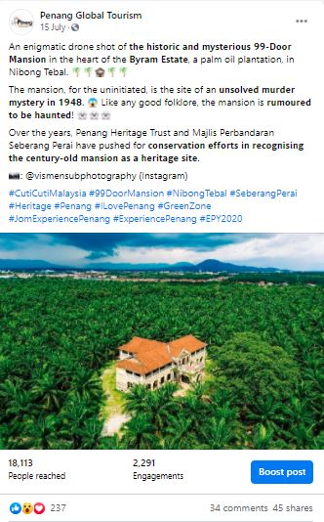 | 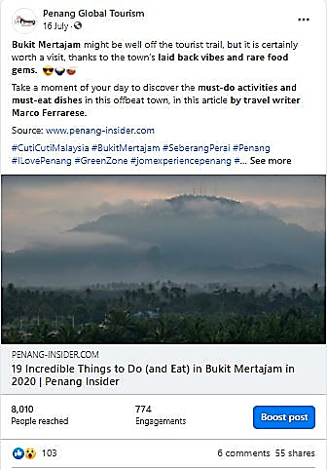

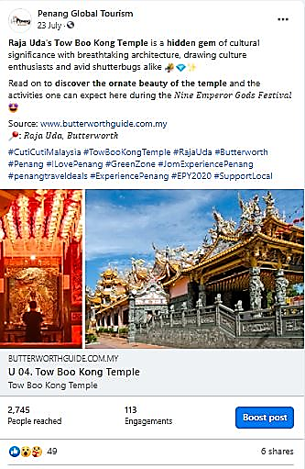 |  | 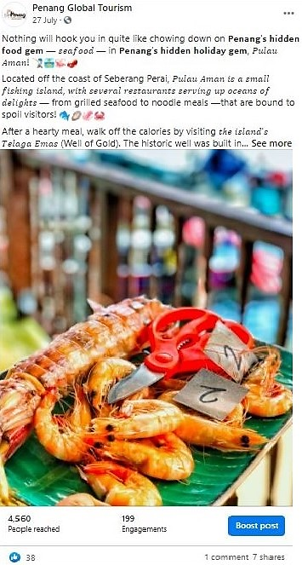
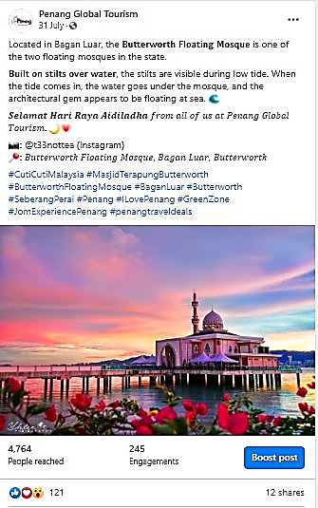

Total Post | Total Reach |  | Total Engagement
5 | 38, 192 |  | 3,622

Period: August 2020
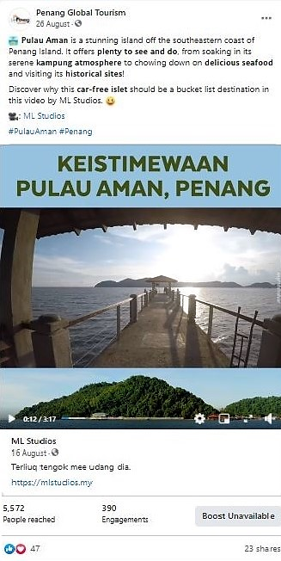 |  | 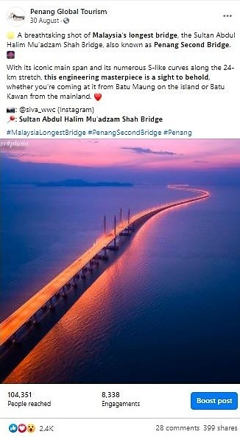
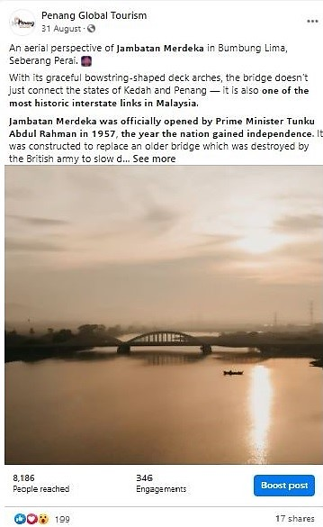

Total Post | Total Reach |  | Total Engagement
3 | 118,109 |  | 9,074

Period: September 2020
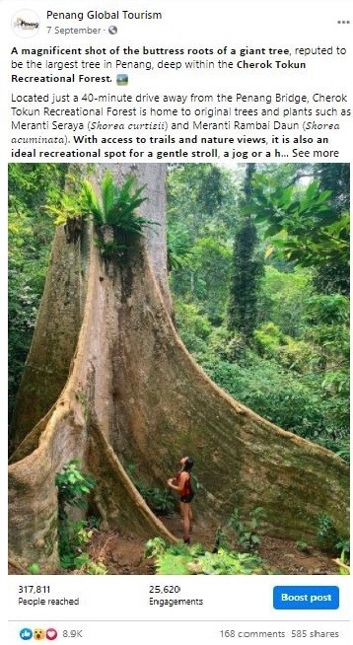 |  | 
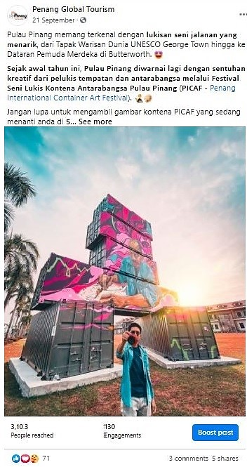 |  | 
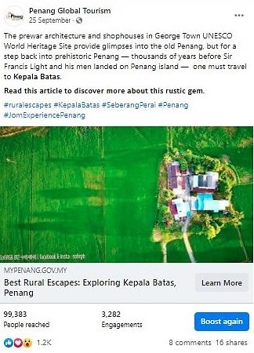 |  | 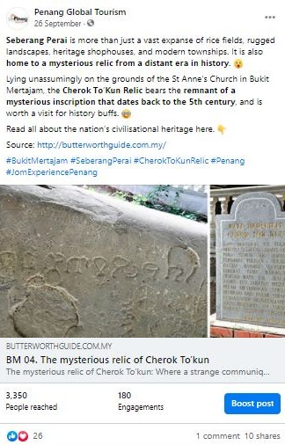
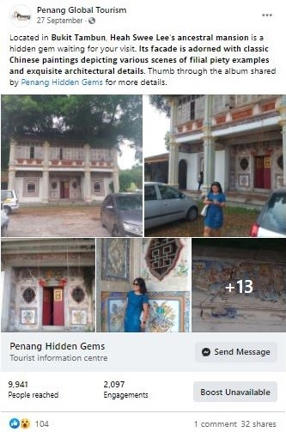

Total Post | Total Reach |  | Total Engagement
7 | 438,885 |  | 31,461

Period: October 2020
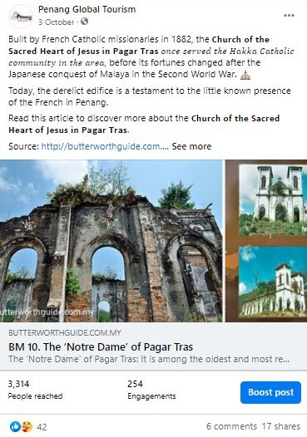 | 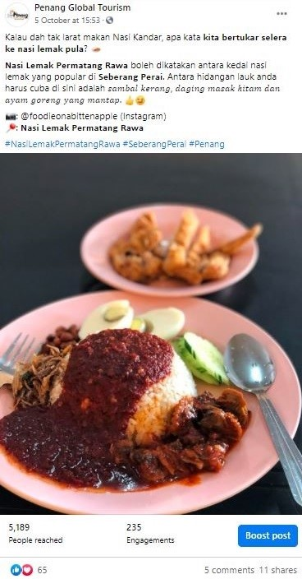
 | 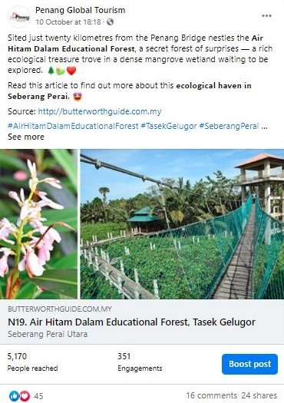

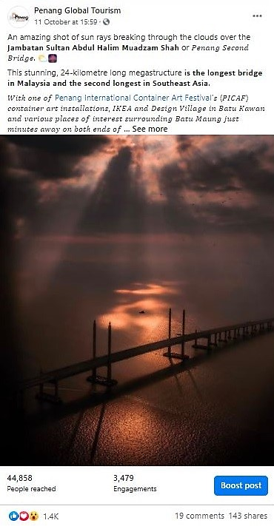 | 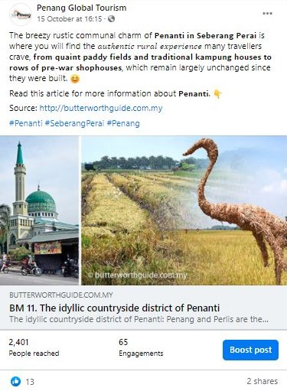
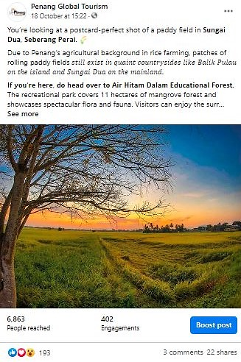 | 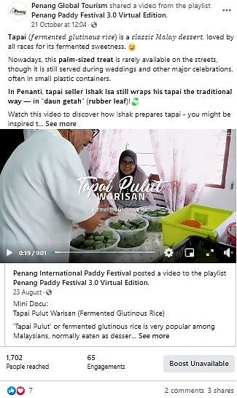
 | 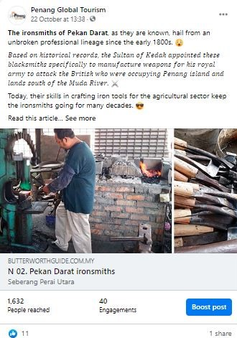

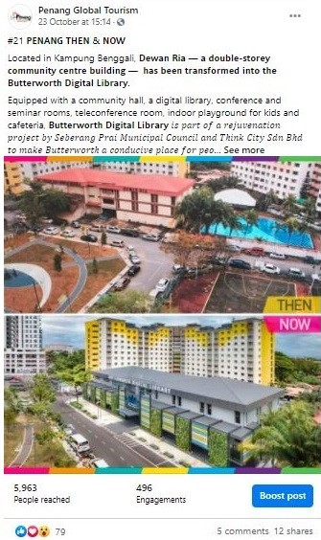 |  | 
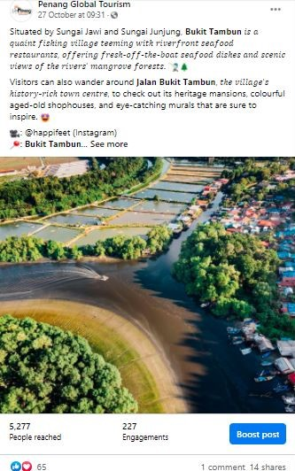
Total Post | Total Reach |  | Total Engagement
13 | 96,097 |  | 6,657

Period: November 2020
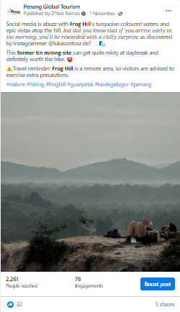 | 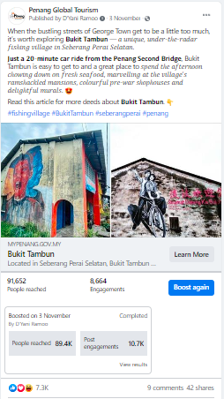
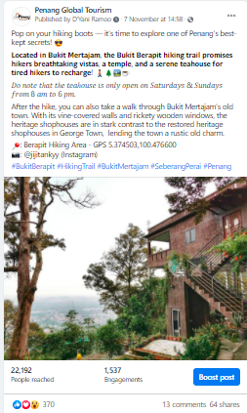 | 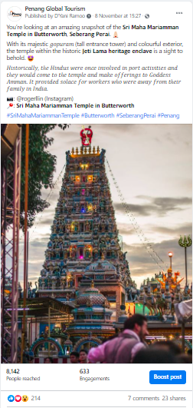

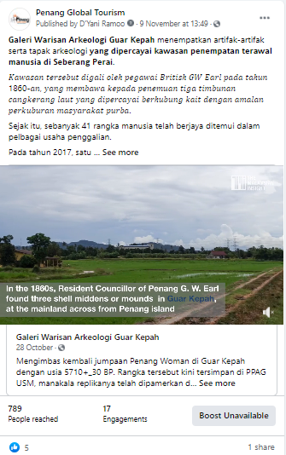 | 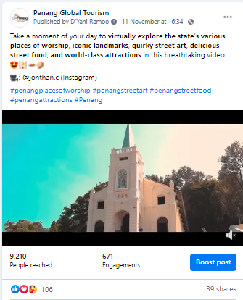
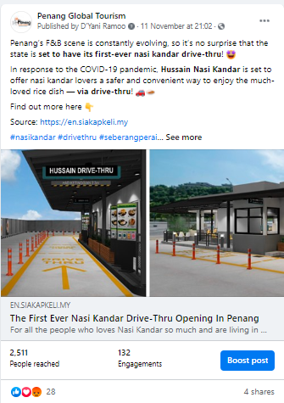 | 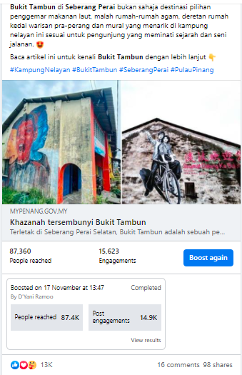

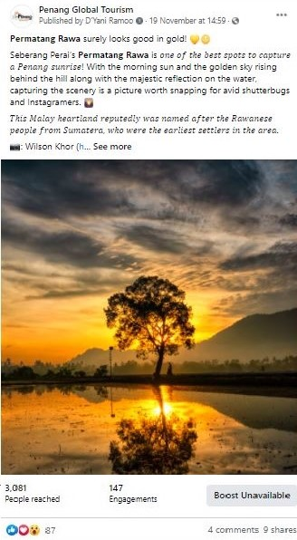 | 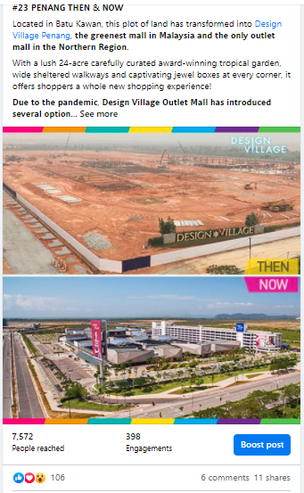
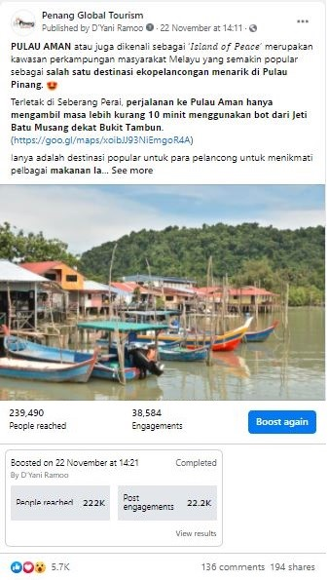 | 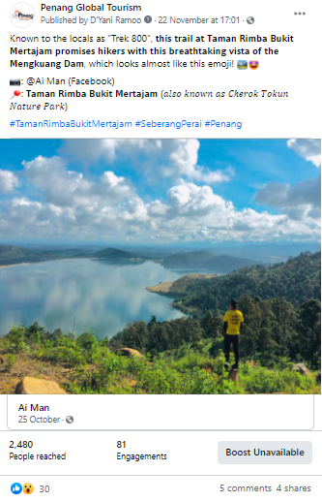

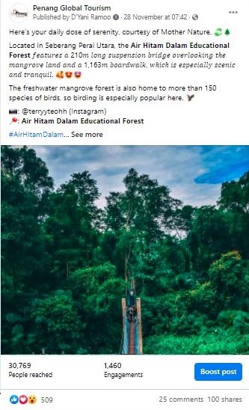 |  | 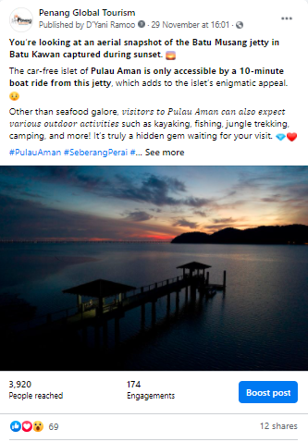
Total Post | Total Reach |  | Total Engagement
14 | 511,429 |  | 68,199

3.2.8 PGT’s Facebook Page Analytics
Based on the insights of PGT’s Facebook Page, there has been a pretty good increase in the number of Page Followers in comparison to the same period, a year before. The number of Page Followers recorded for current period of 1 July to 30 November 2020 was 63,046 and 69,579 whereas the number of Page Followers recorded on 1 July to 30 November 2019 was 55,600 and 58,641. Therefore, there’s a clear indication that the increase of Page Followers for current period is at a good pace.

Comparison of Page Followers:
YOY Comparison | Page Followers |  | Increased by
1 July – 30 November 2019 | 55,600 | 58,641 | 3,041
1 July – 30 November 2020 | 63,046 | 69,579 | 6,533

Page Followers: 1 July to 30 November 2019
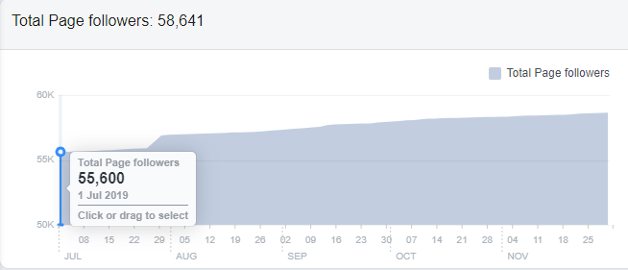

Page Followers: 1 July to 30 November 2020
,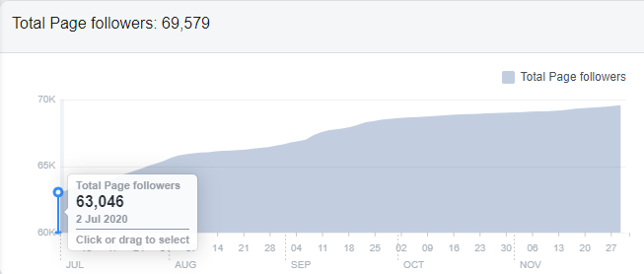

Each month from July to November 2020, the top posts on PGT’s FB Page, are as follows:
Month | Posts/Videos | Total Reach
July | #4 JOM! NIKMATI PULAU PINANG – 20 Lokasi Insta di Pulau Pinang | Organic: 316,285  Paid: 335,134
August | Instagram Photo – Malaysia’s Longest Bridge, the Sultan Abdul Halim Mu’adzam Shah Bridge | Organic: 104,351  Paid: -
September | 7 Keajaiban Dunia di Pulau Pinang! | Organic: 138,779  Paid: 301,677
October | Techfest | Organic: 2,071  Paid: 1,031,002
November | Pulau Aman by Buletin Mutiara | Organic: 18,216  Paid: 218,897

3.2.9 Website Google Analytics for mypenang.gov.my
The analytics report shows a year-on-year (YOY) comparison between two time periods –
1 December 2020 – 31 March 2021 and 1 December 2019 – 31 March 2020

Website traffic
The Google Analytics Report shows a spike on 20 July 2020 with 554 users although in comparison to 20 July 2019, it had 3,785 users, which is higher than this year. There was also a spike on 21 October 2020 with 314 users and comparatively to the previous year on the same date, there were 2,244 users. Additionally, there was also a spike on 16 November 2020 with users in comparison to 16 November 2019, it had 1,656 users to the site, which is higher than this year.
The significant decrease of users to the website for July to November 2020 could be due to the unforeseen circumstances of the Covid-19 pandemic. Based on previous reports, visitors head to the site mainly to know more on latest events and programmes. There were quite a number of visitors that were linked to our website, mypenang.gov.my via organic google search, PGT’s Facebook Page, Penang state government’s website, Penang Sentral’s official website, www.penangsentral.com.my and via yahoo.com
According to the analytics report, majority of users to our mypenang.gov.my website was acquired organically via Google. There were also users who were linked to our website through Facebook posts, some organically and some through adverts.

The following is a list of the top 10 sites, mypenang.gov.my was accessed:
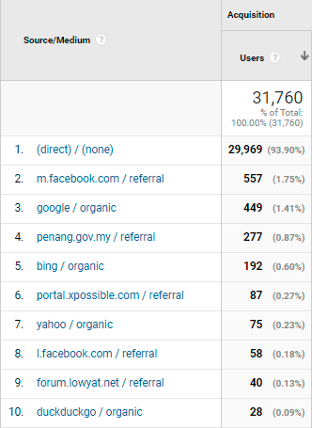

Comparison between 1 December 2020 – 31 March 2021 and 1 December 2019 – 31 March 2020
The comparison report shows a decrease of 59.57% in new users to the website. The number of sessions per user also recorded a slight decrease of 0.53%. However, there’s an increase on the bounce rate which is at 5.18%

Top 5 countries visiting the site and most viewed pages
The top 5 countries visiting the site are Malaysia, United States, Singapore, China and Australia. Their most-viewed pages are mainly on Events, Culture & Heritage, Penang Stories, Directory and About Penang.
The following pages show the relevant charts and tables summarizing the Google analytics report as highlighted above.

Period: 1 December 2020 – 31 March 2021
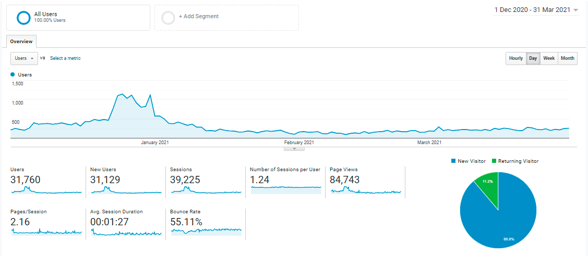
Period: 1 December 2020 - 31 March 2021
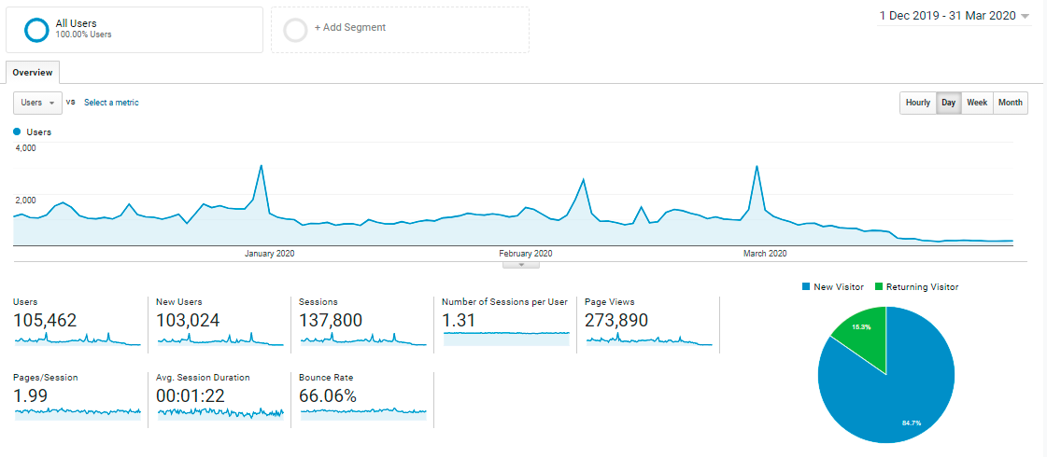

Comparison Chart of 1 December 2020 – 31 March 2021 and 1 December 2019 – 31 March 2020
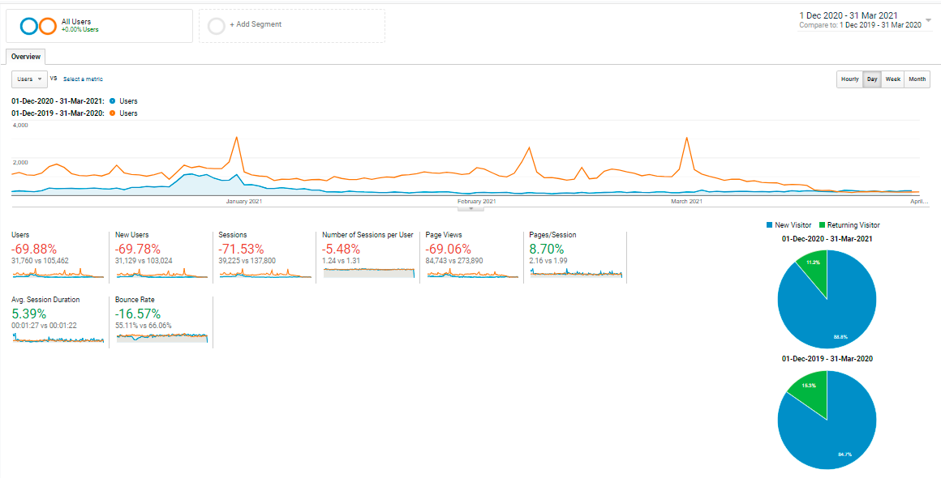

With reference to the above, visitors to the site, in comparison of the time periods:
Item | 1 December 2020 – 31 March 2021 | 1 December 2019 – 31 March 2020
Users | 31, 760 | 105, 462
Sessions | 39, 225 | 137, 800
Page Views | 84, 743 | 273, 890
Ave. Session Duration | 00:01:27 | 00:01:22
Bounce Rate | 55.11% | 66.06%

Current period’s Top 10 users by Country from 1 December 2020 – 31 March 2021:
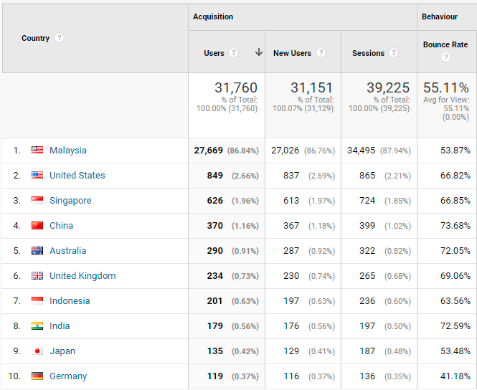

Comparison of the Top 10 users by Country:
(1 December 2020 – 31 March 2021 and 1 December 2019 – 31 March 2020)
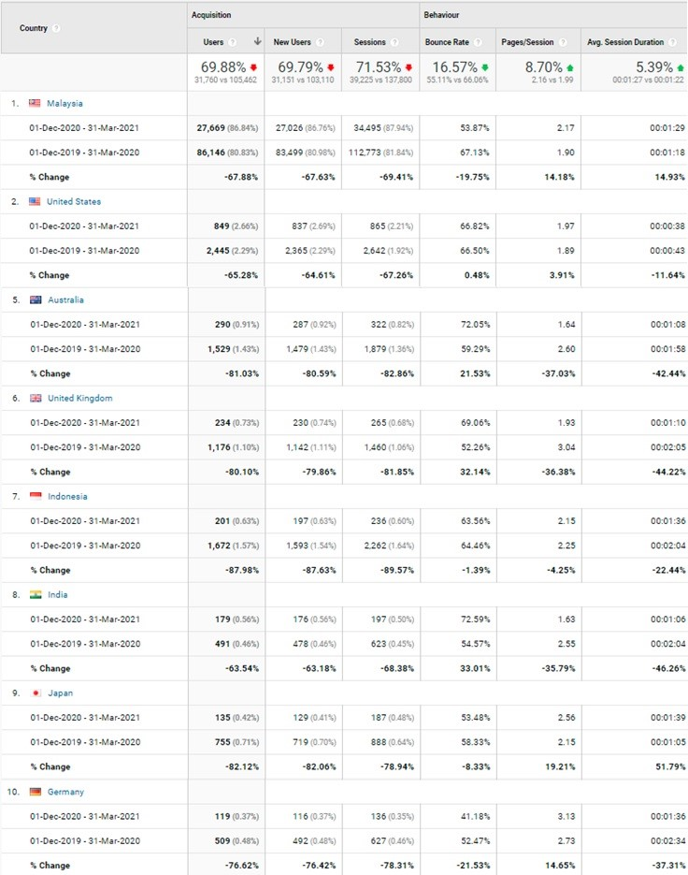

Most viewed pages by the Top 5 Countries visiting our website:
Country | Most viewed Pages
Malaysia | Events, Penang Stories, Culture and Heritage and Directory
United States | Penang Stories, Home page, Events
Singapore | Penang Stories, Culture and Heritage
China | Penang Stories
Australia | Penang Stories, Culture and Heritage

Top page views in the mypenang.gov.my website from 1 December 2020 – 31 March 2021:
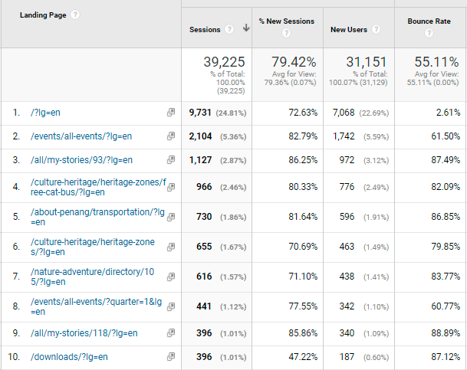

3.2.10 Website Google Analytics for Penang Travel Deals (penangtraveldeals.com)
The analytics report shows the time period of the website from the time it was launched on
1 December 2020 – 31 March 2021.

Website traffic
The Google Analytics Report shows a spike on 14 July 2020 with 2,530 users. There was also a spike on 17 July 2020 with 2,352 users.
The significant increase of users to the website in July 2020 could be brought by visitors searching for travel deals and it could be a driven crowd from Facebook posts (organically and through adverts). There were quite a number of visitors that were linked to our penangtraveldeals.com website via Facebook and there were also users that searched for the website directly. Besides that, the other source that directed users to the website are via organic google search, mstar (mstar.com.my) and news portal, Malay Mail (www.malaymail.com).

The following is a list of the top 10 sites, penangtraveldeals.com was accessed:
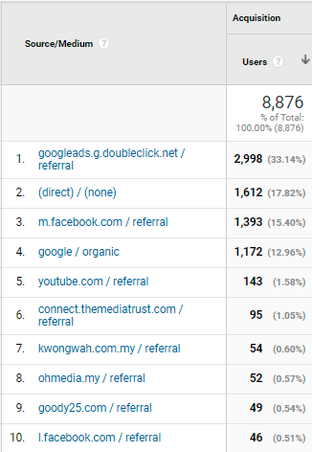

Top 5 countries visiting the site and most viewed pages
The top 5 countries visiting the site are Malaysia, United States, Singapore, China and Indonesia. Their most-viewed pages are mainly on Best Tour Packages, Best Attraction Deals and Best Hotel Deals.
The following pages show the relevant charts and tables summarizing the Google analytics report as highlighted above.

Period: 1 December 2020 – 31 March 2021
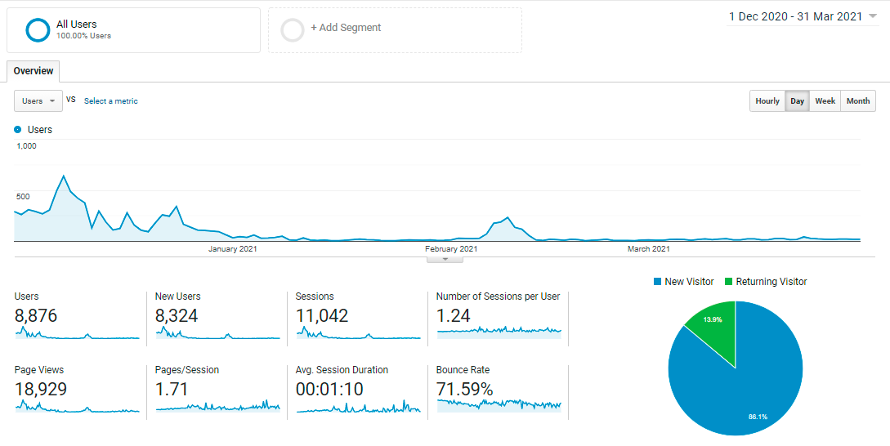

Current period’s Top 10 users by Country from 1 December 2020 – 31 March 2021:
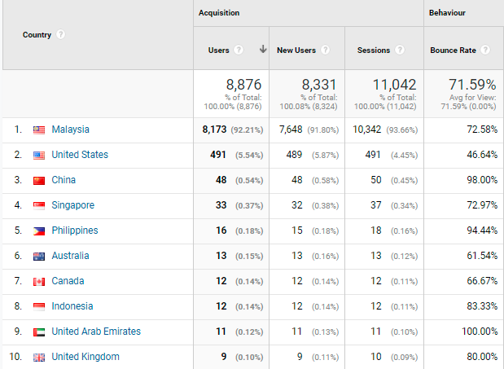

Most viewed pages by the Top 5 Countries visiting our website:
Country | Most viewed Pages
Malaysia | Best Tour Packages, Frontliner Attraction Deals, Best Hotel Deals, Best Attraction Deals, Best Food & Lifestyle Deals
Singapore | Best Tour Packages, Best Attraction Deals, Frontliner Attraction Deals, Best Hotel Deals
United States | Home Page, Best Frontliner Deals, Best Tour Packages
China | Home Page, Best Attraction Deals
Australia | Best Tour Packages, Best Attraction Deals

Top page views in penangtraveldeals.com website from 1 December 2020 – 31 March 2021:
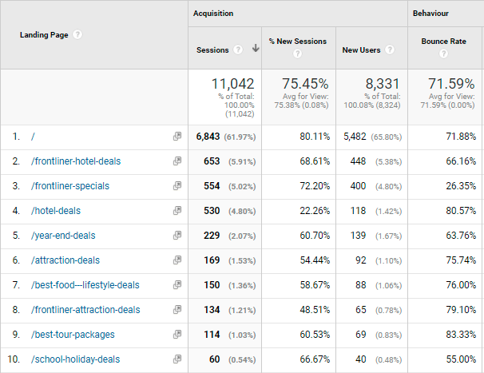

3.3 Recent Publicity (July - November 2020)

July 2020
Local
No | Name | Description | Type of Publication
1 | The Star | For just RM15 per person, anyone can now enjoy a full day’s tour of the best spots in Penang. | Online
2 | The Star | Penang covid-19 accreditation programme has seen 17 tourism players go the extra length to follow added standard operating procedures (SOP). | Online
3 | Tin Media | Penang tour package is expected to draw state revenue of RM1.54 million | Online
4 | Tin Media | Malaysian Chinese Inbound Association (MICA) is confident to attract 50,00 domestic tourists from July till the end of this year which targets to bring in RM 15 million of revenue. | Online
5 | Guang Ming Daily | 23 great value package discounts until the end of October starting RM 15 per person for major attractions in Penang. | Online
6 | Kwong Wah Yit Poh | Jom! Experience Penang RM 15 to take you on easy tour in Penang | Online
7 | Wartasaya.com | Penang launches Jom! Experience Campaign to woo local tourists | Online
8 | China Press Northern Region | Jom! Experience Penang Campaign launch calls domestic travellers to Penang. | Print
9 | Advertising + Marketing | Penang State Tourism unveils campaign hoping to capture domestic footfall | Online
10 | Weareunited.com | Jom! Experience Penang campaign launch to boost Penang’s tourism industry | Online
12 | Sin Chew Northern | YB Yeoh Soon Hin launches “Jom! Experience Penang” campaign | Print
13 | Oriental Daily News | Jom! Experience Penang features multiple discounts for domestic travellers travelling into Penang | Online
14 | RTM | News coverage on Jom! Experience Penang campaign launch | Television

July 2020
Foreign
No | Name | Description | Type of Publication
1 | TTG Asia | At The Habitat Penang Hill, an eco-tourism hotspot in Penang, visitor numbers have bounced back to “near normal”, with more than 90 per cent visitor ship comprising locals and expatriates living and working in Malaysia | Online

August 2020
Local
No | Name | Description | Type of Publication
1 | Where2lifestylemagazine | Penang promotes “Responsible Tourism” as it is among the longest recorded “Green Zones” in the country during the Covid-19 pandemic | Online
2 | New Straits Times | #JOM! GO: Seven World Wonders of Penang. The campaign is highlighting the seven World Wonders of Penang. | Online
3 | The Star | The Sia Boey Urban Archaeological Park is touted as the first of its kind in Malaysia. | Online
4 | Malay Mail | Rising occupancy rates at hotels here indicate the state’s tourism sector was gradually recovering from the Covid-19 pandemic | Online
5 | New Straits Times | Together with its Unesco World Heritage Site, seven world wonders, delicious local cuisine and a rich tapestry of culture, Penang State Exco for Tourism, Arts, Culture and Heritage wants visitors to know that the state is host to many other unique attractions. | Online
6 | The Edge Markets | The third edition of the Penang International Travel Exchange 2020 (PITE 2020) will be held virtually between Oct 14 and 16 due to the COVID-19 pandemic and international travel ban. | Online
7 | Malaysian Parenting | Jom! Experience Penang campaign launch | Online
8 | Lancareno.com | Pulau Pinang lokasi percutian antarabangsa | Online
9 | Isaactan.net | Blog post on Jom! Experience Penang campaign | Online
10 | Clefffairy.com | Blog post on Jom! Experience Penang campaign | Online

September 2020
Local
No | Name | Description | Type of Publication
1 | The Star | The Penang government has been tirelessly helping stakeholders to restore the state’s tourism industry to its former glory. | Online
2 | Buletin Mutiara | PENANG is expected to welcome more domestic tourists after the state has been declared free of Covid-19 by the Health Ministry. | Online
3 | Malay Mail | As the international borders remain barred, the Penang government aims to promote the state as the top domestic tourism destination in Malaysia. | Online
4 | Buletin Mutiara | PENANGITES as well as local and foreign tourists can look forward to knowing more about the footprints left by the French in the state through the French Heritage Trail initiative. | Online
5 | The Star | PENANG had a low-key celebration of annual World Tourism Day on 20th September 2020 as a string of programmes initially lined up has to cease due to the Covid-19 pandemic. | Online

September 2020
Foreign

No | Name | Description | Type of Publication
1 | Tour Hero | Living like in Crazy Rich Asians: 48 hours in Penang, Malaysia | Online
2 | Express – Home of the Daily and Sunday Express | The Singapore Grip drama series which was aired on ITV, a British commercial television network was filmed in George Town, Penang | Online

October 2020
Local
No | Name | Description | Type of Publication
1 | Buletin Mutiara | The Penang government has been actively carrying out promotional and marketing campaigns to develop domestic tourism in the state amid the Covid-19 pandemic. | Online
2 | Buletin Mutiara | The state government is embarking on initiatives to create new tourist attractions in Seberang Perai to ensure a balanced development between the island and the mainland. | Online
3 | Buletin Mutiara | Creative industries will help to boost Penang’s tourism image and transform existing cultural and heritage assets into revenue for the state in the long term | Online

October 2020
Foreign
No | Name | Description | Type of Publication
1 | CNN Travel | Penang’s Assam Laksa ranked world’s 7th best dish by CNN Travel | Online

November 2020
Local
No | Name | Description | Type of Publication
1 | The Edge Markets | To place heritage under sustainable development | Online
2 | Free Malaysia Today | George Town Development Plan to be business and heritage friendly | Online
3 | The Star | Invest in creative economy | Online
4 | Digital News Asia | Penang TECHFEST Live features Road-to-WCIT in hybrid series of events to drive inclusivity of tech for all | Online
5 | World of Buzz | Penang to have first drive-thru Nasi Kandar in Seberang Perai | Online
6 | The Star | Article on Penang War Museum | Online
7 | The Star | Hoteliers urge govt to allow tourism activities in green zones | Online
8 | Guang Ming | ATAP hopes that the government and the people will join forces to revive the tourism industry | Online
9 | Malay Mail | Penang asks Putrajaya for measures to safeguard tourism industry | Online
10 | Kwong Wah Yit Poh | Penang Airport Expansion plan postponed | Online
11 | Guang Ming | Penang Tourism Exco writes in to Tourism Minister on suggestion to alleviate the plight of the tourism industry | Online
12 | New Straits Times | #JOM! EAT: Vegan Laksa in Penang | Online
13 | Malay Mail | Penang extends hotel room fee exemption to June 2021 | Online
14 | The Star | First Penang Bridge International Marathon virtual run kicks off | Online

November 2020
Foreign
No | Name | Description | Type of Publication
1 | South China Morning Post | The Singapore Grip filmed in Penang and Kuala Lumpur | Online
2 | Travel Weekly | Article on lesser-known attractions in Penang and Kuala Lumpur | Online
3 | Think Advisor | 11 Best Islands for Retirement Abroad | Online

The following are the number of local and foreign news coverage based on what we have managed to monitor - mainly online, via Google Alerts and physical publications/magazines received through free subscriptions:

Month (2020) | Local News Coverage | Foreign News Coverage
July | 14 | 1
August | 10 | -
September | 5 | 2
October | 3 | 1
November | 14 | 3
Total | 46 | 7

