August Socmed

Date | Original text | Change to | Graphic Edits
19.8 | There's more than just food at Penang Food & Culture Festival.  Want to know more? Visit our website: penangafcf.com  #PAFCF #ExperiencePenangTasteAsia #AsianFoodCulture #Penang #Website | There's more than just food at Penang Asian Food & Culture Festival.  Want to know more? Visit our website: penangafcf.com  #PAFCF #ExperiencePenangTasteAsia #AsianFoodCulture #Penang #Website (is this hashtag necessary?) | No change.
20.8 | Ni Hao! Experience authentic Chinese dining and culture! Don't miss out on this 3-day festival of food and experiences from 13-15 September at Gurney Plaza, Penang.  Find out more at penangafcf.com  #PAFCF #ExperiencePenangTasteAsia #foodfestival #chinesefood #penang | Ni Hao! Experience authentic Chinese dining and culture from 13-15 September at Gurney Plaza, Penang.  Find out more at penangafcf.com  #PAFCF #ExperiencePenangTasteAsia #foodfestival #chinesefood #penang | 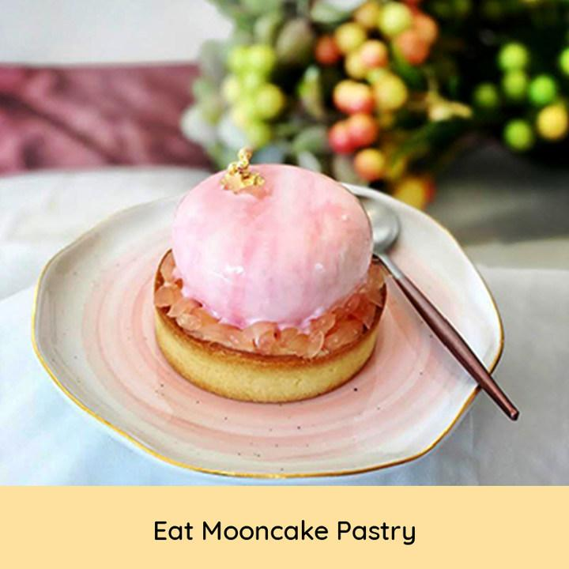  Editor’s note: Change current text to Mooncake Pastry Galore
21.8 | Satisfy your cravings for all things Korean at Queensbay Mall, Penang this 13-15 September. From oodles of ramen to rich marshmallow coffee, there are lots to try and experience at Penang Asian Food & Culture Festival 2019!  Find out more at www.penangafcf.com  #PAFCF #ExperiencePenangTasteAsia #SouthKorea #penang | NIL | 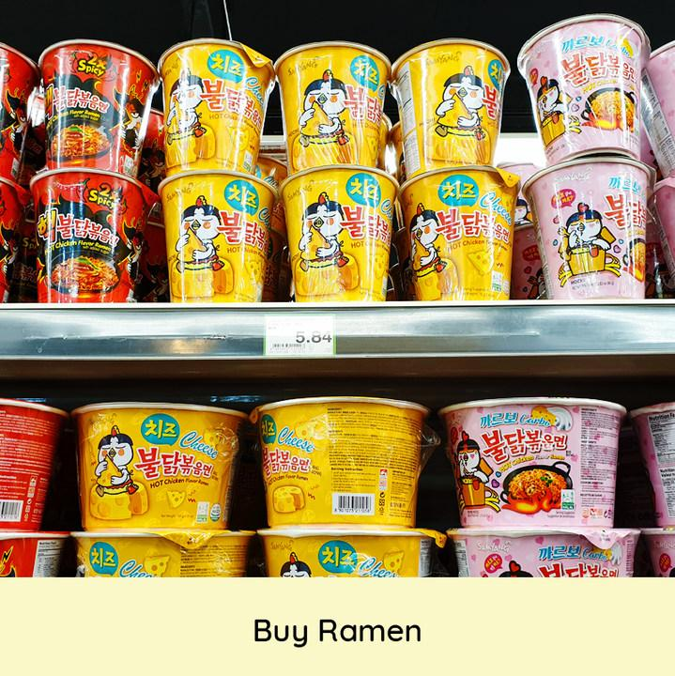  Change caption to: Ramen Galore    Change caption to: Marshmallow Coffee Galore
22.8 | Challenge yourself to spicy tom yam or see if you have the stomach to chomp down on Thailand's popular street food, bugs!  Take your taste buds on a tour of Asia at Penang Asian Food & Culture Festival this 13-15 September 2019. See you there!  Find out more at www.penangafcf.com  #PAFCF #ExperiencePenangTasteAsia #Thailand #penang | Challenge yourself to a bowl of fiery tom yum or see if you have the stomach to chow down on Thailand's popular snacks – fried bugs!  Take your taste buds on a tour of Asia at Penang Asian Food & Culture Festival this 13-15 September 2019. See you there!  Find out more at www.penangafcf.com  #PAFCF #ExperiencePenangTasteAsia #Thailand #penang | 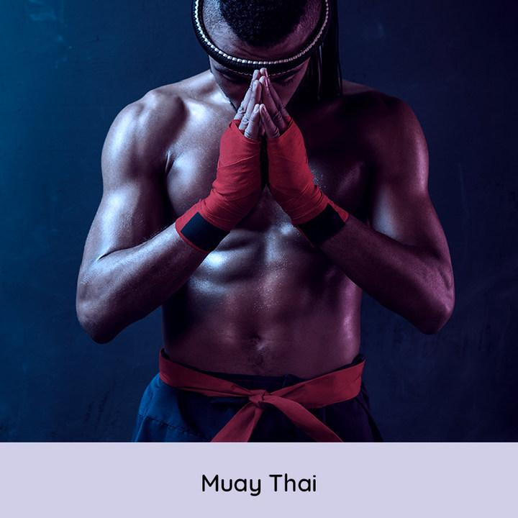  Change caption to: Muay Thai Demo  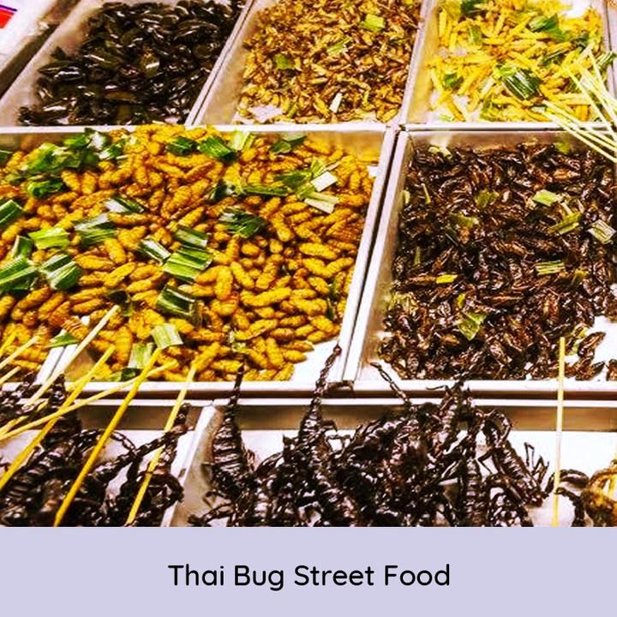  Change caption to: Fried Bugs Galore
23.8 | Ohayo! Experience authentic Japanese food and culture. Make your own bento box and watch a traditional Nihon Buyo performance this 13-15 September at Gurney Paragon mall, Penang. Get ready for all things Japan. Itadakumasu!  Find out more at www.penangafcf.com  #PAFCF #ExperiencePenangTasteAsia #Japan #penang | Ohayo! Experience authentic Japanese food and culture this 13-15 September at Gurney Paragon mall, Penang. Make your own bento box, watch a traditional Nihon Buyo performance and get ready to devour all things Japan! Itadakumasu!  Find out more at www.penangafcf.com  #PAFCF #ExperiencePenangTasteAsia #Japan #penang | 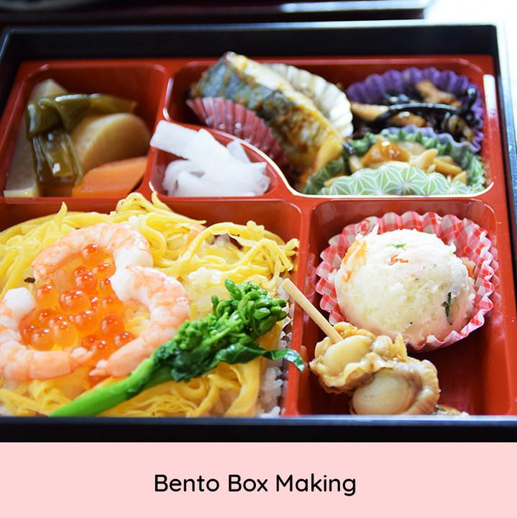  Change caption to: Bento Box-Making Workshop  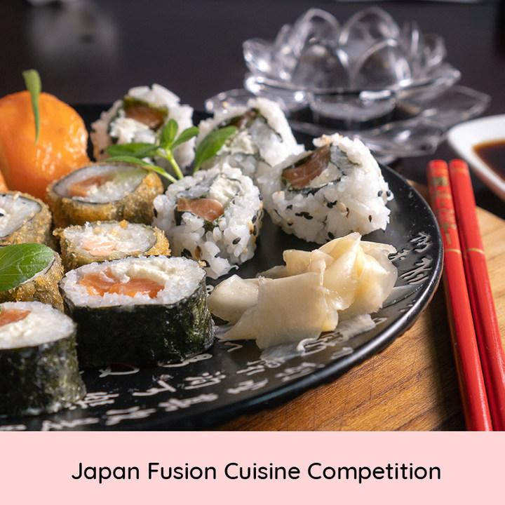  Change caption to: Japanese Fusion Cooking Competition
24.8 | Makan yuk! The famous instant noodle Indomie will be at Penang Asian Food & Culture Festival.. in doughnut form? Come try it out and other Indonesian experiences this 13-15 September 2019 at Sunway Carnival Mall, Penang!  Find out more at www.penangafcf.com  #PAFCF #ExperiencePenangTasteAsia #Indonesia #penang | Makan yuk! The Instagram-worthy Indomie doughnut is ready for its close-up at the upcoming Penang Asian Food & Culture Festival. Head to the festival for the Indomie doughnut but stay for other Indonesian dishes and experiences this 13-15 September 2019 at Sunway Carnival Mall, Penang!  Find out more at www.penangafcf.com  #PAFCF #ExperiencePenangTasteAsia #Indonesia #penang | 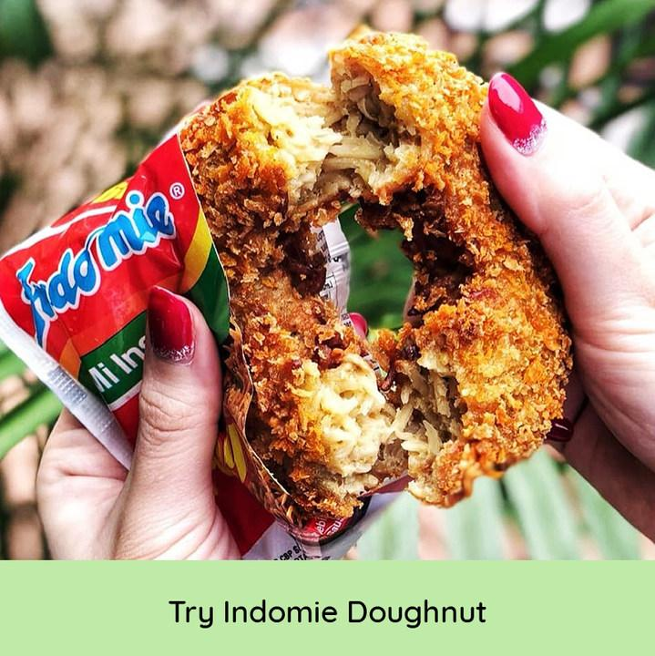  Change caption to: Indomie Doughnut Galore!  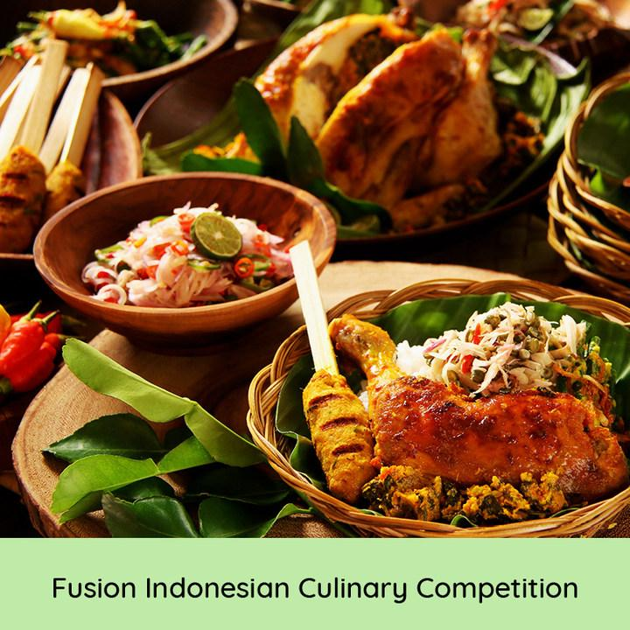  Change caption to: Indonesian Fusion Cooking Competition

