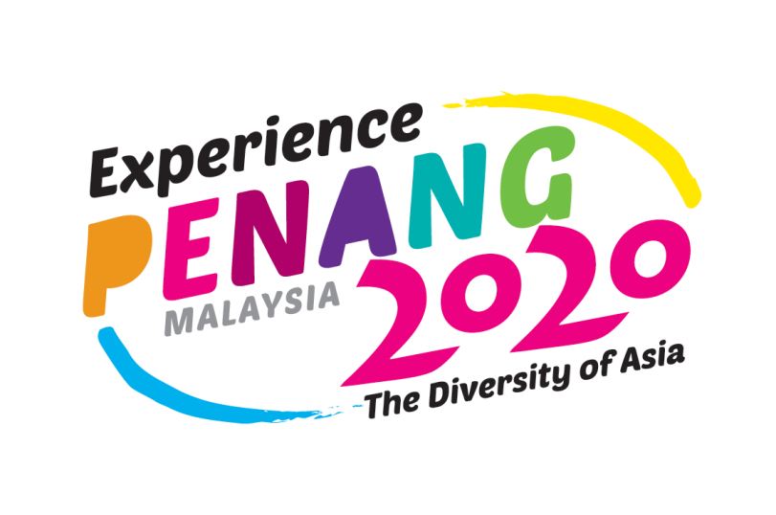
The Penang State Tourism is currently promoting a campaign to drive visitors to its shores with more exciting features and happenings for year 2020 and beyond. The "Experience Penang 2020" campaign, with the tagline "The Diversity of Asia", encompasses diverse elements of beauty, fun, amusement, excitement and satisfaction. The campaign aims to highlight all of Penang’s splendor to visitors locally and abroad showcasing every aspect of Penang’s amazing diversity in culture, heritage, arts, food as well as its natural surroundings of lovely sandy beaches and breathtaking hills.

