July Posts Edits
Date | Suggested Text | Suggested changes to Image/Video
5.7 | No Change | 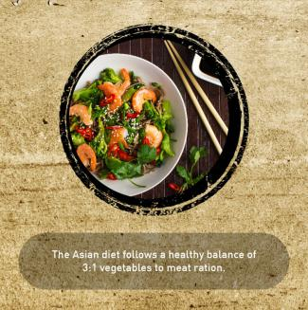  Edit to the text in the picture Image 3 of 6: The Asian diet follows a healthy balance of 3:1 vegetables to meat ratio.
10.7 | No Change | 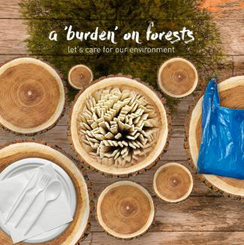  Edit to the text in the picture: Disposable cutlery is a burden on the environment. That’s why we’re going green!
23.7 | Note to Yani/Reena: [This suggested text was not implemented].  What you put in your body is just as important as what you put on your skin! Asian cuisines are known to promote better health and well being. So, eat your way to a healthier you and let your inner beauty shine bright.  #PAFCF #AsianFoodCulture #Penang #qotd | No Change

