Penang Hot Air Balloon Fiesta 2020 - Balloon & Pilot List
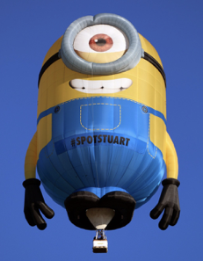 | 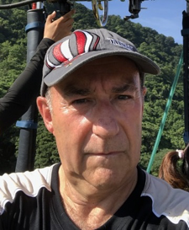 |  | 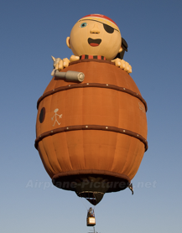 | 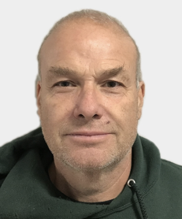
Minion Balloon |  |  | Little Pirate
United Kingdom | Nick Langley |  | United States | Derek Hancock
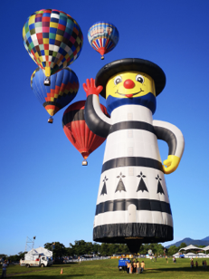 | 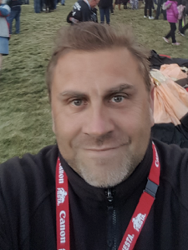 |  | 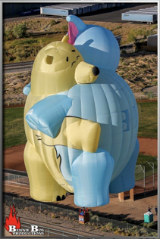 | 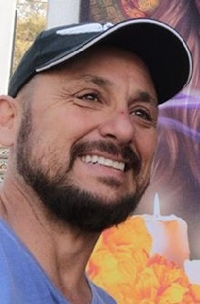
Light House |  |  | Big Hug
United Kingdom | Paul Burrows |  | Brazil | Ricardo de Almeida
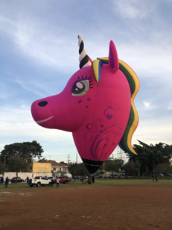 | 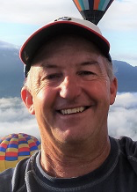 |  | 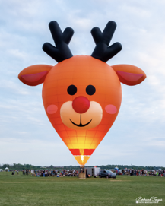 | 
Unicorn |  |  | My Deerling
Australia | Craig Ferrell |  | Canada | Alain Bard

 | 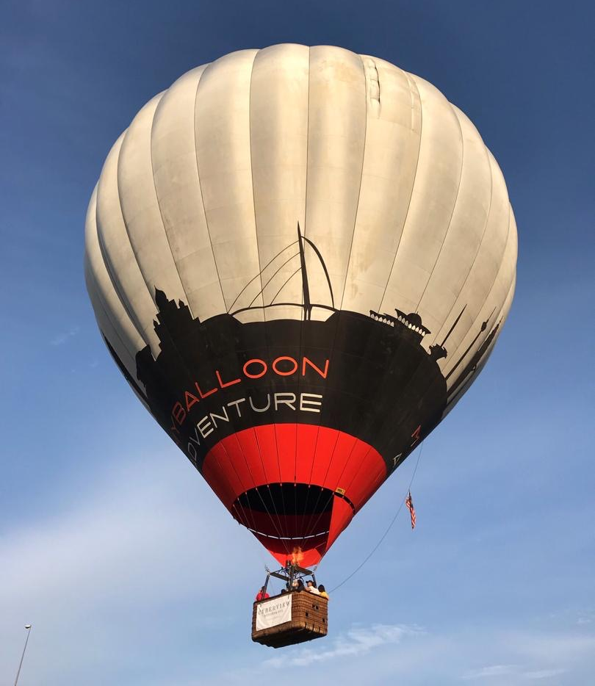
 | My Balloon Adventure
 | Belgium | Jonas Van Dosselarae
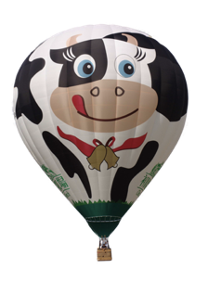 | 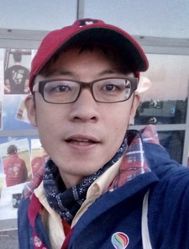 |  | 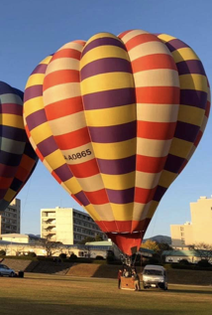
Moo Moo |  |  | Shoga
Taitung | Yuan-Ting Lin |  | United Kingdom | Alex Choi
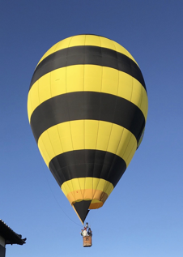 |  |  | 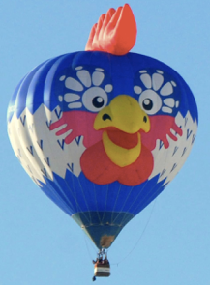 | 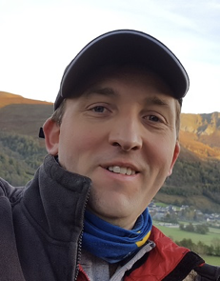
Friction |  |  | Cocky
 |  |  | France | Mickael Savart
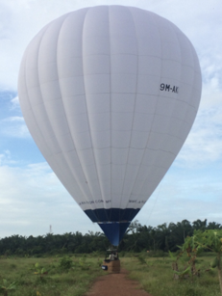 |  |  | 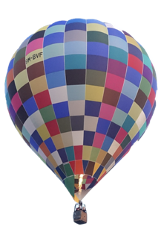
AKA |  |  | Patch Adams

Moo Moo |  |  | Shoga
Taitung | Yuan-Ting Lin |  | United Kingdom | Alex Choi
Friction |  |  | Cocky
 |  |  | France | Mickael Savart
AKA |  |  | Patch Adams

Moo Moo |  |  | Shoga
Taitung | Yuan-Ting Lin |  | United Kingdom | Alex Choi
Friction |  |  | Cocky
 |  |  | France | Mickael Savart
AKA |  |  | Patch Adams

 |  |  |  | 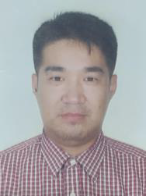
Moo Moo |  |  | Shoga
Taiwan | Yuan-Ting Lin |  | Japan | Alex Choi
 | 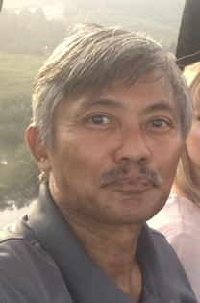
Friction |  |  | Cocky
Malaysia | Sobri Saad |  | France | Mickael Savard
 | 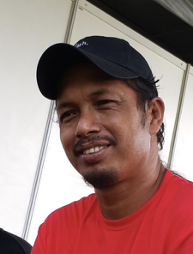 |  |  | 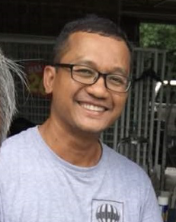
AKA |  |  | Patch Adams
Malaysia | Ropizan Ahmad |  | Malaysia | Kharulazri

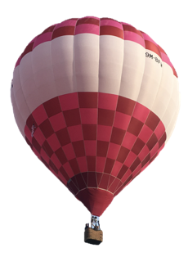 | 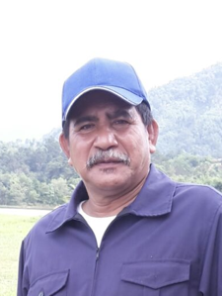 |  | 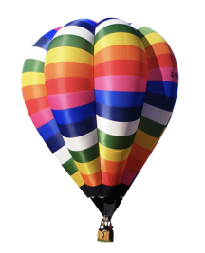 | 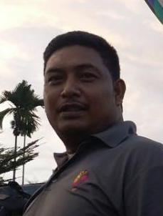
Moon |  |  | Bowie
Malaysia | Nordin Hussin |  | Malaysia | Mohd Faizal

