Print ads on Experience Penang – inflight magazines’ advertorials 2019
SEPTEMBER
- Travel 360 September 2019 Issue – Advertorial on Experience Penang 2020

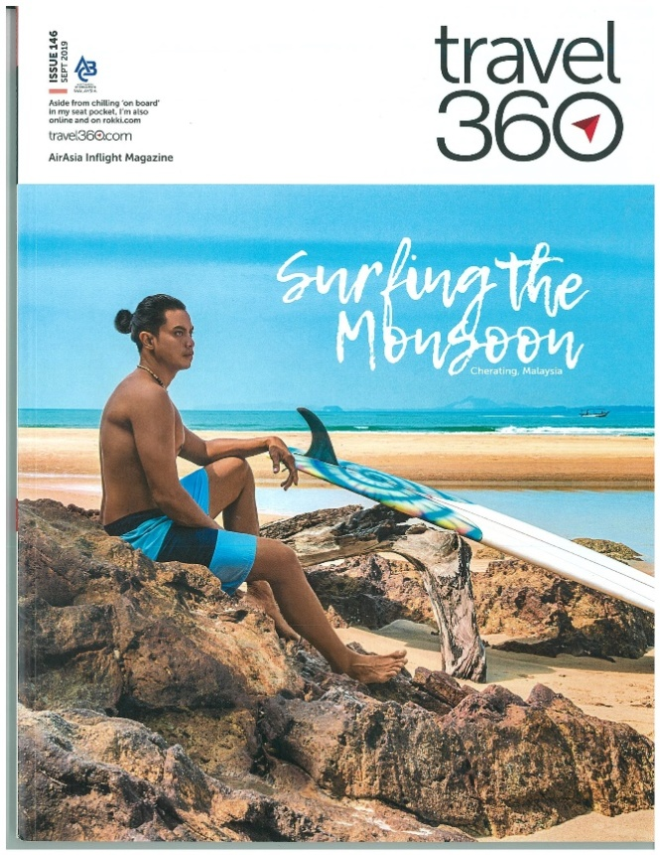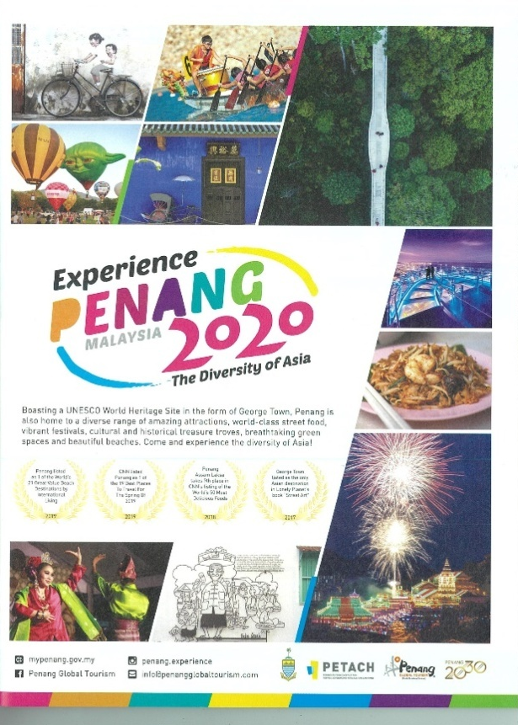

EZ Malaysia, Faces of Penang Vol.55 – 19 – Advertorial on Penang Asian Food & Culture Festival
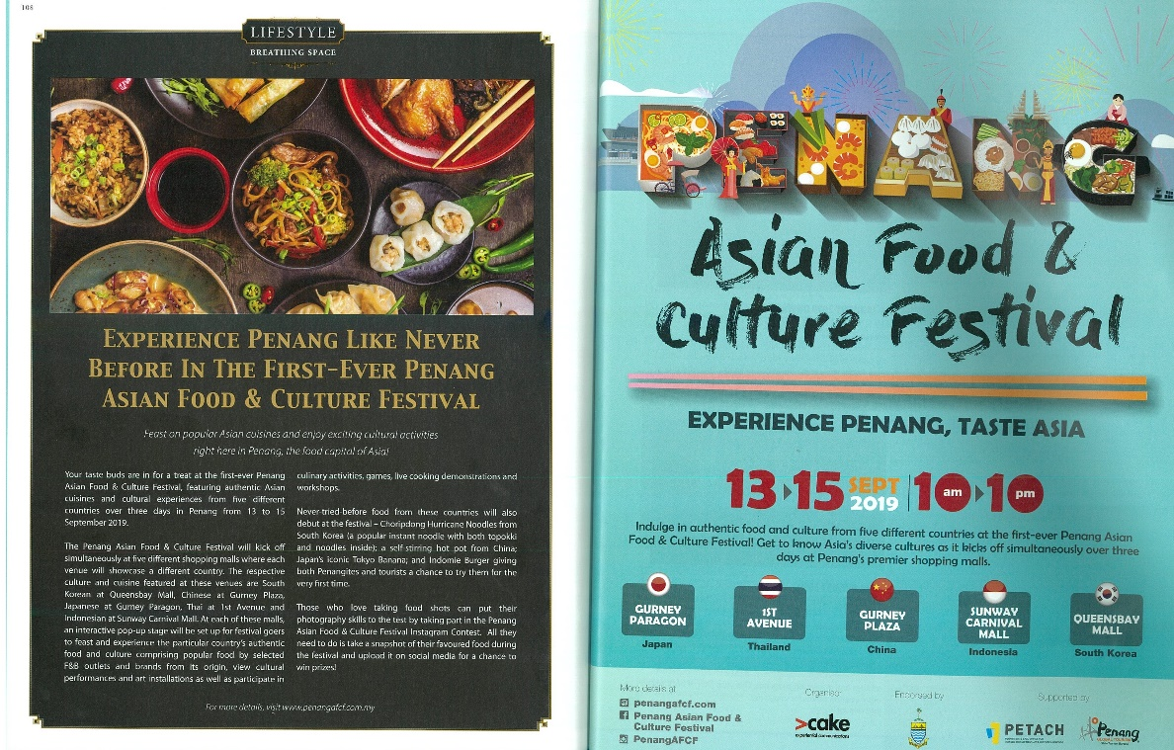
- EZ Malaysia, Faces of Penang Vol.55 – 19 – Advertorial on YB Yeoh Soon Hin

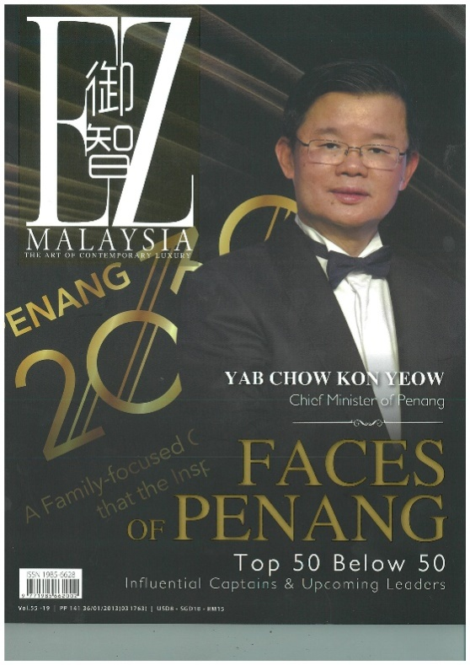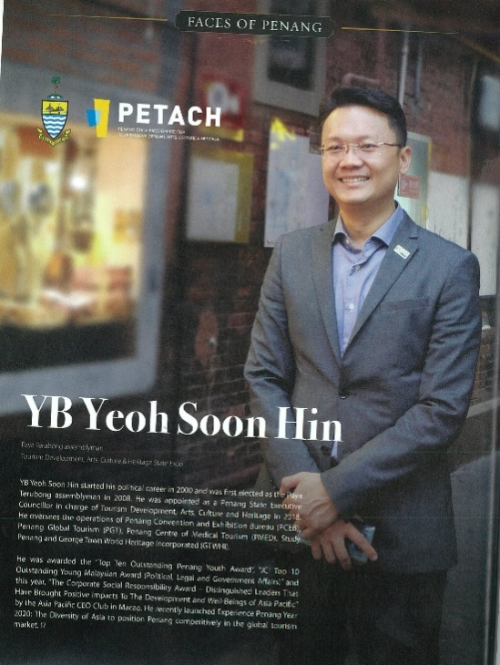

OCTOBER
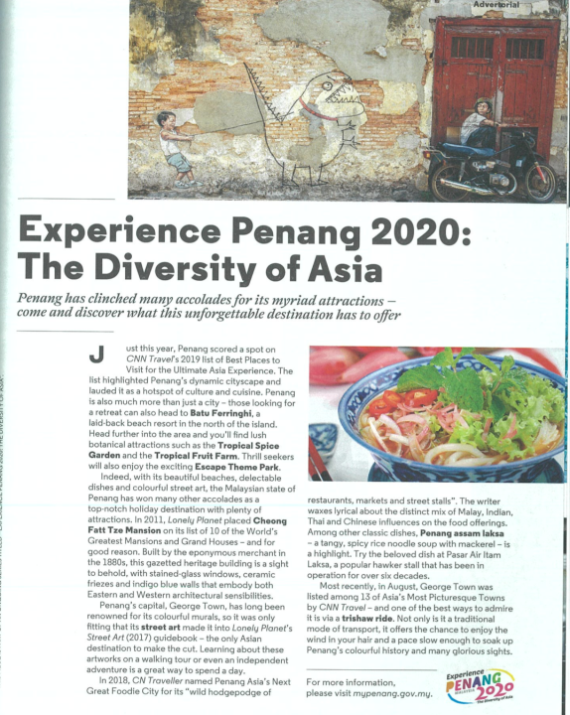
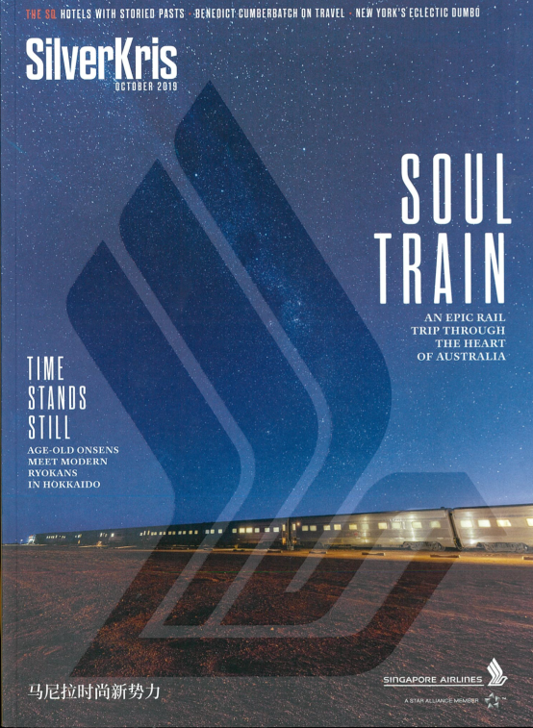
- SilverKris Oct 2019, Advertorial page 65, Advertorial on Experience Penang Year 2020

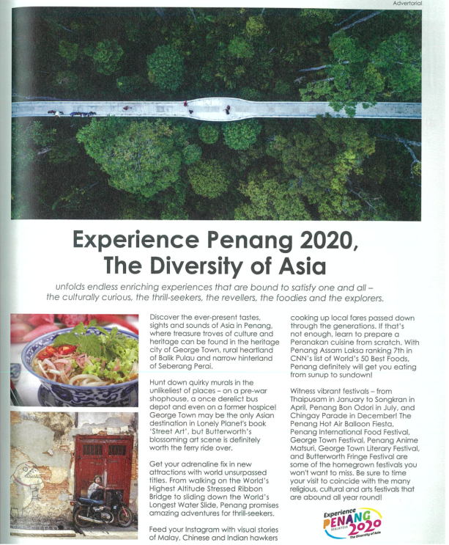
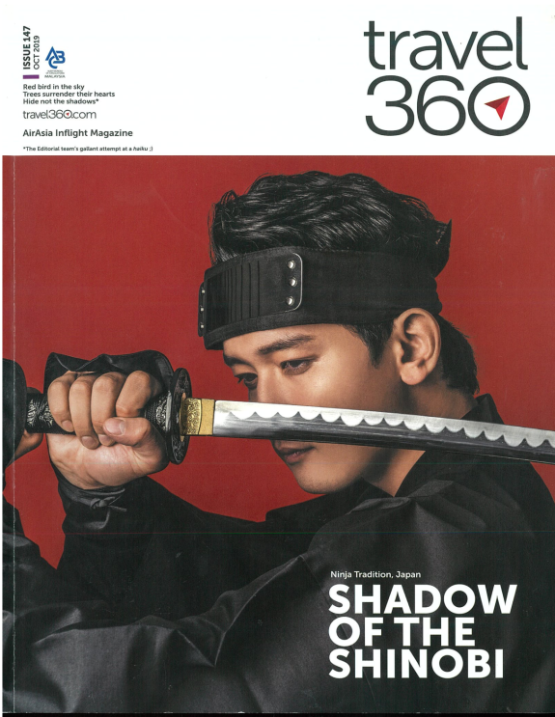
-Travel360, Issue 147, Pg. 45, Advertorial on Experience Penang Year 2020

-Silkwinds, October 2019, Pg. 16, Advertorial on Experience Penang Year 2020
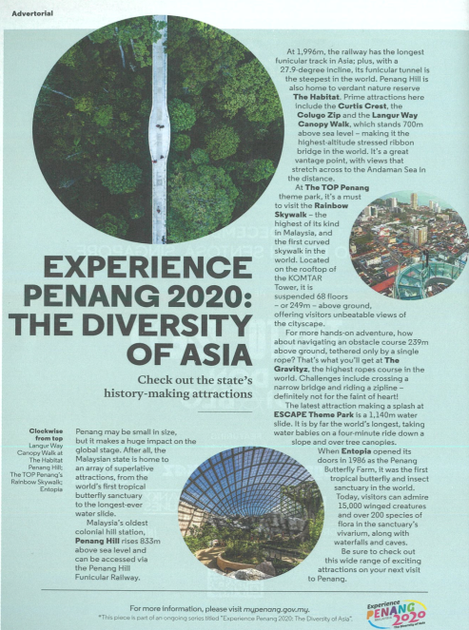
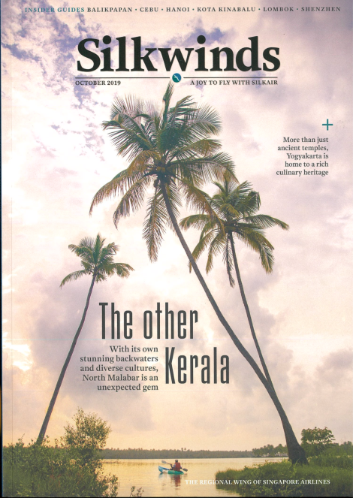

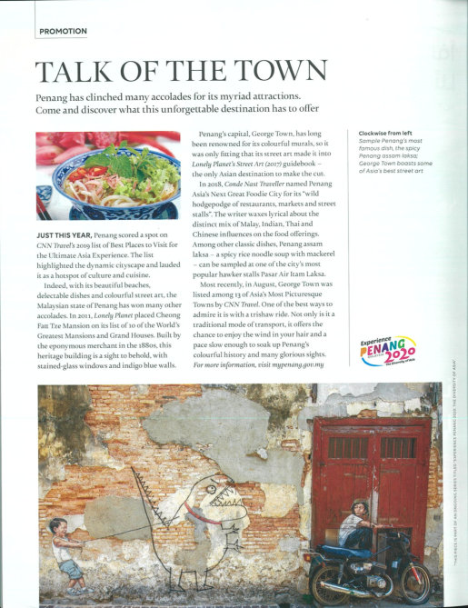
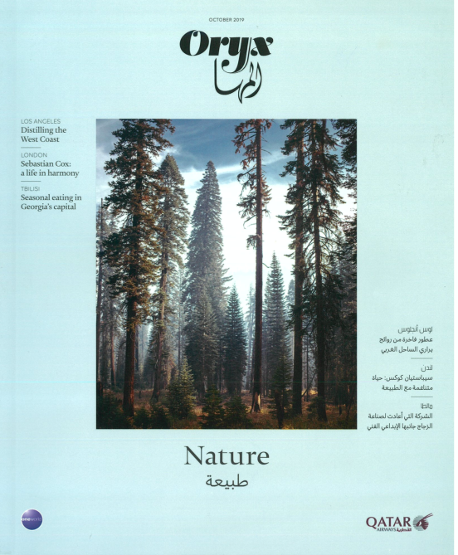
-Oryx, October 2019, Pg. 154, Advertorial on Experience Penang 2020

NOVEMBER
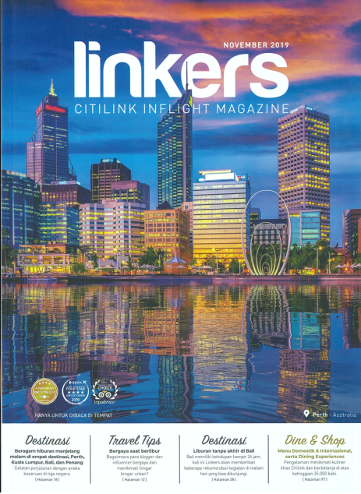
-Linkers, November 2019, Pg. 52 – 58, Advertorial on Malam di Penang Festival dan Kuliner,
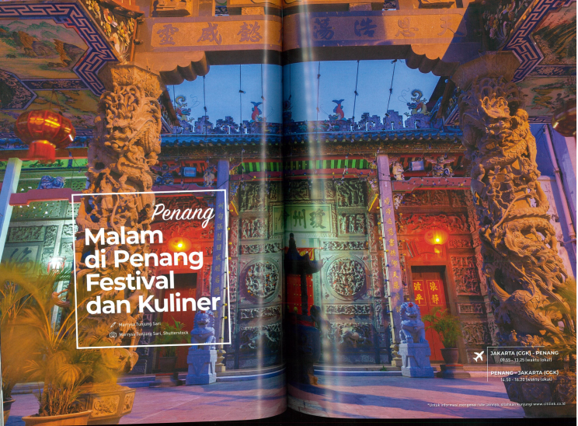

-Linkers, November 2019, Pg. 66 – 67, Advertorial on Experience Penang 2020
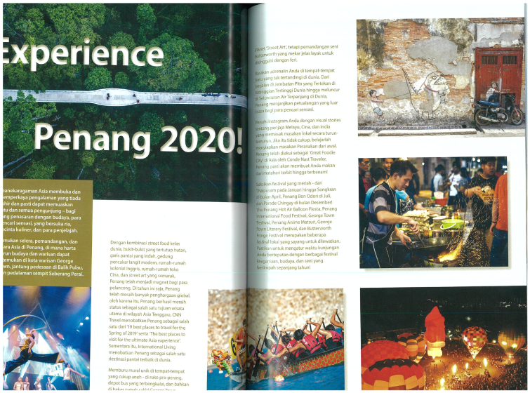
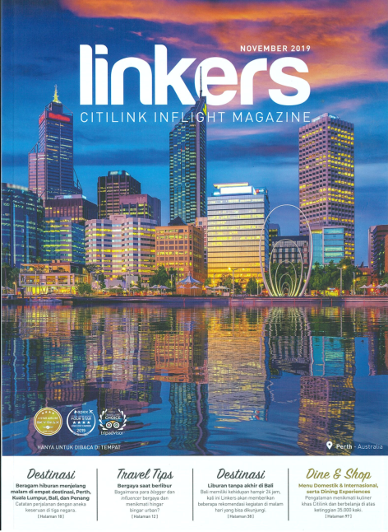


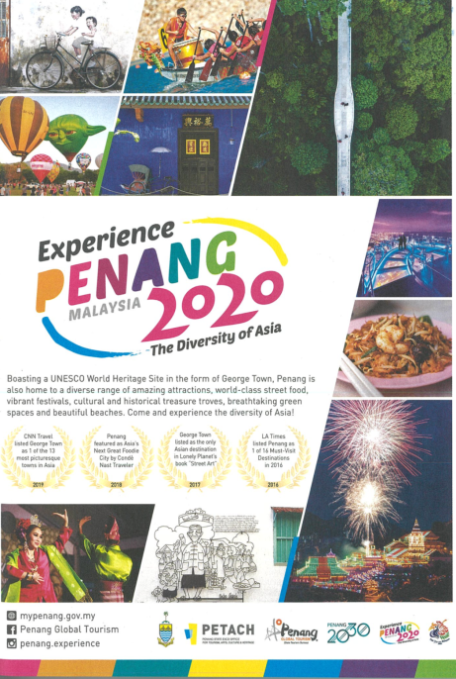
- Open Skies (Emirates), November 2019, Pg. 25, Advertorial on Experience Penang 2020

-Travel360, Nov.2019 - Issue 148, Pg. 73, Advertorial on Butterworth Fringe Festival (BFF)
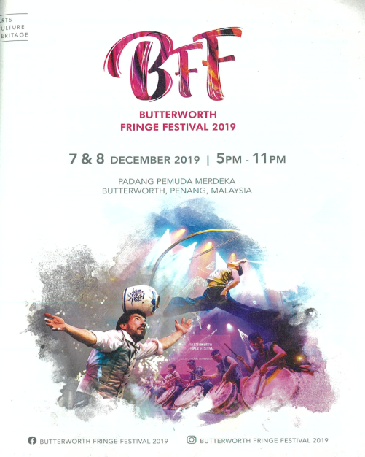
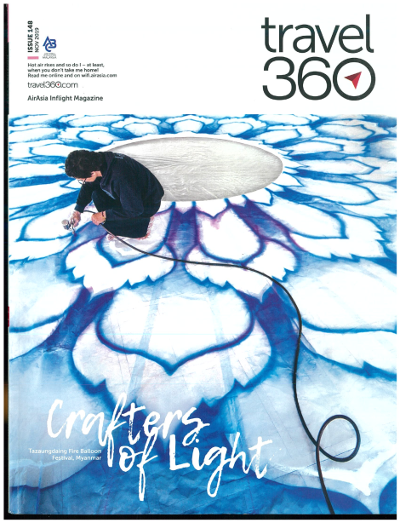

-inPenang, Vol.82 - Nov. 2019, Pg. 14 – 15, Advertorial on Butterworth Fringe Festival (BFF)
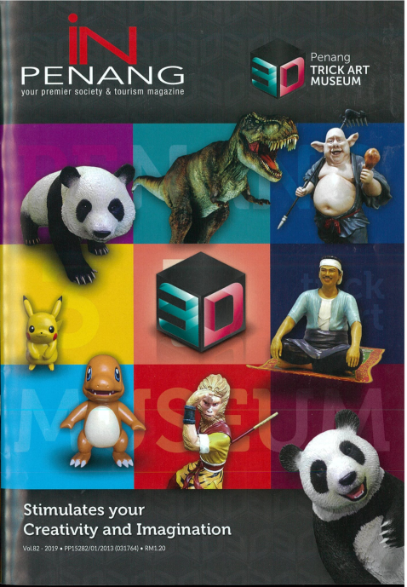

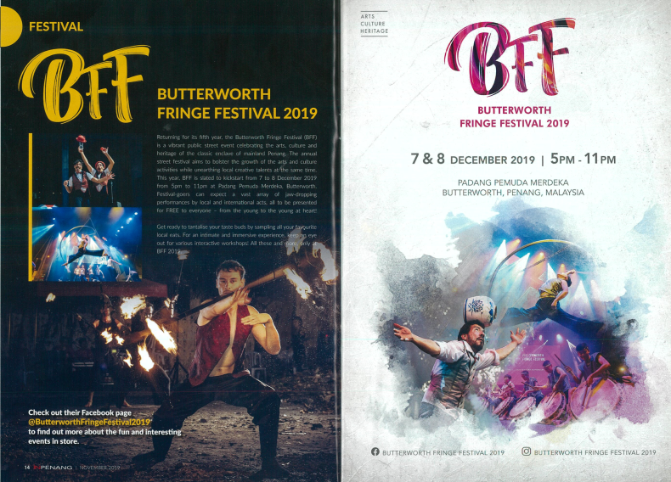

DECEMBER
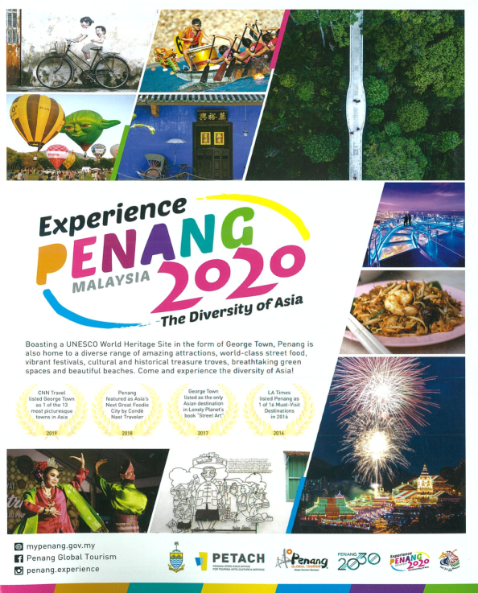
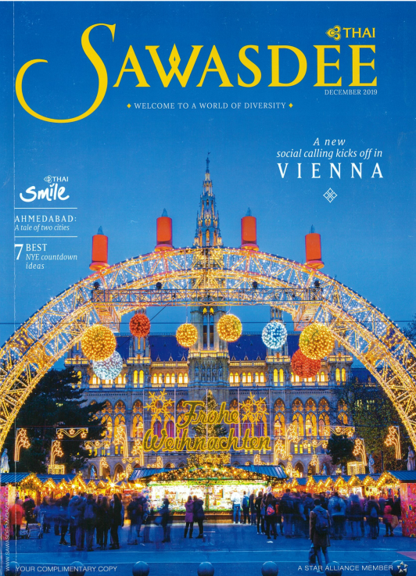
-Sawasdee (Thai), December 2019, Back Cover, Advertorial on Experience Penang 2020

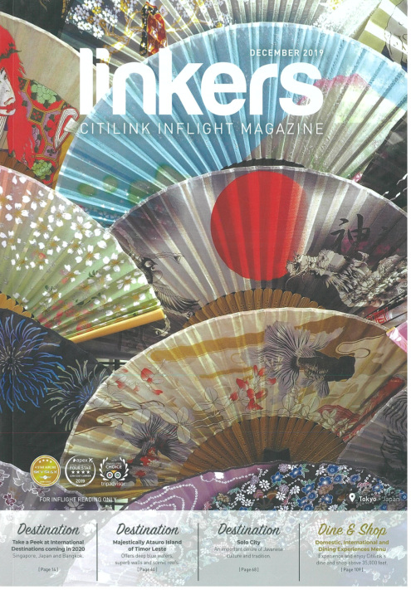
-Linkers, December 2019, Pg. 38 – 39, Advertorial on Experience Penang 2020

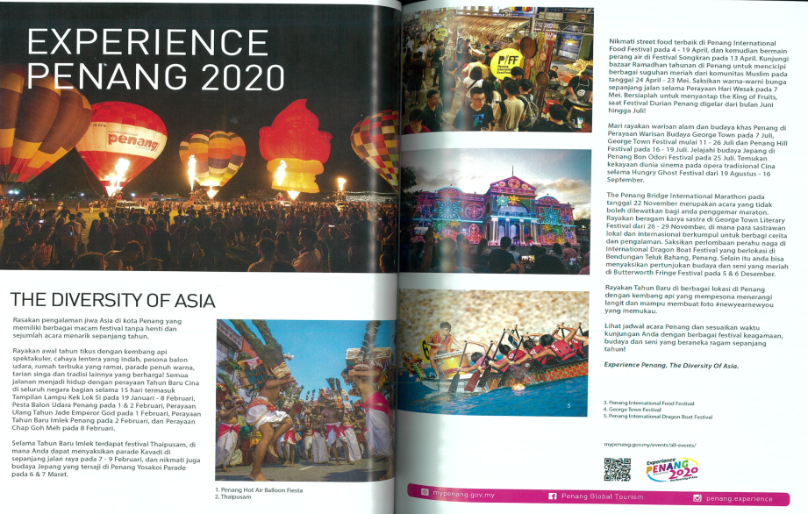

-Linkers, December 2019, Pg. 46 – 53, Advertorial on UNESCO WORLD HERITAGE SITE
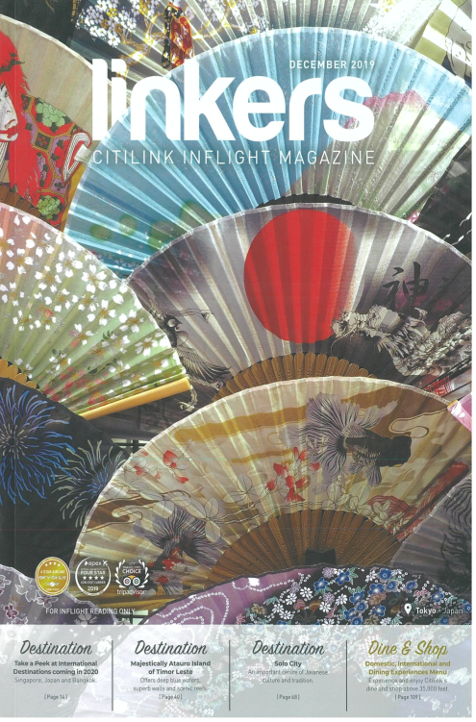
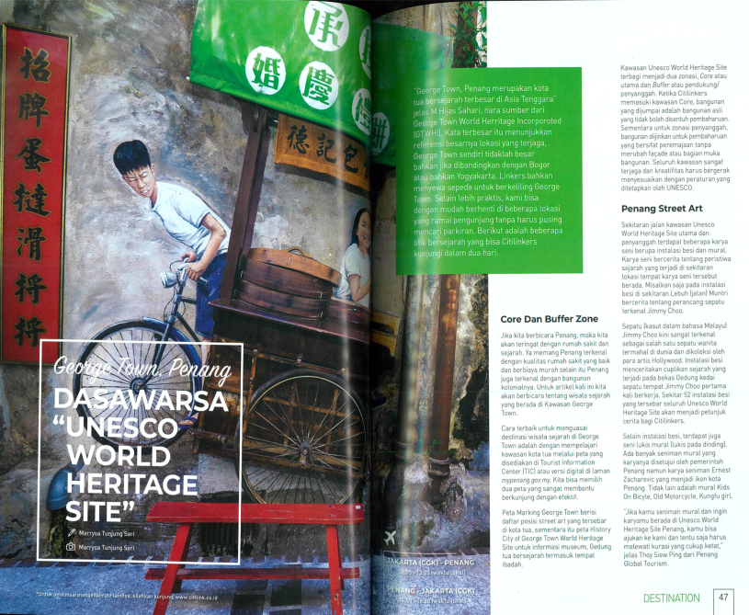

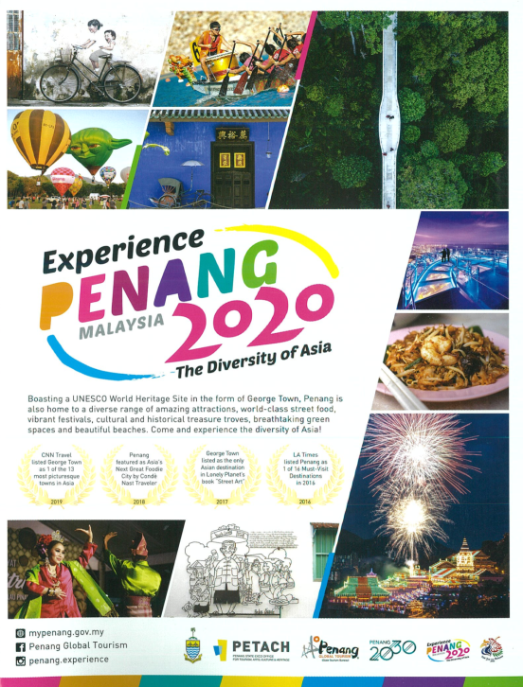
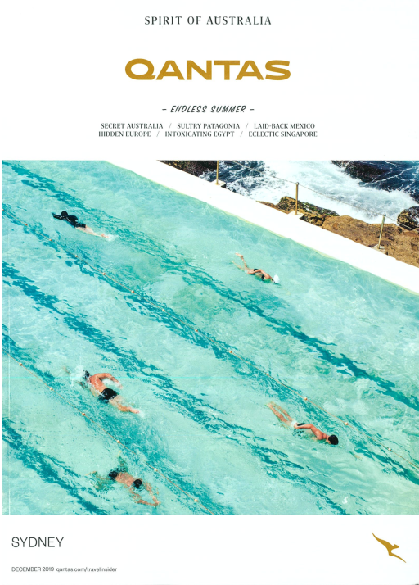
-Qantas (Endless Summer), December 2019, Pg. 165, Advertorial on Experience Penang 2020

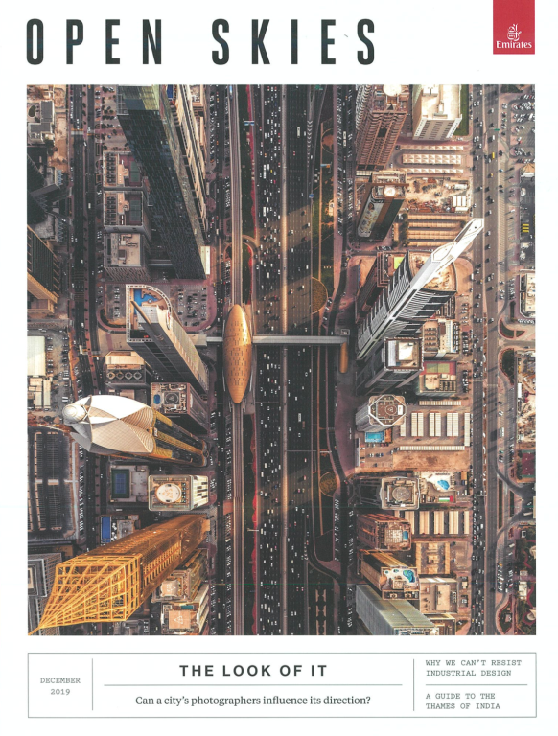
-Open Skies (Emirates), December 2019, Pg. 43, Advertorial on Experience Penang 2020
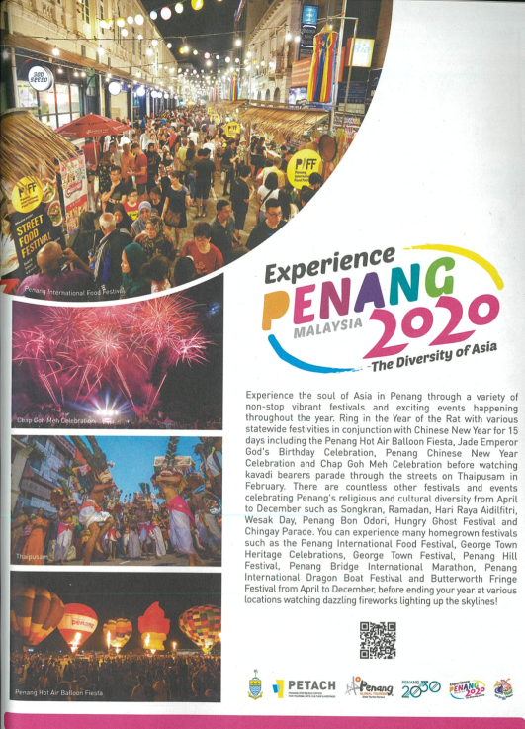

-SilverKris, December 2019, Pg. 55, Advertorial on Experience Penang 2020

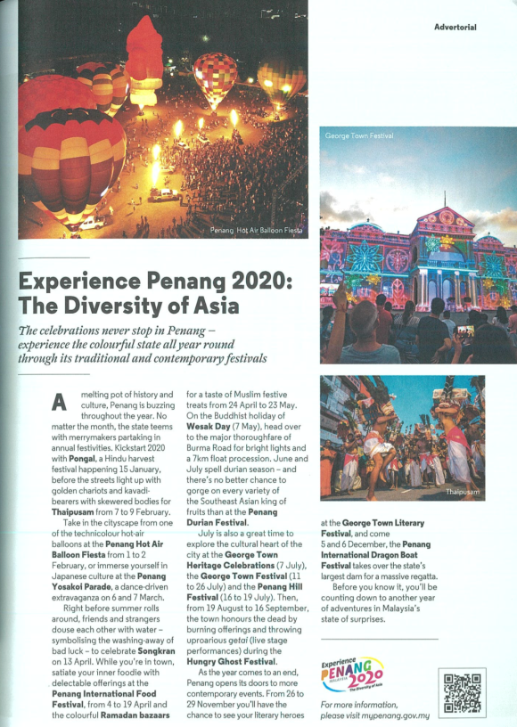


-

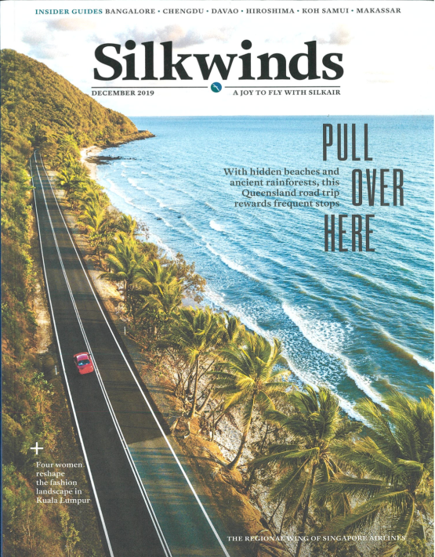
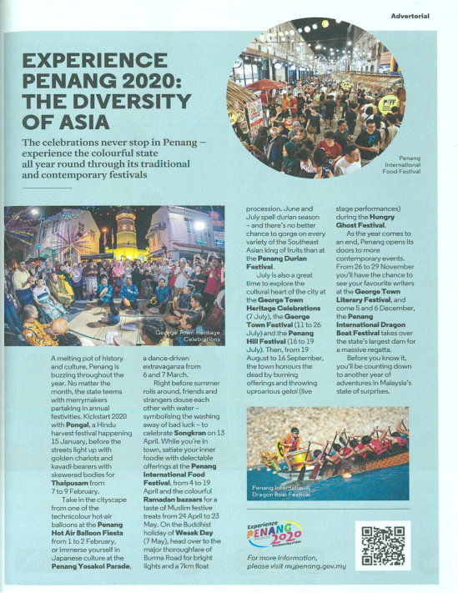
Silkwinds, December 2019, Pg. 65, Advertorial on Experience Penang 2020

-Travel360, December 2019-Issue 149, Pg. 111, Advertorial on Experience Penang 2020
