FOR IMMEDIATE RELEASE

An elevating experience this CNY in Penang!

George Town, 23 January 2019... Held in conjunction with Chinese New Year, the Penang Hot Air Balloon Fiesta returns for the 5th consecutive year! Visitors to the event have the opportunity to float above Padang Polo (Polo Ground) in Penang on a huge hot air balloon. It will be held on 9 and 10 February, from 7am to 9pm. What better way to celebrate this festivity with your family and friends where there’ll be loads of fun and excitement for all ages, with free entrance into the event grounds.

The highlight of the main event is 15 colourful hot air balloons displayed during the morning and evening sessions. There’ll also be ‘Night Glow’ shows featuring 10 balloons lighted up with music and lights to fascinate spectators. International balloonists from US, Brazil, Spain, Belgium, Slovakia, Japan, Korea, Vietnam and Taiwan will participate plus special shaped balloons will be featured. [A full list of the participating balloonists is attached]

Over this two-day event, ticketed tethered balloon rides will be available where one can go up as high as 60 feet. There’ll also be the ‘cold inflation’ activity where visitors can walk into a balloon envelope that’s filled with cold air as it lies on the ground. Additionally, F&B stalls and family-friendly activities will be available throughout the event such as inflatables, creative workshops, paddle boat rides on a huge pool, reverse bungees, giant trampoline and more!

Pre-Event Promotions
This year, two pre-event promotions are held to hype up the main event:

The Path
Recently launched at Penang Esplanade and Butterworth Art Walk, colourful mini paper craft hot air balloons are lit-up like lanterns and displayed from 7.30pm to 12 midnight till March 2019. In December 2015, The Path was lit for the first time at the Esplanade to promote the 2016 hot air balloon event. However, from last year, The Path is not only displayed at the Esplanade on the island but also at Butterworth Art Walk in the mainland. At both locations in the island and mainland, you’ll be sure to capture great instagrammable shots.

The Pop-up
Yet another Instagram-worthy photo opportunity is when you get to catch the ‘balloon pop-up’ that’ll take place at various locations in the island – Penang Youth Park, Penang Esplanade and PARKROYAL Penang Resort’s beachfront. This is the other pre-event held and called The Pop-up where you get to see a huge hot air balloon ‘pop-up’ at various locations in the island. Happening on 8 February 2019 between 7am to 9am, be sure not to miss the huge hot air balloon beforehand.

Free Flying at Padang Awam Jawi Seberang Perai Selatan
Free Flying will be undertaken only at the mainland where 10 hot air balloons will take off on 8 February at Padang Awam Jawi Seberang Perai Selatan. To add to the excitement, there will be a ‘God of Prosperity’ character and a clown making their appearances then where they will mingle with the crowd. Details are as follows:

Date : Friday, 8 February 2019
Venue : Padang Awam Jawi Seberang Perai Selatan - Jalan Jawi
GPS Coordinates : 5° 11' 52 . 00"N 100° 29' 33.10"E
7.00am : Setting up of balloons
7.15am : Balloons take off
8.00am : Estimated landing time
*The free flying hot air balloons will be for spectators’ viewing only - they will not be available for public to ride.

Full Programme:
Time | Saturday (9 Feb 2019) | Sunday (10 Feb 2019)
7am | Event starts with food and handicraft stalls
7am | Setting up of balloons for display and tethered rides
7.15am | Ticket counter opens (numbered tags given 30mins prior)
7.30am - 9pm | Fun Zone - Water orb, Roller orb, Hamster orb, Paddle boat ride  Trampoline, Reverse bungees for adults & kids, Inflatables
7.30am - 9am | Balloon display
7.30am - 10.30am | Tethered balloon rides
7.30am - 9.30am | Clown appearance / Busking
8am - 11am | Cold inflation activity
10.30am - 6.30pm | *Workshops
5pm - 8pm | Cold inflation activity
5.30pm - 7.30pm | Clown appearance / Busking
5.45pm | Ticket counter opens (numbered tags given 30mins prior)
6pm - 7pm | Setting up of balloons for display
6pm - 9pm | Tethered balloon rides
8.15pm | Official launch | -
8.45pm - 9pm | Night Glow Show
9pm | Fireworks Display | -
*The programme is subject to change without prior notice and balloon activities are subject to weather conditions

*Workshops
Hanging Paper Craft Hot Air Balloon
9 Feb (Sat): 10.30am - 12.30pm | 12.30pm - 2.30pm
Fee: RM8 per person

Hot Air Balloon Pottery
9 Feb (Sat): 10.30am - 12.30pm | 12.30pm - 2.30pm
10 Feb (Sun): 12.30pm - 2.30pm | 3.30pm - 5.30pm
Fee: RM30 / RM70

DIY Hot Air Balloon Batik
9 Feb (Sat): 11.00am - 1.00pm | 1.30pm - 3.30pm
10 Feb (Sun): 10.30am - 12.30pm | 12.30pm - 2.30pm | 2.30pm - 4.30pm
Fee: Small RM6 / Big RM12

Bookmark Paper Craft Hot Air Balloon
10 Feb (Sun): 10.30am - 12.30pm | 1.30pm - 3.30pm | 3.30pm - 5.30pm
Fee: RM5

Opening Ceremony
An Opening Ceremony by the Penang Governor and Penang Chief Minister will be held on 9 February at 8.15pm. There will be exciting performances plus a spectacular Night Glow show followed by fireworks display.

Tickets
On both days, three tethered balloons are open for rides to the public at RM50 per person while cold inflation (where you can walk into a balloon envelope that’s filled with cold air as it lies on the ground) is RM5 per person.

There will be two tethered balloon ride sessions a day. Tethered balloon ride is chargeable at RM50 per person on first-come first-served basis. Tickets are limited to the first 150 persons (with numbered tags) in the queue and there will only be one ticket sold to each person. Numbered tags will be given out 30 minutes prior to the opening of the ticket counter. The tethered ride ticketing details are as follows:

Ticket Counter Operating Times:
- 7.15am [tickets sold only for morning session]
- 5.45pm [tickets sold only for evening session]
*Tickets sold each day will be applicable for the particular day only, e.g. purchase of tickets on 9 Feb can only be used on the same day for the specific morning or evening session.
*Children below 4ft are prohibited to ride the balloon due to safety reasons.
*Tethered rides are subject to weather conditions.
*Should weather conditions prohibit the ride, visitors can claim a full refund from the ticket counter within 3 hours of ticket purchase.
* Safety is our utmost priority, however passengers are to ride at their own risk.
*Appropriate clothing is advised such as pants or shorts for the ride.

Fun Zone Activities
In addition to the the impressive hot air balloons, there will be fun activities for the whole family to participate such as giant inflatables, creative workshops, paddle boat rides, reverse bungees, trampoline and many more. Here are a list of the Fun Zone Activities and its charges. Note that the images are for reference only as the equipment may vary on actual day.
Activity | Price (RM)
Water Orb  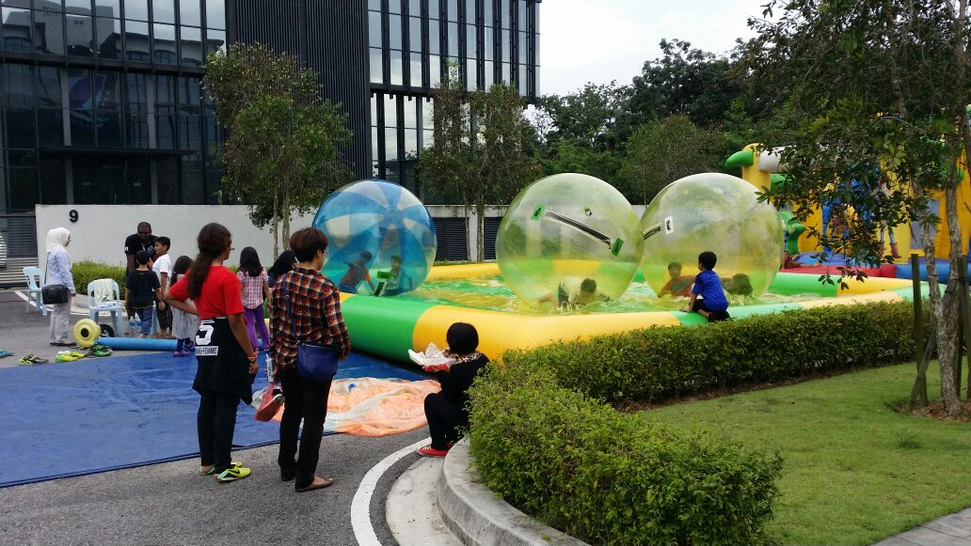 | 15 per person
Roller Orb  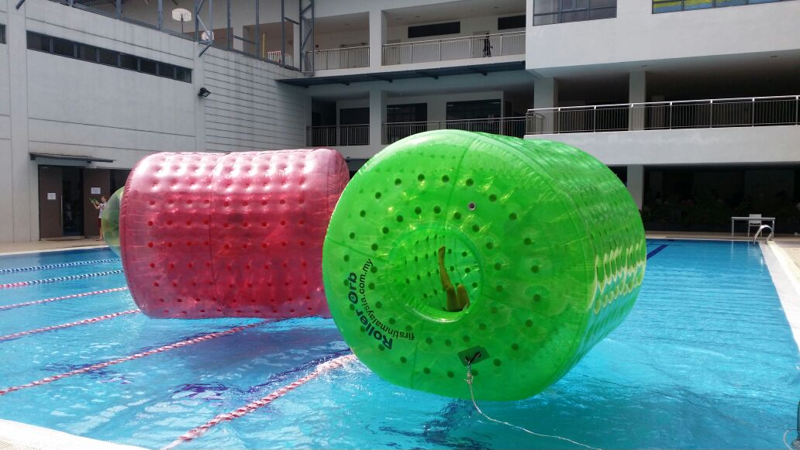 | 15 per person

Activity | Price (RM)
Paddle Boat  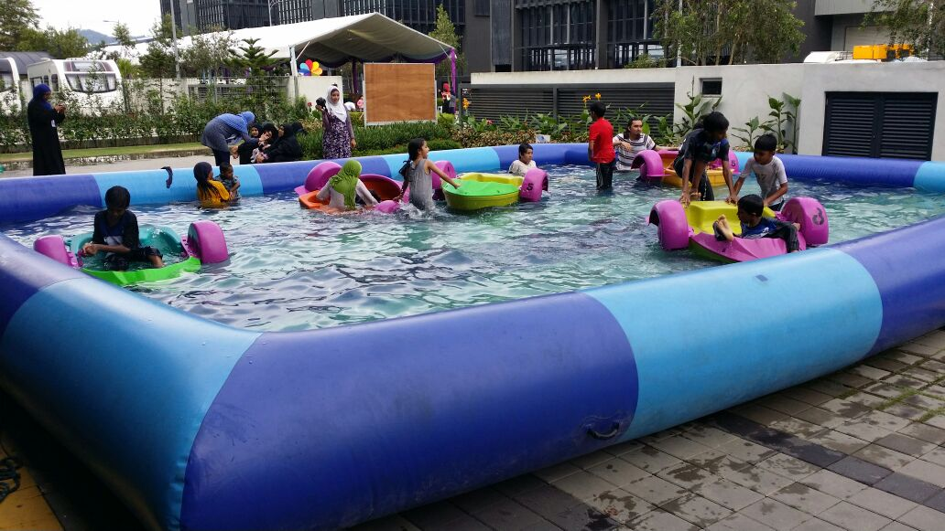 | 15 per boat
Trampoline  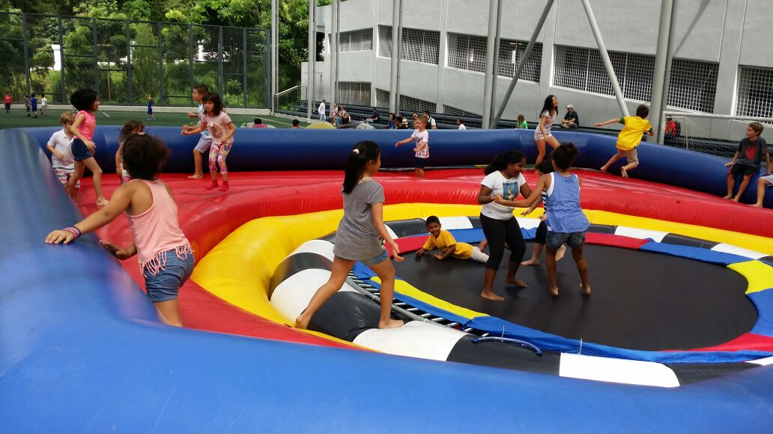 | 10 per person
Hamster Orb  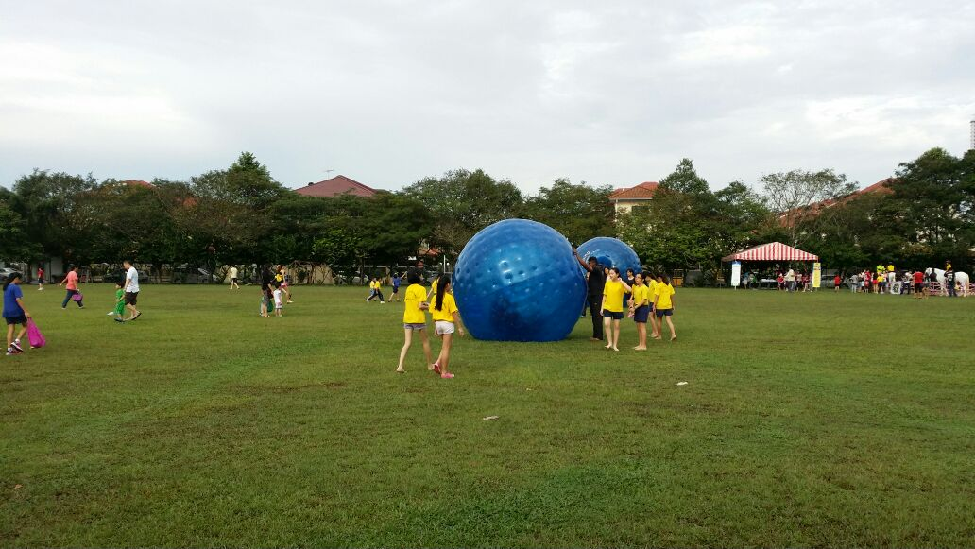 | 10 per person
Bull Ride  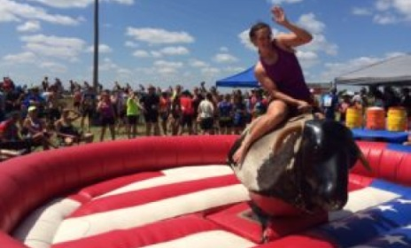 | 15 per person
Reverse Bungee (adults only)  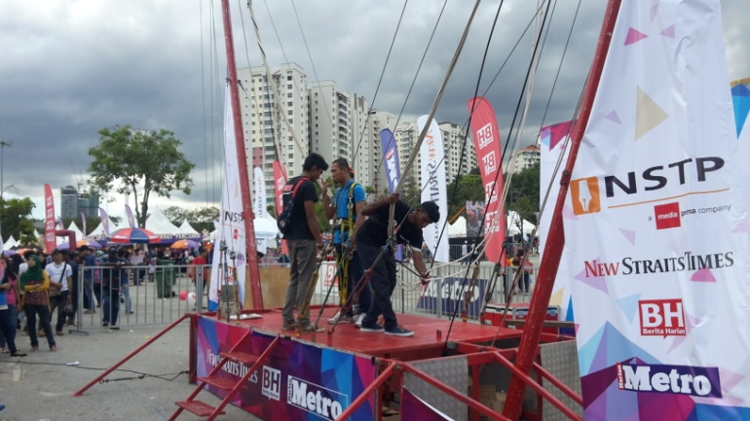 | 30 per person

Activity | Price (RM)
Reverse Bungee (adults only) | 30 per person
Junior Bungee  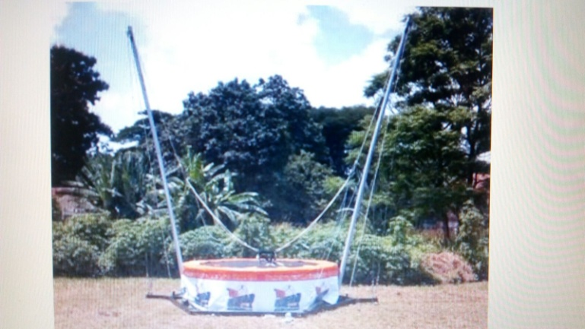 | 20 per person
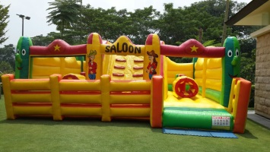  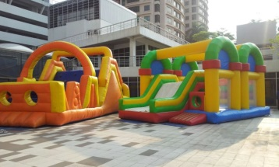  Inflatable Zone (10 units)  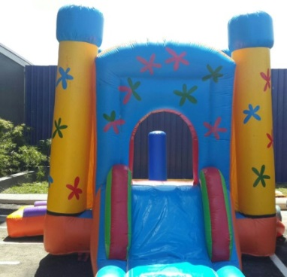 | 15 per entry

Facilities
Food and beverage stalls as well as a variety of arts & crafts stalls will be available on both event days from 7am to 9pm. Additional mobile toilets will also be placed throughout the event area to cater to the large crowd.

Road Closure
Jalan Sepoy Lines will be closed to public access from 10pm on 8 February till 11pm on 10 February 2019.

Event Supporters

Organiser : AKA Balloon Sdn Bhd
Endorsed by : Penang State Government
Supported by : City Council of Penang Island (MBPP), Seberang Perai Municipal Council (MPSP)
& Penang Global Tourism
Co-organiser : TLM Event
Sponsor : IJM Land Bhd
In collaboration with : Tourism Malaysia

For updates, log onto www.penanghotairballoonfiesta.com

Media inquiries:
Ms Nur Izzati Khairudin
CEO, AKA Balloons Sdn Bhd
Email: ettykhai@gmail.com
Tel: +6012 365 0380

