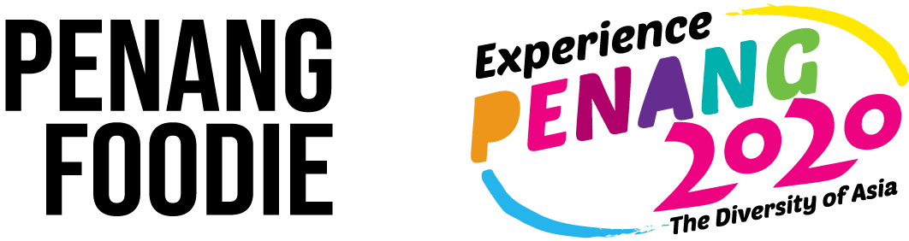

FOR IMMEDIATE RELEASE

Penang Foodie partners with Penang Global Tourism
to promote Penang’s popular food & attractions
in conjunction with Experience Penang 2020

Penang, 15th August 2019: In conjunction with Experience Penang 2020, Penang Foodie, a digital media startup, had produced 20 distinct videos featuring Penang’s diverse food and attractions that are top on its list. Collaborating with Penang Global Tourism (PGT), Penang Foodie launches its first video today via Facebook, counting down towards year 2020 with a different video posted every Thursday for 20 weeks. The launch is graced by YB Yeoh Soon Hin, Penang State EXCO For Tourism Development, Arts, Culture & Heritage (PETACH).

PETACH together with PGT kick-started the tourism campaign "Experience Penang 2020, The Diversity of Asia" in conjunction with Visit Malaysia Year 2020. Experience Penang 2020 aims to highlight all of Penang’s splendour to visitors locally and abroad showcasing every aspect of Penang’s amazing diversity in culture, heritage, arts, food as well as its scenic natural surroundings.

Today’s launching marks the first week’s video of “Penang Foodie - Experience Penang 2020” series, entitled “20 MUST-TRY FOOD IN PENANG”. After today, one video will be posted weekly on Penang Foodie’s Facebook page for the next 19 weeks counting down to the year 2020. The launching of Penang Foodie’s first video - “20 MUST-TRY FOOD IN PENANG” showcases Penang’s famed street food. Each video comprises a list of 20 items that have been compiled to suit the 20 different categories such as Penang’s 20 unique experiences, family-friendly activities, historical & cultural spots, best Muslim-friendly food, seafood places and things to do in the mainland, to name a few.

In March 2019, PGT initiated this project with Penang Foodie to align with Experience Penang 2020 where the number “20” forms the basis of the 20 listicle videos’ content. The project hopes to attract tourists from all over the world to visit Penang next year.

Penang Foodie’s Facebook and Instagram pages have garnered more than 700,000 and 217,000 followers in less than three years, respectively. Penang Foodie’s notable videos are able to achieve more than 20 million reach and 10 million views per month. Penang Foodie’s website on the other hand has 1 million monthly traffic.

“Penang Foodie has a mixture of local and international followers, so we are really excited to highlight Penang’s hidden gems to attract more tourists, in view of Experience Penang 2020,” says Nicholas Lim, Co-founder of Penang Foodie.

“The partnership with Penang Foodie is our latest effort to promote EPY2020 using new media apart from collaborating with world leading OTAs and the popular social media video app, TikTok. We certainly look forward to leveraging on Penang Foodie’s wide following reaching out to the young generation,” says YB Yeoh Soon Hin, Penang State EXCO For Tourism Development, Arts, Culture & Heritage.

End

About Good Foodie Media Sdn Bhd
Good Foodie Media Sdn Bhd, the company behind Penang Foodie was founded by Nicholas Lim, Edward Lim, and Ang Rui Mei. With the aim of showcasing Penang to the world, the trio started producing videos of food, events, and things to do around Penang armed with just a Samsung camera phone. Within the span of three years, the digital media company became well-known with high social media followings, and presence in Kuala Lumpur, Johor, and Singapore.

For media enquiry, kindly contact:
Editor, Good Foodie Media Sdn Bhd
- Qua Mei Rei - rei@foodie.my
- Thexeilia Yeap - thexeilia@foodie.my

