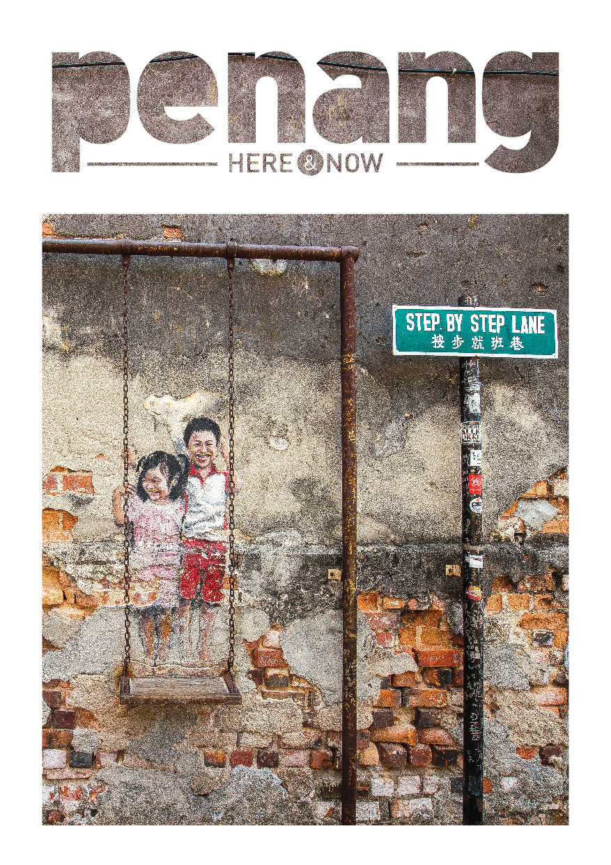

Experience Penang
Located at Malaysia’s northwest coast, Penang is one of the thirteen states of Malaysia that comprises an island and strip of land on the peninsula called Seberang Perai. Penang’s capital George Town was inscribed onto UNESCO’s World Heritage list in 2008 where it features Malaysia’s best restored traditional architecture plus a multitude of heritage trades and arts.

Amid the city's fascinating colonial buildings and century old trading shophouses, you will find its characteristics of past and present, places of worship displaying the peoples’ rich and diverse spiritual faiths, clan houses and its much raved about culinary cuisines.

Street of Harmony
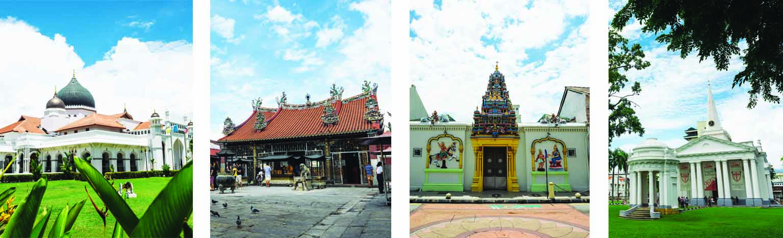

As Penang is so compact, travelling around the island and exploring the mainland is relatively easy. Hop on a tour coach or trishaw to explore George Town, go on a round island sight-seeing or embark on a scenic boat tour of the mangrove forests. To connect with Penang’s unique rainforest and mangrove bio-diversity, trek up Penang Hill or explore Penang National Park. Discover Penang’s legendary spice trade and history, its proud Penang Peranakan (Straits Chinese) heritage, or just enjoy travelling along the serene countryside taking in the charms of age-old farming and fishing villages at Balik Pulau. In the heritage zone, enjoy the sprawling rustic pre-war shop houses, coffee shops and restaurants.

Heritage Architecture
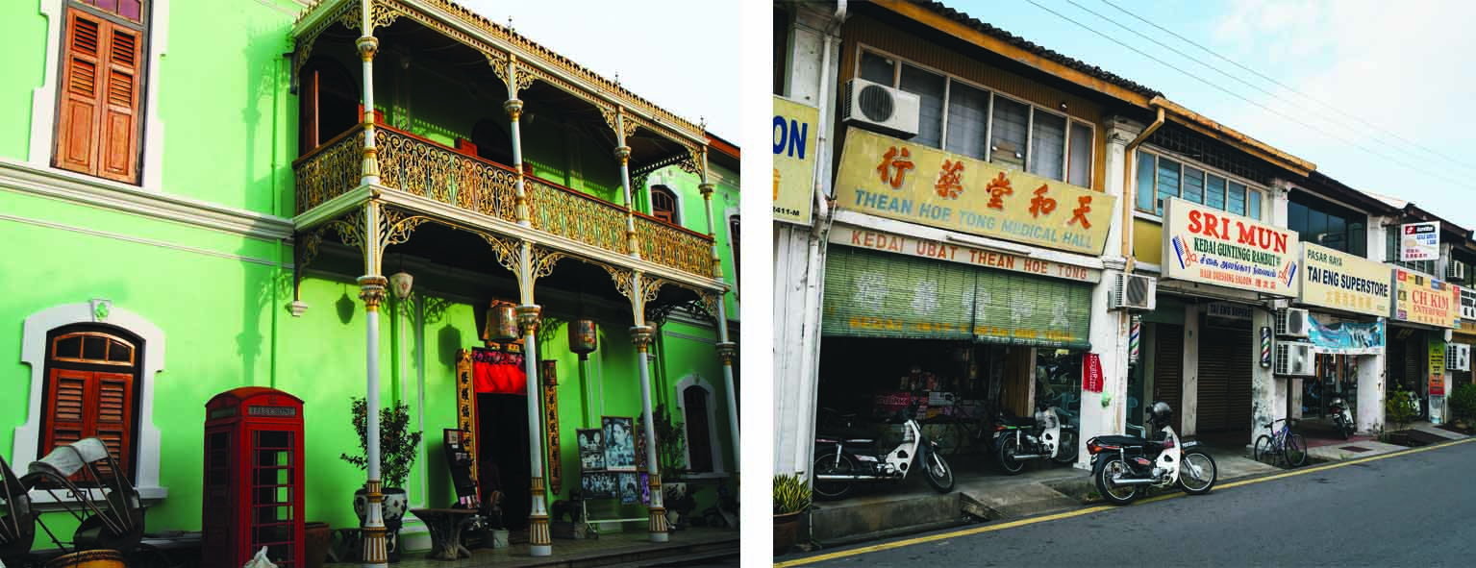

Penang’s street food or hawker food is famous the world over for its incredible variety and quality. Asia’s great culinary traditions live on in Penang’s coffee shops and fine dining establishments. Treat yourself to Penang’s famous Char Koay Teow, Hokkien Mee, Nasi Kandar, Laksa, and Cendol – these are popular dishes and dessert that have people around the world harping on about.

Local Delicacies
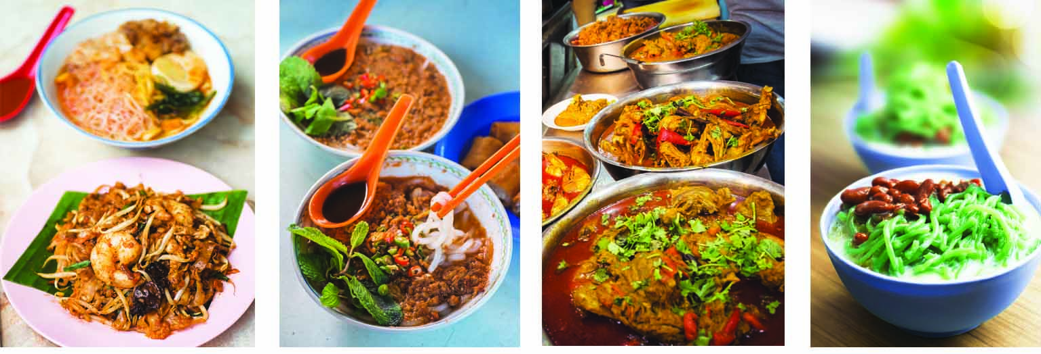

The people in Penang celebrate all year round festivals including religious, cultural and arts. They happen almost every month such as the acrobatic lion dances during Chinese New Year, the intricate weaving of ketupat (rice dumplings) during Hari Raya Aidilfitri (Eid Mubarak) and the unbelievable body piercings that are seen during Thaipusam (a Hindu religious festival). Besides these, Home-grown arts festivals are increasingly popular with global travellers such as the highly-anticipated George Town Festival and the international award-winning George Town Literary Festival. Other annual events such as the Catholic St Anne’s Feast Day, Penang International Food Festival, Penang Anime Matsuri, Penang Hot Air Balloon Fiesta, Japanese Bon Odori Festival, George Town Heritage Celebration, Penang Bridge International Marathon and Dragon Boat Festival are not to be missed in Penang.

Annual Festivals & Events
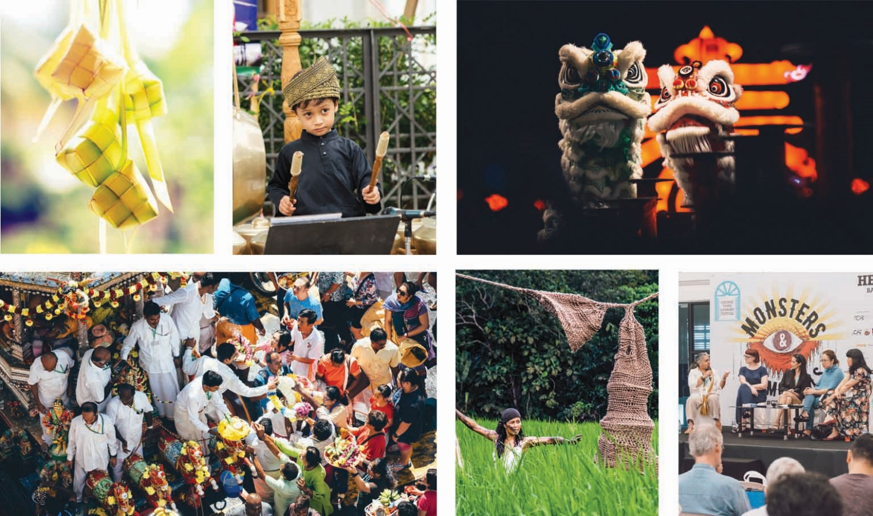
Penang Peranakan
The Peranakans or Straits Chinese are a unique community concentrated in the former Straits Settlements of Penang, Malacca and Singapore. The women are referred to as Nyonyas, and the men, as Babas. Through the old trade triangle of Phuket and Medan with Penang, these three cities today share the same Baba-Nyonya lineage. Originating from southern China, the immigrants sailed to Malaya and over time adopted and adapted various local customs into their own. Although Peranakans are essentially Chinese in character, the blend of Malay, Thai and Burmese influences is highly apparent in their fashion, cuisine and superstitions. Traditionally, Nyonyas would spend most of their time at home, learning domestic arts – cooking, embroidery, beadwork - passed down from generation to generation. Many of these traditions still live on today in Penang, where Peranakans are immensely proud of their heritage and customs.

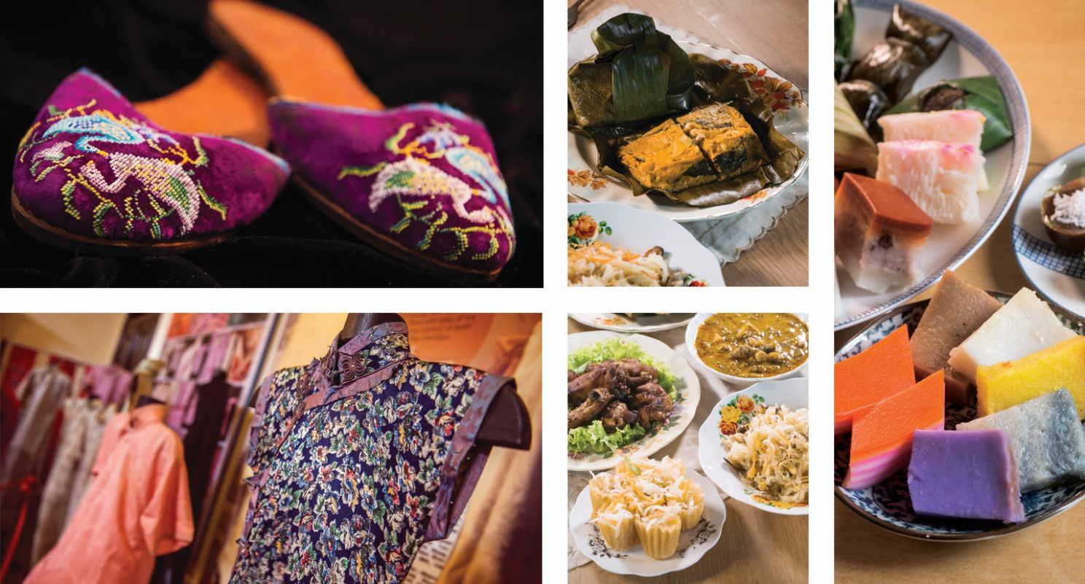

Nyonya Fashion
Penang Nyonya fashion also adapted styles from other ethnic communities and the Kebaya and Sarong are very similar to traditional Malay outfits, with a dash of Chinese, Thai and Burmese influences thrown in. While the men or Babas would have been more comfortable in Western style clothing, Nyonyas preferred their ornate, unique style. Nyonya fashion was all about intricate detailing and many of their outfits would have been made at home from scratch. These include the beadwork of the delicate Kasut Manek or beaded shoes and the exquisite open-work embroidery of the Kebaya blouses.

Nyonya Cuisine
Penang Nyonya cuisine is famous the world over and highly sought after by visitors, typical must try foods include Assam Laksa, Curry Kapitan and Loh Bak. As the Nyonyas artfully blended cooking techniques and ingredients from Chinese, Malay, Thai and southern Indian traditions, Penang Nyonya food is not shy of flavour or fragrance. Spices play a significant role in the preparation of Nyonya food as well as ingredients such as belachan (shrimp paste), coconut milk, lemon grass, galangal and bunga kantan (torch ginger).

Museums
Pinang Peranakan Mansion
Add: 29 Lebuh Gereja, 10200 George Town, Penang
Time: 9.30am - 5.00pm (Mon-Sun)
Tel: +604 264 2929
Info: pinangperanakanmansion.com.my

Cheong Fatt Tze – The Blue Mansion
Add: 14 Lebuh Leith, 10200 George Town, Penang
Time: Daily tours at 11.00am, 2.00pm & 3.30pm
Tel: +604 262 0006
Email: reservations@cheongfatttzemansion.com
Info: cheongfatttzemansion.com

House of Yeap Chor Ee
Add: 4 Lebuh Penang, 10200 George Town, Penang
Time: 10.00am - 6.00pm (closed on Sat & Sun)
Tel: +604 261 0190
Email: houseyce@gmail.com
Info: houseyce.com

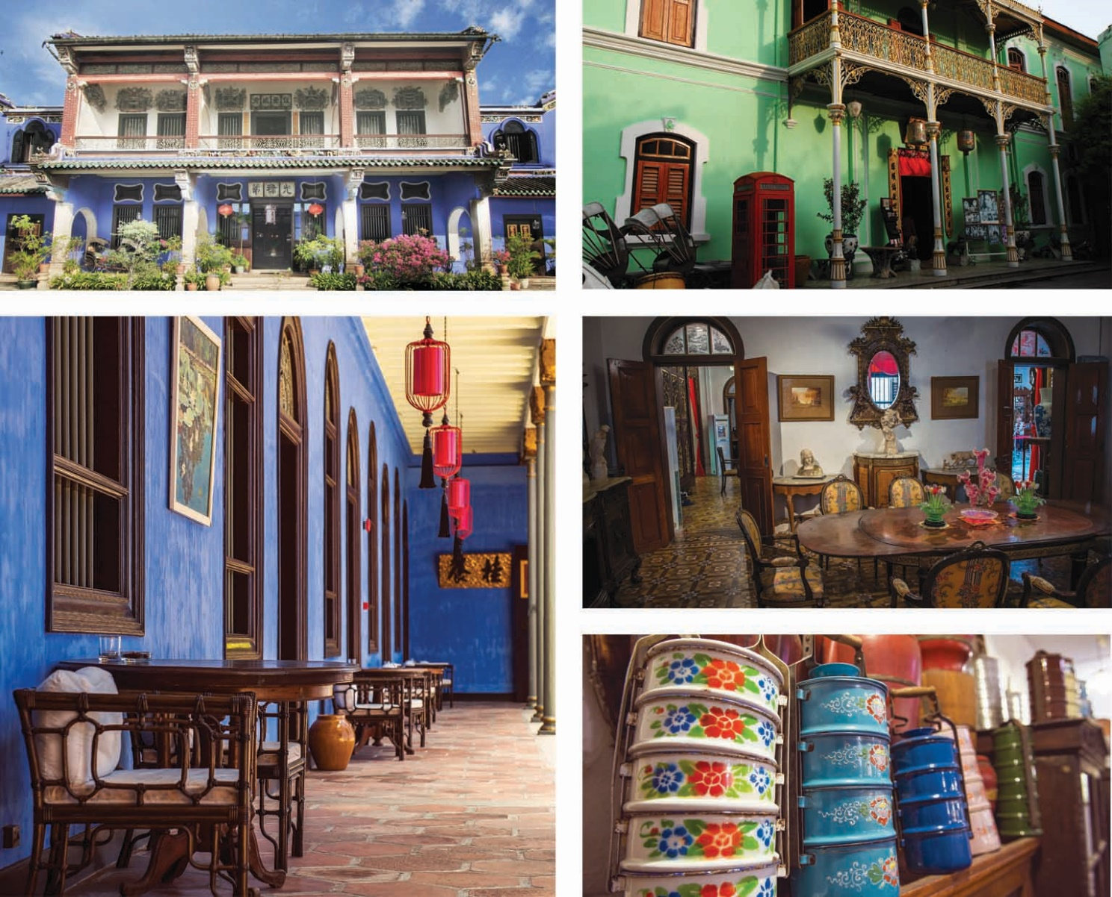

Heritage & Culture
As a UNESCO World Heritage Site, culture and heritage is at the root of everything in Penang’s capital city, George Town. Visitors can discover religious diversity at the Street of Harmony along Jalan Masjid Kapitan Keling, where four places of worship are just a stone-throw away from one another. They can also say “Hello” to the residents of the clan jetties, who are still staying in wooden stilt houses built by their ancestors. Equally fascinating is wandering about on a trishaw and hunting down recognisable street art pieces and murals around the old town.

Folklore by The Sea @ 59a Chew Jetty
Set within the famed Clan Jetties enclave and strategically located in the heart of Chew Jetty, Folklore by the Sea is where live theatrical shows take place daily. The Clan Jetties are built on stilts over the sea and are a cherished and conserved element of George Town’s cultural heritage legacy.

At Folklore by the Sea, thoughtfully curated live dramas as well as interesting storytelling shows are performed to take the audience back in time to the old days of the dwellers’ simple lives at the jetties where the sea was their main source of sustenance. Aimed to preserve and promote its heritage, arts and culture, Folklore by the Sea aspires to continue passing down the legacy to its ensuing generations as well as offer visitors an opportunity to learn and appreciate it. Visitors who are keen to know more about the Clan Jetties can also book a boat ride that cruises along the jetties’ water frontage. The boat ride offers a mesmerising sunset view of the different Clan Jetties and the Penang Bridge.

Folklore by The Sea @ 59a Chew Jetty
Add: 59A, Chew Jetty, Pengkalan Weld, 10300 George Town, Penang
Time: 11.00am - 9.00pm (Opens daily)
Tel: +6011 6246 2884 / +6014 226 9549
Email: spchew@evoct.com.my / klchan@evoct.com.my
Info: facebook.com/59afolklorebythesea
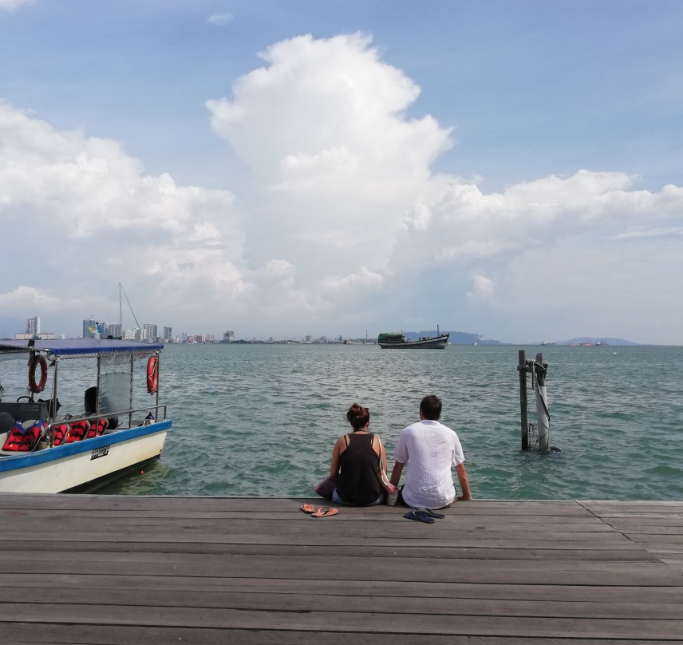
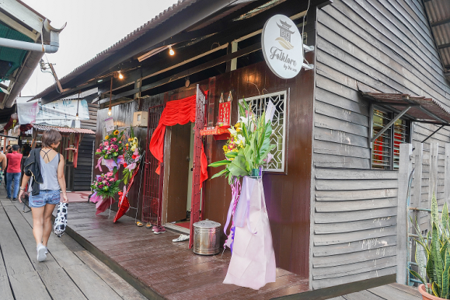
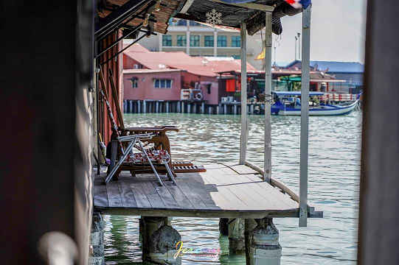

Nature & Adventure
It’s relatively easy for visitors to get around Penang due to its compact size. Sea, hills and jungle adventure is only minutes away to be explored. Penang offers plenty of experiences to enjoy the bounty of nature – home to one of the four meromictic lakes in Asia, an award-winning tropical garden that is home to 500 species of tropical flora and fauna, and the first and among the largest tropical butterfly sanctuary in the world.

The Habitat Penang Hill
The Habitat Penang Hill is a world-class ecotourism facility located at the edge of the magnificent virgin rainforest which dominates the centre of Penang Island. This untouched forest, estimated to be over 130 million years old, provides a tranquil and timeless contrast to the hustle and bustle of urban Penang. With its nature trails, awe-inspiring treetop walkway and canopy walk, The Habitat provides unrivalled opportunities for people to experience the rainforest in a whole new way. By creating a place for people to make new discoveries and to connect with nature, The Habitat aspires to inspire, awaken curiosity, and cultivate support for rainforest conservation among the thousands of Malaysians and international visitors that make their way to Penang Hill each year.

Tree Top Walk
Curtis Crest fondly known as the ‘Tree Top Walk’ is named after Charles Curtis the first Superintendent of the Penang Botanic Gardens. It measures 100m in length and is the highest viewing platform in Penang at 800m above sea level offering visitors a 360-degree view of the island and mainland including Gunung Jerai (Kedah Peak), the paddy fields of Kedah, the ‘rice bowl of Malaysia,’ and on a clear day all the way north to Langkawi.

Langur Way Canopy Walk
Langur Way Canopy Walk is the only 2-span Stressed Ribbon Bridge of its kind in the world and is the only one built amongst the tree top canopy of a tropical rainforest. It is also the highest altitude Stressed Ribbon Bridge in the world at 700m above sea-level on top of Penang Hill. Each span of the Canopy Walk measures 115m making a total span of 230m standing 30m above the forest floor. The total weight of the Canopy Walk is an excess of 1,300 tonnes.

The Colugo Zip
Newly launched in December 2018, The Colugo Zip is an adventure course comprising 5 ziplines, 1 abseil and 1 rope bridge. Named after the Sunda Colugo aka The Malayan Flying Lemur, The Colugo Zip offers visitors a new way to marvel at the beauty of The Habitat’s rainforest - from an aerial perspective. Visitors will experience gliding from tree to tree through the forest canopy like the Colugo. The Colugo Zip was designed and built to have minimal impact on nature, much like the rest of The Habitat’s world-class facility.

The Habitat Penang Hill
Add: Bukit Bendera, 11300 Penang
Time: 9.00am - 7.00pm 9.00am – 8.00pm (Opens daily)
Tel: +604 826 7677
Email: inquiry@thehabitat.my
Info: www.thehabitat.my

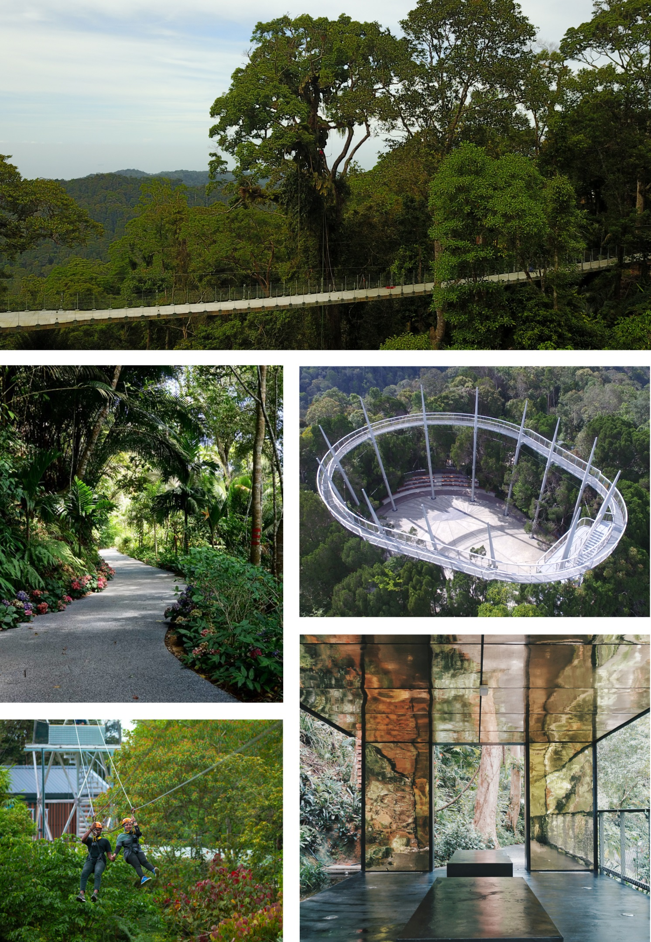

Entopia by Penang Butterfly Farm
Entopia by Penang Butterfly Farm is the first butterfly and insect sanctuary in the tropics. Entopia’s main attractions include a butterfly and dragonfly sanctuary and an indoor invertebrates discovery centre, i.e. The Natureland and The Cocoon. Formerly known as the Penang Butterfly Farm, Entopia was rebranded and launched in May 2016.

The Natureland
The Natureland is a living garden vivarium and it is the largest butterfly and dragonfly garden in Malaysia with 15,000 free-flying butterflies at any one time. This garden vivarium is also a shared ecological space for a variety of other animal species from invertebrates to small reptiles living in their re-created natural habitat. There are more than 200 species of plants with waterfalls, ponds, caves and other artistic garden features.

The Cocoon
The Cocoon is an indoor discovery centre featuring two floors of learning exhibits and activities. It is designed to let visitors self-explore the world of invertebrates through various interactive edu-stations. Aside from having a walk-through experience on their own, visitors will also be guided to participate in fun hands-on learning activities. The entire Cocoon is a state-of-the-art facility where the visitor experience is enhanced by technology guided interpretations.

Entopia by Penang Butterfly Farm
Add: Jalan Teluk Bahang, 11050 Teluk Bahang, Penang
Time: 9.00am - 6.00pm (Opens daily)
Tel: +604 888 8111
Email: info@entopia.com
Info: www.entopia.com

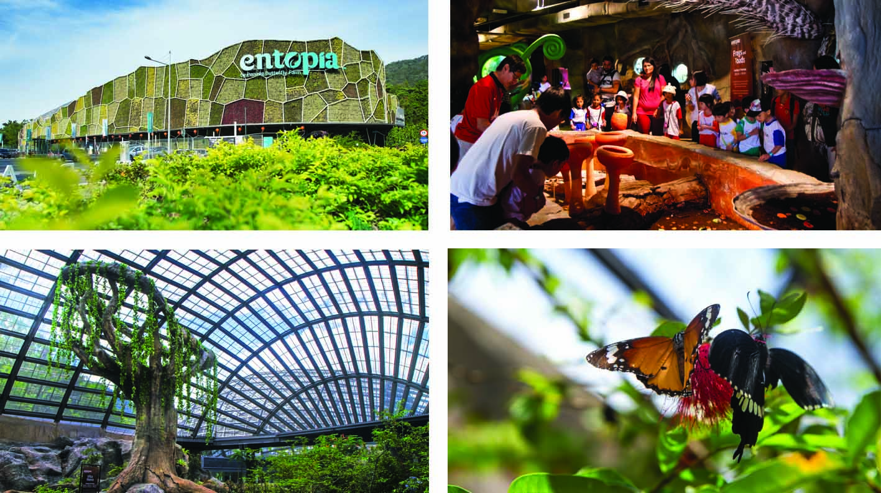

ESCAPE
A departure from the conventional idea of roller-coaster rides, ESCAPE is an outdoor theme park with challenging activities and games suited for children and adults. ESCAPE re-introduces the play and values of yesteryear through fun activities, with an emphasis on self-directed and self-powered play. Sprawled over 22 acres, the park currently comprises two main components – Adventureplay and Waterplay.

Adventureplay
At ESCAPE’s Adventureplay, you can test your balance on the Monkey Business rope course, whizz pass trees on the Flying Lemur zip line or Kite Flyer, and experience anti-gravity as you soar off a launch pad from Atan’s Leap. There are over 20 attractions on this section of the park. Also available at Adventureplay is Base Camp, an outdoor activity where participants can camp in the jungle beneath the stars. It’s a perfect experience to share with family or friends that includes BBQ cooking and back-to-basics fun. Base Camp is in a fenced-up area with 24-hour security and illuminated walkways. The Base Camp pitches do not have electricity but lockers with electrical sockets for charging mobile phones and other mobile devices are available at the reception.

Waterplay
ESCAPE’S Waterplay is a waterpark that spans across 11-acres and features over 20 rides and games - some of which appearing for the first time in the waterpark industry. In September 2019, the waterpark completed its world’s longest tube water slide where the 1,111m-long attraction made it to the Guinness World Records.

ESCAPE
Add: 828 Jalan Teluk Bahang, 11050 Teluk Bahang, Penang
Time: 10.00am - 6.00pm (Opens daily except Mondays)
Tel: +604 881 1106
Email: sales@escape.my info@escape.my
Info: www.escape.my

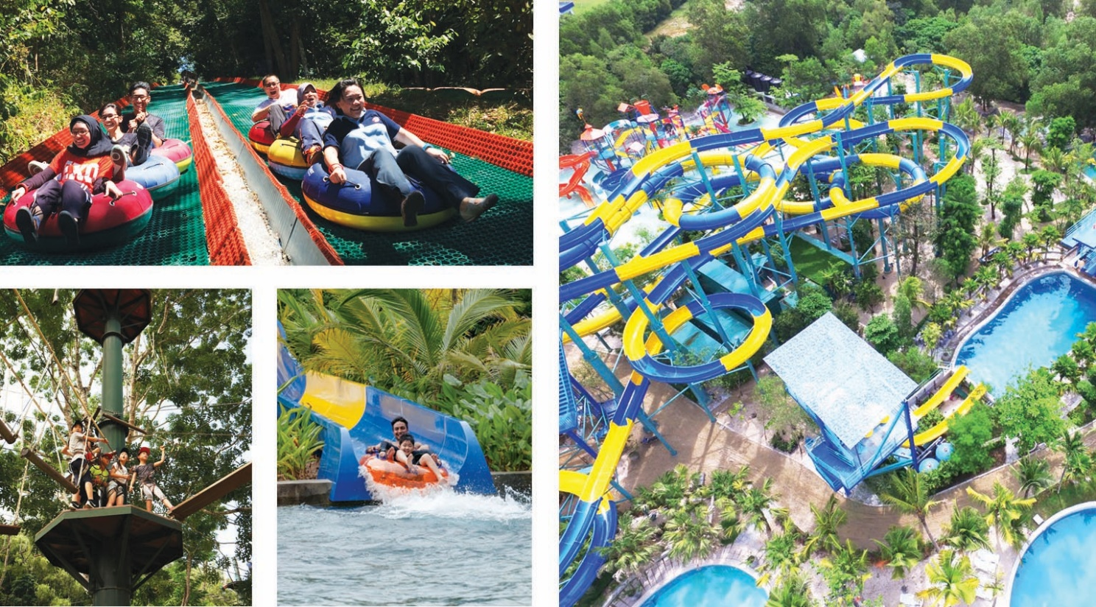

Boulder Valley Glamping
Penang’s latest attraction in the Teluk Bahang-Balik Pulau eco-tourism belt, features ‘glamping’ or glamorous camping. At Boulder Valley Glamping, enchanting nature meets modern luxury where one can enjoy camping ‘in the wild’ without sacrificing modern comforts. Intentionally kept basic and free from over lavishness, Boulder Valley offers amenities like beds, en suite bathrooms, air-conditioning, water heaters, fans, safes and other necessities. Developed on a 10ha site, there are currently 25 rooms, known as tents and villas that can accommodate 2 to a group of 8 people per unit. When fully completed, it will boast a 120-room eco hotel, 36 villas, 40 chalets and 100 ‘Bird Nest’ villas. However, for those who are not keen to try glamping, day trips are available to explore Boulder Valley’s beautiful ambience. The site also provides facilities for events and functions where guests can enjoy natural views of the wilderness through glass rooms or spaces.

Boulder Valley Glamping
Add: 8 Jalan Teluk Bahang, 11050 Teluk Bahang, Penang
Tel: +6012 490 6882
Email: amazingdisc@gmail.com info@bouldervallyglamping.com.my
Info: bouldervalleyglamping.com.my

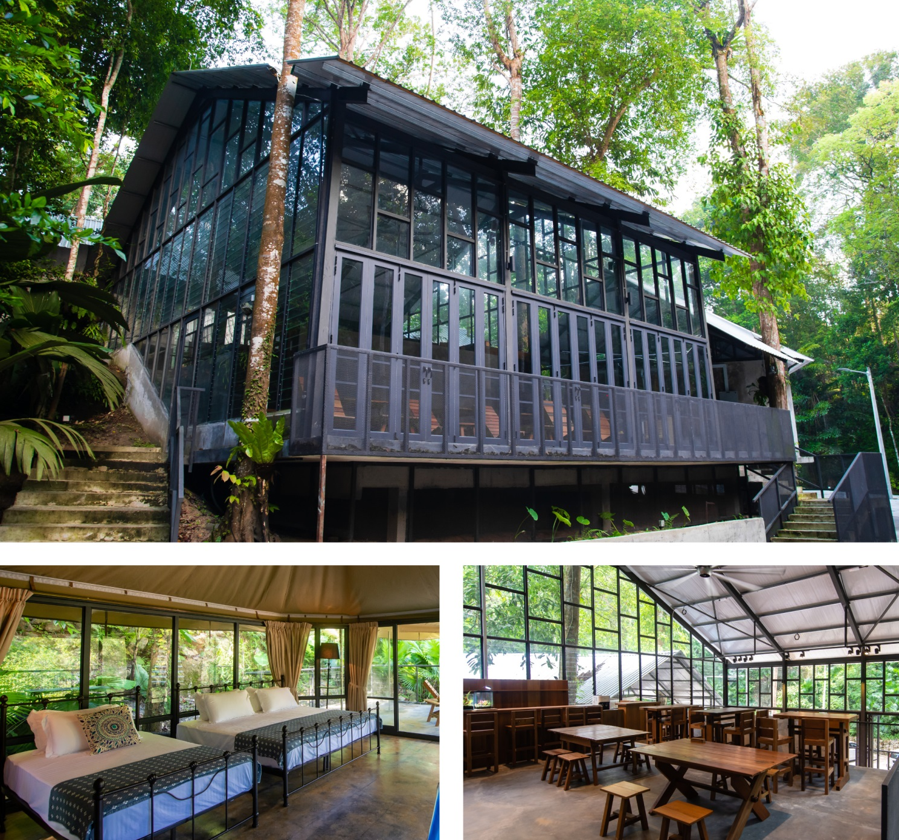

The Gravityz
The Gravityz facilitates activities that are out of the norm, considered by some to be extreme as it involves great heights. Those who are brave at heart may want to conquer the world’s highest rope course challenge at The Gravityz, located at Level 65 of KOMTAR. The rope course challenge comprises six obstacles along a 90m walk which is 239m above ground on the outside of Penang’s landmark monolith. Visitors will get to experience adrenaline-filled moments as they go through challenges such as ‘A Great Bridge’, ‘Z-Wire’ and ‘G Rocky’. Participants will need to walk on narrow platforms and ledges that extend out of the building. Best of all, they get to enjoy the breathtaking view of the city under their feet.
The Gravityz
Add: 65th Floor, The Top Penang, 1 Jalan Penang, 10000 George Town, Penang
Time: 10.00am - 6.00pm (Opens daily) 11.00am – 7.00pm (Opens daily with break time 3pm – 4pm & Fridays 1pm – 3pm)
Tel: +604 293 0616 there is no contact number stated on their website
Email: info@thegravityz.com
Info: www.thegravityz.com

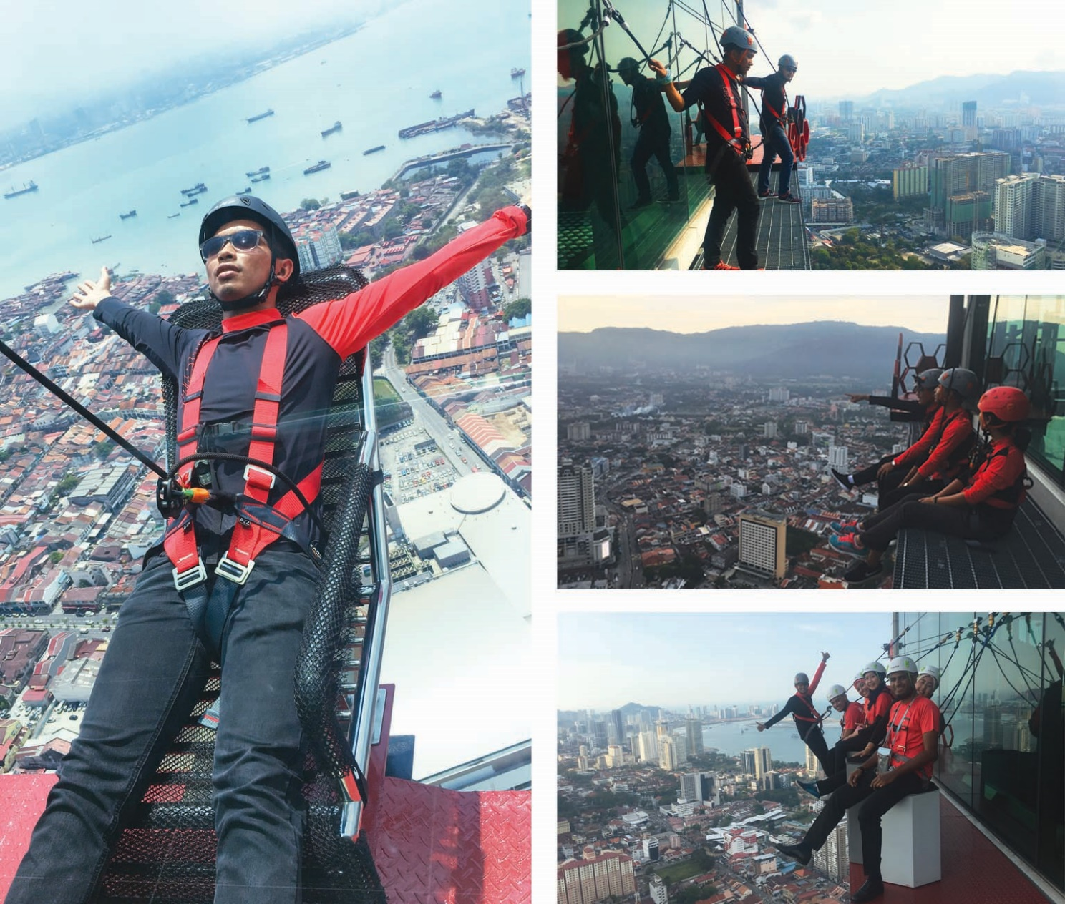

Bird Watching
Penang is home to an estimated 420 species of birds, including rare ones as well. Both the island and mainland are known for its abundant variety of bird species, making it an avian paradise for amateur and experienced bird watchers. Some of the diverse bird habitats include lowland forests, mangrove forests, tidal mudflats, wetlands and paddy fields. Throughout Penang, a wide range of bird species can be found such as eagles, owls, song birds, waders and water birds that include resident and migrant birds. Here’s a list of locations for bird watching. Those that are not listed below are Sungai Burung in Balik Pulau (paddy field/mangrove forest), Teluk Air Tawar in Butterworth (mangrove forest/wetland) and Byram - Pulau Burung in Nibong Tebal (mangrove forest/wetland).

Penang National Park
Tel: +604 881 3530 / 881 3500
Email: tnpp@wildlife.gov.my
Info: www.wildlife.gov.my

Penang Hill
Tel: +604 828 8880 / 828 8839
Email: inquiries@penanghill.gov.my
Info: www.penanghill.gov.my

Penang Botanic Gardens
Tel: +604 226 4401 / 226 4404
Email: botani@penang.gov.my
Air Hitam Dalam Education Forest
Bukit Mertajam Amenity Forest
Bukit Juru Forest Reserve
Tel: +604 539 1743
Email: jhnpp@penang.gov.my
Info: jhn.penang.gov.my/index.php/en/

Bukit Panchor State Park
Tel: +604 593 2977
Email: jhnpp@penang.gov.my
Info: jhn.penang.gov.my/index.php/en/

Info: botanicalgardens.penang.gov.my

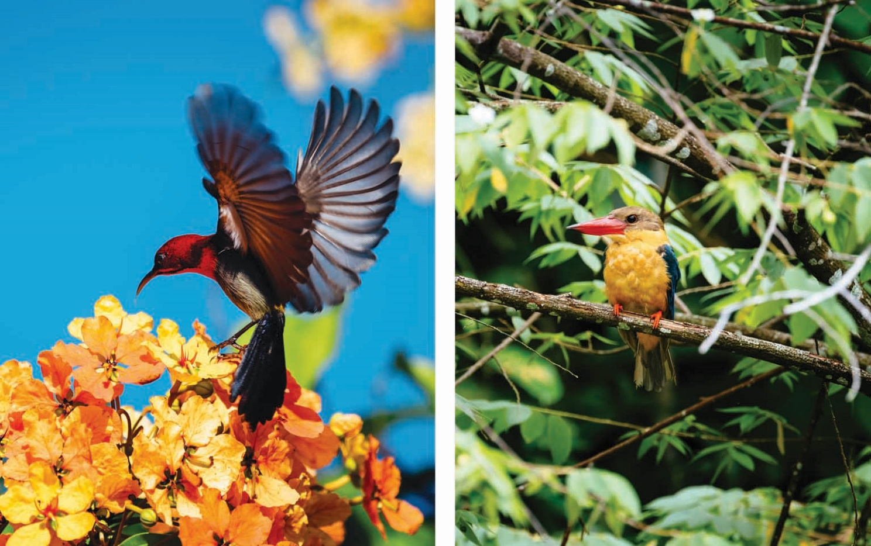
Dine Shop Play
Sights, sounds, aromas and flavours – Asia’s great culinary traditions live on in Penang’s coffee shops and fine dining establishments. Visitors can certainly indulge around the clock with cool entertainment, non-stop shopping and mouth-watering cuisine throughout their stay in Penang.

Kuih Culture
Recently opened, Kuih Culture is the first ‘Nyonya Kuih’ based concept shop in Malaysia that inculcates culture and heritage. The café is also halal certified and it aspires to preserve the taste of yesteryear by practicing traditional methods of making kuih (local snacks or dessert) for generations to come. At Kuih Culture, food is hand-crafted without any shortcuts with the freshest ingredients and most authentic recipes.

There’s more to indulge at Kuih Culture as it houses a ‘cinema lounge’ where visitors can watch traditional kuih making techniques as well as have a hands-on experience over at its Workshop. Adding on to the fun element is a small Gallery where diners can take photos with mural art. At the Workshop, participants as young as 4-years old are taught to master simple kuih-crafting techniques. Classes are conducted in a small group setting where it focuses extensively on hands-on learning. The Gallery and Workshop tour takes 50-60 minutes. Private sessions for team building or events can also be arranged.

Kuih Culture
Add: 59A, Lebuh Kimberley, 10100 George Town, Penang
Time: 10.00am - 7.00pm (Opens daily) Opens daily except Wednesdays
Tel: +6011 5628 2889
Info: www.facebook.com/kuihculture
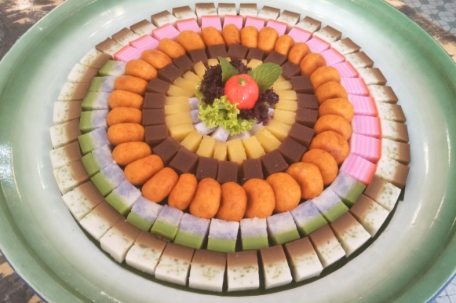
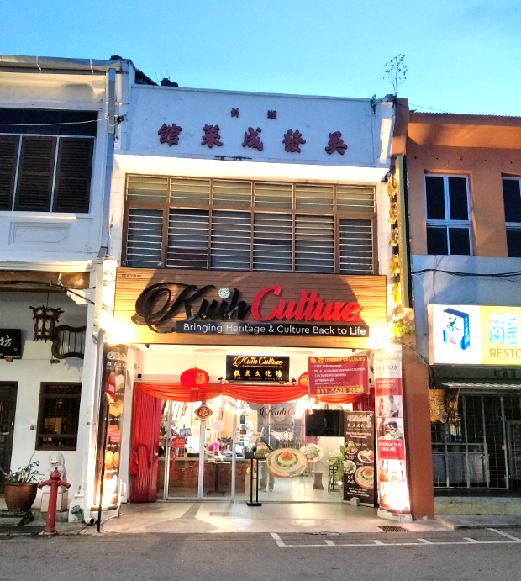

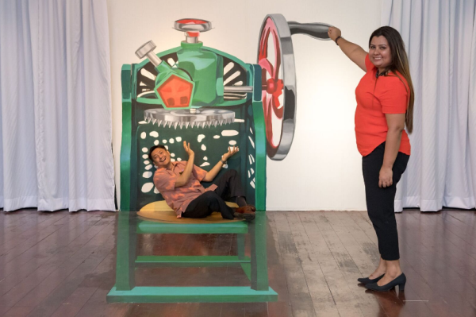

The Top Penang
The Top Penang at KOMTAR (Kompleks Tun Abdul Razak - the tallest building in Penang), is home to a plethora of activities, retail and F&B outlets catering for the entire family. The Top Penang is a new pulse of George Town, offering a breathtaking panoramic view of the surrounding island from its summit. The attractions at The Top Penang encompass both modern attractions as well as attractions that pay homage to local flavour. Among the must-sees include the Rainbow Skywalk as well as an Observatory Deck, Jurassic Research Centre, 7D Discovery Motion Theatre, Ocean Explorer, Magic Mirror Maze, Musical Carrousel, Boutique Aquarium, the adjacent Tech Dome, and a host of other attractions plus food and beverage outlets. The Top Penang also boasts a members-only exclusive club called Tower Club, complete with business suites, dining deck & lounge, sky gym, spa, bar, wines & cigar room, karaoke suites and more. Additionally, there is Banquet at Level 5, a pillarless event venue with a built-up area of 14,400 sq ft, that’s versatile to accommodate up to 1,000 guests.

The Top Penang
Add: Jalan Penang, 10000 George Town, Penang 1, Jalan Penang, 10000 George Town, Penang
11.00am - 8.00pm (Weekdays)
11.00am - 9.00pm (Weekends)
10.00am - 10.00pm (Public Holidays & School Holidays)

Time:

Tel: +604 262 3800
Email: reservation@thetop.com.my sales@thetop.com.my
Info: www.thetop.com.my

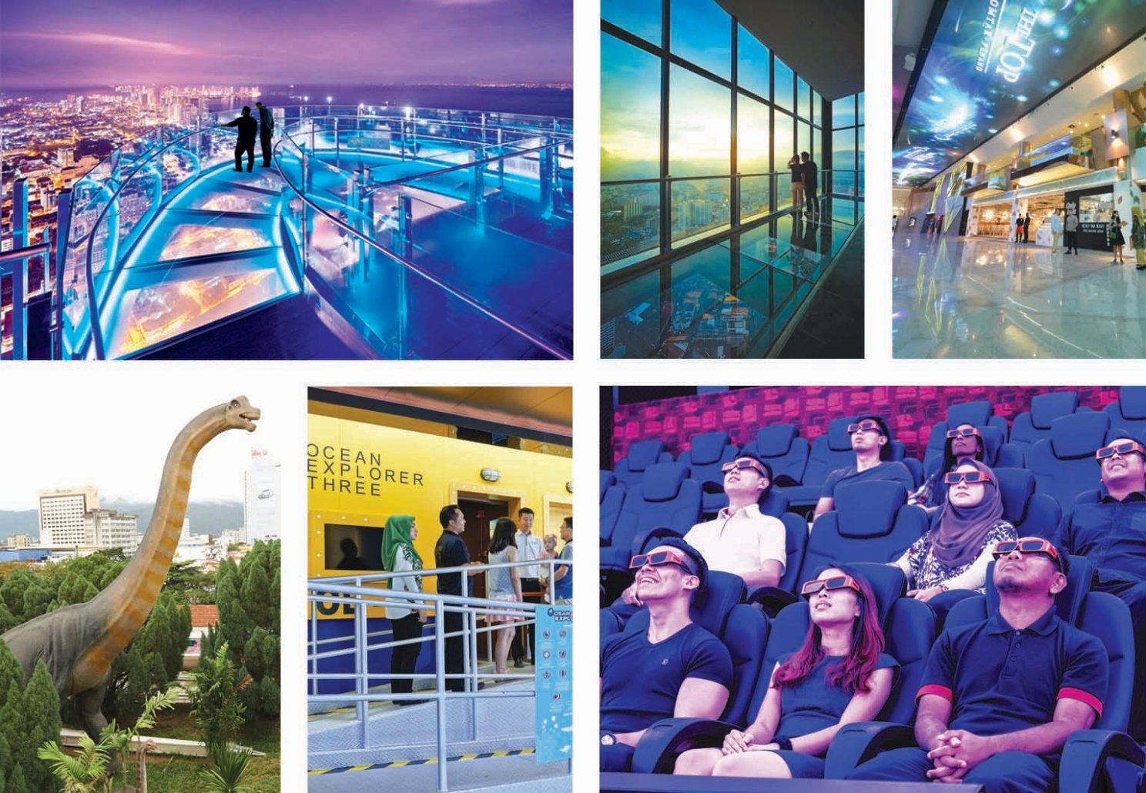

Tech Dome Penang
Tech Dome Penang is the first science discovery centre in Penang that aims to provide an immersive and experiential presentation on the marvels of science and technology. The centre’s 120 interactive exhibits spread across 40,000 sq ft of floor space and includes six thematic galleries such as robotics, life tech, optics and electro-magnetism — but particularly interesting is the Astronomy Observatory where visitors can learn about stars and constellations from the Astronomical Society of Penang.

A substantial portion of the exhibits are from Science Alive from New Zealand and Huttinger from Germany but exhibits from locally-based MNCs as well as local corporations are also on display. This is in line with the objective for Tech Dome to showcase local technology and those originating from Penang. Aside from showcasing exhibits on science, technology and engineering, Tech Dome also runs educational programs, workshops and science camps.

Tech Dome Penang
Add: KOMTAR Geodesic Dome, Jalan Penang, 10000 George Town, Penang
Time: 10.00am - 6.00pm (Mon-Fri) (Daily)
10.00am - 7.00pm (Weekends & Public Holidays) (Public Holidays)
Tel: +604 262 6663
Email: info@techdomepenang.org
Info: www.techdomepenang.org

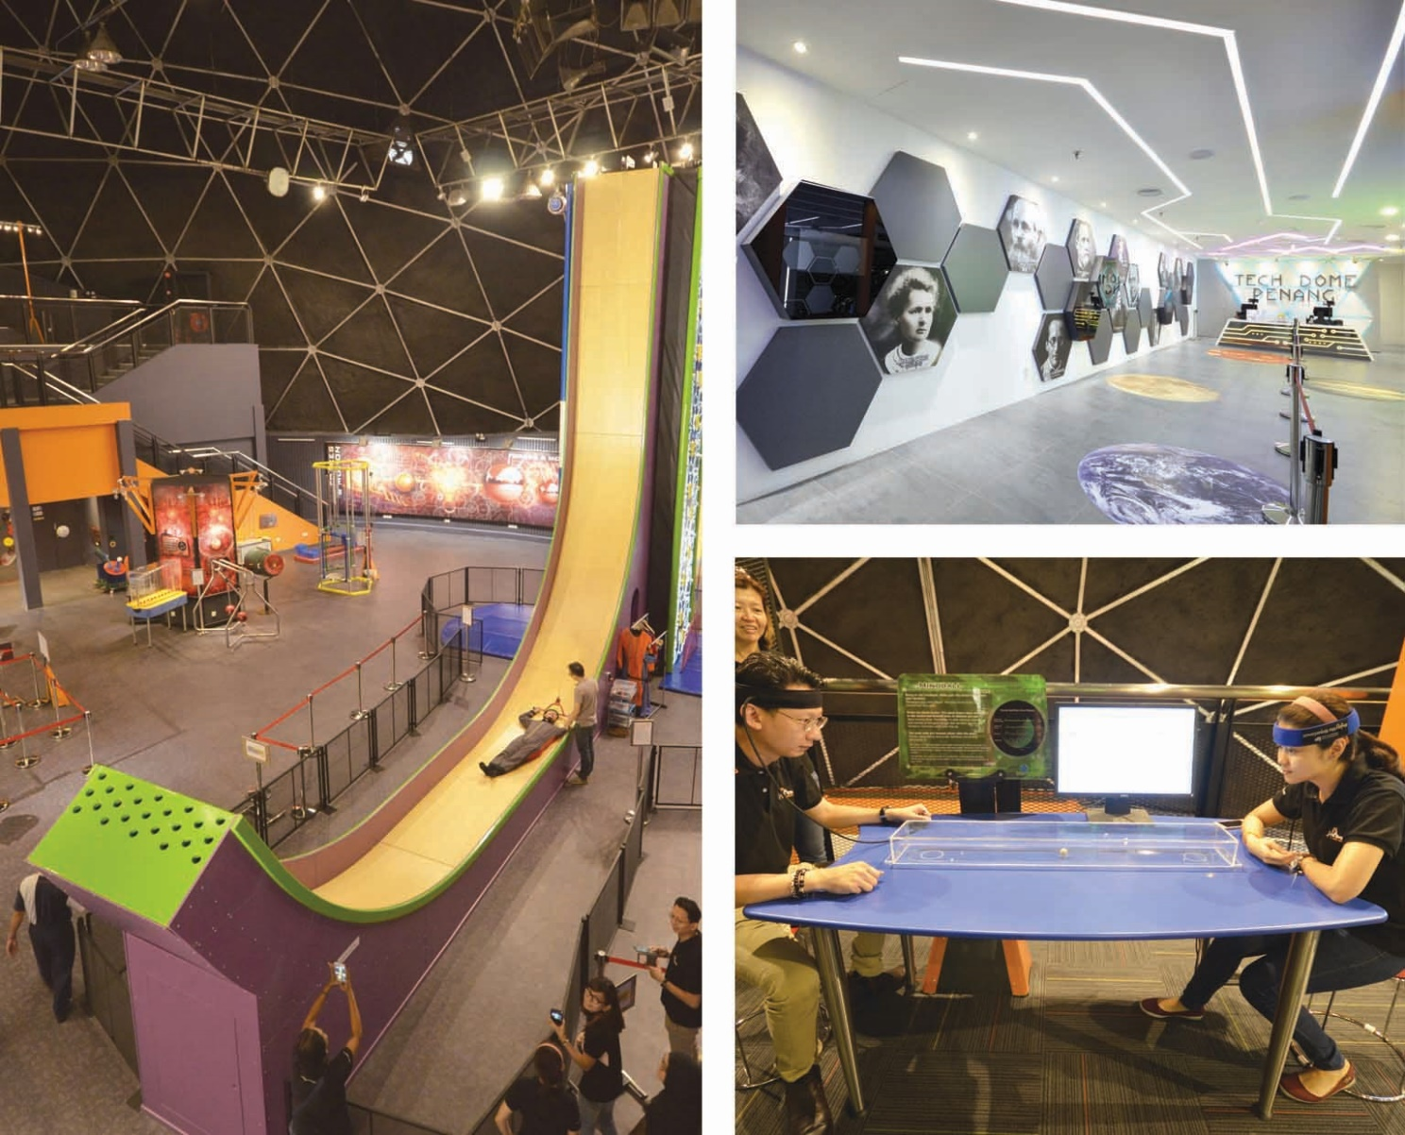

Penang House of Music
The Penang House of Music celebrates the rich heritage and diversity of Penang’s musical heritage, and aims to conserve its inspiration and legacy for many generations to come. The Gallery showcases some of the history and influences that make up the many facets of Penang’s rich musical inheritance, interspersed with interactive features offering a slice of life experience of Penang in the 1940s to 1960s, and beyond. The Penang House of Music comprises the following components:

Gallery - showcases the music of Penang’s communities offering a glimpse of the rich cultural life of the past.

Radio Room - visitors can experience being a radio announcer in this authentic Radio Room, present a song ‘live’ and return home with the recording.

Cinema room - offers visitors the experience of going to the movies back in the day.

VR Room - lets visitors enjoy an amazing soundscape in virtual reality (VR) where it combines the music of the past with the technology of today.

Black Box - a dedicated performing space for music and arts-related events.

Resource Center - it’s the heartbeat of the Penang House of Music that houses a growing collection of data on Penang’s musical heritage - including articles, books, digital music and voice files, magazines, photographs, posters, press cuttings, sheet music, souvenir programmes, vinyls, cassettes and CDs.

Penang House of Music
Add: L4-02 Level 4 KOMTAR, Jalan Penang, 10000 George Town, Penang
Time: 11.00am - 8.00pm (Opens daily)
Tel: +604 370 6675
Email: info@penanghouseofmusic.com
Info: www.penanghouseofmusic.com
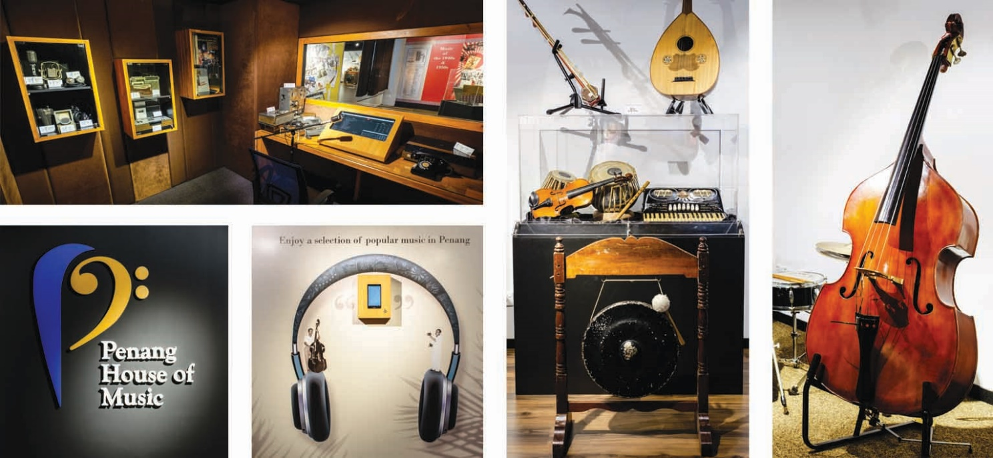

Design Village Outlet Mall
The Design Village Outlet Mall is the first and only outlet mall in Penang as well as the biggest outlet mall in Malaysia. Located in Batu Kawan in a township called Bandar Cassia, it is just five minutes from the mainland entrance of the Second Penang Bridge. It is a component of a 245-acre land to be developed for the purpose of constructing shopping malls (premium outlets), a golf course, specialist hospital and an international school. Via the Second Penang Bridge, the Batu Kawan development is linked to Batu Maung, an industrial zone on the island close to the Penang International Airport.

The Design Village Outlet Mall spans 40 acres and boasts a 400,000 sq ft shopping mall, set in a lush 24-acre tropical garden with wide sheltered walkways and captivating jewel boxes at every corner. There are a total of 150 shop units and 2,500 car park lots. Being the largest outlet mall in Malaysia, it hosts a broad variety of exciting international and local brands, both premium and high-street. From fashion and children’s wear to sports and home, restaurants and cafes, the mall offers the best selection of high-quality products at lowered prices with up to 70% discounts every day.

Design Village Outlet Mall
Add: 733, Jalan Cassia Barat 2, 14110, Bandar Cassia, Penang
Time: 11.00am - 10.00pm (Opens daily)
Tel: +604 589 9888
Email: sayhello@designvillage.today
Info: www.designvillage.today

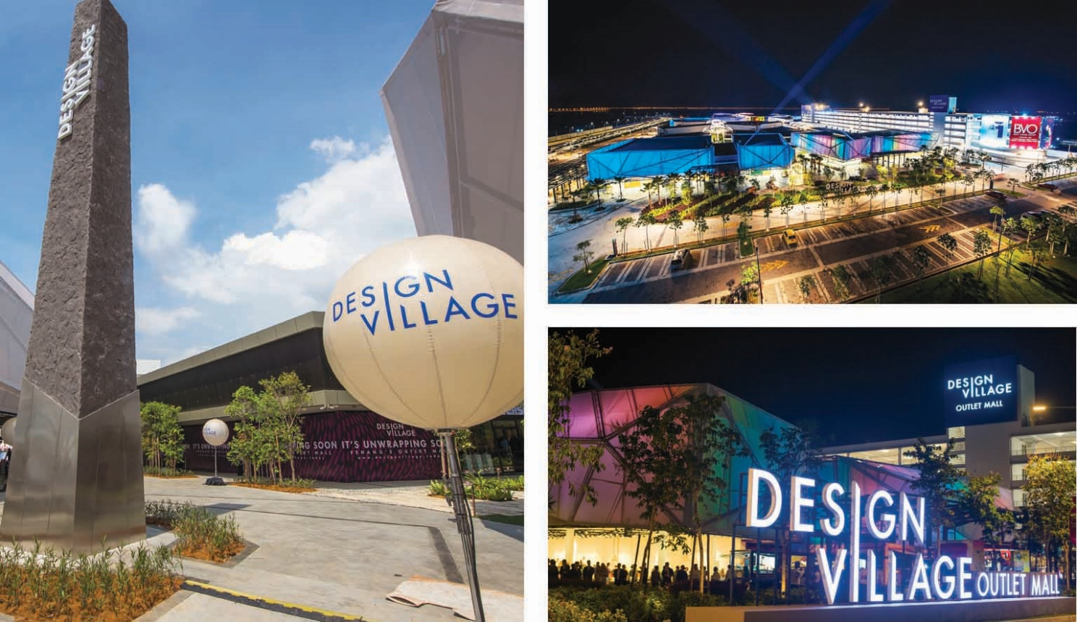

E-Coupon
The E-Coupon is an ongoing effort of Penang Global Tourism (PGT) whereby visitors may download offers such as discounts and value-added benefits of attractions, F&B outlets and other tourism-related products and services online.

The E-Coupon is accessible through PGT’s website, mypenang.gov.my/ecoupon or on its mobile app called Penang Tourist Info available on both Android and iOS. Visitors will have the ease of selecting the E-Coupon of their choice at any time, wherever they are.

PGT constantly updates this E-Coupon service for the convenience of visitors who are in the midst of planning their trip to Penang or when they are already here in Penang. They can indeed take advantage of the E-Coupons by keeping a constant check on PGT’s website and mobile app for new discounts and promotions offered by the various participating vendors.

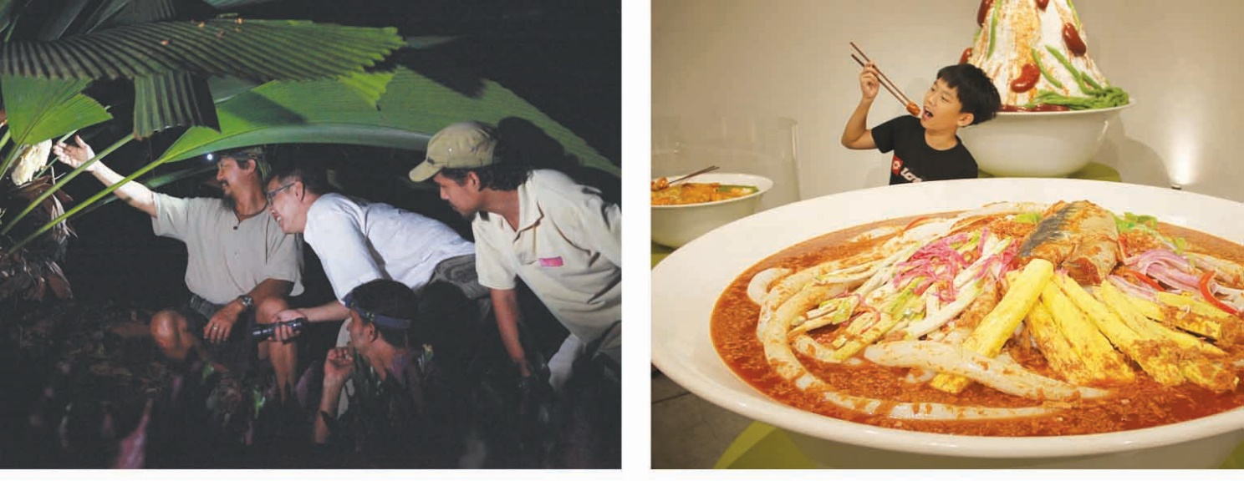
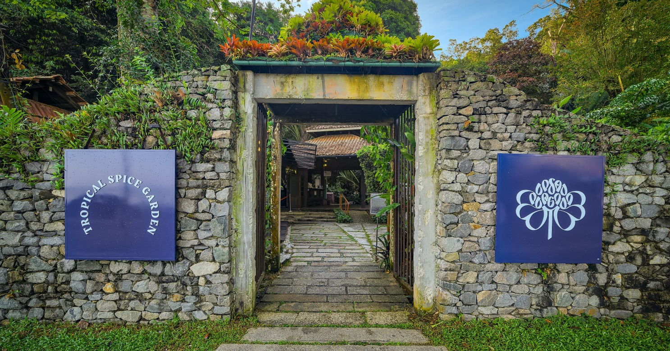

Website: mypenang.gov.my/ecoupon
Mobile app: Penang Tourist Info

MICE
Penang’s Meetings, Incentives, Conventions and Exhibitions (MICE) business currently accounts for 4 times the spending of its leisure tourists. It possesses a world-class reputation in providing hospitality to guests of any size and complexity. Penang’s attractive mix of modern convention centres, world class hotels and resorts as well as unique venues, gives it an edge above other regional destinations. What truly sets Penang apart is its seamless marriage of the old and new, of modernity and heritage, making Penang the ideal destination for regional and international business and leisure events.

SPICE (Subterranean Penang International Convention and Exhibition)
The Subterranean Penang International Convention and Exhibition Centre (SPICE) is an integrated business and leisure hub, and Malaysia’s largest of its kind outside the capital. It is well connected to major entry points to the island and only a 5-minute drive away from Penang International Airport and about 20 minutes to Penang Bridge and Ferry Terminal in George Town. The SPICE development consists of the SPICE Convention Centre, SPICE Arena, SPICE Aquatic Centre, SPICE Canopy and a Business Class Hotel.

The SPICE Convention Centre is the first hybrid solar powered Convention Centre in the world and it is also Eco Green GBI certified. It features a 4,500m2 pillarless ballroom with a maximum capacity of 8,000 theatre seating and is supported by 13 meeting rooms. Additionally, atop the Convention Centre is a 6-acre green rooftop park, suitable for outdoor events.

The SPICE Arena is a multipurpose built venue that is especially suited for shows, concerts, sporting events, and exhibitions. It has played host to a series of major events such as Amway Conference, Disney On Ice, SEMICON South East Asia, V Conference Malaysia and many more. The SPICE Arena provides a 3,100m2 3,300m2 floor-space at the main arena, a 4,300m2 4,600m2 floor-space at the concourse level, a capacity of 10,000 terrace seats surrounding and is supported by 7 meeting rooms.

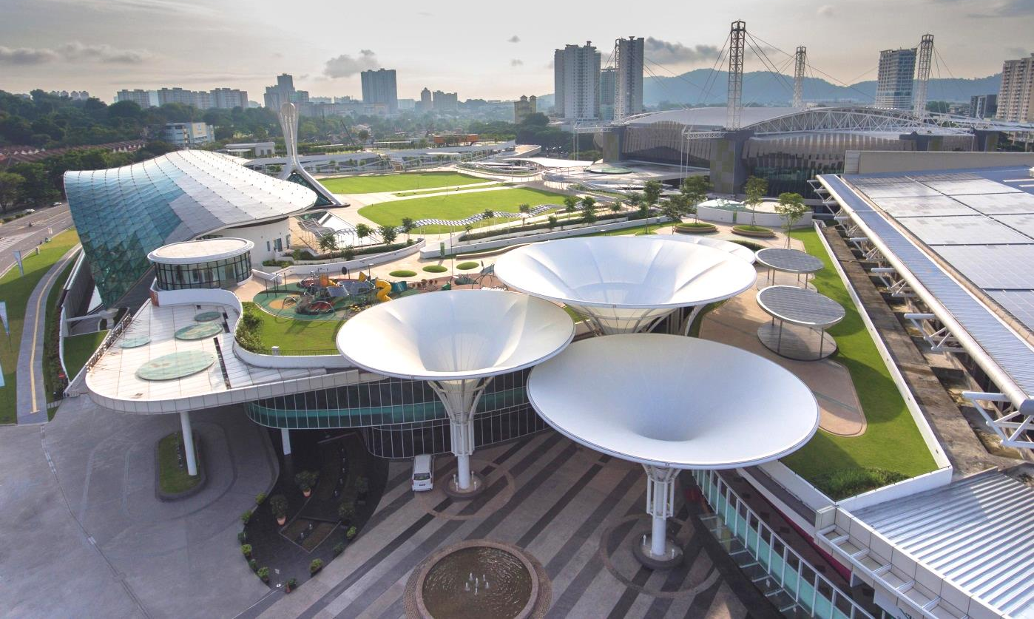

The SPICE Aquatic Centre provides a choice of both wet and dry activities. Highlights include a large indoor Olympic size swimming pool, kids play pool with salt water treatment, 3-tier diving platform, lounge, dance studio studios, sauna rooms, badminton and squash courts, gymnasium and viewing terrace seats.

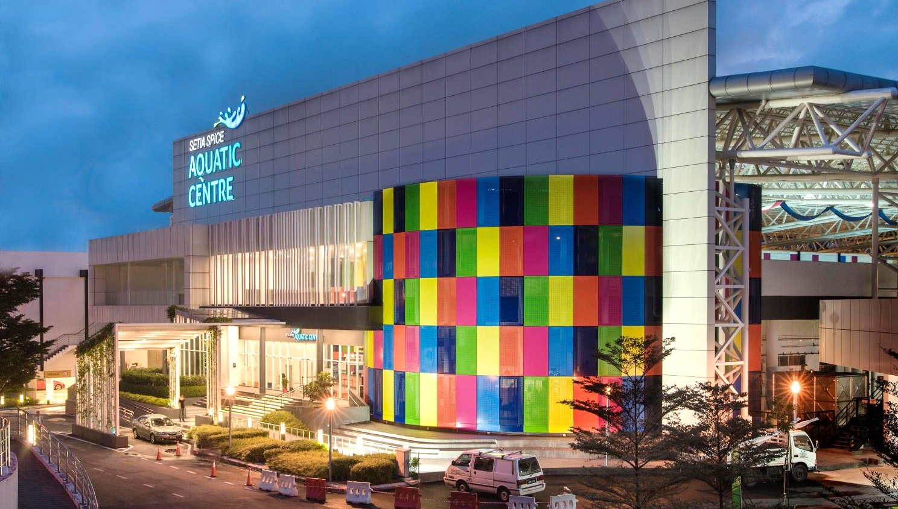

The SPICE Canopy is a one stop retail lifestyle venue, comprising 59 retails, food & beverage units catering to Penang’s best and international cuisine at a single location.

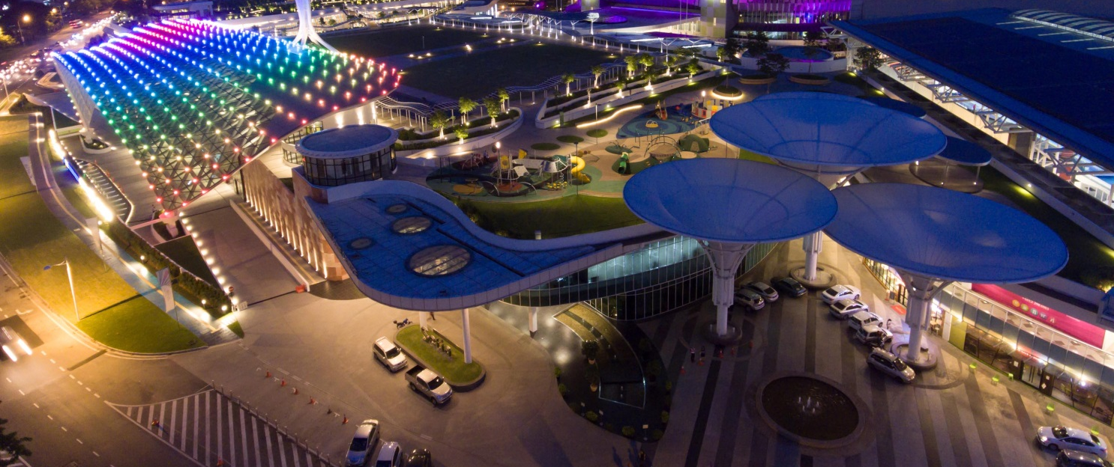

Connected to the SPICE Convention Centre, is a Business Class Hotel with 453 rooms earmarked for completion in 2019 completion in Q3 year 2020. The hotel will be well connected to the convention centre providing great convenience for conference and convention delegates.

Setia SPICE Convention Centre
Add: No. 208, Jalan Tun Dr Awang, 11900 Bayan Lepas, Penang SPICE, No. 108, Jalan Tun Dr. Awang,11900 Penang, Malaysia.
Tel: +604 643 2525
Email: spice@spsetia.com setiaspice@spsetia.com
Info: www.setiaspice.com
Cool Stays
From luxury, boutique to budget hotels as well as serviced apartments, Penang offers a wide selection of accommodation to suit different tastes and budgets for a memorable stay. The popular and dense areas are at George Town UNESCO World Heritage Site, Gurney Drive, Batu Ferringhi, Bayan Lepas as well as in the mainland such as Seberang Jaya, Butterworth and Bukit Mertajam.

List of hotels in the recent years, of various categories and located at different areas in Penang.
Hotels | Rooms | Zone | Web Address
AC Hotel | 423 | Bayan Baru | marriott.com/hotels/travel/penar-ac-hotel-penang/
DoubleTree Resort by Hilton Penang | 316 | Batu Ferringhi | penangresort.doubletree.com
The Light Hotel | 302 | Seberang Jaya | thelighthotelpg.com
*Angsana Teluk Bahang | 250 | Teluk Bahang | angsanatelukbahang.com
Olive Tree Hotel | 250 | Bayan Lepas | olivetreehotel.com.my
Jazz Hotel Penang | 255 | Tanjung Tokong | jazzhotelpg.com
Aroma Hotel | 248 | Butterworth | aromahotel.com.my
Hompton by the Beach, Penang | 240 | Tanjung Tokong | homptonhotel.com
Cititel Express | 234 | George Town | cititelexpress-penang.com
Lexis Suites Penang | 222 | Bayan Lepas | lexissuitespenang.com
G Hotel Kelawai | 208 | Gurney Drive | ghotelkelawai.com.my
Iconic Hotel | 195 | Bukit Mertajam | iconichotel.com.my
The Prestige Hotel | 162 | George Town | theprestige.my
Loop On Leith Hotel | 140 | George Town | loophotelpenang.com
U Hotel Penang | 128 | Bayan Lepas | uhotelpenang.com
De’ Garden Hotel | 123 | Butterworth | degardenhotel.com.my
Kimberley Hotel Penang | 118 | George Town | kimberleyhotel.com.my
M Summit 191 | 96 | George Town | summit191.com
Jerejak Island Resort | 72 | Jerejak Island | jerejakislandresort.com
The Savv Hotel | 46 | George Town | savvhotel.com
Le Dream Boutique Hotel (boutique) | 43 | George Town | ledreamhotel.com
Le Embassy Hotel | 33 | George Town | leembassy.com.my
Macalister Terraces | 20 | George Town | macalisterterraces.com
Jawi Peranakan Mansion Penang (boutique) | 14 | George Town | georgetownheritage.com/jawi-peranakan-mansion
Tien Hotel | 8 | George Town | tienhotel.com
Botanica Mansion (boutique) | 4 | Balik Pulau | facebook.com/botanicamansion
*Opening in Q1 of 2020

Wedding Tourism
Warm sunny beaches, lush tropical forests, awe-inspiring architecture – these are the places where one can say “I do” for life. Penang offers more than just a wedding destination. It boasts a mélange of multi-cultural traditions where Malay Chinese, Indian and European influences co-exist. For this, Penang has a wide range of themed weddings from contemporary to traditional Peranakan, Chinese, Malay and Indian. Coupled with these, the breathtaking sights and unique locations in Penang offer memorable once-in-a-lifetime experience.

Perfect Wedding Venues
The UNESCO World heritage Site in George Town provides a glimpse of the past decades. Home to many Penangites, George Town has a fascinating fusion of eastern and western influences. Till today, you can explore George Town in vintage trishaws as well as discover and learn traditional trades that are popular among tourists and locals. Iconic sites like Cheong Fatt Tze Mansion and Pinang Peranakan Mansion are heavily steeped in history, inviting everyone to reminisce the good old days. Our famous north coast strip comprising Tanjung Bungah, Batu Ferringhi and Teluk Bahang is home to world-renowned beach resorts, shopping and nightlife. This is where the sun sets panting a beautiful beginning for every newlywed.

Below is a list of hotels and unique venues that cater to any type of weddings:
Venue | Web Address
Cheong Fatt Tze Mansion | www.cheongfatttzemansion.com
Eastern & Oriental Hotel | www.eohotels.com
Macalister Mansion | www.macalistermansion.com
Hotel Equatorial Penang | penang.equatorial.com
Pinang Peranakan Mansion | www.pinangperanakanmansion.com.my
Suffolk House | suffolkhouse.com.my
PARKROYAL Penang Resort | www.parkroyalhotels.com/penang
Shangri-La’s Rasa Sayang Resort & Spa | www.shangri-la.com/penang/rasasayangresort
Tropical Spice Garden | tropicalspicegarden.com
Boulder Valley Glamping | bouldervalleyglamping.com.my
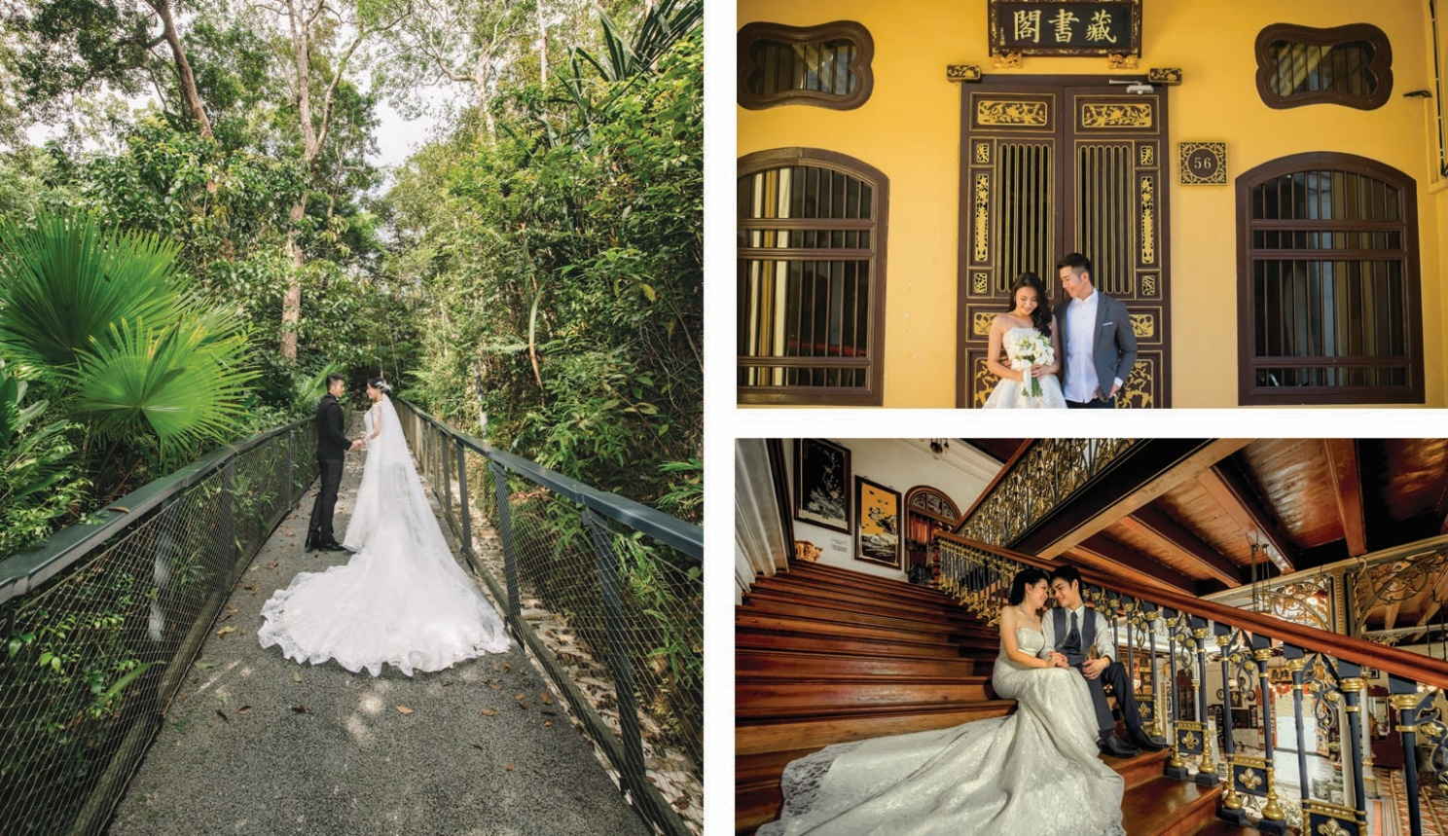

Health Tourism
Health Tourism
Malaysia is currently ranked among the world’s top medical tourism destinations, thanks to its affordable, high quality medical facilities. Medical tourism in Penang is closely monitored by the Malaysian Ministry of Health and Ministry of Tourism to ensure that visiting patients receive the best level of care. Penang’s leading private healthcare institutions meet the Malaysian Society for Quality in Health (MSQH) standards. In addition, many hospitals are also ISO 9001 accredited for Quality Management Systems and have Joint Commission International (JCI) accreditation. For more information, visit pmed.my

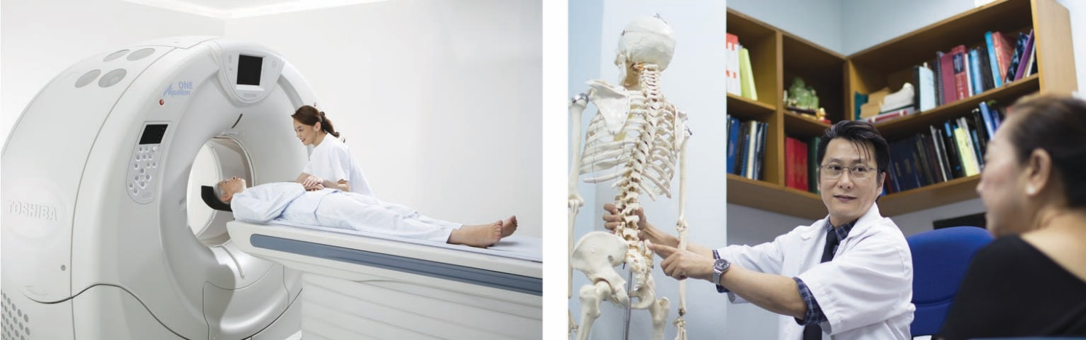

Education Tourism
Penang is evolving into a world class educational hub, offering a professional learning experience, for students all over the world. With its variety of courses offered in top class internationally recognised colleges and universities, Penang has become a prime choice to pursue higher education. Penang is proud of its legacy of an excellent education system, with a history that stretches back to the early days of the British administration. Many of the public schools in Penang are among the best and oldest in the country and the region. Building on this illustrious history, and with English widely spoken, Penang is well-poised to become a centre of educational excellence. For more information, visit studypenang.gov.my

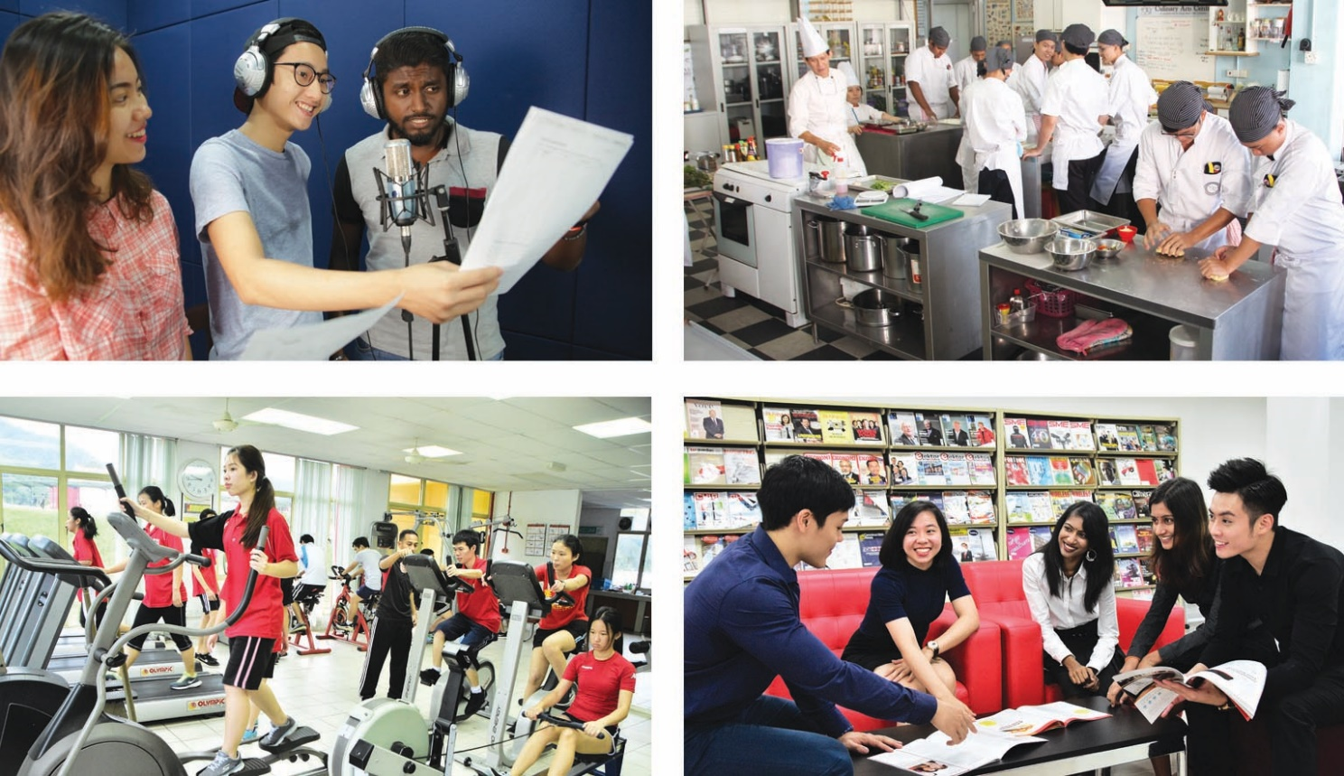

Global Connectivity
Direct air links between Penang and major cities, international and domestic:
Frequency of International Flights
NO. | SECTOR | AIRLINE | TOTAL/WEEK
1 | Singapore | SilkAir | 42 | 107
1 | Singapore | AirAsia | 35 | 107
1 | Singapore | Scoot | 16 | 107
1 | Singapore | Jetstar Airways | 14 | 107
2 | Medan | AirAsia | 35 | 56
2 | Medan | Lion Air | 14 | 56
2 | Medan | Sriwijaya Air | 7 | 56
3 | Jakarta | AirAsia | 14 | 29
3 | Jakarta | Citilink | 8 | 29
3 | Jakarta | Batik Air | 7 | 29
4 | Surabaya | AirAsia | 5 | 6
4 | Surabaya | Citilink | 1 | 6
5 | Banda Aceh | Firefly | 4 | 8
5 | Banda Aceh | Malindo Air | 4 | 8
6 | Hong Kong | Cathay Dragon | 14
7 | Don Mueang (Bangkok) | AirAsia | 14
8 | Suvarnabhumi (Bangkok) | Thai Smile | 10
9 | Guangzhou | China Southern Airlines | 14
10 | Taipei | China Airlines | 7
11 | Ho Chi Minh City | AirAsia | 7
12 | Doha | Qatar Airways | 4
13 | Phuket | Firefly | 4
14 | Shenzhen | Shenzhen Airlines | 4
15 | Kunming | Lucky Air | 2
16 | Chang Sha / Quan Zhou | Qingdao Airlines | 2
17 | Chengdu | AirAsia * | 3
18 | Dubai / Singapore | Emirates ** | 7
TOTAL |  |  | 303

NO. | SECTOR | AIRLINE | TOTAL/WEEK
1 | KLIA | AirAsia | 113 | 180
1 | KLIA | MAS | 46 | 180
1 | KLIA | Malindo Air | 21 | 180
2 | Subang | Firefly | 80 | 129
2 | Subang | Malindo Air | 49 | 129
3 | Langkawi | AirAsia | 25 | 32
3 | Langkawi | Firefly | 7 | 32
4 | Melaka | Malindo Air | 7 | 14
4 | Melaka | AirAsia | 7 | 14
5 | Johor Bahru | AirAsia | 45
6 | Kota Kinabalu | AirAsia | 14
7 | Kota Bharu | Firefly | 14
8 | Kuching | AirAsia | 14
9 | Kuantan | Firefly | 4
TOTAL |  |  | 446
Frequency of Domestic Flights
Source: Malaysia Airports Holdings Berhad (Updated February 2020)
*Flight commences Q1/Q2
**Flight commences 9 April 2020



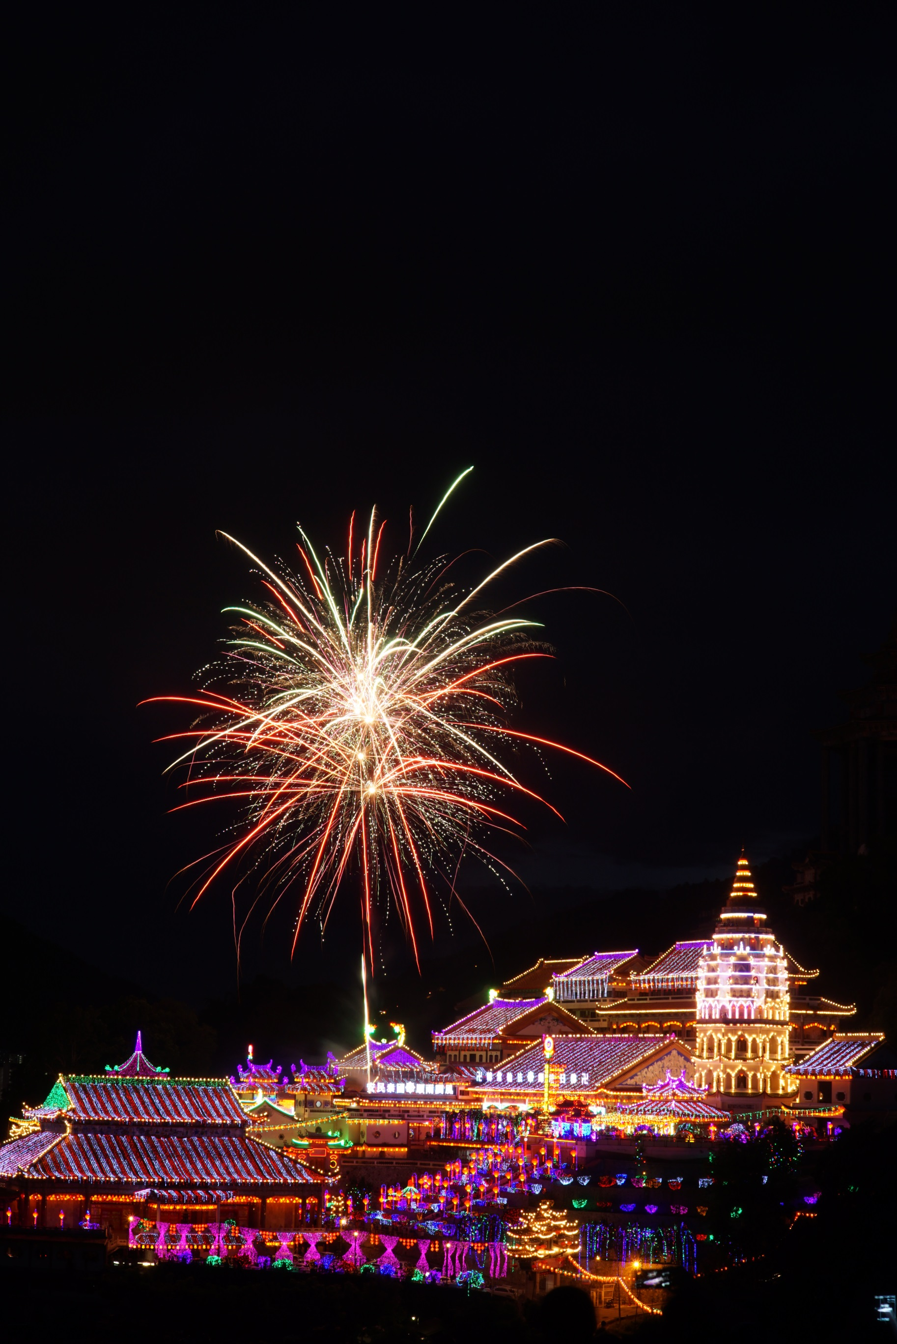

IT’S ALL IN PENANG,
EXPERIENCE IT.


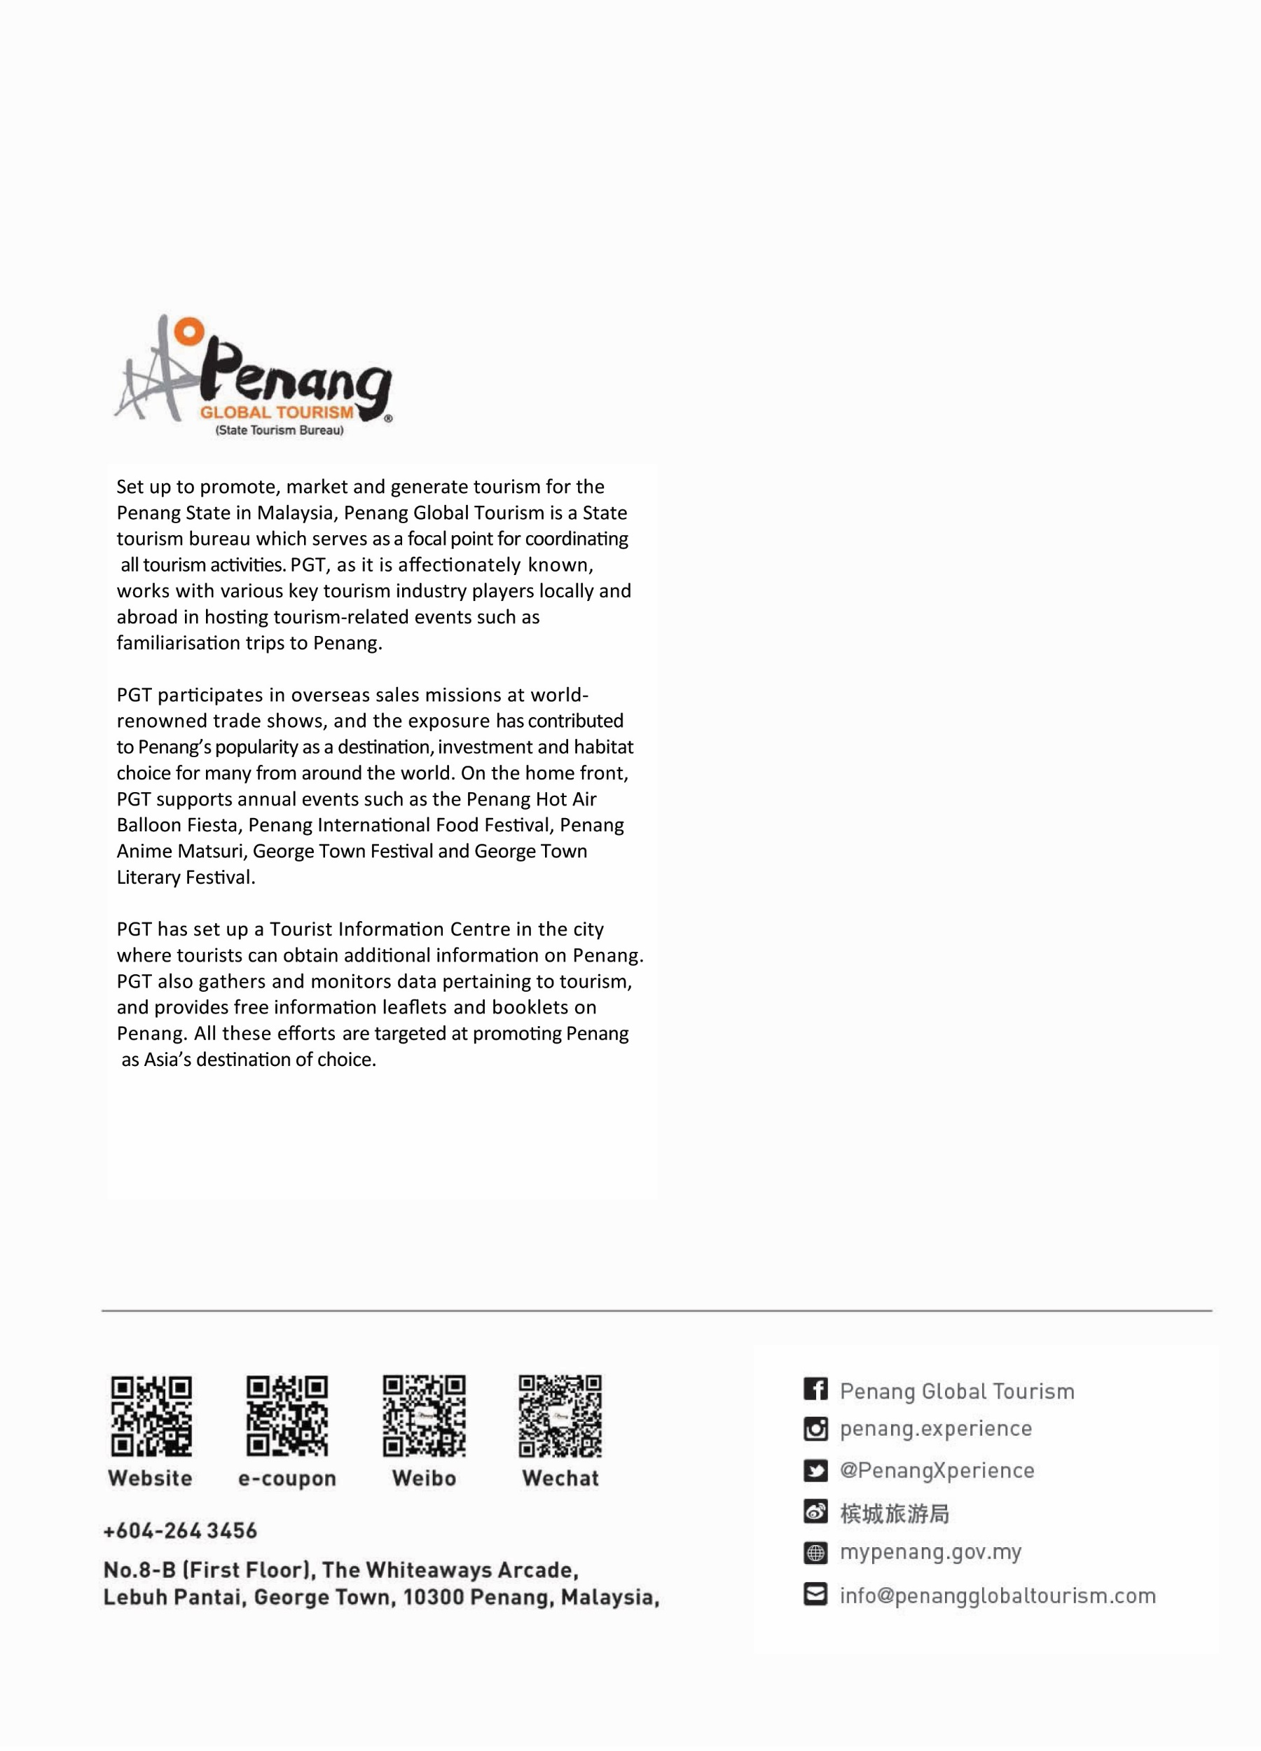
LinkedIn – Penang Global Tourism
Set up to promote, market and generate tourism for the Penang State in Malaysia, Penang Global Tourism is a state tourism bureau which serves as a focal point for coordinating
all tourism activities. PGT, as it is affectionately known, works with various key tourism industry players locally and abroad in hosting tourism-related events such as familiarisation trips to Penang.

PGT participates in overseas sales missions at world-renowned trade shows, and the exposure has contributed
to Penang’s popularity as a destination, investment and habitat choice for many from around the world. On the home front, PGT supports annual events such as the Penang Hot Air Balloon Fiesta, Penang International Food Festival, Penang Anime Matsuri, George Town Festival, George Town Literary Festival and more.

PGT has set up a Tourist Information Centre in the city
where tourists can obtain additional information on Penang. PGT also gathers and monitors data pertaining to tourism, and provides free information leaflets and booklets on Penang. All these efforts are targeted at promoting Penang
as Asia’s destination of choice.

