CAT Shuttle Bus in Penang

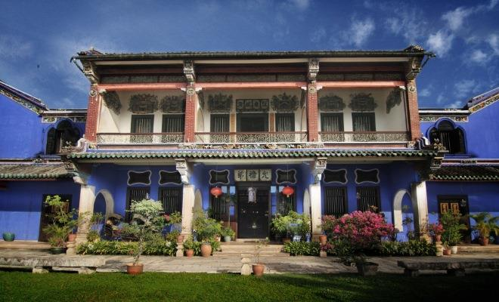

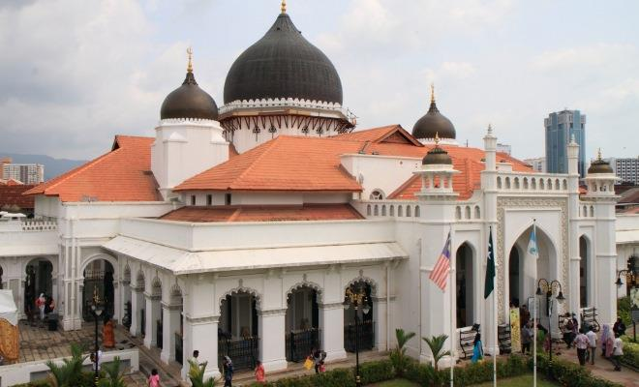

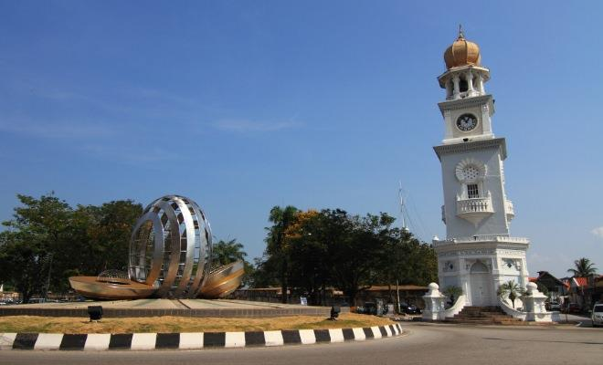

Central Area Transit (or CAT, as it's fondly called) is a free shuttle service that picks you up from Weld Quay Bus Terminal, travels along major streets in George Town and drops you at designated bus stops that are mere walking distance from major attractions.
As of June 2014, Rapid Penang is revamping their shuttle buses (brand new changes include up-to-date exterior and bus routes). Till the makeover is fully integrated, these CAT shuttle buses are under several guises such as ‘5 Shuttle’, ‘Free Shuttle’ or 'Free Hop On - CAT Shuttle'. Worry not, the original bus routes remain the same.
For a shuttle bus adventure in George Town, here’s where you should hop on and hop off:
Station 1: Pengkalan Weld
Here’s where George Town’s main bus terminal is located and this marks the first stop of the CAT route. For a view of Swettenham Pier and Chulia Street Pier, try to snag a seat on the left side of the bus.
Station 2: Feri
The journey to Station 2 is a quick one and if you’re interested to snap photographs of Wisma Yeap Chor Ee and Wisma Kastam, these buildings are 7-10 minutes’ walk from Station 1.
Station 3: Little India
Little India becomes a lot more vibrant when it hits noon. Hop off if you’re planning to shop for spices and sarees. Other nearby attractions include Pinang Peranakan Mansion, Chung Keng Kwee Ancestral Temple and a vintage-looking OCBC building.
Station 4: Imigresen
Banks, commercial buildings and administrative offices reside within the British colonial buildings. Station 4 is located at the end of Lebuh Pantai, where the police station is, so hop off and admire these buildings up close. There's also a good lunch spot at the nearby Sri Weld Food Court.
Station 5: Bank Negara
If you're in a hurry to visit City Hall, Town Hall, Fort Cornwallis and War Memorial, hop off here. Or wait for the bus to complete its round till Station 17 where these attractions are situated nearby.
Station 6: Muzium
History lovers, here’s your stop. Within walking distance from Station 6 are Penang State Museum, St. George’s Church (closer at Station 16), Church of Assumption, Convent Light Street, Court Buildings and St. Xavier’s Institution.
Station 7: Lebuh Muntri
If you enjoy a great amount of strolling, stop by at Station 7 for attractions like St. Francis Xavier Church and Cheong Fatt Tze Mansion. For the mystery of the undead, there’s an age-old Christian Cemetery nearby too.
Station 8: Lebuh Campbell
If your main incentive in Penang is to cover the religious and shopping aspects of this town, this station is within walking distance from Benggali Mosque and Chowrasta Market (closer at Station 12).
Station 9: Komtar Pusat
Komtar also provides buses to off-route journey such as Batu Ferringhi, Bayan Lepas, Balik Pulau and more. Komtar currently serves as an administrative office and houses ICT Digital Mall for affordable gadget and technology goods. Should you prefer Cotton On tee shirts over Canon cameras, take the Komtar's link bridge to Prangin Mall and 1st Avenue Mall.
Station 10: Jalan Kedah
Never underestimate the lack of beautiful surroundings at Station 10. Make your way out of Jalan Transfer and turn towards Jalan Burma to check out the first Glass Museum in Malaysia.
Station 11: Chowrasta
For nutmegs, tau sar peah and fresh pickles, Station 11 is located right at the entrance of Chowrasta Market. So, set yourself free. There are also a couple of second-hand bookshops located on the first floor of the market that is filled with biographies, paperback novels and even, old comics. Don’t forget to set aside 15 minutes for a bowl of cendol at Penang Famous Teochew Chendul on Lebuh Keng Kwee.
Station 12: Komtar Timur
If you change your mind, here’s your last chance to hop off at Prangin Mall. Nearby attraction include Masjid Pintal Tali.
Station 13: Lebuh Carnarvon
While Penang Islamic Museum is under renovation, trace the history of Sun Yat Sen at his Penang base and then, treat yourself to a stroll at Campbell Street Market.
Station 14: Kampung Kolam
The station is surrounded by Acheen Street Mosque, Masjid Kapitan Keling, Yap Kongsi, Khoo Kongsi, Cheah Kongsi and Lim Kongsi, collectively known as ‘Street of Harmony’. If you’re up for a hefty dinner, Nasi Kandar Beratur, situated next to Masjid Kapitan Keling, promises a feast for the senses.
Station 15: Mahkamah
The shuttle stops in front of St. George’s Church and close to other places of worship such as Kuan Yin Teng and Sri Mahamariamman Temple.
Station 16: Dewan Sri Pinang
If you prefer to be dropped off at the entrance of Dewan Sri Pinang, alight here. You can also catch up on earlier attractions (reachable from Station 6) such as City Hall, Town Hall, Court Buildings, War Memorial and Logan Memorial.
Station 17: Kota Cornwallis
For a peek at our historical fort, the Fort Cornwallis, here is where you should be. You could also catch a view of Queen Victoria’s Memorial Clock Tower from your current stop.
Station 18: Lebuh Downing
This is your last stop before the bus heads back to the Weld Quay Bus Terminal. Do a final catch-up of the colonial architecture of Spaces Building (formerly known as Standard Chartered Building), Islamic Council Building and HSBC Building.
Bus frequency from Weld Quay Bus Terminal and other bus stops are within 15-20 minutes. For bus arrival time, kindly contact Rapid Penang ICIS Centre at 04-255 8000. Arrival time is subjected to traffic and weather conditions. For more information, visit Rapid Penang website.
Operating hours for this shuttle service are from 6.00am – 12.00am.

