Explore Teluk Bahang!

The Penang National Park is probably one of Malaysia’s best kept eco-tourism attractions. While the Park is comparatively tiny next to Taman Negara or the Belum Rainforest, its small size makes it especially manageable for visitors on a tight schedule and unlike the other National Parks, there are beaches galore to explore!
Diversity of wildlife and terrain is what makes this Park so interesting. Even though it's the world’s smallest forest reserve at just over 25sq km, it’s packed with over 150 species of birds, 400 species of flora and 140 species of fauna. In terms of terrain, the Park is home to a rare meromictic lake, mangroves, mudflats and has a turtle nesting beach and turtle sanctuary.

The Park is especially popular with local trekkers as there are plenty of well-marked jungle trails of varying difficulties. Take a hike through the jungle to the Muka Head lighthouse which was built in 1883 and admire the spectacular views of the island from the top. If hiking isn’t your thing, pack a picnic basket, hire a boat from one of the many booths at the Park’s entrance and head off for a relaxing day on a remote, secluded beach. It is possible to camp overnight in the National Park just don’t forget to register with the Park authorities and pack plenty of mosquito repellent.
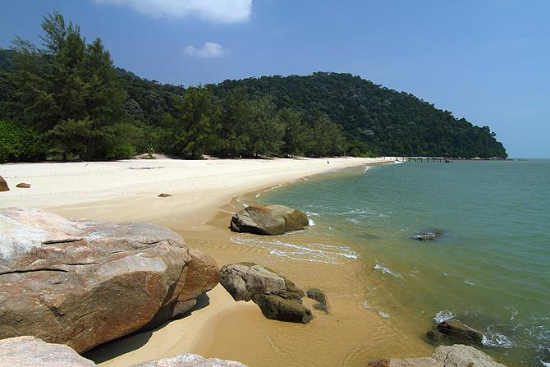
Things to do
Enjoy traditional Malay food at any of the roadside restaurants in the fishing village of Teluk Bahang, there’s plenty of fresh seafood on offer! There are also a number of sport fishing operators in the area for keen anglers. Minutes away from the National Park is Asia’s only dedicated spice garden - Tropical Spice Garden, a tiny piece of paradise dedicated to Penang’s heritage as a spice island. Entopia by The Penang Butterfly Farm showcases over 4,000 butterflies as well as reptiles, amphibians and assorted creepy crawlies. For high-adrenaline family fun eco-themed Escape, is the place to climb giant trees, experience hi-speed ziplines and take on rope obstacle courses. Cool down with refreshing fruit juices and relax with great views of the sea and jungle from the Tropical Fruit Farm. Penang’s famous durian and nutmeg plantations are all located in the lush hills around Balik Pulau; most of the fruit orchards are open to the public for fruit tasting.

