5 ways to soak up the Deepavali feels in Penang's Little India

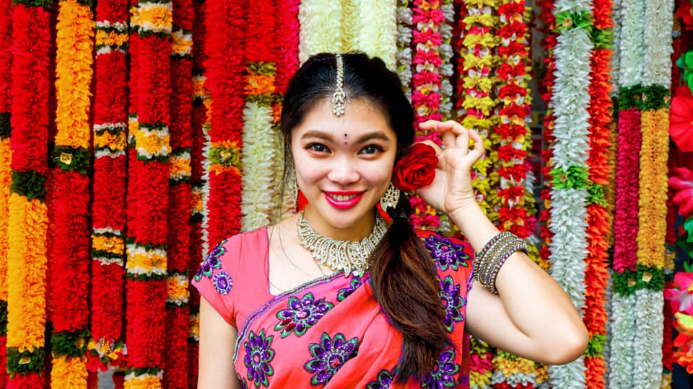

Photo credit: Eeda Shiu
Fringed by Queen Street, Chulia Street and Market Street, Penang's Little India is shining bright since the beginning of the month in anticipation of Deepavali. Vibrant, colourful and chaotic, the heritage-rich Indian enclave is one of the best places to soak up some Deepavali feels. Here's our guide for an all-round sensorial Deepavali experience.
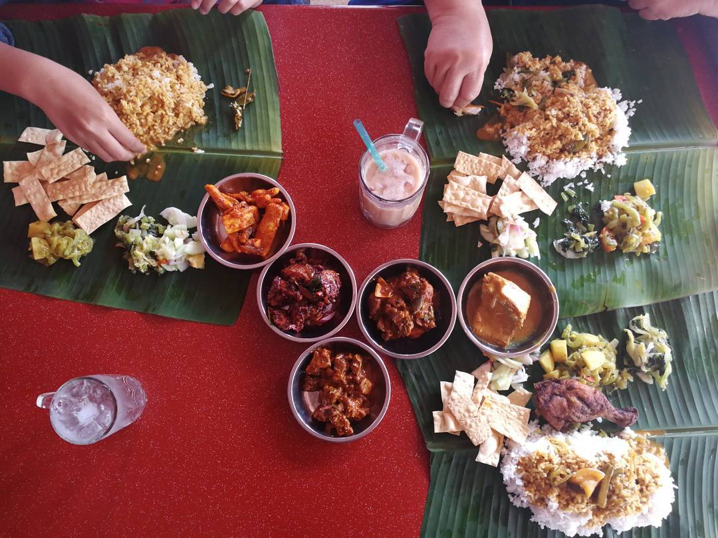

#1: Feast on banana leaf rice
The best way to experience a culture is through its food, so sit back and fill your belly with banana leaf rice. Little India has a long lineage of ethnic Indian restaurants serving banana leaf rice, and its finger-licking goodness is perfect for an authentic taste of Deepavali. A typical banana leaf meal is served with white rice, vegetable dishes, an assortment of curries and crispy papadum and is best eaten with hands! Pro tip: If you’re not a rice person, then opt for thosai, a savoury South Indian pancake, instead.

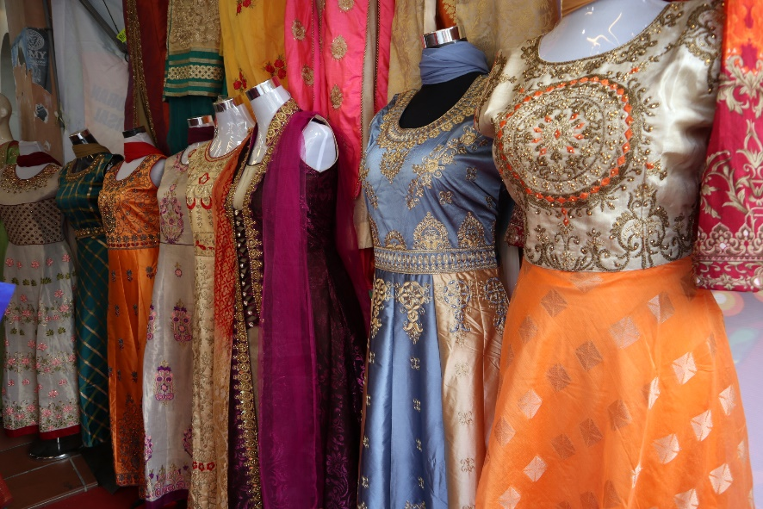

#2: Glam up your Deepavali #ootd
Glam up your Deepavali #ootd with brightly coloured Punjabi suits and sarees! Shops in Little India sell Punjabi suits and sarees sourced from major cities in India such as Chennai and Delhi. There are also crisply starched cottons and intricate thread work sarees to choose from. The streets are filled with vendors selling flower garlands and fashion accessories so dress up your hair with jasmine flowers and complete your look with a rhinestone handbag, shoes, and jewelry!
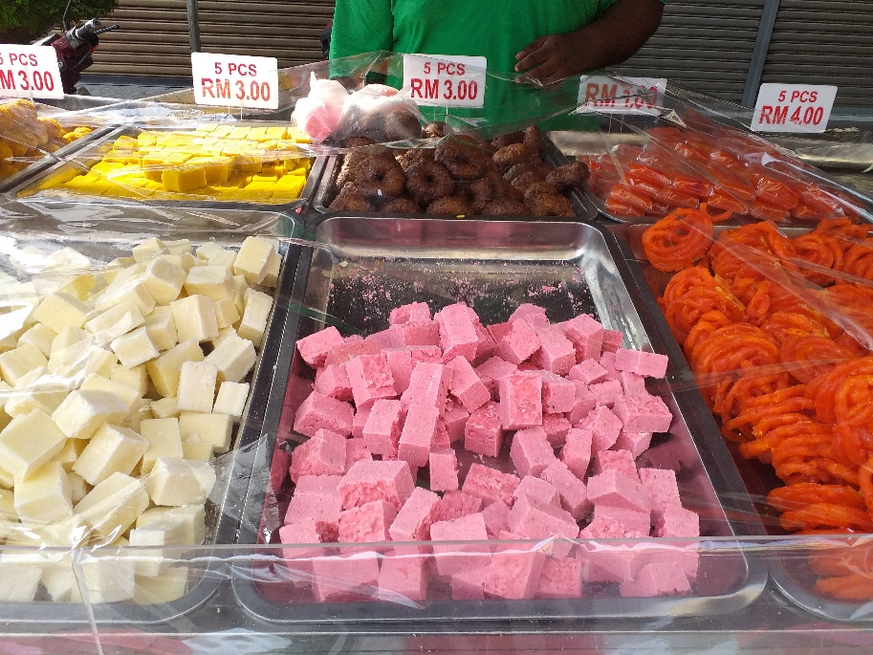

#3: Feast on Instagram-ready Indian sweets
No Deepavali celebration is complete without feasting on Instagram-ready Indian sweets. According to Ravi, a street vendor at Queen Street whose cart is filled with traditional Indian festive treats, local Indian customers would look for adhirasam (Indian-style doughnut) and jalebi (spiral-shaped sweets) while tourists prefer brightly coloured coconut candies instead. If you’ve got a sweet tooth, this is your chance to indulge but if sinfully sweet treats are a thing of the past, then chow down on savoury snacks such as murukku and mixed nuts.

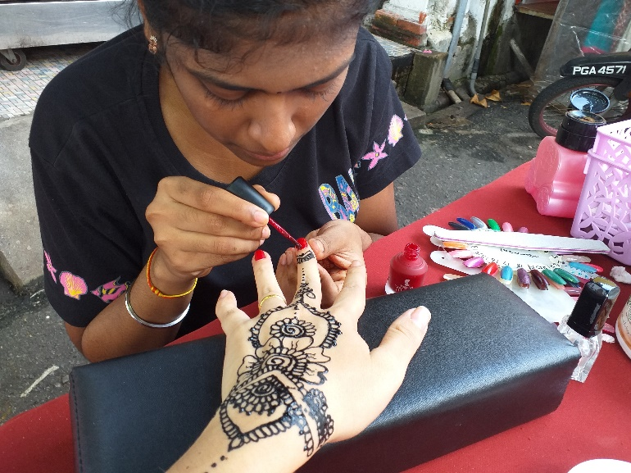

#4: Get a henna tattoo
One of the coolest unexpected Deepavali trends in recent years is henna tattoos, and frankly, we’re all about it. This well-loved Indian tradition, once seen only on brides, has become a much sought-after festive trend. According to Ramya from Ruba’s Bridal & Beauty Salon, there are various designs and colours to choose from, but customers are more likely to choose a floral motif tattoo with added rhinestones to bedazzle their palms, hands, legs and ankles! Henna tattoos, although temporary, can surely make a lasting impression! Also, you can get a manicure to match your tattoo!
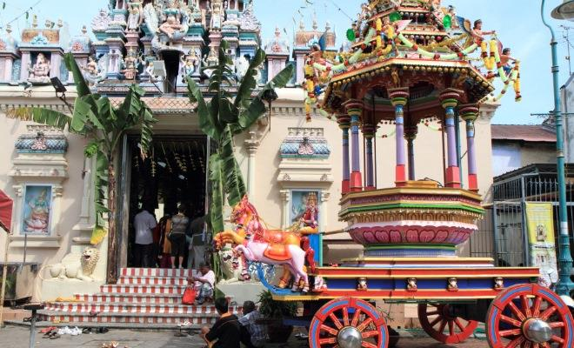

#5: Visit Penang’s oldest Hindu temple
Dedicated to the Hindu deity Sri Muthu Mariamman, the century-old Sri Mahamariamman Temple on Queen Street is the jewel in Little India’s crown. You can spend all day admiring sculptures of gods and goddesses over its main entrance and facade. Be sure to reach the temple before 12pm if you want to watch the temple’s priests anointing the deity with oils, sandalwood paste, and milk before bathing the deity with water. Observing the priests performing puja (prayers) while devotees performing archanai (offering) amidst a riot of colours stemming from saree-clad womenfolk, intricately drawn kolam and garlands of flowers can be spiritually pleasing, too.

Penang Hill: Cool Respite and Awe-Inspiring
With its misty morning trails, vegetable and flower farms and charming colonial bungalows, Penang Hill (or Bukit Bendera) has been a popular hill resort since the 18th century when visitors were taken up on horseback or special sedan chairs. Now, getting to the top is easy-peasy thanks to the upgraded funicular which whisks visitors from the station at the foot of the hill to the summit in only a matter of minutes.
The top of the Hill offers fantastic views of the island and mainland, lush greenery, quaint colonial style architecture and cooler temperatures. There are a number of eateries on the Hill and David Brown's Restaurant & Tea Terrace is the ideal place to enjoy a traditional afternoon tea with scones.
There are plenty of trails to explore at a leisurely pace, including four bypass trails. Download a map at: http://www.penanghill.gov.my/index.php/takeatour/maps. Taking the funicular isn’t the only way up the Hill, there is a jeep service which leaves from the Botanical Gardens and takes approximately 20 minutes. For the more adventurous there are also a number of jungles trails up the Hill.

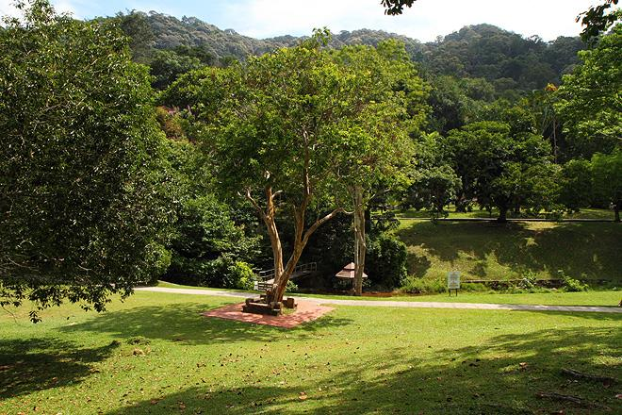

Things to do
Before taking the funicular up the Hill, enjoy a Penang-style breakfast at the Air Itam market - a vibrant, bustling local market crammed with fresh produce, kitchenware and assorted knick-knacks. The sprawling Kek Lok Si Temple with its ornate pagoda is close by. The Temple is one of SE Asia’s largest.

The Penang Botanic Gardens is one of Asia’s oldest botanical institutions. Take a leisurely wander through the sprawling gardens and look out for the exotic Cannon Ball Tree and Bat Lily. There are plenty of excellent nature trails of varying lengths and to suit different interests - the Friends of the Penang Botanic Gardens Society run guided tours.
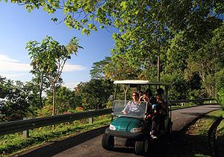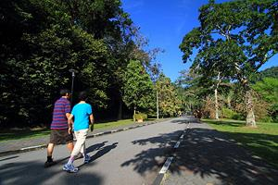
Unique Shopping Experience
Shopping in Penang is a unique experience, with its modern shopping malls juxtaposed with traditional bazaars and street markets. However, for those on the hunt for something special Lebuh Armenian is the place to go with its plethora of funky artisanal boutiques.
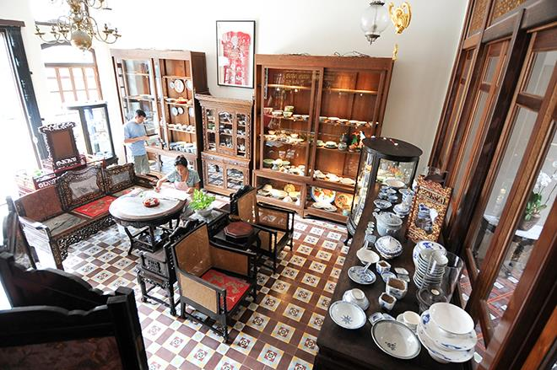
Shops to look out for include, Studio Howard for bright, unique photography, Fuan Wong for artisanal glass sculptures and Jonathan Yun Sculptural Jewelry. Close by is Galeri Seni Mutiara which regularly showcases promising and established Malaysian artists. While China Joe's is directly opposite the Yap Kongsi has a great collection of art books and Asian furniture. 41 Living Story at Love Lane stocks a wide range of small handicrafts and unusual handmade knick-knacks.
There are a number of antique shops to be found along Lebuh Chulia and Lebuh Campbell. For high quality antique furniture and period porcelain a visit to Seven Terraces is a must; this beautifully-restored row of terrace houses is also a popular boutique hotel.
Other boutique hotels in the heart of the George Town World Heritage Site include, Cheong Fatt Tze - The Blue Mansion, Campbell House, and Muntri Mews. Away from the city are the historic Lone Pine Hotel in Batu Ferringhi and Malihom nestled in the rolling hills of Balik Pulau.

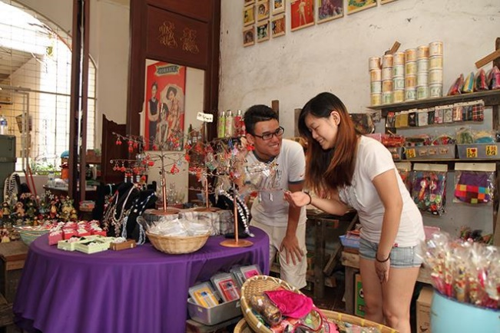

Things to do
There are numerous traders and craftspeople in Penang that still create and sell heritage products such as stone seals, furniture, traditional lanterns, wooden signboards, calligraphy, antiques, coffee powder etc. To find out more visit www.gtwhi.com.my or www.pht.org.my

