Penang War Museum: Hidden War Relic in Modern Day Penang
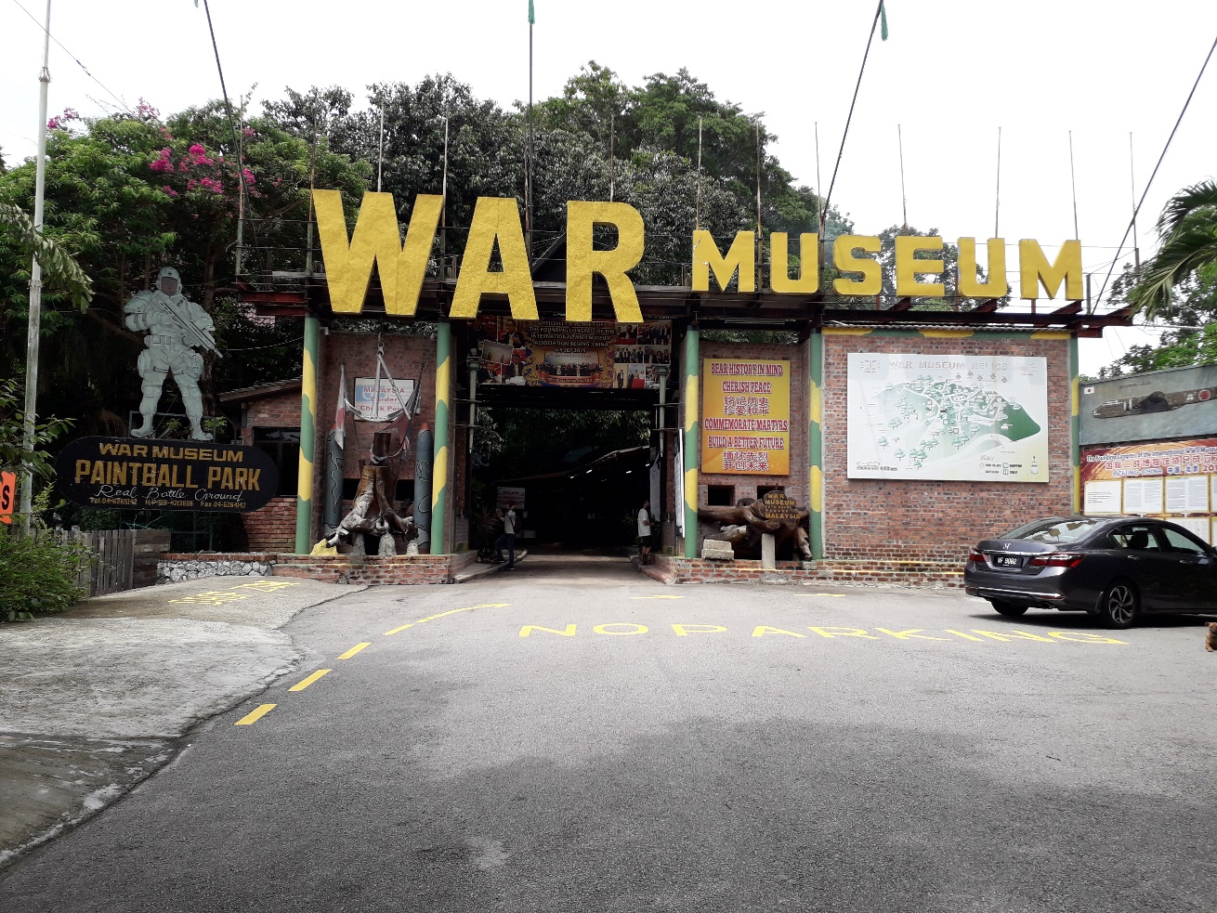
The Penang War Museum is reputed to be the largest war museum in South East Asia. Strategically located on top of the Batu Maung Hill on the south-east of the island, the Penang War Museum was initially a military fortress designed by the British in the 1930s. The 19.36 acres military fortress has a magnificent 320-degree view of the sea around the island, to defend the Straits of Malacca from Japanese attack coming from the South channel.
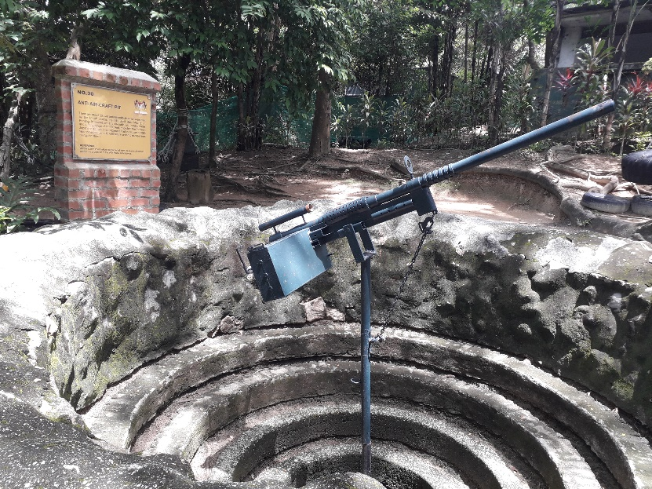
An Anti Aircraft Pit which was used by the British to shoot at overflying aircraft

It houses a cannon-firing bay, anti-aircraft firing pits, sleeping quarters for soldiers, cookhouse, lockup, and a command centre.
“This place was a military stronghold for the British, but unfortunately it was lost to the invading Japanese during World War II in 1942. In history, the British had anticipated an attack from the sea, but the Japanese army approached the fortress by land instead, after pressuring the Thai government to allow the passage of Japanese troops to invade British-held Malaya,” said Jenny Johari, Manager of the Penang War Museum.

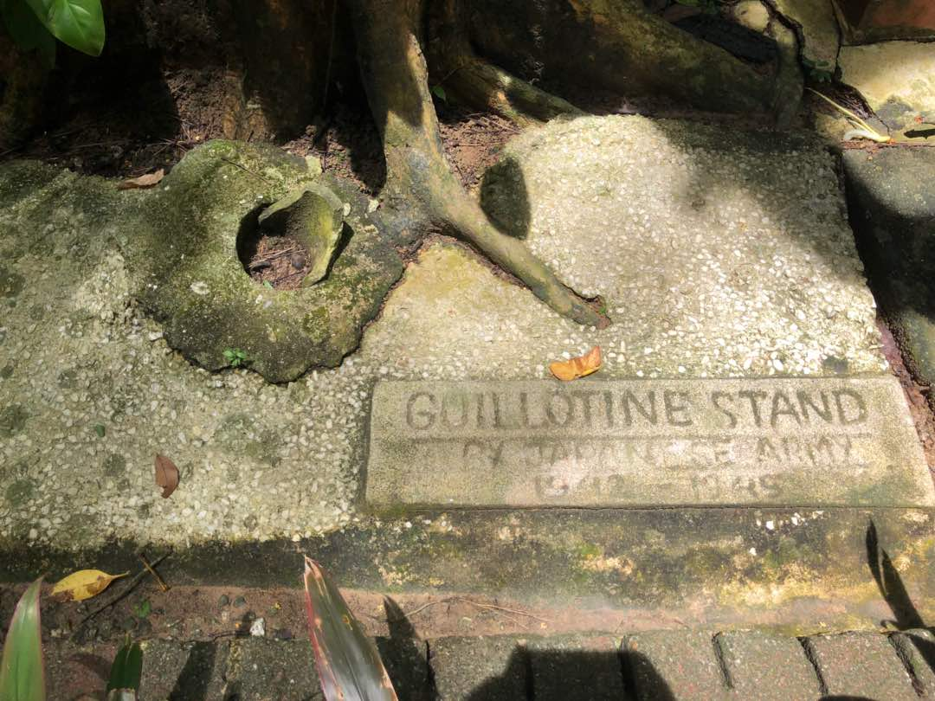
Remnant of a guillotine stand used by the Japanese Army
“When the Japanese took over this fortress, it was used as a site to detain prisoners of war. During that time, the Chinese community in Penang lived in constant fear of being targeted victims by the Japanese. The Japanese often detained and interrogate students from local Chinese schools, Chinese community leaders and others.
“Many untold atrocities were carried out here. There is a guillotine stand used by the Japanese army and a room riddled with bullet holes on the wall. Civilians and prisoners of war were tortured and executed,” Jenny says.
The Japanese remained in occupation until their surrender to the Allies in 1945 and left Malaya. For almost 60 years, the fortress was abandoned and remained unknown, untouched, forgotten, until the founder, Johari Shafie took a civil initiative and restored the fortress to its former glory.
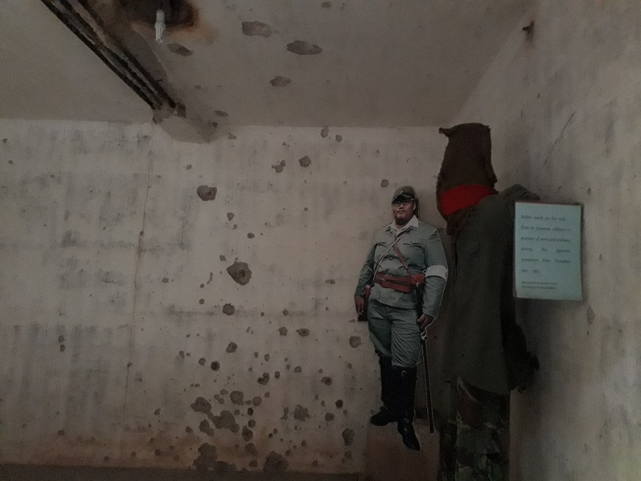
Wall riddled with bullet holes
“Most of the buildings and structures here have stood the test of time. Much of what you see is in the same condition as when the fortress was built, except for some missing brass doors and windows which was looted by scavengers. The road that visitors walk on today also survived. We display a portion of the road as a relic. You will see it as you walk into the museum,” says Jenny.
The museum also makes use of replicas, picture exhibits, and testimonies to recreate pieces of history, in the case of soldiers and survivors in Penang during the war, from whom the Penang War Museum collected their oral histories.
Mohammad Nasrullah, a first-time visitor from Melaka, was surprised at how much he enjoyed being at the museum. “I expected to see endless displays of weapons, old documents, pictures, guns, grenades, and uniforms. Instead, I get to wander around cannon firing bay, underground tunnels, and a lockup. I get to feel the function of this place back in the days. I spent my time trying to imagine what this military fortress would have looked like.”
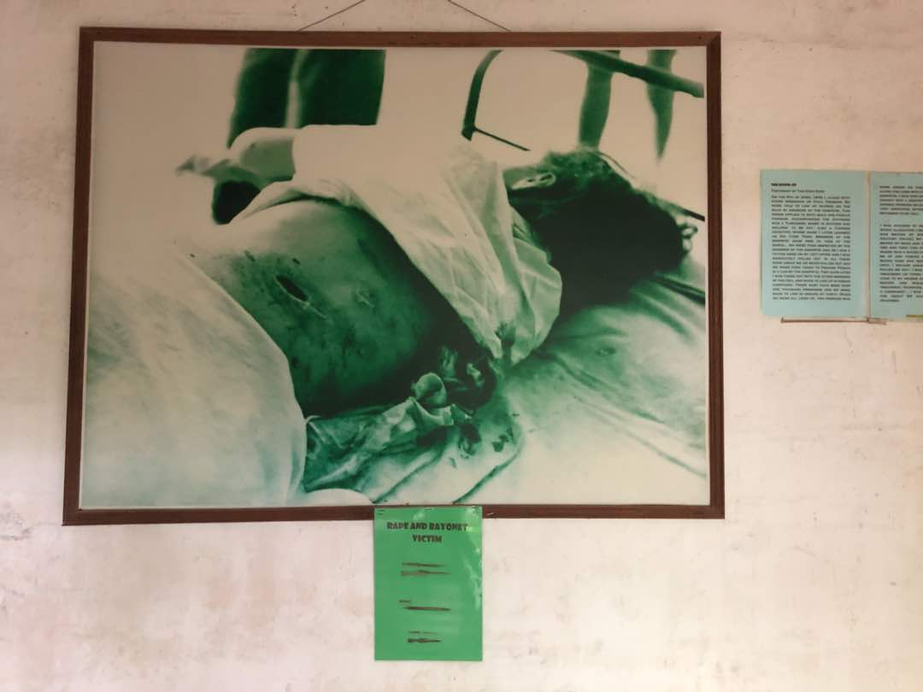
A picture of a rape and bayonet victim
Nasrullah said he was drawn to the pictures of a rape and bayonet victim in the museum. “There’s something about the picture that gives me the chills. I cannot imagine the extend of atrocities during the World War II. I don’t think I would have survived.”
In 2013, Penang War Museum was featured on National Geographic. In 2015, the Penang War Museum was the first war museum in South East Asia to be invited as part of the members of The Founding Congress of the International WWII Museum Association, a nod to the founder's tireless effort to protect wartime heritage.
"The Japanese Occupation of Malaya was such an enormous event for the nation, but we are now at a point where it has fallen from living memory. We try to preserve our wartime heritage so that our people get to explore and discover what it was like during the World War II. See history come alive at Penang War Museum!” Jenny says.
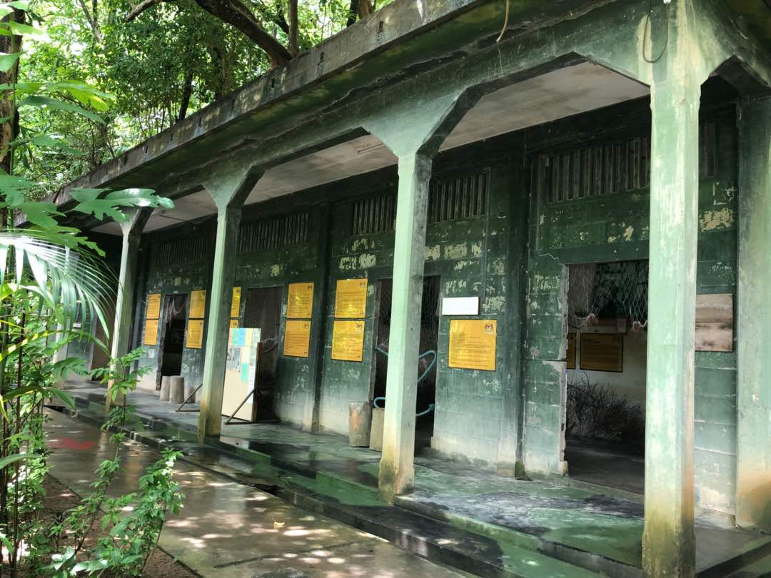
One of the buildings within the fortress
Tips:
Dress in light, cool clothing, wear comfy shoes, put on a dull coloured hat, and be armed with a pair of binoculars, insect repellent, notebook and pen.

Getting there:
We recommend hiring a taxi or using a ride-hailing platform. But if you're up for an adventure, then take Rapid Penang Bus 302 from Komtar and tell the driver to drop you at the Penang War Museum. You will have to hike up quite a bit, but it's worth it.

Entrance Fee
Mykad Holder (Child): RM10.00
Mykad Holder (Adult): RM20.00
Foreign Guest (Child): RM17.00
Foreign Guest (Adult): RM35.00

The Penang War Museum opens daily from 9am to 6pm. For sales and ticketing enquiries, you may call their customer service at +604 626 5142 or email them at penangwarmuseum@yahoo.com

A “Living Heritage Treasure of Penang”
Having had a valuable title of a “Living Heritage Treasure of Penang” bestowed on him, Mr. Sim Buck Teik is the owner of Seang Hin Leong on Beach Street. Now in his eighties, Buck Teik no longer works full time, but he still spends most of his day at the shop. He loves sitting in his shop facing the street, where he can enjoy the breeze gushing in. His shop is being prolonged by his son and daughter, Mr. Sim Hin Leong and Ms. Sim Jeck Choo. Buck Teik learnt his craft techniques from his father, in his home district of Teochew in China, before the family moved to Malaya (how Malaysia was referred to in that era).
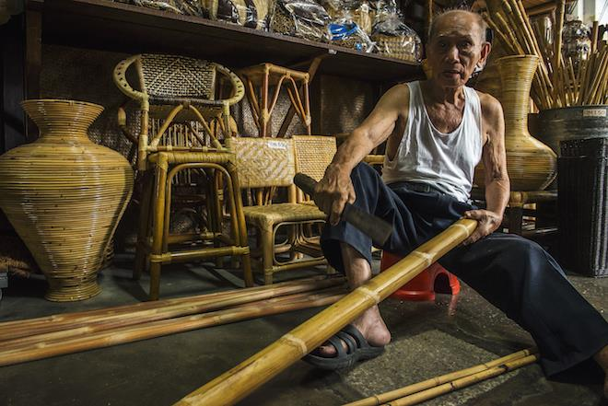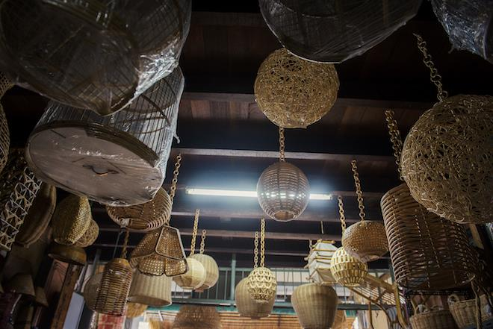
At the shop, the Sims work with rattan and bamboo, making them into furniture and household objects. They are all highly skilled in rattan weaving and is capable of weaving in all shapes and sizes demanded by their customers. At Seang Hin Leong, they are specialised in making customised items and doing repairs on an old object. Other than producing objects for sale, they also run rattan weaving classes for tourists at a reasonable price of RM80.
Other than items made in-house, the shop also sells ready-made products from China, Indonesia and Singapore. Business these days are considered low compared to when demand for rattan products was high. Despite this, the Sim family is still determined in growing their business and passionate as ever in rattan weaving. Most of their rattan supplies are taken from Pahang.
Rattan is known for its durability but if it’s not treated the right way, it will come out as fragile. Furniture and any other products made by rattan are proved to be robust. Prior to any weaving, they must be soaked in water, increasing the flexibility of each rattan so that it does not break when it’s bent. When the rattan dries, it will become tighter and sturdier. As certain parts of the rattan can be sharp and could cause hurt, it is important to make sure that its surfaces are smooth and parts with black marks are not sticking out. Buck Teik will smoothen the rattan with a knife, and double check by rubbing his hands across the rattan, making sure that it’s smooth. Buck Teik is good at weaving small items. The products they make ranges from furniture to unique items such as handbags made using rattan. Smaller products like decorative items could take them up to one day to complete, and a furniture can take a few days, depending on its size.
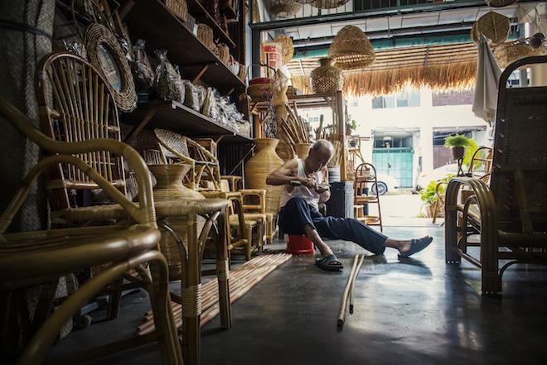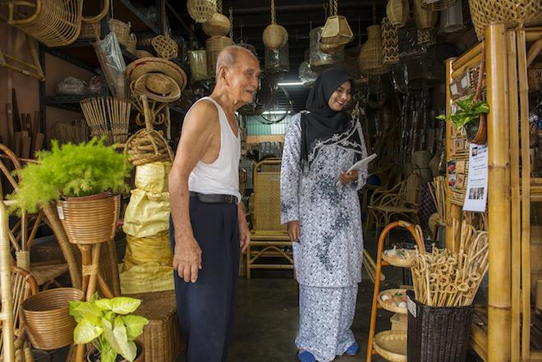

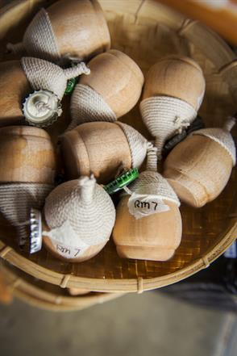
Majority of the customers at Seang Hin Leong are locals. Prices at the shop are fixed, with a price tag pasted on each of their items. Other than rattan products, souvenirs such as keychains, fridge magnets, wooden spoons etc are also sold.
Having run his business here all these years, Buck Teik adores the environment around him and he is grateful that the road has remained at its quiet pace, allowing his customers to be able to park when visiting his shop. On top of everything else, he is extremely pleased that his children has taken after him with a passion in rattan weaving and is working hard in growing and prolonging this brainchild of his.

Ecosites to visit in Penang
Penang Hill
Rising more than 2,000 feet above sea level, Penang Hill offers a panoramic view of George Town with a 15-min funicular train ride up to the top. Enjoy the cool climate while you explore and learn the history, flora and fauna of this prominent hill in Penang. Audio guide sets are available for rent at a reasonable price, and this enables the convenience of having your tour around, including other attractions up the hill at your own pace. Penang Hill holds a record of a 10-million-year-old rainforest ecosystem. It offers a dipterocarp forest and oak-laurel forest that houses a plethora of endemic and endangered species, such as the Exorhopalia Ruficeps, Maingaya Malayana or even the Penang Slipper Orchid! Wildlife such as Dusky Leaf-Eating Monkeys, squirrels, wild boars and tree shrews can be seen there too!
Address: Jalan Stesen Bukit Bendera, Air Itam, 11500 Penang
Contact: +604-828 8839 / 828 8880 / 828 8861 / 828 8862
Website: http://penanghill.gov.my/
The Habitat
The place to visit for the most complete, exciting and educational Malaysian rainforest experience. With world-class facilities, dramatic natural beauty, and a commitment to conservation and environmental awareness, soak into the genuine beauty of this magical natural kingdom the moment you enter. The first of its kind in Malaysia, rolling hills, pristine rain forest, lush flora, enormous granite boulders and distant views makes this place a world-class and must-see ecotourism site in Penang!
Address: Penang Hill, Jalan Stesen Bukit Bendera, Air Itam, 11500 Penang
Contact: +604-826 7677
Website: http://thehabitat.my/
Bukit Panchor State Park
A well-developed state recreation park that is brimming with wildlife, a flowing river and lush greeneries. A suitable place for an adventurous nature escapade, be sure to explore the unique mangrove life forms, bat caves and the wetland boardwalk while here!
Address: Nibong Tebal Recreational Forest, Seberang Perai, Penang
Contact: +604-593 2977
Penang National Park
Known as the smallest national park in the world, the Penang National Park is home to a massive family of flora and fauna. The park includes a rare meromictic lake where fresh and sea water meet; and eight beaches with the popular one being the Pantai Kerachut that has its very own turtle sanctuary. There are well-marked trails for trekking here, leading into the meromictic lake, jungles and bays and an old lighthouse from the 19th century in Mukah Head; which was used to warn ships of dangers around the waters.
Other eco-attractions in the Penang National Park:
- Mangrove Forest and Dipterocarp Forest
- 410 flora species and 143 fauna species like snakes, macaques, leaf monkeys, otters, hawksbill turtles, dolphins and more
- Pantai Kerachut – rent a boat for the day and get to the beaches for a picnic!
- Bukit Batu Hitam – the tallest peak, slopes from the eastern boundary between Penang National Park and the Teluk Bahang Dam
Address: Jalan Hassan Abas, Teluk Bahang, 11050 Penang
Contact: +604-881 3530

Tropical Spice Garden
Spanning over eight acres of secondary jungle and dotted with more than 500 species of tropical flora and fauna, discover the enchanting paradise of the Tropical Spice Garden in Penang. Tucked within a natural valley facing the Straits of Malacca, explore the diversity of nature through the hills, natural streams and jungle terraces or just sit back and unwind with some food or tea at the Tree Monkey Restaurant.
Address: Lone Crag Villa, Lot 595 Mukim 2, Jalan Teluk Bahang, Penang
Contact: +604-881 1797
Pulau Jerejak
An eye-opening insight into the beautiful tropical island, Pulau Jerejak is set amidst rich diversity of flora and fauna, making it an absolute nature lover’s dream! Rich in historical background topped with a variety of activities such as abseiling, rock climbing, mountain biking, fishing, jungle trekking or even a camping session, your adventure starts right here!
Address: Daerah Timur Laut, Pulau Jerejak, Bayan Lepas, 11900 Penang

Penang Botanic Gardens
Over a hundred years’ old, the Penang Botanic Gardens is where you can ‘escape’ to for a dose of greenery! It is famous for its flora and fauna namely the long-tailed Macaque monkeys who roams freely in the gardens. A popular spot for joggers and those who enjoy brisk walking, it's manicured lawns and pockets of nurseries boast hundreds of species of flora. There are many walking paths and tracks here, including forest paths that lead to Penang Hill.
Address: Jalan Kebun Bunga, 10350 Penang
Contact: +604-227 0428
Entopia by Penang Butterfly Farm
The world's first live tropical butterfly sanctuary featuring a nature park with live butterflies of various species & small reptiles living in their natural habitat. With its recent rebirth as ENTOPIA, experience nature’s largest classroom and discovery hub, where the butterflies and insects are free to come out to play - an Entomological Utopia.
Address: 830, Jalan Teluk Bahang, 11050 Penang
Contact: +604-888 8111
Air Hitam Dalam Educational Forest
A fresh water swamp spanning over approximately 10ha, the Air Hitam Dalam Educational Forest is located to the north of Province Wellesley (Seberang Perai Utara). Its name ‘Air Hitam Dalam’ refers to a river nearby that is deep and dark. Housing an ecosystem that has many plants and animals, especially birds, there are two observation towers here that is linked by a 210m suspension bridge. Birding is possible here, where the sites for birding are canopied and connected by a 1163m boardwalk.
Address: Sungai Dua, Butterworth, 13310 Penang

Firefly Nibong Tebal
Be amazed by the synchronised flashes of lights gently hovering over mangrove trees lining the Nibong Tebal river bank. Attracting these pretty fireflies is the berembang (sonneratia caseolaris), a specific species of mangrove tree. Firefly watching at Sungai Kerian has been much lauded by visitors as a must-visit attraction. Indulge further by viewing the twinkling fireflies on a sunset cruise. It’s not all about the fireflies. Visitors here can also engage in some octopus catching, bat cave exploration and fit in a visit to Penang’s largest sea fish cage farm.
Address: 2938, Jalan Teluk Ipil, Nibong Tebal, 14300 Penang.
Aquarium
Located within the Fisheries Research Institute complex in the southeast tip of Penang Island, Batu Maung, the main attraction at the aquarium is the large tank measuring 15ft by 10ft, set in a room. It feels like a big theatre showcasing big fishes including snappers, huge green turtles, tudung periuk, nyior nyior, and many more including a display of corals and sea anemones.
Address: Batu Maung, 11960 Penang
Contact: +604-626 3925/26
