Penang Stories:
- Tangible Heritage
Penang’s colourful history is a meeting point bridging the East and West as well as Asia’s major civilisations is apparent in the island’s unique architecture that showcases a wide array of Malay, Chinese, Indian, Peranakan and European styles.
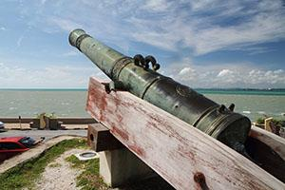
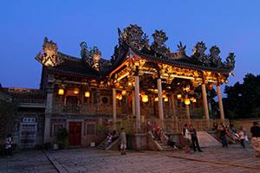
Check out this link to read more about brief history of Penang: https://mypenang.gov.my/all/my-stories/89/

- A Trishaw Maker of Penang
Decades before the arrival of comfortable taxis and public buses, thousands of trishaws shaped Penang's transportation system since the 1950s. Today, the numbers dwindled to 200 trishaws in George Town alone and it is now a part of the city's living heritage. Here’s the story of Penang’s known Trishaw maker: https://mypenang.gov.my/all/my-stories/79/

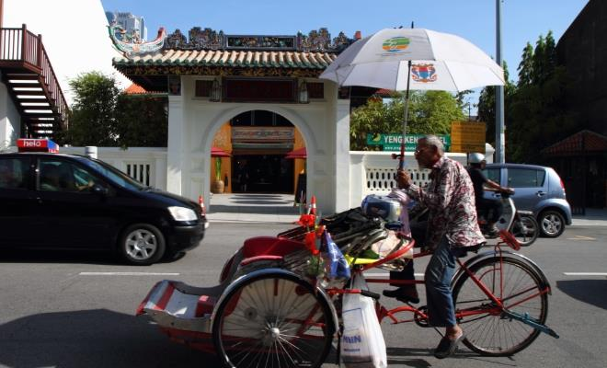
- Feasting, Penang Style
When in Penang, you don’t need an excuse to indulge. You simply just do. So, to minimise the hard work of choosing from the dizzying array of street food, click on this link https://mypenang.gov.my/all/my-stories/19/ to learn the favourites one should try while visiting Penang.
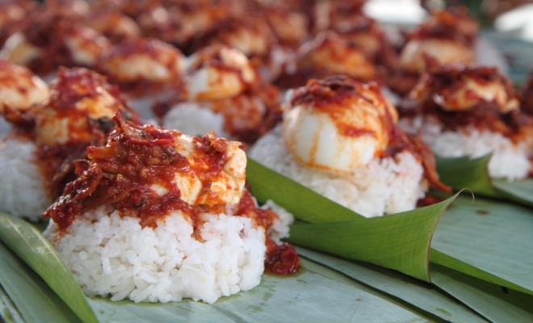
https://mypenang.gov.my/all/my-stories/19/

