SUMMARY TABLE OF CUSTOMIZABLE BROCHURE RACK
NO. | COMPANY  NAME | PRICE  (RM) | SIZE | INCLUDED ITEM | DELIVERY  CHARGES | TOTAL COST  (RM) | Justification
1 | Vcreate | *2,100 per unit (minimal order 10 unit)  *1,900 peer unit (minimal order 40 unit)  *1,800 per unit (minimal order 60 unit & above)  *exclude display panel/24” LED TV  590 per unit (minimal order 10 unit)  550 per unit  (minimal order 40 unit)  520 per unit  (minimal order 60 unit & above) | 6.5ft (h) x 2ft (w) | >Cover with timber structure with plywood base  >Maica finishing  >Storage with lock  >A3 poster acrylic panel (1 set)  > Acrylic brochure panel (8 nos)  >Sticker design  24” LED TV  >Widescreen 16:09  >AV Input, VGA Input, HDMI input  > USB (play movie, music, photo) |  | [2,100 x10 unit]  = 21,000  [1,900 x 40 unit]  = 76,000  [1,800 x 60 unit] above  = 108,000  **include display panel  21,000 + (590 x10 unit)  =21,000 + 5,900  = **26,9000 unit  76,000 + (550 x 40 unit)  = 76,000 + 22,000  = **98,000 unit  108,000 + (520 x 60 unit)  = 108,000 + 31,200  = **139, 200 unit | Pros  >Design wise- unique and capture aesthetic of brochure rack  > Movable  >Include brochure storage with lock  Cons  >Display panel is not at eye level  >less brochure pockets
2 | ROD Creative | 6,000 per unit  4,900 per unit  *minimal order 50 unit | 1830mm x 400mm x 730mm | >Powder coated brochure rack  > A space for PGT brand logo  > Adjustable screw (bottom)  > A display screen (excluded 24" monitor)  > Brochure holders/pockets  > Panel for slotting A3 poster information  > Brochure storage | Within Pulau Pinang- 200 per trip  (F.O.C for George Town area) | 6,000 per unit + 200  = 6,200 per unit  [4,900 x 50 unit]  = 245, 000  Within Pulau Pinang  (245, 000 + 200)  = 245,200 | Pros:  >Design wise- capture the aesthetic of brochure rack  > Movable  > An eye level design for visitors  > Include brochure storage  > Can detach the display screen and replace with A3 poster or vice versa  Cons:  > The monitor is excluded in the costing
3 | DSOP  Office | 11,850  *minimal order quantity 10 unit | 24"(w)x26"(d)x66"(h) | > TV 20"  >Movable display brochure rack  >Transparent Holder (66 slots)  >A3 Poster Frame  >Company Logo Sticker Printing (8" x 24") = 3 unit | Penang Island -  150 per trip  Mainland -  200 per trip | *[11,850 x 10 unit]  = 118,500  Penang Island  118,500 + 150  = 118,650  Mainland  118,500 + 200  = 118,700 | Pros:  > Movable (roller at the bottom of the brochure rack)  Cons:  >holder is transparent (probaly made of plastic)  >Design wise – to bulky/boxy
4 | Karisma  Kreatif | 7,800  *minimal order 50 units | 3ft (w) x 6ft (h) | Finishing: Mild steel structure  , wood grain laminated solid wooden panel  2 sided clear acrylic brochure and magazine pockets  Lit logo Sign  1ft x 2ft LED advertising Panel | Penang Island - 150 per trip  Mainland - 200 per trip | *[7,800 x 50 units]  = 390,000  Penang Island  390,000 + 150  = 390,150  Mainland  390,000 + 200  = 390,200 | Pros:  >Quality use for brochure rack is in high quality  > signage is changeable  *upon request  >logo sign can be light up  Cons:  > Price is quite expensive if were to buy in large quantity  >Design wise - Does not capture the brochure rack aesthetic

Design by KARISMA KREATIF (Option 1)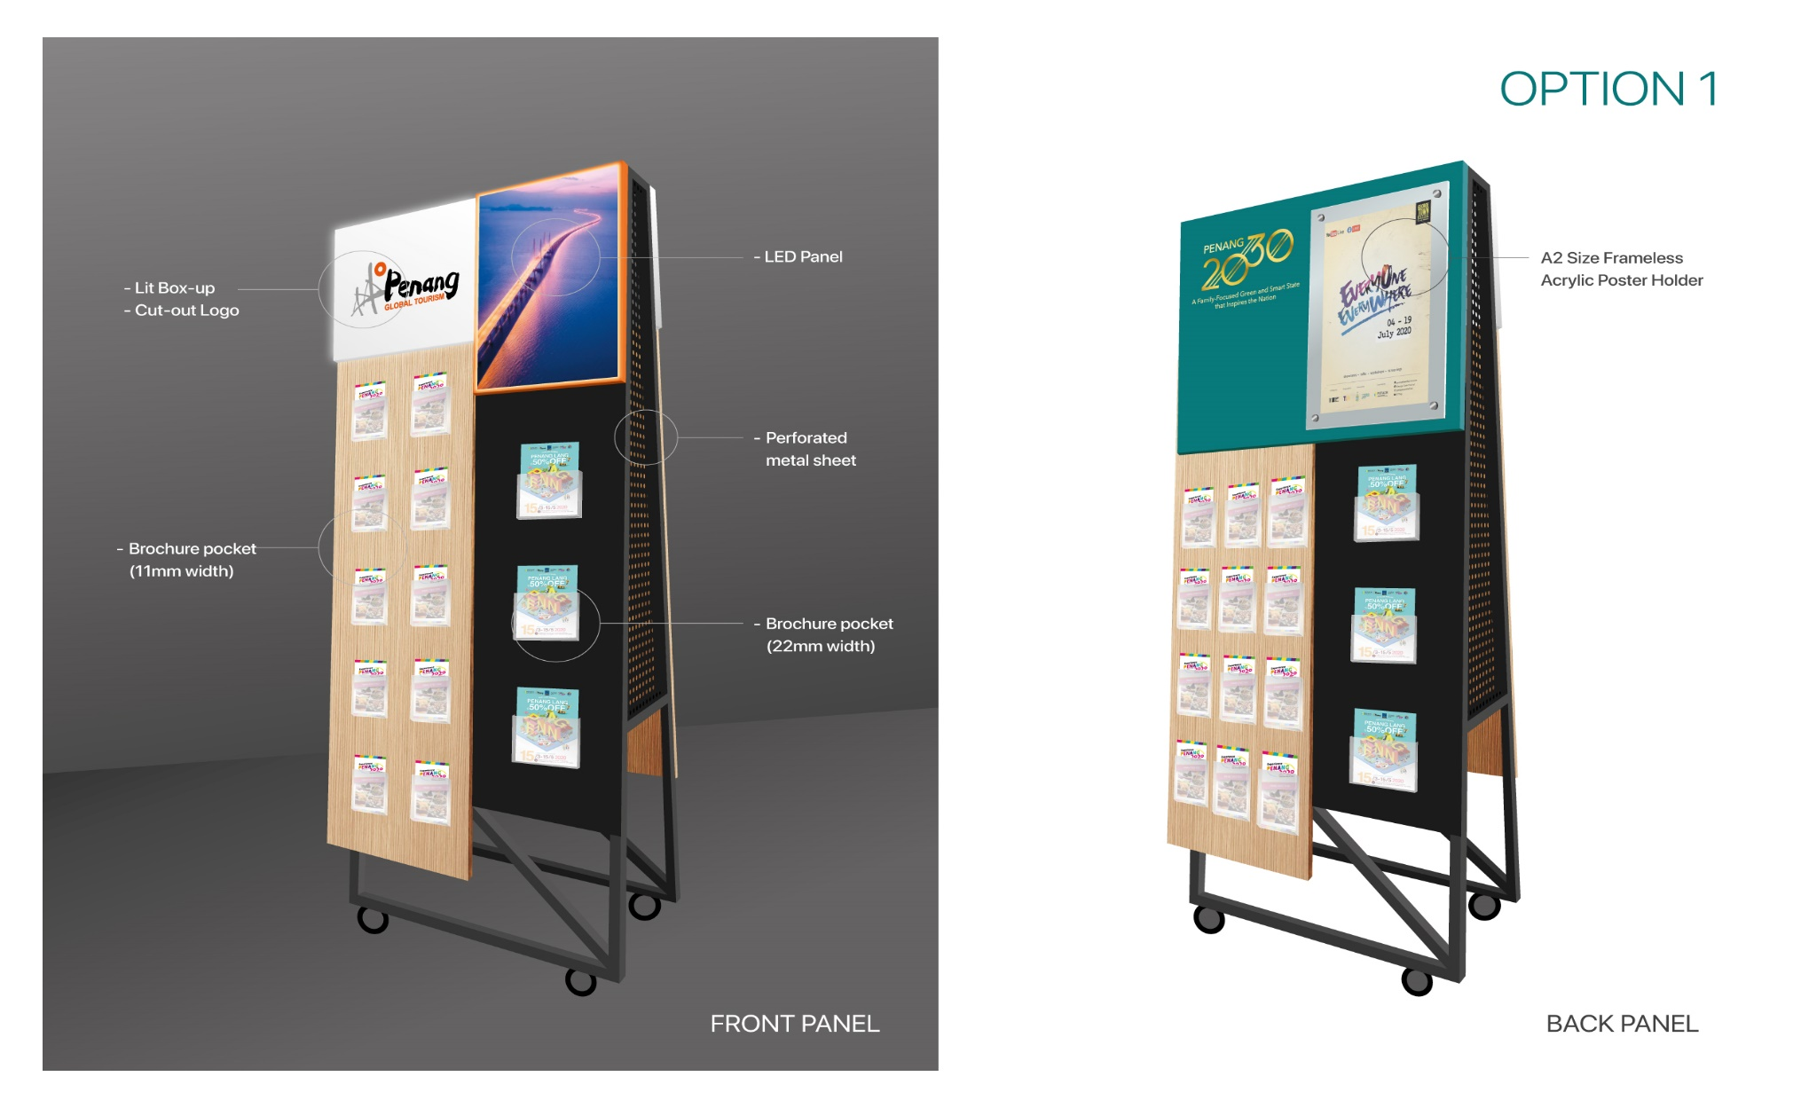
Design by KARISMA KREATIF (Option 2)
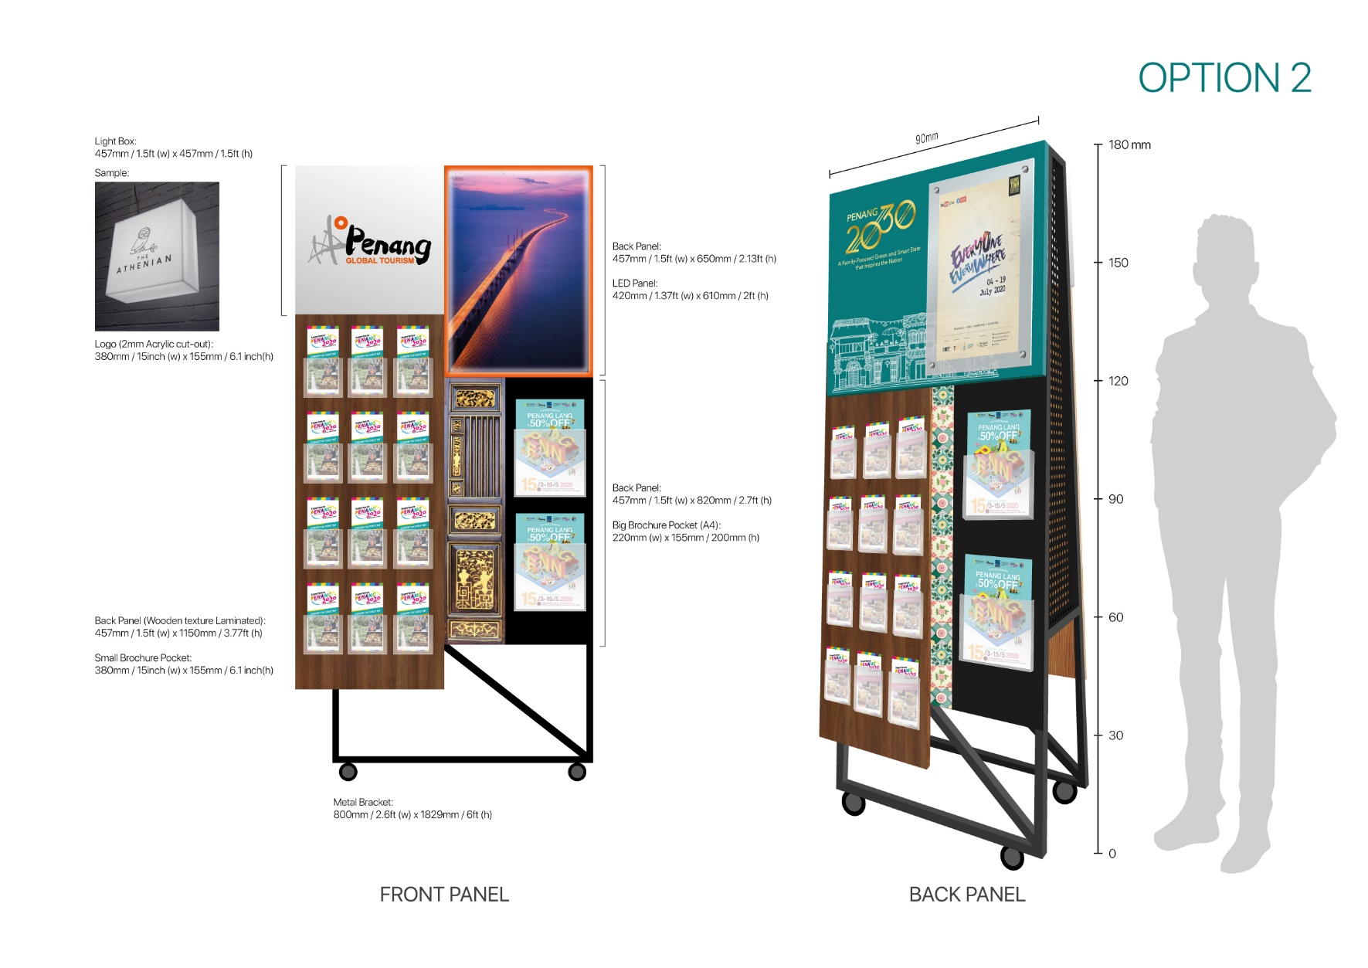
Design by DSOP Office
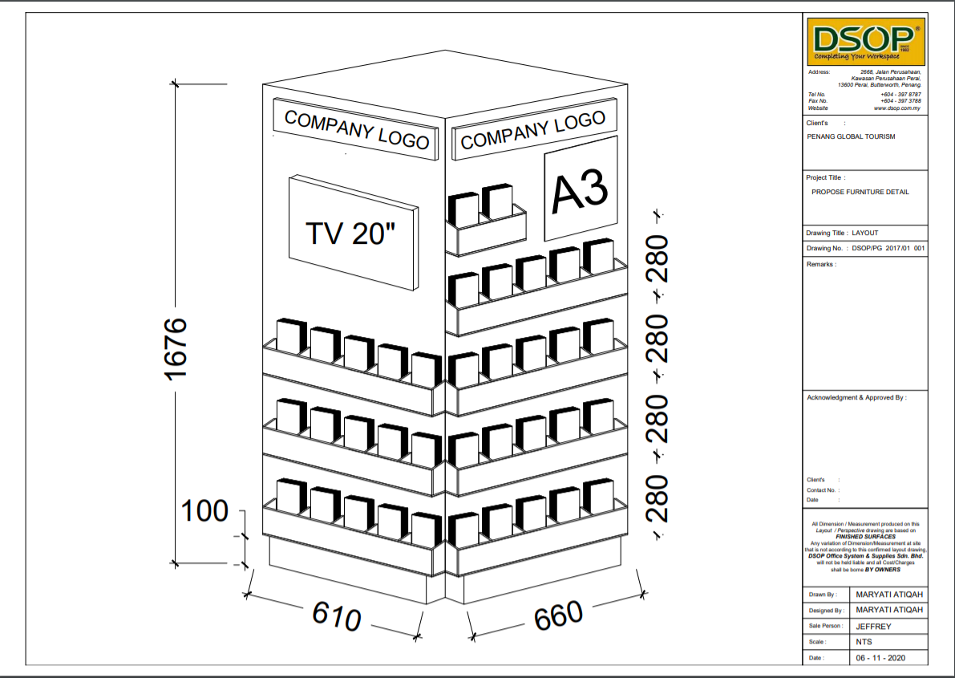
Design by ROD Creative
