PICAF Social Media Posting Draft

Date and Time | Content | Caption | Platform | Remarks
8/1/21  Facebook post and story  2PM  Instagram post and story  8PM | Sharing posts of public photos on Instagram and Facebook posts and story.  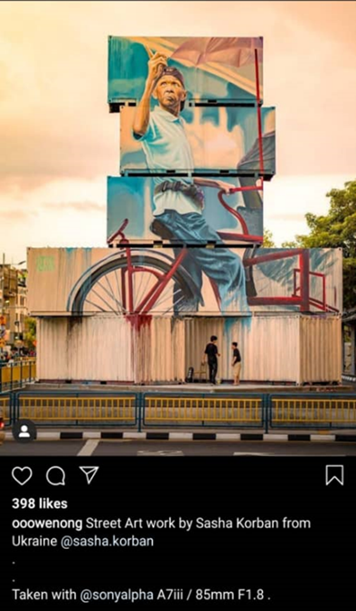  Events nearby :  Master Law Teng Huat Cup Penang Traditional Lion Dance Competition (9 January 2021) | Located at Prangin Mall.This container art is specialy featuring one of 𝑃𝑒𝑛𝑎𝑛𝑔'𝑠 𝑓𝑎𝑚𝑜𝑢𝑠 𝑡𝑟𝑖𝑠ℎ𝑎𝑤 𝑟𝑖𝑑𝑒𝑠, offering a memorable touring experience within the heritage sites.😉  Nowadays trishaw rides or trishaw riders became a part of the Penang city’s living heritage!  Whilst at the area, check out the Lion Dance Competition at 1st Avenue Penang ! Click below the link for more info.  Source : PICAF Website / Prangin Mall Facebook  Art by @sasha.korban  📍: Prangin Mall  📸:@ooowenong  #Trishawrides #Penang #PICAF #PenangInternationalContainerArtFestival #PranginMall #GeorgeTown # | Facebook and Instagram | - For visitor to visit the container art after/before watching lion dance.  - No reply from the owner of picture, use CCPA photo.  -DONE POST
11/1/21  Facebook post and story  1PM  Instagram post and story  8PM | Sharing locations of PICAF on Facebook and Instagram.  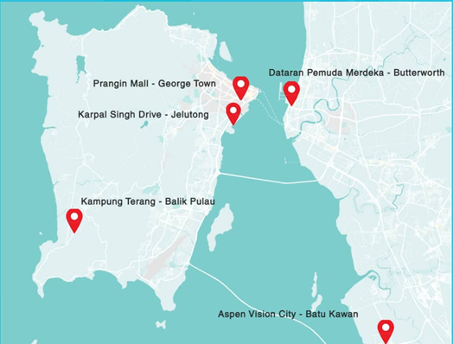 | GOOD NEWS!! PICAF has been extended to 31March 2021!! 😲 🎉  🎉  After the MCO is lifted, don’t forget to catch Penang’s amazing container arts at these 5 locations !!!  📍: 𝗞𝗮𝗺𝗽𝘂𝗻𝗴 𝗧𝗲𝗿𝗮𝗻𝗴, 𝗕𝗮𝗹𝗶𝗸 𝗣𝘂𝗹𝗮𝘂 - https://goo.gl/maps/u1FYyAp3uybgWvVd7  📍: 𝗣𝗿𝗮𝗻𝗴𝗶𝗻 𝗠𝗮𝗹𝗹, 𝗚𝗲𝗼𝗿𝗴𝗲 𝗧𝗼𝘄𝗻 - https://goo.gl/maps/CeQMM7SkMdk2K5fF7  📍: 𝗞𝗮𝗿𝗽𝗮𝗹 𝗦𝗶𝗻𝗴𝗵 𝗗𝗿𝗶𝘃𝗲, 𝗝𝗲𝗹𝘂𝘁𝗼𝗻𝗴 - https://goo.gl/maps/VGHSxj8xgyfQDWMv5  📍: 𝗗𝗮𝘁𝗮𝗿𝗮𝗻 𝗣𝗲𝗺𝘂𝗱𝗮 𝗠𝗲𝗿𝗱𝗲𝗸𝗮, 𝗕𝘂𝘁𝘁𝗲𝗿𝘄𝗼𝗿𝘁𝗵 - https://goo.gl/maps/VtSpQYvc4z3mZ9yr6  📍: 𝗔𝘀𝗽𝗲𝗻 𝗩𝗶𝘀𝗶𝗼𝗻 𝗖𝗶𝘁𝘆, 𝗕𝗮𝘁𝘂 𝗞𝗮𝘄𝗮𝗻 -https://goo.gl/maps/wAz25JJDND2phg7eA | Facebook and Instagram | -DONE POST
13/1/21  Facebook post and story  1PM | Sharing Videos of PICAF from Youtube.  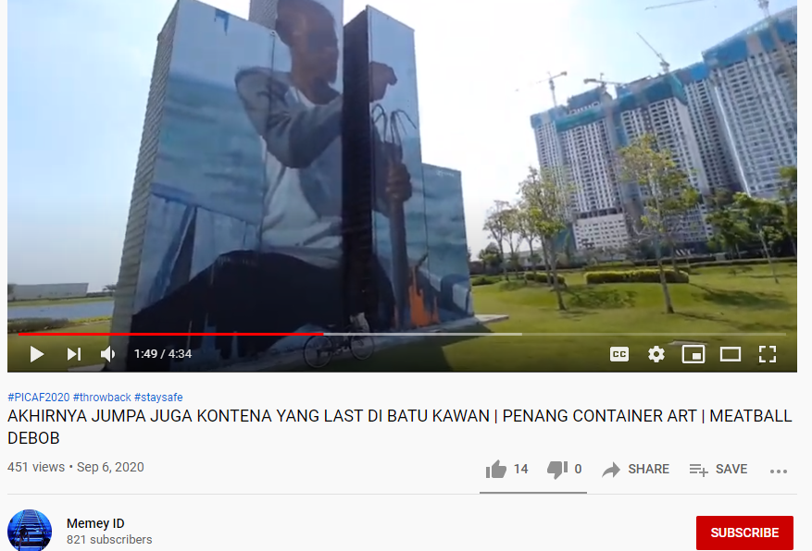 | Memey ID will take us on their journey to discover the container arts in 𝐴𝑠𝑝𝑒𝑛 𝑉𝑖𝑠𝑖𝑜𝑛 𝐶𝑖𝑡𝑦 𝑖𝑛 𝐵𝑎𝑡𝑢 𝐾𝑎𝑤𝑎𝑛 😍😍 Amazing isn’t it? :D  Link: https://www.youtube.com/watch?v=bZIbIF95bF8&ab_channel=MemeyID  📹 : Memey ID  📍𝐴𝑠𝑝𝑒𝑛 𝑉𝑖𝑠𝑖𝑜𝑛 𝐶𝑖𝑡𝑦, 𝐵𝑎𝑡𝑢 𝐾𝑎𝑤𝑎𝑛  #Penang #PICAF #PenangInternationalContainerArtFestival #videolog #AspenVisionCity #batukawan #responsibletourism | Facebook
15/1/21  Facebook post and story  1PM | Sharing Videos from Youtube.  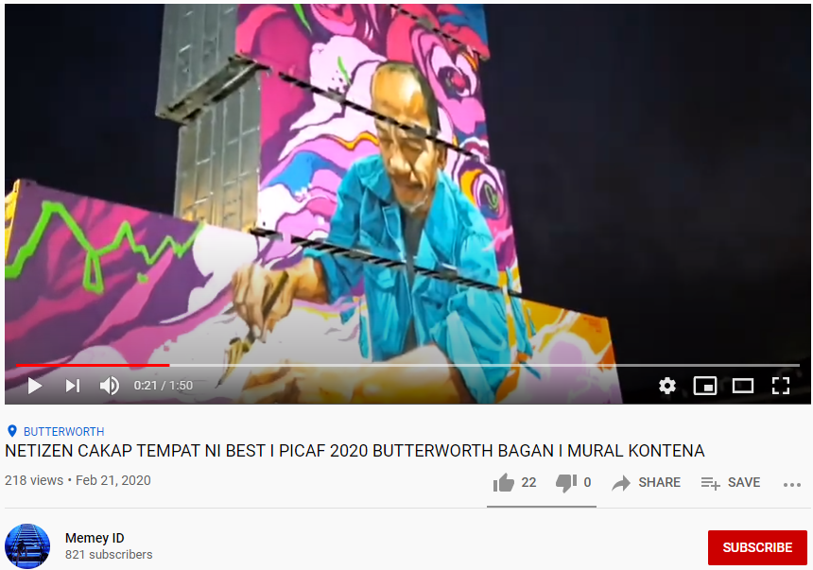 | “Netizen cakap tempat ni best!!”  (Netizens says this place is best!!)  In this video, Memey ID will bring us to discover one of Penang’s Container Arts which is in Dataran Pemuda Merdeka, Butterworth and other exciting things to do there!!  Catch the vibrant colors of the container arts from various angles!!  Link : https://www.youtube.com/watch?v=sxmnXs_Z--8  📹: Memey ID  📍 : 𝐷𝑎𝑡𝑎𝑟𝑎𝑛 𝑃𝑒𝑚𝑢𝑑𝑎 𝑀𝑒𝑟𝑑𝑒𝑘𝑎, 𝐵𝑢𝑡𝑡𝑒𝑟𝑤𝑜𝑟𝑡ℎ  #Penang #PICAF #PenangInternationalContainerArtFestival #butterworth #dataranpemudamerdeka #responsibletourism | Facebook | -
19/1/21  Facebook post and story  1PM | Sharing videos of PICAF from Youtube.  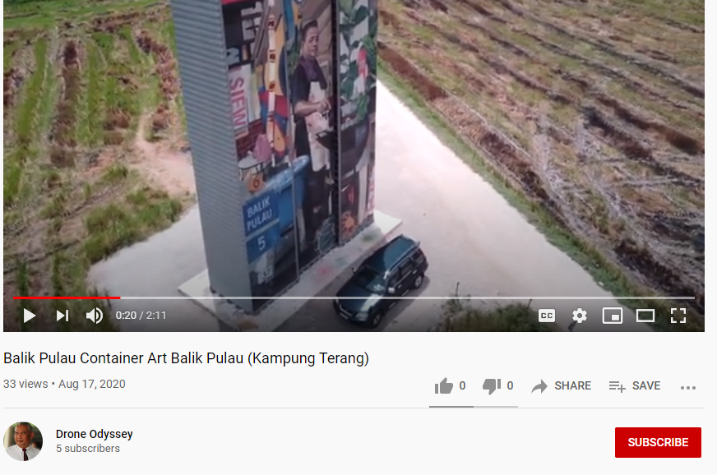 | Drone Odyssey has shared with us his amazing drone photography skills for us to discover 𝐾𝑎𝑚𝑝𝑢𝑛𝑔 𝑇𝑒𝑟𝑎𝑛𝑔'𝑠 𝐵𝑎𝑙𝑖𝑘 𝑃𝑢𝑙𝑎𝑢, 𝐶𝑜𝑛𝑡𝑎𝑖𝑛𝑒𝑟 𝐴𝑟𝑡😲 Check out the container art view from an eagle’s eye through this video!!  Link : https://www.youtube.com/watch?v=ZLZjgSASCr0&t=20s&ab_channel=DroneOdyssey  📹 : 𝐷𝑟𝑜𝑛𝑒 𝑂𝑑𝑦𝑠𝑠𝑠𝑒𝑦  📍: 𝐾𝑎𝑚𝑝𝑢𝑛𝑔 𝑇𝑒𝑟𝑎𝑛𝑔, 𝐵𝑎𝑙𝑖𝑘 𝑃𝑢𝑙𝑎𝑢  #Penang #PICAF #PenangInternationalContainerArtFestival #balikpulau #kampungterang #responsibletourism | Facebook | -
/1/21  Facebook post and story  2 PM | Sharing videos of PICAF from Youtube  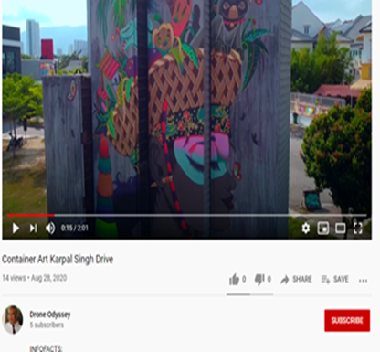 | Here’s another segment of the #𝑃𝑒𝑛𝑎𝑛𝑔𝐼𝑛𝑡𝑒𝑟𝑛𝑎𝑡𝑖𝑜𝑛𝑎𝑙𝐶𝑜𝑛𝑡𝑎𝑖𝑛𝑒𝑟𝐴𝑟𝑡𝐹𝑒𝑠𝑡𝑖𝑣𝑎𝑙 by Drone Odyssey, but this time it’s in Karpal Singh Drive!! 🤩🤩🤩🤩🤩  Link : https://www.youtube.com/watch?v=N-kU6vNGiDM&t=15s&ab_channel=DroneOdyssey  📹 : 𝐷𝑟𝑜𝑛𝑒 𝑂𝑑𝑦𝑠𝑠𝑠𝑒𝑦  📍: 𝐾𝑎𝑟𝑝𝑎𝑙 𝑆𝑖𝑛𝑔ℎ 𝐷𝑟𝑖𝑣𝑒  #Droneshots  #Penang #PICAF #PenangInternationalContainerArtFestival #karpalsinghdrive #jelutong | Facebook | -
20/1/21  Facebook post and story  12PM  Instagram post and story  7 PM | Sharing nearby attractions of PICAF (Balik Pulau)  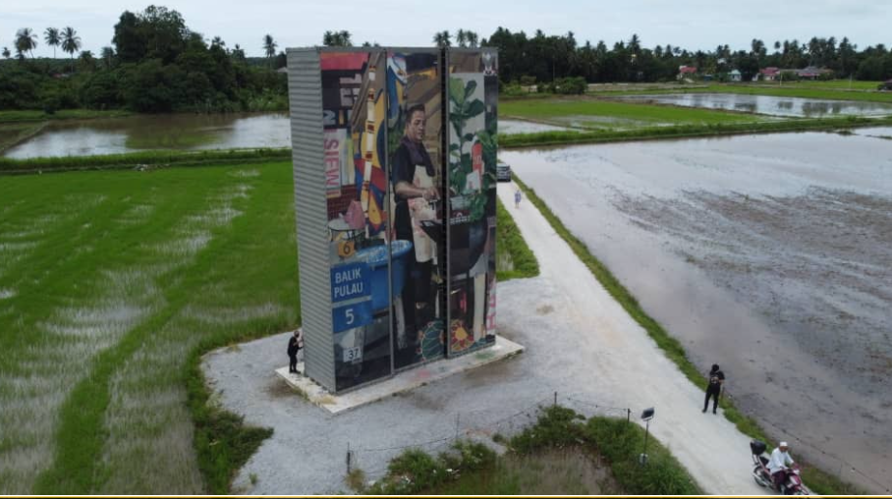  Attractions:  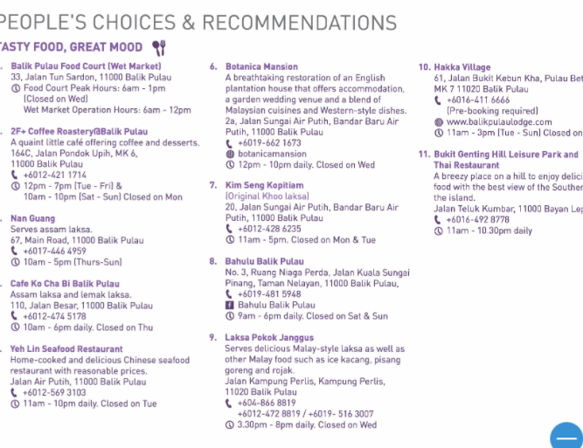  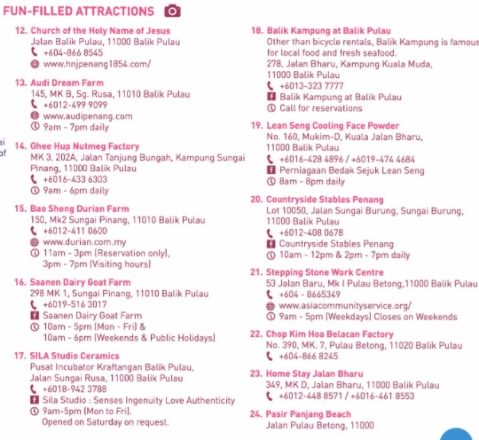 | This Container Art “Once at Balik Pulau’s Street Market” is situated in Kampung Terang, Balik Pulau potrays a local street hawker.  Speaking about hawkers, don’t forget to try out the variety of eateries nearby Kampung Terang, Balik Pulau😋🍴🍜  Balik Pulau too is filled with fun attractions!🐑 😯😯😯  To find out more, visit PICAF’s website  https://www.picafpenang.com/attractions-bp  📍 : 𝐾𝑎𝑚𝑝𝑢𝑛𝑔 𝑇𝑒𝑟𝑎𝑛𝑔, 𝐵𝑎𝑙𝑖𝑘 𝑃𝑢𝑙𝑎𝑢  📹: Cancan Public Art  #attractions #eateries  #Penang #PICAF #PenangInternationalContainerArtFestival #resonsibletourism #BalikPulau #kampungterang | Facebook and Instagram | For visiters to check out Balik Pulau’s attractions while visiting.
22/1/21  Facebook post and story  1PM  Instagram post and story  8PM | Sharing nearby attractions of PICAF (Prangin Mall)  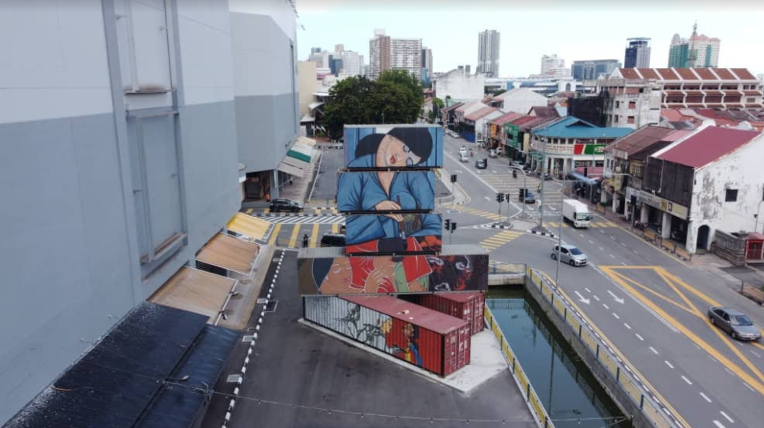  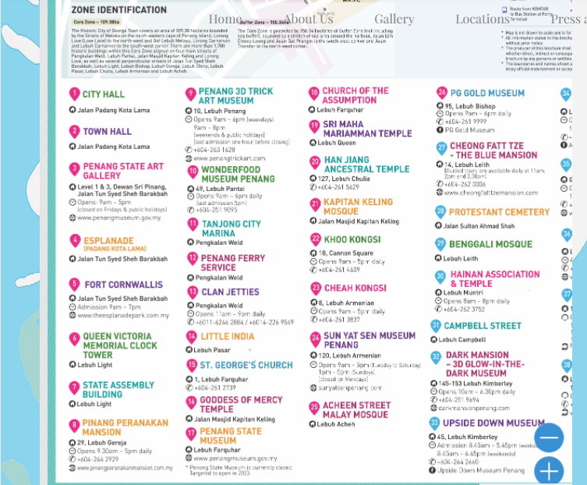 | Tired of shopping?? Take a tour to majestic temples, variation of museums and historical attractions surrounded nearby Prangin Mall . Make the trip to this container art worthwhile. 🏛️💒🕌  For more info visit PICAF’s website to find out more!  https://www.picafpenang.com/attractions-prangin  📍: Prangin Mall  📹: Cancan Public Art  #temples #museums  #Penang #PICAF #PenangInternationalContainerArtFestival | Facebook and Instagram | For visitors to visit more places of attractions nearby Prangin Mall during their visit.
25/1/21  Facebook post and story  12:30 PM | Sharing videos of PICAF from Youtube  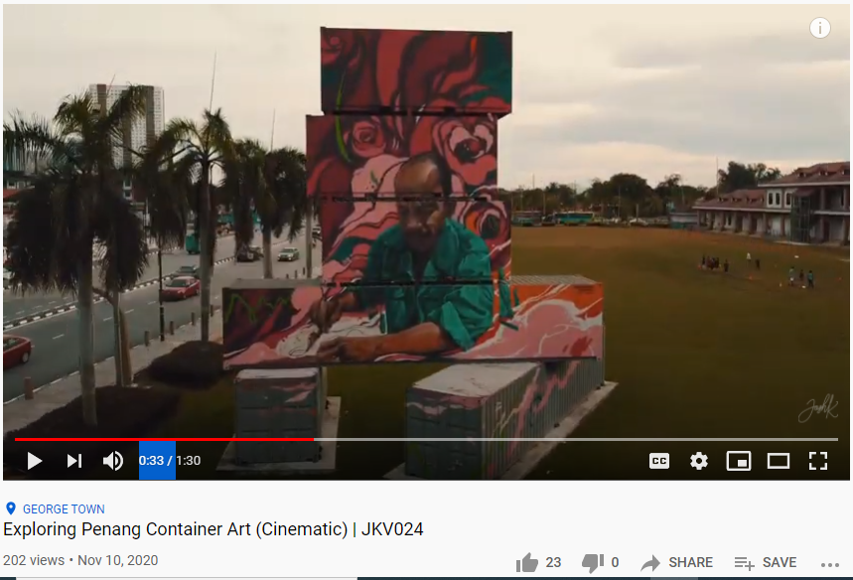 | Worry to catch Ms Corona in public? No time to visit the container arts? Well, worry not! Thanks to Josh Koay and his video, we can now witness these container arts with a more cinematic experience. How cool is that?! 😎😎😎😎  Link : https://www.youtube.com/watch?v=0W09uv_gUNM&ab_channel=JoshKoay  📹 : 𝐽osh Koay  #Penang #PICAF #PenangInternationalContainerArtFestival #responsibletourism | Facebook | -
27/1/21  Facebook post and story  1 :30 PM  Instagram post and story  7:30 PM | Sharing nearby attractions of PICAF ( Batu Kawan)  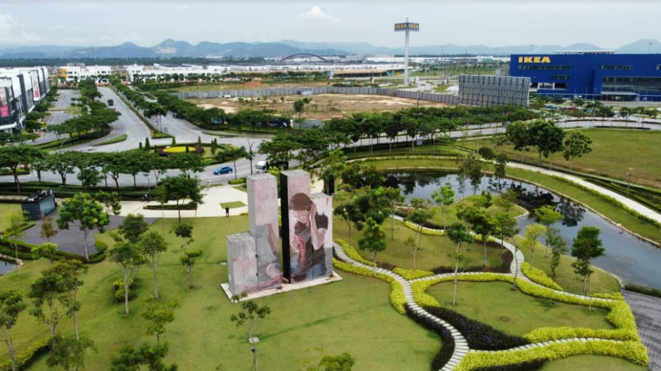  Attractions :  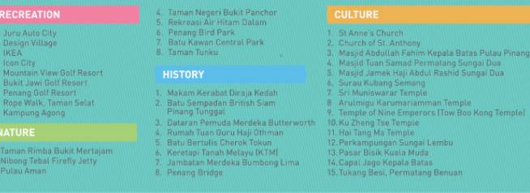 | Speaking of Batu Kawan, it’s not only just the IKEA Penang!!! 😅😅😅😅 There are container arts too at Aspen Vision City.  Bring your family and friends to explore Batu Kawan hidden attractions that you wouldn’t want to miss it! 𝐵𝑎𝑡𝑢 𝐾𝑎𝑤𝑎𝑛 is an undeniable place to visit! ⛳🌳🚆🏛️💒🕌  For more details on the attractions, click to this website below  https://www.picafpenang.com/attractions-aspen  📍: 𝐴𝑠𝑝𝑒𝑛 𝑉𝑖𝑠𝑖𝑜𝑛 𝐶𝑖𝑡𝑦 , 𝐵𝑎𝑡𝑢 𝐾𝑎𝑤𝑎𝑛  #𝐶𝑜𝑛𝑡𝑎𝑖𝑛𝑒𝑟𝑎𝑟𝑡 #Batu Kawan  #Penang #PICAF #PenangInternationalContainerArtFestival #responsibletourism | Facebook and Instagram | For visitors to visit more places of attractions nearby Batu Kawan during their visit.
29/1/21  Facebook post and story  2 PM | Sharing videos of PICAF from Youtube.  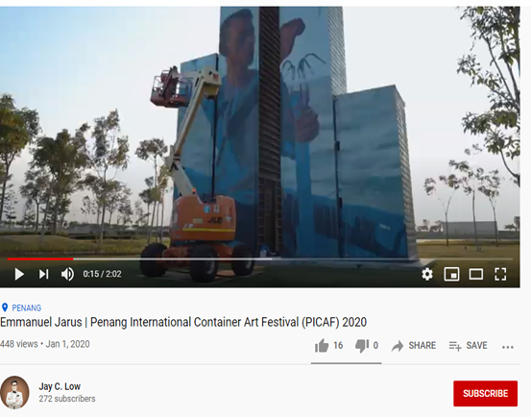 | Want to know how the 𝐶𝑜𝑛𝑡𝑎𝑖𝑛𝑒𝑟 𝐴𝑟𝑡 are drawn?? Jay C. Low has shared with us his video featuring how the artist Emanuel Jarus painted the container in 𝐴𝑠𝑝𝑒𝑛 𝑉𝑖𝑠𝑖𝑜𝑛 𝐶𝑖𝑡𝑦, 𝐵𝑎𝑡𝑢 𝐾𝑎𝑤𝑎𝑛.  Link : https://www.youtube.com/watch?v=t4xD2DnChFM&ab_channel=JayC.Low  📹 : 𝐽𝑎𝑦 𝐶. 𝐿𝑜𝑤  📍: 𝐴𝑠𝑝𝑒𝑛 𝑉𝑖𝑠𝑖𝑜𝑛 𝐶𝑖𝑡𝑦 , 𝐵𝑎𝑡𝑢 𝐾𝑎𝑤𝑎𝑛  #Penang #PICAF #PenangInternationalContainerArtFestival #containerarts #AspenVisionCity #BatuKawan | Facebook

