2. Tourism Services

2.1 Tourist Information Centre (TIC) - Reported by Gayathiri

2.1.1 Merchandise

Updates on New Product

- Penang at a Glance book

We started selling this book by TLM Event Sdn Bhd at TIC in April 2021.
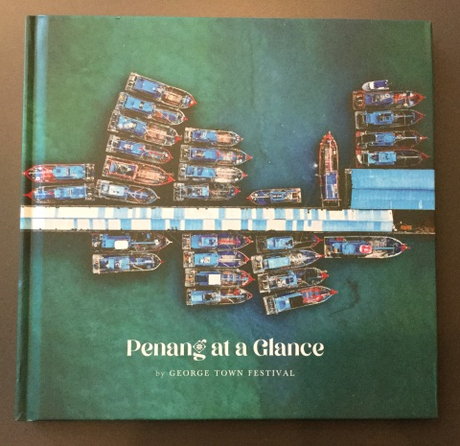

2.1.2 Monthly Sales Figures for TIC (December 2020 – August 2021)

Tours and Merchandise
Month | Total Sales (RM) | Total Profit (RM)
December 2020 | 70.00 | 27.00
January 2021 | 0.00 | 0.00
February 2021 | 0.00 | 0.00
March 2021 | 140.00 | 72.68
April 2021 | 0.00 | 0.00
May 2021 | 0.00 | 0.00
June 2021 | 0.00 | 0.00
July 2021 | 0.00 | 0.00
August 2021 | 0.00 | 0.00
Total: | 210.00 | 99.68

** Due to COVID-19 pandemic, not much sales were recorded from December 2020 until April 2021

    - Number of visitors from December 2020 – August 2021 based on TIC visitor record
Month | Number of visitors
December 2020 | 83
January 2021 | 28
February 2021 | 0
March 2021 | 16
April 2021 | 7
May 2021 | 1
June 2021 | 0
July 2021 | 0
August 2021 | 0

** TIC closed to the public during MCO 2.0 from 13th January until 4th March 2021 and closed to the public during MCO 3.0/ NRP from 10th May 2021 until further notice.

    - TIC operation hours

- TIC was operating during CMCO (5th March 2021 – 9th May 2021) from Monday - Saturday and closed on Sunday.
- Operation hours was 9.00am -5.00pm
- TIC closed to the public on 10th May 2021 onwards until further notice due to MCO 3.0/NRP

    - Penang MHholiday & Air Asia SNAP booking packages voucher redemption in TIC

Campaign Packages | Number of Voucher redeemed
Penang MHholiday | 7
AirAsia SNAP | 12
TOTAL | 19

- Air Asia SNAP Campaign
  - Total 221 bookings and 12 vouchers were claimed as of 30th April 2021.
  - The campaign is on hold due to MCO/CMCO and no interstate travelling restriction.

- Penang MHholiday Campaign
  - Total 33 bookings and 7 vouchers were claimed and the campaign ended on 4th January 2021.

