Tourist Information Centre (TIC)

- Monthly Sales Figures for TIC (June 2020- November 2020)

  - Tours and Merchandise

Month | Total Sales (RM) | Total Profit (RM)
June2020 | 0.00 | 0.00
July 2020 | 0.00 | 0.00
August2020 | 0.00 | 0.00
September 2020 | 0.00 | 0.00
October 2020 | 39.00 | 7.80
November 2020 | 0.00 | 0.00
Total: | 39.00 | 7.80

- Due to COVID-19 pandemic, there are no sales recorded during June to September & November 2020.

- Number of visitors from June 2020 – October 2020

The record below is based on Visitor Log Book & TIC visitor record.

Month | Number of visitors
June 2020 | 10
July 2020 | 22
August 2020 | 25
September 2020 | 26
October 2020 | 26
November 2020 | 8

- From the month of June to October, there are only a few visitors who visited TIC during CMCO and RMCO.
- Most of the visitors are domestic tourists.
- Most of enquiries received through phone calls and emails.
- TIC was closed to the public during CMCO from 9th November until 6th December 2020.

- George Town Walkabout Tours

- Due to COVID-19 pandemic, George Town Walkabout Tours were postponed until further notice.

- COVID-19 - Precautionary Measure at TIC

- All the TIC staff ensure visitor abide Do & Don’t rules before entering Tourist Information Centre.

The following rules are our practises in Tourist Information Centre

- It is compulsory for Visitors to wear face masks at all times.
- Visitors are required to go through temperature checking prior to gaining access into the premise
- Visitors are required to check in through MySejahtera QR code or fill in the Visitor Log Book at the entrance for movement tracking purposes.
- Mandatory for all walk-in visitors to apply hand sanitizer once they enter the premise.
- Physical distancing must be practiced in the premise at all times.
- Any visitor with body temperature above 37.5 degrees Celsius and/or displaying respiratory symptoms will be denied entry and required to seek medical attention at any nearby medical centre.
- “No Handshaking Policy” in the premise.

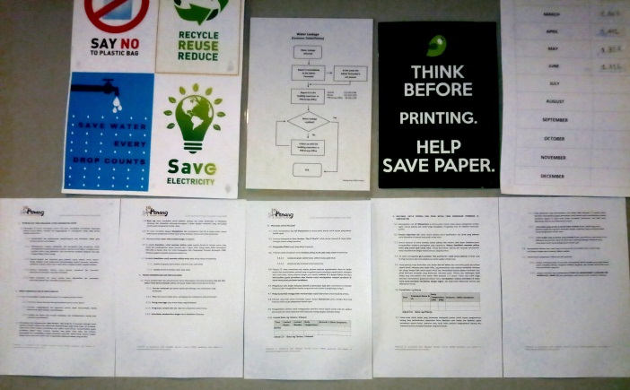
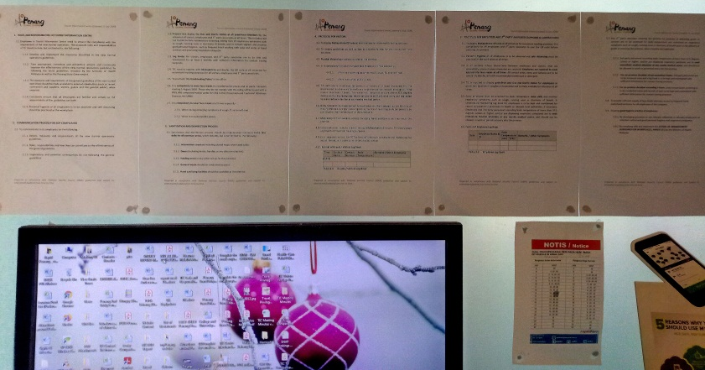

- SOP of TIC for COVID-19 displayed in TIC for the reference of TIC staffs.

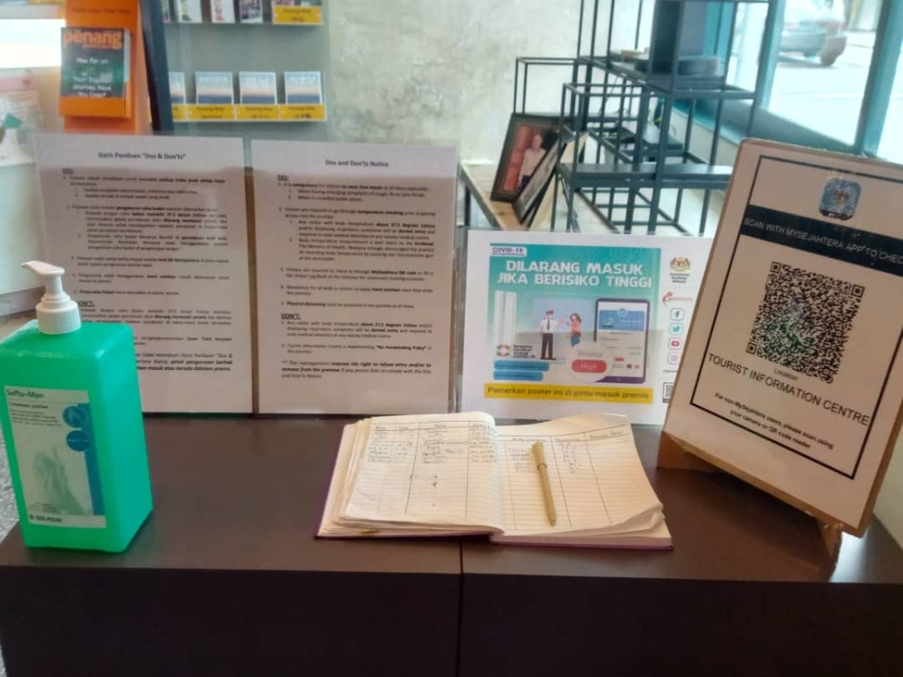
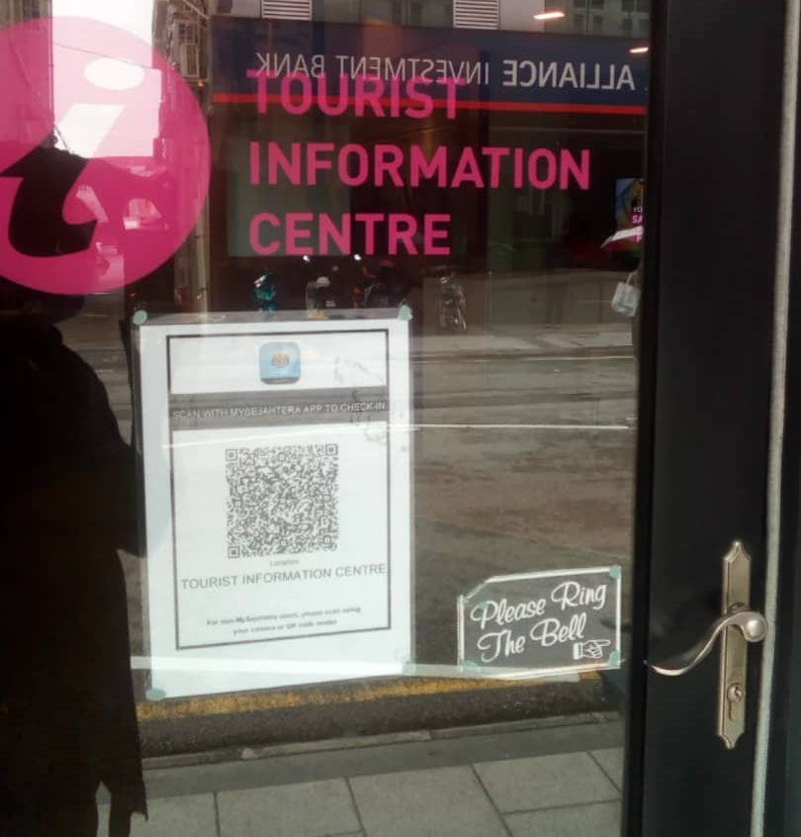

- MySejahtera QR code displayed at the door and main entrances of TIC .
- Do’s and Don’ts notices have been display at the entrance area in TIC for the reference of visitors.
- Visitor log book and hand sanitizing was place in front of the main entrance of Tourist Information Centre
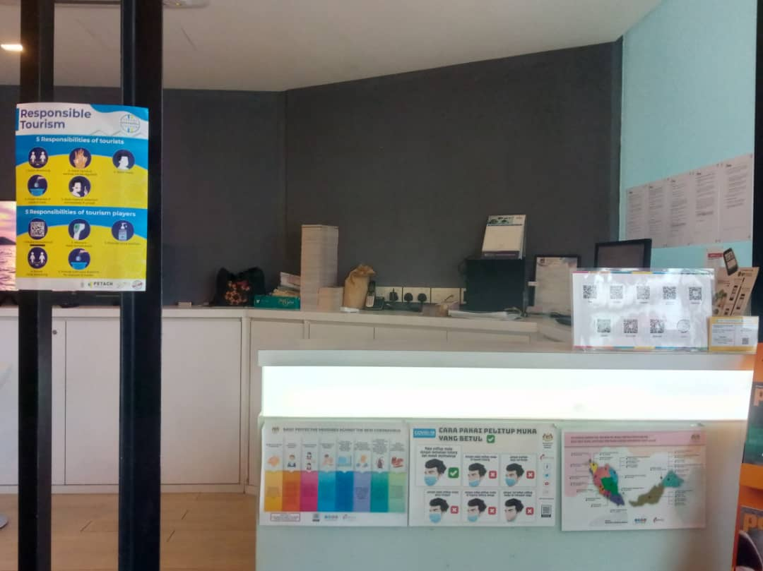

- Display posters from Ministry of Health on COVID-19 precaution in TIC

