2. Tourism Services

2.1 Tourist Information Centre (TIC) - Reported by Shirley

2.1.1 Monthly Sales Figures for TIC (September 2021 –March 2022)

Merchandise
Month | Total Sales (RM) | Total Profit (RM)
September 2021 | 0.00 | 0.00
October 2021 | 0.00 | 0.00
November 2021 | 95.00 | 41.63
December 2021 | 212.90 | 53.81
January 2022 | 27.00 | 10.91
February 2022 | 0.00 | 0.00
March 2022 | 46.00 | 13.20
Total | 334.90 | 106.35

** Due to COVID-19 pandemic, not much sales were recorded from September 2021 until March 2022.

    - Number of visitors from September 2021 – March 2022 based on TIC visitor record
Month | Number of visitors
September 2021 | 0
October 2021 | 17
November 2021 | 41
December 2021 | 100
January 2022 | 53
February 2022 | 32
March 2022 | 40

    - Operation hours

- Staff attendance not more than 60% during NRP 2 (from 10th May 2021 until 17th October 2021).
- Staff attendance not more than 80% during NRP 3 (from 18th October 2021 until 07th November 2021).
- TIC operating hours during NRP 2 and NRP 3 was 9:00am – 4:00pm.
- TIC operating hours back to usual 9:00am – 5:00pm during NRP 4 (from 08th November 2021 until 31st March 2022).

    - AirAsia SNAP & AirAsia Penang Contest Winners Campaign

Campaign Packages | Number of Voucher redeemed
AirAsia SNAP | 12
AirAsia Penang Contest Winners | 6
Total | 19

- AirAsia SNAP Campaign
  - The campaign is to promote Penang with offering flight + hotel combos covering more than 25 hotels, inclusive of return flights and 3D2N stays at hotels in Penang.
  - Voucher redemption in TIC.
  - Total 221 bookings and 12 vouchers were claimed, campaign ended on 31st December 2021.

- AirAsia Penang Contest Winners Campaign
  - In conjunction with the AirAsia Super App launch and to promote Penang, the winners of the campaign is being randomly picked via social network submissions such as Instagram etc.
  - Voucher redemption in TIC.
  - Campaign period from 25th November 2021 until 31st December 2021.
  - Total 3 winners and 6 vouchers were claimed.

    - SOP: COVID-19 - Precautionary Measure & Guidelines

The following rules are our practises in Tourist Information Centre (TIC):-

- It is compulsory for all the staff and visitor wear face masks at all times.
- Physical distancing must be practiced in the premise at all times.
- “No Handshaking Policy” in the premise.
- All staffs must perform body temperature screening twice daily i.e. once in the morning upon checking in and once in the evening before leaving the office
(Refer picture 1).
- All staffs and visitors are required to check-in using MySejahtera app upon arrival. Visitor have to fill in their details in the visitor log book provided
(Refer picture 1).
- Only fully vaccinated visitor with “Low Risk” status including “Casual Contact Low Risk” in MySejahtera or Covid-19 Vaccination Card are allowed to enter premises
(Refer picture 2).
- A maximum of 5 visitors only are allowed in premise at any one time
(Refer picture 2).
- Sanitization and disinfection process implemented daily for all common areas.
(Refer picture 3).
- Notice of number of premise staff vaccination updates displayed for visitors acknowledgment.
(Refer picture 4).

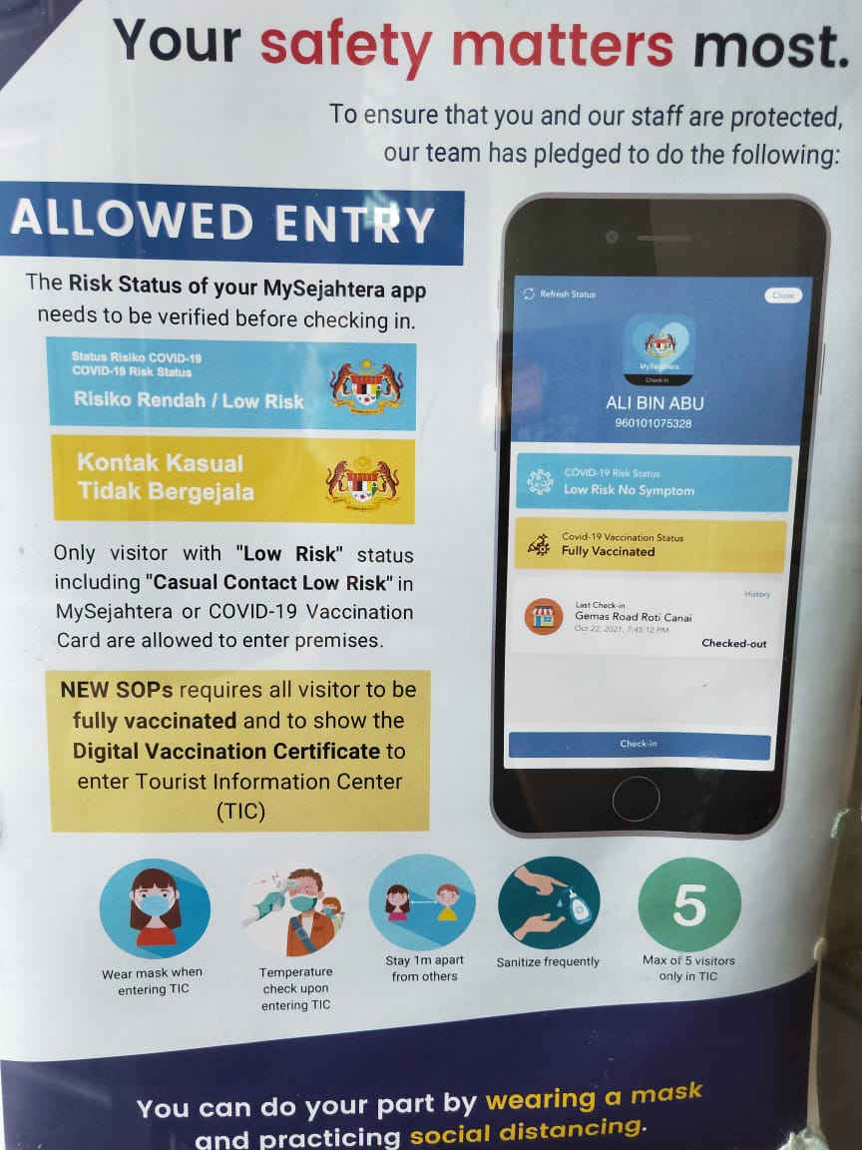
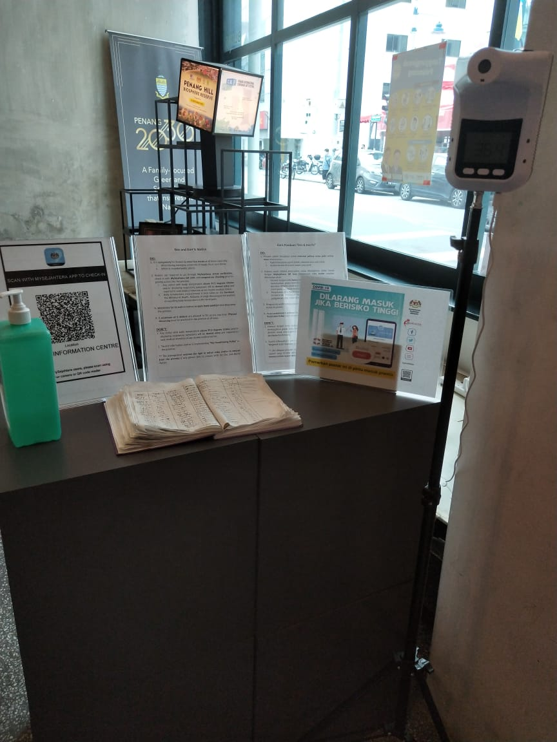Picture 1 Picture 2

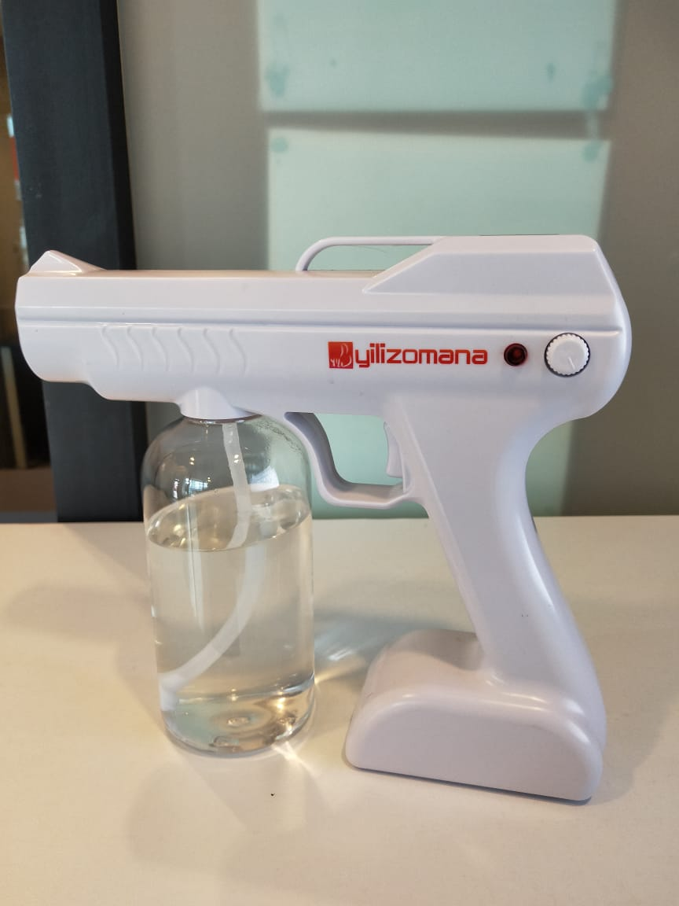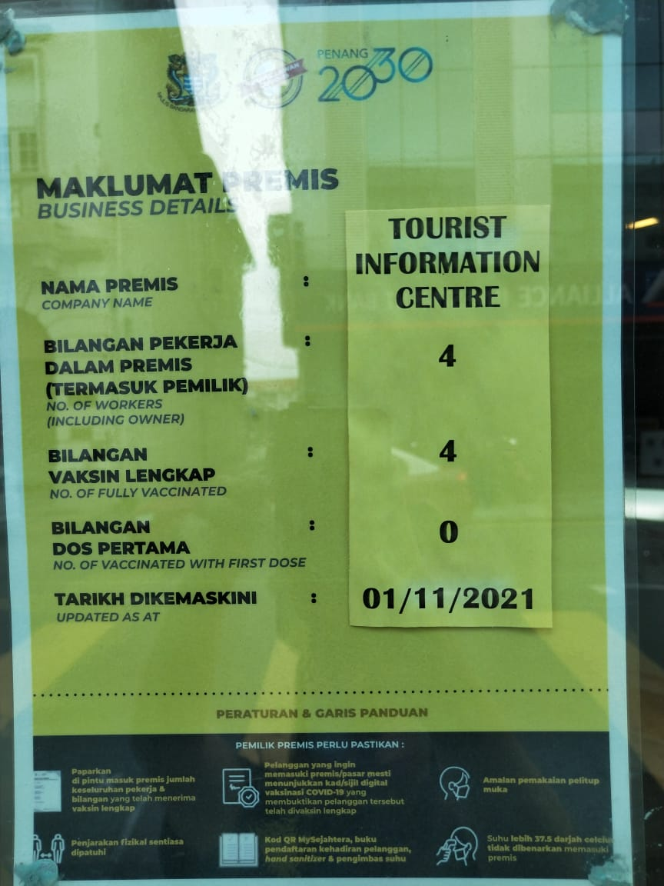
Picture 3 Picture 4

    - Replace New PCs

Tourist Information Centre (TIC) have replaced 3 set of new PCs which are under performance and exceeded it life span.

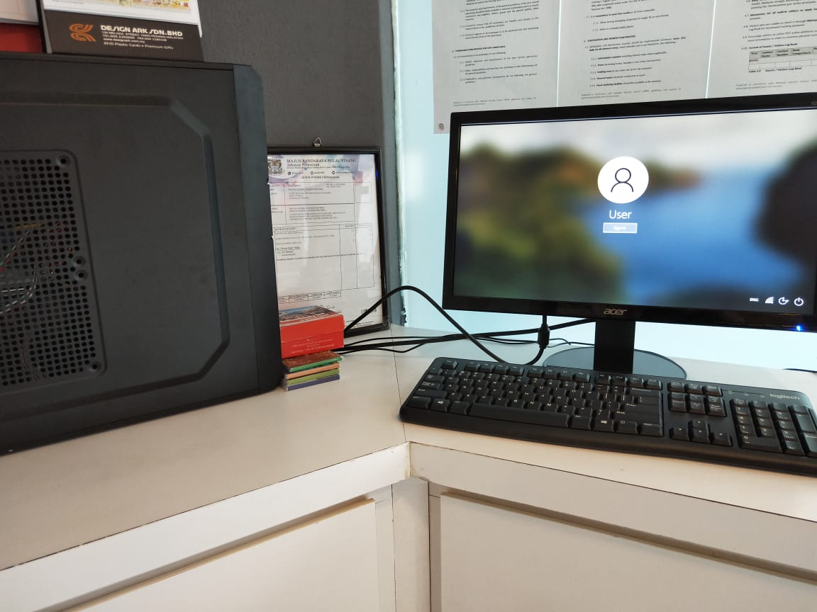

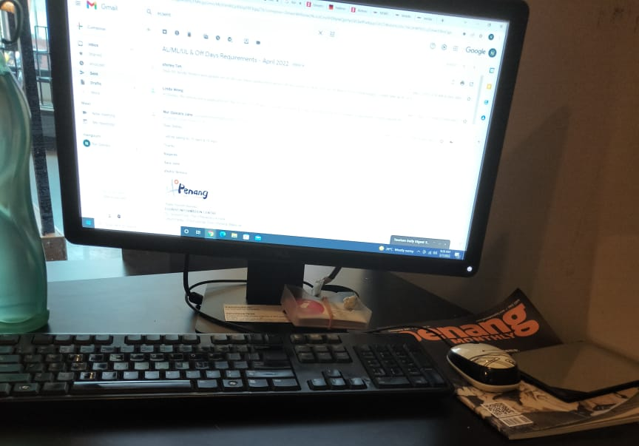

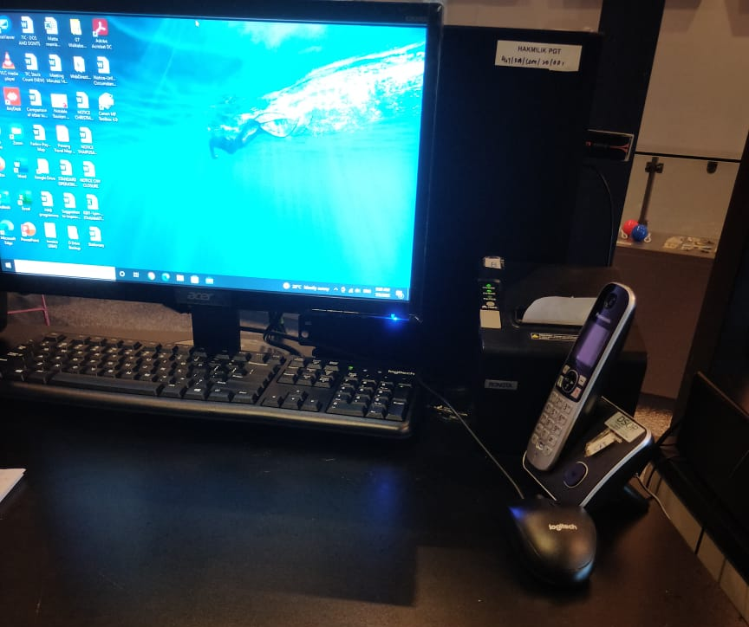

    - Merchandise
Updates on New Product

- Coaster Set (6 designs per set)

This item will be made available for sale at TIC with the selling price of RM10 per set.

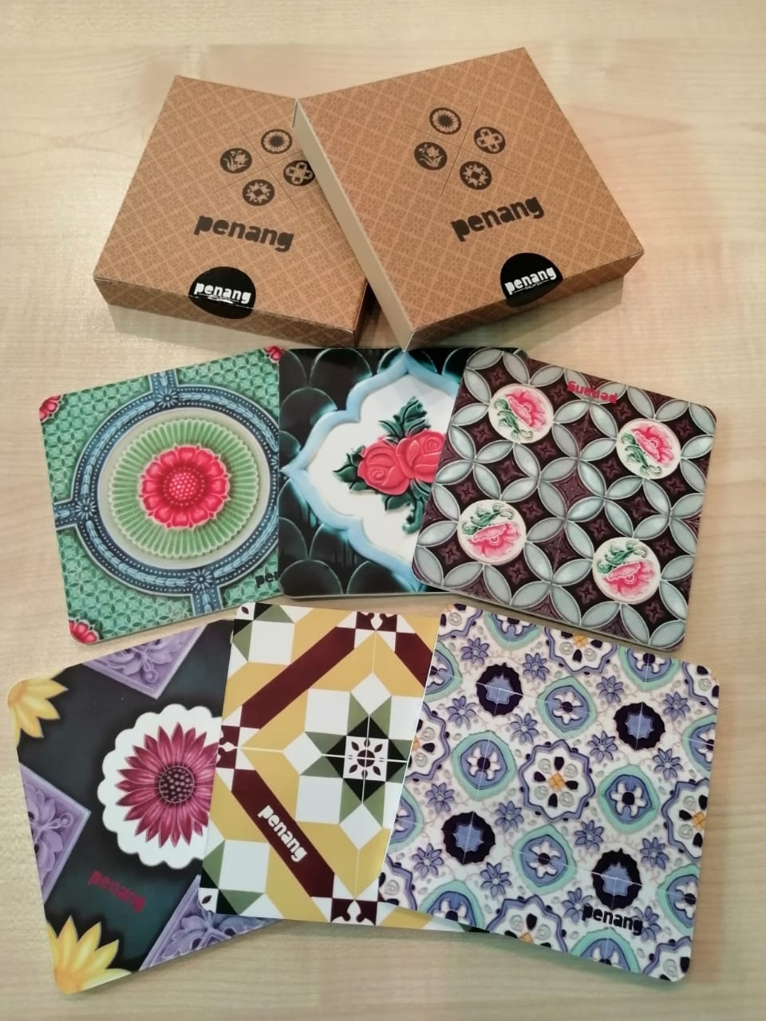

    - Responsible Tourism

- Responsible Tourism poster and banner displayed in TIC for visitor’s reference.

