2. Tourism Services

2.1 Tourist Information Centre (TIC) - Reported by Shirley

2.1.1 Monthly Sales Figures for TIC (September – November 2022)

Merchandise
Month | Total Sales (RM) | Total Profit (RM)
September 2022 | 467.00 | 256.23
October 2022 | 331.00 | 165.31
November 2022 | 294.00 | 122.36
Total | 1092.00 | 543.90

    - Number of visitors from September – November 2022 based on TIC visitor record
Month | Number of visitors
September 2022 | 666
October 2022 | 731
November 2022 | 746

- Effective August 2022, TIC has stopped requesting tourists to fill up the visitors’ log book due to most of the tourists refuse to fill up the visitors‘ log book physically.
- The current visitors’ log book only records the countries where the tourists are from, total number of visitors and number of days the visitor/s stay in Penang.
- Below are the countries where the tourists are from:-

Malaysia, Singapore, Thailand, China, Hong Kong, Taiwan, South Korea, Japan, India, Philippines, Indonesia, Cambodia, Vietnam, Pakistan, Australia, Spain, Germany, Belgium, Canada, France, Italy, UK, USA, Netherland, Switzerland, Poland, Holland, Ireland, Austria, New Zealand, Finland, Sweden, Brazil, Portugal, Argentina, Czech Republic, Denmark, Barcelona, Costa Rica, Panama, Hungary, Uruguay, Latvia, Kenya, Yemen, El Salvador, Bosnia and Herzegovina, Bahrain and Mauritius.

- Number of cruise visitors based on TIC visitor record
Month | Cruise | Number of visitors | Total
September 2022 | Spectrum of the seas | 22 | 64
September 2022 | Genting Dream | 42 | 64
October 2022 | Spectrum of the seas | 65 | 141
October 2022 | Genting Dream | 76 | 141
November 2022 | Spectrum of the seas | 53 | 134
November 2022 | Genting Dream | 78 | 134
November 2022 | Viking Cruises | 3 | 134

    - TIC Updates

Effective September 2022, big-sized George Town city maps are displayed at TIC.
(Refer picture 1 & 2)

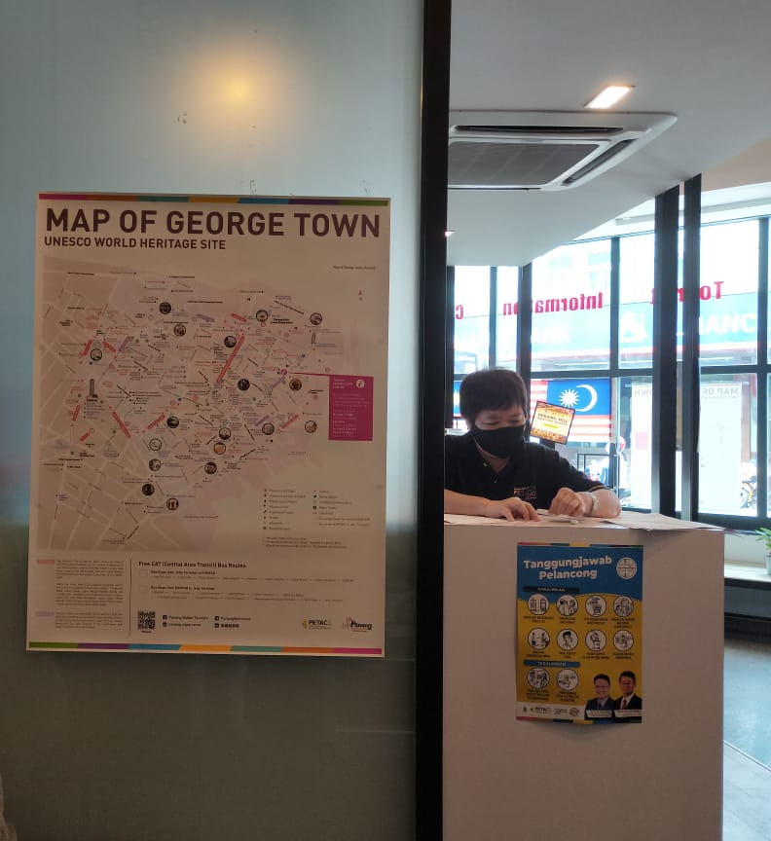

Picture 1: Displayed inside TIC for explanation to tourists.

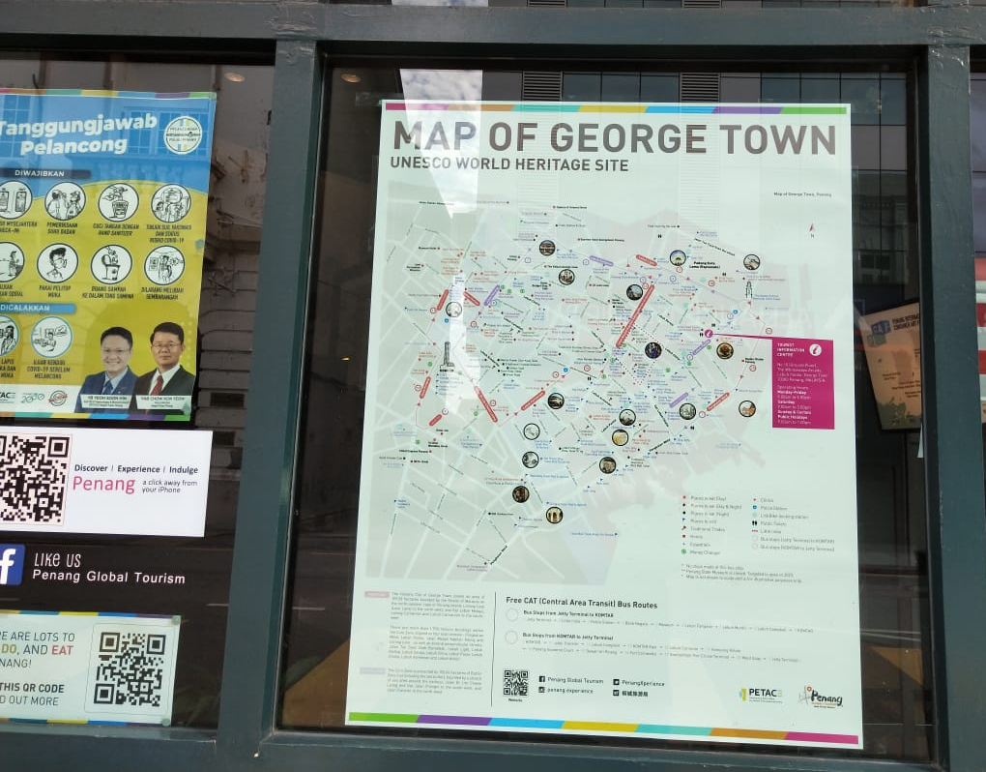

Picture 2: Displayed at the window facing outside for tourists to view.

